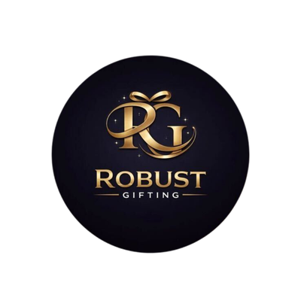
ROBUST GIFTING
Keychain Catalogue
Premium Branded Keychains | Wholesale Prices

19 Styles | Metal, Leather, Bamboo & Cork

KEYCHAINS
KC-01  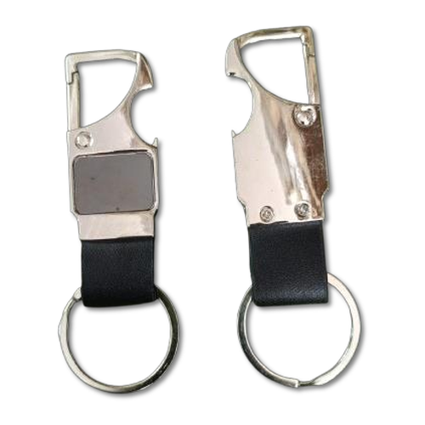  Hook Keychain with Bottle Opener  Dual-function metal keychain with a sturdy hook clasp and integrated bottle opener — a practical everyday carry.  Material: Zinc Alloy  Colour: Silver / Black  ₹36 + 18% GST |  | KC-02  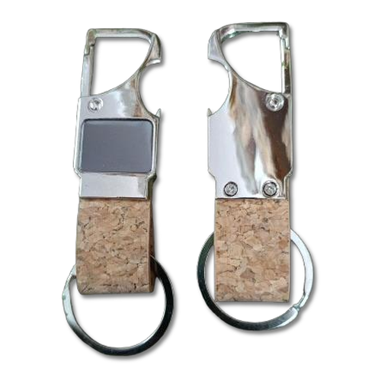  Cork Hook Keychain with Bottle Opener  Eco-friendly cork body with a metal hook and bottle opener — lightweight, natural, and great for gifting.  Material: Cork + Metal  Colour: Natural Brown / Silver  ₹38 + 18% GST
KC-03  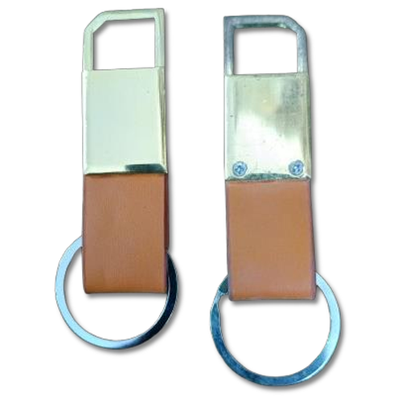  Hook Keychain  Compact metal hook keychain with a smooth polished finish — simple, functional, and easy to personalise.  Material: Metal  Colour: Silver  ₹36 + 18% GST |  | KC-04  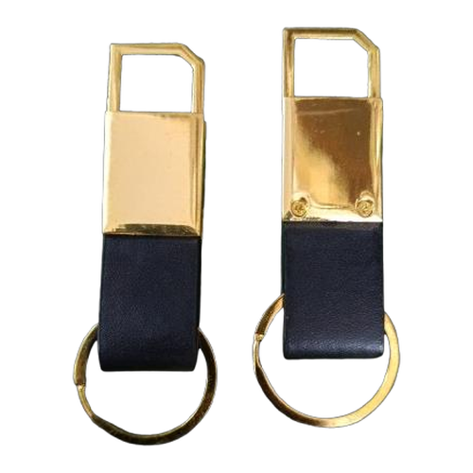  Hook Keychain  Sleek hook-style keychain with a larger loop and brushed metal body — ideal for corporate branding.  Material: Metal  Colour: Silver  ₹40 + 18% GST
KC-05  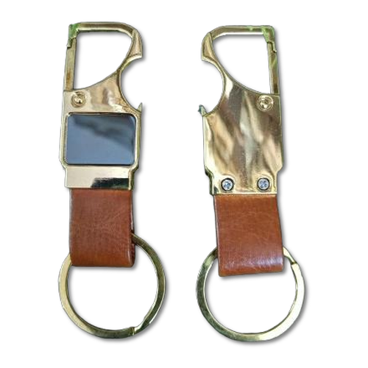  Hook Keychain  Heavy-duty metal hook keychain with a wide split ring — robust and polished for premium gifting.  Material: Metal  Colour: Silver  ₹40 + 18% GST |  | KC-06  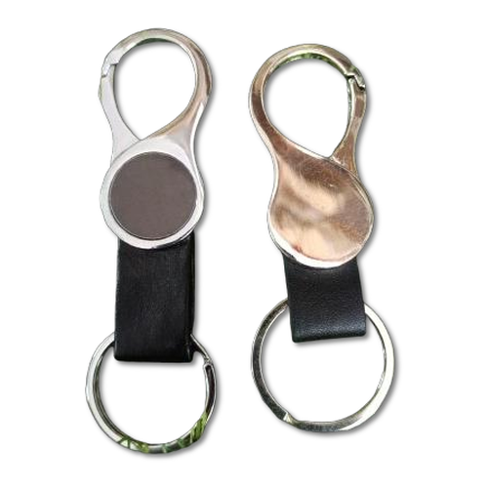  Ring Loop Leather Keychain  Genuine leather strap keychain with a large metal ring loop — available in classic Black, Brown, and Tan.  Material: Genuine Leather + Metal  Colour: Black / Brown / Tan  ₹36 + 18% GST
KC-07  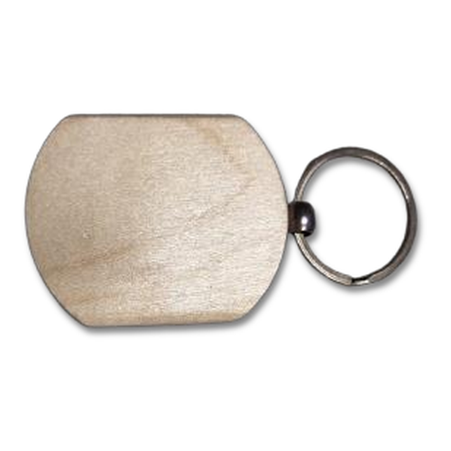  Bamboo Keychain  Eco-friendly bamboo keychains in 6 distinctive laser-engravable shapes — sustainable gifting at great value.  Material: Bamboo  Colour: Natural  From ₹7.50 + 12% GST |  | KC-08  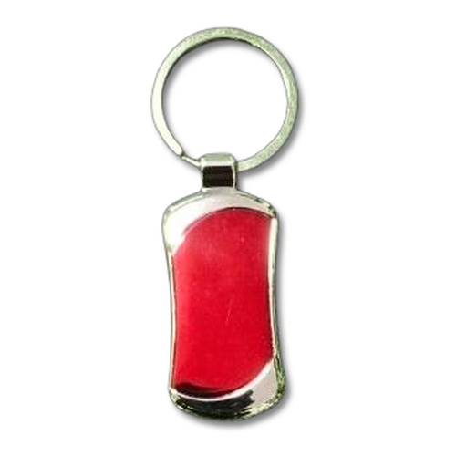  Enamel Metal Tag Keychain  Curved metal tag keychain with vibrant enamel fill in multiple colours — eye-catching and brandable.  Material: Metal + Enamel  Colour: Red / Blue / Black / Gold  ₹33–₹35 + 18% GST
KC-09  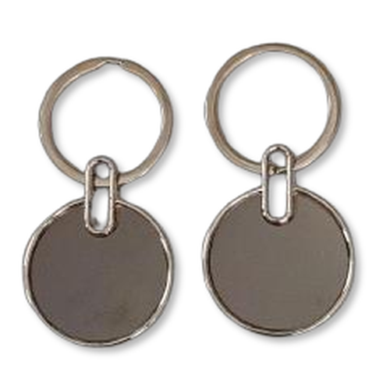  Round Disc Metal Keychain  Smooth circular metal disc keychain with a polished surface — perfect for laser engraving logos and names.  Material: Metal  Colour: Silver / Gunmetal  ₹17–₹25 + 18% GST |  | KC-10  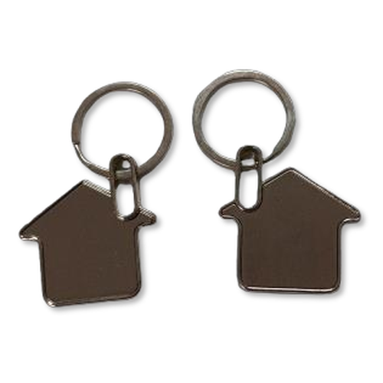  Home Keychain  Charming house-shaped metal keychain — a thoughtful housewarming or real estate promotional gift.  Material: Metal  Colour: Silver  ₹18 + 18% GST
KC-11  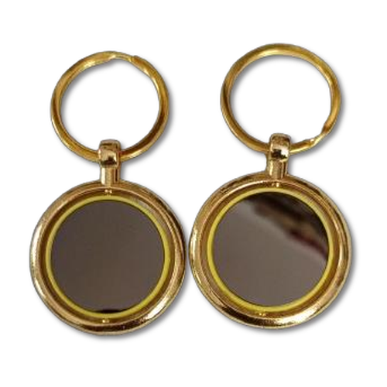  Round Disc Gold / Silver Keychain  Elegant round disc keychain with a premium plated finish — available in gold and silver for corporate gifting.  Material: Metal (Plated)  Colour: Gold / Silver  Gold ₹35 | Silver ₹30 + 18% GST |  | KC-12  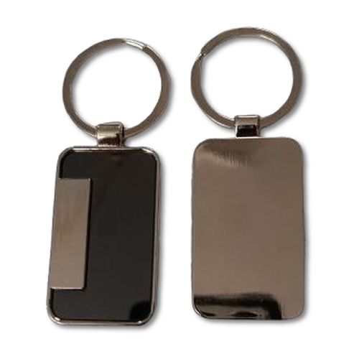  Metal Rectangle Keychain  Clean rectangular metal keychain with wide engravable surface — a classic choice for branded gifting.  Material: Metal  Colour: Silver / Black  ₹20–₹25 + 18% GST
KC-13  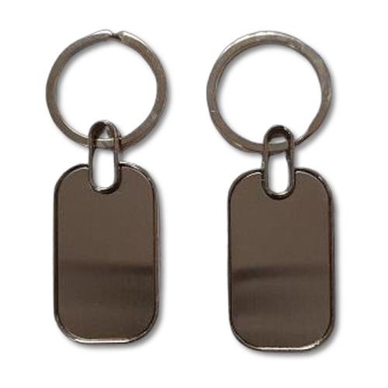  Metal Keychain  Minimalist polished metal keychain with a smooth oblong body — versatile and ideal for bulk personalisation.  Material: Metal  Colour: Silver  ₹17 + 18% GST |  | KC-14  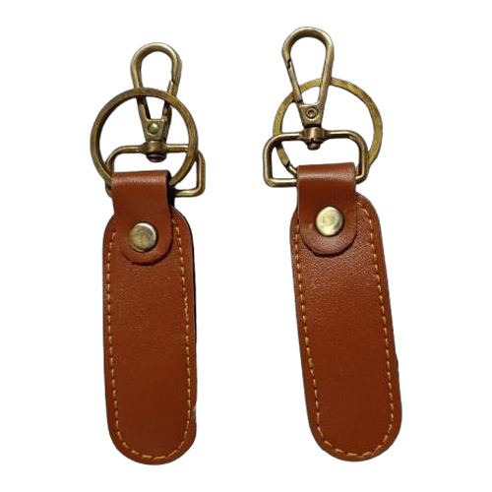  Leather Strap Keychain  Premium leather strap keychain with metal hardware — available in standard and wide strap options.  Material: Genuine Leather + Metal  Colour: Brown / Black / Tan  ₹35–₹65 + 18% GST
KC-15  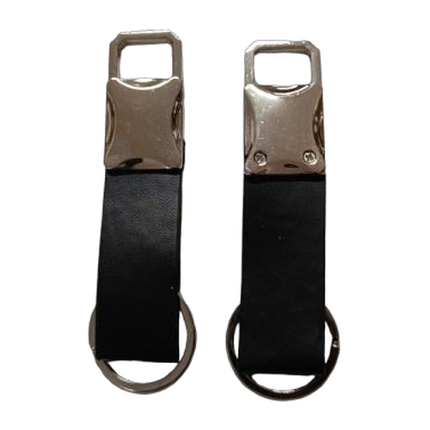  Leather Belt Keychain  Belt-loop leather keychain with a secure metal clasp — practical and stylish for everyday use.  Material: Genuine Leather + Metal  Colour: Brown  ₹50 + 18% GST |  | KC-16  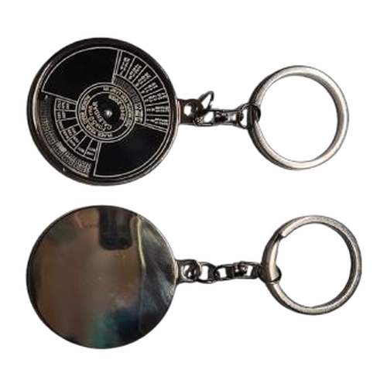  Calendar Keychain  Compact metal keychain with an annual calendar — a smart promotional item that gets used year-round.  Material: Metal  Colour: Silver  ₹40 + 18% GST
KC-17  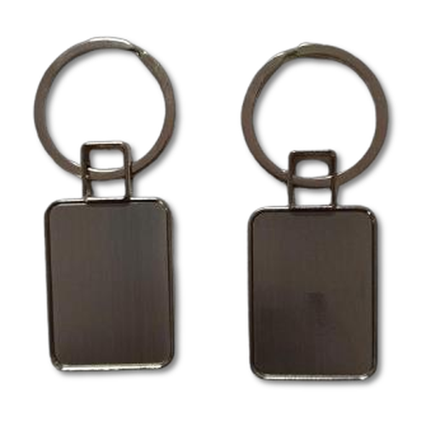  Metal Round Flat Keychain  Ultra-thin flat round metal keychain with a mirror-like finish — lightweight and ideal for logo stamping.  Material: Metal  Colour: Silver  ₹17 + 18% GST |  | KC-18  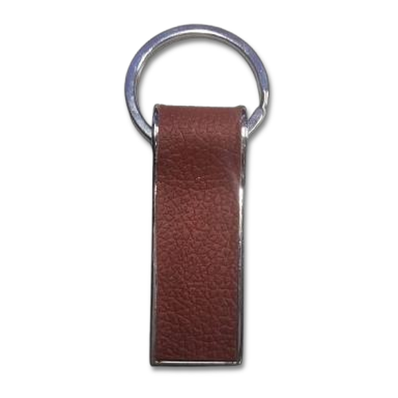  Metal Curved Keychain  Curved barrel-style metal keychain with a smooth finish — ergonomic design that sits well in the hand.  Material: Metal  Colour: Silver  ₹33 + 18% GST
KC-19
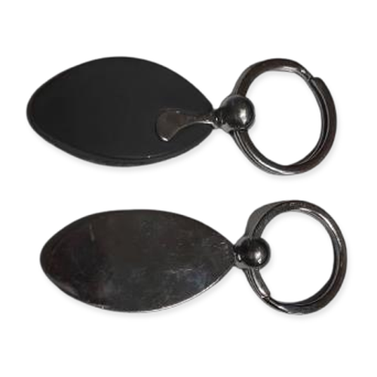
Metal Keychain Duo
Two-piece linked metal keychain set with contrasting finishes — a premium gifting option with a distinctive look.

Material: Metal
Colour: Silver / Gunmetal
₹30–₹40 + 18% GST
Thank you
for considering Robust Gifting

All items available for custom branding.
Minimum order quantities and lead times on request.
Prices are exclusive of 18% GST. Valid 2026.

