
ROBUST GIFTING
Mobile Stand Catalogue
Premium Desk Accessories | Wholesale Prices

14 Models | Stainless Steel & Powder Coated

MOBILE STANDS
Model A01  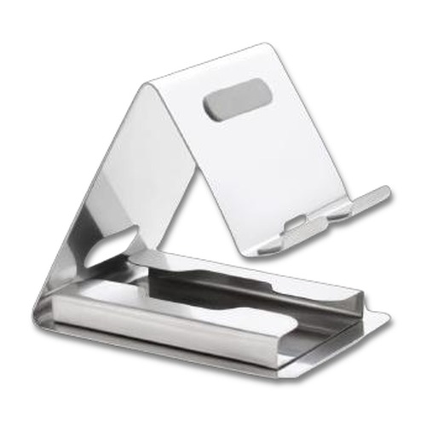  Stainless Steel Mobile Stand  Premium polished stainless steel desktop stand with wide weighted base and dual-slot cradle for stable device support.  Material: Stainless Steel  Colour: Silver  ₹120 + 18% GST |  | Model A02  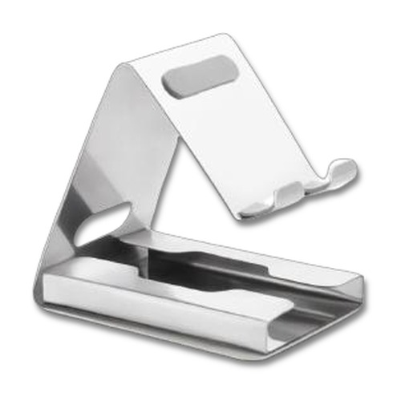  Stainless Steel Mobile Stand  Compact stainless steel stand with a hinged fold-flat design — adjustable viewing angle for phone and tablet.  Material: Stainless Steel  Colour: Silver  ₹110 + 18% GST
Model A03  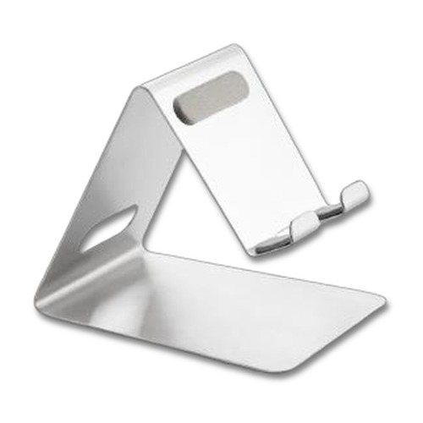  Stainless Steel Mobile Stand  Slim, low-profile stainless steel stand with a wide flat base — minimalist and sturdy for desk use.  Material: Stainless Steel  Colour: Silver  ₹100 + 18% GST |  | Model A04  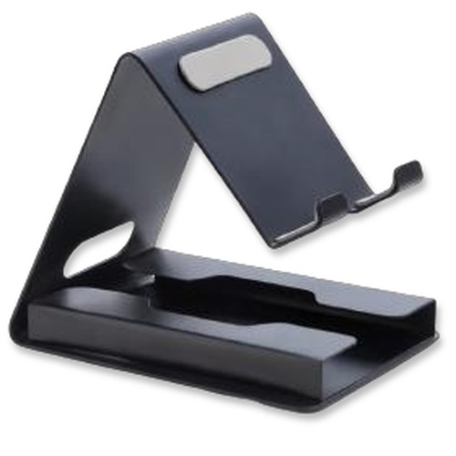  Metal Powder Coated Stand  Sleek powder-coated metal stand with adjustable tilt — durable matte finish ideal for branding and gifting.  Material: Metal (Powder Coated)  Colour: Black  ₹60 + 18% GST
Model A05  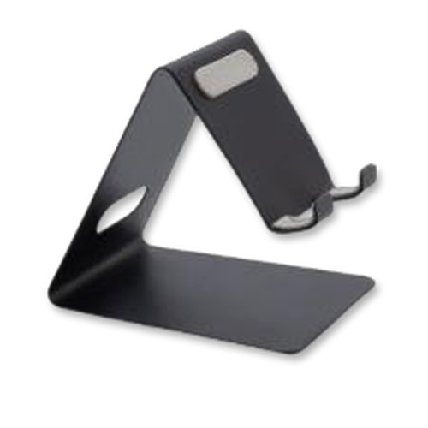  Metal Powder Coated Stand  Ultra-slim flat-fold metal stand with smooth powder coating — lightweight and easy to carry.  Material: Metal (Powder Coated)  Colour: Black  ₹45 + 18% GST |  | Model A07  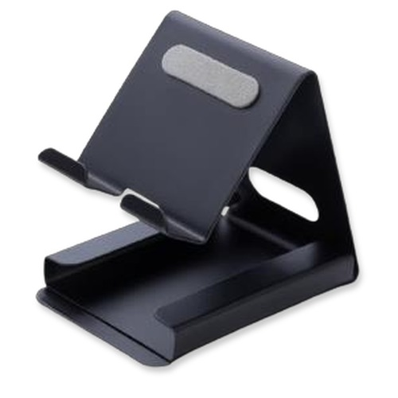  Metal Powder Coated Stand  Heavy-duty powder-coated metal stand with a solid triangular frame for maximum stability on any desk.  Material: Metal (Powder Coated)  Colour: Black  ₹85 + 18% GST
Model A08  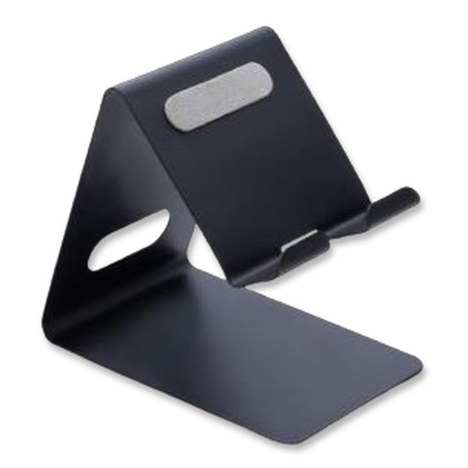  Metal Powder Coated Stand  Angled powder-coated metal stand with a large flat base — steady support at an optimal viewing angle.  Material: Metal (Powder Coated)  Colour: Black  ₹50 + 18% GST |  | Model A09  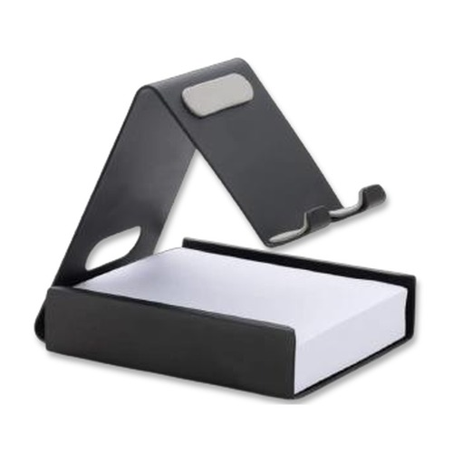  Stand with Notepad Holder  Multifunctional metal stand combining a phone cradle with an integrated notepad and card holder at the base.  Material: Metal (Powder Coated)  Colour: Black / White  ₹85 + 18% GST
Model A10  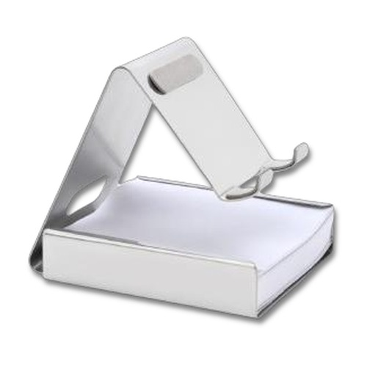  Steel Stand with Notepad Holder  Polished stainless steel phone stand with a built-in base compartment for notepads and business cards.  Material: Stainless Steel  Colour: Silver  ₹110 + 18% GST |  | Model A11  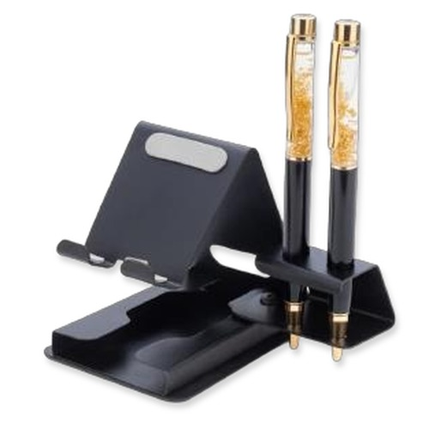  Stand with Pen Holder  Metal powder-coated desk stand with an upright multi-pen holder — a dual-purpose organiser for any workspace.  Material: Metal (Powder Coated)  Colour: Black  ₹100 + 18% GST (Stand Only)
Model A12  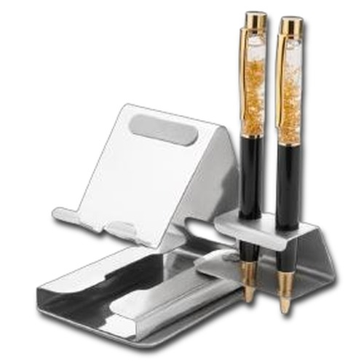  Steel Stand with Pen Holder  Stainless steel mobile stand paired with a vertical pen holder — elegant and functional for executive desks.  Material: Stainless Steel  Colour: Silver  ₹110 + 18% GST (Stand Only) |  | Foldable  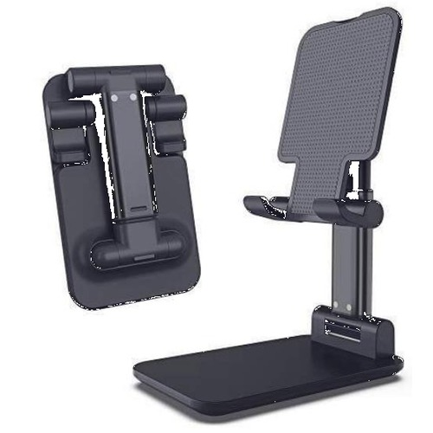  Foldable Mobile Stand  Height-adjustable foldable stand with a telescopic neck — portable, collapsible and perfect for travel gifting.  Material: Metal (Powder Coated)  Colour: Black  ₹75 + 18% GST
Foldable Pro  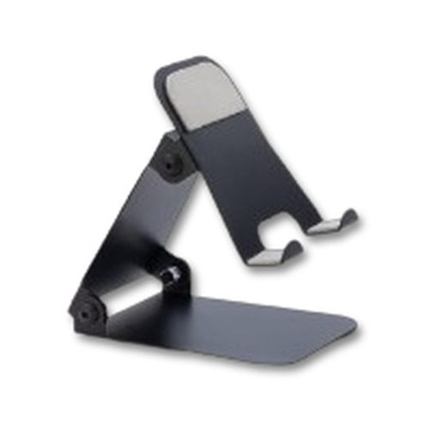  Foldable Mobile Stand Pro  Premium compact foldable stand with smooth angle adjustment and a flat-fold design for easy portability.  Material: Metal (Powder Coated)  Colour: Black / White  ₹90 + 18% GST |  | Model A13  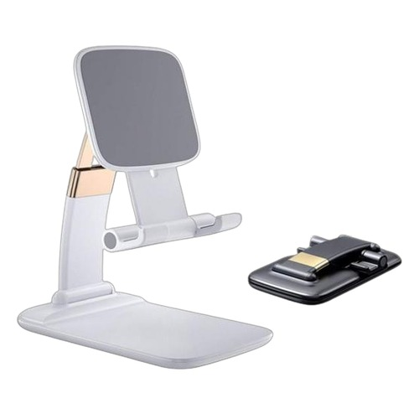  Folding Metal Stand  Compact folding metal powder-coated stand with a wide base — folds flat for storage and unfolds instantly.  Material: Metal (Powder Coated)  Colour: Black  ₹65 + 18% GST
Thank you
for considering Robust Gifting

All items available for custom branding.
Minimum order quantities and lead times on request.
Prices are exclusive of 18% GST. Valid 2026.

