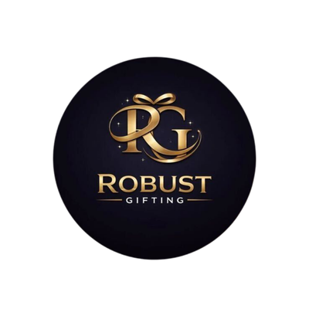
ROBUST GIFTING
Vacuum Flasks & Mugs Catalogue
Premium Drinkware | Wholesale Prices

18 Products | Stainless Steel & Bamboo

VACUUM FLASKS & MUGS
VF-01  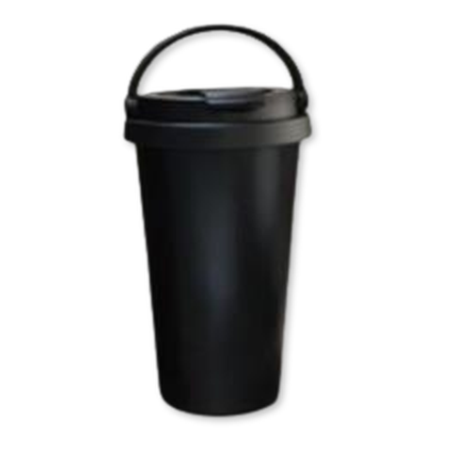  Vacuum Insulated Tumbler  Sleek 500 ml vacuum-insulated tumbler with a secure lid — keeps drinks hot or cold for hours.  Material: Stainless Steel  Colour: Black  ₹250 + 18% GST |  | VF-02  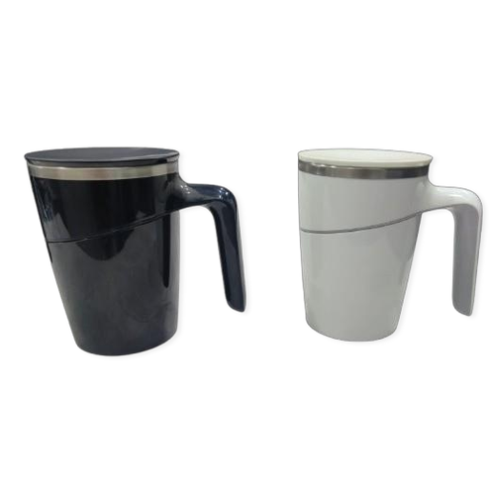  Vacuum Mug with Handle  Premium 400 ml vacuum mug with an ergonomic handle and stainless steel lid — ideal desk companion.  Material: Stainless Steel  Colour: Black / White  ₹425 + 18% GST
VF-03  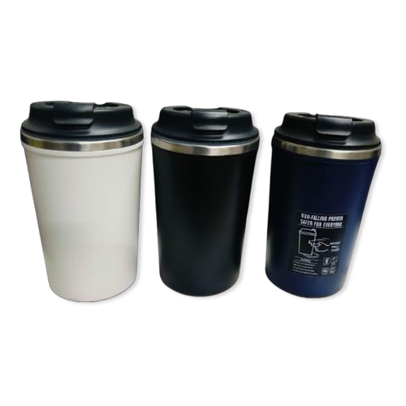  Section Travel Mug  Stylish 300 ml insulated section mug with a snap-lock flip lid — available in multiple colour options.  Material: Stainless Steel  Colour: White / Black / Navy  ₹300 + 18% GST |  | VF-04  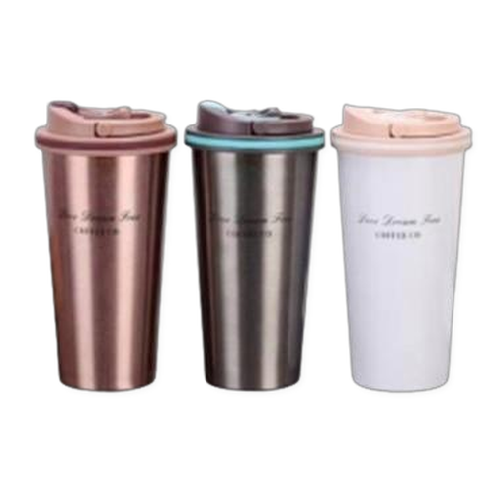  Slim Vacuum Flask  Elegant 500 ml slim coffee flask with a leak-proof lid — perfect for on-the-go gifting.  Material: Stainless Steel  Colour: Rose Gold / Black / White  ₹275 + 18% GST
VF-05  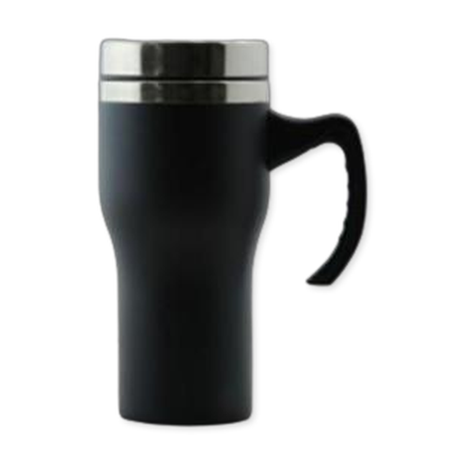  Tall Vacuum Mug  Tall 500 ml vacuum mug with a sturdy handle and polished steel rim — hot and cold retention.  Material: Stainless Steel  Colour: Black  ₹185 + 18% GST |  | VF-06  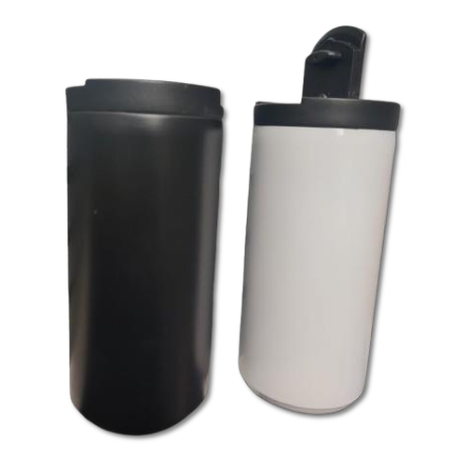  Compact Vacuum Flask  Compact 350–400 ml vacuum flask with a flip-lock lid — lightweight and easy to carry anywhere.  Material: Stainless Steel  Colour: Black / White  ₹225 + 18% GST
VF-07  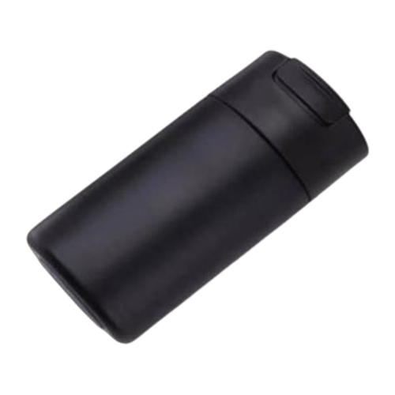  Slim Insulated Flask  Sleek 450 ml slim-profile vacuum flask with a push-fit lid — minimalist design for everyday use.  Material: Stainless Steel  Colour: Black  ₹210 + 18% GST |  | VF-08  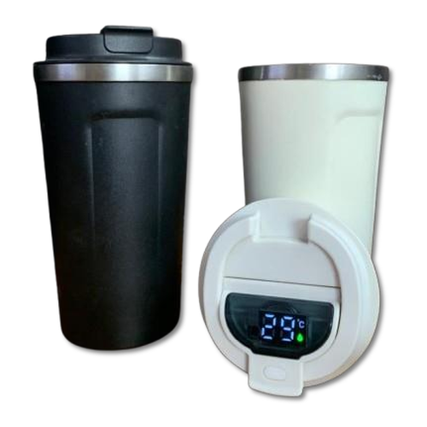  Temp-Display Travel Flask  Smart 300–510 ml vacuum flask with a built-in LED temperature display on the lid — hot and cold.  Material: Stainless Steel  Colour: Black / White  ₹185 + 18% GST
VF-09  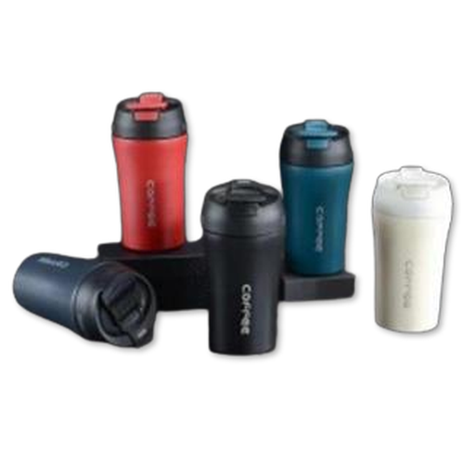  Coffee Travel Mug  Vibrant 500 ml vacuum coffee travel mug with a secure snap lid — available in 5 bold colours.  Material: Stainless Steel  Colour: Red / Navy / Black / Teal / White  ₹195 + 18% GST |  | VF-10  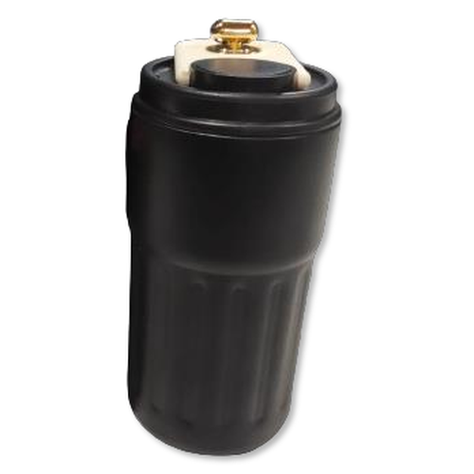  Wide-Body Tumbler  Sturdy 500 ml wide-body vacuum tumbler with a spill-proof lid — great for desk or travel use.  Material: Stainless Steel  Colour: Black  ₹225 + 18% GST
VF-11  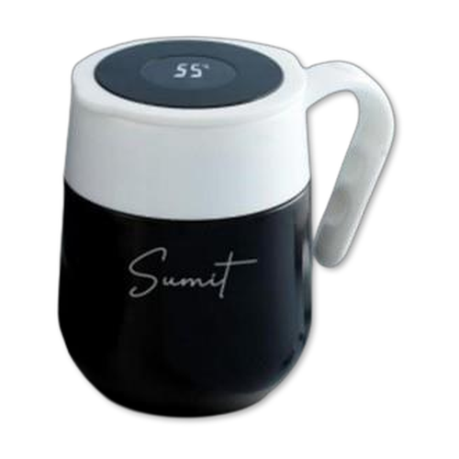  Smart Insulated Mug  Premium 450 ml insulated mug with a temperature-display lid, ergonomic handle, and personalised finish.  Material: Stainless Steel  Colour: Black / White  ₹400 + 18% GST |  | VF-12  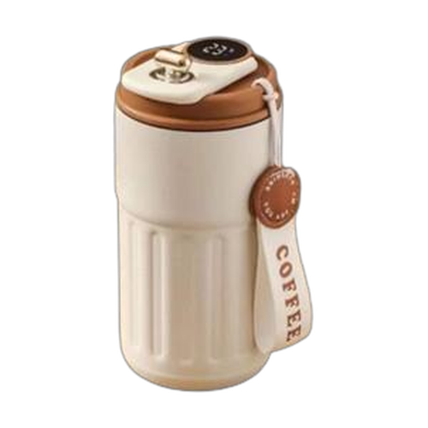  Coffee Canister Flask  Retro-style 500 ml coffee canister flask with a leather carry strap and locking lid — gift-ready.  Material: Stainless Steel  Colour: Beige / Black  ₹250 + 18% GST
VF-13  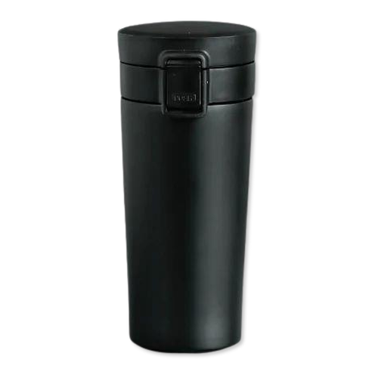  Push Button Travel Mug  Handy 400 ml vacuum mug with a one-touch push-button lid — convenient for commuters.  Material: Stainless Steel  Colour: Black / Grey  ₹145 + 18% GST |  | VF-14  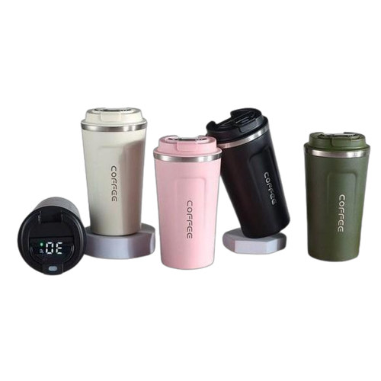  Temperature Coffee Travel Mug  510 ml stainless steel coffee travel mug with a digital temperature display — available in 5 colours.  Material: Stainless Steel  Colour: Beige / Pink / Black / Olive / White  ₹190 + 18% GST
VF-15  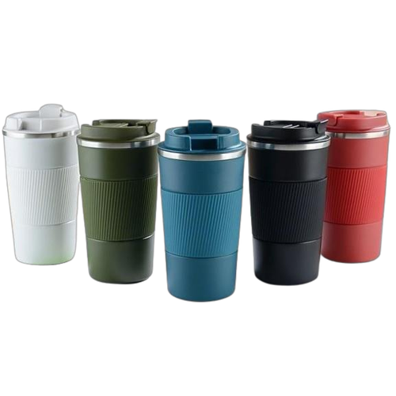  Vacuum Insulated Travel Mug with Grip  500 ml vacuum mug with a ribbed silicone grip band and flip lid — anti-slip and spill-proof.  Material: Stainless Steel + Silicone  Colour: White / Olive / Teal / Black / Red  ₹185 + 18% GST |  | VF-16  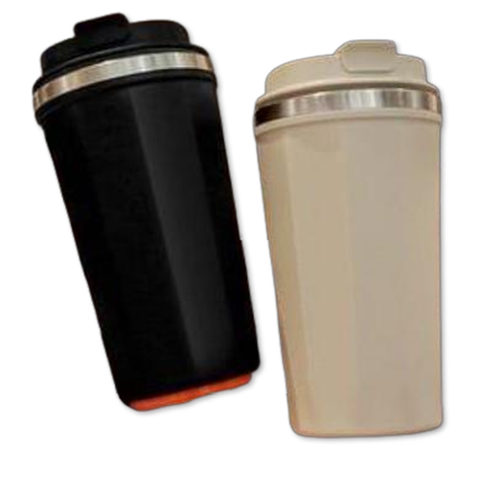  Stainless Steel Double Wall Mug  Classic 350 ml double-wall stainless steel mug with a wide mouth and secure lid — timeless gifting.  Material: Stainless Steel (Double Wall)  Colour: Black / Beige  ₹330 + 18% GST
VF-17  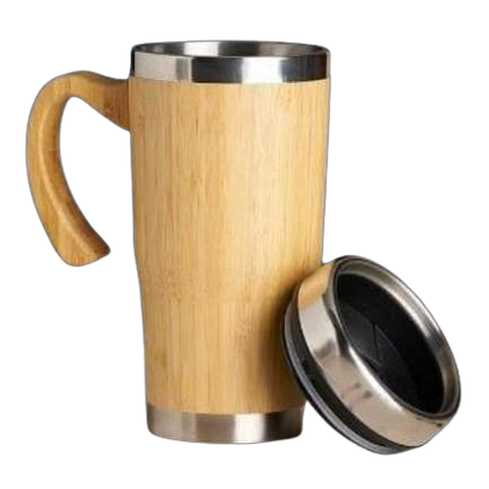  Bamboo Vacuum Flask Coffee Mug  Eco-friendly bamboo vacuum flask mug with a steel interior and bamboo handle — natural and stylish.  Material: Bamboo + Stainless Steel  Colour: Natural Bamboo / Silver  ₹240 + 18% GST |  | VF-18  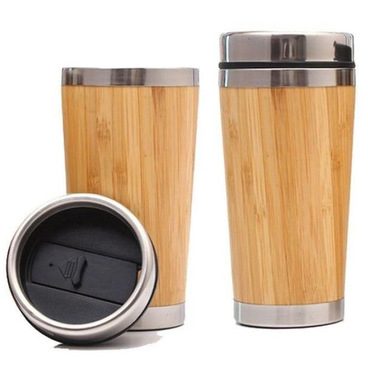  Bamboo Coffee Travel Cup  Sustainable 500 ml bamboo coffee travel cup with a steel-trimmed snap lid — perfect eco gifting.  Material: Bamboo + Stainless Steel  Colour: Natural Bamboo / Silver  ₹240 + 18% GST

Thank you
for considering Robust Gifting

All items available for custom branding.
Minimum order quantities and lead times on request.
Prices are exclusive of 18% GST. Valid 2026.

