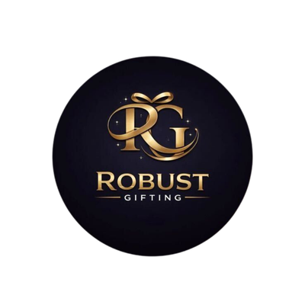
ROBUST GIFTING
Wooden Coasters & Ashtrays Catalogue
Premium Wooden Gifts | Wholesale Prices

13 Products | Bamboo, Beechwood, Pine & Cork

WOODEN COASTERS & ASHTRAYS
HGS-WC-1  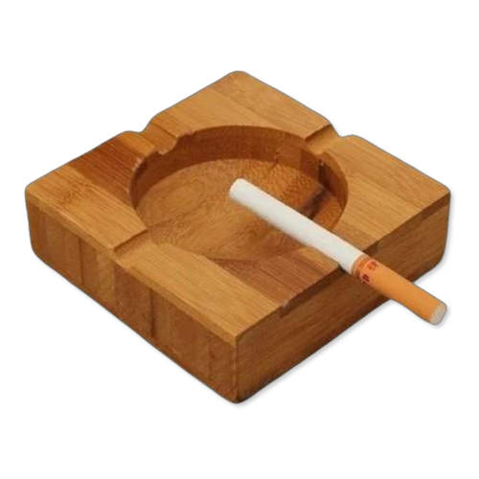  Bamboo Square Ashtray  Solid bamboo square ashtray with a deep bowl and four cigarette rests — natural, sturdy, and eco-friendly.  Material: Bamboo  Colour: Natural Brown  ₹100 + 12% GST |  | HGS-WC-2  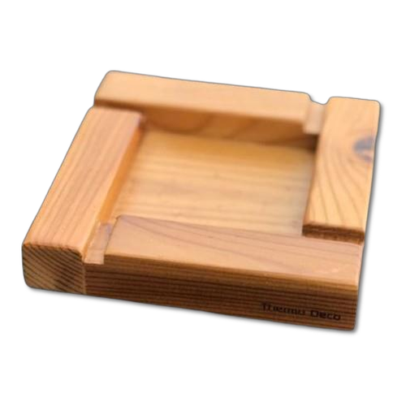  Pine Wood Ashtray  Lightweight pine wood square ashtray with corner cigarette grooves — clean, minimalist gifting option.  Material: Pine Wood  Colour: Natural  ₹100 + 12% GST
HGS-WC-3  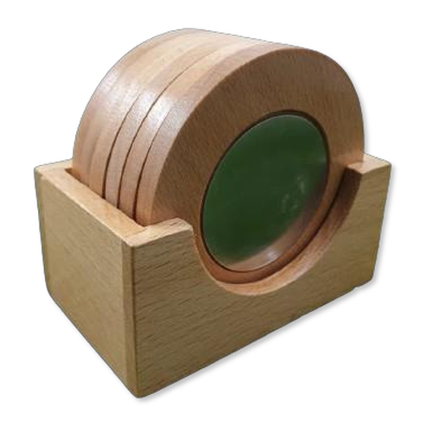  Round Coaster Set with Holder  Set of round beechwood coasters with a square wooden holder featuring a green cork base disc.  Material: Beechwood + Cork  Colour: Natural + Green  ₹200 + 12% GST |  | HGS-WC-4  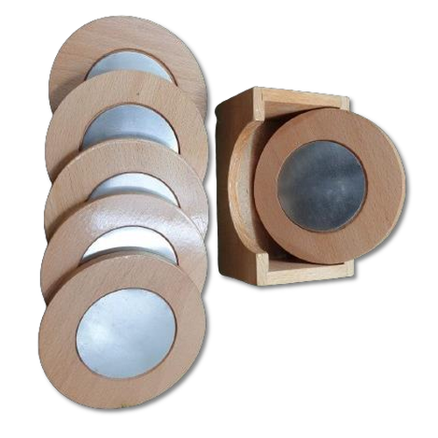  Round Coaster Set with Metal Inserts  Premium round wooden coasters with silver metal-insert centres in a matching wooden holder — elegant table accessory.  Material: Beechwood + Metal  Colour: Natural + Silver  ₹200 + 12% GST
HGS-WC-5    Pine Wood Square Ashtray  Simple pine wood square ashtray with notched corner rests — unfinished natural surface ideal for custom branding.  Material: Pine Wood  Colour: Natural  ₹100 + 12% GST |  | HGS-WC-6  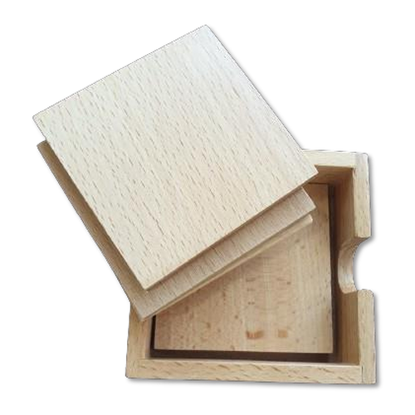  Square Coaster Set in Sliding Box  Beechwood square coasters housed in a smooth sliding-lid wooden box — gift-ready presentation packaging.  Material: Beechwood  Colour: Natural  ₹150 + 12% GST
HGS-WC-7  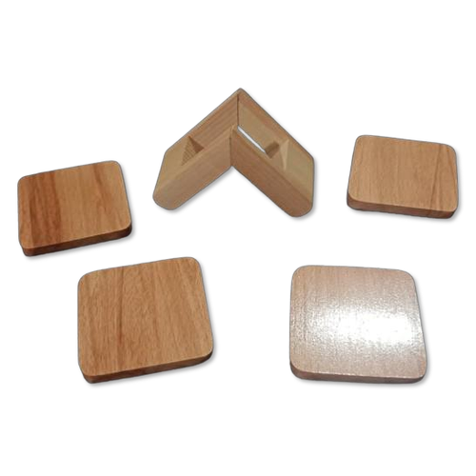  Square Coaster Set with V-Stand  Set of smooth beechwood square coasters with a V-shaped stand holder — contemporary desk accessory.  Material: Beechwood  Colour: Natural  ₹150 + 12% GST |  | HGS-WC-8  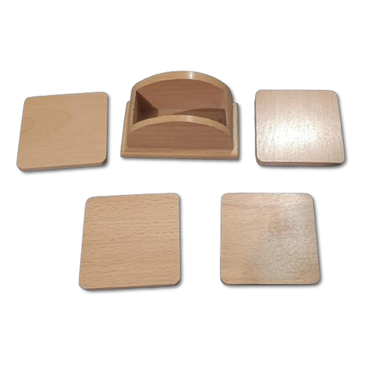  Square Coaster Set with Arch Holder  Polished beechwood square coasters with a curved arch-top stand — refined and functional tabletop set.  Material: Beechwood  Colour: Natural  ₹150 + 12% GST
HGS-WC-9  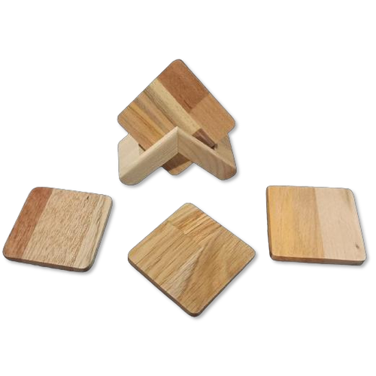  Mixed Wood Coaster Set with Stand  Square coasters in mixed natural wood grains with a V-shaped stand — a unique, varied look for every set.  Material: Mixed Hardwood  Colour: Multi-grain Natural  ₹150 + 12% GST |  | HGS-WC-10  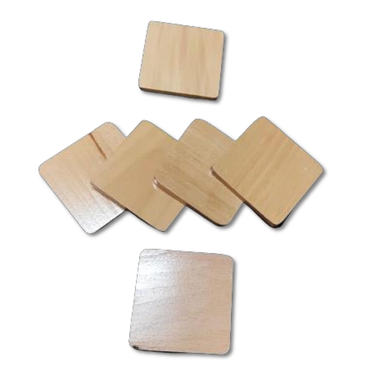  Plain Beechwood Coaster Set  Set of six plain beechwood square coasters — unfinished and ready for laser engraving or custom printing.  Material: Beechwood  Colour: Natural  ₹120 + 12% GST
HGS-WC-11  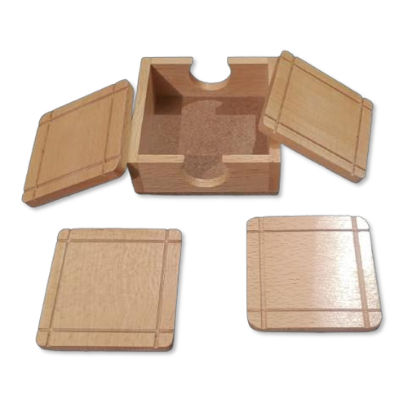  Grid Coaster Set in Box  Beechwood coasters with decorative grid-line detailing, stored in a matching sliding-lid wooden gift box.  Material: Beechwood  Colour: Natural  ₹135 + 12% GST |  | HGS-WC-12  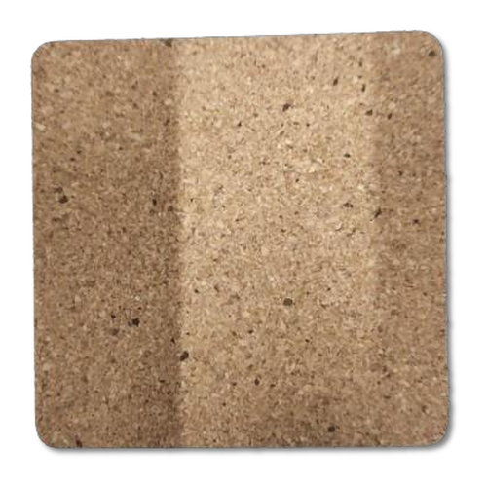  Square Cork Coaster  Natural cork square coaster with a smooth surface — heat-resistant, eco-friendly, and easy to customise.  Material: Cork  Colour: Natural Brown  ₹20 + 18% GST
HGS-WC-13
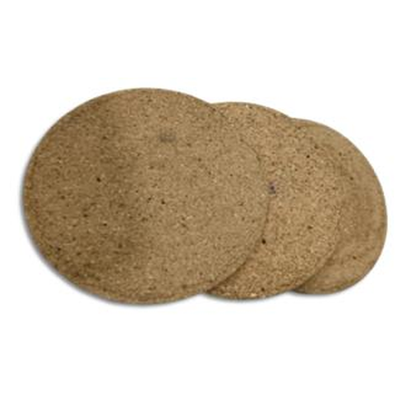
Round Cork Coaster
Natural round cork coaster — lightweight, heat-resistant, and ideal for branded printing per piece.

Material: Cork
Colour: Natural Brown
₹20 + 18% GST (per piece)

Thank you
for considering Robust Gifting

All items available for custom branding.
Minimum order quantities and lead times on request.
Prices are exclusive of 18% GST. Valid 2026.

