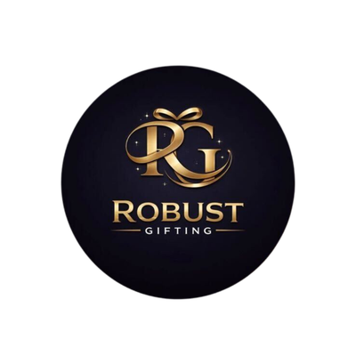
Wooden Stand Catalogue
Robust Gifting | Premium Corporate Gifting Solutions
74 Premium Designs | Prices exclusive of GST

HGS-WS-01  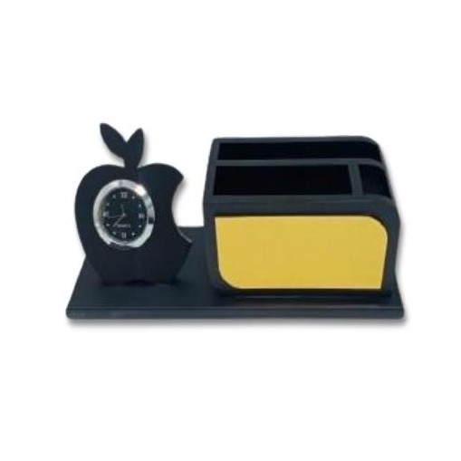  Apple Clock Desk Organiser  MDF Wood  Black MDF organiser with apple-shaped clock, pen & card compartments  ₹200 + 12% GST |  | HGS-WS-02  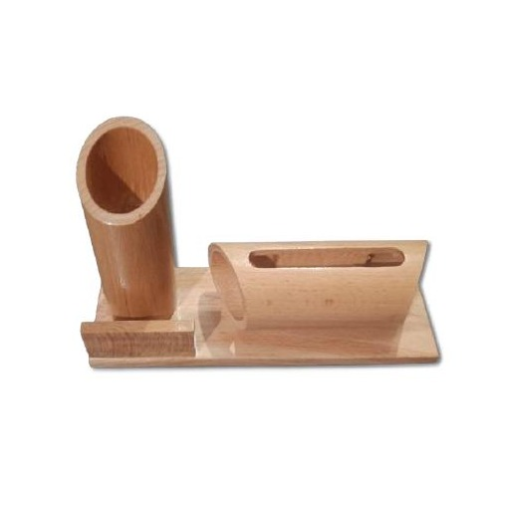  Wooden Pen Cup & Phone Stand  Natural Wood  Natural wood cylindrical pen holder with built-in phone / tablet slot  ₹175 + 12% GST
HGS-WS-03  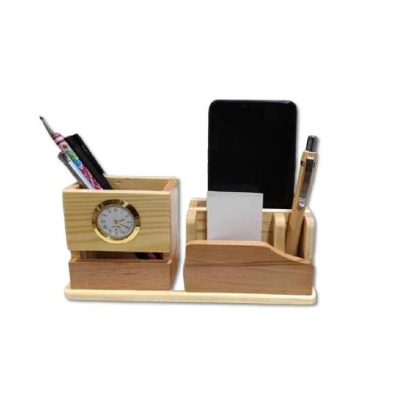  Multi-Compartment Desk Organiser  Natural Wood  Wooden desk organiser with clock, pen holder, card & mobile slots  ₹165 + 12% GST |  | HGS-WS-04  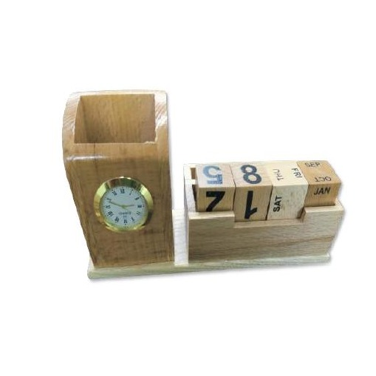  Wooden Desk Organiser with Calendar  Natural Wood  Compact wooden organiser with analogue clock and flip calendar  ₹180 + 12% GST
HGS-WS-05  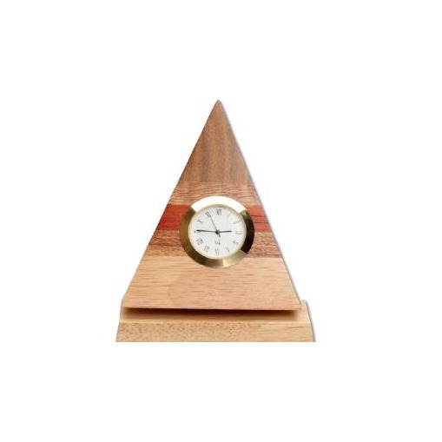  Pyramid Clock Desk Stand  Natural Wood  Handcrafted pyramid-shaped wooden stand with embedded analogue clock  ₹200 + 12% GST (Make to Order) |  | HGS-WS-06  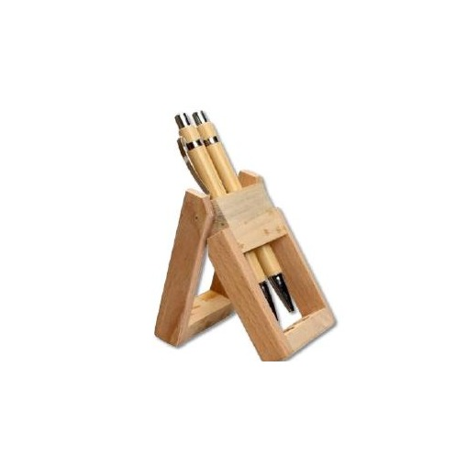  Easel Pen Holder  Natural Wood  Easel-style natural wood pen stand, compact and functional design  ₹60 + 12% GST
HGS-WS-07  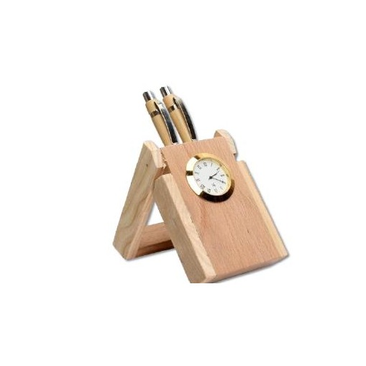  Easel Pen Stand with Clock  Natural Wood  Natural wood easel pen holder with integrated analogue clock face  ₹120 + 12% GST |  | HGS-WS-08  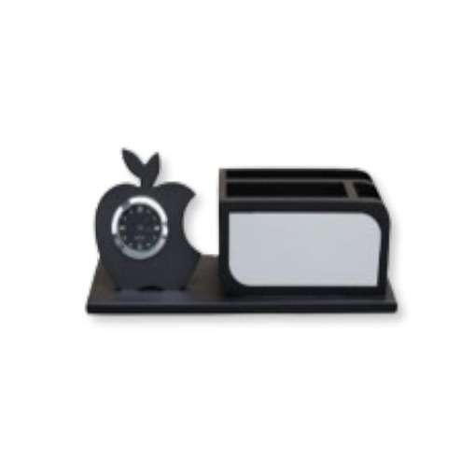  Apple Clock Organiser with Notepad  MDF Wood  Black MDF desk set — apple clock, pen compartments and notepad holder  ₹200 + 18% GST
HGS-WS-09  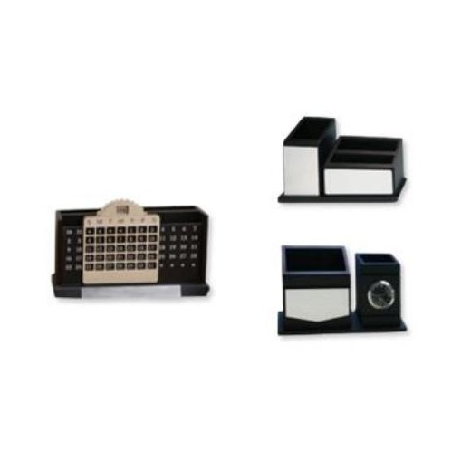  Premium Wooden Desk Organiser  Natural Wood  Wide natural wood organiser with multiple pen, card and device slots  ₹240 + 18% GST |  | HGS-WS-10  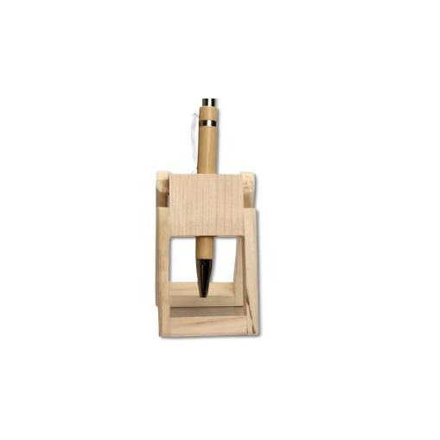  Mini Wooden Pen Stand  Natural Wood  Minimalist natural wood single-slot pen stand, small desk footprint  ₹35 + 12% GST
HGS-WS-11  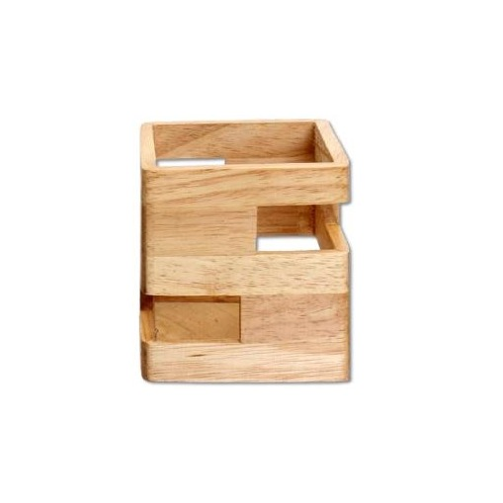  Dual Pen Cup Stand  Natural Wood  Natural wood stand with dual cylindrical pen cup holders  ₹60 + 12% GST |  | HGS-WS-12  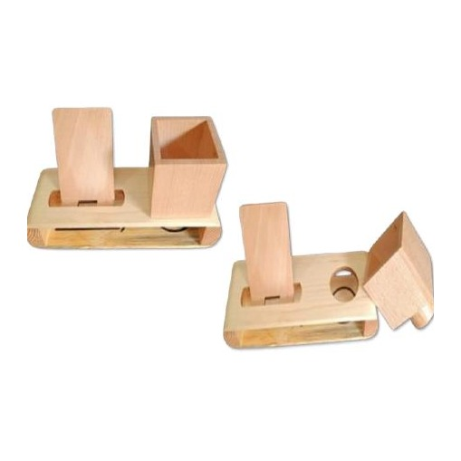  Wooden Desk Organiser with Drawer  Natural Wood  Natural wood organiser with pen holder, card slot and pull-out drawer  ₹165 + 12% GST
HGS-WS-13  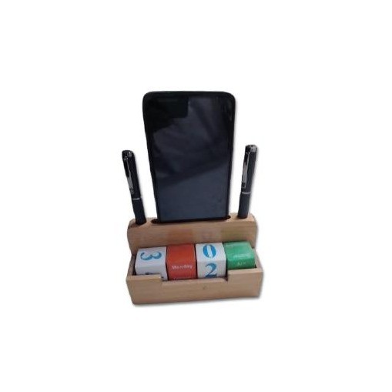  Wooden Card & Pen Organiser  Natural Wood  Natural wood desktop organiser with card holder and pen compartments  ₹135 + 12% GST |  | HGS-WS-14  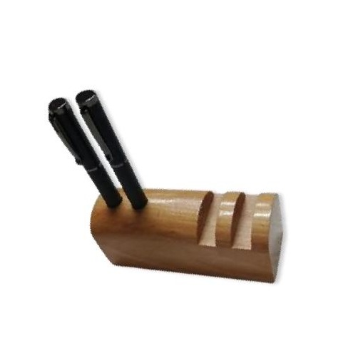  Wooden Desktop Stationery Set  Natural Wood  Multi-slot wooden stationery organiser for pen, cards and accessories  ₹150 + 12% GST
HGS-WS-15  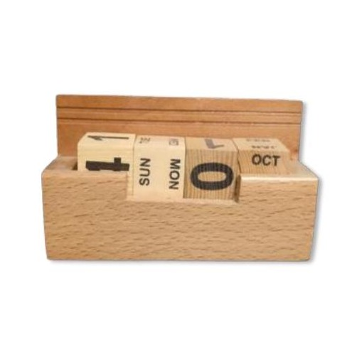  Compact Wooden Desk Stand  Natural Wood  Streamlined natural wood desk stand with pen and card storage slots  ₹130 + 12% GST |  | HGS-WS-16  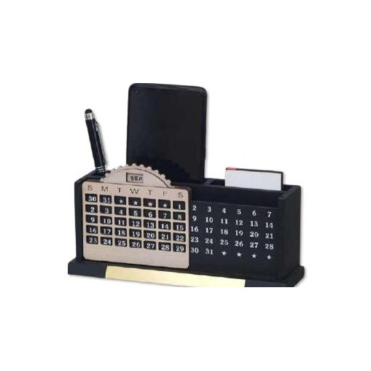  Executive Wooden Desk Organiser  Natural Wood  Premium natural wood organiser with pen, card, mobile and clock slots  ₹240 + 18% GST
HGS-WS-17  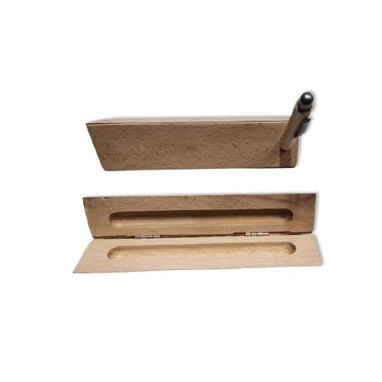  Wooden Flip Pen Box  Natural Wood  Elegant flip-open natural wood pen presentation box, includes pen  ₹70 + 12% GST (with Pen) |  | HGS-WS-18  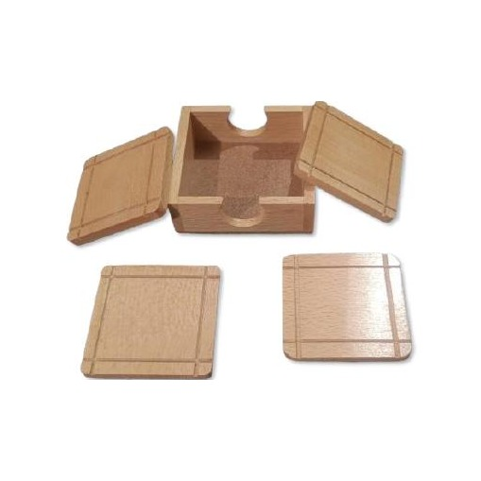  Wooden Storage Box  Natural Wood  Hinged-lid natural wood gift / keepsake storage box, customisable  ₹130 + 12% GST
HGS-WS-19  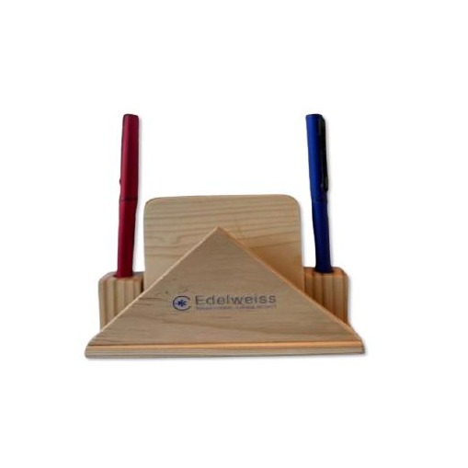  Triangular Wooden Pen Stand  Natural Wood  Pyramid-shaped wood pen holder, dual pen slots, sleek minimalist design  ₹130 + 12% GST (without Pen) |  | HGS-WS-20  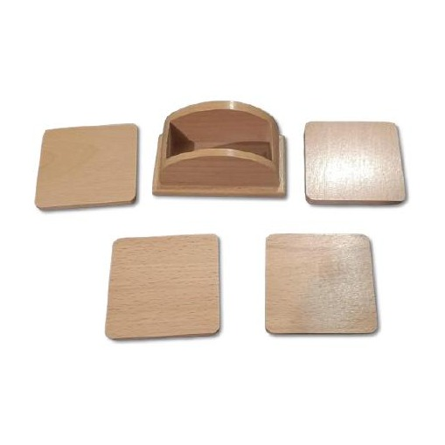  Wooden Coaster Set with Card Holder  Natural Wood  Natural wood coaster set with integrated desktop business card holder  ₹130 + 12% GST
HGS-WS-21  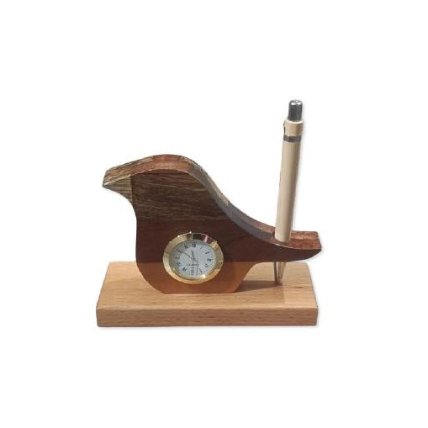  Wooden Phone & Pen Stand  Natural Wood  Natural wood stand with phone slot and pen holder, angled for easy view  ₹175 + 12% GST |  | HGS-WS-22  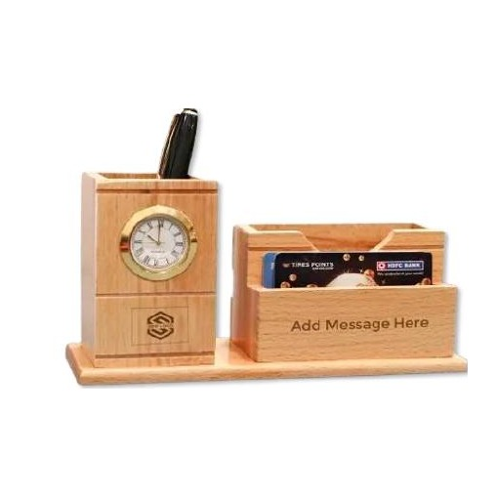  Wooden Tablet & Pen Stand  Natural Wood  Sturdy natural wood stand accommodating tablets, phones and pens  ₹175 + 12% GST
HGS-WS-23  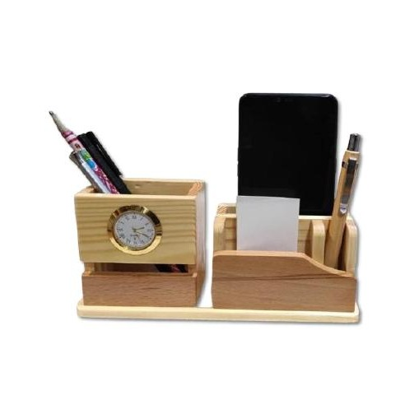  Wooden Phone Stand with Organiser  Natural Wood  Compact wood phone stand with pen holder and card storage slot  ₹165 + 12% GST |  | HGS-WS-24  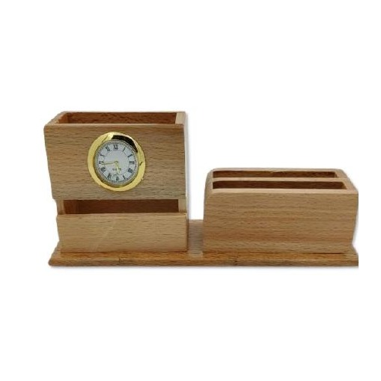  Wooden Desk Station with Phone Slot  Natural Wood  Flat-base wood organiser with angled phone stand and pen compartment  ₹165 + 12% GST
HGS-WS-25  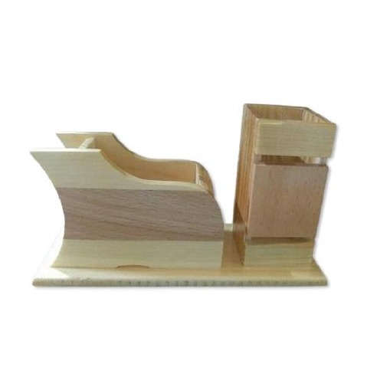  Wooden Desk Organiser Set  Natural Wood  Complete wood desk set with pen holder, card tray and mobile stand  ₹120 + 12% GST |  | HGS-WS-26  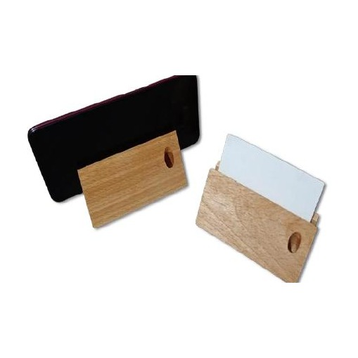  Single Pen Stand  Natural Wood  Simple solid wood single-pen display stand with stable base  ₹65 + 12% GST
HGS-WS-27  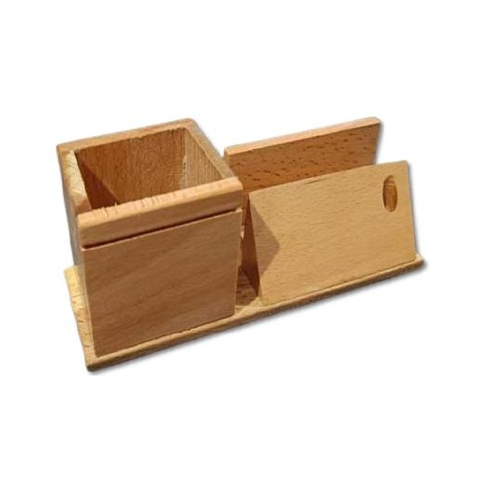  Wooden Multi-Slot Pen Stand  Natural Wood  Natural wood stand with multiple pen and pencil holder slots  ₹130 + 12% GST |  | HGS-WS-28  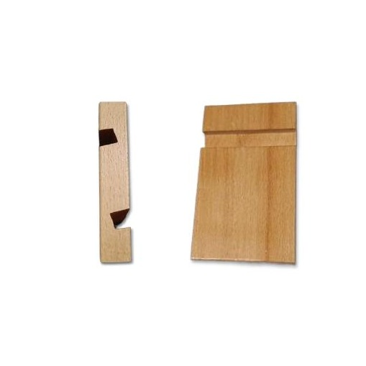  Wooden Mobile Stand  Natural Wood  Portable natural wood mobile phone stand with non-slip base  ₹75 + 12% GST (Mobile Stand)
HGS-WS-29  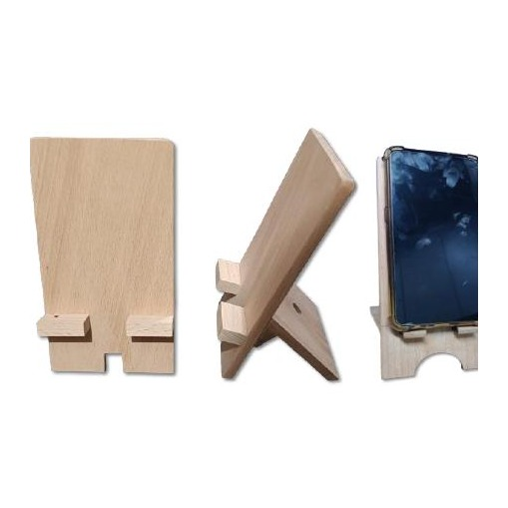  Wooden Mobile Dock  Natural Wood  Solid wood mobile phone docking stand, landscape and portrait support  ₹75 + 12% GST (Mobile Stand) |  | HGS-WS-30  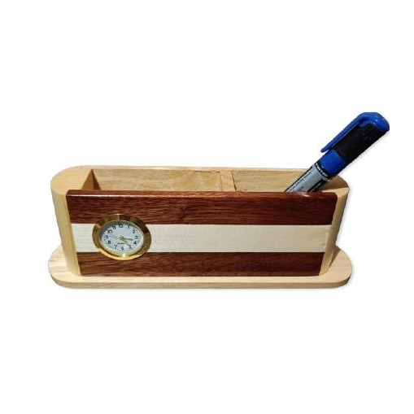  Wooden Executive Desk Organiser  Natural Wood  Wide-format natural wood organiser with pen cup and multiple trays  ₹200 + 12% GST
HGS-WS-31  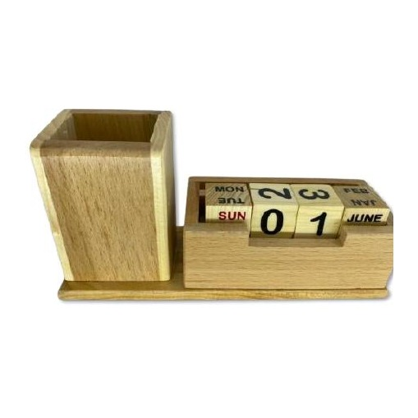  Wooden Stationery Organiser  Natural Wood  Natural wood desk organiser with divided compartments for stationery  ₹150 + 12% GST |  | HGS-WS-32  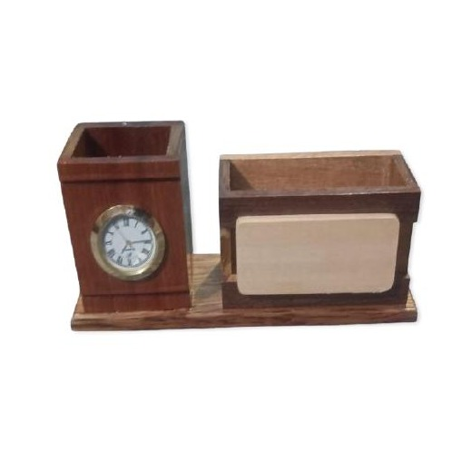  Wooden Desktop Pen & Card Set  Natural Wood  Wooden desktop organiser set with pen holder and card / note tray  ₹165 + 12% GST
HGS-WS-33  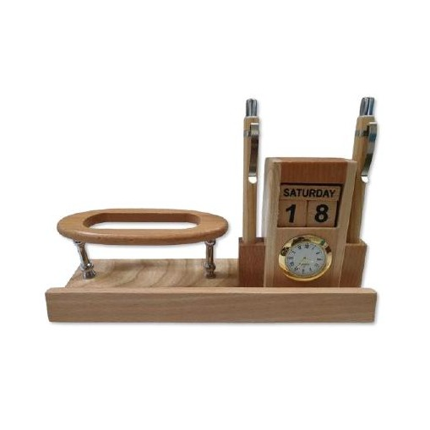  Wooden Desk Organiser with Tray  Natural Wood  Natural wood organiser with large pen section and flat accessory tray  ₹175 + 12% GST |  | HGS-WS-34  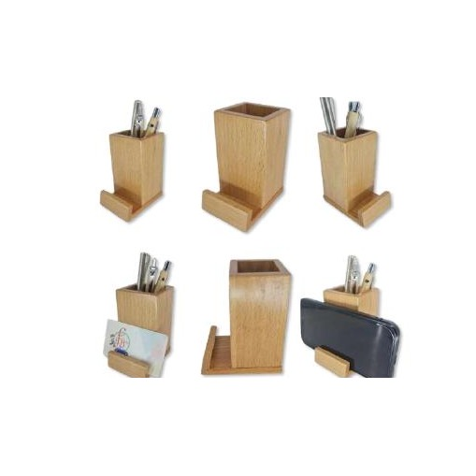  Wooden Pen & Visiting Card Stand  Natural Wood  Compact natural wood stand with upright pen slot and card display  ₹75 + 12% GST
HGS-WS-35  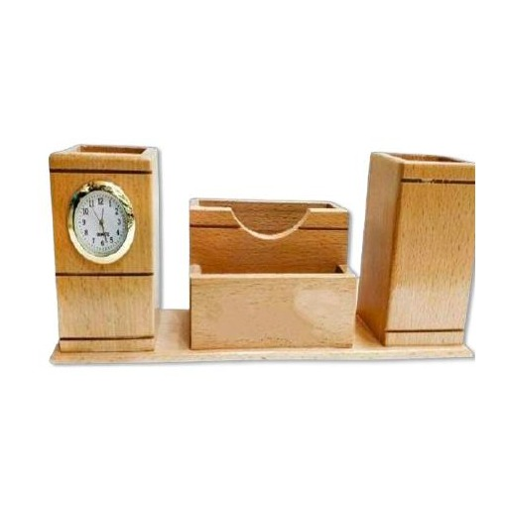  Wooden Desk Organiser with Clock  Natural Wood  Natural wood desk organiser featuring an embedded analogue clock  ₹200 + 12% GST |  | HGS-WS-36  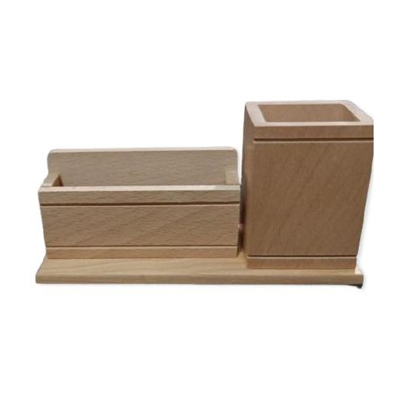  Wooden Name Plate & Pen Stand  Natural Wood  Natural wood combined name plate holder and dual-slot pen stand  ₹100 + 12% GST
HGS-WS-37  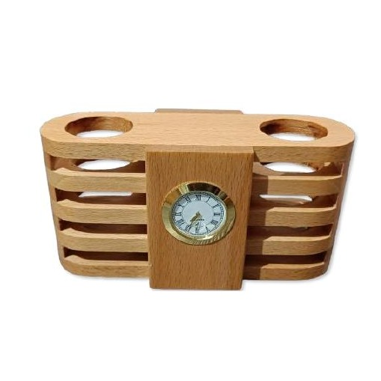  Barrel Clock Desk Organiser  Natural Wood  Barrel-shaped natural wood organiser with embedded gold analogue clock  ₹200 + 12% GST |  | HGS-WS-38  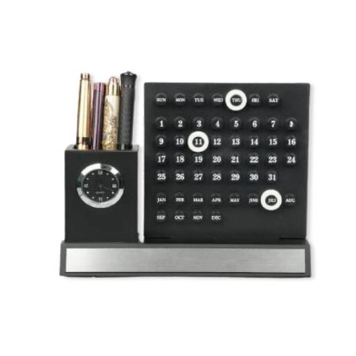  Executive Desk Set with Calendar  MDF Wood  MDF executive pen stand with digital-style perpetual calendar display  ₹300 + 18% GST
HGS-WS-39  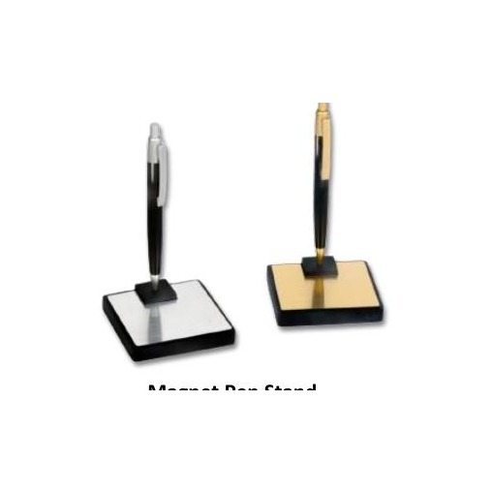  Magnetic Pen Stand  Metal & Wood Base  Magnetic floating pen stand with wood or metal base, premium gift item  ₹150 + 18% GST (Magnet Pen Stand) |  | HGS-WS-40  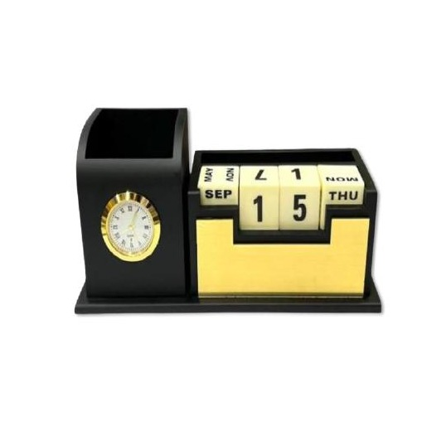  Premium Desk Organiser with Calendar  MDF Wood  MDF organiser with clock, pen holder, flip date & month calendar block  ₹240 + 18% GST
HGS-WS-41  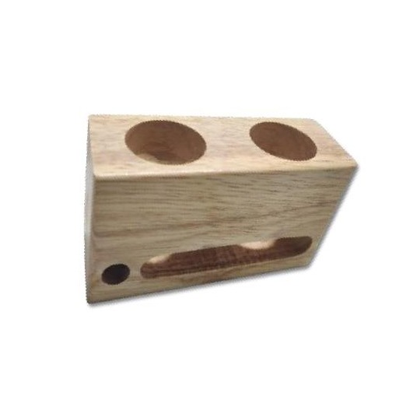  Dual-Hole Wooden Pen Block  Natural Wood  Solid natural wood block with dual cylindrical pen and pencil holes  ₹75 + 12% GST |  | HGS-WS-42  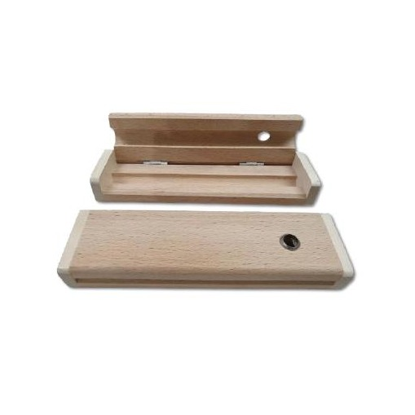  Wooden Slide-Open Pen Tray  Natural Wood  Flat natural wood slide-open pen tray, clean minimalist presentation  ₹50 + 12% GST
HGS-WS-43  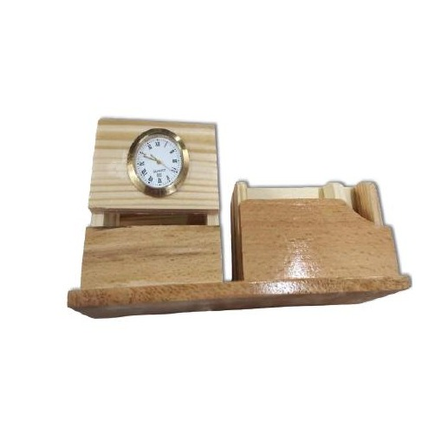  Wooden Clock & Card Holder  Natural Wood  Natural wood desk piece with analogue clock and business card tray  ₹165 + 12% GST |  | HGS-WS-44  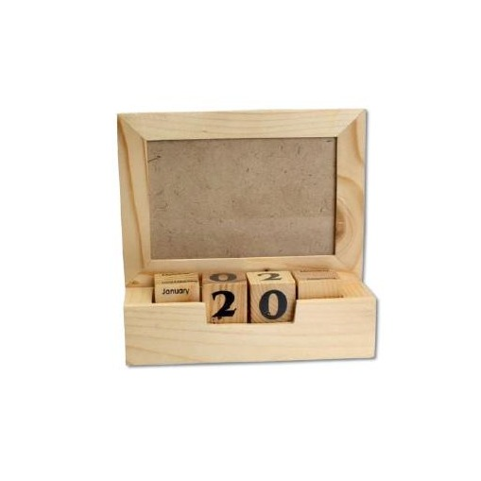  Wooden Photo Frame with Calendar  Natural Wood  Natural wood photo frame with rotating block date and month calendar  ₹275 + 12% GST
HGS-WS-45  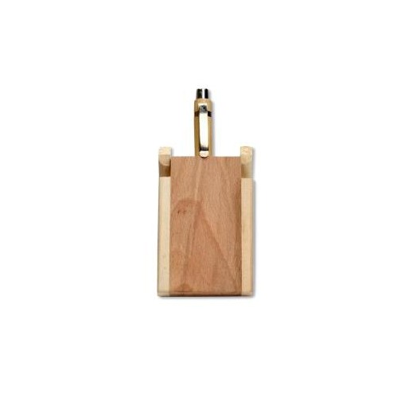  Wooden Coaster  Natural Wood  Round natural wood coaster with smooth finish, ideal for branding  ₹35 + 12% GST |  | HGS-WS-46  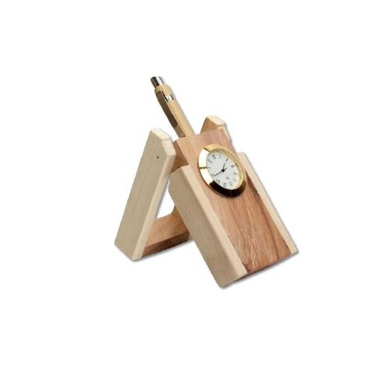  Wooden Visiting Card Holder  Natural Wood  Elegant natural wood desktop visiting card display and holder  ₹100 + 12% GST
HGS-WS-47  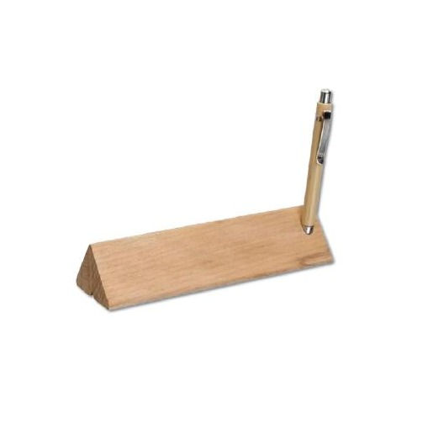  Wooden Single Pen Holder  Natural Wood  Stylish natural wood single pen holder with weighted base  ₹70 + 12% GST |  | HGS-WS-48  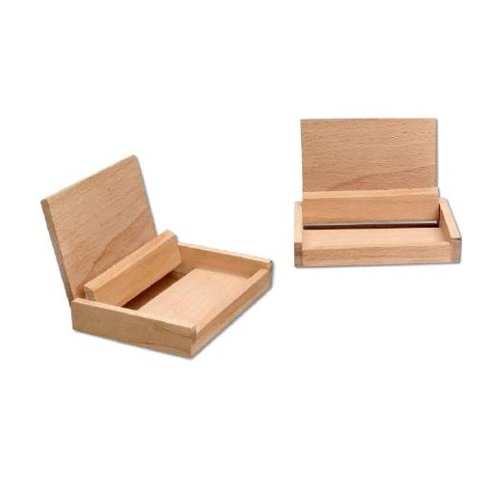  Wooden Coaster Set  Natural Wood  Set of natural wood coasters with holder stand, customisable surface  ₹50 + 12% GST
HGS-WS-49  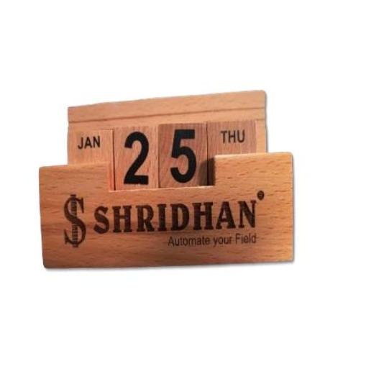  Wooden Desk Organiser with Name Plate  Natural Wood  Natural wood organiser with engraved name plate and pen / card slots  ₹130 + 12% GST |  | HGS-WS-50  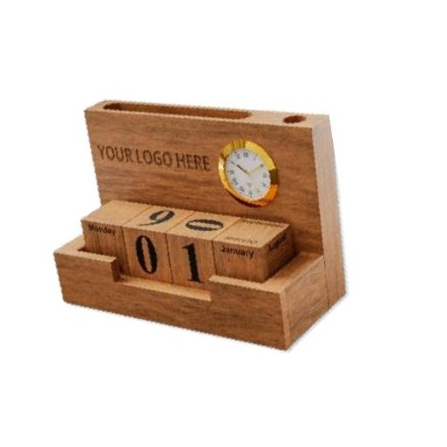  Wide Wooden Desk Organiser  Natural Wood  Spacious natural wood organiser with separated pen, card and accessory zones  ₹200 + 12% GST
HGS-WS-51  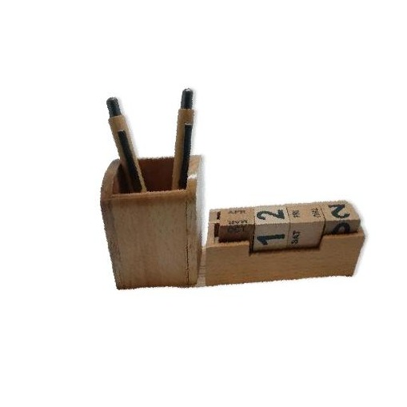  Wooden Pen & Mobile Organiser  Natural Wood  Natural wood desktop set with pen holder, card slot and mobile stand  ₹150 + 12% GST |  | HGS-WS-52  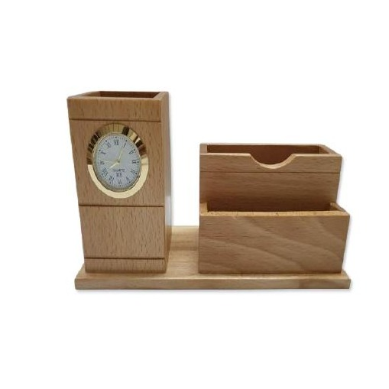  Wooden Multi-Tray Desk Organiser  Natural Wood  Multi-tray natural wood organiser for pens, cards, notes and accessories  ₹165 + 12% GST
HGS-WS-53  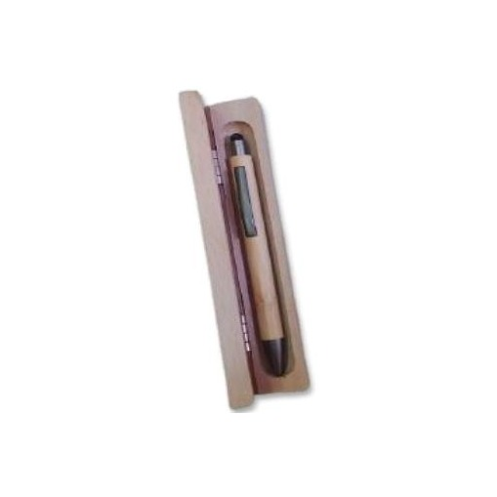  Wooden Pen Presentation Case  Natural Wood  Premium flip-open natural wood pen case, includes pen, ideal for gifting  ₹50 + 12% GST (with Pen) |  | HGS-WS-54  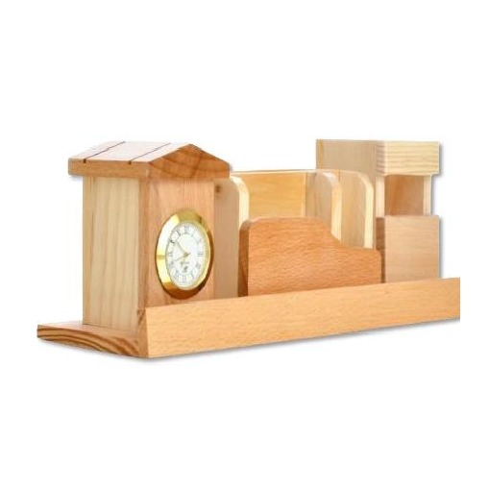  Executive Wooden Desk Organiser  Natural Wood  Large-format natural wood desk organiser with ample storage compartments  ₹200 + 12% GST
HGS-WS-55  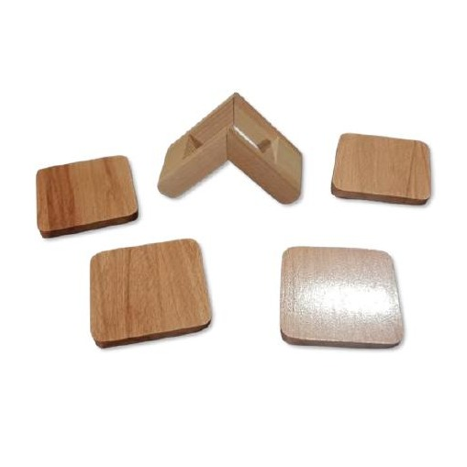  Wooden Desktop Stationery Holder  Natural Wood  Solid natural wood stationery holder with pen and accessory compartments  ₹130 + 12% GST |  | HGS-WS-56  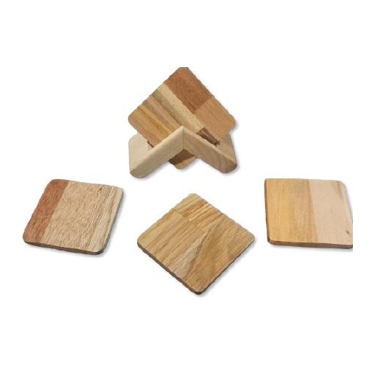  Wooden Pen & Card Desk Set  Natural Wood  Natural wood desk set combining pen holder and card / note tray  ₹130 + 12% GST
HGS-WS-57  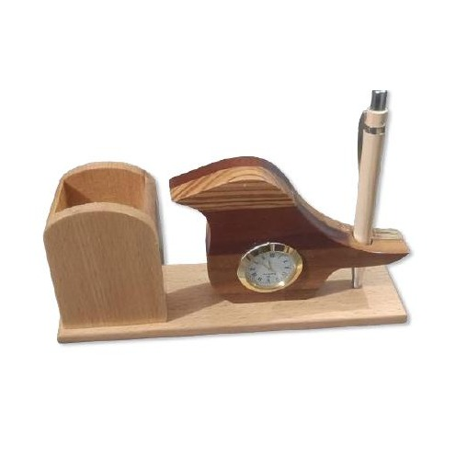  Wooden Desktop Organiser with Tray  Natural Wood  Natural wood organiser with raised pen section and wide accessory tray  ₹200 + 12% GST |  | HGS-WS-58  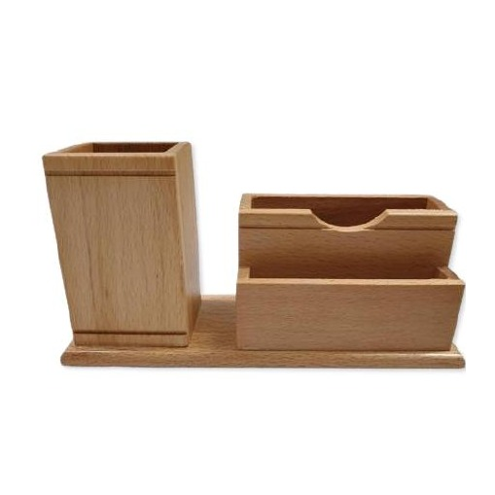  Wooden Pen Stand with Card Slot  Natural Wood  Compact natural wood stand with pen holder and front card display slot  ₹135 + 12% GST
HGS-WS-59  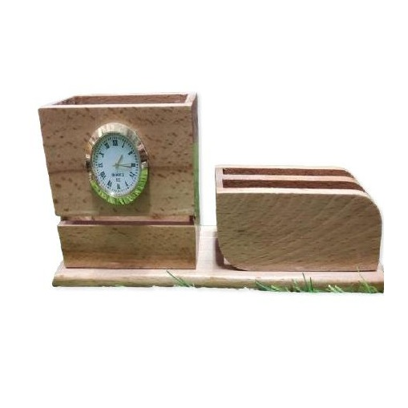  Wooden Multi-Compartment Stand  Natural Wood  Natural wood multi-compartment stand for pens, cards and small items  ₹165 + 12% GST |  | HGS-WS-60  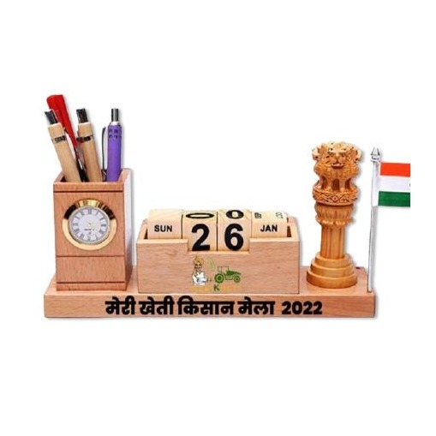  Premium Wooden Desk Station  Natural Wood  Premium natural wood full desk station with organiser, stand and tray  ₹350 + 12% GST
HGS-WS-61  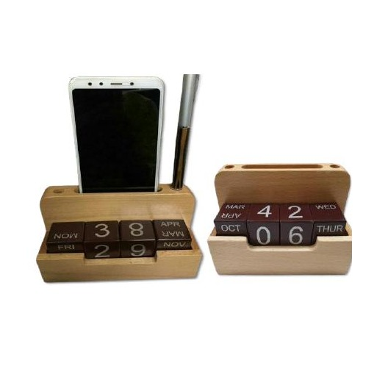  Wooden Clock & Pen Organiser  Natural Wood  Natural wood desk piece with analogue clock and pen / card holder  ₹135 + 12% GST |  | HGS-WS-62  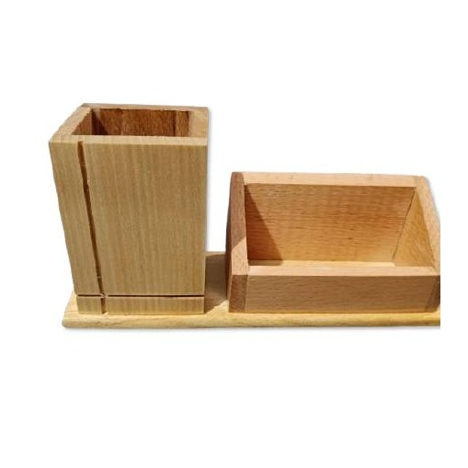  Wooden Single Pen & Card Stand  Natural Wood  Compact natural wood stand with single pen slot and card display tray  ₹100 + 12% GST
HGS-WS-63  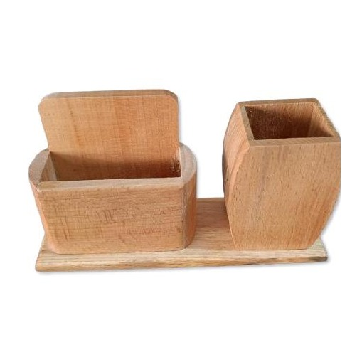  Wooden Desk Organiser Set  Natural Wood  Natural wood desk organiser set with divided pen and card sections  ₹130 + 12% GST |  | HGS-WS-64  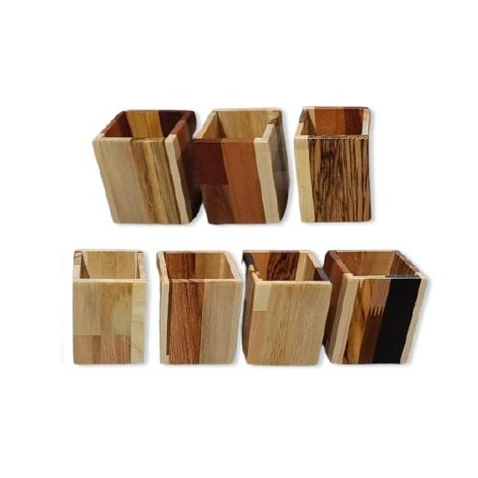  Wooden Pen Display Stand  Natural Wood  Slender natural wood pen display stand with engraving space on base  ₹65 + 12% GST
HGS-WS-65  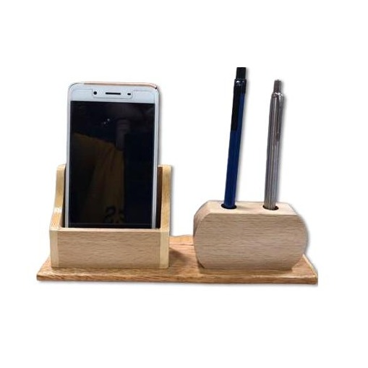  Wooden Pen & Accessory Stand  Natural Wood  Natural wood desk stand with dedicated pen, card and mobile slots  ₹135 + 12% GST |  | HGS-WS-66  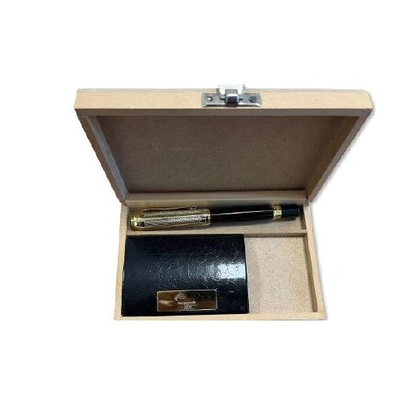  Premium Wooden Desk Organiser Set  Natural Wood  Premium natural wood multi-piece desk organiser set with ample storage  ₹250 + 12% GST
HGS-WS-67  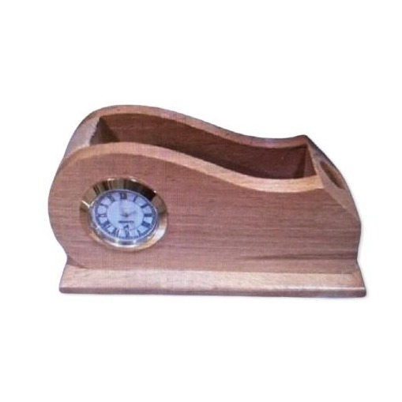  Wooden Card & Pen Holder  Natural Wood  Neat natural wood holder with separate pen and visiting card sections  ₹130 + 12% GST |  | HGS-WS-68  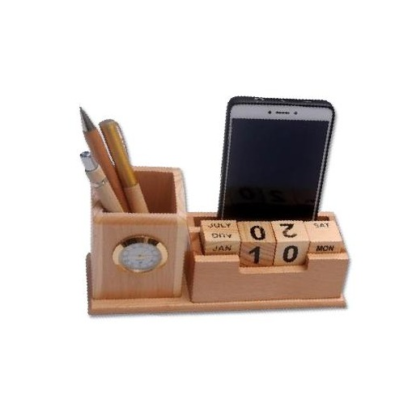  Wooden Desk Organiser with Clock  Natural Wood  Natural wood organiser with analogue clock, pen and card compartments  ₹180 + 12% GST
HGS-WS-69  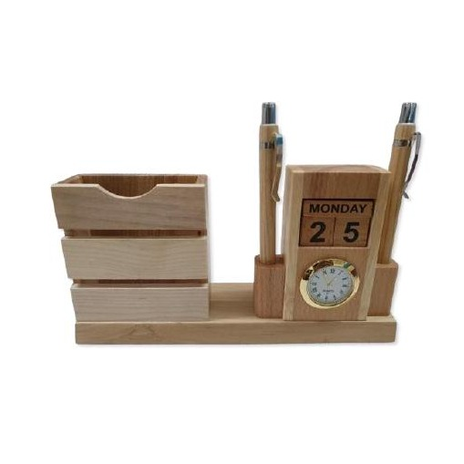  Wide Wooden Pen & Card Organiser  Natural Wood  Broad natural wood desk organiser with multiple pen and card sections  ₹200 + 12% GST |  | HGS-WS-70  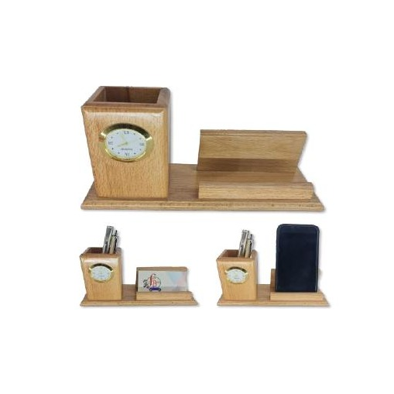  Wooden Desktop Card & Pen Tray  Natural Wood  Low-profile natural wood tray organiser for card, pen and accessories  ₹150 + 12% GST
HGS-WS-71  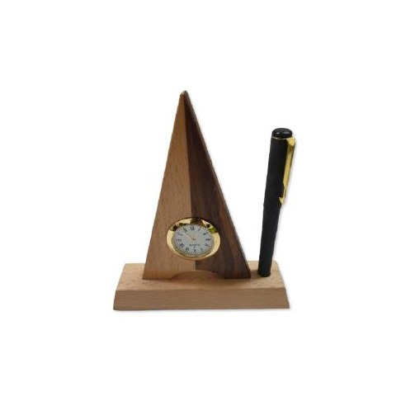  Wooden Executive Stationery Set  Natural Wood  Executive natural wood stationery set with pen, card and note trays  ₹200 + 12% GST |  | HGS-WS-72  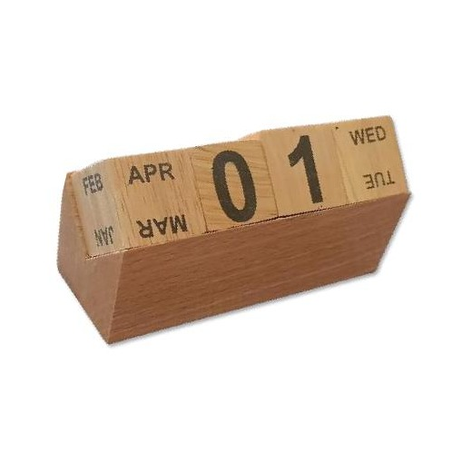  Wooden Mini Desk Organiser  Natural Wood  Compact natural wood mini organiser for small desk or reception use  ₹100 + 12% GST
HGS-WS-73  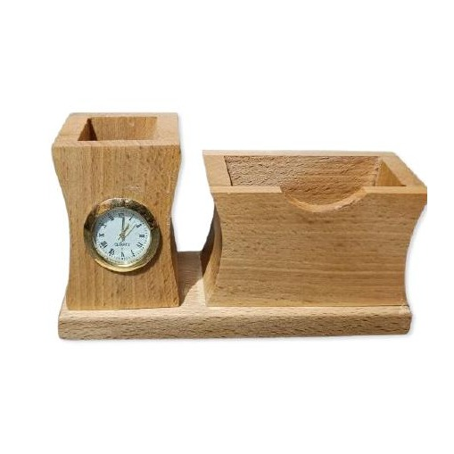  Wooden Pen & Stationery Organiser  Natural Wood  Natural wood desk organiser with dedicated pen and stationery storage  ₹165 + 12% GST |  | HGS-WS-74  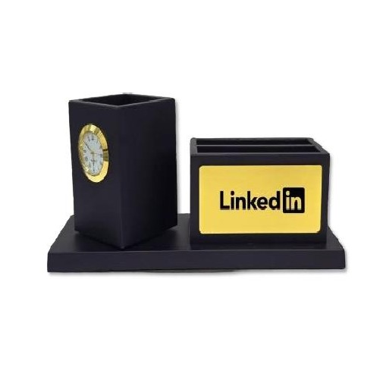  Premium Wooden Clock Organiser  Natural Wood  High-quality natural wood organiser with premium analogue clock insert  ₹240 + 18% GST
Thank you
for considering Robust Gifting

All items available for custom branding.
Minimum order quantities and lead times on request.
Prices are exclusive of 18% GST. Valid 2026.

