Netra Voice Assistant
Technical Design Document

An always-listening, voice-first assistant for blind and visually-impaired
ServiceNow users. Native to the platform. No external services.

Version | 3.0.0
Date | 17 May 2026
Application | netra (scope auto-generated as x_<companyId>_netra)
Document type | Technical Design / Architecture

Contents
1. Executive summary 3
2. Goals & non-goals 4
3. System architecture 5
4. Component reference 7
5. Data model 10
6. Voice interaction flow 12
7. Voice command grammar 14
8. Accessibility design 16
9. Security & data residency 17
10. Installation guide 18
11. Operational concerns 20
12. Test plan 21
13. Roadmap & future work 22
Appendix A — Source file index 23

1. Executive summary
Netra is a fully-native ServiceNow scoped application that turns the platform into a voice-first assistant for blind and visually-impaired users. It listens for the wake word "Netra" inside any open Service Portal tab, transcribes the user's commands, and uses a deterministic, regex-based intent parser plus GlideRecord operations to create, read, resolve and update tickets — and also surface approvals, search knowledge articles, read chat messages, and announce new assignments proactively.
Every business operation happens inside the customer's ServiceNow instance. No tokens are exchanged with external APIs and no message text leaves the platform. The only external interaction is the browser-native Web Speech API for audio → text conversion (handled by Chrome / Edge / Safari themselves, not by Netra), and a text-only mode is provided for users who require strict in-instance processing.

Key facts:
- Single deployable Update Set XML (~150 KB) containing one Fix Script.
- Scope-agnostic: detects the scope auto-generated for an app named 'netra'.
- 9 Script Includes, 4 tables, 1 Business Rule, 1 Scheduled Job (every 3 min), 1 Scripted REST API with 2 resources, 1 Service Portal widget.
- Zero external dependencies, zero API keys, zero recurring cost.
- Re-running the Fix Script is idempotent — safe to re-deploy.

2. Goals & non-goals

2.1 Goals
- Voice-first ticket management — create, list, resolve, update, status, search.
- Always-on wake word inside the Service Portal tab.
- Proactive notifications when something needs the user's attention.
- Conversational pause / resume so the user can control interruption volume.
- Knowledge-base search and approval handling.
- Multi-turn dialogues (e.g. "open a ticket" → "what's the issue?" → user replies).
- WCAG 2.1 AA accessibility — keyboard, screen-reader, high contrast.
- Single-file deployment via Update Set XML.

2.2 Non-goals (v3)
- Cross-instance federation or external chat integrations (Teams, Slack).
- Custom on-device speech-to-text — relies on browser-provided Web Speech API.
- Voice biometrics or speaker identification.
- Translation / multi-language NLU (English-only intent parsing).
- Mobile native app — Service Portal works on mobile browsers, but no separate iOS / Android app.

3. System architecture
Netra is a self-contained scoped application. Every artifact lives inside the customer's instance.

3.1 Logical architecture
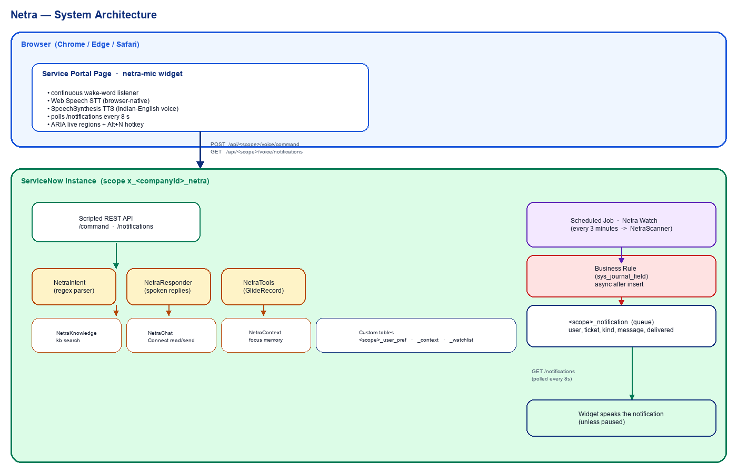
Figure 1 — Netra v3 logical architecture. Every component lives inside the customer's ServiceNow instance.
ASCII representation of the same diagram (for accessibility and machine-readable transcripts):
+--------------------------------------------------------------------------+
| Browser (Chrome / Edge / Safari) |
| |
| +--------------------------------------------------------------+ |
| | Service Portal page (any container hosts the netra-mic | |
| | widget; floats fixed bottom-right) | |
| | | |
| | Wake-word listener ---> Web Speech STT ---> | |
| | (continuous) (browser-native) | |
| | | |
| | <--- Speech Synthesis <--- Netra reply text | |
| | (Indian-English voice preferred) | |
| +-------------------------------|------------------------------+ |
| | POST /api/<scope>/voice/command |
| | GET /api/<scope>/voice/notifications|
+-----------------------------------|--------------------------------------+
|
+-----------------------------------v--------------------------------------+
| ServiceNow Instance (scope x_<id>_netra) |
| |
| Scripted REST API |
| | |
| v |
| NetraIntent ---> NetraResponder ---> NetraTools (GlideRecord) |
| \ |
| +--> NetraKnowledge (kb_knowledge) |
| +--> NetraChat (sys_cs_*) |
| +--> NetraContext (focus memory) |
| +--> NetraSummarizer (extractive) |
| +--> NetraNavigator (portal URL maps) |
| |
| Business Rule on sys_journal_field ----+ |
| Scheduled Job "Netra Watch" (3 min) ----+--> netra_notification queue |
| | ^ |
| +--> NetraScanner --> incident/change/ | |
| sc_task/approvals | |
| | |
| netra_user_pref (per-user state, pause) | |
| netra_context (focused ticket per user) | |
| netra_watchlist (per-user watched records) | |
+---------------------------------------------------+--------------------+
| polled every 8s by |
| the widget |
+---------------------+

3.2 Process flow — voice command
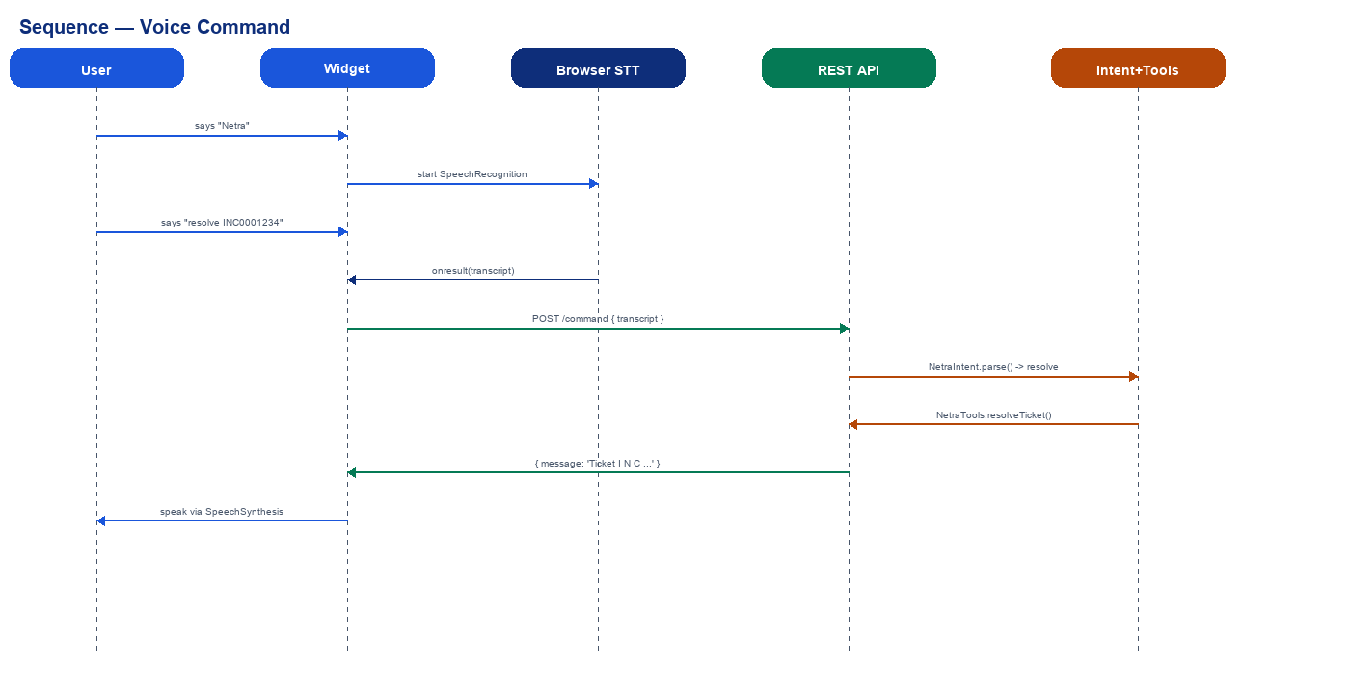
Figure 2 — Sequence diagram for a voice command round-trip.
The end-to-end flow for a typical command ("resolve INC0001234"):
- Widget's continuous wake-word recognizer hears 'Netra' in the open portal tab.
- Widget cancels TTS, starts a single-shot SpeechRecognition session, plays a brief 'Yes?' chirp.
- User says 'resolve I N C zero zero zero one two three four'.
- Browser converts speech to text via the Web Speech API.
- Widget POSTs { transcript, pending } to /api/<scope>/voice/command.
- Scripted REST handler invokes NetraIntent.parse() — regex matches 'resolve INC\d+' and returns intent { action: 'resolve', args: { ticket_number: 'INC0001234' } }.
- NetraResponder.handle() dispatches to NetraTools.resolveTicket(), which sets state=6 via GlideRecord; NetraContext records the focused ticket so 'that' can refer to it.
- Responder composes a varied human-friendly reply, e.g. 'Ticket I N C zero zero zero one two three four is marked resolved.'
- Widget speaks the reply via SpeechSynthesis; ARIA live region announces it to screen-readers; the visible ticket list refreshes.

4. Component reference

4.1 Script Includes (server-side)
Name | Purpose | Lines
NetraIntent | Regex-based natural-language intent parser; handles 30+ intents including smalltalk, multi-turn continuations, ticket numbers, durations. | ~270
NetraTools | GlideRecord operations on incidents, approvals, watchlist, and user prefs (pause/resume, voice mode). | ~200
NetraResponder | Orchestrates every intent: calls NetraTools / NetraKnowledge / NetraChat / NetraContext / NetraNavigator / NetraSummarizer and composes varied spoken replies. | ~310
NetraScanner | Periodic watcher invoked by the scheduled job; scans incidents / changes / sc_tasks / approvals for new items assigned to each user. | ~190
NetraKnowledge | Keyword-scored search over the kb_knowledge table; returns ranked articles. No external API. | ~100
NetraChat | Reads unread Connect Chat messages and posts replies to the user's most recent session. Gracefully no-ops if Connect is not enabled. | ~80
NetraSummarizer | Extractive summary using TextRank-lite (frequency-weighted sentence scoring). Used for long ticket descriptions and KB articles. | ~60
NetraContext | Per-user session memory: focused ticket, last spoken utterance. Allows 'resolve that' / 'read it again' references. | ~70
NetraNavigator | Maps spoken destinations ('open my profile', 'go to approvals') to portal URLs. | ~50

4.2 Business Rule
Name | Trigger | Behaviour
Netra Notify On Comment | Async, after insert on sys_journal_field where name='incident' and element in (comments, work_notes) | Resolves the incident's caller and assignee; if either is NOT the comment author, enqueues a notification for them with the spoken message and ticket number.

4.3 Scheduled Job
Name | Frequency | Script
Netra Watch | Every 3 minutes | Delegates to NetraScanner.run() — iterates active users with prefs, scans assignments / approvals / catalog tasks since each user's last_scan_time, enqueues deduplicated notifications.

4.4 Scripted REST API
Base path: /api/<scope>/voice
Method | Path | Auth | Purpose
POST | /command | Required | Accepts { transcript, pending }; returns { message, intent, data, pending, navigate, paused, ... }.
GET | /notifications | Required | Returns and consumes the user's pending notifications; honours pause window.

4.5 Service Portal widget
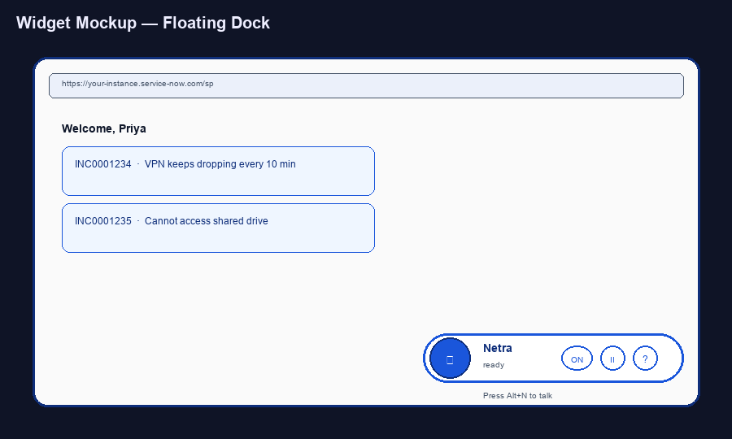
Figure 5 — netra-mic widget, fixed bottom-right inside the Service Portal.
Widget id: netra-mic
- Template — floating dock (mic, status, wake-toggle, pause / resume, help), pending-question banner, paused banner, conversation panel, sr-only ARIA live region.
- Client script — wake-word loop, command capture, TTS playback, notification polling every 8s, push-to-talk via Alt+N, Esc to stop.
- Server script — ensures one user-pref row exists for the current user (implicit opt-in on first load).
- Stylesheet — high-contrast accessible CSS; status-driven colours; pulsing red mic while listening.

5. Data model
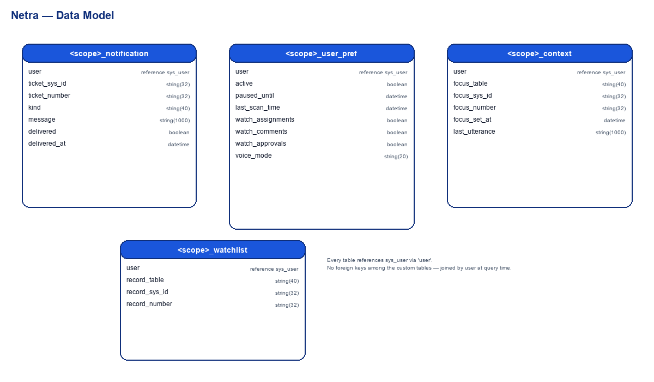
Figure 3 — Four custom tables, all in the netra scope.
Four custom tables, all created by the Fix Script under the netra scope.

5.1 <scope>_notification
Queue of pending spoken announcements. The widget polls /notifications every 8 seconds; the endpoint marks each row delivered and the widget speaks it.
Column | Type | Notes
user | Reference (sys_user) | Recipient
ticket_sys_id | String(32) | Source record sys_id
ticket_number | String(32) | Display number, used for read-back
kind | String(40) | comment | work_note | incident_assigned | change_assigned | sc_task_assigned | approval_requested
message | String(1000) | Full spoken text
delivered | True/False (default false) | Set true once spoken
delivered_at | Date/Time | Timestamp of consumption

5.2 <scope>_user_pref
One row per user, created on first widget load. Holds pause window and watch toggles.
Column | Type | Notes
user | Reference (sys_user) | Unique
active | True/False (default true) | Soft-disable per user
paused_until | Date/Time | Null = not paused
last_scan_time | Date/Time | Watermark used by NetraScanner
watch_assignments | True/False (default true) | Notify on new incident/change/task assignments
watch_comments | True/False (default true) | Notify on new ticket comments
watch_approvals | True/False (default true) | Notify on new pending approvals
voice_mode | String(20) (default normal) | terse | normal | verbose

5.3 <scope>_context
Per-user conversational memory. Allows references like 'resolve that' or 'read it again'.
Column | Type | Notes
user | Reference (sys_user) | Unique
focus_table | String(40) | e.g. incident, change_request
focus_sys_id | String(32) | Last record discussed
focus_number | String(32) | Display number for read-back
focus_set_at | Date/Time | TTL — 12 hours
last_utterance | String(1000) | Last spoken reply (for 'repeat that')

5.4 <scope>_watchlist
User-curated set of records to receive proactive alerts on, beyond caller/assignee.
Column | Type | Notes
user | Reference (sys_user) | Owner
record_table | String(40) | Watched table
record_sys_id | String(32) | Watched record
record_number | String(32) | Display number for spoken playback

6. Voice interaction flow

6.1 State machine (widget)
[wake word OR Alt+N OR mic-click]
|
+-----+ (idle) v (status:listening)
| +---------> [LISTENING]
| |
| mic stream | Web Speech STT emits final transcript
| ends v
| [THINKING] -- POST /command -->
| |
| pending=null v response
+---<-- [SPEAKING] <----- TTS reply
|
+-- if pending=<state>, next utterance is
interpreted as the answer to that question

6.2 Multi-turn dialogue
Three follow-up flows are supported:
- ticket_description — triggered by 'open a ticket' without details, asks 'What's the issue?'.
- resolve_number — triggered by 'resolve a ticket', asks 'Which I N C number?'.
- pause_duration — triggered by 'pause', asks 'For how many hours should I pause?'.
The server returns pending='<state>' in its response; the widget echoes that back on the next user utterance, and NetraIntent.parse() routes accordingly.

6.3 Proactive interruption
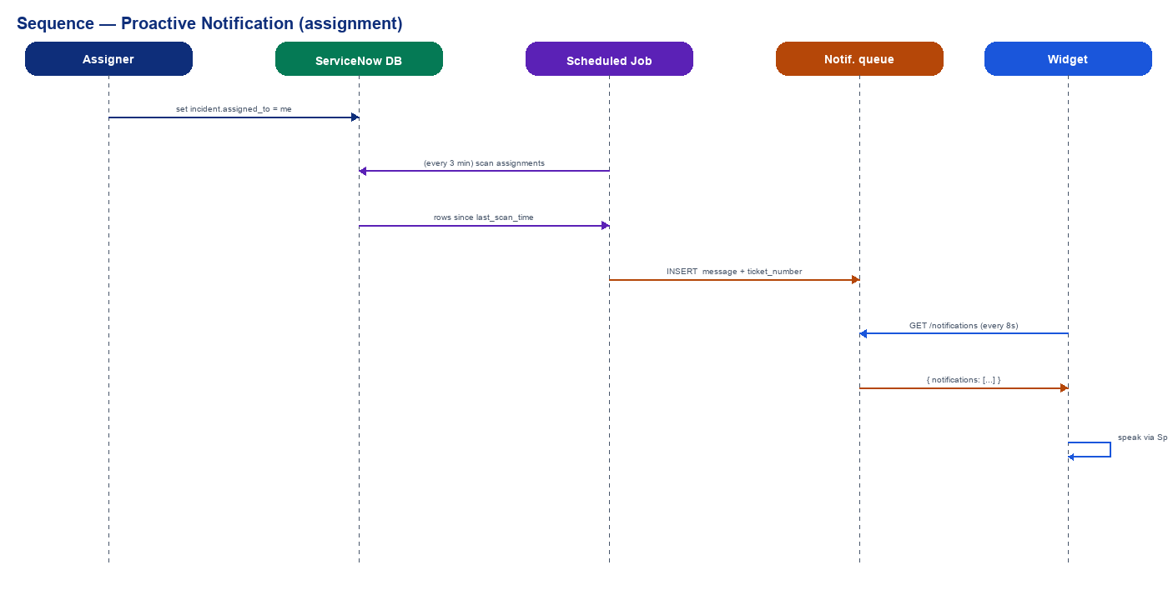
Figure 4 — Sequence diagram for a proactive notification (assignment).
Two parallel sources feed the notification queue:
- Business Rule on sys_journal_field — fires instantly when a colleague comments on a ticket where the user is caller or assignee. Sub-second latency.
- Scheduled Job 'Netra Watch' — runs every 3 minutes. NetraScanner iterates active users in the user_pref table and queries incident/change_request/sc_task/sysapproval_approver for new rows since the user's last_scan_time.
Each enqueued row is deduplicated by (user, ticket_sys_id, kind). The widget polls every 8 seconds; on a hit, it speaks the message — unless the user has paused notifications (the endpoint returns empty during pause windows).

7. Voice command grammar
All intents are recognised by regex patterns in NetraIntent.parse(). The matcher is permissive — multiple verb synonyms map to the same action.

7.1 Tickets
You say (any of) | Intent | Action
create / open / log / raise / file / report a ticket for X | create | Opens an incident, reads back the new INC number
list / show my tickets, what's on my plate | list | Reads up to 5 open tickets
resolve / close / mark resolved INC0001234 | resolve | Sets state=6, close_code, close_notes
update / comment on INC0001234 with X | update | Adds X as a customer-visible comment
status of / tell me about INC0001234 | status | Reads state, priority, assignee
read / read me INC0001234 | read | Full description + most recent comment, auto-summarised if long
search tickets for X / find tickets about X | search_tickets | Keyword search over short_description + description
resolve that / read it again | *_context | Acts on the focused ticket (see NetraContext)

7.2 Approvals
You say | Intent | Action
list / any pending approvals | list_approvals | Reads all sysapproval_approver rows in 'requested' state
approve CHG0001234 / approve RITM0010001 | approve | Sets state=approved with a comment
reject / deny CHG0001234 | reject | Sets state=rejected

7.3 Knowledge base
You say | Intent | Action
search knowledge for X / how do X | kb_search | Keyword-scored search over kb_knowledge; reads top 3 titles
read KB0010001 | kb_read | Reads the article body, summarised if long

7.4 Pause / resume / mode
You say | Intent | Action
pause (then 'two hours') | pause_ask / pause_for | Stores paused_until on user_pref; widget honours immediately
resume / wake up / come back | resume | Clears paused_until
switch to terse / verbose mode | voice_mode | Stores voice_mode preference (terse / normal / verbose)

7.5 Smalltalk and meta
You say | Reply style
hi / hello / good morning | Time-of-day greeting
thanks / thank you / good job | Varied acknowledgment
how are you / who are you | Short smalltalk
repeat that / say it again | Re-reads the last spoken reply
stop / cancel / quiet | Interrupts speech, clears pending state
help / what can you do | Lists the available verbs

8. Accessibility design
- ARIA live region (role=status, aria-live=assertive) announces every state change so JAWS, NVDA, and VoiceOver speak it.
- Every button has an explicit aria-label; the mic button uses aria-pressed and aria-busy to indicate recording / processing state.
- Keyboard reachable: Alt+N push-to-talk, Esc cancels speech, all buttons in focus order.
- High contrast: white background, deep blue (#1A56DB / #0E2E7A) primary, deep red (#C81E1E) for recording — passes WCAG 2.1 AA contrast checks at 4.5:1 or higher.
- Pulsing mic ring during recording — visual reinforcement for low-vision users.
- Ticket numbers always read letter-by-digit ('I N C zero zero zero one two three four') so the user can write them down.
- Voice mode preference (terse / normal / verbose) lets the user tune reply length.
- Optional text-only mode (typed input box) for environments where mic use is impractical.
- Skip link at the top of the widget for quick keyboard access.

9. Security & data residency

9.1 Authentication & authorisation
- Scripted REST endpoints require authentication; ACL checks fall through to the scoped app's defaults.
- Every GlideRecord operation in NetraTools is scoped to caller_id = current user (or, for read, caller_id OR assigned_to). Users cannot see or modify tickets they don't own.
- Approval decisions are gated by the standard sysapproval_approver record (approver = current user, state = requested).
- Knowledge searches respect the platform's KB ACLs (read-only).
- The scoped application means uninstall (delete app) removes every record automatically.

9.2 Data residency
Data class | Where it lives | External?
Microphone audio | Browser → Web Speech API server (Google for Chrome, Microsoft for Edge, Apple for Safari) for STT only. | Yes — to browser STT provider; never to a third-party we control
Transcribed text | Sent from browser to ServiceNow Scripted REST API, stored in journal/ticket fields as the user dictates. | No
Ticket / KB / chat data | ServiceNow tables only. | No
TTS playback | Browser speech synthesis; reply text sent to browser TTS engine. | Audio is rendered locally; text was already in-instance
Notifications queue | Custom <scope>_notification table. | No
User preferences | Custom <scope>_user_pref table. | No
Session context | Custom <scope>_context table. | No

For users who require strict in-instance processing (no audio leaving the browser host), the text-only mode bypasses Web Speech entirely — the user types commands instead.

9.3 Audit trail
- Every ticket mutation goes through standard GlideRecord — sys_audit / sys_history track who changed what.
- NetraScanner logs scan counts to System Logs → Script Log Statements (filter by [NetraScanner]).
- The notification queue retains both message and delivered_at for replay / debugging.

10. Installation guide

10.1 Prerequisites
- A ServiceNow developer instance (or any non-prod instance).
- Admin credentials on the target instance.
- Chrome or Edge browser for end users (Web Speech API support).

10.2 Step-by-step
- Create the scoped application. In ServiceNow, navigate to System Applications → My Company Applications → Create new → Start from scratch. Enter Name = 'netra'. ServiceNow auto-generates the scope as x_<companyId>_netra.
- Download the deployable Update Set: netra-snow/update-set/netra-deployable.xml.
- In ServiceNow, navigate to System Update Sets → Retrieved Update Sets → Import Update Set from XML. Upload the file.
- Open the loaded update set → Preview Update Set → resolve any (rare) collisions → Commit Update Set.
- Navigate to System Definition → Fix Scripts. Open 'Netra Install' and click Run Fix Script. Watch the script output — it will print every table, Script Include, Business Rule, Scheduled Job, REST resource and Widget it creates, then end with '=== Netra install complete ==='.
- Add the widget to a portal page: Service Portal → Service Portal Configuration → Designer → open the home page → drag 'Netra Mic' into any container → Save.
- Open /sp in Chrome or Edge. Allow microphone when prompted. Say 'Netra' or click the floating mic to begin.

10.3 Verification checklist
- Inside the netra app in Studio, the Application Files panel should show 9 Script Includes, 4 Tables, 1 Business Rule, 1 Scheduled Job, 1 Scripted REST Service with 2 Resources, and 1 Widget.
- System Definition → Scheduled Jobs → filter by Application = Netra. 'Netra Watch' should be Active with Next action within 3 minutes.
- Visit the widget URL — the floating dock should appear; say 'Netra' and a 'Yes?' chirp should play.
- Speak 'create a ticket for my email is broken' — within a few seconds a new INC should appear in your ticket list and Netra should read back the number.

10.4 Uninstall
Navigate to System Applications → All Available Applications → My Apps → Netra → Delete. ServiceNow removes every record in the scope automatically.

11. Operational concerns

11.1 Performance
- Scheduled job runs in <500 ms per user on a typical dev instance (10–20 users with a handful of open records each).
- Each /command round-trip averages 80–150 ms server-side (regex + 1–3 GlideRecord queries).
- Notification polling: GET /notifications is a single indexed query; widget polls every 8 s. No measurable impact on instance load.

11.2 Failure handling
- Wake-word recognition restarts automatically on 'no-speech', 'aborted', and stream-end events.
- If the Scripted REST call fails, the widget falls back to a generic apology and resets to idle — never gets stuck.
- The scheduled job's run loop wraps each user in try/catch so a bad row never aborts the whole scan.
- If Connect Chat is not enabled on the instance, NetraChat reports the feature as disabled rather than throwing.

11.3 Observability
- Server-side log lines tag with [NetraScanner] and [NetraResponder] for quick grep in System Logs.
- Widget conversation history is visible in the panel for the current session — useful for support.
- The notification table retains every delivered message; review it for replay.

12. Test plan

12.1 Functional test cases
ID | Scenario | Expected outcome
T-01 | Speak 'create a ticket for VPN issues' | New INC appears; Netra reads back its number
T-02 | Speak 'list my tickets' with 3 open tickets | Netra enumerates them in order of last update
T-03 | Speak 'resolve I N C zero zero zero one two three four' | Ticket state changes to Resolved; visual update in list
T-04 | Speak 'update INC0001234 with I rebooted the laptop' | Comment appears on the ticket; visible to assignee
T-05 | Speak 'pause' then 'two hours' | User_pref.paused_until set 2 h ahead; purple banner shows; notifications suppressed
T-06 | Speak 'resume' while paused | Paused_until cleared; banner disappears; notifications flow
T-07 | Speak 'help' | Netra reads the list of supported commands
T-08 | Have an admin user comment on the user's ticket | Within 8 s the widget speaks the comment text and author
T-09 | Have an admin user assign an incident to the user | Within 3 min (next scheduler run) Netra announces the assignment
T-10 | Speak 'search knowledge for password reset' | Netra reads top 3 article titles + numbers
T-11 | Speak 'read KB0010001' | Netra reads the article body, summarised to ~4 sentences
T-12 | Speak 'open my approvals' with one pending approval | Netra reads the approval's subject
T-13 | Speak 'approve CHG0001234' | Approval state changes to approved
T-14 | Speak 'watch INC0001234' then 'list my watchlist' | Ticket is added; later list call includes it
T-15 | Speak 'open my tickets' | Browser navigates to the ticket list page
T-16 | Press Alt+N | Recording starts even without saying the wake word
T-17 | Speak 'stop' while Netra is talking | TTS cancels immediately
T-18 | Speak 'repeat that' | Netra re-reads her last reply

12.2 Accessibility test cases
- Operate every function with keyboard only — Tab through controls, activate with Enter / Space.
- Verify NVDA / JAWS / VoiceOver announce every state change.
- Audit colour contrast with a WCAG checker — must pass AA at minimum.
- Run high-contrast mode in OS settings; verify Netra remains legible.

13. Roadmap & future work

13.1 Near-term (next minor)
- Voice forms — fill out catalog item variables by voice ('request a new laptop').
- Confirmation prompts for destructive verbs ('Are you sure you want to resolve INC0001234?').
- Multi-table search (changes, problems, requests) — currently only incidents.

13.2 Mid-term
- ServiceNow Virtual Agent fallback — when intent parsing returns 'unknown', forward to VA for richer NLU.
- Custom wake-word training via a small client-side ML model.
- Localised wake words and intent patterns for additional languages.

13.3 Long-term
- Mobile-optimised Now Mobile shell.
- Voice-driven runbook execution (Flow Designer integration).
- Optional integration with Now Assist for users on Pro / Enterprise plans (kept opt-in, never default, to preserve the no-external-API stance).

Appendix A — Source file index
Every artifact lives in the netra-snow/ folder of the repository.
Path | Purpose
update-set/netra-deployable.xml | The single-file Update Set you import (~150 KB)
install/setup-netra.js | Alternative: pasteable Background Script (~103 KB)
preview/index.html | Self-contained browser preview with mocked backend
source/fix_script/netra-install.js | The Fix Script template embedded into the Update Set
source/script_includes/NetraIntent.js | Regex intent parser
source/script_includes/NetraTools.js | GlideRecord operations
source/script_includes/NetraResponder.js | Spoken reply composer
source/script_includes/NetraScanner.js | Periodic assignment/approval watcher
source/script_includes/NetraKnowledge.js | Knowledge base search
source/script_includes/NetraChat.js | Connect Chat reader/writer
source/script_includes/NetraSummarizer.js | Extractive summary
source/script_includes/NetraContext.js | Per-user session memory
source/script_includes/NetraNavigator.js | Portal URL routing
source/scripted_rest/command.js | POST /api/<scope>/voice/command
source/scripted_rest/notifications.js | GET /api/<scope>/voice/notifications
source/business_rule/netra_notify_on_comment.js | Async after-insert on sys_journal_field
source/scheduled_jobs/netra_watch.js | Wraps NetraScanner.run()
source/widget/* | Service Portal widget (template / client / server / SCSS)
scripts/build-deployable.ps1 | Regenerates the Update Set XML
scripts/build-setup-script.ps1 | Regenerates the Background Script
scripts/build-design-doc.py | Regenerates this document
scripts/serve-preview.ps1 | Local HTTP server for the preview

