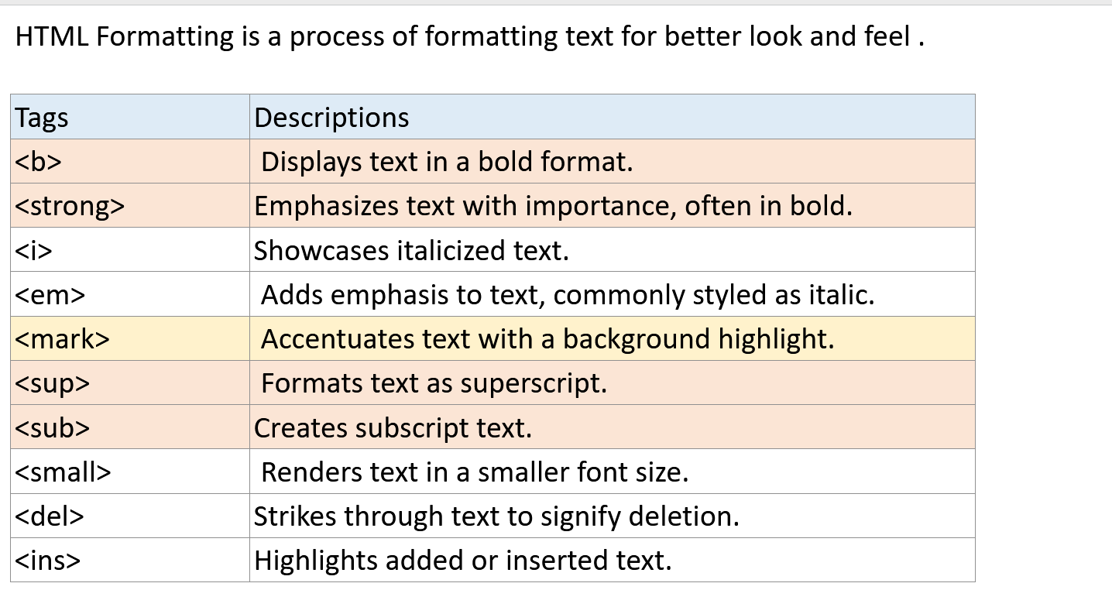

Tag | Description
<abbr> | Defines abbreviation or acronym.
<address> | Defines contact info for the author/owner of a document.
<bdo> | Defines text direction, left-to-right or right-to-left.
<blockquote> | Defines a section quoted from another source.
<cite> | Defines the title of a work, book, article, or publication.
<q> | Defines short inline quotation, enclosed in quotation marks.

