Name – Prabhnoor
Roll no.- 2610997055
Experiment No.1
Aim:- Write a basic HTML-5 document structure and implement all six heading <h1>to<h6>with
sample text.

Code:-

<html>
<title>
2610997055
</title>
<body>
<h1> this is my first heading </h1>
<h2> this is my second heading</h2>
<h3>this is my third heading </h3>
<h4>this is my fourth heading </h4>
<h5>this is my fifth heading </h5>
<h6>this is my sisth heading </h6>
</body>
</html>

Output-: 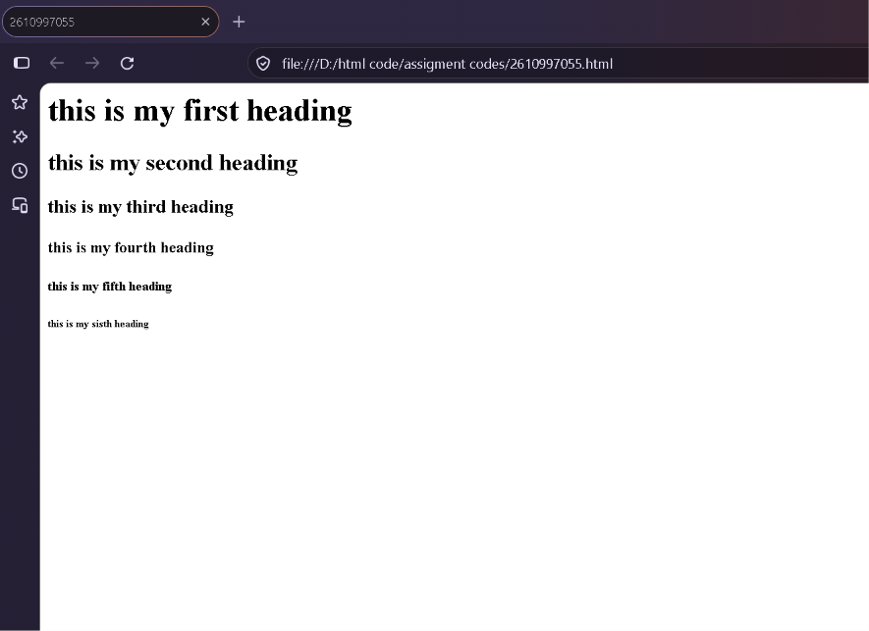

Name – Prabhnoor
Roll no.- 2610997055
Experiment – 2
Aim :- Create a paragraph and apply text formatting text (<b>, <i>,<u>,<strong>,<em>)to given
Content.
Code:-

<html lang="en">
<head>
<meta charset="UTF-8">
<meta name="viewport" content="width=device-width, initial-scale=1.0">
<title>2610997055</title>
</head>
<body>
<p>
This is a <b>bold</b> text,
this is an <i>italic</i> text,
this is an <u>underlined</u> text,
this is a <strong>strongly emphasized</strong> text,
and this is an <em>emphasized</em> text.
</p>
</body>
</html>

Output-: 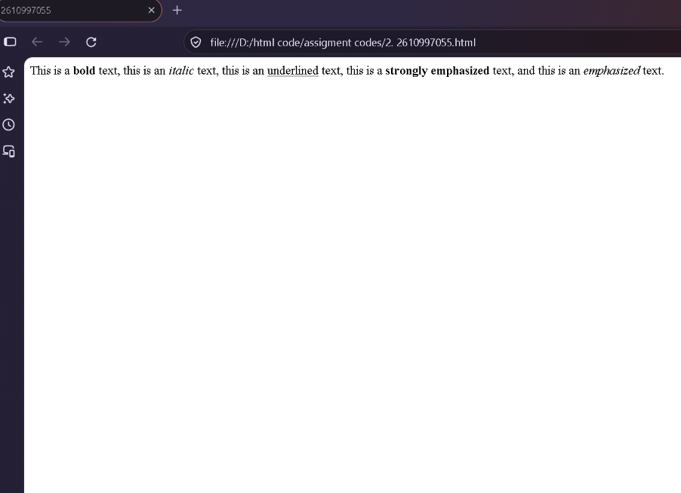

Name – Prabhnoor
Roll no.- 2610997055
Experiment – 3
Aim :-Create an ordered list (<ol>) for a recipe's steps and an unordered list (<ul>) for its
ingredients on the same page.
Code :-
<html>
<head>
<title>2610997055</title>
</head>
<body>

<h2>Recipe: Maggi</h2>

<h3>Ingredients</h3>
<ul>
<li>Maggi noodles</li>
<li>Water</li>
<li>Maggi masala</li>
<li>Vegetables</li>
</ul>

<h3>Steps</h3>
<ol>
<li>Boil water in a pan.</li>
<li>Add the Maggi noodles.</li>
<li>Add the masala and vegetables.</li>
<li>Cook for 2–3 minutes.</li>
<li>Serve hot.</li>
</ol>

</body>
</html>

Output-: 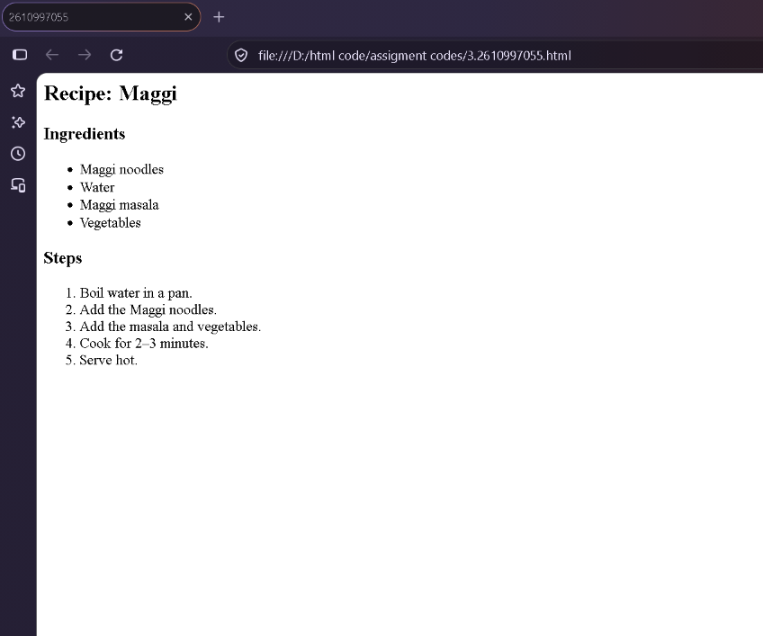

Name – Prabhnoor
Roll no.- 2610997055
EXPERMINENT NO.4
Aim:-Build a nested list showing a book hierarchy: Category BooksChapters using <ul> and <ol>
together.
Code :
<html>
<head>
<title>Book Hierarchy</title>
</head>
<body>

<h1>Book Hierarchy</h1>

<ul>
<li>Programming
<ul>
<li>C Basics
<ol>
<li>Introduction</li>
<li>Variables</li>
<li>Data types</li>
</ol>
</li>
<li>Web Development
<ol>
<li>HTML</li>
<li>Css</li>
</ol>
</li>
</ul>
</li>
</ul>

</body>
</html>

Output-:
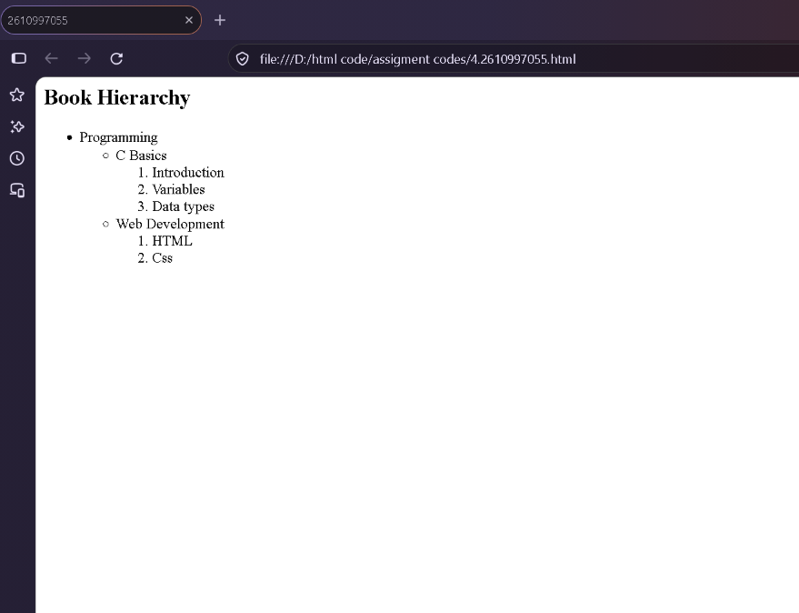

Name – Prabhnoor
Roll no.- 2610997055
EXPERIMENT NO.5
Aim:- Insert an image using <img> and set src, alt, width, height, and title attributes with valid
paths.
Code:-

<HTML>
<HEAD>
<TITLE> 2610997055 </TITLE>
</HEAD>
<BODY>
<h2> My Image </h2>
<img src="https://encrypted-tbn0.gstatic.com/images?q=tbn:ANd9GcSI7Yw4GC0vU0YHSJmMZcqxEdr6-XGe-LdA3wNorB6giw&s=10"
width="400" height="400">
</BODY>
</HTML>

Output-:
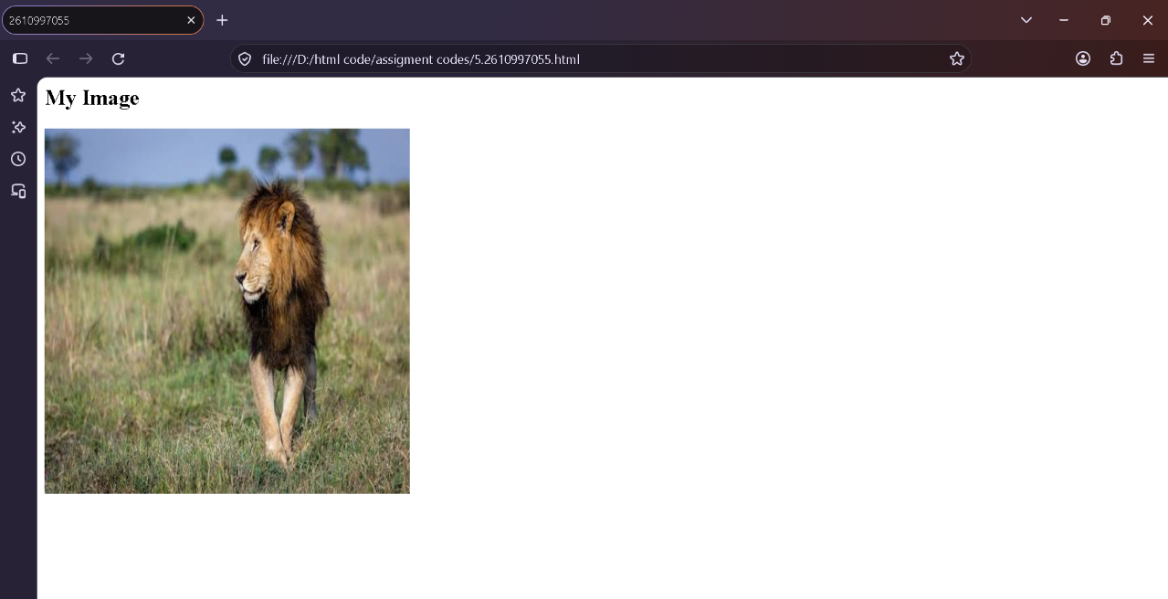

Name – Prabhnoor
Roll no.- 2610997055
EXPERIMENT NO.6
Aim:- Set a background image for the entire webpage within the <body> tag.
Code:-

<html>
<head>
<title>2610997055</title>
</head>
<body background="C:\Users\Hp\OneDrive\Desktop\scorpio.webp" height="50">
<h1>Welcome to My Webpage</h1>
</body>
</html>

Output-: 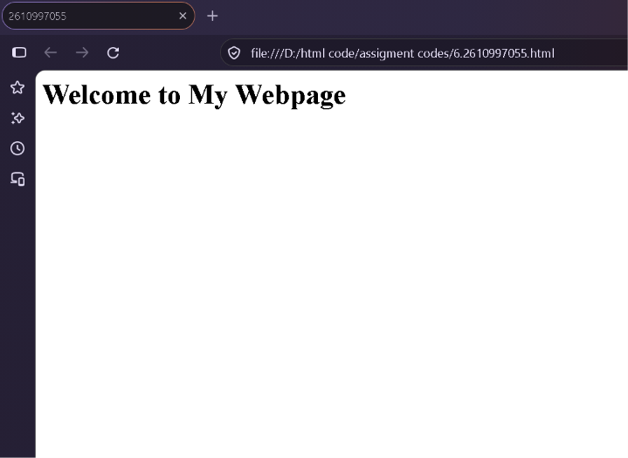
Name – Prabhnoor
Roll no.- 2610997055
EXPERIMENT NO.7
Aim:- Create internal anchor links that jump to sections on the same page and one external link to
university website.
Code:-
<html>
<head>
<title>2610997055</title>
</head>
<body>
<h1>My Webpage</h1>
<a href=“about">About Us</a> |
<a href=“courses">Courses</a> |
<a href=“contact">Contact</a>
<hr>
<h2 id="about">About Us</h2>
<p>Welcome to our webpage. </p>
<h2 id="courses">Courses</h2>
<p>We offer various courses for students. </p>
<h2 id="contact">Contact</h2>
<p>Contact us for more information. </p>
<h2>University Website</h2>
<a href="https://www.chitkara.edu.in/" target="_blank">
Visiting Chitkara University
</a>
</body>
</html>

Output-:
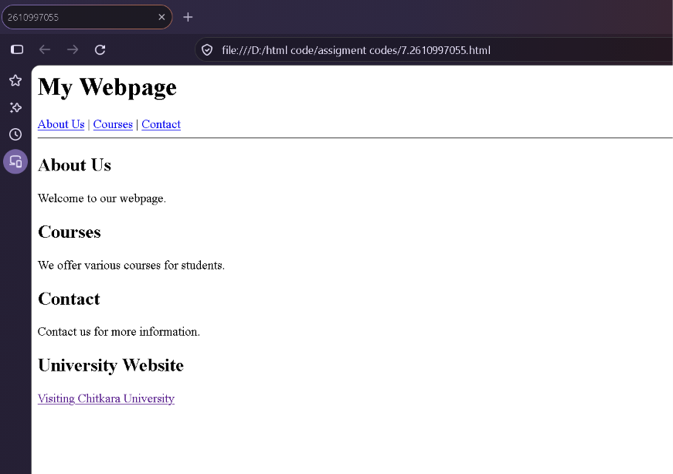

Name – Prabhnoor
Roll no.- 2610997055
EXPERIMENT NO.8
Aim:-Design an image map with clickable regions.
Code:-
<html>
<head>

</head>
<body>
<img src="https://encrypted-tbn0.gstatic.com/images?q=tbn:ANd9GcS0PEnjlofG_BTDBfdKLua2HwgmGxjJdDGgj0AZP6cPlA&s=10" width="1463" height="1021" usemap="#india-map">

<map name="india-map">

<area shape="circle" coords="610,130,35"
href="https://en.wikipedia.org/wiki/Jammu_and_Kashmir_(union_territory)"
alt="Jammu and Kashmir">

<area shape="circle" coords="625,215,25"
href="https://en.wikipedia.org/wiki/Himachal Pradesh"
alt="Himachal Pradesh">

<area shape="circle" coords="570,252,25"
href="https://en.wikipedia.org/wiki/Punjab"
alt="Punjab">

<area shape="circle" coords="595,285,25"
href="https://en.wikipedia.org/wiki/Haryana"
alt="Haryana">

<area shape="circle" coords="515,375,55"
href="https://en.wikipedia.org/wiki/Rajasthan"
alt="Rajasthan">

<area shape="circle" coords="455,455,35"
href="https://en.wikipedia.org/wiki/Gujarat"
alt="Gujarat">

<area shape="circle" coords="700,360,55"
href="https://en.wikipedia.org/wiki/Uttar Pradesh"
alt="Uttar Pradesh">

<area shape="circle" coords="840,395,35"
href="https://en.wikipedia.org/wiki/Bihar"
alt="Bihar">

<area shape="circle" coords="650,485,60"
href="https://en.wikipedia.org/wiki/Madhya Pradesh"
alt="Madhya Pradesh">

<area shape="circle" coords="590,605,55"
href="https://en.wikipedia.org/wiki/Maharashtra"
alt="Maharashtra">

<area shape="circle" coords="750,525,35"
href="https://en.wikipedia.org/wiki/Chhattisgarh"
alt="Chhattisgarh">

<area shape="circle" coords="905,475,30"
href="https://en.wikipedia.org/wiki/ West Bengal"
alt="West Bengal">

<area shape="circle" coords="825,555,35"
href="https://en.wikipedia.org/wiki/Odisha"
alt="Odisha">

<area shape="circle" coords="670,670,45"
href="https://en.wikipedia.org/wiki/Andhra Pradesh"
alt="Andhra Pradesh">

<area shape="circle" coords="565,745,35"
href="https://en.wikipedia.org/wiki/Karnataka"
alt="Karnataka">

</map>
</body>
</html>

Output-:
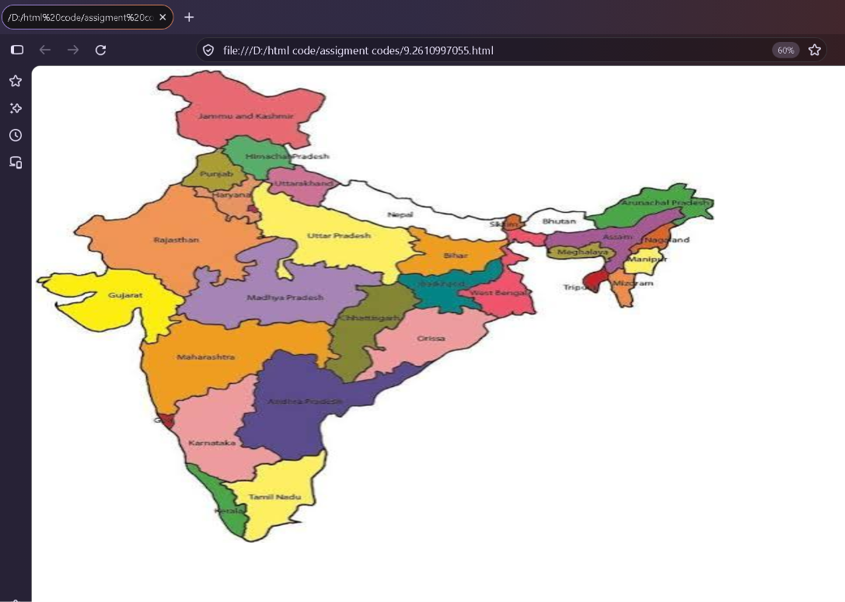

Name – Prabhnoor
Roll no.- 2610997055
EXPERIMENT NO.9
Aim:-Build a student marksheet table.
Code:-
<html>
<head>
<title> 2610997055 </title>
</head>
<body>
<table border="2" cellspacing="0" cellpadding="5" align="center">
<tr>
<th>Sr. No</th>
<th>Student Roll No.</th>
<th>Student Name</th>
<th>Student Marks</th>
</tr>
<tr>
<td>1</td>
<td>999</td>
<td>A</td>
<td>95</td>
</tr>
<tr>
<td>2</td>
<td>978</td>
<td>B</td>
<td>95</td>
</tr>
</body>
</html>

Output-:
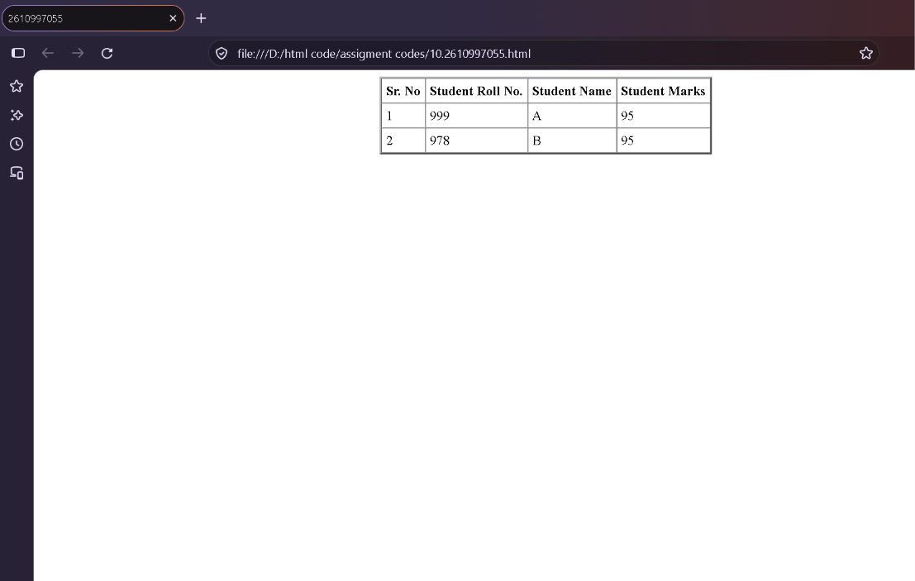

Name – Prabhnoor
Roll no.- 2610997055
EXPERIMENT NO.10
Aim:- Create A Nested Timetable
Code:-
<html>
<head>
<title>2610997055</title>
</head>
<body>
<center>
<h1>BCA1A</h1>
<table border="1" width="100%" cellspacing="0" cellpadding="10">
<tr>
<th></th>
<th>1<br>9:00 - 9:55</th>
<th>2<br>9:55 - 10:50</th>
<th>3<br>10:50 - 11:45</th>
<th>4<br>11:45 - 12:40</th>
<th>5<br>12:40 - 1:35</th>
<th>6<br>1:35 - 2:30</th>
<th>7<br>2:30 - 3:25</th>
<th>8<br>3:25 - 4:20</th>
</tr>
<tr>
<th rowspan="2">Mo</th>
<td rowspan="2" bgcolor="orange">
Stat.Maths<br><br>
</td>
<td rowspan="2"></td>
<td rowspan="1"></td>
<td colspan="2" rowspan="1" bgcolor="lightgreen">
<b>BasicCS-Lab</b><br>
DM-210 &nbsp;
</td>
<td rowspan="2"></td>
<td colspan="2" rowspan="1" bgcolor="lightgreen">
<b>PC-LAB</b><br>
DM-213 &nbsp;
</td>
</tr>
<tr>
<td colspan="2" bgcolor="yellow">
<b>UIDW-LAB</b><br>
TG-518 &nbsp;
</td>
<td colspan="2"></td>
</tr>
<tr>
<th rowspan="2">Tu</th>
<td colspan="2" rowspan="1" bgcolor="yellow">
<b>UIDW-LAB</b><br>
TG-518 &nbsp;
</td>
<td rowspan="2"></td>
<td rowspan="2" bgcolor="lightgreen">
<h1> <center>PC<br><br></h1></center>
</td>
<td rowspan="2"></td>
<td rowspan="2" bgcolor="orange">
Stat.Maths<br><br>PY
</td>
<td colspan="2" bgcolor="yellow">
<b>UIDW-LAB</b><br>
TG-518 &nbsp; AM / DR
</td>
</tr>
<tr>
<td colspan="2"></td>
<td colspan="2" bgcolor="lightgreen">
<b>PC-LAB</b><br>
DM-212 &nbsp;
</td>
</tr>
<tr>
<th rowspan="2">We</th>
<td rowspan="2"></td>
<td rowspan="2" bgcolor="orange">
Stat.Maths<br><br>
</td>
<td rowspan="2"></td>
<td colspan="2" bgcolor="yellow">
<b>UIDW-LAB</b><br>
TG-518 &nbsp;
</td>
<td rowspan="2"></td>
<td rowspan="2" colspan="2" bgcolor="lightcyan">
BasicCS<br><br>
</td>
</tr>
<tr>
<td colspan="2" bgcolor="lightgreen">
<b>BasicCS-Lab</b><br>
DM-212 &nbsp;
</td>
</tr>
<tr>
<th rowspan="2">Th</th>
<td colspan="2" bgcolor="yellow">
<b>UIDW-LAB</b><br>
TG-518 &nbsp;
</td>
<td rowspan="2" bgcolor="lightgreen">
PC<br><br>HS
</td>
<td rowspan="2"></td>
<td rowspan="2" bgcolor="lightcyan">
BasicCS<br><br>
</td>
<td rowspan="2"></td>
<td colspan="2" bgcolor="yellow">
<b>UIDW-LAB</b><br>
TG-518 &nbsp;
</td>
</tr>
<tr>
<td colspan="2"></td>
<td colspan="2" bgcolor="lightgreen">
<b>PC-LAB</b><br>
DM-211 &nbsp;
</td>
</tr>
<tr>
<th rowspan="2">Fr</th>
<td colspan="2" bgcolor="lightgreen">
<b>UIDW-LAB</b><br>
TG-518 &nbsp;
</td>
<td rowspan="2"></td>
<td rowspan="2" bgcolor="lightcyan">
BasicCS<br><br>
</td>
<td rowspan="2"></td>
<td colspan="2" bgcolor="lightgreen">
<b>PC-LAB</b><br>
DM-213 &nbsp;
</td>
<td rowspan="2"></td>
</tr>
<tr>
<td colspan="2"></td>
<td colspan="2" bgcolor="yellow">
<b>UIDW-LAB</b><br>
TG-518 &nbsp;
</td>
</tr>
<tr>
<th>Sat</th>
<td colspan="8"></td>
</tr>
</table>
</center>
</body>
</html>

Output-:
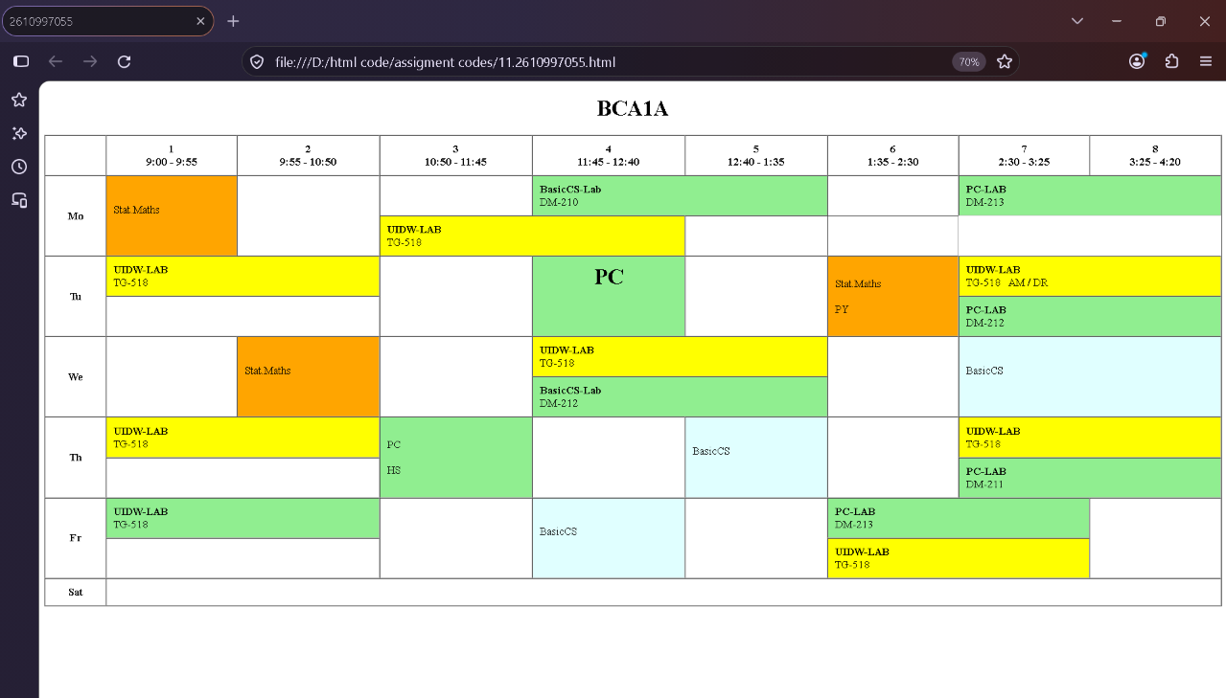

Name – Prabhnoor
Roll no.- 2610997055
EXPERIMENT NO.11
Aim:-Design a table using rowspan or colspan.
Code:
<html>
<body>
<title>2610997055</title>
<table border="4" cellspacing="0" cellpadding="5" align="center" >
<tr >
<th>
Name</th>
<th>
Roll No</th>
</tr>
<tr >
<td>
A</td>
<td>
B</td>
</tr>
<tr>
<td colspan="2" >
C</td>
<td rowspan="2">
D </td>
</tr>
</table>
</body>
</html>
Output-:
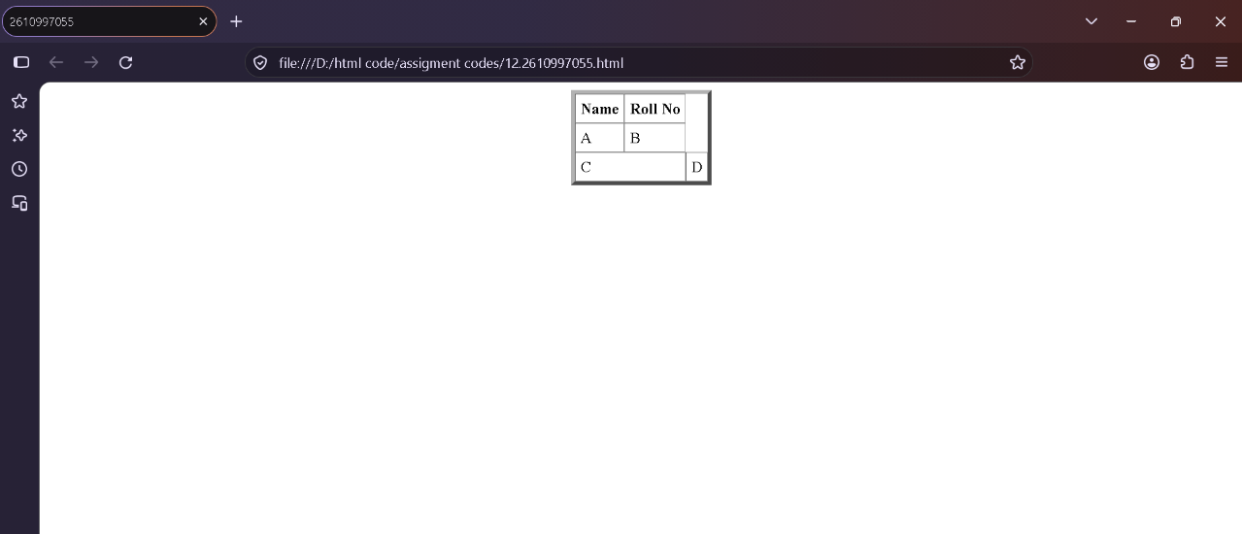

Name – Prabhnoor
Roll no.- 2610997055
EXPERIMENT NO.12
Aim:-Build a registration form using GET method.
Code:-
<html>
<head>
<title>2610997055</title>
</head>
<body bgcolor="pink">
<fieldset>
<legend align="center"><h2>Student Registeration Form</h2></legend>
<form>
<table align="center">
<tr>
<td>Enter name:</td>
<td><input type="text" maxlength="20" required></td>
<tr>
<td>Enter Email:</td>
<td><input type="email" maxlength="20" required></td>
</tr>
<tr>
<td>Enter mobile no.:</td>
<td><input type="text" maxlength="10" required></td>
</tr>
<tr>
<td>Enter Address:</td>
<td><textarea rows="3" cols="20" required></textarea></td>
</tr>
<td>City:</td>
<td><input type="text" maxlength="30" required></td>
</tr>
<tr>
<td>Pincode:</td>
<td><input type="text" maxlength="6" required></td>
</tr>
<td>Enter country:</td>
<td><select name="country" required>
<option value="">Select country</option>
<option value="India">India</option>
<option value="USA">USA</option>
<option value="UK">UK</option>
</select></td>
</tr>
<td><br>QUALIFICATION DETAILS:</td>
</tr>
<tr>
<td>
<table>
<tr>
<td align="center"><b>Sl.No.</b></td>
<td align="center"><b>Examination</b></td>
<td align="center"><b>Name of the Board</b></td>
<td align="center"><b>Marks Obtained</b></td>
<td align="center"><b>Year of Passing</b></td>
<td align="center"><b>Percentage</b></td>
</tr>
<tr>
<td>1</td>
<td>Class X:</td>
<td><input type="text" name="BoardName" maxlength="30" /></td>
<td><input type="text" name="MarksObtained" maxlength="30" /></td>
<td><input type="text" name="YearrOfPassing" maxlength="30" /></td>
<td><input type="text" name="percentage" maxlength="30" /></td>
</tr>
<tr>
<td>2</td>
<td>Class XII:</td>
<td><input type="text" name="BoardName" maxlength="30" /></td>
<td><input type="text" name="MarksObtained" maxlength="30" /></td>
<td><input type="text" name="YearrOfPassing" maxlength="30" /></td>
<td><input type="text" name="percentage" maxlength="30" /></td>
</tr>
<tr>
<td>3</td>
<td>Graduation:</td>
<td><input type="text" name="BoardName" maxlength="30" /></td>
<td><input type="text" name="MarksObtained" maxlength="30" /></td>
<td><input type="text" name="YearrOfPassing" maxlength="30" /></td>
<td><input type="text" name="percentage" maxlength="30" /></td>
</tr>
<tr>
<td>4</td>
<td>Masters:</td>
<td><input type="text" name="Masters_Board" maxlength="30" /></td>
<td><input type="text" name="Masters_Percentage" maxlength="30" /></td>
<td><input type="text" name="ClassX_YrOfPassing" maxlength="30" /></td>
<td><input type="text" name="Masters_YrOfPassing" maxlength="30" /></td>
</tr>
</table>
</td>
</tr>
<tr>
<td><br>COURSES APPLIED FOR:
B.Sc
<input type="radio" name="Course_BCA" value="BCA">
B.Com
<input type="radio" name="Course_BCom" value="B.Com">
BA
<input type="radio" name="Course_BSc" value="B.Sc">
BCA
<input type="radio" name="Course_BA" value="B.A">
</td>
</tr>
<tr>
<td colspan="2" align="center">
<input type="submit" value="Submit">
<input type="reset" value="Reset">
</td>
</tr>
</table>
</form>
</fieldset>
</body>
</html>

Output-:
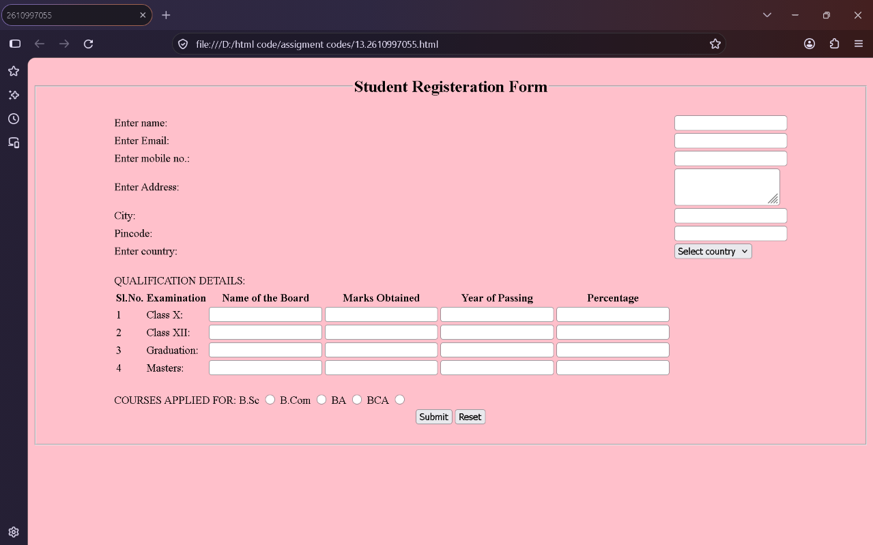

Name – Prabhnoor
Roll no.- 2610997055
EXPERIMENT NO.13
Aim:- Build A Feedback Form Using Post Method.
Code:-
<html>
<head>
<title>2610997055</title>
</head>
<body>
<fieldset>
<legend align="center">HP AGGENCY FEEDBACK FORM</legend>
<table>
<tr>
<td>NAME :</td>
<td><input type="text" maxlength="15" placeholder="your name"></td>
</tr>
<tr>
<td>EMAIL :</td>
<td><input type="email" maxlength="20" placeholder="enter your email id"></td>
</tr>
<tr>
<td>ADDRESS</td>
<td><textarea rows="3" cols="50"></textarea></td>
</tr>
<tr>
<td>POSTE CODE</td>
<td><input type="text"></td>
</tr>
<tr>
<table align="CENTER" border="1" cellpadding="10"
bgcolor="yellowgreenblueredorange">
<br><br>
<tr>
<td>Product</td>
<td>Product Image</td>
<td>Quantity</td>
<td>Unit price</td>
<td>Subtotal</td>
</tr>
<tr>
<td>HP VICTUS</td>
<td> <img src="C:\Users\Hp\OneDrive\Desktop\hp victus.webp" align="center"
height="100"></td>
<td><progress id="file-progress" max="100" value="70">70%</progress></td>
<td>120,000</td>
<td><input type="text"></td>
</tr>
<tr>
<td>HP OMEN SERIES</td>
<td> <img src="C:\Users\Hp\OneDrive\Desktop\hp omen series.webp"
align="center" height="100"></td>
<td><progress id="file-progress" max="100" value="65">65%</progress></td>
<td>250,000</td>
<td> <input type="text"></td>
</tr>
<tr>
<td>HP HYPERSTRIX OMEN</td>
<td> <img src="C:\Users\Hp\OneDrive\Desktop\hp hyperx omen.webp"
align="center" height="100"></td>
<td><progress id="file-progress" max="100" value="50">50%</progress></td>
<td>200,000</td>
<td><input type="text"></td>
</tr>
<tr>
<td>HP 95 lx</td>
<td> <img src="C:\Users\Hp\OneDrive\Desktop\hp 95 lx.jpg" align="center"
height="100"></td>
<td><progress id="file-progress" max="100" value="90">90%</progress></td>
<td>350,000</td>
<td><input type="text"></td>
</tr>
</table>
</tr>
</table>
<br>
<table width="100%">
<tr>
<br><br>
<td valign="top">
<form method="post">
<h2><b>CREDIT CARD DETAILS</b></h2>
<label>Card Holder Name:</label>
<input type="text" name="cardholder">
<br><br>
<label>Card Type:</label>
<select name="cardtype">
<option value="visa">Visa</option>
<option value="mastercard">MasterCard</option>
<option value="rupay">RuPay</option>
<option value="American Express">American Express</option>
</select>
<br><br>
<label>Card Number:</label>
<input type="text" name="cardnumber">
<br><br>
<label>Expiry Date:</label>
<input type="month" name="expiry">
<br><br>
<label>CVV:</label>
<input type="password" name="cvv" maxlength="3">
<br><br>
<label>Delivery address</label>
<input type="text" name="address" maxlength="100">
<br><br>
<input type="submit" value="Pay Now">
<br><br>
</form>
</td>
<td valign="top">
<form method="post">
<h2>FEEDBACK</h2>
<label>Rate Our Service:</label>
<br><br>
<input type="radio" name="rating" value="1"> ★
<input type="radio" name="rating" value="2"> ★★
<input type="radio" name="rating" value="3"> ★★★
<input type="radio" name="rating" value="4"> ★★★★
<input type="radio" name="rating" value="5"> ★★★★★

<br><br>
<label>Your Feedback:</label>
<br>
<textarea name="feedback" rows="5" cols="50"
placeholder="Write your feedback here"></textarea>
<br><br>
<input type="submit" value="Submit Feedback">
</form>
</fieldset>
</body>
</html>

Output-:
