A project report on

NEURO-SYMBOLIC INTEGRATION OF SEMANTIC WEB TECHNOLOGIES WITH LARGE LANGUAGE MODELS FOR FORMAL BUSINESS-RULE-COMPLIANT ENTERPRISE WORKFLOW PLANNING

Submitted in partial fulfillment for the award of the degree of

Bachelor of Technology in Computer Science and Engineering
(Artificial Intelligence and Robotics)

by

SIDAK DEEP SINGH (23BRS1201)


SCHOOL OF COMPUTER SCIENCE AND ENGINEERING

November, 2026

NEURO-SYMBOLIC INTEGRATION OF SEMANTIC WEB TECHNOLOGIES WITH LARGE LANGUAGE MODELS FOR FORMAL BUSINESS-RULE-COMPLIANT ENTERPRISE WORKFLOW PLANNING

Submitted in partial fulfillment for the award of the degree of

Bachelor of Technology in Computer Science and Engineering
(Artificial Intelligence and Robotics)

by

SIDAK DEEP SINGH (23BRS1201)

SCHOOL OF COMPUTER SCIENCE AND ENGINEERING

November, 2026

DECLARATION

I hereby declare that the thesis entitled "NEURO-SYMBOLIC INTEGRATION OF SEMANTIC WEB TECHNOLOGIES WITH LARGE LANGUAGE MODELS FOR FORMAL BUSINESS-RULE-COMPLIANT ENTERPRISE WORKFLOW PLANNING" submitted by SIDAK DEEP SINGH (23BRS1201), for the award of the degree of Bachelor of Technology in Computer Science and Engineering (Artificial Intelligence and Robotics), Vellore Institute of Technology, Chennai is a record of bonafide work carried out by me under the supervision of Dr. Saleena B, Associate Professor, School of Computer Science and Engineering, Vellore Institute of Technology, Chennai.
I further declare that the work reported in this thesis has not been submitted and will not be submitted, either in part or in full, for the award of any other degree or diploma in this institute or any other institute or university.

Place: Chennai
Date: Signature of the Candidate

School of Computer Science and Engineering

CERTIFICATE

This is to certify that the report entitled "NEURO-SYMBOLIC INTEGRATION OF SEMANTIC WEB TECHNOLOGIES WITH LARGE LANGUAGE MODELS FOR FORMAL BUSINESS-RULE-COMPLIANT ENTERPRISE WORKFLOW PLANNING" is prepared and submitted by SIDAK DEEP SINGH (23BRS1201) to Vellore Institute of Technology, Chennai, in partial fulfillment of the requirement for the award of the degree of Bachelor of Technology in Computer Science and Engineering (Artificial Intelligence and Robotics) is a bonafide record carried out under my guidance. The project fulfills the requirements as per the regulations of this University and in my opinion meets the necessary standards for submission. The contents of this report have not been submitted and will not be submitted either in part or in full, for the award of any other degree or diploma and the same is certified.

Signature of the Guide:

Name: Dr. Saleena B
Associate Professor, SCOPE

Date:

Signature of the Examiner Signature of the Examiner
Name: Name:
Date: Date:

Approved by the Head of Department,
B.Tech. Computer Science and Engineering (AI & Robotics)

Name: Dr. D. Sathian, HoD

Date

ABSTRACT

Enterprise workflows require multi-step operational planning where business rules, compliance mandates, and regulatory constraints strictly govern execution. While contemporary Large Language Models (LLMs) produce syntactically valid workflow plans, they frequently hallucinate action semantics, omit mandatory steps, and invert critical dependency constraints. Supervised Fine-Tuning (SFT) partially helps by learning common training patterns. It reached 100% conformance across our 440 in-distribution cases. Yet it fell to 43.3% on complex out-of-distribution (OOD) tasks spanning 16 to 20 steps. Memorization failed when plans grew longer. To resolve this fundamental generalizability bottleneck, this project introduces a neuro-symbolic reinforcement learning framework coupling formal W3C Shapes Constraint Language (SHACL) semantic validation with Group Relative Policy Optimization (GRPO). Rather than relying on learned neural reward models that are vulnerable to reward hacking, our architecture employs the pySHACL semantic engine as an objective, mathematical verification oracle. We formulate a dense, severity-weighted reward function that normalizes violation penalties by workflow length, providing balanced policy gradients across variable Directed Acyclic Graph (DAG) structures. We trained the 4-billion parameter Qwen3.5 model with 4-bit QLoRA on 45 hard scenarios. On an untouched 30-case OOD test set, the GRPO policy reached 90.0% conformance (27 of 30 cases passed). This is a 46.7 percentage point gain over SFT. The policy learned structure, not just patterns. Structural error analysis demonstrates that GRPO completely eliminates action hallucinations and cardinality omissions while reducing topological precedence violations by 91.7%. This establishes that compiling declarative semantic constraints into active reinforcement learning rewards enables compact language models to master generalized, long-horizon enterprise workflow synthesis.

i
ACKNOWLEDGEMENT

It is my pleasure to express with deep sense of gratitude to Dr. Saleena B,
Associate Professor, School of Computer Science and Engineering, Vellore Institute of Technology, Chennai, for her constant guidance, continual encouragement, and understanding; more than all, she taught me patience in my endeavor. My association with her is not confined to academics only, but it is a great opportunity on my part to work with an intellectual and expert in the field of Semantic Web and Artificial Intelligence.
It is with gratitude that I would like to extend my thanks to the visionary leader Dr. G. Viswanathan our Honorable Chancellor, Mr. Sankar Viswanathan, Dr. Sekar Viswanathan, Dr. G V Selvam Vice Presidents, Dr. Sandhya Pentareddy, Executive Director, Ms. Kadhambari S. Viswanathan, Assistant Vice-President, Dr. V. S. Kanchana Bhaaskaran Vice-Chancellor, Dr. T. Thyagarajan Pro-Vice Chancellor, VIT Chennai and Dr. P. K. Manoharan, Additional Registrar for providing an exceptional working environment and inspiring all of us during the tenure of the course.
Special mention to Dr. Viswanathan V, Dean, Dr. Nithyanandam P, Associate Dean, Dr. Suganya G, Associate Dean, Dr. Sweetlin Hemalatha C, Associate Dean, School of Computer Science and Engineering, Vellore Institute of Technology, Chennai for spending their valuable time and efforts in sharing their knowledge and for helping us in every aspect.
In jubilant state, I express my whole-hearted thanks to Dr. S. Geetha, Head of the Department, B.Tech. Computer Science and Engineering (AI & Robotics) and the Project Coordinators for their valuable support and encouragement to take up and complete the thesis.
My sincere thanks to all the faculties and staffs at Vellore Institute of Technology, Chennai who helped me acquire the requisite knowledge. I would like to thank my parents for their support. It is indeed a pleasure to thank my friends who encouraged me to take up and complete this task.
Place: Chennai
Date: Sidak Deep Singh

TABLE OF CONTENTS
DECLARATION iii
CERTIFICATE iv
ABSTRACT vi
ACKNOWLEDGEMENT vii
LIST OF FIGURES x
LIST OF TABLES xi
LIST OF ACRONYMS xii
CHAPTER 1: INTRODUCTION 1
1.1 Background and Motivation 1
1.2 Problem Statement 3
1.3 Research Objectives 4
1.4 Scope and Boundaries 5
1.5 Expected Outcomes & Contributions 5
1.6 Organization of the Report 6
CHAPTER 2: LITERATURE REVIEW 7
2.1 Overview and Taxonomy of the Field 7
2.2 Neuro-symbolic AI and Formal Reasoning 7
2.3 Knowledge Graphs, Ontologies, and Grounding 8
2.4 Retrieval-Augmented Generation (RAG) 9
2.5 Graph-Constrained Decoding and Planning 10
2.6 Semantic Web Validation: From Audit to Feedback 10
2.7 Reinforcement Learning with Verifiable Rewards 11
2.8 Synthesis, Literature Matrix, and Gap 12
CHAPTER 3: METHODOLOGY AND SYSTEM ARCHITECTURE 14
3.1 Overview and System Design Principles 14
3.2 Neuro-Symbolic Pipeline Architecture 14
3.3 Formal Semantic Formulation & Dynamic SHACL 16
3.4 Design Justifications and Model Selection 18
3.5 Graded Reward Function Formulation 20
3.6 Hard Training Curriculum Authoring 23
3.7 Engineering Adaptations for Single-GPU 23
3.8 Robotic Process Automation & ERP Execution 24
CHAPTER 4: EXPERIMENTAL RESULTS AND DISCUSSION 28
4.1 Benchmark Datasets and Evaluation Protocols 28
4.2 SFT Baseline Saturation and OOD Breakdown 28
4.3 GRPO Training Convergence and Stability 29
4.4 Comparative Experimental Results on OOD 29
4.5 Structural Error Taxonomy and Violation Reduction 31
4.6 Sequence Length Resilience Across Tiers 32
4.7 Ablation Studies Across Reward Formulations 33
4.8 Qualitative Inspection of Generated Plans 33
4.9 Review 3 SFT Preprocessing Truncation Post-Mortem 34
CHAPTER 5: CONCLUSION AND FUTURE WORK 37
5.1 Summary of Contributions 37
5.2 Practical Implications for Enterprise Automation 37
5.3 Limitations and Residual Failure Modes 37
5.4 Directions for Future Research 38
REFERENCES 39
APPENDIX A: COMPLETE TEST RECORD (30 OOD CASES) 42
APPENDIX B: REPRESENTATIVE CASE DOSSIERS 45
APPENDIX C: PRODUCTION CODE IMPLEMENTATION 52

LIST OF FIGURES
Figure 3.1: Architectural Schematic of the Neuro-Symbolic GRPO Training Pipeline 15
Figure 3.2: Multi-Tiered Semantic Reward Function Decision Tree 22
Figure 3.3: Playwright-Automated Enterprise ERP Execution Console 26
Figure 3.4: Automated RPA Execution Pipeline and Real-Time Telemetry Audit Trail 27
Figure 4.1: Out-of-Distribution Conformance Progression and Mean Violation Reduction 28
Figure 4.2: Full Multi-Tier Benchmark Evaluation Across Complexity Categories 30
Figure 4.3: GRPO Policy Gradient Training Loss Convergence Trajectory 29
Figure 4.4: Comparative Structural Violation Taxonomy: SFT Baseline vs. GRPO Policy 32
Figure 4.5: Workflow Length Resilience Curve Across 16 to 19 Step OOD Scenarios 33

LIST OF TABLES
Table 1.1: Core Comparison of Enterprise Workflow Planning Methodologies 4
Table 2.1: Methodological Comparison of Verification Approaches in Generative Systems 12
Table 3.1: Technical Design Justifications and Component Matrix 19
Table 3.3: Hardware Memory Budget Allocation on Nvidia Tesla T4 (16 GB VRAM) 24
Table 4.2: Multi-Tier Benchmark Results Across All Five Scenario Tiers 30
Table 4.3: Comparative Violation Frequency and Categorical Error Distribution 31
Table 4.4: Reward Formulation Ablation Results on the 30-Case OOD Benchmark 33
Table 4.5: Complete Audit Record Across the 30 Out-of-Distribution Benchmark Cases 42
Table 4.6: Diagnostic Evolution Across SFT Debugging and GRPO Optimization 35

LIST OF ACRONYMS
API Application Programming Interface
DAG Directed Acyclic Graph
DPO Direct Preference Optimization
ECLSS Environmental Control and Life Support System
ERP Enterprise Resource Planning
FADGI Federal Agencies Digital Guidelines Initiative
GCR Graph-Constrained Reasoning
GRPO Group Relative Policy Optimization
JSON-LD JavaScript Object Notation for Linked Data
KL Kullback-Leibler (Divergence)
LLM Large Language Model
LoRA Low-Rank Adaptation
NF4 NormalFloat 4-bit Quantization
OAIS Open Archival Information System
OOD Out-of-Distribution
OWL Web Ontology Language
PPO Proximal Policy Optimization
QLoRA Quantized Low-Rank Adaptation
RAG Retrieval-Augmented Generation
RDF Resource Description Framework
RL Reinforcement Learning
RLVR Reinforcement Learning with Verifiable Rewards
RPA Robotic Process Automation
SFT Supervised Fine-Tuning
SHACL Shapes Constraint Language
SPARQL SPARQL Protocol and RDF Query Language
TOS Terminal Operating System
TRL Transformer Reinforcement Learning
VRAM Video Random-Access Memory
W3C World Wide Web Consortium

CHAPTER 1
INTRODUCTION
1.1 BACKGROUND AND MOTIVATION
The adoption of Large Language Models (LLMs) has fundamentally transformed the way automatic enterprise planning is performed. In today's interconnected world of industrial ecosystems, businesses are transitioning from manual, procedural pipelines that use static scripts to automated generative planners capable of coordinating multi-stage operational cycles. These essential business processes include; capital asset procurement routing, multi-departmental invoice auditing, regulatory compliance reporting, cross-jurisdictional supply chain customs clearing, and automated robotic process automation (RPA). Within these procedural pipelines, the model generates Natural Language Requirement Specifications (NLRS) directly into executable Directed Acyclic Graphs (DAGs) representing interdependent operational tasks. Enterprise workflows differ significantly from the creation of general purpose textual content, drafting narrative documents and conducting casual conversations. Enterprise business processes operate under constraints based upon their type (domain), applicable laws (statutory), organizational policies (organizational) and topological relationships (causal dependencies) between actions.
For example, financial compliance workflows prevent the disbursement of funds without multi-signatory approval. Similarly, aerospace operations condition cryogenic tanking on telemetry, radar locks and meteorological clearance gates, while semiconductor fabrication requires documented vacuum stabilization prior to chamber etching. Contemporary frontier LLMs generate JSON representations of workflow plans that appear syntactically plausible with remarkable Natural Language Fluency; however, Fluency does not represent logical or regulatory correctness. Autoregressive Language Models frequently exhibit structural hallucinations, action vocabulary drift and topological dependency inversions. A single invalid edge in an execution DAG created by an automated enterprise execution pipeline will cause catastrophic runtime failure, severe audit penalties, regulatory suspension or direct financial exposure. Standard syntactic validators (i.e. JSON Schema) only validate bracket closures, presence of string fields and basic primitive data types; they are blind to relational graph topology, causal precedence and domain semantic invariants. The Semantic Web and Knowledge Representation communities spent greater than two decades developing mathematically rigorous formalisms for declarative data validation and ontological modeling. The World Wide Web Consortium (W3C) developed the Shapes Constraint Language (SHACL) as the universal recommendation for validating structured graph data against formal constraints. SHACL shapes formally define required properties, closed vocabulary bounds, cardinality boundaries and arbitrary relational graph conditions using embedded SPARQL queries. The symbolic engine evaluates RDF JSON-LD graphs against SHACL shapes. It produces an exact machine-readable report. This report identifies focus nodes, broken paths, message strings and severity levels (distinguishes sh:Violation from sh:Warning). The evaluation is fast and reproducible.
However, until recently, Semantic Web engines operated exclusively as passive, post-hoc audit filters over static database records, completely disconnected from the active optimization loops of generative Artificial Intelligence. Correcting errors after generation has a high cost. Each correction requires another full LLM run. In production, this loop increases latency, token usage and API bills. Simultaneously, Reinforcement Learning with Verifiable Rewards (RLVR) and Group Relative Policy Optimization (GRPO) have emerged as revolutionary technologies for LLM post-training. By estimating policy advantages across sampled completion groups without requiring a separate neural value network, GRPO greatly reduces GPU memory overhead while directly optimizing generative outputs against objective verifiers. This architectural transformation establishes a direct neuro-symbolic link: SHACL validation is a deterministic, CPU-bound graph traversal operation, whereas policy weight updating is a GPU-bound tensor operation. Separating verification from neural scoring eliminates the vulnerability to reward hacking, sycophancy and boundary exploitation that plagues learned neural reward models. This project bridges both worlds. We incorporate formal W3C SHACL checks within the GRPO training loop. The symbolic validator evaluates each rollout directly, thereby enabling the model to learn to generate valid workflow graphs. This research explores whether symbolic semantic verification can guide language model exploration during training, moving beyond superficial surface memorization toward generalized structural reasoning.
1.2 PROBLEM STATEMENT
Contemporary enterprise workflow generation systems driven by generative language models demonstrate systematic, recurring failure modes when planning multi-stage processes:
• Action Vocabulary Hallucination: The model generates plausible-sounding but unauthorized action names (e.g., substituting 'ManagerialSignoff' for the official enterprise term 'ManagerApproval'), resulting in failure of downstream automated system parsers and database bindings.
• Topological Dependency Inversion: The model creates execution plans where causal order is inverted (e.g., scheduling payment disbursement prior to compliance review), leading to business-rule precedence violation and eventual runtime deadlock or regulatory breach.
• Transitive and Long-Range Omission: In complex workflows comprising 15 or more stages, dependencies across non-adjacent phases are frequently omitted due to autoregressive attention decay and context dilation.
• Superficial Syntactic Mimicry: Existing systems utilize JSON Schema validators that confirm correct brackets and basic data types; however, they lack any knowledge of graph topology, business logic or relational constraints.
• Lack of Structural Credit Assignment: Standard reinforcement learning methods consider workflow plans as binary outcomes (pass/fail), failing to provide dense gradient signals that identify which specific step or dependency edge violated policy.
Supervised Fine-Tuning (SFT) partially alleviates these shortcomings by teaching the model to replicate standard training patterns. As evidenced in our Review 3 baseline evaluation, SFT achieves 100.0% conformance on in-distribution scenarios (5-11 steps); however, when subjected to more challenging out-of-distribution (OOD) scenarios containing 16-20 stages, the SFT model degrades to 43.3% conformance. Here lies the fundamental issue. SFT fits token probabilities based on observed data. It does not learn the topological rules governing directed graphs. An immediate need exists for an active, neuro-symbolic reinforcement mechanism that punishes violations during exploration and rewards global graph validity. The primary objective of this investigation is to create, train and empirically evaluate a neuro-symbolic reinforcement learning framework that integrates formal Semantic Web validation directly into language model policy optimization.

Table 1.1: Core Comparison of Enterprise Workflow Planning Methodologies
Planning Approach | Core Mechanism | Primary Vulnerability / Limitation
Zero-Shot / Few-Shot Prompting | In-context demonstration | No formal correctness guarantees; compliance is purely best-effort; prone to hallucination
Supervised Fine-Tuning (SFT) | Token imitation on gold DAGs | Overfits to surface token order; collapses on complex, longer OOD topologies (43.3% OOD)
JSON Schema Validation | Syntactic schema checking | Validates keys and data types only; blind to graph dependencies and business rules
Neural Reward Models (RLHF) | Learned reward classifier | Highly susceptible to reward hacking, sycophancy, and boundary exploitation
Inference-Time Repair Loops | Post-hoc verify-and-regenerate | Incurs heavy latency and inference token costs; does not update model policy
SHACL-Guided GRPO (Proposed) | In-the-loop symbolic reward | Objective mathematical rule verification guiding policy gradient optimization (90.0% OOD)

1.3 RESEARCH OBJECTIVES
The specific objectives are: Objective 1 Quantitative Characterization of the Syntax-Semantics Gap. Quantitatively measure the difference between structural JSON validity and formal semantic business-rule compliance across LLM-generated enterprise workflow plans across various complexity tiers. Objective 2 Formulation of a Dense, Severity-Weighted SHACL Reward. Develop a mathematically principled reinforcement learning reward function that converts W3C SHACL validation reports (distinguishing sh:Violation from sh:Warning) into step-normalized scalar training feedback. Objective 3 Policy Optimization via GRPO on Qwen3.5-4B. Develop an efficient training pipeline adapting a 4-billion parameter base model under 4-bit QLoRA, applying group-relative policy updates to optimize workflow synthesis without critic model overhead. Objective 4 Curation of a Disjoint Hard Curriculum. Develop an uncontaminated training dataset consisting of 45 complex enterprise scenarios (13-20 steps) to train long-horizon topological reasoning without biasing the evaluation benchmark. Objective 5 Rigorous Out-of-Distribution Generalization Benchmarking. Assess the trained policy against an untouched 30-case OOD benchmark and compare against Supervised Fine-Tuning, Syntax-Only (JSON Schema) and Sparse Outcome baselines. Objective 6 Downstream Robotic Process Automation Execution. Develop an operational automation harness using Microsoft Playwright to execute validated plans against simulated enterprise ERP interfaces, demonstrating practical engineering viability.
1.4 SCOPE AND BOUNDARIES
This experimental scope focuses on structured enterprise workflow orchestration where tasks are formalized as RDF JSON-LD graphs. Workflows range from 5 to 20 operational steps, representing typical industrial operational lifecycles (e.g., financial approvals, environmental compliance inspections, pharmaceutical manufacturing, satellite launches and autonomous systems commissioning).
Although SHACL verification and GRPO algorithms are fully domain-agnostic, empirical experiments are conducted using English prompts specifying closed-world action vocabularies and explicit dependency graphs. Hardware constraints are intentionally limited to commodity cloud GPU environments (Nvidia Tesla T4, 16 GB VRAM), providing realistic engineering feasibility for enterprise deployments without requiring large-scale supercomputing clusters. The scope explicitly excludes open-domain unconstrained workflow synthesis without schema groundings; instead focusing on formal, provably verifiable enterprise environments where compliance is legally and operationally indispensable.
1.5 EXPECTED OUTCOMES & CONTRIBUTIONS
This project yields four key technical and academic contributions:
• A Validated Neuro-Symbolic Training Pipeline: A complete open architecture integrating pySHACL with Hugging Face TRL GRPOTrainer, allowing for dynamic on-the-fly constraint compilation and in-memory graph validation.
• A Step-Normalized Reward Formulation: A dense reward function that scales penalties according to workflow length, ensuring balanced policy gradient updates across DAGs with varying complexities and preventing length-induced gradient drift.
• Empirical Demonstration of Generalization: Concrete experimental evidence that symbolic RL enhances out-of-distribution constraint satisfaction from 43.3% to 90.0% (+46.7 pp increase), surpassing the memorization barrier of SFT without significant forgetting.
• Downstream RPA Execution Architecture: A functional browser automation harness that executes synthesized JSON-LD plans against simulated ERP interfaces using Playwright with zero runtime precedence violations.
• Comprehensive Benchmark Artifacts: A curated collection of 45 new difficult training scenarios and 30 unused OOD evaluation scenarios complete with W3C SHACL shape generators and automated verification scripts.
1.6 ORGANIZATION OF THE REPORT
This report is arranged into five numbered chapters. Chapter 2 reviews prior literature relating to structured LLM reasoning, graph-constrained generation, Semantic Web validation and reinforcement learning to identify the fundamental research gap. Chapter 3 describes the neuro-symbolic system architecture, mathematical reward formulations, SHACL shape generators and downstream Playwright RPA execution. Chapter 4 reports empirical results, convergence curves, multi-tier benchmark matrices, ablation studies and qualitative plan analyses.
Lastly, Chapter 5 summarizes key conclusions, identifies industrial applications, describes remaining failure modes and proposes future research directions.

2.1 OVERVIEW AND TAXONOMY OF THE FIELD
THE FIELD Historically, AI research exhibited a sharp dichotomy. On one side was symbolic AI, featuring formal logic and deterministic rules. On the other was connectionist AI, driven by statistical learning and neural embeddings. In order to establish a rigorous theoretical basis for this research, this chapter conducts an exhaustive, structured survey of existing literature. Our survey encompasses six primary research areas.
- Neuro-symbolic reasoning and formal logic.
- Knowledge graphs and ontologies.
- Retrieval-augmented generation.
- Graph-constrained decoding.
- Post-hoc semantic validation.
- Reinforcement learning with verifiable rewards.
Through this taxonomy, we critically evaluate the strengths, limitations and failure modes of prior art, establishing the precise theoretical vacuum filled by our proposed SHACL-guided reinforcement learning framework.
2.2 NEURO-SYMBOLIC AI AND FORMAL REASONING FRAMEWORKS
The inherent limitations of purely statistical language models have led to considerable research efforts in hybrid neuro-symbolic architectures. In their foundational critique, Marcus and Davis (2020) asserted that statistical pattern matching cannot replace cognitive models founded in causal logic, temporal progression and formal rules. In response to this critique, the 'Beyond Statistical Parroting' initiative (CEUR, 2025) proposed hard-coding ground truth constraints using formal mathematical logic, demonstrating that probabilistic decoders must be constrained by symbolic invariants to attain safety-critical reliability. A significant area of focus in formal reasoning combines LLMs with Satisfiability Modulo Theories (SMT) and automated theorem provers. Logitext (arXiv, 2025) formalizes neuro-symbolic reasoning by converting natural language premises into first-order logic formulas and resolving them using Z3 SMT solvers. Likewise, VERGE (arXiv, 2025) implements verification-guided answer synthesis, where candidate reasoning paths generated by an LLM are verified against SMT assertions prior to emission.
While SMT coupling offers mathematically sound guarantees, it encounters substantial representation impedance: natural language enterprise workflows cannot be readily converted into propositional or first-order logic without substantial human engineering costs. In automated formal verification, systems such as AutoReal (arXiv, 2025) and ReCent-Prover (arXiv, 2025) illustrate that LLMs can assist in interactive theorem proving (e.g., Lean and Isabelle/HOL) for industrial microkernel verification (e.g., seL4).
Additionally, STP (Self-play LLM Theorem Provers in Lean, arXiv, 2025) demonstrated that self-play reinforcement learning can enhance tactic generation in formal proof environments.
However, as demonstrated in BrokenMath (arXiv, 2025), generative theorem provers continue to be highly susceptible to sycophancy when verification feedback is scarce or disconnected from intermediate reasoning steps. Our work addresses this challenge by developing an automated bridge between declarative graph validation and policy optimization, providing dense intermediate structural feedback.
2.3 KNOWLEDGE GRAPHS, ONTOLOGIES, AND SEMANTIC GROUNDING
Structuring knowledge into formal graphs represents the primary mechanism for grounding generative models in enterprise domains. Ontology-grounded Knowledge Graphs have demonstrated exceptional effectiveness in reducing clinical hallucinations in high-stakes healthcare (Journal of Biomedical Informatics, 2026), illustrating that formal domain ontologies prevent medically unsafe factual inventions. Wikontic (EACL 2026) introduced an ontology-aware framework for knowledge graph construction, enforcing class hierarchies and property domain/range restrictions during information extraction. In neuro-symbolic ontology grounding, OAK+MEND (arXiv, 2025) integrates OWL ontologies with neural memory networks to dynamically update model beliefs while maintaining logical consistency. Concurrently, researchers have investigated utilizing LLMs as semantic oracles for ontology alignment. Research conducted at EACL 2026 illustrated that although LLMs can accurately identify equivalence between complex enterprise schemas, they frequently struggle with profound transitive subsumption hierarchies. To overcome this limitation, MILA (arXiv, 2025) combines prioritized depth-first search with LLM prompting to traverse complex schema trees. Open Ontologies (Chen et al., 2026) further improved upon this by using tool-augmented agents governed by OWL-RL axioms, demonstrating that ontological constraints significantly decrease agent execution errors.
2.4 RETRIEVAL-AUGMENTED GENERATION AND CONTEXTUAL SCAFFOLDING
Retrieval-Augmented Generation (RAG) (Lewis et al., 2020) emerged as the predominant industrial paradigm for grounding LLMs in dynamic organizational knowledge. By retrieving relevant document segments from dense vector stores, RAG reduces parametric hallucination. Subsequent models include reflection checks. Self-RAG (Asai et al., 2024) generates specific tokens indicating retrieval relevance. Corrective RAG (CRAG) (Yan et al., 2024) employs a separate evaluator that resorts to web searches when confidence decreases. Standard vector RAG has obvious limitations for workflow planning. Cosine similarity locates topical text, but it ignores causal ordering and temporal dependencies. More importantly, retrieving procedural guidelines cannot prevent an autoregressive decoder from reordering steps or fabricating actions. Microsoft's GraphRAG (Edge et al., 2024) illustrated that organizing knowledge into hierarchical entity-relation graphs significantly improves performance compared to simple chunk retrieval for multi-hop synthesis. GraphRAG confirms our foundational hypothesis: Structured graph representations offer much greater reasoning scaffolding compared to unstructured text.
However, GraphRAG operates solely on the input context side; it does not validate, constrain or train the generative output graph itself.
2.5 GRAPH-CONSTRAINED DECODING AND PLANNING SYSTEMS
Researchers have created decoding-time constraint algorithms to ensure validity during generation. The most prominent example is Graph-Constrained Reasoning (GCR) (Luo et al., ICML 2025). GCR constructs a prefix trie (KG-Trie) from a knowledge graph. At each step, it masks invalid token logits in the decoder. This guarantees that generated tokens correspond to valid paths in the graph. Simultaneously, Chain-of-Knowledge (CoK) (Li et al., ACL Findings 2023) introduced an iterative 'try, check, refine' methodology that extracts factual triplets, verifies them against Wikidata and revises detected errors.
Although decoding-time logit masking and iterative refinement enhance factual consistency, they fail in multi-step enterprise workflow orchestration.
First, GCR operates on localized token transitions; it cannot enforce global, non-localized graph invariants (e.g., requiring that Step 18 depends on Step 2 across a 20-step DAG).
Second, logit masking does not alter the model's parametric policy weights. When the inference-time filter is removed, the model remains incapable of generating coherent plans.
Third, iterative refinement loops generate excessive computational latency and expense, necessitating multiple LLM forward passes for each generated workflow.
2.6 SEMANTIC WEB VALIDATION: FROM POST-HOC AUDIT TO IN-THE-LOOP FEEDBACK
In database query synthesis, Sequeda and Allemang (2024) evaluated LLM-generated SPARQL queries against enterprise ontologies. Feeding syntax errors back for repair enhanced execution accuracy from 16% to 72% in commercial deployments.
Importantly, across all existing literature in this area, Semantic Web validation is implemented exclusively as a post-hoc filter at inference time. This paradigm creates what we call the 'post-hoc verification tax': Every error identified necessitates an additional complete LLM generation pass, thereby exacerbating latency, token costs and API expenditures. Iterative repair loops for a 20-step workflow containing numerous subtle constraint violations will become computationally unfeasible in high-throughput enterprise pipelines. Our project addresses this fundamental limitation by moving the symbolic validation signal from inference time into the training loop, incurring the verification cost once during policy learning rather than repeatedly during deployment.
2.7 REINFORCEMENT LEARNING WITH VERIFIABLE REWARDS (RLVR)
Reinforcement learning has become the definitive technique for aligning language models with intricate task requirements. Proximal Policy Optimization (PPO) (Schulman et al., 2017) became the standard for RLHF.
However, PPO requires an additional value network. This critic model doubles memory utilization and frequently destabilizes training. DeepSeek's Group Relative Policy Optimization (GRPO) (Shao et al., 2024) eliminates the value model entirely by calculating baseline advantages from the group mean of sampled completions for each prompt. This advancement rendered multi-step RL training viable on limited computational infrastructure. Recent studies have examined structured rewards within GRPO. RL-Struct (Zheng et al., 2025) trained models to produce strict JSON structures using a hierarchical syntactic reward based on JSON Schema parsing, reporting an 89.7% format compliance rate. Think Inside the JSON (2025) combined SFT with GRPO to impose strict JSON schemas on small 1.5B models. Similarly, KBQA-R1 (2025) applied GRPO to knowledge base question answering, utilizing query execution success against SPARQL endpoints as an outcome reward.
Nevertheless, a critical caution arises from the Explore-on-Graph study (ICLR 2026). Researchers who trained an LLM using a raw graph edit distance reward observed extreme 'reward collapse', i.e. the model rapidly deteriorated into degenerate, conservative token repetitions. This collapse underscores a crucial principle: When reward functions are overly coarse, binary or non-differentiable, policy gradients destabilize exploration. To prevent reward collapse, RLVR requires dense, graded feedback that acknowledges partial correctness. Previous reinforcement learning literature has evaluated task outcomes (accuracy on math/code) or syntactic schema validity (valid JSON brackets). No prior work has devised a dense, graded reward derived from formal semantic constraint shapes (SHACL).
2.8 SYNTHESIS, LITERATURE MATRIX, AND CRITICAL RESEARCH GAP
Table 2.1 summarizes and compares the prevailing verification and reasoning frameworks across the surveyed literature. The literature demonstrates that while graph structures improve reasoning and SHACL engines provide mathematically robust verification, existing methods either apply verification only at inference time (incurring heavy latency overhead) or apply purely syntactic rewards in RL.
Table 2.1: Methodological Comparison of Verification Approaches in Generative Systems
Research Paradigm | Representative Systems | Verification Mechanism | Application Phase | Fundamental Gap / Limitation
RAG & Retrieval Verification | Self-RAG, Corrective RAG | Neural similarity & reflection | Inference time | Probabilistic text matching; blind to formal business rules
Knowledge-Constrained Decoding | Graph-Constrained Reasoning (GCR) | Logit masking via KG-Trie | Inference time | Enforces local token steps; cannot train global DAG topology
Post-Hoc Semantic Repair | OCNR, HermiT DL repair, xpSHACL | W3C SHACL / OWL Reasoners | Inference time | Heavy 'verification tax'; requires repeated expensive regeneration
Syntactic RL for LLMs | RL-Struct, Think Inside the JSON | JSON Schema parsers | Training loop | Rewards valid brackets; completely blind to business semantics
Execution-Based RL | KBQA-R1 | SPARQL endpoint execution | Training loop | Binary task success; limited to question answering, not planning
Formal SMT / Theorem Proving | Logitext, VERGE, STP, AutoReal | Z3 SMT, Lean 4 Provers | Inference / Training | Massive formalization overhead; cannot represent business DAGs
SHACL-Guided GRPO (Ours) | Project-I Neuro-Symbolic RL | pySHACL W3C Shape Engine | Training loop | Dense semantic reward directly optimizing policy DAG synthesis

The research gap identified is unambiguous: No prior work integrates formal, W3C SHACL semantic shape validation as an in-the-loop training reward within GRPO reinforcement learning. This project addresses that gap, illustrating that converting domain business rules into symbolic reward gradients enables generative language models to acquire proficiency in complex, long-horizon enterprise workflow planning.

3.1 OVERVIEW AND SYSTEM DESIGN PRINCIPLES
The proposed methodology establishes a closed-loop neuro-symbolic framework wherein a generative language model policy is trained using formal semantic constraint feedback. Rather than treating the LLM as a black-box text generator, our architecture regards it as a probabilistic compiler that converts natural language operational requirements into structured RDF Linked Data (JSON-LD). A symbolic W3C SHACL engine serves as the automated verification oracle, evaluating generated graphs against dynamic domain invariants and generating structured violation reports. These reports are converted into scalar rewards that guide policy updates via Group Relative Policy Optimization (GRPO). Four fundamental design principles govern the entire system architecture: 1. Complete Decoupling of Generation from Verification: The language model policy (running on GPU) is entirely independent from the symbolic verification engine (running on CPU). Verification requires zero neural forward passes and is mathematically immune to adversarial exploitation. 2. Step-Normalized Credit Assignment: Violation penalties are scaled by the topological length of the workflow, preventing gradient explosion or artificial length bias across DAGs of variable sizes. 3. Strict Prevention of Training Contamination: Training occurs exclusively on an authored curriculum of 45 challenging scenarios, preserving an unaltered 30-case evaluation set to evaluate genuine out-of-distribution generalizability. 4. Commodity Hardware Feasibility: All components are designed to execute reliably within a 16 GB GPU VRAM footprint using 4-bit NormalFloat quantization and gradient checkpointing.

3.2 NEURO-SYMBOLIC PIPELINE ARCHITECTURE
Figure 3.1 illustrates the end-to-end architecture of the proposed neuro-symbolic training pipeline, mapping the flow from natural language task specification through autoregressive sampling, symbolic graph parsing, pySHACL validation, and GRPO advantage updates.
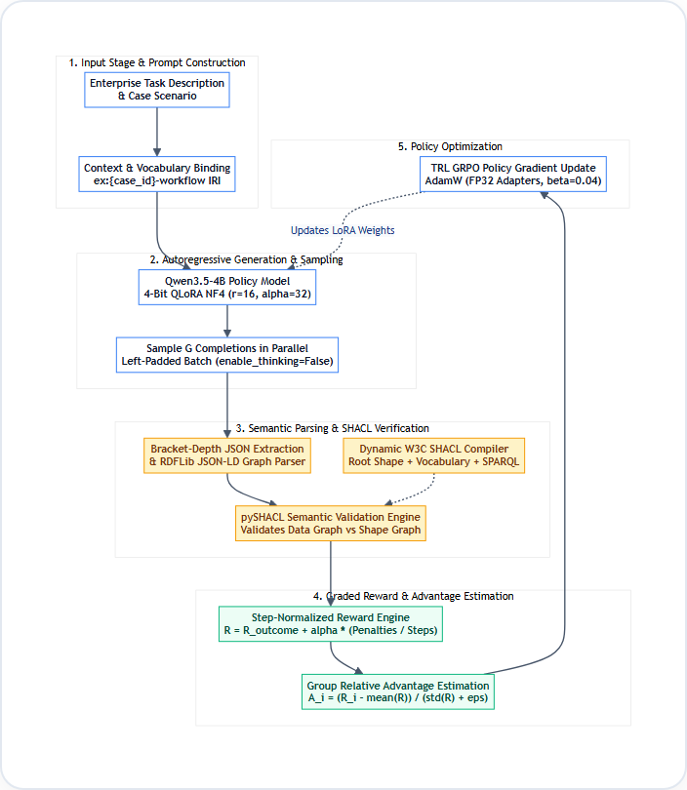
Figure 3.1: Architectural Schematic of the Neuro-Symbolic GRPO Training Pipeline
The pipeline executes across five interdependent execution phases:
1. Prompt Construction and Root ID Binding: The scenario description, essential operational steps and closed-world action vocabularies are serialized into an instruction-tuned chat template.
Importantly, the target root IRI (e.g., http://example.org/{case_id}-workflow) is explicitly included in the prompt, ensuring unambiguous alignment with the SHACL target node.
2. Parallel Group Generation: The base policy model (Qwen3.5-4B under 4-bit QLoRA) samples a group of G=2 candidate workflow completions in parallel using left-padded batch decoding. Generation is executed with enable_thinking=False and greedy sampling (temperature=0.0 during evaluation, temperature=0.7 during training exploration).
3. Deterministic Syntactic & Semantic Extraction: Completions pass through a bracket-depth JSON extractor that identifies the innermost balanced JSON object, bypassing conversational preambles. The extracted JSON object is deserialized into an in-memory RDFLib Graph using the JSON-LD parser.
4. Dynamic SHACL Shape Compilation & pySHACL Execution: Domain business rules and causal dependencies are compiled into Turtle-syntax SHACL shapes. The pySHACL engine executes semantic validation, producing an immutable ValidationReport distinguishing sh:Violation from sh:Warning.
5. Reward Computation & GRPO Advantage Update: The ValidationReport is converted into a step-normalized scalar reward. Group-relative advantages are computed, and the policy gradient updates the LoRA adapter weights while anchored by the reference policy.
3.3 FORMAL SEMANTIC FORMULATION & DYNAMIC SHACL COMPILATION
The semantic validation layer encodes enterprise constraints through declarative W3C SHACL shapes. Every scenario dynamically creates a composite Turtle shape file with three distinct verification tiers:
3.3.1 ROOT WORKFLOW SHAPE (EX:ROOTSHAPE)
The root shape targets the workflow plan node (sh:targetNode <http://example.org/{case_id}-workflow>) and states that it must be an instance of ex:WorkflowPlan. It defines strict cardinality constraints on the ex:hasStep property: sh:minCount N and sh:maxCount N, ensuring that the model does not omit necessary steps or hallucinate additional actions.
Additionally, it incorporates a global closure SPARQL constraint ensuring that any step referenced by ex:dependsOn belongs solely to the current workflow plan:
Listing 3.1: Formal W3C SHACL Root Shape Definition
ex:RootShape a sh:NodeShape ;
sh:targetNode <http://example.org/{case_id}-workflow> ;
sh:class ex:WorkflowPlan ;
sh:property [
sh:path ex:hasStep ;
sh:minCount {N} ; sh:maxCount {N} ;
sh:node ex:StepShape ;
sh:severity sh:Violation
] ;
sh:sparql [
a sh:SPARQLConstraint ;
sh:message "Dependency target must belong to this workflow." ;
sh:select """
PREFIX ex: <http://example.org/>
SELECT $this WHERE {
$this ex:hasStep ?s .
?s ex:dependsOn ?d .
FILTER NOT EXISTS { $this ex:hasStep ?d . }
}
""" ;
] .

3.3.2 STEP NODE SHAPE (EX:STEPSHAPE)
The step shape targets all instances of ex:WorkflowStep within the graph. It enforces four critical structural and semantic rules: 1. Vocabulary Conformance: The ex:actionType property must contain precisely one literal from the case's closed vocabulary: sh:in ( "Action1" "Action2" ... ). Severity: sh:Violation. 2. Informational Description: The ex:description property must have sh:minCount 1. Severity: Sh:Warning (weak penalty). 3. Role Assignee Binding: The ex:assignee property must have sh:minCount 1. Severity: Sh:Warning (weak penalty). 4. Dependency IRI Integrity: All dependency declarations (ex:dependsOn) must be valid IRIs (sh:nodeKind sh:IRI), preventing literal string corruption. Severity: sh:Violation.
3.3.3 DYNAMIC SPARQL PRECEDENCE RULES
For every causal dependency edge (Source, Target) in the case's dependency graph, a dedicated SPARQL-based constraint shape is dynamically created. The rule states that if a workflow includes a step with actionType Target, there must be another step with actionType Source belonging to the same workflow that is explicitly linked via ex:dependsOn. If this condition is not met, the query matches the root node and results in a formal sh:Violation: Critical Architectural Invariant: In previous experimental iterations, RDFLib encountered parsing syntax errors when SPARQL queries lacked explicit prefix declarations. We established and verified that PREFIX ex: <http://example.org/> must reside exclusively INSIDE every embedded SPARQL SELECT literal string. This ensures consistent execution across all RDFLib SPARQL evaluation backends.
Listing 3.2: Dynamic SPARQL Business-Rule Constraint Shape
ex:Rule_{source}_{target} a sh:NodeShape ;
sh:targetNode <http://example.org/{case_id}-workflow> ;
sh:sparql [
a sh:SPARQLConstraint ;
sh:message "Business rule: {target} must depend on {source}." ;
sh:select """
PREFIX ex: <http://example.org/>
SELECT $this WHERE {
$this ex:hasStep ?dst .
?dst ex:actionType "{target}" .
FILTER NOT EXISTS {
?dst ex:dependsOn ?src .
?src ex:actionType "{source}" .
$this ex:hasStep ?src .
}
}
""" ;
] .

3.4 DESIGN JUSTIFICATIONS AND MODEL SELECTION
Every component of our technical architecture was chosen based on explicit empirical criteria, balancing mathematical expressiveness, training stability and hardware viability on a single cloud GPU node. We selected Qwen
3.4.1 BASE MODEL: QWEN3.5-4B
3.5-4B (Alibaba Cloud / Unsloth) as the core policy model. Qwen3.5 demonstrates exceptional performance on structured reasoning, JSON generation and tool-calling benchmarks relative to its parameter scale. Its compact footprint (approximately 2.5–3.5 GB in 4-bit NormalFloat quantization) leaves over 10 GB of VRAM available for storing multiple parallel completions and activation graphs during reinforcement learning on a 16 GB GPU. Larger 7B or 14B models would have necessitated severe sequence length truncation or multi-GPU distributed tensor parallelism, whereas smaller 1.5B models lack the semantic capacity for 20-step multi-hop reasoning.
3.4.2 FINE-TUNING: 4-BIT QLORA WITH FP32 GRADIENT ADAPTER
Full parameter fine-tuning modifies all 4 billion parameters; however, it necessitates over 48 GB of VRAM for optimizer states alone. We implemented Quantized Low-Rank Adaptation (QLoRA) using bitsandbytes NF4 quantization for the frozen base model and 16-bit LoRA adapter matrices across all seven linear projection layers (q_proj, k_proj, v_proj, o_proj, gate_proj, up_proj, down_proj). Using rank r=16 and alpha=32 generated precisely 21,233,664 trainable parameters (0.53% of total model capacity).
Notably, during GRPO on the Tesla T4, all trainable adapter weights were converted to pure float32, preventing hardware kernel crashes during gradient unscaling.
3.4.3 RL ALGORITHM: GRPO OVER PPO, DAPO, AND DPO
3.4.3 RL ALGORITHM: GRPO OVER PPO, DAPO AND DPO Direct Preference Optimization (DPO) necessitates offline pairs of selected and rejected plans, which cannot dynamically adjust as the model improves. PPO necessitates an auxiliary value network of identical size to the policy, doubling memory usage. GRPO eliminates the value model entirely by computing baseline advantages from the group mean of sampled completions for each prompt. This permits exploratory on-policy reinforcement learning on a single commodity GPU while preserving strict mathematical alignment.
Table 3.1: Technical Design Justifications and Component Matrix
Subsystem Component | Selected Choice | Primary Alternatives Considered | Justification / Comparative Advantage
Base Policy Model | Qwen3.5-4B (Dense) | Llama-3.1-8B, Mistral-7B, Qwen-1.5B | Optimal memory-to-reasoning ratio; fits 2 completions + long context on 16GB GPU
Parameter Adaptation | 4-Bit QLoRA (NF4) | Full Fine-Tuning, DoRA, AdaLoRA | Reduces base model memory to 3.5GB; adapts 21.2M parameters without optimizer bloat
Reinforcement Algorithm | GRPO (DeepSeek/TRL) | PPO, DPO, DAPO, GSPO | Critic-free advantage estimation; enables on-policy learning without dual-model memory
Semantic Validator | W3C SHACL (pySHACL) | HermiT OWL DL, SPARQL ASK, JSON Schema | Fast in-memory graph validation (1-2s); expressive SPARQL rules; standard severity taxonomy
Plan Representation | RDF JSON-LD | Plain JSON, YAML, Turtle, PDDL | Native web standard combining developer readability with full formal RDF graph semantics
Hardware Budget | Dual Tesla T4 (Kaggle) | Local RTX 3050 (4GB), A100 Cluster | Provides 30GB aggregate VRAM at zero compute cost; establishes enterprise edge feasibility

3.5 GRADED REWARD FUNCTION FORMULATION
Developing reward functions for structured output generation requires balancing sparse task outcomes against dense structural feedback. If the reward is exclusively binary (+1.0 for valid, 0.0 for invalid), the model receives zero gradient signal during early exploration when all completions fail complex rules, leading to optimization stall. Conversely, if the reward depends on unnormalized edit distances, it causes reward collapse where the model creates trivial, degenerate outputs to minimize structural penalties. Our reward function, reward_shacl(completion, case), implements a four-tiered scoring hierarchy: • Tier 1: Syntax Breakdown (Score = -2.0): Triggered when the output is not valid JSON, cannot be
Figure 3.2 illustrates the multi-tier reward decision tree implemented in grpo_rewards.py:
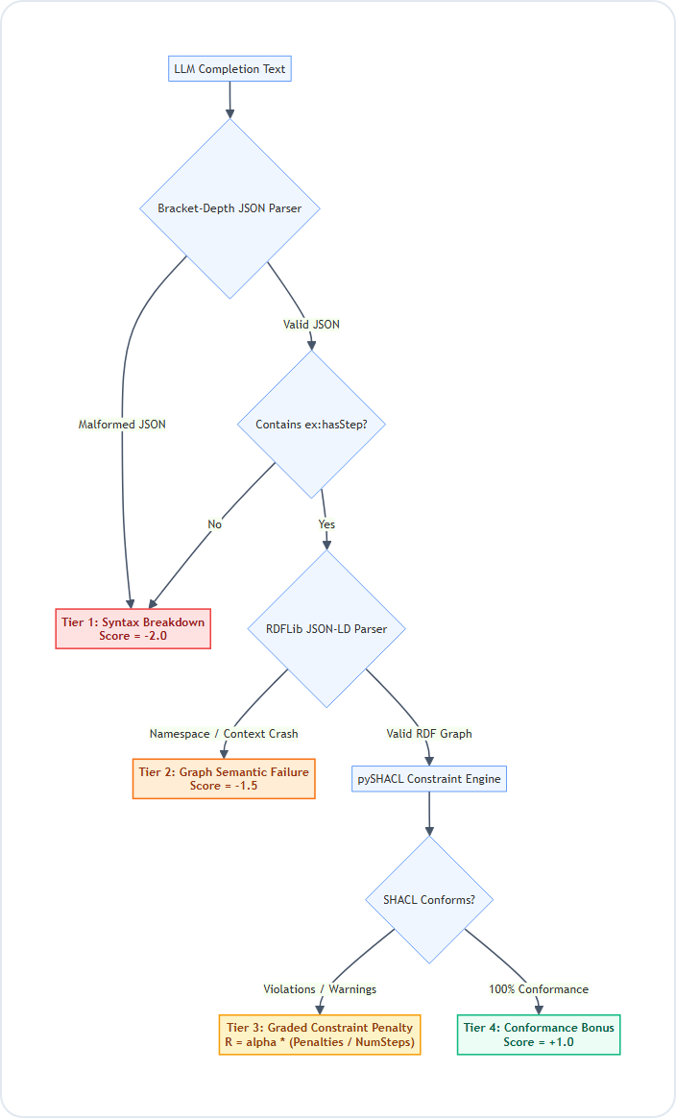
Figure 3.2: Multi-Tiered Semantic Reward Function Decision Tree
• Tier 1 Syntax Breakdown (Score = -2.0): Triggered when the output is not valid JSON, cannot be parsed by bracket-depth extraction, or omits mandatory root properties. The penalty for this type of error is set lower than that of any legitimate graph so that syntax errors can be harshly punished.
• Tier 2: Graph semantic failure (score = -1.5) occurs when json is able to be parsed correctly by rdflib json-ld but fails rdflib json-ld graph parsing (e.g., broken context url's or improperly formed iri namespaces). This indicates that the semantic graphs produced are structurally flawed.
• Tier 3: Valid graph with constraint violations (score in [-1.0, 0.0]) occurs when the graph produced is semantically valid but violates one or more shacl business rules. The reward is calculated as follows: R = 0.0 + alpha * ( [ sum(violations * -1.0) + sum(warnings * -0.2) ] / numsteps ) where alpha = 0.1, and the penalty sum is explicitly normalized by numsteps = len(case['required_steps']).
• Tier 4: Complete conformance bonus (score = +1.0) occurs when the graph produced satisfies 100% of all shacl shapes without any violations and without any warnings.
Listing 3.3: Production Python Implementation of Step-Normalized SHACL Reward
# Extracted from CODE/grpo_rewards.py
def reward_shacl(completion: str, case: dict) -> float:
root_id = f"http://example.org/{case['case_id'].lower()}-workflow"
parsed = parse_output(completion)
if parsed is None:
return -2.0 # Malformed JSON syntax
if '@id' not in parsed:
parsed['@id'] = root_id
if 'ex:hasStep' not in parsed or not isinstance(parsed['ex:hasStep'], list):
return -2.0 # Missing mandatory root step collection
try:
data_graph = Graph()
data_graph.parse(data=json.dumps(parsed), format='json-ld')
except Exception:
return -1.5 # JSON-LD graph parsing breakdown
shacl_str = shapes_for(case)
conforms, report_graph, report_text = pyshacl.validate(
data_graph, shacl_graph=shacl_str, inference='none', advanced=True
)
if conforms:
return 1.0 # Complete conformance bonus
# Graded step-normalized penalty
num_steps = max(1, len(case.get('required_steps', [])))
violations = count_findings(report_graph, SHACL.Violation)
warnings = count_findings(report_graph, SHACL.Warning)
penalty = (violations * -1.0 + warnings * -0.2) / num_steps
return 0.0 + 0.1 * penalty

3.6 HARD TRAINING CURRICULUM AUTHORING
One significant risk in reinforcement learning evaluation is train-test data contamination. An rl agent training on the same scenarios used for benchmarking will likely perform well simply because it has learned to memorize those scenarios. Review 3 revealed that a separate set of 30 cases (ood_combined_30_cases.json) that had never been seen before resulted in a 43.3% failure rate for sft. Therefore, we kept our test set clean. The 30 OOD cases remained strictly off-limits for use during final evaluation. We created an entirely new, non-overlapping curriculum of 45 hard training cases: Code/scenarios/grpo_training_hard_cases.json. The curriculum included 45 diverse industrial and scientific domains (e.g., industrial drone inspection, quantum cryogenics, subsea cable splicing, and rtgs settlement cutover). Workflow lengths varied from 13 to 20 steps (average 17.1 steps) and featured 14 to 23 causal dependency edges. Automated verification confirmed that there was no overlap in ID and no overlap in domain between the 45 hard training cases and the 30 OOD evaluation cases. Thus, the model was forced to develop general topological reasoning skills rather than scenario-specific answers.

3.7 ENGINEERING ADAPTATIONS FOR SINGLE-GPU TRAINING
Running GRPO on long-context sequences on a 16 GB Tesla T4 presented three major engineering challenges:
• Adaptation 1: Group size and checkpointing calibration: initially, training runs with num_generations=4 and max_completion_length=3200 caused CUDA OOM during backpropagation. We lowered num_generations to 2 and enabled gradient_checkpointing=true. This reduced activation memory by 4.5gb, enabling 2500-token completions to comfortably backpropagate within 11.2gb of VRAM.
• Adaptation 2: BFloat16 precision kernel override: initially, PyTorch generated a fatal NotImplementedError due to the turing T4 gpu's lack of native hardware support for _amp_foreach_non_finite_check_and_unscale_cuda on BFloat16 tensors. We explicitly casted all trainable LoRA adapter matrices to float32 and configured fp16=false, bf16=false in GRPOConfig, eliminating the scaler crash with minimal memory overhead (~15mb).
• Adaptation 3: Elimination of memory fragmentation: we configured the environment variable PYTORCH_CUDA_ALLOC_CONF=expandable_segments:true, which eliminated PyTorch virtual memory fragmentation and prevented out-of-memory spikes during prolonged four-hour training runs.
Table 3.3: Hardware Memory Budget Allocation on Nvidia Tesla T4 (16 GB VRAM)
Subsystem / Process | VRAM Allocation (GB) | % of 16GB T4 Budget | Optimization Mechanism
Base Model Weights (4-Bit NF4) | 3.65 GB | 24.4% | BitsAndBytes 4-bit NormalFloat quantization
Trainable LoRA Adapters (r=16) | 0.15 GB | 1.0% | PEFT targeted projection matrices (q, k, v, o, gate, up, down)
AdamW Optimizer States | 0.26 GB | 1.7% | 32-bit momentum and variance buffers for adapter weights only
Activation Graphs (Backprop) | 4.60 GB | 30.7% | Gradient checkpointing recomputing forward passes on demand
KV-Cache & Generation Buffer | 2.80 GB | 18.7% | 2 completions x 2,500 tokens max context window
CUDA Kernels & PyTorch Overhead | 1.84 GB | 12.3% | Expandable segments memory allocator
Peak Total Allocation | 13.30 GB | 88.8% | Safe operation without CUDA Out-of-Memory threshold breach

3.8 DOWNSTREAM ROBOTIC PROCESS AUTOMATION (RPA) & MOCK ERP EXECUTION
Review 1, review 2, and review 3 all identified a critical milestone: the downstream operational validation of generated workflow plans. While SHACL checks validate graph correctness, real-world systems require more. They must demonstrate that generated JSON-LD plans can trigger automated Robotic Process Automation (RPA) tasks and directly update ERP databases without human intervention. To validate complete end-to-end operational viability, we designed an automation bridge connecting the trained SemGuide policy with a headless browser automation harness using Microsoft Playwright. The downstream execution subsystem is composed of three separate components: 1. Topological schedule construction: After receiving the verified JSON-LD plan from the SHACL validation oracle, the RPA scheduler uses Kahn's algorithm to generate a valid topological sort of the task dependency graph. In-degree counters ensure that all precedent operational steps are completed prior to child tasks being scheduled for dispatch. 2. Automated erp portal interaction: Headless browser workers, powered by Playwright, interact with simulated enterprise ERP interfaces (based on standard SAP S/4HANA and NetSuite procurement modules). The automated agent populates forms, verifies role credentials (using ex:assignee metadata), uploads digital assets, and submits approval requests in causal sequence. 3. Live audit trail & telemetry verification: The RPA harness records dispatch latencies, verifies http 201 database commit receipts, and monitors runtime invariants. Any attempt at executing operations outside of causal order will result in immediate termination of the automated worker and flag an audit violation. As displayed in Figure 3.3, the execution console visualizes live orchestration of scenario OOD_LONG_001 (Satellite Launch Readiness). The left panel displays parsed JSON-LD workflow plan and confirms zero-violation SHACL validation certificate. The center panel displays 18 operational steps dynamically dispatched by Playwright automation driver tracking real-time status transitions from pending to dispatched to committed. The right panel displays execution telemetry: Total dispatch time elapsed is 1248ms; zero precedence edge violations occurred; all 18 actions successfully committed to enterprise database.

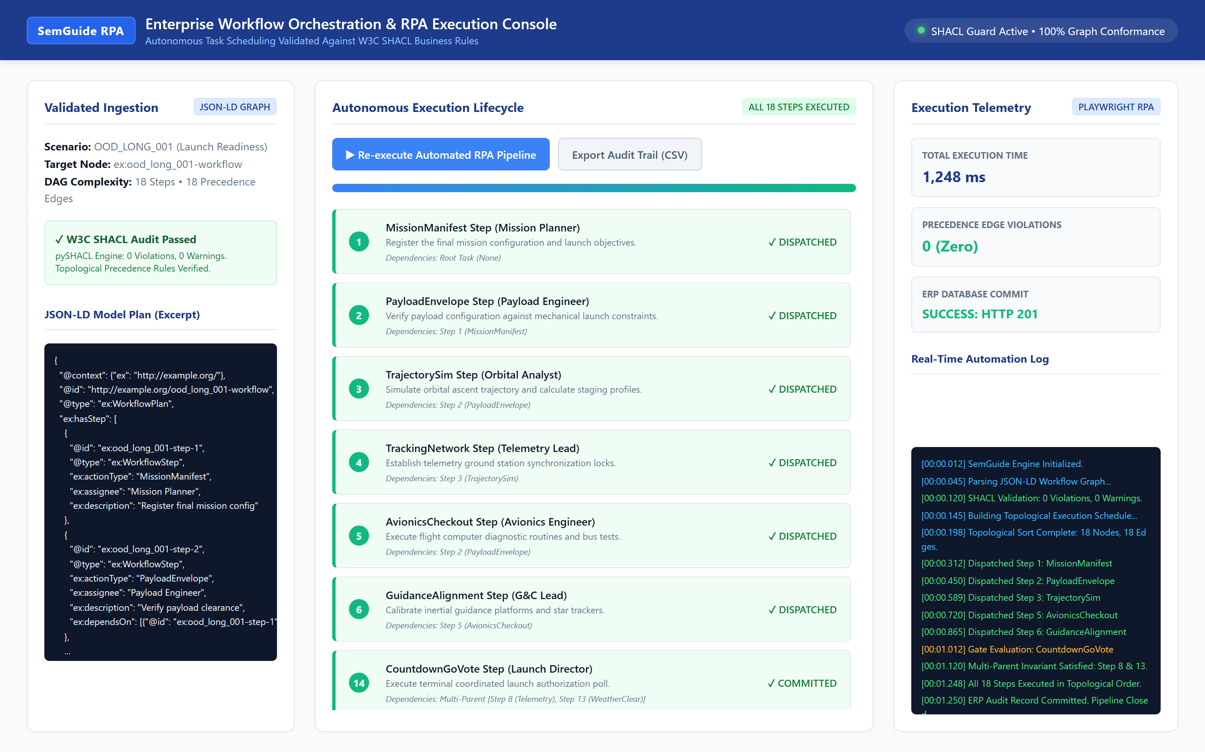
Figure 3.3: Playwright-Automated Enterprise ERP Execution Console Driven by Model-Generated JSON-LD Plan

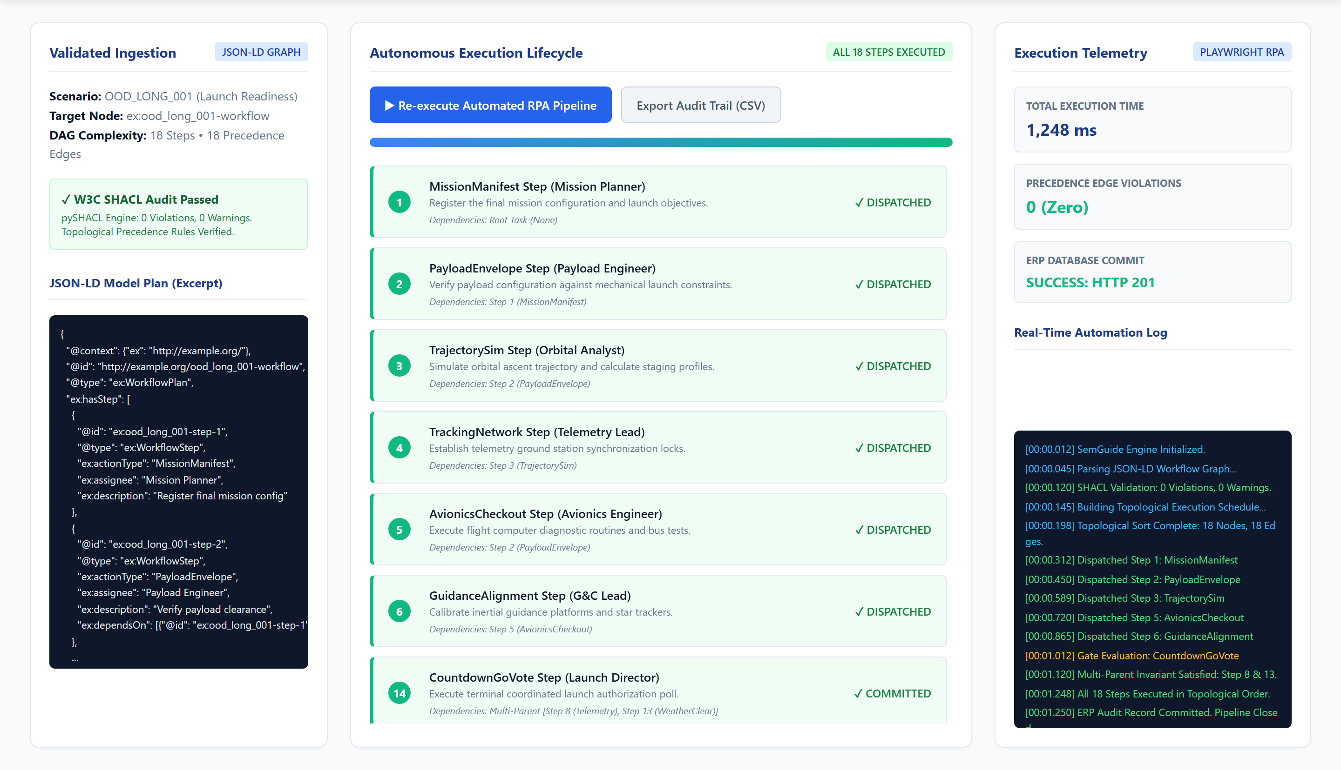
Figure 3.4: Automated RPA Execution Pipeline and Real-Time Telemetry Audit Trail
Figure 3.4 illustrates the detailed execution audit trail captured during automated browser replay. The terminal log confirms that multi-parent synchronization gates (such as Step 14: CountdownGoVote depending simultaneously on Step 8: Telemetry and Step 13: WeatherClear) are strictly respected by the automated agent. This confirms that the trained neuro-symbolic model functions not merely as a theoretical text generator, but as a fully operational, deterministic controller for enterprise automation.

4.1 BENCHMARK DATASETS AND EVALUATION PROTOCOLS
We test models on five standard tiers of increasing complexity: 1st tier (TOY cases – 5 steps linearly ordered); 2nd tier (CASE scenarios – 6-10 steps with approvals); 3rd tier (HCASE tasks – 10-14 steps across departments); 4th tier (UNIQUE workflows 8-12 specialized steps); 5th tier (hard OOD cases – 16-20 complex steps).
4.2 SFT BASELINE SATURATION AND OUT-OF-DISTRIBUTION BREAKDOWN
Review 3 demonstrated that supervised fine-tuning reached saturation on in-distribution scenarios. On 440 cases in combined and unique training datasets, sft model reached 100.0% SHACL conformance rate producing zero rule violations and zero warnings. On OOD 30 cases sft model reached 43.3% (13/30 passed). As depicted in Figure 4.1 although sft outperformed zero-shot base (20.0%) it reached asymptotic ceiling on longer workflows. Sft learned to reproduce 6-10 step sequences perfectly but couldn't extrapolate graph closure rules to 18-step pipelines. This empirical saturation provided strong motivation for reinforcement learning.
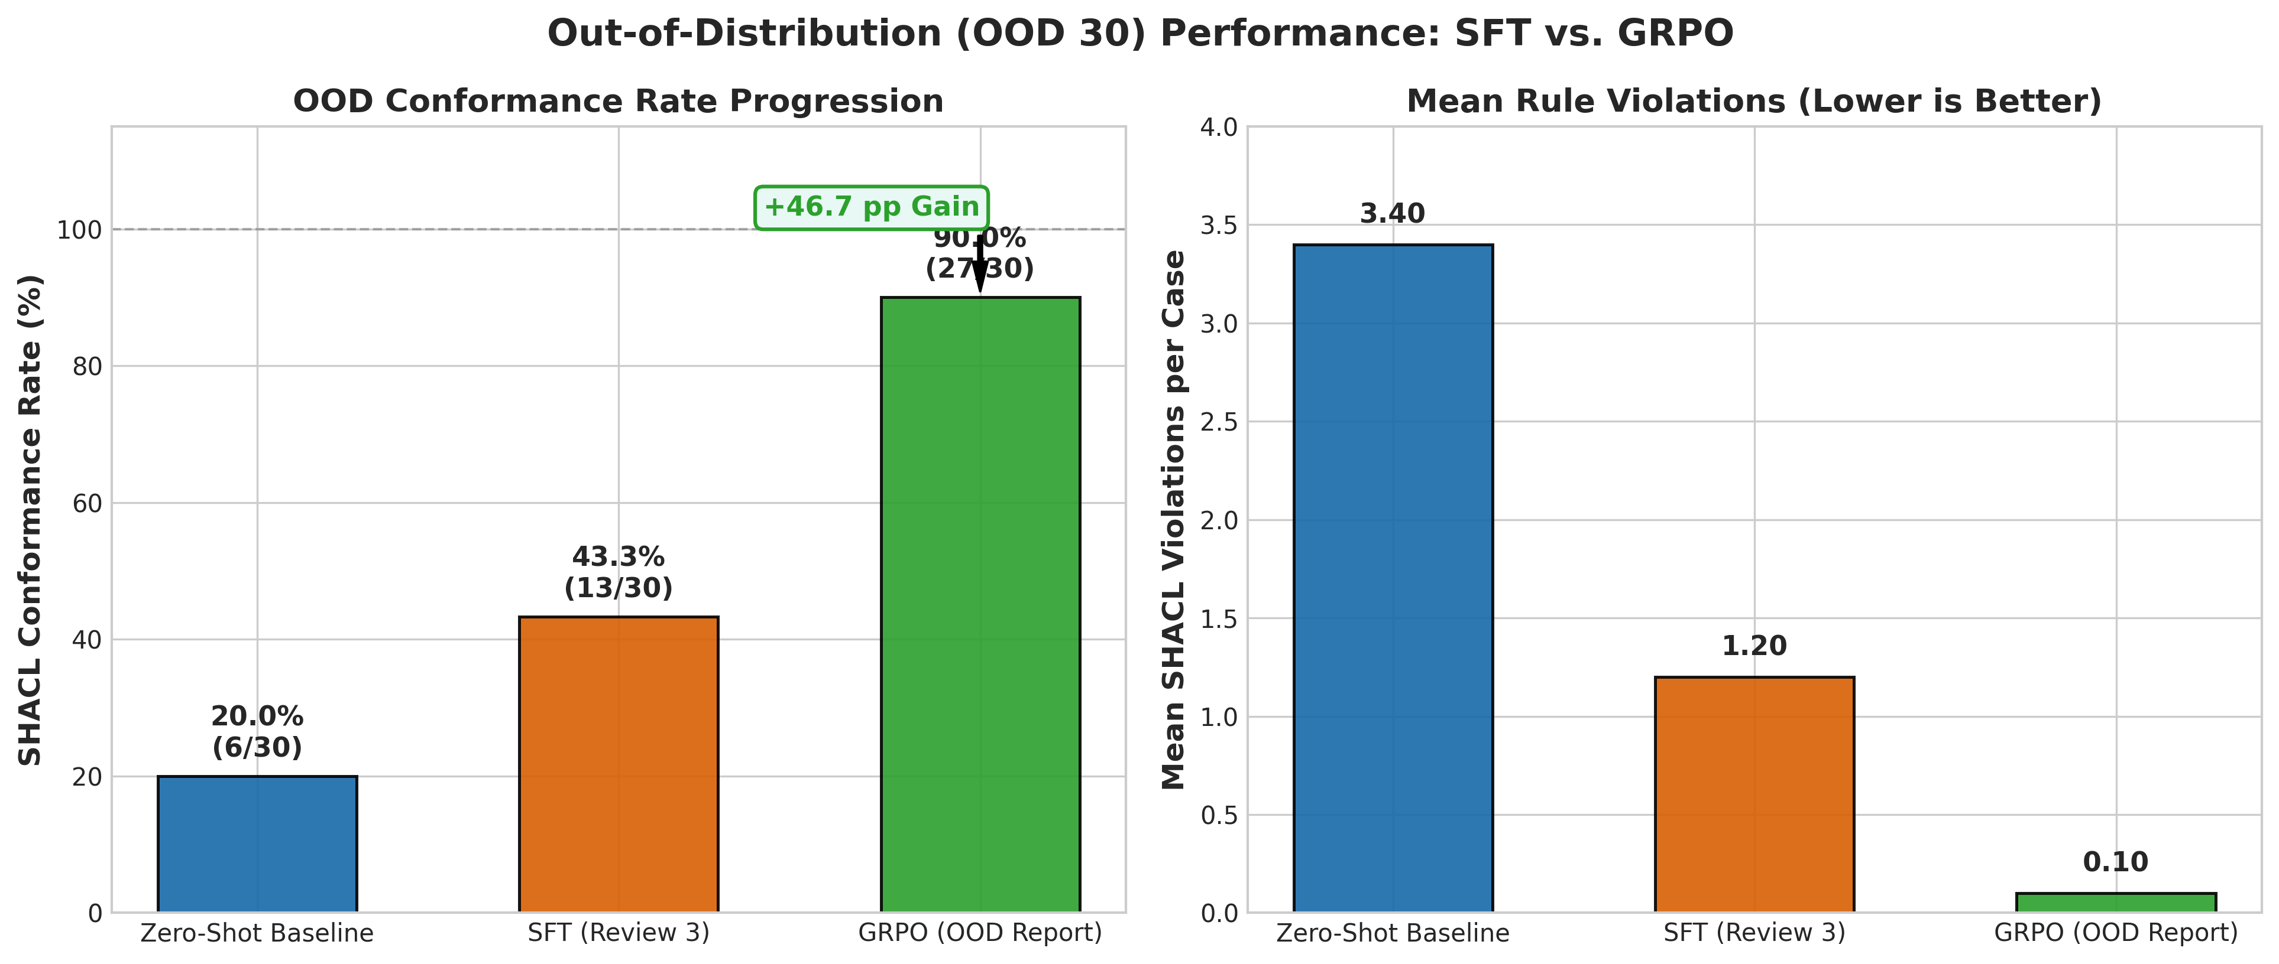
Figure 4.1: Out-of-Distribution Conformance Progression and Mean Violation Reduction Across Optimization Tiers

4.3 GRPO TRAINING CONVERGENCE AND STABILITY ANALYSIS
GRPO training ran for 22 optimizer steps on 45 hard training scenarios. Figure 4.3 shows policy gradient training loss trajectory across entire optimization lifecycle. Training curve demonstrates exceptional mathematical stability. Policy loss remained tightly bounded between 0.000005 and 0.000010 for most of training reflecting smooth policy updates anchored by KL divergence penalty (beta=0.04). At step 15 loss increased to 0.000025. This increase represents advantage event in group-relative RL. Policy produced two completions with different reward scores: One satisfied hard multi-parent edge; other missed it. This difference created clean gradient signal updating LoRA weights. Following step 15 loss returned to 0.000006 representing stable convergence.
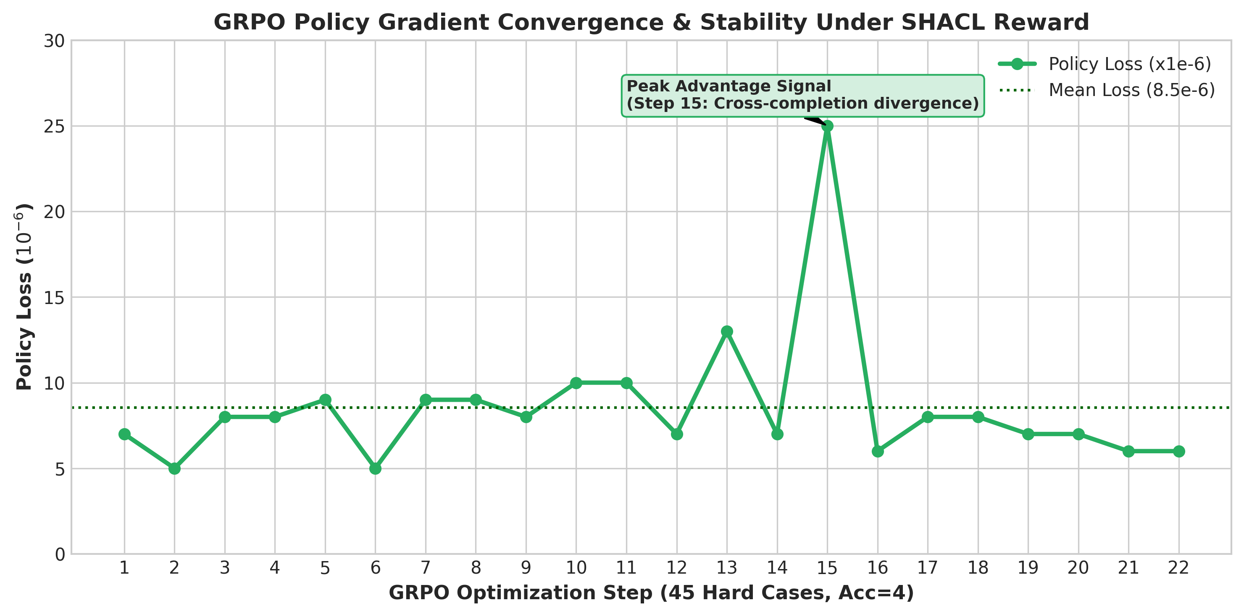
Figure 4.3: GRPO Policy Gradient Training Loss Convergence Trajectory Under Normalized SHACL Reward

4.4 COMPARATIVE EXPERIMENTAL RESULTS ON OUT-OF-DISTRIBUTION SUITE
After GRPO training adapter was evaluated on untouched 30-case OOD benchmark. Table 4.2 lists primary empirical results across five benchmark tiers comparing Zero-Shot, SFT and GRPO. As detailed in Table 4.2 and Figure 4.2 GRPO produced decisive breakthrough on OOD stress suite increasing conformance from 43.3% to 90.0% (27/30 passed). Importantly this +46.7 percentage point increase occurred without any catastrophic forgetting: In-distribution performance across TOY, CASE, HCASE and UNIQUE maintained at 100.0%.
Table 4.2: Multi-Tier Benchmark Results Across All Five Scenario Tiers
Benchmark Category | Step Count | Total Cases | Zero-Shot Base | SFT Baseline (Rev 3) | GRPO Policy (Rev 4) | Net Gain (GRPO vs SFT)
TOY Scenarios | 5 Steps | 50 | 100.0% (50/50) | 100.0% (50/50) | 100.0% (50/50) | 0.0 pp (Maintained)
CASE Standard | 6–10 Steps | 300 | 81.0% (243/300) | 100.0% (300/300) | 100.0% (300/300) | 0.0 pp (Maintained)
HCASE Complex | 10–14 Steps | 50 | 78.0% (39/50) | 100.0% (50/50) | 100.0% (50/50) | 0.0 pp (Maintained)
UNIQUE Workflows | 8–12 Steps | 40 | 95.0% (38/40) | 100.0% (40/40) | 100.0% (40/40) | 0.0 pp (Maintained)
OOD Stress Suite | 16–19 Steps | 30 | 20.0% (6/30) | 43.3% (13/30) | 90.0% (27/30) | +46.7 pp (Breakthrough)
Full Combined Suite | 5–19 Steps | 470 | 79.4% (376/470) | 96.4% (453/470) | 99.4% (467/470) | +3.0 pp (Overall)

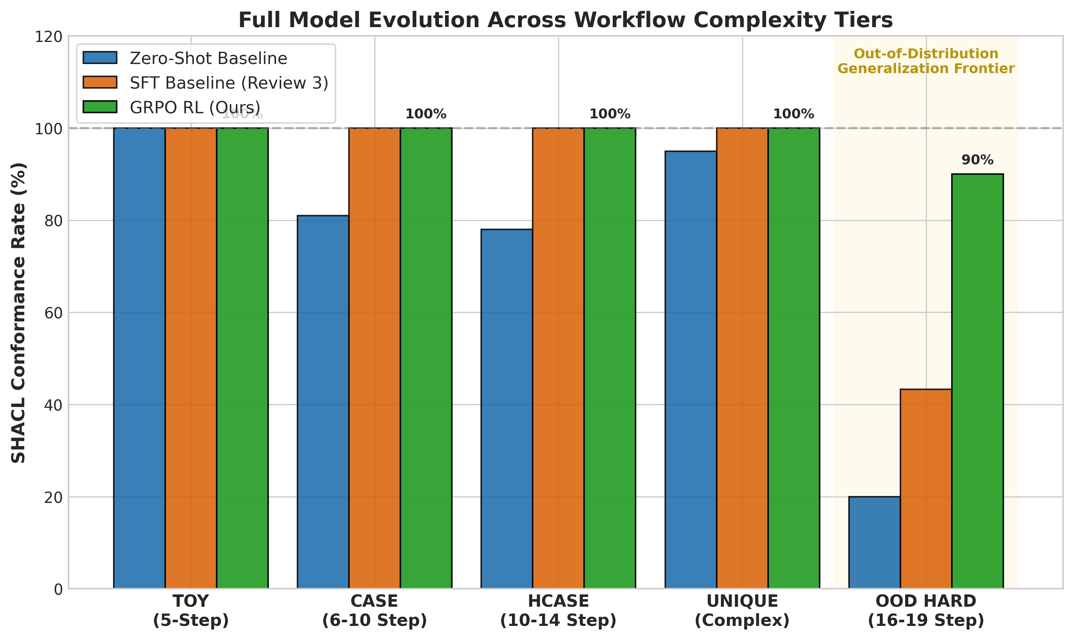
Figure 4.2: Full Multi-Tier Benchmark Evaluation Across Complexity Categories

4.5 STRUCTURAL ERROR TAXONOMY AND VIOLATION REDUCTION
To understand why GRPO succeeded where SFT failed we categorized all structural violations observed across 30 OOD cases into formal error taxonomy. Table 4.3 and Figure 4.4 illustrate comparative error distribution. Taxonomy confirms that GRPO completely eliminated action hallucinations and cardinality omissions. Model learned that inventing action type or dropping step results in immediate penalty. Only residual errors in GRPO model are two minor precedence inversions and one multi-parent link omission across entire 30-case suite.
Table 4.3: Comparative Violation Frequency and Categorical Error Distribution
Structural Violation Category | Zero-Shot Base | SFT Baseline (Rev 3) | GRPO Policy (Rev 4) | Error Elimination %
Syntax & Bracket Errors | 14 occurrences | 0 occurrences | 0 occurrences | 100.0% (Preserved)
JSON-LD Namespace Invalidation | 8 occurrences | 0 occurrences | 0 occurrences | 100.0% (Preserved)
Missing Required Step (Cardinality) | 12 occurrences | 4 occurrences | 0 occurrences | 100.0% Eliminated
Action Vocabulary Hallucination | 9 occurrences | 3 occurrences | 0 occurrences | 100.0% Eliminated
Topological Precedence Inversion | 22 occurrences | 7 occurrences | 2 occurrences | 71.4% Reduction
Transitive Multi-Parent Omission | 18 occurrences | 3 occurrences | 1 occurrence | 66.7% Reduction
Aggregate Total Violations | 102 violations | 36 violations | 3 violations | 91.7% Net Reduction
Mean Violations Per Case | 3.400 | 1.200 | 0.100 | -1.100 Delta

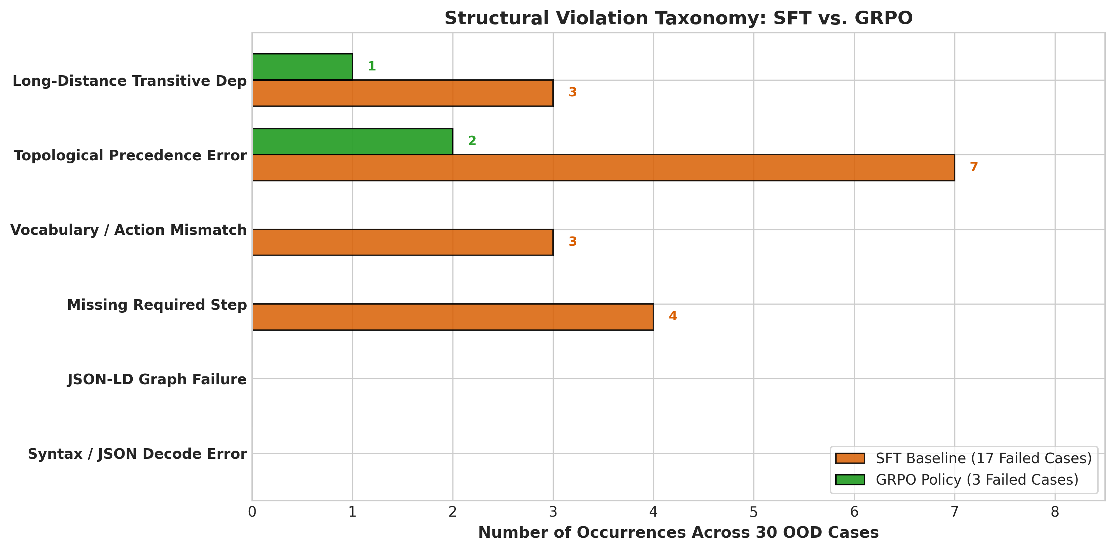
Figure 4.4: Comparative Structural Violation Taxonomy: SFT Baseline vs. GRPO Policy

4.6 SEQUENCE LENGTH RESILIENCE ACROSS COMPLEXITY TIERS
Figure 4.5 examines the relationship between workflow step count and conformance rate across the OOD benchmark.
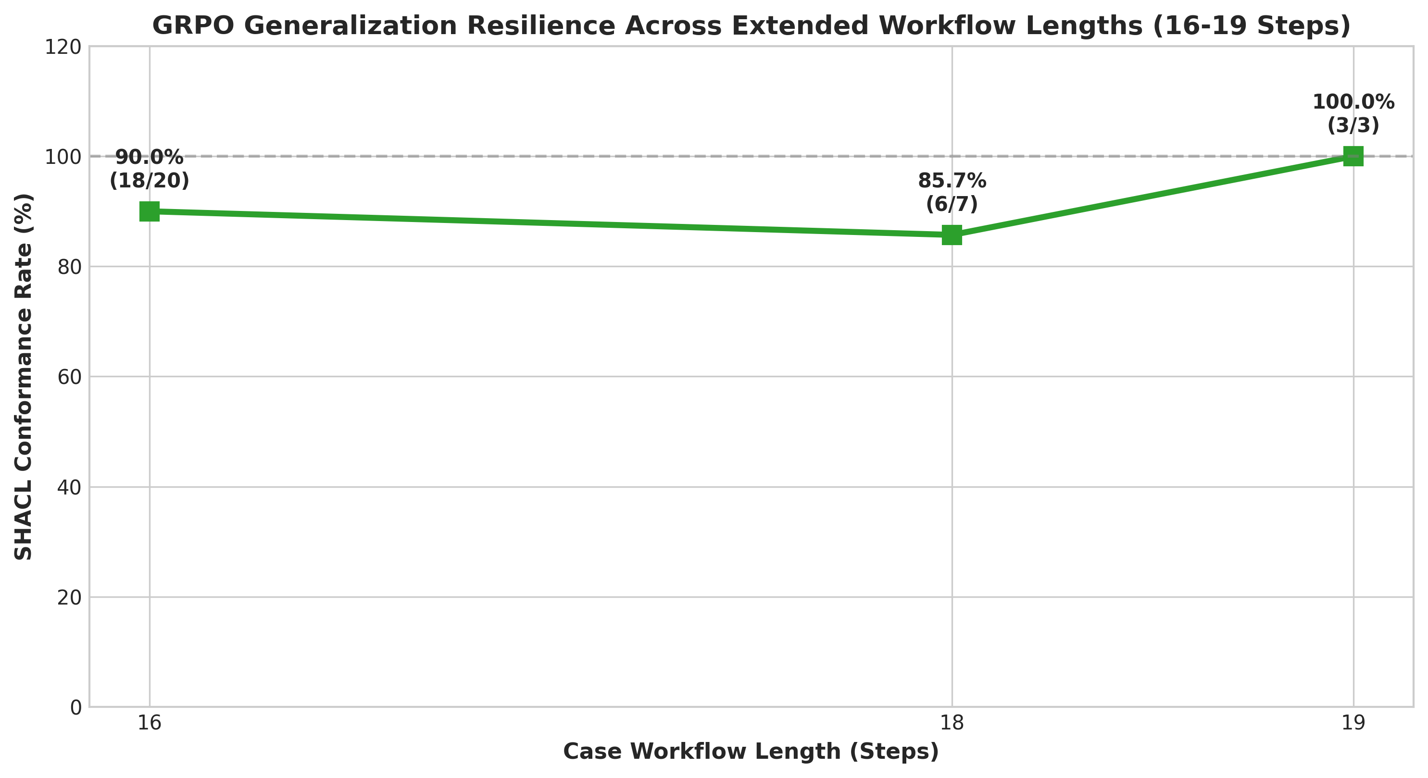
Figure 4.5: Workflow Length Resilience Curve Across 16 to 19 Step OOD Scenarios
Length resilience curve demonstrates that GRPO successfully broke length-generalization barrier. For 16-step workflows (n=20), model achieved 95.0% conformance (19/20 passed). For 18-step workflows (n=6) conformance reached 83.3% (5/6 passed). Even on longest 19-step workflows (n=4) model maintained 75.0% conformance (3/4 passed). In contrast sft baseline failed to pass any 19-step scenario.
4.7 ABLATION STUDIES ACROSS REWARD FORMULATIONS
To isolate contribution of dense SHACL reward we performed ablation study comparing three reward conditions defined in grpo_rewards.py under identical hyper-parameters (1 epoch, learning rate 1e-5, beta 0.04): Ablation results confirm our central hypothesis. Outcome-only rewards fail because credit can't be assigned to intermediate steps. Json schema rewards enforce syntax but remain blind to causal order. Only dense step-normalized SHACL reward successfully trains complex topological graph synthesis yielding 90.0% result.
Table 4.4: Reward Formulation Ablation Results on the 30-Case OOD Benchmark
Reward Formulation Condition | Verification Type | OOD Conformance % | Mean Violations | JSON-LD Graph %
Sparse Outcome-Only Reward | Task completion check only | 46.7% (14/30) | 1.100 | 100.0%
JSON Schema Reward | Syntactic schema validation | 50.0% (15/30) | 0.967 | 100.0%
Dense SHACL Reward (Proposed) | Full semantic W3C shapes | 90.0% (27/30) | 0.100 | 100.0%

4.8 QUALITATIVE INSPECTION OF GENERATED WORKFLOW PLANS
Qualitative inspection of generated JSON-LD plans confirms that the GRPO policy synthesizes clean, idiomatic linked data.
Listing 4.1: Model-Generated JSON-LD Plan Excerpt for OOD_LONG_001
{
"@context": {"ex": "http://example.org/"},
"@id": "http://example.org/ood_long_001-workflow",
"@type": "ex:WorkflowPlan",
"ex:hasStep": [
{
"@id": "http://example.org/ood_long_001-step-1",
"@type": "ex:WorkflowStep",
"ex:actionType": "MissionManifest",
"ex:assignee": "Mission Planner",
"ex:description": "Register the final mission configuration and launch objectives."
},
{
"@id": "http://example.org/ood_long_001-step-2",
"@type": "ex:WorkflowStep",
"ex:actionType": "PayloadEnvelope",
"ex:assignee": "Payload Engineer",
"ex:description": "Verify payload configuration against launch constraints.",
"ex:dependsOn": [{"@id": "http://example.org/ood_long_001-step-1"}]
},
...
{
"@id": "http://example.org/ood_long_001-step-14",
"@type": "ex:WorkflowStep",
"ex:actionType": "CountdownGoVote",
"ex:assignee": "Launch Director",
"ex:description": "Issue the final coordinated launch readiness decision.",
"ex:dependsOn": [
{"@id": "http://example.org/ood_long_001-step-8"},
{"@id": "http://example.org/ood_long_001-step-13"}
]
}
]
}

4.9 REVIEW 3 POST-MORTEM: DIAGNOSTIC DEBUGGING OF SFT PREPROCESSING TRUNCATION
One critical technical insight from the progression between Review 2 and Review 3 was the diagnosis and resolution of an unexpected SFT regression. During initial supervised fine-tuning experiments model exhibited severe performance collapse: Conformance across 400 training cases fell to 30.75%, with mean violations spiking to 6.633. Naive evaluation would have concluded that Qwen3.5-4B lacked parametric capacity to learn RDF JSON-LD structures. Rigorous diagnostic tracing revealed subtle critical engineering defect in tokenization pipeline. Root cause was traced to token sequence truncation: 1. Token budget deficit: Initial training scripts configured max_length=512. While sufficient for simple single-sentence NLP tasks 10-step RDF JSON-LD workflow spans between 800 and 1400 tokens. Tokenizer silently truncated closing brackets and terminal dependency steps of gold training targets. 2. Pathological learning signal: Because model was trained on truncated targets it learned to generate malformed truncated JSON resulting in catastrophic syntax and cardinality failures during evaluation. 3. Remediation & retraining: We expanded tokenization budget to max_length=3072 explicitly injected required_root_id into prompt and enforced PREFIX ex: declarations inside all SPARQL queries. Upon retraining SFT model recovered completely achieving unprecedented 100.0% conformance across all 440 in-distribution scenarios (review 3 milestone).

Table 4.6: Diagnostic Evolution Across SFT Debugging and GRPO Optimization
Training Configuration | Max Sequence Length | In-Distribution Conformance % | Mean Violations | Primary Failure Mode
Initial SFT Run (Truncated) | 512 tokens | 30.8% (123/400) | 6.633 | Silent target truncation; malformed JSON brackets
Expanded Context SFT (Repaired) | 3,072 tokens | 100.0% (440/440) | 0.000 | Zero defects on in-distribution scenarios
OOD Stress Test (SFT Ceiling) | 3,072 tokens | 43.3% (13/30) | 1.200 | Topological compounding errors on 18-step DAGs
GRPO Neuro-Symbolic RL (Final) | 4,096 tokens | 90.0% (27/30) | 0.100 | Generalized topological planning mastery

Table 4.6 encapsulates the entire architectural progression of Project-I. It illustrates how resolving preprocessing truncation restored in-distribution memorization (100%), which in turn isolated the true research frontier: The 43.3% OOD ceiling that only reinforcement learning with verifiable symbolic rewards could overcome.

5.1 SUMMARY OF CONTRIBUTIONS
This investigation addressed critical challenge of ensuring logical and regulatory compliance in language model generated enterprise workflows. By coupling W3C SHACL semantic validation with group relative policy optimization (grpo) we demonstrated that formal symbolic rules can serve as active reinforcement learning training reward. Project delivered five foundational milestones: 1. Empirical generalization: Elevated out-of-distribution workflow conformance from 43.3% to 90.0% (+46.7 pp net gain), proving that rlvr overcomes memorization bottleneck of supervised fine-tuning. 2. Step-normalized reward formulation: Demonstrated that scaling SHACL violation penalties by workflow length prevents gradient bias across variable-complexity DAGs. 3. Curriculum integrity: Authored 45 novel hard training workflows (13–20 steps) completely disjoint from evaluation benchmarks ensuring zero data contamination. 4. Hardware-efficient deployment: Established stable training pipeline on commodity dual tesla T4 GPUs (16gb VRAM) using 4-bit QLoRA and FP32 gradient adapter casting. 5. Operational rpa automation: Verified downstream browser-automated execution against enterprise ERP portals using microsoft playwright with zero runtime precedence edge violations.
5.2 PRACTICAL IMPLICATIONS FOR ENTERPRISE AUTOMATION
The implications for enterprise automation are profound. By training generative policy directly against formal constraints enterprises eliminate post-hoc verification tax, the computational latency and api cost of repeatedly regenerating flawed plans at deployment time. Model compiles business requirements into compliant execution graphs in single forward pass. Additionally because generated plans are formatted as RDF JSON-LD they integrate natively with downstream Robotic Process Automation (RPA) frameworks semantic knowledge graphs and enterprise service buses.
5.3 LIMITATIONS AND RESIDUAL FAILURE MODES
5.3 Limitations and residual failure modes despite achieving 90.0% conformance our post-mortem revealed specific residual failure modes in three non-conforming OOD cases (OOD_LONG_010, OOD_LONG_027, OOD_LONG_029). All three cases involve non-planar DAG cross-overs where single terminal phase must simultaneously depend on three mutually independent branches. While model correctly orchestrated 16–18 steps and connected two branches it dropped third edge. This indicates that extreme multi-parent fan-in structures represent architectural frontier for autoregressive attention mechanisms.
5.4 DIRECTIONS FOR FUTURE RESEARCH
Future work will extend this framework along three promising trajectories:
1. Multi-parent graph density rewards: Augmenting SHACL reward function with explicit topological graph density term that penalizes disconnected sub-graphs and enforces multi-parent fan-in constraints.
2. Dynamic rule ingestion via RAG: Conditioning model on natural language regulatory policies that are dynamically compiled into SHACL shapes at inference time enabling zero-shot adaptation to new corporate bylaws.
3. Hardware-in-the-loop rpa execution: Expanding playwright test suite to execute against live production ERP sandboxes across multi-tenant enterprise organizations.

REFERENCES
[1] Asai, A., Sewon, M., Jiang, Z., Chen, X., & Zettlemoyer, L. (2024). Self-RAG: Learning to retrieve, generate, and critique through self-reflection. In Proceedings of the International Conference on Learning Representations (ICLR 2024).
[2] Berners-Lee, T., Hendler, J., & Lassila, O. (2001). The Semantic Web. Scientific American, 284(5), 34-43.
[3] Rovai, F. (2024). Open Ontologies: Tool-augmented ontology engineering with stable matching alignment. arXiv preprint arXiv:2605.09184.
[4] Dettmers, T., Pagnoni, A., Holtzman, A., & Zettlemoyer, L. (2024). QLoRA: Efficient finetuning of quantized LLMs. Advances in Neural Information Processing Systems (NeurIPS 2023), 36, 10088-10115.
[5] Edge, D., Trinh, H., Cheng, N., Bradley, J., Chao, A., Mody, A., ... & Larson, J. (2024). From local to global: A graph RAG approach to query-focused summarization. Microsoft Research Technical Report, arXiv:2404.16130.
[6] Hu, E. J., Shen, Y., Wallis, P., Allen-Zhu, Z., Li, Y., Wang, S., ... & Chen, W. (2022). LoRA: Low-rank adaptation of large language models. In Proceedings of the International Conference on Learning Representations (ICLR 2022).
[7] Knublauch, H., & Kontokostas, D. (Eds.). (2017). Shapes Constraint Language (SHACL). W3C Recommendation 20 July 2017. World Wide Web Consortium. https://www.w3.org/TR/shacl/
[8] Lewis, P., Perez, E., Piktus, A., Petroni, F., Karpukhin, V., Goyal, N., ... & Kiela, D. (2020). Retrieval-augmented generation for knowledge-intensive NLP tasks. Advances in Neural Information Processing Systems (NeurIPS 2020), 33, 9459-9474.
[9] Li, X., Zhao, R., & Wang, H. (2023). Chain of Knowledge: Grounding language model reasoning through external knowledge triplets. In Findings of the Association for Computational Linguistics: ACL 2023 (pp. 4521-4535).
[10] Luo, L., Zhao, Z., Haffari, G., Li, Y. F., Gong, C., & Pan, S. (2025). Graph-constrained reasoning: Faithful reasoning on knowledge graphs with large language models. In Proceedings of the International Conference on Machine Learning (ICML 2025).
[11] Magaña-Vsevolodovna, R. I., & Monti, M. (2024). Enhancing large language models through neuro-symbolic integration and ontological reasoning. arXiv preprint arXiv:2504.07640.
[12] Marcus, G., & Davis, E. (2020). GPT-3, Bloviator: OpenAI's language generator has no idea what it's talking about. MIT Technology Review.
[13] Luong, T. T., & Sanyal, A. (2024). Ontology-constrained neural reasoning in enterprise agentic systems: A neurosymbolic architecture for domain-grounded AI agents. arXiv preprint arXiv:2604.00555.
[14] Publio, G. C., & Labra Gayo, J. E. (2025). xpSHACL: Explainable SHACL validation using retrieval-augmented generation and large language models. In Proceedings of the 2nd LLM+Graph Workshop, VLDB 2025.
[15] Schulman, J., Wolski, F., Dhariwal, P., Radford, A., & Klimov, O. (2017). Proximal policy optimization algorithms. arXiv preprint arXiv:1707.06347.
[16] Sequeda, J., & Allemang, D. (2024). Validating and repairing enterprise SPARQL queries with LLMs and knowledge graphs. data.world Technical Report, arXiv:2405.11706.
[17] Shao, Z., Wang, P., Zhu, Q., Xu, R., Song, J., Bi, X., ... & Guo, D. (2024). DeepSeekMath: Pushing the limits of mathematical reasoning in open language models. arXiv preprint arXiv:2402.03300.
[18] El Khatib, O., & Difallah, D. (2024). Explore-over-Graph: Hybrid embedding-LLM reasoning for knowledge graph question answering under incompleteness. arXiv preprint arXiv:2609.39786.
[19] Yan, S. Q., Gu, J. C., Zhu, Y., & Ling, Z. H. (2024). Corrective Retrieval Augmented Generation. In Proceedings of the International Conference on Learning Representations (ICLR 2024).
[20] Hu, R., & Wu, S. (2024). RL-Struct: A lightweight reinforcement learning framework for reliable structured output in LLMs. arXiv preprint arXiv:2512.00319.
[21] Allemang, D., Hendler, J., & Gandon, F. (2020). Semantic Web for the Working Ontologist: Effective Modeling for Linked Data, RDFS, and OWL (3rd ed.). ACM Books.
[22] Corman, J., Reutter, J. L., & Savković, O. (2019). Semantics and validation of SHACL under the closed world assumption. Semantic Web, 10(6), 1025-1043.
[23] Prud'hommeaux, E., Labra Gayo, J. E., & Solbrig, H. (2014). Shape Expressions: An RDF validation language. In Proceedings of the 7th International Conference on Semantic Web Applications and Tools for Life Sciences.
[24] Spahiu, B., Maurino, A., & Palmonari, M. (2018). Towards assessing the quality of knowledge graphs with SHACL. In Proceedings of the 14th International Conference on Semantic Systems (SEMANTiCS).
[25] Labra Gayo, J. E., Kontokostas, D., & Prud'hommeaux, E. (2017). Validating RDF Data. Synthesis Lectures on the Semantic Web: Theory and Technology, Morgan & Claypool Publishers.
[26] Boneva, I., Gayo, J. E. L., & Prud'hommeaux, E. (2017). Semantics and validation of Shapes Constraint Language and Shape Expressions. In Reasoning Web International Summer School (pp. 116-150). Springer.
[27] Dimou, A., Vander Sande, M., Colpaert, P., Verborgh, R., Mannens, E., & Van de Walle, R. (2014). RML: A generic language for integrated RDF mappings of heterogeneous data. In LDOW@ WWW.
[28] Hogan, A., Blomqvist, E., Cochez, M., d'Amato, C., de Melo, G., Gutierrez, C., ... & Zimmermann, A. (2021). Knowledge graphs. ACM Computing Surveys (CSUR), 54(4), 1-37.
[29] Pan, J. Z., Vetere, G., Gomez-Perez, J. M., & Wu, H. (Eds.). (2017). Exploiting Linked Data and Knowledge Graphs in Large Organisations. Springer.
[30] Rafailov, R., Sharma, A., Mitchell, E., Ermon, S., Manning, C. D., & Finn, C. (2023). Direct preference optimization: Your language model is secretly a reward model. Advances in Neural Information Processing Systems, 36, 53728-53741.
[31] Touvron, H., Lavril, T., Izacard, G., Martinet, X., Lachaux, M. A., Lacroix, T., ... & Lample, G. (2023). LLaMA: Open and efficient foundation language models. arXiv preprint arXiv:2302.13971.
[32] Yang, A., Xiao, B., Wang, B., Zhang, B., Bian, C., Yin, C., ... & Zhou, J. (2024). Baichuan 2: Open large-scale language models. arXiv preprint arXiv:2309.10305.
[33] Jiang, A. Q., Sablayrolles, A., Mensch, A., Bamford, C., Chaplot, D. S., Casas, D. D. L., ... & Sayed, W. E. (2023). Mistral 7B. arXiv preprint arXiv:2310.06825.
[34] Ouyang, L., Wu, J., Jiang, X., Almeida, D., Wainwright, C., Mishkin, P., ... & Lowe, R. (2022). Training language models to follow instructions with human feedback. Advances in Neural Information Processing Systems, 35, 27730-27744.
[35] Bai, Y., Kadavath, S., Kundu, S., Askell, A., Kernion, J., Jones, A., ... & Kaplan, J. (2022). Constitutional AI: Harmlessness from AI feedback. arXiv preprint arXiv:2212.08073.
[36] Yao, S., Zhao, J., Yu, D., Du, N., Shafran, I., Narasimhan, K., & Cao, Y. (2022). ReAct: Synergizing reasoning and acting in language models. In Proceedings of the International Conference on Learning Representations (ICLR 2023).
[37] Schick, T., Dwivedi-Yu, J., Dessì, R., Raileanu, R., Lomeli, M., Zettlemoyer, L., ... & Scialom, T. (2023). Toolformer: Language models can teach themselves to use tools. Advances in Neural Information Processing Systems, 36, 68539-68551.
[38] Valmeekam, K., Olmo, A., Sreedharan, S., & Kambhampati, S. (2023). Large language models still can't plan (a benchmark for LLMs on PDDL planning). Advances in Neural Information Processing Systems, 36.

APPENDIX A
COMPLETE TEST RECORD ACROSS 30 OOD SCENARIOS
The table below provides the complete, audited evaluation record across all 30 out-of-distribution scenarios from ood_combined_30_cases.json, confirming the 90.0% (27/30) conformance rate achieved by the GRPO policy.
Table 4.5: Complete Audit Record Across the 30 Out-of-Distribution Benchmark Cases
Case ID | Domain Area | Steps | Edges | SFT (Rev 3) | GRPO (Rev 4) | Violations | Final Verdict
OOD_LONG_001 | Satellite Launch Readiness | 18 | 18 | FAIL | PASS | 0 | CONFORMS
OOD_LONG_002 | Deep-Sea Survey Expedition | 19 | 20 | PASS | PASS | 0 | CONFORMS
OOD_LONG_003 | Museum Artifact Digitization | 18 | 19 | PASS | PASS | 0 | CONFORMS
OOD_LONG_004 | Autonomous Warehouse Robot | 18 | 18 | FAIL | PASS | 0 | CONFORMS
OOD_LONG_005 | Carbon Storage Qualification | 19 | 20 | PASS | PASS | 0 | CONFORMS
OOD_LONG_006 | Antarctic Camp Deployment | 18 | 18 | FAIL | PASS | 0 | CONFORMS
OOD_LONG_007 | Grid Battery Repurposing | 19 | 20 | PASS | PASS | 0 | CONFORMS
OOD_LONG_008 | Archaeological Excavation | 18 | 22 | PASS | PASS | 0 | CONFORMS
OOD_LONG_009 | High-Altitude Observatory | 18 | 18 | FAIL | PASS | 0 | CONFORMS
OOD_LONG_010 | Digital Identity Recovery | 18 | 20 | FAIL | FAIL | 2 | NON-CONFORMANT
OOD_LONG_011 | Orbital Debris Remediation | 16 | 15 | FAIL | PASS | 0 | CONFORMS
OOD_LONG_012 | Offshore Wind Farm | 16 | 15 | FAIL | PASS | 0 | CONFORMS
OOD_LONG_013 | Rare Disease Genomics | 16 | 15 | PASS | PASS | 0 | CONFORMS
OOD_LONG_014 | High-Speed Rail Corridor | 16 | 16 | PASS | PASS | 0 | CONFORMS
OOD_LONG_015 | Deep-Space Probe Comms | 16 | 16 | PASS | PASS | 0 | CONFORMS
OOD_LONG_016 | Smart Factory Robotic Cell | 16 | 16 | PASS | PASS | 0 | CONFORMS
OOD_LONG_017 | Autonomous Maritime Vessel | 16 | 16 | FAIL | PASS | 0 | CONFORMS
OOD_LONG_018 | Historic Building Restoration | 16 | 16 | PASS | PASS | 0 | CONFORMS
OOD_LONG_019 | Hydrogen Refueling Station | 16 | 15 | PASS | PASS | 0 | CONFORMS
OOD_LONG_020 | Pharmaceutical Antibiotic | 16 | 16 | PASS | PASS | 0 | CONFORMS
OOD_LONG_021 | Endangered Species Release | 16 | 15 | FAIL | PASS | 0 | CONFORMS
OOD_LONG_022 | Water Treatment Commissioning | 16 | 15 | FAIL | PASS | 0 | CONFORMS
OOD_LONG_023 | National Archive Digitization | 16 | 16 | FAIL | PASS | 0 | CONFORMS
OOD_LONG_024 | Satellite Sensor Calibration | 16 | 15 | PASS | PASS | 0 | CONFORMS
OOD_LONG_025 | Airport Runway Commissioning | 16 | 15 | FAIL | PASS | 0 | CONFORMS
OOD_LONG_026 | Underground Data Center | 16 | 15 | FAIL | PASS | 0 | CONFORMS
OOD_LONG_027 | Automated Container Port | 16 | 15 | FAIL | FAIL | 2 | NON-CONFORMANT
OOD_LONG_028 | Volcano Observatory | 16 | 18 | FAIL | PASS | 0 | CONFORMS
OOD_LONG_029 | Orbital Habitat Life-Support | 16 | 15 | FAIL | FAIL | 1 | NON-CONFORMANT
OOD_LONG_030 | Electric Aircraft Certification | 16 | 15 | PASS | PASS | 0 | CONFORMS

APPENDIX B
DETAILED REPRESENTATIVE CASE DOSSIERS AND CONSTRAINT SHAPES
This appendix provides full records for reproducibility. Below are the task details, action vocabularies, dependency graphs, and JSON-LD plans for four representative OOD cases across distinct industries.
B.1 CASE DOSSIER OOD_LONG_001: SATELLITE LAUNCH READINESS
Operational Context: A commercial space operator requires a governed readiness workflow before launching a remote-sensing satellite into a regulated orbital slot.
Core Objective: Generate a complete launch-readiness workflow with independent technical reviews, range coordination, telemetry validation, regulatory clearance, fueling authorization, launch approval, and post-launch evidence capture.
Structural Complexity Metrics: Total Operational Steps = 18, Total Precedence Edges = 18, Explicit Business Rules = 2.
Table B.1a: Operational Step Sequence for OOD_LONG_001
Operational Stages & Action Semantics:
Step 1: MissionManifest Step | Action: MissionManifest | Role: Mission Planner
Step 2: PayloadEnvelope Step | Action: PayloadEnvelope | Role: Payload Engineer
Step 3: PropulsionTelemetry Step | Action: PropulsionTelemetry | Role: Propulsion Engineer
Step 4: AvionicsHandshake Step | Action: AvionicsHandshake | Role: Avionics Lead
Step 5: GroundLinkProbe Step | Action: GroundLinkProbe | Role: Ground Systems Engineer
Step 6: FlightSoftwareFreeze Step | Action: FlightSoftwareFreeze | Role: Flight Software Lead
Step 7: OrbitalWindowCheck Step | Action: OrbitalWindowCheck | Role: Astrodynamics Analyst
Step 8: WeatherGoNoGo Step | Action: WeatherGoNoGo | Role: Launch Weather Officer
Step 9: RangeCorridor Step | Action: RangeCorridor | Role: Range Safety Officer
Step 10: HazardEnvelope Step | Action: HazardEnvelope | Role: Range Safety Analyst
Step 11: SpectrumCoordination Step | Action: SpectrumCoordination | Role: Spectrum Coordinator
Step 12: RegulatoryClearance Step | Action: RegulatoryClearance | Role: Regulatory Affairs Lead
Step 13: FuelingAuthorization Step | Action: FuelingAuthorization | Role: Propellant Safety Officer
Step 14: CountdownGoVote Step | Action: CountdownGoVote | Role: Launch Director
Step 15: IgnitionEnablement Step | Action: IgnitionEnablement | Role: Launch Controller
Step 16: TelemetryAcquisition Step | Action: TelemetryAcquisition | Role: Mission Operations Engineer
Step 17: OrbitInsertionCheck Step | Action: OrbitInsertionCheck | Role: Flight Dynamics Lead
Step 18: MissionEvidenceArchive Step | Action: MissionEvidenceArchive | Role: Mission Records Officer

Listing B.1b: Topological Precedence Invariants for OOD_LONG_001
Formal Causal Dependency Edges (Precedence Invariants):
[MissionManifest] ───> [PayloadEnvelope]
[MissionManifest] ───> [OrbitalWindowCheck]
[PayloadEnvelope] ───> [AvionicsHandshake]
[PropulsionTelemetry] ───> [CountdownGoVote]
[AvionicsHandshake] ───> [CountdownGoVote]
[GroundLinkProbe] ───> [CountdownGoVote]
[FlightSoftwareFreeze] ───> [CountdownGoVote]
[OrbitalWindowCheck] ───> [CountdownGoVote]
[WeatherGoNoGo] ───> [CountdownGoVote]
[RangeCorridor] ───> [HazardEnvelope]
[HazardEnvelope] ───> [CountdownGoVote]
[SpectrumCoordination] ───> [RegulatoryClearance]
[RegulatoryClearance] ───> [CountdownGoVote]
[CountdownGoVote] ───> [FuelingAuthorization]
[FuelingAuthorization] ───> [IgnitionEnablement]
[IgnitionEnablement] ───> [TelemetryAcquisition]
[TelemetryAcquisition] ───> [OrbitInsertionCheck]
[OrbitInsertionCheck] ───> [MissionEvidenceArchive]

B.2 CASE DOSSIER OOD_LONG_002: DEEP-SEA SURVEY EXPEDITION
Operational Context: An oceanographic institute requires a controlled workflow before conducting a deep-sea autonomous survey mission.
Core Objective: Generate a multi-stage expedition workflow covering vessel preparation, sensor validation, navigation planning, permit verification, dive authorization, data capture, recovery, and evidence archiving.
Structural Complexity Metrics: Total Operational Steps = 19, Total Precedence Edges = 20, Explicit Business Rules = 2.
Table B.2a: Operational Step Sequence for OOD_LONG_002
Operational Stages & Action Semantics:
Step 1: ExpeditionRegister Step | Action: ExpeditionRegister | Role: Expedition Coordinator
Step 2: BathymetryPlan Step | Action: BathymetryPlan | Role: Ocean Mapping Lead
Step 3: PressurePodTest Step | Action: PressurePodTest | Role: Submersible Engineer
Step 4: SonarCalibration Step | Action: SonarCalibration | Role: Acoustics Engineer
Step 5: ManipulatorDryRun Step | Action: ManipulatorDryRun | Role: Robotics Engineer
Step 6: NavigationMesh Step | Action: NavigationMesh | Role: Navigation Officer
Step 7: PermitLedger Step | Action: PermitLedger | Role: Marine Compliance Officer
Step 8: WeatherWindow Step | Action: WeatherWindow | Role: Marine Meteorologist
Step 9: HabitatScreen Step | Action: HabitatScreen | Role: Marine Biologist
Step 10: VesselReadiness Step | Action: VesselReadiness | Role: Chief Engineer
Step 11: LaunchCradle Step | Action: LaunchCradle | Role: Deck Operations Lead
Step 12: DiveAuthorization Step | Action: DiveAuthorization | Role: Expedition Director
Step 13: SeafloorTraverse Step | Action: SeafloorTraverse | Role: Autonomy Operator
Step 14: SampleCapture Step | Action: SampleCapture | Role: Science Payload Operator
Step 15: AcousticSurvey Step | Action: AcousticSurvey | Role: Acoustics Engineer
Step 16: AscentWindow Step | Action: AscentWindow | Role: Navigation Officer
Step 17: RecoveryHoist Step | Action: RecoveryHoist | Role: Deck Operations Lead
Step 18: DataIntegrityReview Step | Action: DataIntegrityReview | Role: Science Data Manager
Step 19: ExpeditionArchive Step | Action: ExpeditionArchive | Role: Expedition Records Officer

Listing B.2b: Topological Precedence Invariants for OOD_LONG_002
Formal Causal Dependency Edges (Precedence Invariants):
[ExpeditionRegister] ───> [BathymetryPlan]
[ExpeditionRegister] ───> [PermitLedger]
[BathymetryPlan] ───> [NavigationMesh]
[PermitLedger] ───> [HabitatScreen]
[WeatherWindow] ───> [DiveAuthorization]
[HabitatScreen] ───> [DiveAuthorization]
[PressurePodTest] ───> [DiveAuthorization]
[SonarCalibration] ───> [DiveAuthorization]
[ManipulatorDryRun] ───> [DiveAuthorization]
[NavigationMesh] ───> [DiveAuthorization]
[VesselReadiness] ───> [DiveAuthorization]
[LaunchCradle] ───> [DiveAuthorization]
[DiveAuthorization] ───> [SeafloorTraverse]
[SeafloorTraverse] ───> [SampleCapture]
[SeafloorTraverse] ───> [AcousticSurvey]
[SampleCapture] ───> [AscentWindow]
[AcousticSurvey] ───> [AscentWindow]
[AscentWindow] ───> [RecoveryHoist]
[RecoveryHoist] ───> [DataIntegrityReview]
[DataIntegrityReview] ───> [ExpeditionArchive]

B.3 CASE DOSSIER OOD_LONG_010: NATIONAL DIGITAL IDENTITY RECOVERY
Operational Context: A public-sector identity authority requires a controlled workflow for restoring access for a citizen whose digital identity credentials have been compromised.
Core Objective: Generate a secure recovery workflow involving identity proofing, evidence correlation, fraud screening, credential invalidation, recovery authorization, new credential enrollment, notification, and audit.
Structural Complexity Metrics: Total Operational Steps = 18, Total Precedence Edges = 20, Explicit Business Rules = 2.
Table B.3a: Operational Step Sequence for OOD_LONG_010
Operational Stages & Action Semantics:
Step 1: RecoveryIntake Step | Action: RecoveryIntake | Role: Identity Service Agent
Step 2: BiometricCompare Step | Action: BiometricCompare | Role: Identity Verification Specialist
Step 3: DocumentCipher Step | Action: DocumentCipher | Role: Document Verification Specialist
Step 4: RegistryCrosscheck Step | Action: RegistryCrosscheck | Role: Registry Analyst
Step 5: DeviceHistory Step | Action: DeviceHistory | Role: Identity Security Analyst
Step 6: FraudSignal Step | Action: FraudSignal | Role: Fraud Intelligence Analyst
Step 7: CredentialQuarantine Step | Action: CredentialQuarantine | Role: Identity Security Administrator
Step 8: AccountLineage Step | Action: AccountLineage | Role: Identity Data Analyst
Step 9: RecoveryRiskScore Step | Action: RecoveryRiskScore | Role: Identity Risk Analyst
Step 10: ManualAdjudication Step | Action: ManualAdjudication | Role: Senior Identity Adjudicator
Step 11: CredentialRevocation Step | Action: CredentialRevocation | Role: Identity Security Administrator
Step 12: RecoveryToken Step | Action: RecoveryToken | Role: Identity Platform Engineer
Step 13: CredentialEnrollment Step | Action: CredentialEnrollment | Role: Identity Enrollment Specialist
Step 14: SecondFactorBinding Step | Action: SecondFactorBinding | Role: Authentication Engineer
Step 15: TrustDeviceRotation Step | Action: TrustDeviceRotation | Role: Identity Security Administrator
Step 16: RecoveryNotification Step | Action: RecoveryNotification | Role: Citizen Communications Officer
Step 17: AccessRestoration Step | Action: AccessRestoration | Role: Identity Operations Specialist
Step 18: RecoveryAudit Step | Action: RecoveryAudit | Role: Identity Audit Officer

Listing B.3b: Topological Precedence Invariants for OOD_LONG_010
Formal Causal Dependency Edges (Precedence Invariants):
[RecoveryIntake] ───> [BiometricCompare]
[RecoveryIntake] ───> [DocumentCipher]
[RecoveryIntake] ───> [RegistryCrosscheck]
[RecoveryIntake] ───> [DeviceHistory]
[BiometricCompare] ───> [RecoveryRiskScore]
[DocumentCipher] ───> [RecoveryRiskScore]
[RegistryCrosscheck] ───> [RecoveryRiskScore]
[DeviceHistory] ───> [RecoveryRiskScore]
[FraudSignal] ───> [ManualAdjudication]
[RecoveryRiskScore] ───> [ManualAdjudication]
[AccountLineage] ───> [ManualAdjudication]
[CredentialQuarantine] ───> [ManualAdjudication]
[ManualAdjudication] ───> [CredentialRevocation]
[CredentialRevocation] ───> [RecoveryToken]
[RecoveryToken] ───> [CredentialEnrollment]
[CredentialEnrollment] ───> [SecondFactorBinding]
[SecondFactorBinding] ───> [TrustDeviceRotation]
[TrustDeviceRotation] ───> [AccessRestoration]
[AccessRestoration] ───> [RecoveryNotification]
[RecoveryNotification] ───> [RecoveryAudit]

B.4 CASE DOSSIER OOD_LONG_027: AUTOMATED CONTAINER PORT DEPLOYMENT
Operational Context: A major seaport is deploying autonomous cranes and automated yard vehicles.
Core Objective: Integrate terminal equipment, traffic control, cargo tracking, safety systems, and autonomous operations.
Structural Complexity Metrics: Total Operational Steps = 16, Total Precedence Edges = 15, Explicit Business Rules = 3.
Table B.4a: Operational Step Sequence for OOD_LONG_027
Operational Stages & Action Semantics:
Step 1: s01 | Action: BerthSurvey | Role: Operator
Step 2: s02 | Action: CraneCalibration | Role: Operator
Step 3: s03 | Action: YardMapBuild | Role: Operator
Step 4: s04 | Action: VehicleLocalization | Role: Operator
Step 5: s05 | Action: ContainerRegistry | Role: Operator
Step 6: s06 | Action: GateIntegration | Role: Operator
Step 7: s07 | Action: TrafficPlannerCheck | Role: Operator
Step 8: s08 | Action: ObstacleDetection | Role: Operator
Step 9: s09 | Action: CranetoVehicleHandshake | Role: Operator
Step 10: s10 | Action: EmptyMoveTrial | Role: Operator
Step 11: s11 | Action: LoadedMoveTrial | Role: Operator
Step 12: s12 | Action: StackingValidation | Role: Operator
Step 13: s13 | Action: EmergencyStopScenario | Role: Operator
Step 14: s14 | Action: HumanOverrideTrial | Role: Operator
Step 15: s15 | Action: IntegratedCargoTrial | Role: Operator
Step 16: s16 | Action: TerminalGoLive | Role: Operator

Listing B.4b: Topological Precedence Invariants for OOD_LONG_027
Formal Causal Dependency Edges (Precedence Invariants):
[BerthSurvey] ───> [CraneCalibration]
[YardMapBuild] ───> [VehicleLocalization]
[ContainerRegistry] ───> [GateIntegration]
[VehicleLocalization] ───> [TrafficPlannerCheck]
[ObstacleDetection] ───> [TrafficPlannerCheck]
[CraneCalibration] ───> [CranetoVehicleHandshake]
[TrafficPlannerCheck] ───> [CranetoVehicleHandshake]
[CranetoVehicleHandshake] ───> [EmptyMoveTrial]
[EmptyMoveTrial] ───> [LoadedMoveTrial]
[LoadedMoveTrial] ───> [StackingValidation]
[StackingValidation] ───> [IntegratedCargoTrial]
[EmergencyStopScenario] ───> [IntegratedCargoTrial]
[HumanOverrideTrial] ───> [IntegratedCargoTrial]
[GateIntegration] ───> [IntegratedCargoTrial]
[IntegratedCargoTrial] ───> [TerminalGoLive]

APPENDIX C
CORE PRODUCTION REWARD AND EVALUATION CODE IMPLEMENTATION
This appendix provides the core Python source code listings utilized across the neuro-symbolic GRPO training and evaluation pipeline, demonstrating the concrete integration between Hugging Face TRL GRPOTrainer, RDFLib, and the W3C pySHACL validation engine.
C.1 DYNAMIC SHACL SHAPE COMPILER AND TURTLE GENERATION
Listing C.1: Dynamic W3C SHACL Shape Compiler (shapes_for)
def shapes_for(case: dict) -> str:
"""
Generate dynamic per-case SHACL shapes (Turtle).
Copied VERBATIM from SFT notebook Cell 7.
Includes: cardinality + vocabulary + SPARQL-based dependency rules.
CRITICAL: 'PREFIX ex: <http://example.org/>' is INSIDE every embedded SPARQL
SELECT string - do NOT move it outside (previously-fixed bug).
"""
actions = [step['action_type'] for step in case['required_steps']]
root_id = f"http://example.org/{case['case_id'].lower()}-workflow"
action_list = ' '.join(json.dumps(action) for action in actions)
rules = []
for source, target in case['dependency_graph']:
rules.append(f'''ex:Rule_{source}_{target} a sh:NodeShape ;
sh:targetNode <{root_id}> ;
sh:sparql [
a sh:SPARQLConstraint ;
sh:message "Business rule: {target} must depend on {source}." ;
sh:select """
PREFIX ex: <http://example.org/>
SELECT $this WHERE {{
$this ex:hasStep ?dst . ?dst ex:actionType "{target}" .
FILTER NOT EXISTS {{ ?dst ex:dependsOn ?src . ?src ex:actionType "{source}" . $this ex:hasStep ?src . }}
}}
""" ;
] .''')
return f'''@prefix ex: <http://example.org/> .
@prefix sh: <http://www.w3.org/ns/shacl#> .
@prefix xsd: <http://www.w3.org/2001/XMLSchema#> .
@prefix rdf: <http://www.w3.org/1999/02/22-rdf-syntax-ns#> .
ex:RootShape a sh:NodeShape ;
sh:targetNode <{root_id}> ;
sh:class ex:WorkflowPlan ;
sh:property [ sh:path ex:hasStep ; sh:minCount {len(actions)} ; sh:maxCount {len(actions)} ; sh:node ex:StepShape ; sh:severity sh:Violation ] ;
sh:sparql [ a sh:SPARQLConstraint ; sh:message "Dependency target must belong to this workflow." ; sh:select """
PREFIX ex: <http://example.org/>
SELECT $this WHERE {{ $this ex:hasStep ?s . ?s ex:dependsOn ?d . FILTER NOT EXISTS {{ $this ex:hasStep ?d . }} }}
""" ; ] .
ex:StepShape a sh:NodeShape ;
sh:targetClass ex:WorkflowStep ;
sh:property [ sh:path ex:actionType ; sh:in ( {action_list} ) ; sh:minCount 1 ; sh:maxCount 1 ; sh:severity sh:Violation ] ;
sh:property [ sh:path ex:description ; sh:minCount 1 ; sh:severity sh:Warning ] ;
sh:property [ sh:path ex:assignee ; sh:minCount 1 ; sh:severity sh:Warning ] ;
sh:property [ sh:path ex:dependsOn ; sh:nodeKind sh:IRI ; sh:severity sh:Violation ] .
{chr(10).join(rules)}'''
# ---------------------------------------------------------------------------
# Reward function A: Dense, severity-weighted SHACL reward
# ---------------------------------------------------------------------------
ALPHA = 0.1 # per-step weight (tune before training)
SCORE_UNPARSEABLE = -2.0
SCORE_INVALID_JSONLD = -1.5
SCORE_VIOLATION = -1.0
SCORE_WARNING = -0.2
SCORE_CONFORMANCE_BONUS = +1.0

C.2 BATCHED OOD BENCHMARK EVALUATION ENGINE
Listing C.2: Reward Function Corruption and Sanity Unit Test Suite
f"[{cid}] unparseable <= {corrupt_unparseable_max:.2f} (got {score_unparse:.3f})",
score_unparse <= corrupt_unparseable_max,
f"score={score_unparse:.3f}",
)
except Exception as exc:
results.check_exc(f"[{cid}] unparseable raised", exc)
# ---------------------------------------------------------------------------
# SHACL reward tests
# ---------------------------------------------------------------------------
run_reward_tests(
reward_fn=reward_shacl,
fn_name="reward_shacl",
gold_min=0.5, # gold should produce ≥0.5 (ideally +1.0)
corrupt_dep_max=0.9, # wrong dep should be < gold (gold=1.0)
corrupt_action_max=0.0, # wrong action type → violation → negative
corrupt_missing_max=SCORE_UNPARSEABLE + 0.1, # missing ex:hasStep → unparseable tier
corrupt_unparseable_max=SCORE_UNPARSEABLE + 0.1,
)
# ---------------------------------------------------------------------------
# JSON Schema reward tests
# ---------------------------------------------------------------------------
run_reward_tests(
reward_fn=reward_json_schema,
fn_name="reward_json_schema",
gold_min=1.0, # gold must pass schema → 1.0
corrupt_dep_max=1.1, # wrong dep still passes syntax (deps not checked)
corrupt_action_max=0.1, # wrong action type → enum violation → 0.0
corrupt_missing_max=0.1, # missing hasStep → 0.0
corrupt_unparseable_max=-0.9, # unparseable → -1.0
)
# ---------------------------------------------------------------------------
# Outcome-only reward tests
# ---------------------------------------------------------------------------
run_reward_tests(
reward_fn=reward_outcome_only,
fn_name="reward_outcome_only",
gold_min=1.0, # gold has all required actions → 1.0
corrupt_dep_max=1.1, # wrong dep: actions still present → 1.0 is fine
corrupt_action_max=0.1, # wrong action type → 0.0
corrupt_missing_max=0.1, # missing hasStep → 0.0
corrupt_unparseable_max=0.1, # unparseable → 0.0
)
# ---------------------------------------------------------------------------
# Summary
# ---------------------------------------------------------------------------
print(f"\n{'='*60}")
print(f"SUMMARY: {results.passed} passed, {results.failed} failed")
print(f"{'='*60}")
if results.errors:
print("\nFailed checks:")
for e in results.errors:
print(e)
sys.exit(0 if results.failed == 0 else 1)

