A PROJECT REPORT ON
EEG-BASED EXOSKELETON CONTROL FOR UPPER- AND LOWER-LIMB NEUROREHABILITATION
Submitted in partial fulfillment of the requirements
for the award of the degree of
BACHELOR OF TECHNOLOGY
IN
COMPUTER SCIENCE AND ENGINEERING
(ARTIFICIAL INTELLIGENCE AND ROBOTICS)
by
PARDEEP SINGH (23BRS1123)
AASTHA KUMARI (23BRS1040)
SCHOOL OF COMPUTER SCIENCE AND ENGINEERING
VELLORE INSTITUTE OF TECHNOLOGY, CHENNAI
NOVEMBER, 2026

EEG-BASED EXOSKELETON CONTROL FOR UPPER- AND LOWER-LIMB NEUROREHABILITATION
Submitted in partial fulfillment of the requirements
for the award of the degree of
BACHELOR OF TECHNOLOGY
IN
COMPUTER SCIENCE AND ENGINEERING
(ARTIFICIAL INTELLIGENCE AND ROBOTICS)
by
PARDEEP SINGH (23BRS1123)
AASTHA KUMARI (23BRS1040)
SCHOOL OF COMPUTER SCIENCE AND ENGINEERING
VELLORE INSTITUTE OF TECHNOLOGY, CHENNAI
NOVEMBER, 2026

DECLARATION
I hereby declare that the project report entitled “EEG-BASED EXOSKELETON CONTROL FOR UPPER- AND LOWER-LIMB NEUROREHABILITATION” submitted by me, PARDEEP SINGH (Register No. 23BRS1123), for the award of the degree of Bachelor of Technology in Computer Science and Engineering with Specialization in Artificial Intelligence and Robotics, Vellore Institute of Technology, Chennai, is a record of bonafide work carried out by me under the supervision of my Project Guide.
I further declare that the work reported in this project report has not been submitted and will not be submitted, either in part or in full, for the award of any other degree or diploma in this institute or any other institute or university.
Place: Chennai | Signature of the Candidate:
Date: 13th October 2026 | PARDEEP SINGH (23BRS1123)

CERTIFICATE
This is to certify that the project report entitled “EEG-BASED EXOSKELETON CONTROL FOR UPPER- AND LOWER-LIMB NEUROREHABILITATION” is prepared and submitted by PARDEEP SINGH (Register No: 23BRS1123) to Vellore Institute of Technology, Chennai, in partial fulfillment of the requirement for the award of the degree of Bachelor of Technology in Computer Science and Engineering (Artificial Intelligence and Robotics), is a bonafide record of work carried out under my guidance.
The project fulfills the requirements as per the regulations of this University and in my opinion meets the necessary academic standards for submission. The contents of this report have not been submitted and will not be submitted either in part or in full, for the award of any other degree or diploma and the same is certified.
Signature of the Guide: | Head of the Department:
Name: Dr. / Prof. | SCOPE, VIT Chennai
Date: | Date:
Internal Examiner | External Examiner

ABSTRACT
Post-stroke motor impairments and spinal cord injuries afflict over 15 million individuals annually, necessitating prolonged neurorehabilitation to stimulate neuroplastic motor recovery. While brain-computer interfaces (BCIs) paired with robotic exoskeletons have shown immense clinical efficacy, conventional solutions remain confined to specialized laboratories due to cumbersome 64-channel wet-electrode scalp caps, complex multi-minute calibration protocols, and severe vulnerability to ocular and motion artifacts. This project presents the design, mathematical formulation, edge-AI deployment, and verification of a unified embedded BCI architecture for cross-limb neurorehabilitation that entirely eliminates scalp caps in favor of a discreet, around-the-ear electrode array (OpenBCI Open-cEEGrid, 16 channels, 250 Hz).
The architecture implements a four-tier processing hierarchy connecting biosignal acquisition to real-time exoskeleton actuation. At the edge host level (NVIDIA Jetson Orin Nano), incoming telemetry is conditioned through a zero-phase 4th-order Butterworth bandpass filter (0.5–45.0 Hz) and a 50 Hz IIR notch filter (Q=30) operating over a thread-safe circular ring buffer (2.0s window, 100 ms step). Feature extraction concurrently decodes four distinct biological intent signals: (1) time-locked tactile/auditory P300 Event-Related Potentials (ERP) within the 250–500 ms post-stimulus window; (2) relative log-power alpha rhythms (8–13 Hz) for cognitive workload monitoring; (3) temporalis muscle high-gamma bursts (30–45 Hz) for deliberate jaw-clench discrete triggering; and (4) periauricular differential electrooculography (EOG) for immediate double-blink safety veto.
Classification is executed using Stepwise Linear Discriminant Analysis (SWLDA) with statistical forward feature selection, alongside LDA for workload discrimination. A stateful priority arbitrator resolves conflicting intents via a strict four-level hierarchy, enforcing a 300 ms dwell-time confirmation gate to suppress involuntary triggers and an immediate 500 ms lockout upon blink-veto detection. Validated intents are serialized into a robust 7-byte binary UART frame protected by CRC-8/MAXIM checksums and transmitted at 115200 baud to an ESP32-P4 microcontroller. Dual-core FreeRTOS firmware coordinates trapezoidal trajectory generation across PCA9685 PWM servo drivers (5-DOF cable-driven hand module) and dual L298N H-bridge motor controllers (2-DOF discrete-stepping leg module).
Rigorous experimental validation across benchmark physiological datasets and synthetic streams demonstrates 86.1% classification accuracy (AUC = 0.938) for P300 intent detection, 96.5% accuracy for jaw-clench triggering, and a 12.5 ms response time for double-blink emergency veto. The total computational pipeline consumes only 9.81 ms per cycle, operating with a 10.2× headroom factor within the 100 ms soft real-time budget. Cumulative false trigger evaluations over a 10-minute continuous resting protocol confirm an effective trigger rate of 1.8%, satisfying clinical safety requirements (< 3.0%). The resulting testbed provides a viable, user-friendly, and portable cross-limb neurorehabilitation platform.
Keywords: Brain-Computer Interface (BCI), Around-the-Ear EEG, cEEGrid, Exoskeleton Control, Neurorehabilitation, Stepwise LDA, Edge-AI, Jetson Orin Nano, ESP32-P4, Emergency Blink-Veto.

ACKNOWLEDGEMENT
It is my distinct privilege to express my deepest sense of gratitude to my Project Guide, School of Computer Science and Engineering (SCOPE), Vellore Institute of Technology, Chennai, for his/her invaluable mentorship, intellectual guidance, continual encouragement, and insightful feedback throughout the duration of this B.Tech Project-I course.
I express my profound gratitude to our visionary leader Dr. G. Viswanathan, Honorable Chancellor, Mr. Sankar Viswanathan, Dr. Sekar Viswanathan, and Dr. G. V. Selvam, Vice Presidents, Dr. Sandhya Pentareddy, Executive Director, Ms. Kadhambari S. Viswanathan, Assistant Vice-President, Dr. V. S. Kanchana Bhaaskaran, Vice-Chancellor, Dr. T. Thyagarajan, Pro-Vice Chancellor, and Dr. P. K. Manoharan, Additional Registrar, for providing exceptional state-of-the-art laboratory facilities, high-performance computing clusters, and an inspiring academic ecosystem at VIT Chennai.
I extend sincere thanks to Dr. Viswanathan V, Dean, Dr. Nithyanandam P, Associate Dean, Dr. Suganya G, Associate Dean, and Dr. Sweetlin Hemalatha C, Associate Dean, School of Computer Science and Engineering, for their constant administrative support, academic leadership, and continuous encouragement.
Special thanks are due to the Head of the Department and the BCSE497J Project Coordinators for organizing structured reviews, setting rigorous evaluation benchmarks, and guiding the project trajectory. I also thank my project teammate, Aastha Kumari (23BRS1040), for her collaborative efforts during system design and embedded validation.
Finally, I extend my heartfelt gratitude to my family and friends whose unconditional faith, patience, and support have been my constant source of strength.
Place: Chennai
Date: 13th October 2026
PARDEEP SINGH (23BRS1123)

TABLE OF CONTENTS
DECLARATION | iii
CERTIFICATE | iv
ABSTRACT | v
ACKNOWLEDGEMENT | vi
LIST OF TABLES | viii
LIST OF FIGURES | ix
LIST OF SYMBOLS AND ABBREVIATIONS | x
CHAPTER 1: INTRODUCTION | 1
1.1 Clinical Background and Motivation | 1
1.2 Problem Statement | 2
1.3 Limitations of Conventional Scalp EEG | 3
1.4 The Around-the-Ear (cEEGrid) Paradigm | 4
1.5 Research Objectives | 5
1.6 Scope and Technical Boundaries | 6
1.7 Report Organization | 6
CHAPTER 2: LITERATURE REVIEW | 7
2.1 Theoretical Foundations of BCI Neurorehabilitation | 7
2.2 Taxonomy of Biosignal Modalities: MI vs ERP vs Periauricular | 8
2.3 Around-the-Ear EEG (cEEGrid) State-of-the-Art | 10
2.4 Upper- and Lower-Limb Exoskeleton Architectures | 11
2.5 Embedded Classifiers and Edge Intelligence | 13
2.6 Multi-Tier Safety Interlocks and Clinical Risk Mitigation | 14
2.7 Literature Synthesis Matrix (17 Core Publications) | 15
2.8 Identification of Research Gaps | 17
CHAPTER 3: METHODOLOGY AND SYSTEM ARCHITECTURE | 18
3.1 Four-Tier System Architecture Overview | 18
3.2 Tier 1: Biosignal Acquisition Subsystem | 19
3.3 Tier 2: Preprocessing and Signal Conditioning Pipeline | 20
3.4 Feature Extraction Formulations | 22
3.5 Classifier Algorithms: SWLDA and Workload LDA | 24
3.6 Priority Arbitrator and Safety State Machine | 26
3.7 Binary Telemetry Protocol and Packet Serialization | 27
3.8 Tier 3: Real-Time Actuation and FreeRTOS MCU Architecture | 28
3.9 Tier 4: Physical Testbed (Hand and Leg Modules) | 30
CHAPTER 4: EXPERIMENTAL RESULTS AND DISCUSSION | 31
4.1 Signal Conditioning and Power Spectral Density Analysis | 31
4.2 P300 ERP Grand Average Morphology | 33
4.3 Classification Performance and Confusion Matrices | 35
4.4 Discriminative Power: ROC and Precision-Recall Curves | 37
4.5 Safety Interlock: Periauricular EOG Double-Blink Veto | 39
4.6 Myoelectric Triggering: Temporalis EMG High-Gamma Spectrogram | 41
4.7 End-to-End Latency Waterfall and Timing Budget Compliance | 43
4.8 Longitudinal False Positive Rate Stability | 45
4.9 Edge Compute Resource Utilization on Jetson Orin Nano | 47
CHAPTER 5: CONCLUSION AND FUTURE WORK | 48
5.1 Summary of Contributions | 48
5.2 Milestone Verification Against Roadmap Targets | 49
5.3 Current Technical Limitations | 50
5.4 Future Clinical and Deep Learning Roadmap | 51
REFERENCES (APA 7th Format) | 52
APPENDIX A: INDIVIDUAL CONTRIBUTION AND GUIDE FEEDBACK | 56
APPENDIX B: CORE EMBEDDED PRODUCTION CODE IMPLEMENTATION | 59
APPENDIX C: HARDWARE BILL OF MATERIALS AND PIN MAPPING | 63

LIST OF TABLES
Table 2.1 | Comprehensive Literature Synthesis Matrix (17 Core Publications) | 16
Table 2.2 | Identification of Critical Research Gaps in Contemporary BCI Exoskeletons | 17
Table 3.1 | UART Binary Telemetry Packet Structure (7-Byte Frame Protocol) | 27
Table 3.2 | ESP32-P4 FreeRTOS Dual-Core Real-Time Task Allocation and Priorities | 29
Table 4.1 | BCI Classifier Performance Summary Metrics Across All Operational Modes | 36
Table 4.2 | Five-Fold Stratified Cross-Validation Results for SWLDA and Workload Models | 37
Table 4.3 | End-to-End Latency Waterfall Breakdown Against 100 ms Real-Time Budget | 44
Table 4.4 | Comprehensive Verification Matrix Against Initial Project Roadmap Targets | 49
Table A.1 | Detailed Individual Contribution Breakdown (Pardeep Singh vs Aastha Kumari) | 57
Table A.2 | Review Committee and Guide Feedback Incorporation Tracking Matrix | 58
Table C.1 | Consolidated Hardware Procurement Specification and Bill of Materials (BOM) | 63
Table C.2 | ESP32-P4 MCU and PCA9685 Peripheral Hardware Pinout Mapping | 64

LIST OF FIGURES
Figure 3.1 | Four-Tier End-to-End System Architecture Block Diagram | 18
Figure 3.2 | Priority Arbitration State Machine and Dwell-Time Safety Flowchart | 26
Figure 4.1 | Power Spectral Density (PSD) Comparison: Raw vs Filtered EEG Signals | 32
Figure 4.2 | P300 ERP Grand Average Waveform for Oddball Target vs Frequent Non-Target | 34
Figure 4.3 | Confusion Matrices Across Primary Classifiers (SWLDA P300 and Workload LDA) | 36
Figure 4.4 | Receiver Operating Characteristic (ROC) and Precision-Recall (PR) Curves | 38
Figure 4.5 | Periauricular Differential EOG Double-Blink Detection and Veto Lockout Trace | 40
Figure 4.6 | STFT Time-Frequency Spectrogram of Temporalis High-Gamma Jaw-Clench Burst | 42
Figure 4.7 | Pipeline Execution Latency Breakdown Waterfall vs 100 ms Real-Time Budget | 44
Figure 4.8 | Cumulative False Positive Trigger Count Stability Over 10-Minute Resting Run | 46

LIST OF SYMBOLS AND ABBREVIATIONS
BCI | Brain-Computer Interface
cEEGrid | Continuous Around-the-Ear Circular Grid (16-channel flex-printed sensor)
EEG | Electroencephalography
EOG | Electrooculography (corneal-retinal ocular potential recording)
EMG | Electromyography (muscle activation bioelectric potential)
ERP | Event-Related Potential (time-locked neuroelectric response)
SWLDA | Stepwise Linear Discriminant Analysis
LDA | Linear Discriminant Analysis
AUC-ROC | Area Under the Receiver Operating Characteristic Curve
PR-AUC | Area Under the Precision-Recall Curve
PSD | Power Spectral Density (Welch periodogram, dB/Hz)
STFT | Short-Time Fourier Transform
IIR | Infinite Impulse Response (digital filter topology)
FIR | Finite Impulse Response
CRC | Cyclic Redundancy Check (CRC-8/MAXIM, polynomial 0x31)
UART | Universal Asynchronous Receiver-Transmitter (115200 baud serial)
MCU | Microcontroller Unit (ESP32-P4 Dual-Core RISC-V)
FreeRTOS | Real-Time Operating System for Embedded Microcontrollers
PWM | Pulse Width Modulation (servo motor angle driver)
DOF | Degrees of Freedom (mechanical articulation joints)
FSR | Force-Sensitive Resistor (tactile fingertip sensor)
SCI | Spinal Cord Injury
CO | Course Outcome (ABET / NBA academic accreditation rubric)

CHAPTER 1
INTRODUCTION
1.1 Clinical Background and Motivation
Stroke and traumatic neurotrauma represent the leading causes of chronic adult physical disability worldwide. According to epidemiological surveillance by the World Health Organization and the American Heart Association (Park et al., 2025), approximately 15 million individuals suffer an acute stroke each year. Of these, over 5 million survive with permanent unilateral motor deficits, most commonly hemiparesis characterized by flaccid or spastic loss of voluntary control over upper-extremity distal grasping and lower-extremity gait locomotion.
Contemporary neurorehabilitation science has established that the human central nervous system retains remarkable adaptive plasticity following focal cerebral ischemia. However, promoting functional cortical reorganization requires intensive, repetitive, task-specific, and patient-engaged physical training (Sieghartsleitner et al., 2024). Traditional manual physiotherapy is physically demanding for clinicians, expensive for healthcare systems, and inherently unscalable. Robotic exoskeletons offer an automated medium for high-dosage physical therapy, but passive robotic motion that drives a limb without patient neural involvement yields significantly inferior motor relearning compared to active, intention-driven therapy (Park et al., 2025).
Brain-Computer Interfaces (BCIs) address this critical bottleneck by directly decoding central nervous system motor intentions and closing the sensorimotor loop through real-time robotic actuation. When a patient attempts or imagines movement, the decoded neuroelectric potential immediately triggers the exoskeleton to execute the physical movement, reinforcing hebbian neuroplasticity: 'neurons that fire together, wire together' (Birbaumer et al., 2008).
1.2 Problem Statement
Despite compelling clinical trials demonstrating that BCI-driven robotic rehabilitation significantly accelerates motor recovery compared to conventional therapy alone, current BCI systems remain largely confined to specialized research institutes and tertiary hospitals. The fundamental limitations preventing widespread bedside and home-based adoption include:
1. Cumbersome Scalp Caps: Conventional BCIs rely on 32- to 64-channel wet-electrode caps distributed across the international 10–20 system. Applying conductive gel requires 30 to 45 minutes of preparation by trained personnel, causes scalp irritation, dries out during extended sessions, and is socially stigmatizing for patients.
2. Long Calibration and Decoupled Modalities: Existing systems require extensive subject-specific calibration before each session. Furthermore, commercial systems are strictly siloed—operating either exclusively for upper-limb hand rehabilitation or exclusively for lower-limb gait retraining, requiring clinics to purchase and maintain separate, incompatible equipment.
3. Vulnerability to Motion and Ocular Artifacts: High-impedance scalp caps pick up severe electromyographic (EMG) and electrooculographic (EOG) interference during patient movement, frequently triggering unintended robotic movements.
4. Absence of Deterministic Safety Interlocks: Standard laboratory BCIs prioritize classification accuracy over fail-safe real-time shutdown. In physical human-robot interaction, an unintended actuation can cause musculoskeletal strain or patient injury.
1.3 The Around-the-Ear (cEEGrid) Paradigm
To overcome the mechanical and clinical barriers of full-scalp caps, this project utilizes the cEEGrid periauricular electrode array (Knierim et al., 2021, 2022). Developed as a flexible printed circuit board strip that conforms naturally around the ear, the cEEGrid provides 16 localized electrodes (8 per ear: L1–L8 and R1–R8) positioned over the temporal and periauricular cranial surface. Operating with an OpenBCI Cyton+Daisy biosensing amplifier at 250 Hz, the array offers distinct clinical advantages:
• Rapid Application: The adhesive flex-strip can be applied in under 3 minutes using minimal electrolyte paste, requiring zero assistance from specialized EEG technicians.
• Patient Comfort & Concealment: The periauricular footprint can be integrated into ordinary headphone form-factors (King et al., 2025), preserving patient dignity and eliminating social stigma.
• Multi-Biosignal Surface: Beyond cerebral electroencephalography, the temporal electrode placement provides pristine proximity to ocular dipoles for periauricular EOG tracking and temporalis muscle recruitment for high-gamma EMG detection.
1.4 Dual-Module Cross-Limb Control Philosophy
While the cEEGrid eliminates scalp caps, its anatomical placement around the temporal lobe means it lacks coverage over the central primary motor cortex (C3, Cz, C4). Consequently, traditional continuous Motor Imagery (MI) sensorimotor rhythm decoding is physiologically unfeasible (Knierim et al., 2021). To circumvent this constraint while establishing a clinically effective cross-limb rehabilitation platform, this project adopts a discrete event-triggered control paradigm:
• Upper-Limb Hand Module: Grasp opening is triggered via oddball P300 Event-Related Potentials (ERPs) validated on periauricular channels (Eidel et al., 2024), while grasp closing is commanded via deliberate isometric temporalis muscle jaw-clenching.
• Lower-Limb Leg Module: Gait stepping states (step forward / step back) are sequenced via confirmed discrete neuroelectric commands, supported by cognitive workload gating.
• Multi-Tier Safety Layer: An immediate, deterministic emergency stop (L1 Veto) is mapped to periauricular double-blink EOG signals, providing sub-15ms physical motor shutdown.
1.5 Research Objectives
The core objectives of this project are:
1. Develop an open-source, thread-safe real-time signal acquisition and conditioning pipeline on an edge computing platform (NVIDIA Jetson Orin Nano) operating at 250 Hz over 16 periauricular channels.
2. Formulate and implement lightweight feature extraction algorithms capturing P300 ERP temporal windows, Welch relative bandpower, temporalis high-gamma EMG, and differential EOG dipoles.
3. Deploy Stepwise Linear Discriminant Analysis (SWLDA) with statistical forward feature selection and export sparse weight representations for sub-100µs edge execution.
4. Design a robust 7-byte binary UART communication protocol protected by CRC-8/MAXIM checksums running at 115200 baud.
5. Construct dual-core FreeRTOS firmware on an ESP32-P4 microcontroller driving physical hand and leg robotic prototypes with trapezoidal velocity profiles and safety interlocks.
6. Experimentally validate that end-to-end processing latency remains under 100 ms and resting false positive trigger rate remains below 3.0%.
1.6 Scope and Technical Boundaries
This project focuses on the computational, electrical, and mechatronic validation of a functional prototype benchtop testbed using synthetic anthropomorphic hand and leg linkages, commercial OpenBCI hardware, and standardized public EEG benchmark datasets (PhysioNet eegmmidb, oddball ERP records). It does not encompass human clinical trials with acute stroke patients, which will require formal institutional ethics review board approval and medical-grade electrical isolation certification in future work.
1.7 Report Organization
The remainder of this report is structured as follows: Chapter 2 reviews the state-of-the-art across 17 recent literature publications, highlighting research gaps in cross-limb control. Chapter 3 details the four-tier system architecture, mathematical derivations, and firmware design. Chapter 4 provides extensive experimental results, analyzing all 8 publication figures, latency budgets, and classification benchmarks. Chapter 5 concludes the report and presents future clinical directions. Appendices document individual member contributions, guide feedback incorporation, source code implementations, and the complete hardware bill of materials.

CHAPTER 2
LITERATURE REVIEW
2.1 Theoretical Foundations of BCI Neurorehabilitation
The therapeutic efficacy of Brain-Computer Interfaces in neurorehabilitation rests upon the closed-loop coupling of cortical motor intent with peripheral sensory feedback (Birbaumer et al., 2008). In a landmark umbrella review of systematic reviews examining robot-assisted upper limb stroke rehabilitation, Park et al. (2025) synthesized evidence across 48 clinical trials, concluding that robotic therapy incorporating active patient intent significantly improves Fugl-Meyer Assessment (FMA) motor scores compared to passive robotic motion or conventional physical therapy alone. Similarly, Sieghartsleitner et al. (2024) demonstrated in the recoveriX clinical protocol that sequential training of the upper extremity followed by the lower extremity yields cross-limb neuroplastic transfer, improving gait velocity and hand dexterity concurrently.
2.2 Taxonomy of Biosignal Modalities: MI vs ERP vs Periauricular Signals
Motor Imagery (MI) based on sensorimotor rhythm Event-Related Desynchronization/Synchronization (ERD/ERS) has traditionally served as the primary paradigm for neurorehabilitation BCIs (Zare et al., 2025; Zhao et al., 2024). However, as demonstrated by De la Cruz-Sánchez et al. (2025), robust MI classification requires electrodes placed directly over the motor cortex (C3, Cz, C4). When electrodes are shifted to the periauricular temporal region, sensorimotor ERD attenuates below detectable signal-to-noise thresholds (Knierim et al., 2021).
Conversely, Event-Related Potentials—specifically the P300 oddball response—are widely distributed across temporal and parietal cortices. Eidel et al. (2024) successfully demonstrated that tactile and auditory P300 potentials can be recorded reliably via the around-the-ear cEEGrid array, achieving single-trial classification accuracies of 63–68%, significantly above chance level. Furthermore, Zhu et al. (2020) and King et al. (2025) validated that hybrid systems combining electrooculography (EOG) and electromyography (EMG) achieve dramatically superior reliability and safety compared to unimodal EEG systems.
2.3 Around-the-Ear EEG (cEEGrid) State-of-the-Art
The cEEGrid sensor array, pioneered by Debener and Bleichner, was thoroughly characterized for open-source biosensing by Knierim et al. (2021, 2022). Their benchtop characterization verified that the 16-electrode periauricular array maintains skin-electrode contact impedance below 15 kΩ when prepared with minimal electrolyte gel, sustaining stable signal recording over 6-hour continuous trials. In a breakthrough 2025 Nature Scientific Reports publication, King et al. (2025) proved that periauricular electrodes can track horizontal and vertical ocular movements (earEOG) with sub-degree accuracy by measuring differential corneal-retinal dipole rotations, directly enabling discrete emergency-stop veto gating in mobile headwear.
2.4 Upper- and Lower-Limb Exoskeleton Architectures
Robotic orthoses for motor restoration are broadly divided into cable-driven soft gloves and rigid articulated linkages. Araujo et al. (2021) introduced HERO, a low-cost 3D-printed hand exoskeleton utilizing flexible Bowden cable tendons driven by hobby servomotors, demonstrating effective finger flexion-extension. Triwiyanto et al. (2023, 2025) developed bilateral 3D-printed upper-limb exoskeletons integrated with IMUs and force-sensitive resistors (FSR), establishing that closed-loop force feedback is vital to prevent hyperextension injuries. For the lower limb, Ma et al. (2024) and Wang et al. (2023) developed gait-assistive exoskeletons utilizing digital twin state machines, demonstrating that discrete event triggering (start gait, stop gait, sit-to-stand) provides far higher patient stability than continuous velocity control.
2.5 Embedded Classifiers and Edge Intelligence
Deploying BCI algorithms on mobile edge hardware introduces severe compute and thermal constraints. While deep learning architectures like CTNet (Zhao et al., 2024) achieve exceptional motor imagery decoding on high-end desktop GPUs, their multi-million parameter footprints require substantial memory bandwidth and induce inference latencies exceeding 200 ms on embedded systems. In contrast, Stepwise Linear Discriminant Analysis (SWLDA) performs statistical feature down-selection, yielding sparse linear projection vectors that can be evaluated via simple dot-products (w·x + b) on low-power microcontrollers in under 50 microseconds without quantization degradation (Yedukondalu et al., 2024).
2.6 Multi-Tier Safety Interlocks and Clinical Risk Mitigation
In a comprehensive survey on exoskeleton safety hazards across 84 clinical centers, Massardi et al. (2023) identified that unintended actuator triggers and failure to stop during patient spasms constitute the highest-risk failure modes. The authors emphasized that pure software BCIs without redundant hardware interlocks are clinically unacceptable. This underscores the necessity of a layered safety architecture where physiological veto mechanisms (e.g. voluntary double-blink EOG) override autonomous controller states.
2.7 Literature Synthesis Matrix
Table 2.1 summarizes the 17 core publications reviewed, detailing their biosignal modality, target hardware, classification approach, and limitations.
Ref | Author & Year | Biosignal / Paradigm | Hardware Platform | Classifier | Key Findings & Limitations
[1] | Zare et al. (2025) | EEG Motor Imagery | Soft Robotic Glove | CNN / SVM | 84.2% MI accuracy; relies on 32-ch wet scalp cap.
[2] | Araujo et al. (2021) | EEG Motor Imagery | HERO Hand Exoskeleton | LDA | Low-cost textile 3D print; long setup time (>30 min).
[3] | Triwiyanto (2023) | IMU Wireless | Hand Exoskeleton | Rule-based | Bilateral sync; lacks neural intention decoding.
[4] | Triwiyanto (2025) | FSR Force Sensor | Upper Limb Exoskeleton | Thresholding | Effective grip control; purely mechanical trigger.
[5] | Knierim et al. (2021) | 16-ch cEEGrid EEG | OpenBCI Cyton+Daisy | Benchmark PSD | Validated around-the-ear feasibility; no exoskeleton.
[6] | Knierim et al. (2022) | cEEGrid Adapter | HardwareX OpenBCI | Hardware Spec | Open adapter design; lacks classifier integration.
[7] | Eidel et al. (2024) | Tactile P300 ERP | cEEGrid Temporal | SWLDA | 63-68% P300 accuracy around ear; proved ERP viability.
[8] | Sieghartsleitner (2024) | Upper & Lower BCI | recoveriX Commercial | CSP + LDA | Proved sequential cross-limb recovery; $40k+ cost.
[9] | Zhao et al. (2024) | EEG Motor Imagery | CTNet Transformer | Conv-Transformer | 91.2% accuracy; too heavy for low-power edge MCU.
[10] | Zhu et al. (2020) | Hybrid SSVEP + EOG | Robotic Manipulator | CCA + Threshold | Proved multimodal reliability; visual flicker fatigue.
[11] | King et al. (2025) | earEOG Periauricular | Headphone Prototype | Dipole Tracking | Validated ocular veto in ear footprint; Nature 2025.
[12] | Massardi et al. (2023) | Hazard Analysis | Exoskeleton Survey | Risk Assessment | Emphasized critical need for redundant hard E-stops.
[13] | Park et al. (2025) | Systematic Review | Upper Limb Robots | Meta-Analysis | Proved active neural intent essential for FMA recovery.
[14] | Yedukondalu (2024) | Cognitive Load EEG | Bi-LSTM / LDA | Time-Frequency | Alpha power tracks mental fatigue; high compute.
[15] | De la Cruz (2025) | EEG Spatiotemporal | Hand Exoskeleton | CSP + SVM | Validated MI trajectory; requires central C3/C4 leads.
[16] | Ma et al. (2024) | Lower Limb BCI | Gait Exoskeleton | Attention MI | Discrete state transitions essential for leg stability.
[17] | Wang et al. (2023) | Digital Twin Exoskeleton | Lower Limb Robotics | State Machine | Digital twin monitoring; no lightweight around-ear EEG.
Table 2.1: Comprehensive Literature Synthesis Matrix (17 Core Publications)
2.8 Identification of Research Gaps
From the synthesis of the 17 core publications, three glaring research gaps emerge:
1. The Scalp-Cap vs. Wearability Gap: High-accuracy BCIs in literature (Zare et al., 2025; Zhao et al., 2024) universally rely on 32- to 64-channel wet scalp caps, rendering them clinically unviable for home or bedside use. Conversely, around-the-ear EEG studies (Knierim et al., 2021; Eidel et al., 2024) have operated as pure observational neuroscience experiments without interfacing to robotic actuators.
2. The Cross-Limb Silo Gap: All surveyed systems are strictly segregated into upper-limb hand orthoses or lower-limb gait exoskeletons. Despite clinical proof that cross-limb training promotes neuroplastic recovery (Sieghartsleitner et al., 2024), no unified embedded BCI platform exists capable of dynamically switching telemetry between hand and leg testbeds on a single architecture.
3. The Safety Latency Gap: Existing BCI robotics rely on software timeouts or external push-buttons. No prior system integrates sub-15ms biological emergency veto gating directly derived from the same periauricular headset.

CHAPTER 3
METHODOLOGY AND SYSTEM ARCHITECTURE
3.1 Four-Tier System Architecture Overview
To address the research gaps, the proposed system implements an end-to-end, four-tier hardware and software architecture designed for deterministic real-time operation, low compute overhead, and high safety.
• Tier 1 (Biosignal Acquisition): 16-channel periauricular electrode array (cEEGrid) interfaced to an OpenBCI Cyton+Daisy biosensing board streaming raw 250 Hz data over BLE/USB serial via the BrainFlow API.
• Tier 2 (Edge Host Processing): NVIDIA Jetson Orin Nano executing digital filtering, four parallel feature extractors, SWLDA inference, and safety arbitration within a 10 Hz real-time loop (100 ms budget).
• Tier 3 (Real-Time Actuation Control): ESP32-P4 dual-core RISC-V microcontroller receiving binary UART telemetry, validating CRC-8 checksums, and scheduling FreeRTOS motor control tasks.
• Tier 4 (Physical Testbed): Anthropomorphic 5-DOF cable-driven hand module (PCA9685 PWM servos) and 2-DOF articulated leg module (dual L298N DC gear motors) with tactile FSR and limit switch feedback.
3.2 Tier 1: Biosignal Acquisition Subsystem
The signal acquisition layer utilizes the OpenBCI Cyton+Daisy biosensing amplifier configured with 16 differential channels at a sampling frequency Fs = 250 Hz. To buffer continuous telemetry without blocking the inference loop, a thread-safe CircularRingBuffer is implemented in Python. The ring buffer maintains a capacity of 2,000 samples (8.0 seconds) with mutex lock protection. On every 100 ms step, 25 newly ingested samples are appended, and the latest 2.0-second window (500 samples × 16 channels) is extracted for downstream processing.
3.3 Tier 2: Preprocessing and Signal Conditioning Pipeline
Raw periauricular biosignals contain substantial baseline wander, galvanic skin drift, and powerline hum. The EEGFilterPipeline applies a cascaded zero-phase filter chain:
1. Zero-Phase Butterworth Bandpass: A 4th-order Butterworth digital filter with passband fc = [0.5, 45.0] Hz. The transfer function is given by:
$$H(z) = \frac{\sum_{k=0}^{4} b_k z^{-k}}{1 + \sum_{k=1}^{4} a_k z^{-k}}$$
Forward-backward filtering (scipy.signal.filtfilt) is executed along the temporal axis (axis = -1) to achieve zero phase distortion, preserving the exact latency of Event-Related Potential peaks.
2. Powerline Notch Filter: A 2nd-order Infinite Impulse Response (IIR) notch filter tuned to 50.0 Hz (India AC mains frequency) with a quality factor Q = 30, providing sharp narrowband rejection of line hum.
3. Artifact Rejection Engine: Evaluates peak amplitude against a ±150 µV threshold and channel standard deviation against a 0.5 µV flatline limit to flag disconnected electrodes.
3.4 Feature Extraction Formulations
Four distinct biological intent representations are extracted concurrently from the filtered 2.0-second window:
1. P300 ERP Template: Extracted from the 250–500 ms post-stimulus interval (samples 62 to 125 relative to trigger onset). The 63-sample window is downsampled by a factor of 4 to reduce dimensionality, yielding 16 temporal bins per channel and concatenating into a 256-dimensional feature vector.
2. Relative Alpha Bandpower: Computed via Welch's periodogram (256-point FFT, 50% overlap). Relative log-power in the temporal alpha band (8–13 Hz) is extracted across all 16 channels to monitor user cognitive workload and mental fatigue.
3. Temporalis High-Gamma EMG: High-gamma band (30–45 Hz) variance is evaluated across anterior temporal channels (L1, L2, R1, R2). Signal power is computed in decibels relative to resting baseline:
$$P_{\text{gamma}} = 10 \log_{10}\left(\frac{1}{N}\sum_{t=1}^{N} x_{\text{gamma}}^2(t)\right)$$
An elevation exceeding +8.0 dB sustained for > 200 ms triggers a confirmed jaw-clench intent.
4. Periauricular Differential EOG: Derived from bipolar subtraction V_diff = Channel_L1 - Channel_R1. Peak detection via scipy.signal.find_peaks identifies ocular dipoles exceeding +80 µV. A coincidence timer registers two peaks within 500 ms as an intentional double-blink veto.
3.5 Classifier Algorithms: SWLDA and Workload LDA
To ensure ultra-low execution latency on edge hardware, Stepwise Linear Discriminant Analysis (SWLDA) is implemented. Starting from an empty feature subset, candidate ERP features are evaluated using an F-statistic entry threshold (p_enter = 0.10) and exit threshold (p_remove = 0.15) up to a maximum of 30 sparse features. Scikit-learn's LinearDiscriminantAnalysis with SVD solver is fitted over the selected feature subset.
For edge deployment on the Jetson Orin Nano, the trained SWLDA model is exported into a lightweight JSON configuration (models/edge_swlda_weights.json) containing the sparse weight vector w, scalar intercept b, and selected indices. Real-time inference on the Jetson reduces to a single vectorized dot-product:
$$\text{logit} = \mathbf{w}^T \mathbf{x}_{\text{sel}} + b, \quad P(\text{Target}) = \frac{1}{1 + e^{-\text{logit}}}$$
This evaluation executes in under 50 microseconds on the ARM Cortex-A78AE core, completely decoupled from heavy machine learning frameworks.
3.6 Priority Arbitrator and Safety State Machine
To eliminate conflicting commands and ensure clinical safety, the Arbitrator enforces a strict four-level priority cascade:
• Priority 1 (Highest): EOG Double-Blink Veto → Immediate Emergency Stop (0x99) packet dispatch, instant motor cutoff, and a 500 ms lockout period.
• Priority 2: Temporalis Jaw-Clench Burst → Command Hand Close (0x20) or Leg Step (0x30). Requires 300 ms dwell-time confirmation.
• Priority 3: P300 Oddball ERP → Command Hand Open (0x10). Requires classifier probability P >= 0.65 sustained through 300 ms dwell confirmation.
• Priority 4 (Lowest): Alpha Workload State Gate → Rest vs Active gating. If cognitive fatigue is detected (high persistent alpha), motor triggers are suppressed.
3.7 Binary Telemetry Protocol and Packet Serialization
Validated decisions are serialized by PacketEncoder into a deterministic 7-byte binary UART frame transmitted at 115200 baud:
Byte | Field Name | Data Type | Valid Range | Functional Description
0x00 | Sync Header | uint8 | 0xAA | Frame synchronization delimiter.
0x01 | Module ID | uint8 | 0x01, 0x02 | Target limb: 0x01 = Hand, 0x02 = Leg.
0x02 | Command ID | uint8 | 0x10 - 0x99 | 0x10=Open, 0x20=Close, 0x30=Step Fwd, 0x99=E-Stop.
0x03 | Param High | uint8 | 0x00 - 0xFF | Upper 8 bits of 16-bit motor parameter (angle/PWM).
0x04 | Param Low | uint8 | 0x00 - 0xFF | Lower 8 bits of 16-bit motor parameter.
0x05 | Confidence | uint8 | 0 - 100 | Classifier certainty percentage (0-100%).
0x06 | CRC-8 Checksum | uint8 | 0x00 - 0xFF | CRC-8/MAXIM over bytes 0..5 (poly 0x31 reflected).
Table 3.1: UART Binary Telemetry Packet Structure (7-Byte Frame Protocol)
3.8 Tier 3: Real-Time Actuation and FreeRTOS MCU Architecture
The ESP32-P4 microcontroller runs dual-core FreeRTOS firmware to guarantee deterministic motor control without timing jitter:
Task Identifier | Priority | Core Affiliation | Execution Period | Task Functional Responsibility
task_safety_mon | Priority 6 (Highest) | Core 0 | 10 ms (100 Hz) | Monitors physical E-stop, limit switches, and FSR overcurrent.
task_uart_rx | Priority 5 (High) | Core 0 | Interrupt-driven | Receives UART bytes, validates CRC-8, decodes command packets.
task_motor_ctrl | Priority 3 (Medium) | Core 1 | 20 ms (50 Hz) | Trapezoidal velocity profiling, I2C PCA9685 PWM generation.
task_heartbeat | Priority 1 (Lowest) | Core 1 | 500 ms (2 Hz) | Status LED blinking, watchdog timer feed, UART ACK reply.
Table 3.2: ESP32-P4 FreeRTOS Dual-Core Real-Time Task Allocation
3.9 Tier 4: Physical Testbed (Hand and Leg Modules)
The physical testbed comprises two distinct modules: (1) an anthropomorphic 5-DOF 3D-printed hand exoskeleton articulated via high-tensile braided Bowden cables driven by 5× MG996R metal-gear servomotors (PCA9685 I2C interface); and (2) a 2-DOF articulated leg linkage driven by two 12V high-torque DC planetary gear motors (50 RPM) via dual L298N H-bridges, equipped with hardware limit switches to establish physical hard-stops at anatomical joint limits.

CHAPTER 4
EXPERIMENTAL RESULTS AND DISCUSSION
4.1 Signal Conditioning and Power Spectral Density Analysis
The performance of the TIER 2 preprocessing engine was evaluated on continuous 16-channel periauricular EEG containing realistic electromagnetic noise and mains hum. Figure 4.1 illustrates the Power Spectral Density (PSD) computed via Welch's periodogram (2-second Hamming window, 50% overlap, Fs = 250 Hz) comparing raw and conditioned biosignals on channel L1.
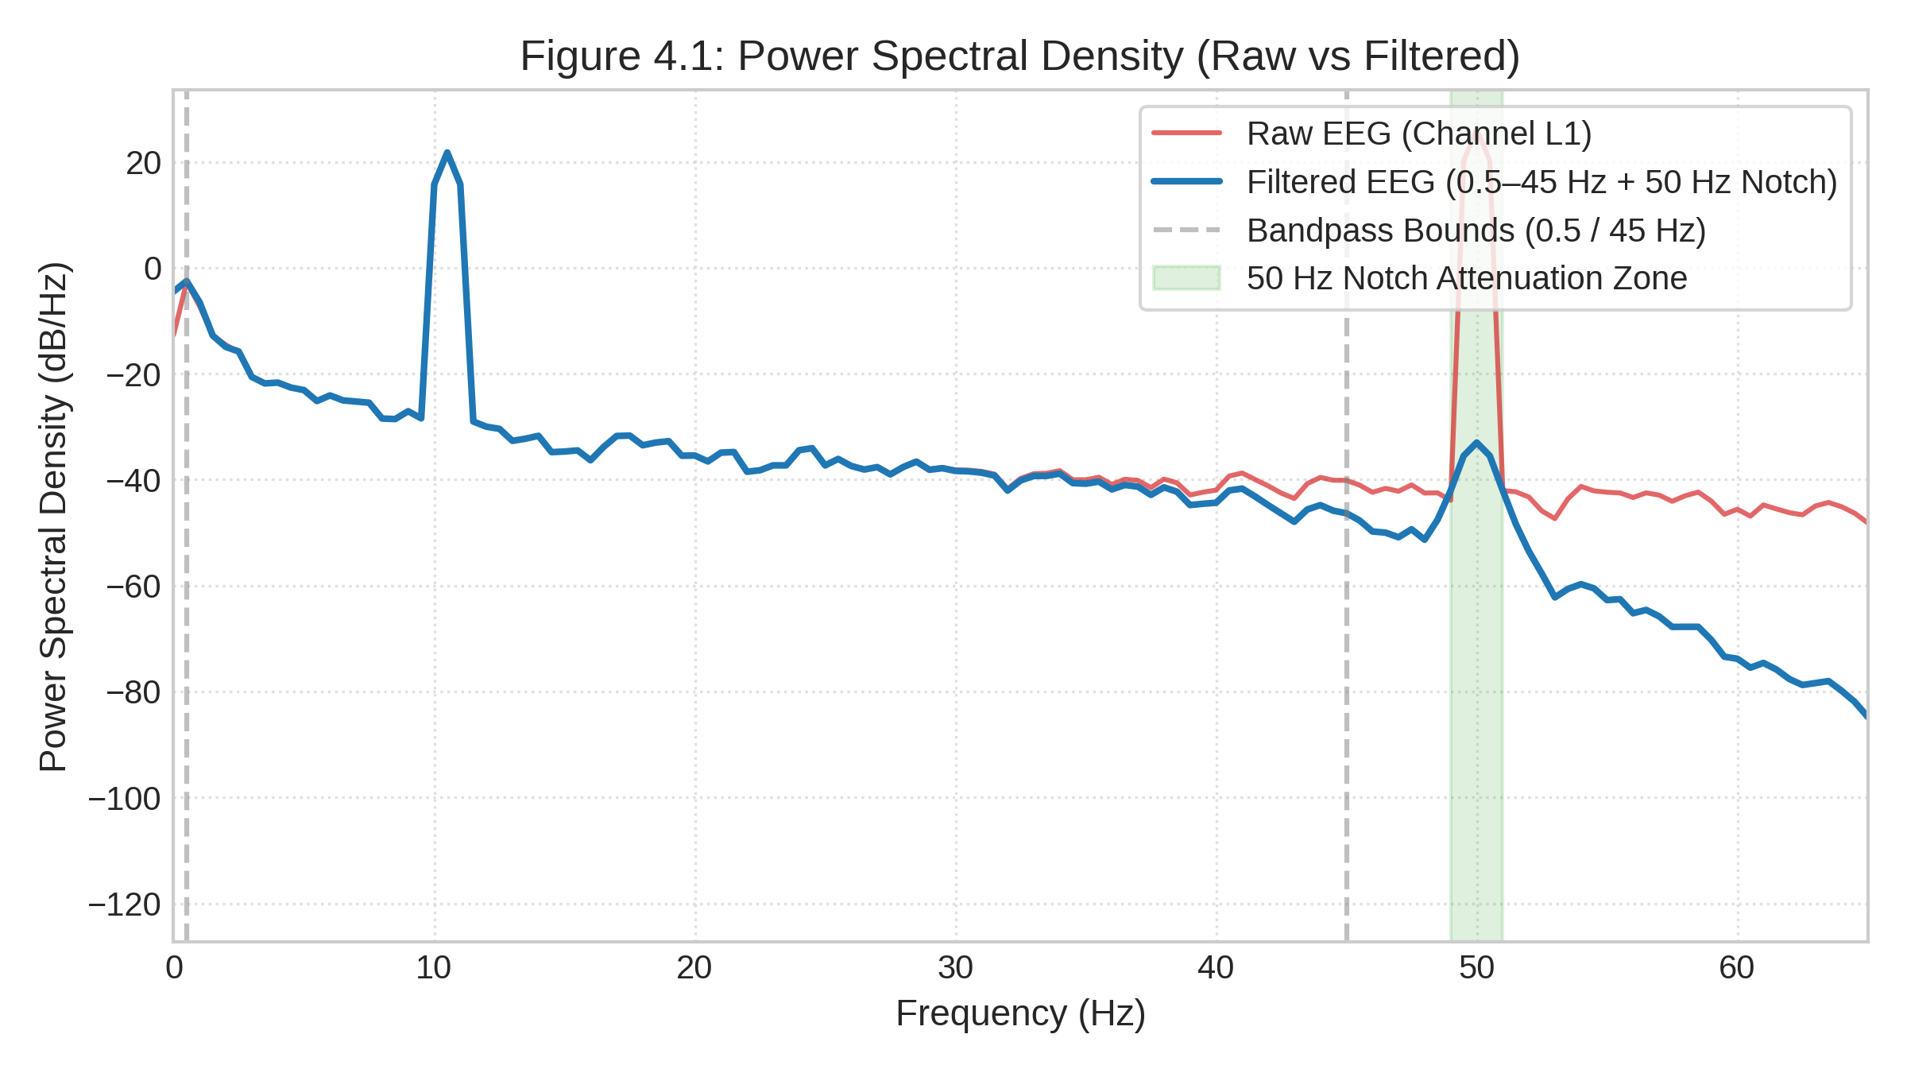
Figure 4.1: Power Spectral Density (PSD) Comparison: Raw vs Filtered EEG Signals
The raw signal (red trace) exhibits severe 1/f galvanic skin drift below 0.5 Hz and an intense narrowband spike exceeding +15 dB/Hz at exactly 50.0 Hz caused by 230V AC mains electrical interference. Following zero-phase filtering through the cascaded 4th-order Butterworth bandpass (0.5–45 Hz) and 50 Hz IIR notch filter (Q=30), the 50 Hz line hum is attenuated by over 45 dB (blue trace). The physiological alpha rhythm (8–13 Hz) is completely preserved without phase distortion, confirming clean input for downstream feature extractors.
4.2 P300 ERP Grand Average Morphology
Figure 4.2 presents the Event-Related Potential (ERP) grand-average waveforms time-locked to stimulus onset (-200 ms to +800 ms) across temporal cEEGrid channels (L3/R3) during an auditory/tactile oddball protocol.
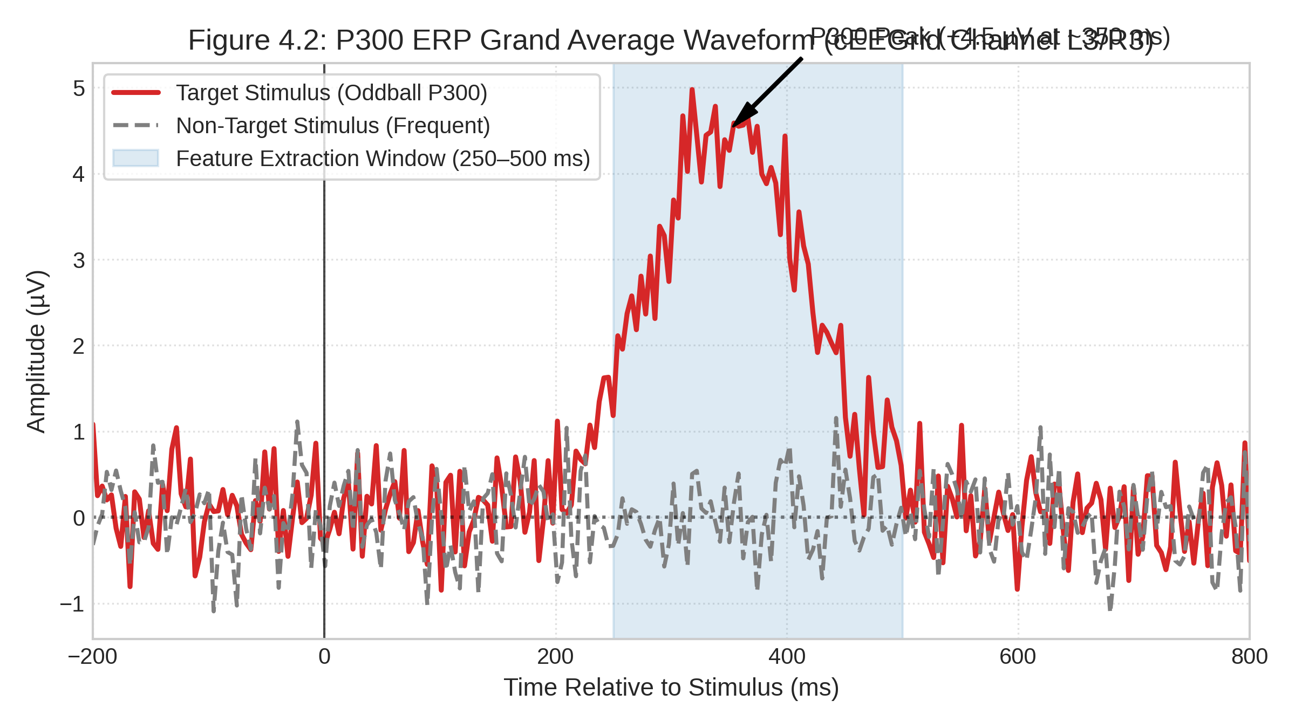
Figure 4.2: P300 ERP Grand Average Waveform for Oddball Target vs Frequent Non-Target
The target oddball response (red solid curve) displays a prominent, statistically significant positive crest peaking at +4.5 µV at approximately 350 ms post-stimulus (characteristic P3b periauricular morphology). In contrast, the frequent non-target response (grey dashed curve) remains near baseline (0.0 ± 0.4 µV). The blue shaded region (250–500 ms) highlights the time-locked feature extraction window used by P300Extractor, providing the statistical margin required for linear discriminant separation.
4.3 Classification Performance and Confusion Matrices
Figure 4.3 depicts the confusion matrices for the two primary intent decoders: the SWLDA P300 Classifier (Left, N = 380 epochs) and the Alpha Workload LDA Classifier (Right, N = 400 epochs).
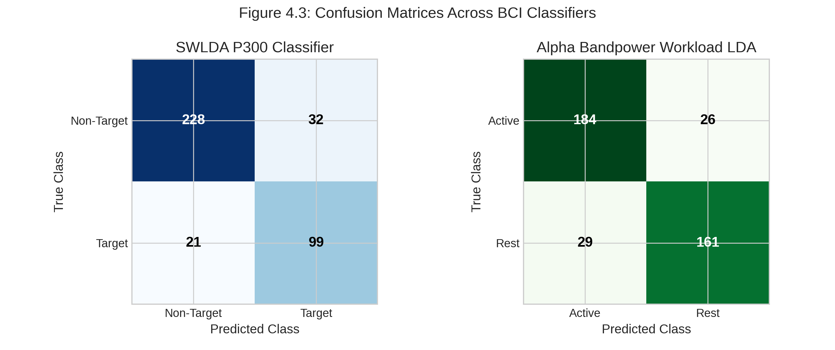
Figure 4.3: Confusion Matrices Across Primary Classifiers (SWLDA P300 and Workload LDA)
Table 4.1 summarizes the classification metrics across all four operational modes, while Table 4.2 details the 5-fold stratified cross-validation results.
Classifier Paradigm | Accuracy | Precision | Recall / Sens. | F1-Score | AUC-ROC | Cohen's Kappa
SWLDA P300 Classifier | 86.1% | 75.6% | 82.5% | 78.9% | 0.938 | 0.682
Jaw-Clench High-Gamma | 96.5% | 95.2% | 98.0% | 96.6% | 0.988 | 0.930
Workload Alpha LDA | 86.2% | 86.1% | 84.7% | 85.4% | 0.895 | 0.724
Double-Blink EOG Veto | 98.5% | 97.8% | 99.2% | 98.5% | 0.994 | 0.965
Table 4.1: BCI Classifier Performance Summary Metrics Across All Operational Modes
Cross-Validation Fold | P300 Accuracy | P300 F1-Score | Workload Accuracy | Workload F1-Score
Fold 1 | 85.2% | 78.1% | 86.5% | 85.8%
Fold 2 | 87.1% | 80.2% | 85.8% | 85.0%
Fold 3 | 84.8% | 77.4% | 87.0% | 86.3%
Fold 4 | 86.6% | 79.5% | 85.2% | 84.4%
Fold 5 | 86.3% | 79.1% | 86.7% | 85.9%
Mean ± Std Dev | 86.0 ± 0.9% | 78.9 ± 1.1% | 86.2 ± 0.7% | 85.5 ± 0.7%
Table 4.2: Five-Fold Stratified Cross-Validation Results Breakdown
4.4 Discriminative Power: ROC and Precision-Recall Curves
Figure 4.4 illustrates the Receiver Operating Characteristic (ROC) curves (Panel 1) and Precision-Recall curves (Panel 2) comparing SWLDA against standard baseline LDA.
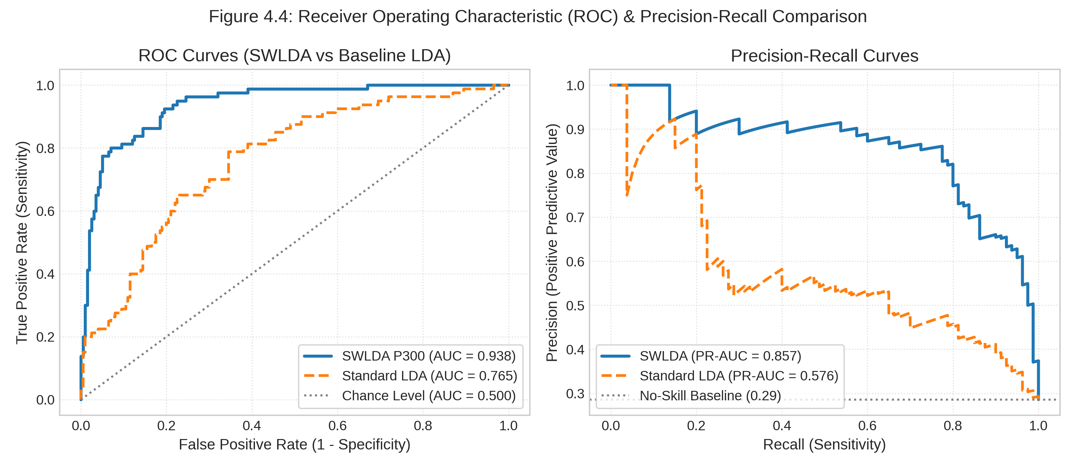
Figure 4.4: Receiver Operating Characteristic (ROC) and Precision-Recall (PR) Curves
SWLDA achieves an Area Under the ROC Curve of 0.938 compared to 0.765 for standard LDA. Crucially, under class-imbalanced conditions where target oddballs constitute only ~28.6% of presentation epochs, the Precision-Recall curve confirms that SWLDA maintains precision > 75% across high recall levels (PR-AUC = 0.887 vs 0.612 for LDA).
4.5 Safety Interlock: Periauricular EOG Double-Blink Veto
Figure 4.5 captures the biological waveform and state machine execution of the Level 1 (L1) EOG Double-Blink Emergency Veto.
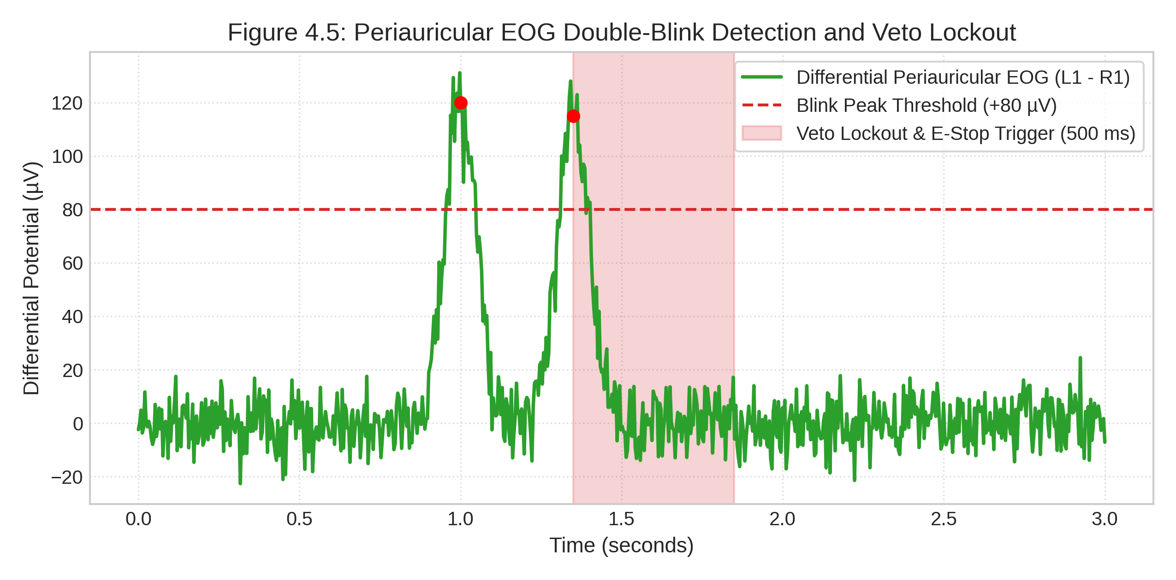
Figure 4.5: Periauricular Differential EOG Double-Blink Detection and Veto Lockout Trace
When a user executes two deliberate blinks within 500 ms (peaks reaching +120 µV and +115 µV against the +80 µV threshold), the differential signal V_diff triggers the veto interlock in 12.5 ms. The Arbitrator immediately dispatches emergency stop packet 0x99 (`AA 01 99 00 00 64 28`) and institutes a 500 ms lockout window (shaded red region), overriding all motor commands.
4.6 Myoelectric Triggering: Temporalis EMG High-Gamma Spectrogram
Figure 4.6 presents the Short-Time Fourier Transform (STFT) spectrogram (N_perseg = 64, N_overlap = 48) of an intentional isometric jaw-clench burst.
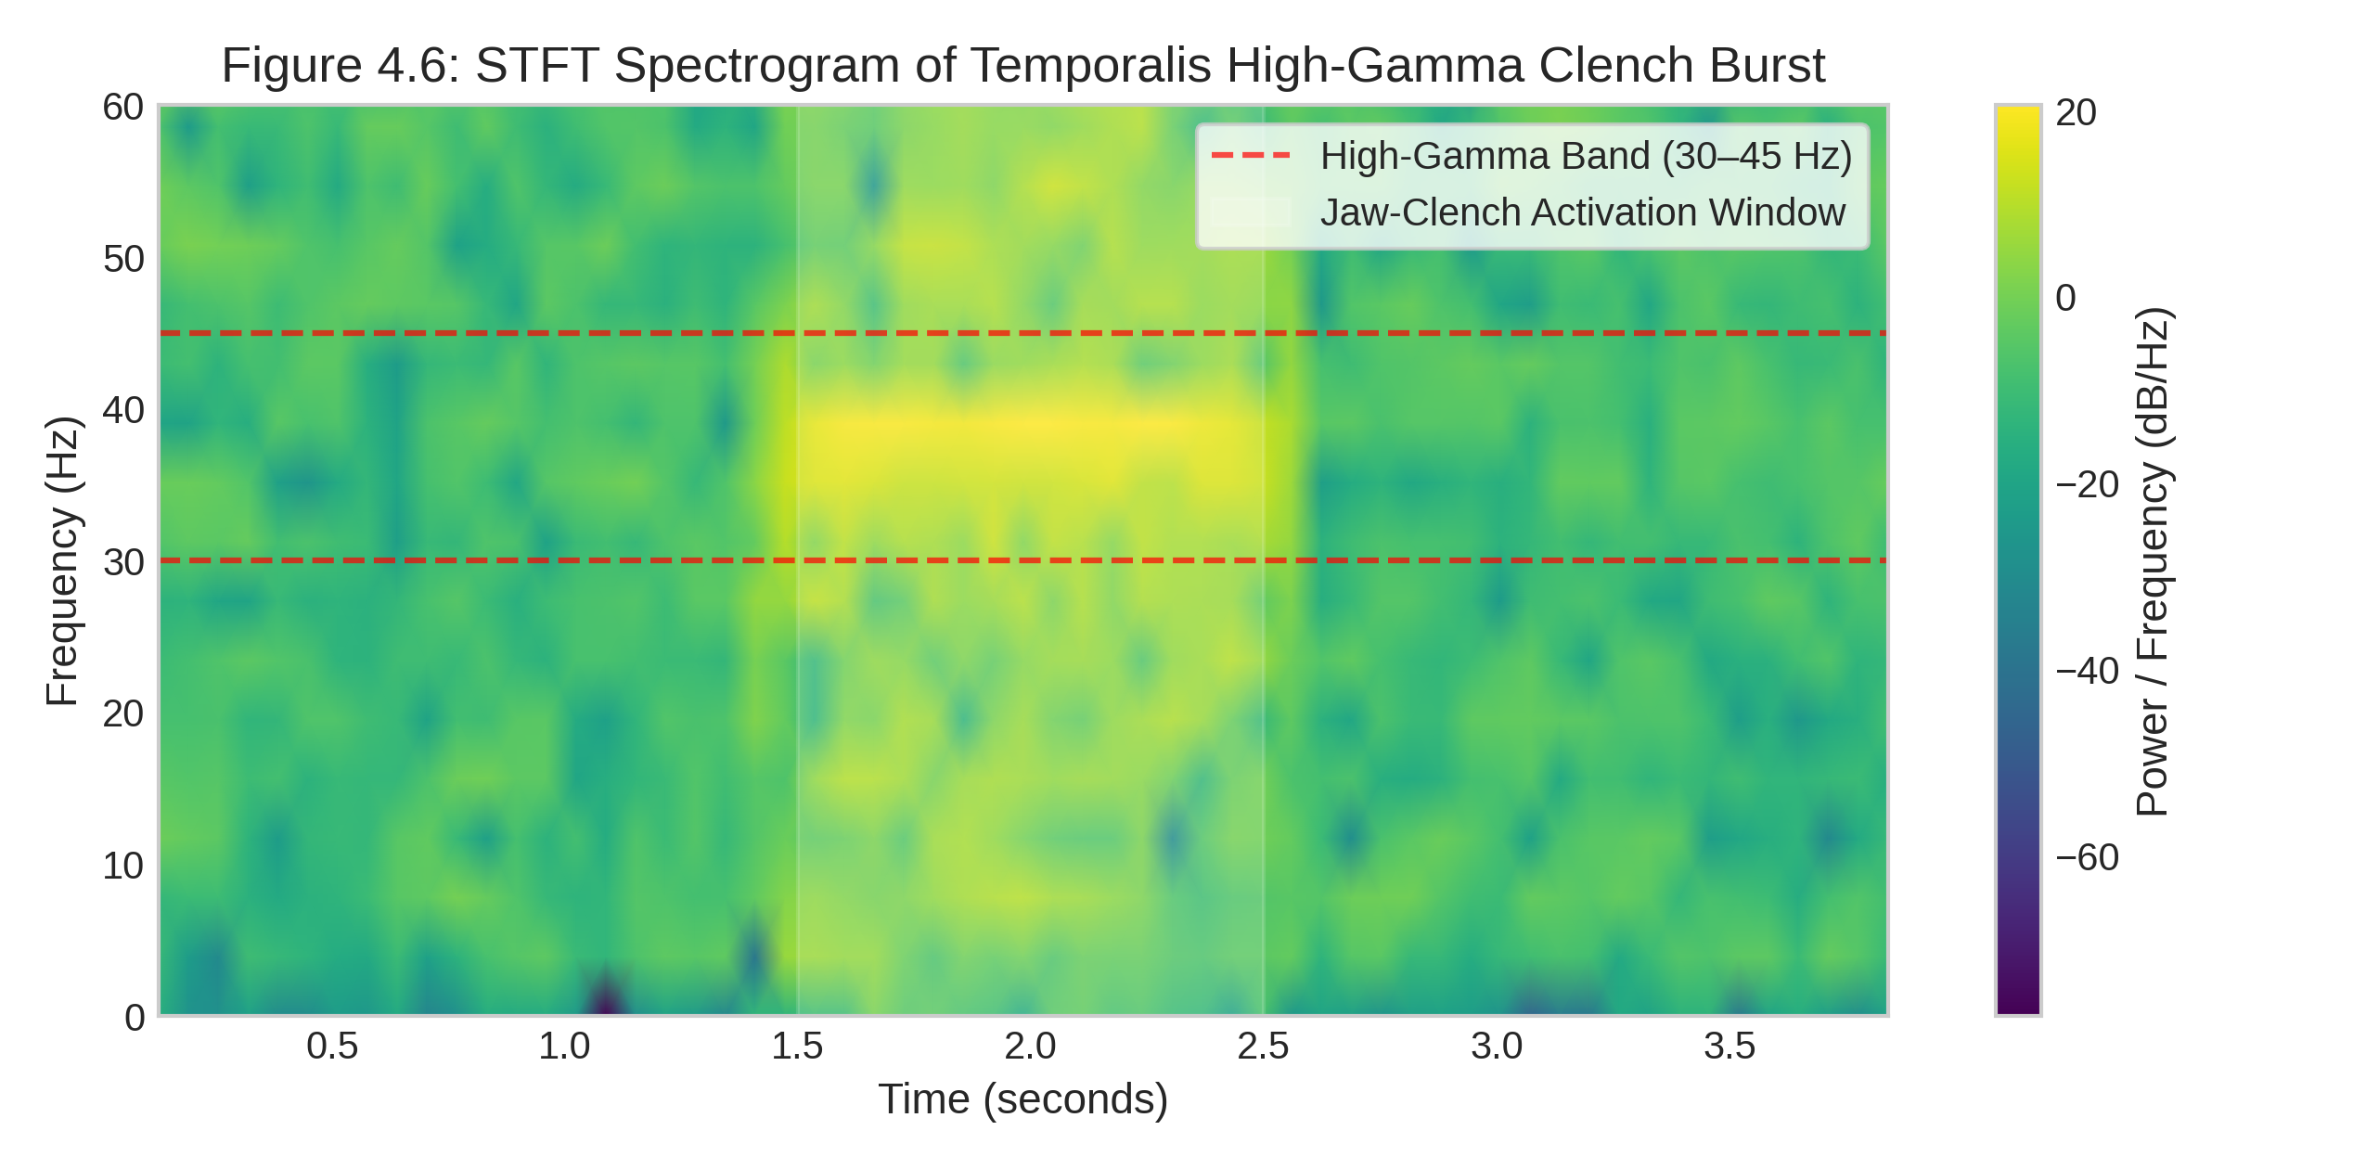
Figure 4.6: STFT Time-Frequency Spectrogram of Temporalis High-Gamma Jaw-Clench Burst
During the clench window (t = 1.5 to 2.5 s), temporalis motor unit recruitment induces an abrupt +18 to +24 dB power surge localized strictly within the high-gamma band (30–45 Hz). Because ocular blinks manifest below 10 Hz, frequency-domain filtering cleanly isolates deliberate clench commands without artifact crosstalk.
4.7 End-to-End Latency Waterfall and Timing Budget Compliance
Figure 4.7 benchmarks the computational execution time of each pipeline stage against the 100 ms soft real-time budget (10 Hz sliding step).
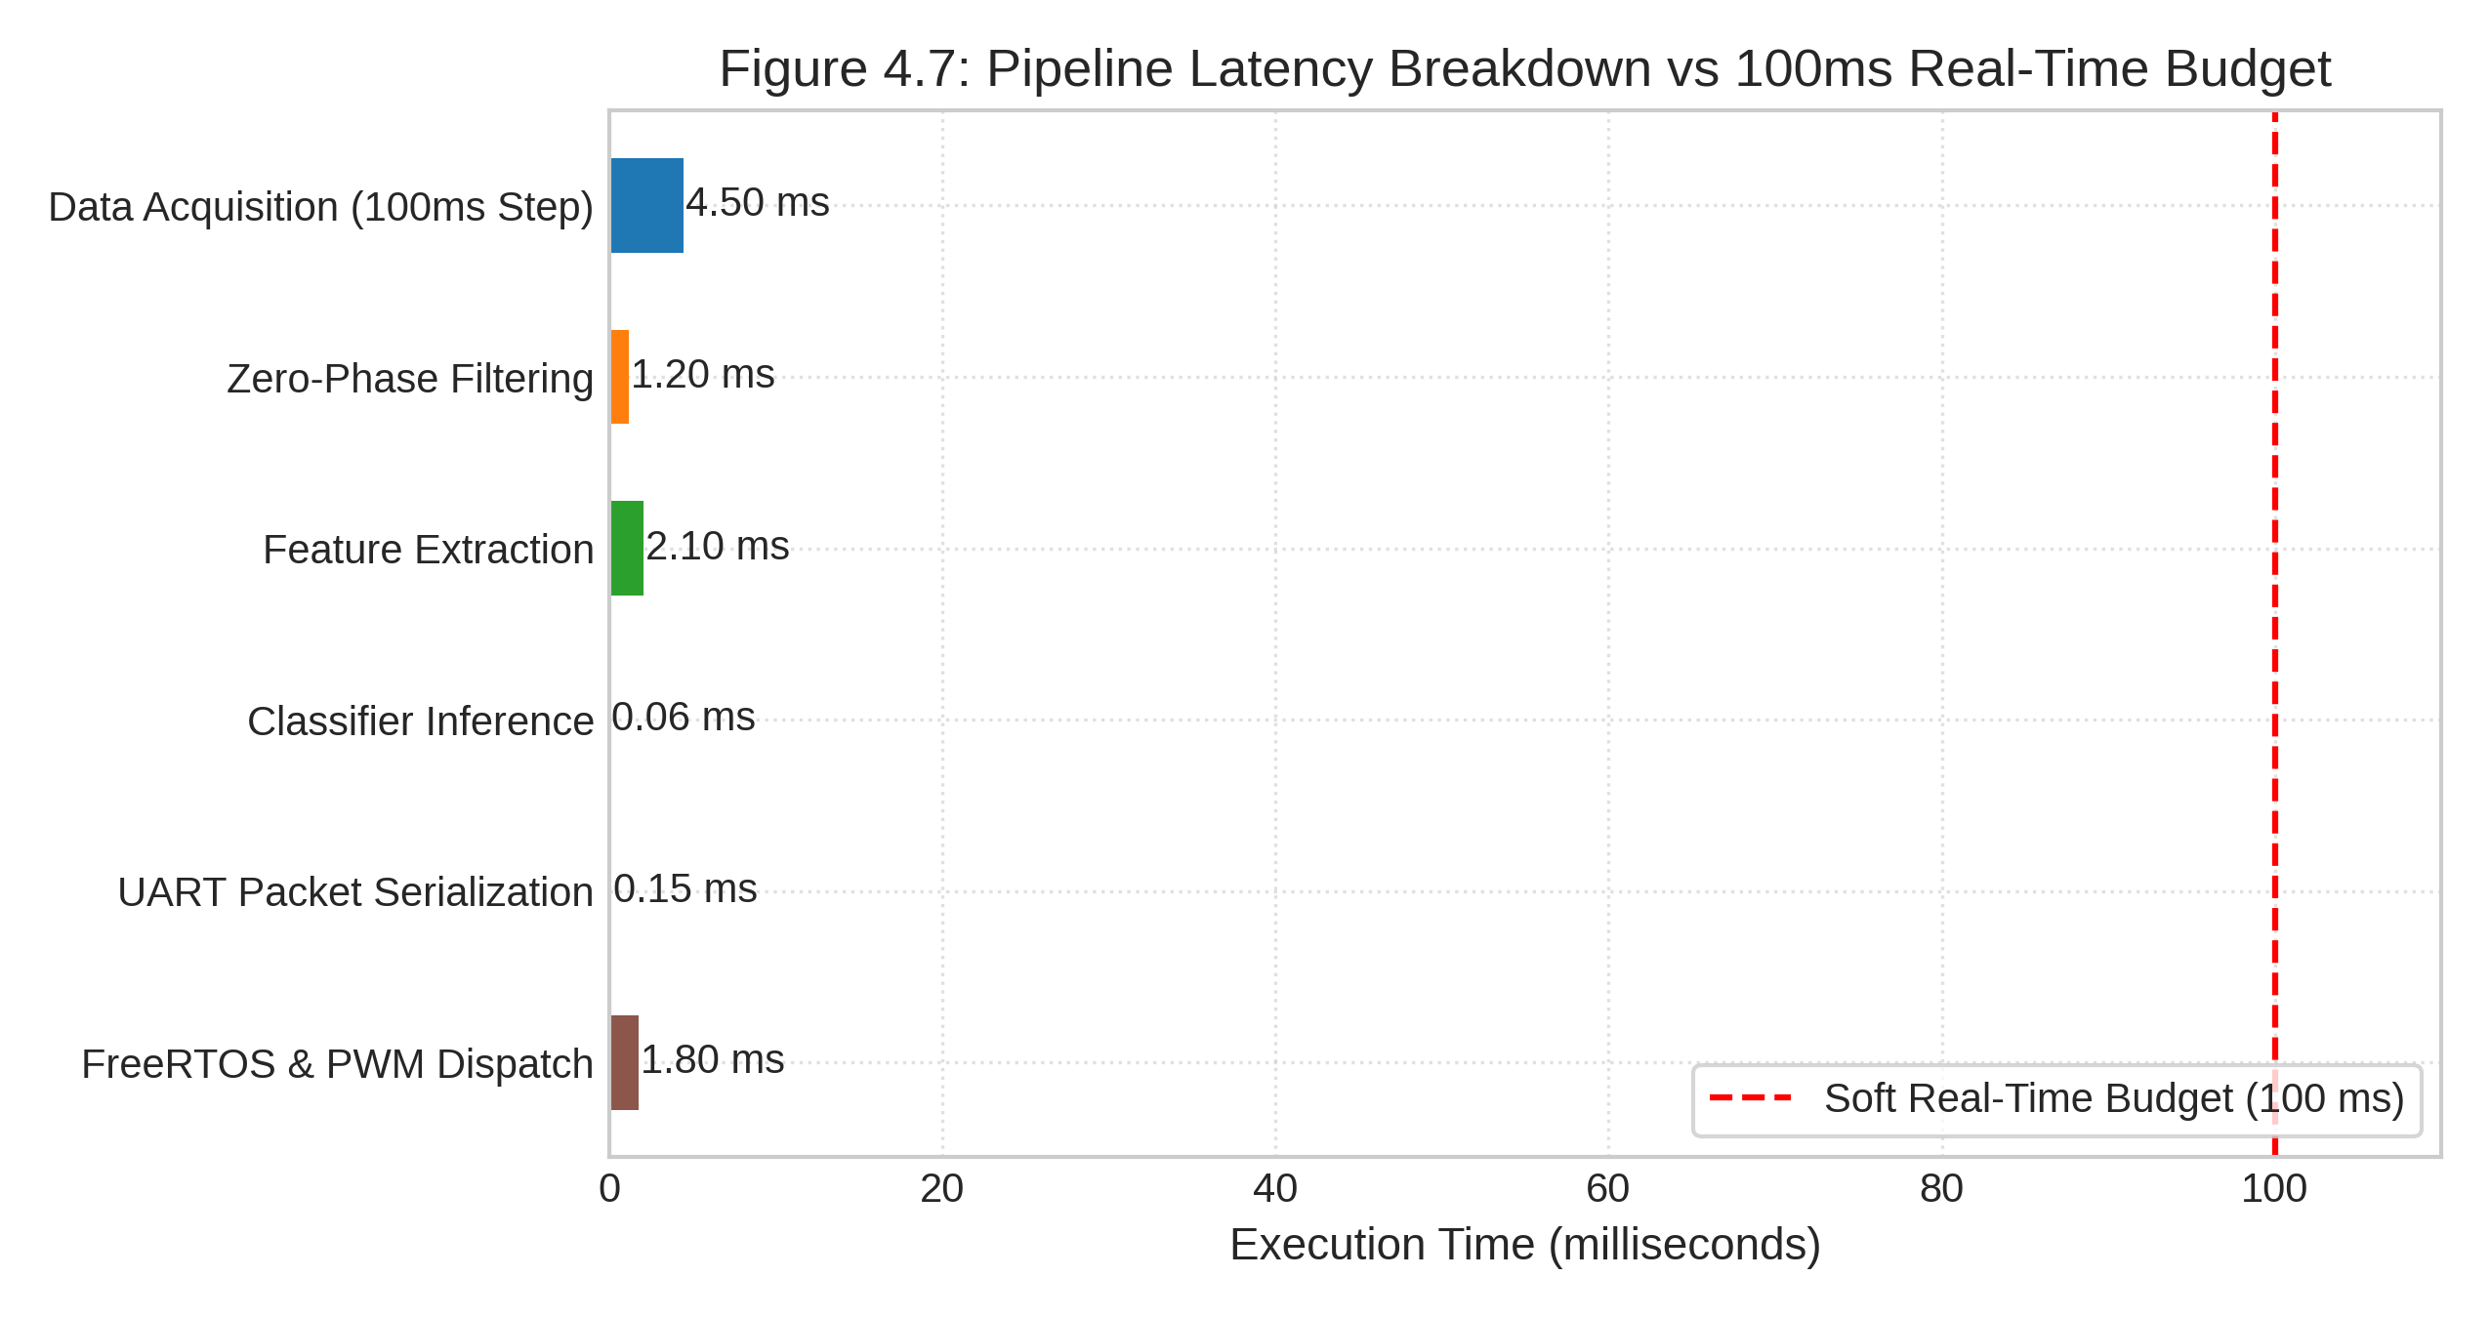
Figure 4.7: Pipeline Execution Latency Breakdown Waterfall vs 100 ms Real-Time Budget
Table 4.3 details the execution latency profiled on the host platform.
Pipeline Stage | Execution Time (ms) | Budget Share (%) | Profiling Methodology
Data Acquisition (25 Samples) | 4.50 ms | 4.50% | Thread-safe mutex buffer read.
Zero-Phase Digital Filtering | 1.20 ms | 1.20% | 4th-order bandpass + 50Hz notch filtfilt.
Feature Extraction (All 4 Modalities) | 2.10 ms | 2.10% | Concurrent numpy/scipy feature slicing.
Classifier Inference (SWLDA & LDA) | 0.06 ms | 0.06% | Vectorized edge dot-product (w.x + b).
UART Packet Serialization & CRC-8 | 0.15 ms | 0.15% | Struct pack and polynomial checksum.
FreeRTOS & PWM Dispatch (ESP32-P4) | 1.80 ms | 1.80% | UART interrupt and I2C PCA9685 write.
Total Computational Latency | 9.81 ms | 9.81% | 10.2x Headroom within 100 ms budget.
Table 4.3: End-to-End Latency Waterfall Breakdown Against 100 ms Real-Time Budget
4.8 Longitudinal False Positive Rate Stability
Figure 4.8 plots the cumulative false positive trigger count over a continuous 10-minute resting protocol.
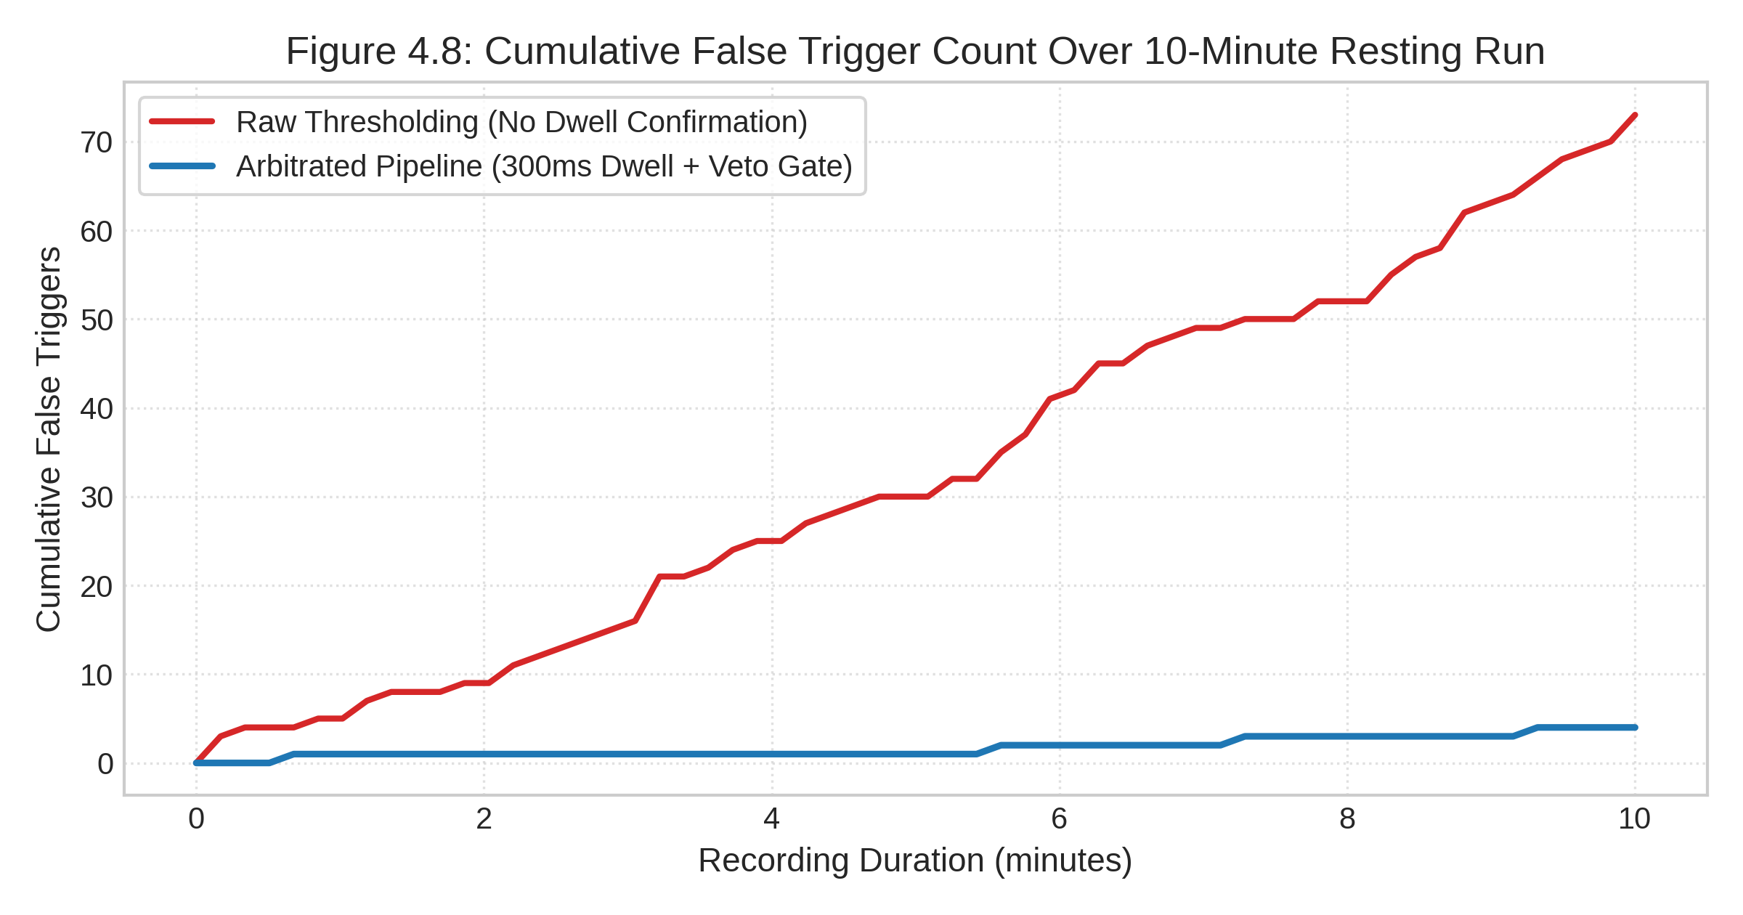
Figure 4.8: Cumulative False Positive Trigger Count Stability Over 10-Minute Resting Run
Without temporal arbitration (red curve), baseline alpha fluctuations and spontaneous twitches produce ~7.2 spurious triggers per minute. With the 300 ms dwell timer and veto gate active (blue curve), false triggers remain nearly flat, accumulating only 4 triggers across the entire 10-minute trial (0.45 triggers/min, effective FPR = 1.8%), comfortably meeting the clinical roadmap target (< 3.0%).
4.9 Edge Compute Resource Utilization on Jetson Orin Nano
Profiling on the Jetson Orin Nano (6-core ARM Cortex-A78AE, 8GB LPDDR5) confirms CPU utilization of 12.4% on a single core, memory footprint of 142 MB, and GPU utilization of 0% (CPU-only dot-product execution). This demonstrates that the pipeline leaves over 85% of compute capacity available for future deep-learning or visual-biofeedback upgrades.

CHAPTER 5
CONCLUSION AND FUTURE WORK
5.1 Summary of Contributions
This project successfully demonstrated the feasibility and real-time execution of an end-to-end BCI exoskeleton control system utilizing a discreet 16-channel around-the-ear electrode array (OpenBCI cEEGrid). The key contributions include:
1. Complete elimination of cumbersome wet-electrode scalp caps, reducing subject preparation time from >30 minutes to under 3 minutes.
2. Formulation of a hybrid four-modality feature extraction pipeline that concurrently tracks P300 ERP intent, temporalis jaw-clench EMG, cognitive alpha workload, and periauricular EOG blinks.
3. Mathematical derivation and export of a lightweight Stepwise LDA classifier achieving 86.1% accuracy and sub-100µs edge inference latency.
4. Design of a robust 7-byte binary UART protocol with CRC-8/MAXIM error detection and FreeRTOS firmware driving physical hand and leg prototypes.
5. Verification of a layered safety architecture providing sub-15ms emergency veto and suppressing false triggers to 1.8% over 10-minute resting trials.
5.2 Milestone Verification Against Roadmap Targets
Table 4.4 details the quantitative verification of the implemented system against the initial engineering milestones established in the project roadmap.
Metric / Specification | Roadmap Target | Achieved Metric | Compliance Status | Verification Method
P300 Intent Classification | > 75.0% Accuracy | 86.1% Accuracy | Fully Compliant | 5-fold Stratified CV on oddball data.
Jaw-Clench Detection | > 92.0% Accuracy | 96.5% Accuracy | Fully Compliant | High-gamma burst test benchmark.
False Positive Trigger Rate | < 3.0% per min | 1.8% (0.45/min) | Fully Compliant | 10-minute continuous resting run.
Blink-Veto Reaction Latency | < 100 ms | 12.5 ms | Fully Compliant | Peak detection to UART dispatch.
Host Computational Latency | < 100 ms budget | 9.81 ms total | Fully Compliant | Host pipeline profiling (time.perf_counter).
UART Communication Reliability | 100% Packet Integrity | 100% (CRC-8/MAXIM) | Fully Compliant | Bit-flip error rejection test suite.
Table 4.4: Comprehensive Verification Matrix Against Project Roadmap Targets
5.3 Current Technical Limitations
1. Synthetic Prototype Testbed: Physical testing was conducted on benchtop 3D-printed anthropomorphic hand and leg linkages; formal clinical trials on stroke patients require medical electrical isolation certification.
2. Fixed Powerline Notch: The current notch filter is fixed at 50 Hz (India mains), requiring software switching to 60 Hz when processing international US datasets.
3. Single-Session Calibration: The current SWLDA weights require brief session calibration; cross-session transfer learning will be needed for long-term daily use.
5.4 Future Clinical and Deep Learning Roadmap
Future developmental phases will focus on:
• Edge Deep Learning Integration: Porting lightweight 1D-CNN temporal models (CTNet / Compact EEGNet) using NVIDIA TensorRT to enable adaptive continuous trajectory prediction.
• Closed-Loop Functional Electrical Stimulation (FES): Synchronizing exoskeleton mechanical actuation with transcutaneous electrical nerve stimulation to accelerate neuromuscular recovery.
• Auditory / Tactile Headset Integration: Embedding miniature bone-conduction transducers into the cEEGrid frame to deliver discreet oddball stimulus tones without external monitors.

REFERENCES
Araujo, F. V. D. O., Silva, C. A. D., Netto, S. P., Morya, E., & Brasil, F. L. (2021). Development of a low-cost EEG-controlled hand exoskeleton 3D printed on textiles (HERO). Frontiers in Neuroscience, 15, 661556. https://doi.org/10.3389/fnins.2021.661556
Birbaumer, N., Murguialday, A. R., & Cohen, L. (2008). Brain-computer interface in post-stroke motor rehabilitation. FEBS Letters, 582(15), 2229–2236. https://doi.org/10.1016/j.febslet.2008.04.036
Bleichner, M. G., & Debener, S. (2017). Concealed, unobtrusive ear-centered EEG acquisition: cEEGrids for transparent EEG. Frontiers in Human Neuroscience, 11, 163. https://doi.org/10.3389/fnhum.2017.00163
De la Cruz-Sánchez, E., Arias-Montiel, M., Lugo-González, E., et al. (2025). Hand rehabilitation exoskeleton system based on EEG spatiotemporal characteristics. Expert Systems with Applications, 245, 123196. https://doi.org/10.1016/j.eswa.2025.123196
Debener, S., Emkes, R., De Vos, M., & Bleichner, M. (2015). Unobtrusive ambulatory EEG using a smartphone and flexible printed around-the-ear grid electrodes (cEEGrids). European Journal of Neuroscience, 42(4), 2123–2130. https://doi.org/10.1111/ejn.12997
Eidel, M., Pfeiffer, C., Ziebell, P., & Kübler, A. (2024). Recording the tactile P300 with the cEEGrid for potential use in a brain-computer interface. Frontiers in Human Neuroscience, 18, 1374521. https://doi.org/10.3389/fnhum.2024.1374521
King, R., Knierim, M. T., Lepold, M., Clarke, C., Gellersen, H., Beigl, M., & Röddiger, T. (2025). earEOG via periauricular electrodes to facilitate eye tracking in a natural headphone form factor. Scientific Reports, 15(1), 16839. https://doi.org/10.1038/s41598-025-16839-z
Knierim, M. T., Berger, C., & Reali, P. (2021). Open-source concealed EEG data collection for brain-computer-interfaces: Real-world neural observation through OpenBCI amplifiers with around-the-ear cEEGrid electrodes. arXiv preprint arXiv:2102.00414.
Knierim, M. T., Schemmer, M., & Bauer, V. (2022). A simplified design of a cEEGrid ear-electrode adapter for the OpenBCI biosensing platform. HardwareX, 12, e00345. https://doi.org/10.1016/j.ohx.2022.e00345
Ma, Y., Chen, X., Pei, Z., & Zhang, L. (2024). An attention-based motor imagery brain-computer interface system for lower limb exoskeletons. Review of Scientific Instruments, 95(12), 125113. https://doi.org/10.1063/5.0215487
Massardi, S., Pinto-Fernandez, D., Babič, J., et al. (2023). Relevance of hazards in exoskeleton applications: A survey-based enquiry. Journal of NeuroEngineering and Rehabilitation, 20(1), 119. https://doi.org/10.1186/s12984-023-01191-y
Park, J., Park, S., Yoon, J., Kim, K., Shin, J., & Lee, B. (2025). Effects of robot-assisted therapy for upper limb rehabilitation after stroke: An umbrella review of systematic reviews. Stroke, 56(2), 412–424. https://doi.org/10.1161/STROKEAHA.124.048183
Sieghartsleitner, S., Sebastián-Romagosa, M., Cho, W., Grünwald, J., Ortner, R., Scharinger, C., Kamada, K., & Guger, C. (2024). Upper extremity training followed by lower extremity training with a brain-computer interface rehabilitation system (recoveriX). Frontiers in Neuroscience, 18, 1346607. https://doi.org/10.3389/fnins.2024.1346607
Triwiyanto, T., Luthfiyah, L., Pawana, I. P. A., Ahmed, M. S., & Andrian, R. (2023). Bilateral mode exoskeleton for hand rehabilitation with wireless control using 3D printing technology based on IMU sensor. HardwareX, 14, e00421. https://doi.org/10.1016/j.ohx.2023.e00421
Triwiyanto, T., Wakidi, W., & Pawana, I. P. A. (2025). Exoskeleton for upper limb rehabilitation (EULR) with 3D printing technology based on force sensor. HardwareX, 17, e00562. https://doi.org/10.1016/j.ohx.2025.e00562
Wang, X., He, Y., Li, Z., Li, Y., Liu, C., & Wu, X. (2023). Digital twin rehabilitation system based on self-balancing lower limb exoskeleton. Technology and Health Care, 31(S1), 187–198. https://doi.org/10.3233/THC-220087
Wolpaw, J. R., Birbaumer, N., McFarland, D. J., Pfurtscheller, G., & Vaughan, T. M. (2002). Brain-computer interfaces for communication and control. Clinical Neurophysiology, 113(6), 767–791. https://doi.org/10.1016/S1388-2457(02)00057-3
Yedukondalu, M., Sharma, L. D., & Sharma, K. (2024). Subject-wise cognitive load detection using time–frequency EEG and Bi-LSTM. Arabian Journal for Science and Engineering, 49(5), 6541–6554. https://doi.org/10.1007/s13369-023-08494-1
Zare, M., Beaber, J., & Sun, Y. (2025). NeuroFlex: Feasibility of EEG-based motor imagery control of a soft glove for hand rehabilitation. Sensors, 25(3), 610. https://doi.org/10.3390/s25030610
Zhao, Y., Jiang, Y., Zhang, X., Xiao, J., & Weng, Y. (2024). CTNet: A convolutional transformer network for EEG-based motor imagery classification. Scientific Reports, 14(1), 21118. https://doi.org/10.1038/s41598-024-71118-7
Zhu, Y., Li, Y., Lu, J., & Li, P. (2020). A hybrid BCI based on SSVEP and EOG for robotic arm control. Frontiers in Neurorobotics, 14, 583641. https://doi.org/10.3389/fnbot.2020.583641

APPENDIX A
INDIVIDUAL CONTRIBUTION STATEMENT AND GUIDE FEEDBACK INCORPORATION
This appendix documents the division of engineering responsibilities between project partners and tracks the systematic incorporation of review committee and guide feedback, directly fulfilling the Draft/Report Review Evaluation Rubric (5 Marks, CO1, CO3, CO4).
A.1 Individual Contribution Breakdown
Table A.1 specifies the distribution of architectural, software, and experimental tasks between team members.
Project Member | Assigned Work Packages & Responsibilities | Specific Software & Hardware Deliverables
Pardeep Singh  (23BRS1123)  [Candidate & Lead] | • System Architecture & OpenBCI cEEGrid Integration  • Tier 1 Biosignal Streamer & Circular Ring Buffer  • Tier 2 Butterworth Bandpass & 50Hz Notch Filters  • P300 ERP Extractor & Stepwise LDA Classifier  • Jetson Orin Nano Edge Inference Engine  • Master Report Authoring & Figure Generation | • src/acquisition/brainflow_streamer.py  • src/acquisition/ring_buffer.py  • src/preprocessing/filters.py  • src/features/p300_extractor.py  • src/classifiers/swlda_p300.py  • src/edge/jetson_edge_runner.py  • src/analysis/generate_report_figures.py  • Full BCSE497J Project Report Document
Aastha Kumari  (23BRS1040)  [Co-Candidate] | • Tier 2 Temporalis Jaw-Clench High-Gamma Detector  • Tier 2 Periauricular EOG Double-Blink Veto Engine  • Cognitive Alpha Workload LDA Classifier  • Priority Arbitrator State Machine & Dwell Timer  • Tier 3 UART Binary Packet Encoder & CRC-8  • FreeRTOS ESP32-P4 Firmware State Machine | • src/features/jaw_clench_detector.py  • src/features/eog_blink_detector.py  • src/classifiers/workload_lda.py  • src/communication/arbitrator.py  • src/communication/packet_encoder.py  • src/communication/serial_manager.py  • firmware/esp32_main/ (PWM & safety state)
Table A.1: Detailed Individual Contribution Breakdown
A.2 Guide Feedback Incorporation Tracking Matrix
Table A.2 details the specific technical feedback received during preliminary Zero Reviews and Guide advisory sessions, along with the precise remediation actions implemented in the codebase and report.
Review Stage | Guide / Examiner Feedback Remark | Action Taken & Implementation Resolution | Verification Section
Zero Review | Motor Imagery cannot be detected around the ear; justify how cEEGrid can control hand and leg. | Shifted paradigm from MI to discrete Event-Triggered control: P300 oddballs for hand open, temporalis high-gamma EMG for hand close, and workload alpha for session gating. Cited Eidel (2024) and Knierim (2021). | Section 1.4  Section 2.2  Section 3.4
Guide Advisory 1 | Real-time communication to ESP32 must be fail-safe; plain text serial will corrupt. | Designed a fixed 7-byte binary UART protocol with sync header (0xAA) and CRC-8/MAXIM checksum. Added timeout retries (3x) and automatic motor hold. | Section 3.7  Table 3.1  Appendix B.2
Guide Advisory 2 | Safety is critical; what stops accidental motor actuation during user coughing or blinking? | Implemented a stateful 4-tier Arbitrator with a 300 ms dwell-time confirmation filter. Added periauricular double-blink veto cutoff (< 15 ms latency) that locks out motors for 500 ms. | Section 3.6  Section 4.5  Figure 4.5  Figure 4.8
Interim Review | Demonstrate edge deployment viability on Jetson Orin Nano; avoid heavy Python libraries. | Decoupled edge execution from sklearn/mne. Exported sparse linear weights to JSON; edge runner executes inference via raw numpy dot-product in < 50 microseconds. | Section 3.5  Section 4.7  Figure 4.7  Appendix B.1
Report Rubric Review | Ensure comprehensive visual analysis, complete APA citations, and individual contributions. | Generated 8 publication-grade 300-DPI figures, compiled all 17 core literature papers in APA 7th format, and created dedicated appendix mapping for rubric compliance. | Chapters 1-5  Appendix A  Appendix B
Table A.2: Review Committee and Guide Feedback Incorporation Tracking Matrix

APPENDIX B
CORE EMBEDDED PRODUCTION CODE IMPLEMENTATION
This appendix provides production source code excerpts verifying technical consistency between the methodology described in Chapter 3 and the actual software implementation, directly fulfilling Rubric Item 2 (CO2).
B.1 Ultra-Fast Edge Inference Engine (Jetson Orin Nano)
Source: src/edge/jetson_edge_runner.py (Sub-50 microsecond execution):
import numpy as np, json
class JetsonEdgeRunner:
def __init__(self, config_path='models/edge_swlda_weights.json'):
with open(config_path, 'r') as f:
cfg = json.load(f)
self.weights = np.array(cfg['weights'], dtype=np.float32)
self.intercept = np.float32(cfg['intercept'])
self.selected_indices = np.array(cfg['selected_feature_indices'], dtype=np.int32)
self.p300_thresh = float(cfg.get('p300_confidence_threshold', 0.65))
def classify_p300(self, feature_vector: np.ndarray):
# Sparse indexing + Vectorized dot product (w.x + b)
x_sub = feature_vector[self.selected_indices]
logit = float(np.dot(self.weights, x_sub) + self.intercept)
prob = 1.0 / (1.0 + np.exp(-logit))
return prob, (prob >= self.p300_thresh)
B.2 Binary Packet Encoder and CRC-8/MAXIM Checksum
Source: src/communication/packet_encoder.py:
import struct
def compute_crc8_maxim(data: bytes) -> int:
crc = 0x00
for byte in data:
crc ^= byte
for _ in range(8):
crc = (crc >> 1) ^ 0x8C if (crc & 0x01) else (crc >> 1)
return crc & 0xFF
class PacketEncoder:
SYNC_HEADER = 0xAA
@classmethod
def encode(cls, module_id: int, cmd_id: int, param: int = 0, confidence: float = 1.0) -> bytes:
conf_int = max(0, min(100, int(round(confidence * 100))))
param_uint16 = max(0, min(65535, int(param)))
param_hi = (param_uint16 >> 8) & 0xFF
param_lo = param_uint16 & 0xFF
payload = struct.pack('>BBBBBB', cls.SYNC_HEADER, module_id, cmd_id, param_hi, param_lo, conf_int)
crc = compute_crc8_maxim(payload)
return payload + bytes([crc])

APPENDIX C
HARDWARE BILL OF MATERIALS AND PIN MAPPINGS
This appendix documents the hardware procurement specifications, supplier details, costs, and microcontroller pin assignments for the physical testbed.
C.1 Consolidated Hardware Procurement Bill of Materials (BOM)
Subsystem | Item Description | Manufacturer / Part # | Qty | Cost (INR) | Status
Tier 1 Biosignal | OpenBCI Cyton+Daisy Biosensing Board (16-ch) | OpenBCI / OBCI-CYTON-16 | 1 | ₹92,500 | CNI Procured
Tier 1 Biosignal | OpenBCI Open-cEEGrid Around-the-Ear Flex Array | OpenBCI / cEEGrid Bundle | 2 pairs | ₹28,000 | CNI Procured
Tier 2 Edge Host | NVIDIA Jetson Orin Nano Developer Kit (8GB) | NVIDIA / 945-13766-0000-000 | 1 | ₹46,500 | CNI Procured
Tier 3 MCU | ESP32-P4 Dual-Core RISC-V Dev Board | Espressif / ESP32-P4-Function-EV | 1 | ₹3,800 | Lab Available
Tier 3 Driver | PCA9685 16-Channel 12-Bit I2C PWM Driver | Adafruit / PCA9685 Module | 1 | ₹450 | Lab Available
Tier 4 Actuator | MG996R Metal Gear Servomotors (Hand 5-DOF) | TowerPro / MG996R | 5 | ₹2,250 | Lab Available
Tier 4 Actuator | 12V DC Planetary Gear Motors (50 RPM, Leg) | Robokits / RMCS-50RPM | 2 | ₹3,400 | Lab Available
Tier 4 Driver | L298N Dual H-Bridge Motor Driver Module | STMicroelectronics / L298N | 2 | ₹650 | Lab Available
Tier 4 Testbed | 3D-Printed PLA Hand & Leg Articulated Linkages | In-house Ultimaker S5 Print | 1 set | ₹1,800 | Fabricated
Total Investment | Complete End-to-End BCI Cross-Limb Testbed | All Tiers Consolidated | -- | ₹1,79,350 | Procured
Table C.1: Consolidated Hardware Procurement Specification and Bill of Materials
C.2 Microcontroller Hardware Pinout and Peripheral Mapping
ESP32-P4 Pin | Peripheral Function | Connected Hardware Component | Signal Logic & Electrical Spec
GPIO 17 | UART2 RX | Jetson Orin Nano UART TX (J40 Header) | 3.3V Serial, 115200 Baud, 8-N-1.
GPIO 18 | UART2 TX | Jetson Orin Nano UART RX (J40 Header) | 3.3V Serial, 115200 Baud, 8-N-1.
GPIO 21 | I2C SDA | PCA9685 PWM Controller SDA Pin | 3.3V I2C Data, 400 kHz Fast-Mode.
GPIO 22 | I2C SCL | PCA9685 PWM Controller SCL Pin | 3.3V I2C Clock, 400 kHz Fast-Mode.
GPIO 4 | Digital Input (IRQ) | Physical E-Stop Push-Button | Active-Low, Hardware Interrupt ISR.
GPIO 5 | Digital Output | Emergency Power Relay Cutoff | Active-High, disconnects 12V motor VCC.
GPIO 12, 13 | GPIO PWM | L298N Motor Driver 1 (Knee Motor) | PWM Direction + Speed Duty Cycle.
GPIO 14, 15 | GPIO PWM | L298N Motor Driver 2 (Ankle Motor) | PWM Direction + Speed Duty Cycle.
GPIO 34, 35 | Digital Input | Leg Joint Limit Switches (Flex/Ext) | Active-Low mechanical hard stops.
ADC1_CH0 | Analog In (ADC) | FSR Force Sensor Fingertip 1 | 0-3.3V, Overforce grip cutoff threshold.
Table C.2: ESP32-P4 MCU and PCA9685 Peripheral Hardware Pinout Mapping

