**REPORT**

**CONFIGURATION USED:**

* APACHE 2.4
* PHP 7.3
* MYSQL 8.0

**OUTPUT:**

HTML FORM:

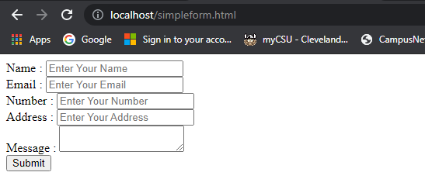

VALID FORM ENTRY:

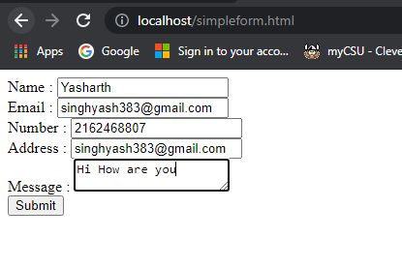

VALIDATION MESSAGE:

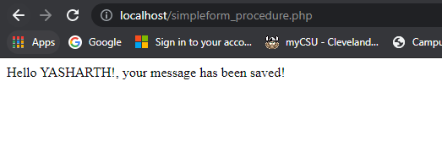

EMAIL CHECK:

Incorrect e-mail:

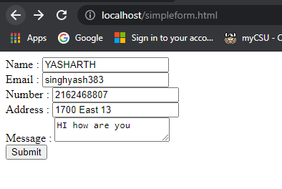

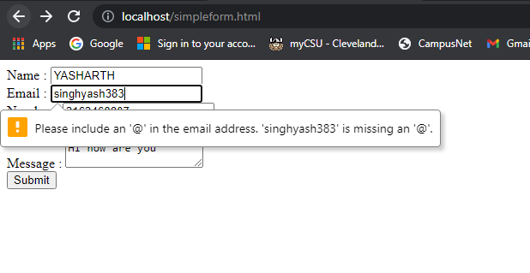

Incorrect phone:

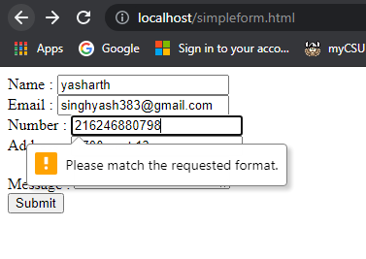

DATABASE SNAPSHOT:

