**JAVA PROJECT REPORT**

(Project Term January-May 2023)

## INGENIOUS CONSTRUCTION OF CUISINES

Submitted by

**Name: Pranjal Singh Registration Number: 12104223**

**CSE 310**

Under the Guidance of

**Dr. Ranjith Kumar A**

**School of Computer Science and Engineering**



**DECLARATION**

We hereby declare that the project work entitled (“Ingenious Construction of Cuisines”) is an authentic record of our own work carried out as requirements of Java Project for the award of B. Tech degree in CSE from Lovely Professional University, Phagwara, under the guidance of (Dr. Ranjith Kumar), during January to May 2023. All the information furnished in this java project report is based on our own intensive work and is genuine.

Name of Student 1: Pranjal Singh

Registration Number: 12104223

**TABLE OF CONTENTS**

1. Introduction…………………………………….(iv)
2. Project Layout…………………………………..(v)
3. Project Working…………………………………(vi)
4. Sample Code……………………………………(ix)
5. Conclusion………………………………………(xii)
6. Future Scope…………………………………….(xiii)
7. **INTRODUCTION**

Food blogging is a feature of food journalism interlinking a gourmet interest in food, blog writing, and food photography. Food blogs are generally written by food enthusiasts often referred to as a “foodie” and can be used commercially by the blogger to earn a profit. Our project “The Food Story” aims to be such a food blogging interface, where foodies can come together and upload their favourite recipes online. A food blog is a website that hosts food-related content and articles, either run by independent bloggers or a team of creators. Food bloggers devote their content to various topics, including original recipes, restaurant reviews, and health food tips.

Essentially this project of ours is being developed to help the foodies as well as anyone who loves to cook, to share and learn about delicious and flavoursome dishes all at one place.

## USER-FRIENDLY PROJECT

The application is reduced as much as possible to avoid errors while entering the data. It also provides error messages while entering invalid data. No formal knowledge is needed for the user to use this system. Thus, by this all our project proves it is user-friendly. Ingenious Construction of Cuisines, as described above, can lead to an error free, secure, reliable and fast management system. It can assist the user to concentrate on their other activities rather than to concentrate on record keeping. Thus, it will help the organization in better utilization of resources.

## PURPOSE OF OUR PROJECT

The main objective of the project is to manage the details of the Blog, New Recipe, View existing recipe etc .The purpose of Ingenious Construction of Cuisines is to automate the existing manual system by the help of computerized equipment and full-fledged computer software, fulfilling their requirements, so that their valuable data/information can be stored for a longer period of time. Essentially, the project describes how to mange for good performance and better services for the clients.

1. **PROJECT LAYOUT**

Essentially the project “Ingenious Construction of Cuisines” consists of four modules. The first and foremost module is the ‘Login Frame’ Module which is the main or the home page of our project. The main part or the home of the project is the ‘Login Frame’ Module which is displayed to the user in the beginning itself. In case of an existing user, the project directs them to the ‘Common Room’ Module, else, they’re directed towards the create new user module, where they can create a new account for themselves. Further they’ll be directed to the ‘Common Room’ Module where they can add new recipe or view existing recipes or delete any other existing recipe.

* **Login Frame**: Here, the user has to provide their credentials to access the system. User credentials are fetched from the database at the time of execution.

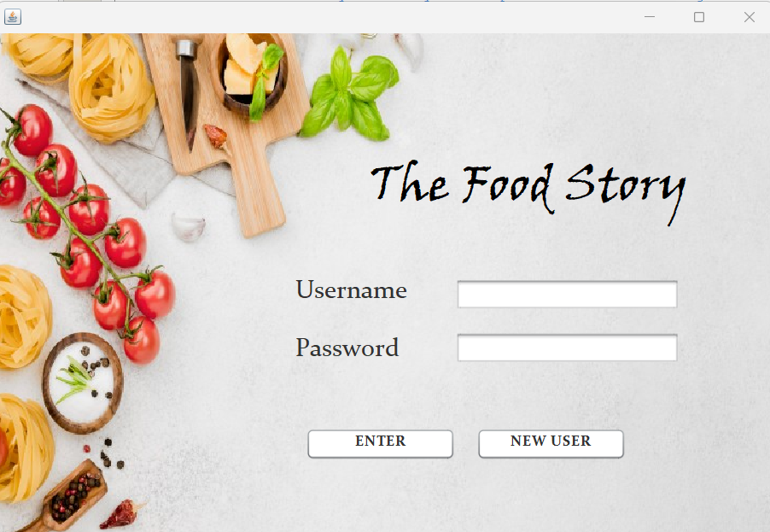

* **Sign Up**: In case of a new user, they are led into the ‘Sign Up’ Module where they have to fill up the necessary credentials to register themselves and create their account.

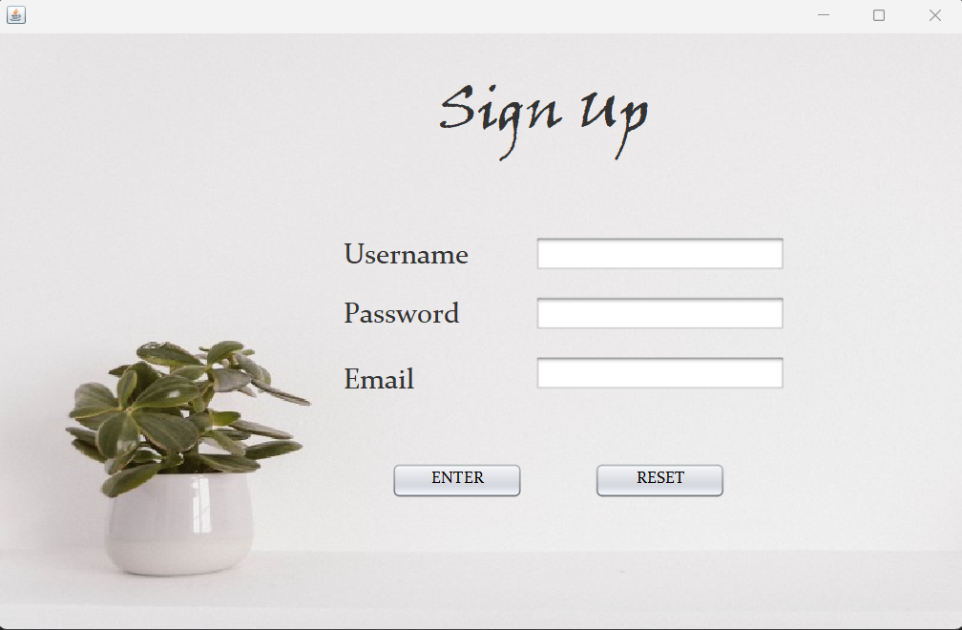

* 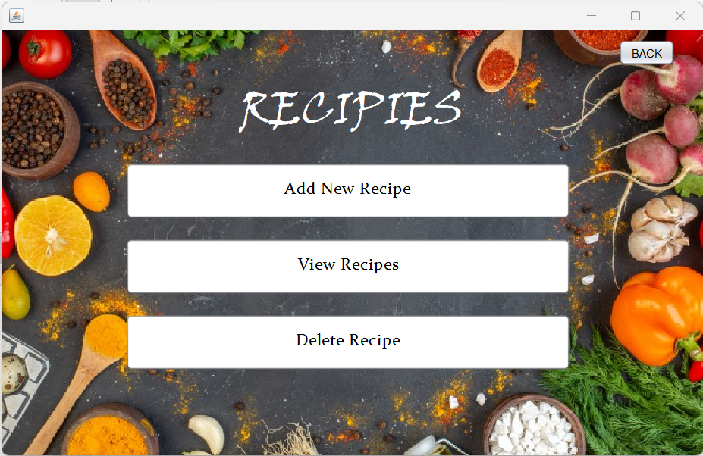**Common Room**: Once the user logs in, either an existing user or by creating a new user profile, the user gets directed to the ‘Common Room’ Module. Here they get to interact with all the major portions of the project. They obtain access to certain features like ‘Add New Recipe’, ‘View Recipes’ and ‘Delete Recipe’.
* **Add New Recipe**: Here the users get to add new recipes to the existing database which can also be viewed by other users.

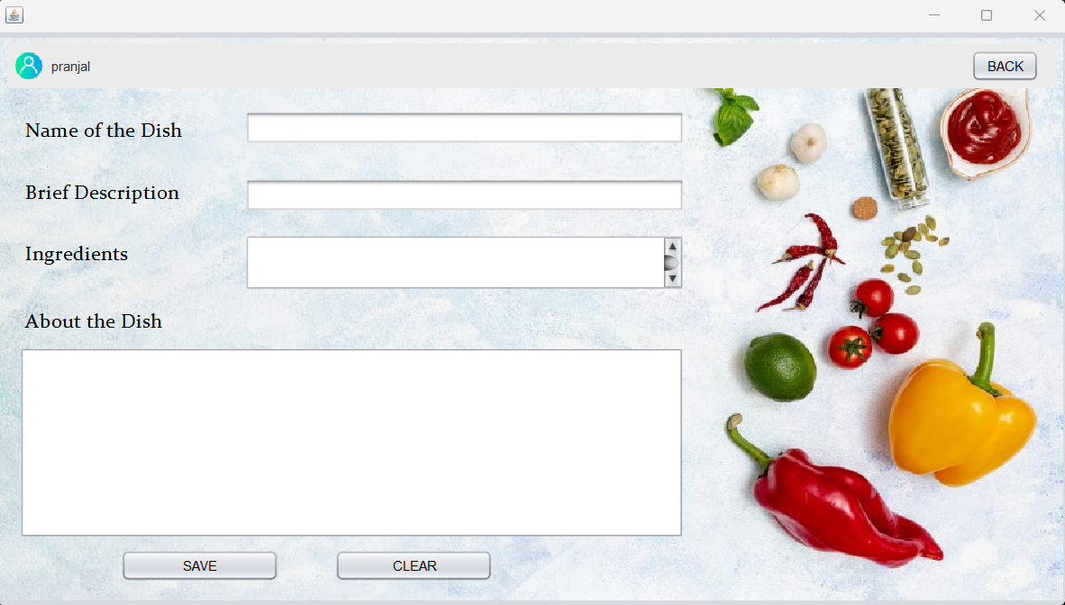

* **View Recipe:** Users can view existing recipes in here, which were created by other users and themselves.
* **View Recipe:** Users can view existing recipes in here, which were created by other users and themselves.

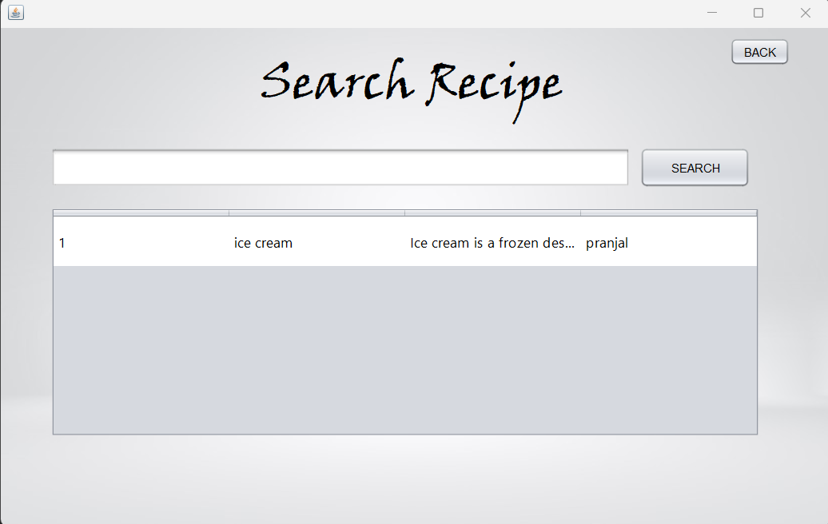

* **Delete Recipe**: Users get to delete recipes from the database using this feature.

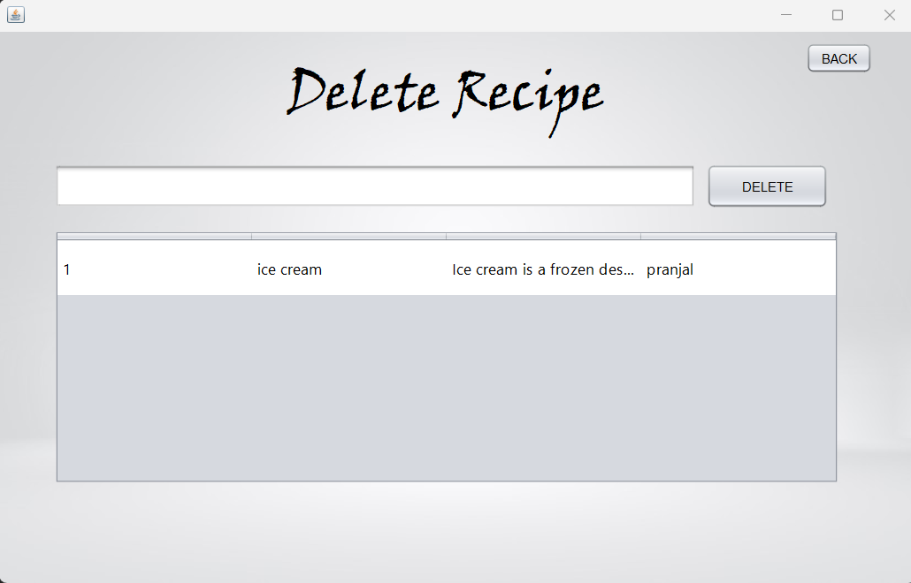

1. **SAMPLE CODE**
2. Login Module:

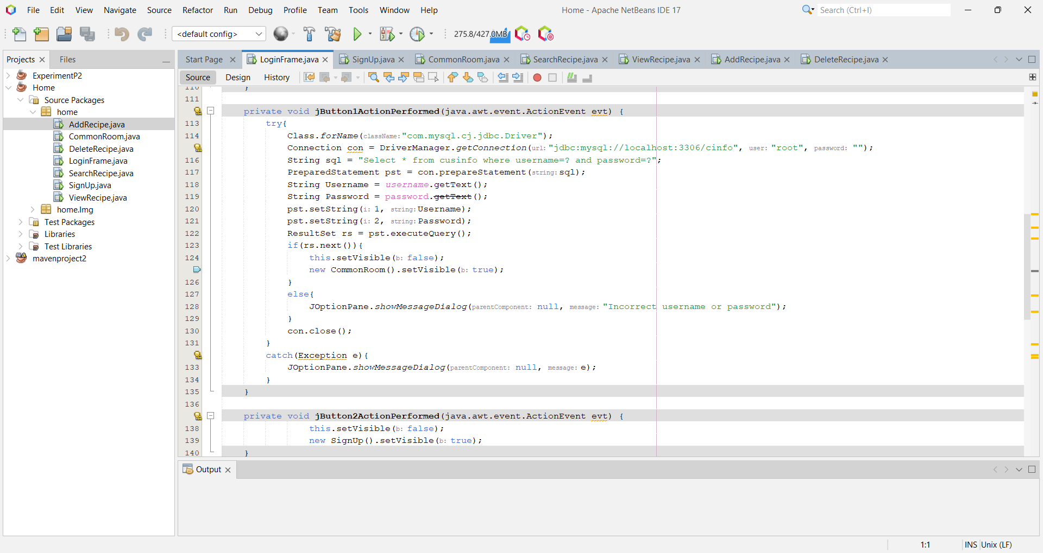

1. Login Module:

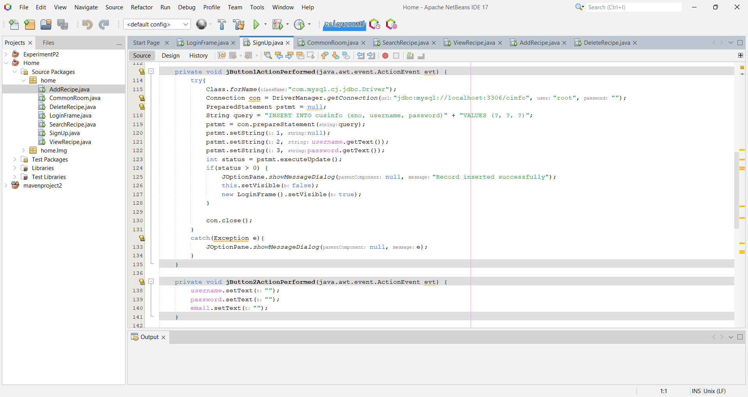

1. Common Room Module:

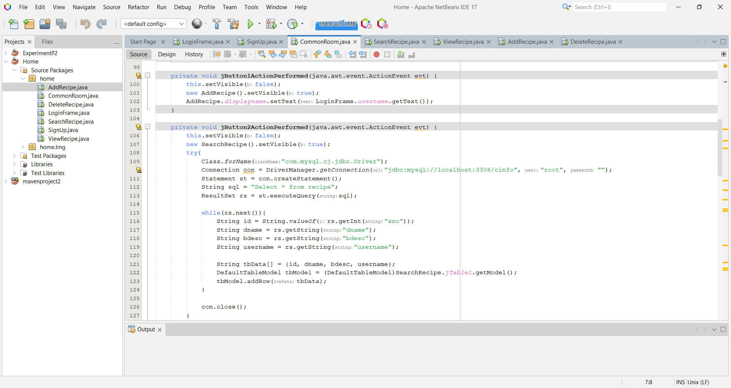

1. Search Recipe Module:

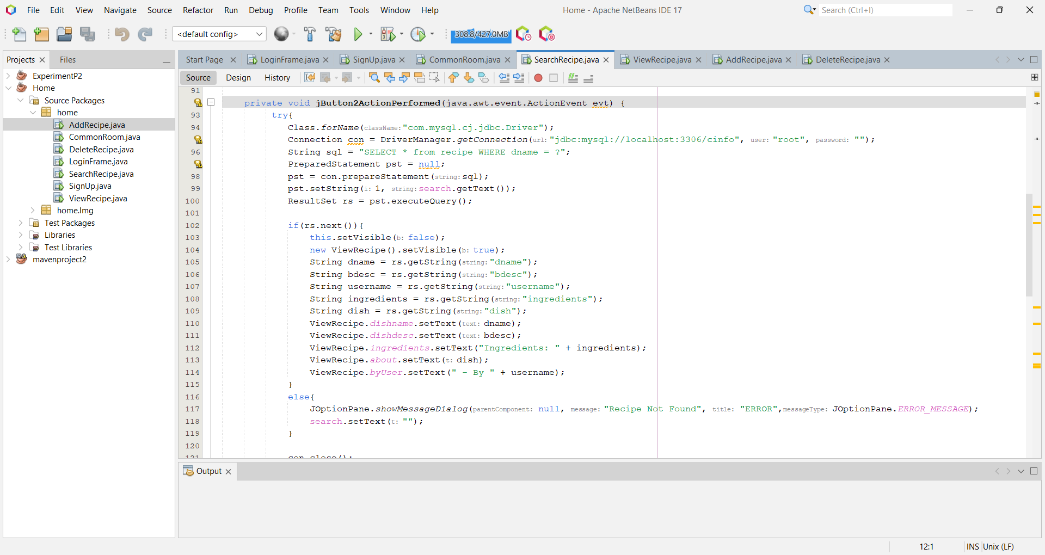

1. Add Recipe Module:

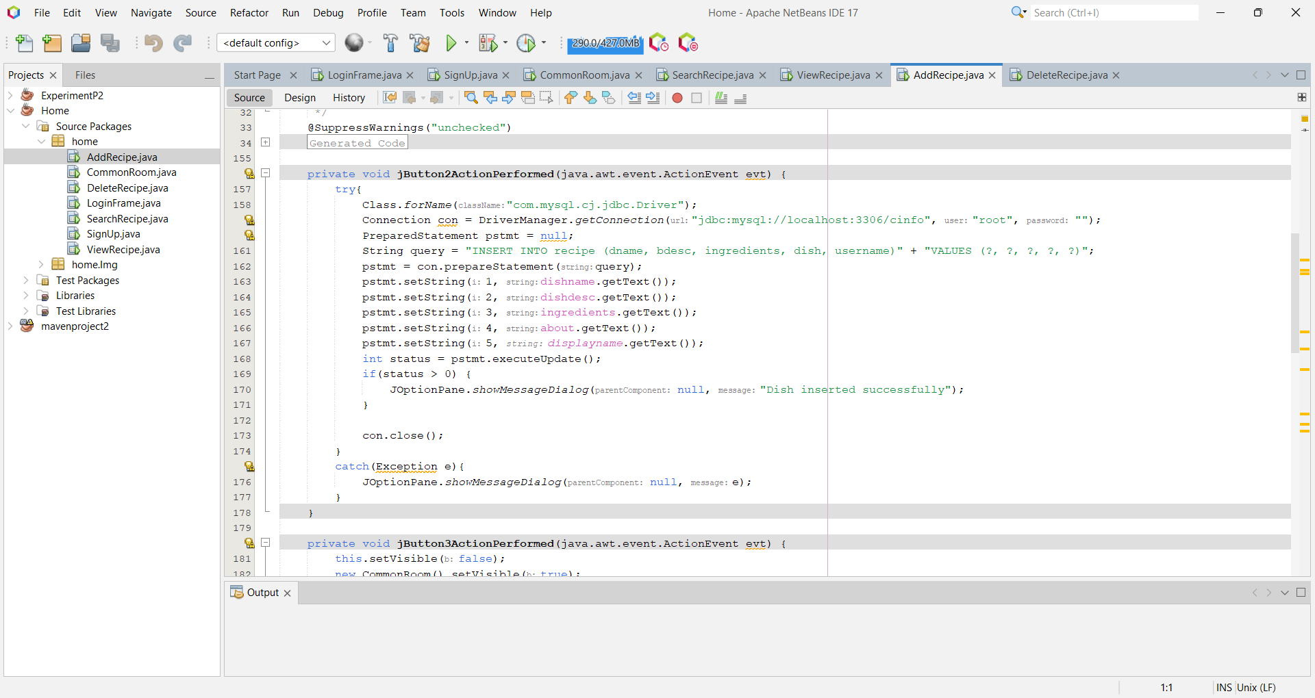

1. Delete Module:

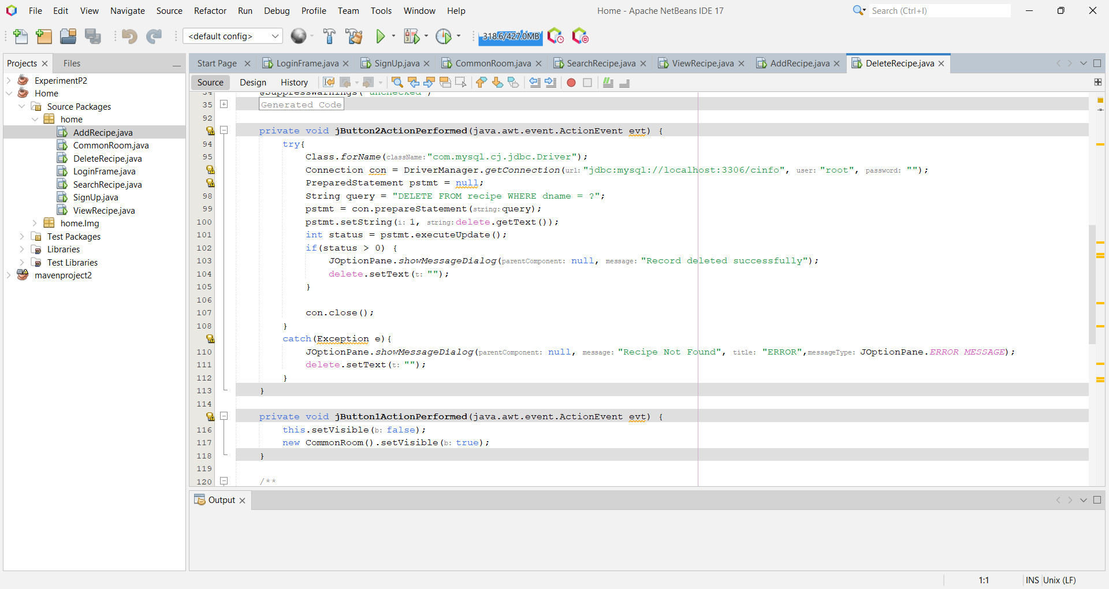

1. **OUTCOME OF PROJECT**

Our project is only a humble venture to satisfy the needs to manage our project work. Several user-friendly coding has also been adopted. Every organization, whether big or small, has challenges to overcome and managing the information of Comment, Blogs, New Blog, Comment, Technology Blog. Every Online Blogging System has different Blogs needs; therefore, we have designed an exclusive management system provides all the basic necessities of a blogging website. Although our project has been made using JFrames in Java. At the end, this system ultimately allows you to manage resources in a better and efficient.

1. **FUTURE SCOPE**

In a nutshell, it can be summarized that the future scope of the project circles around maintaining information regarding:

* We can add more advanced features for Ingenious Construction of Cuisines which will include more facilities.
* We can host the project on a website.
* Integrate multiple load balancers to distribute the loads of the system.
* Implement various database methods like the master and slave database structure to reduce the overload of the database queries.
* Implement a backup mechanism for taking backup of codebase and database on regular basis on different servers.

The above-mentioned points are the enhancements which can be done to increase the applicability and usage of this project. Here, we can maintain records of Blogs, comments. Also, as it can be seen that now a days, the players are versatile, i.e., so there is a scope for introducing a method to maintain the Ingenious Construction of Cuisines. Enhancements can be done to maintain all the Blogs, Comments, New Category, Technology Blog etc.