

PROJECT REPORT/ LITERATURE SURVEY REPORT
ON
COURSES
SUBMITTED TO
DEPARTMENT OF COMPUTER SCIENCE
UNDER THE SUPERVISION OF
DR. AMANDEEP KAUR

Submitted By:
Palak , Prabhat Kumar, Palak Goyal
2210992037 2210992048 2210992015

1st Semester

CHITKARA UNIVERSITY
CHANDIGARH-PATIALA NATIONAL HIGHWAY, RAJPURA, DISTT. PATIALA, PUNJAB, INDIA

CONTENTS

Title Page No.

- Declaration 1
- Acknowledgement 2
- Guidelines and Principles 3
- About Project
4.1 Introduction
4.2 Description
5. Conclusion

DECLARATION

We hereby declare that the courses submitted as part of Bachelor’s degree in CSE, at Chitkara University, Punjab, is an authentic record of our own work carried out under the supervision of Dr. Amandeep Kaur.

Signature(s):

Name: Payal

Roll No: 2210992037

Prabhat Kumar
Roll No:2210992048

Palak Goyal
Roll No:2210992015

ACKNOWLEDGEMENT

We have taken efforts in this project. However, it would not have been possible without the kind support and help of many individuals and organizations. We would like to extend our sincere thanks to all of them.
We are highly indebted to Dr. Amandeep Kaur for their guidance and constant supervision as well as for providing necessary information regarding the project & also for their support in completing the project.
We would like to express our gratitude towards our parents & members of CSE Department for their kind cooperation and encouragement which helped us in completion of this project.
We would like to express our special gratitude and thanks to industry persons for giving us such attention and time.
Our thanks and appreciation also go to our colleague in developing the project and people who have willingly helped us out with their abilities.

HISTORY OF PYTHON

Python is a widely-used general-purpose, high-level programming language. It was initially designed by Guido van Rossum in 1991 and developed by Python Software Foundation. It was mainly developed for emphasis on code readability, and its syntax allows programmers to express concepts in fewer lines of code.

The language was finally released in 1991. When it was released, it used a lot fewer codes to express the concepts, when we compare it with Java, C++ & C. Its design philosophy was quite good too. Its main objective is to provide code readability and advanced developer productivity. When it was released it had more than enough capability to provide classes with inheritance, several core data types exception handling and functions.

Python has come a long way to become the most popular coding language in the world. Python has just turned 30 and just recently at pycon22(python conference) a new feature was released by Anaconda foundation it’s known as py script with this now python can be written and run in the browser like javascript which was previously not possible.

Python 3.10.4 is the latest stable version.
Python has vast libraries for various fields such as Machine Learning (Numpy, Pandas, Matplotlib), Artificial intelligence (Pytorch, TensorFlow), and Game development (Pygame,Pyglet).
In this python project, we require a random module.

Random Variable

It is an in-built module of Python which is used to generate random numbers. These are pseudo-random numbers means these are not truly random. This module can be used to perform random actions such as generating random numbers, print random values for a list or string, etc.

INTRODUCTION OF PROJECT
Password Generator is a simple program which uses a random module for generating password.Secure password is the need of today’s world.
The objective of this project is to help those who have to constantly come up with new passwords to ensure authorized access.hh
In this program users have to specify no of letters, symbols and numbers he or she wants in the password and the program generates the password using a random module.

There are steps followed:
- Importing Module
- Ask input from user
- Generate Password in output window
1.Importing Module:
import random module

2.Ask input from user:
nr_letters= int(input("How many letters would you like in your password?\n"))
nr_symbols = int(input(f"How many symbols would you like?\n"))
nr_numbers = int(input(f"How many numbers would you like?\n"))

3.Generate Password in output window:
Generate a password of length=nr_letters+nr_symbols+nr_numbers

Program Code

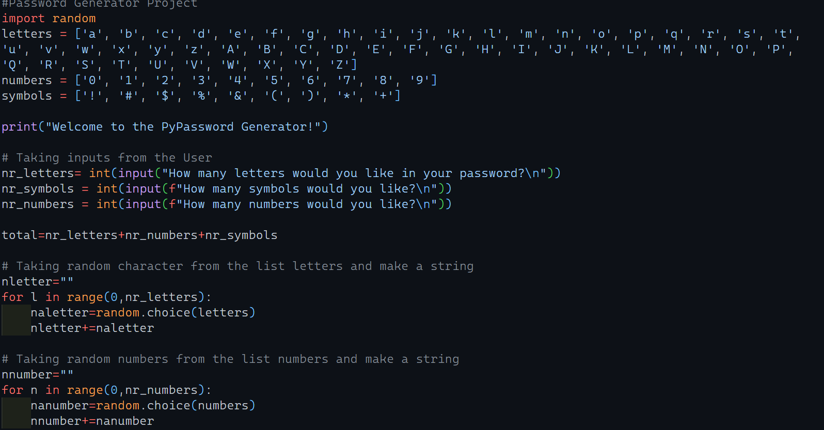

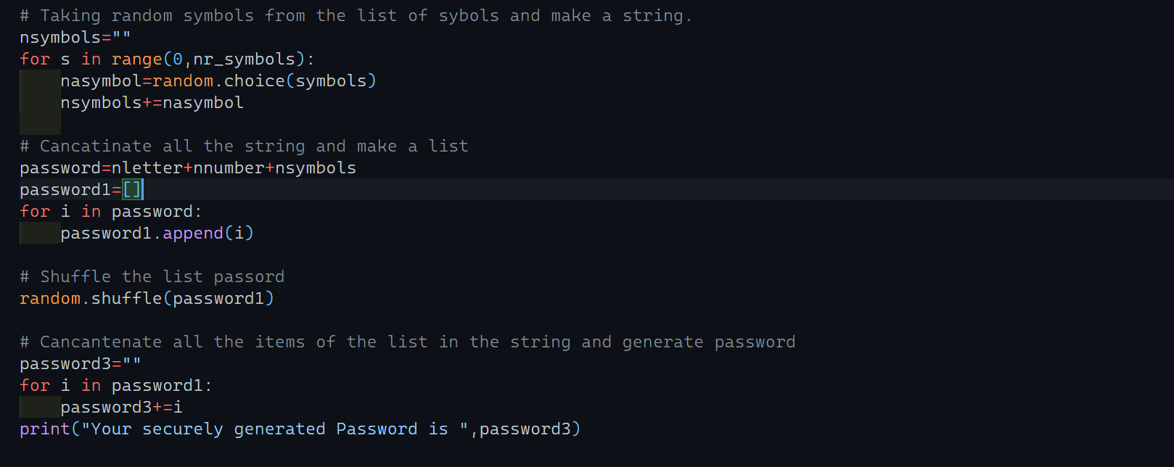

Output Window
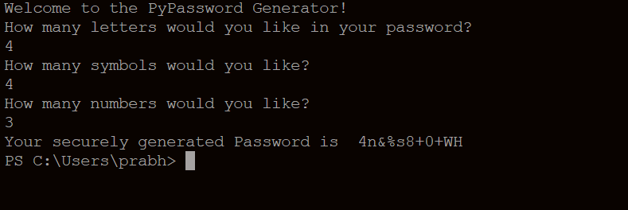

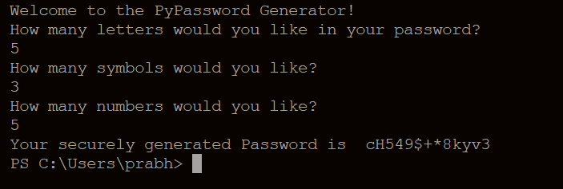

CONCLUSION

After doing this python project, we got to know how to import modules and how to use random module and string concatenation and more about list and string.

