PROJECT REPORT
ON
“COMPARISON BETWEEN DIFFERENT ML AND DL ALGORITHMS FOR SENTIMENT ANALYSIS”

ACKNOWLEDGEMENT
I would like to express my sincere gratitude to everyone who supported and guided me throughout the development of this project titled "Comparison Between Different ML and DL Algorithms for Sentiment Analysis."
First and foremost, I extend my heartfelt thanks to my project guide for constant guidance, valuable suggestions, encouragement, and support throughout the project. The guidance helped me understand the complete workflow of Natural Language Processing, machine learning model training, deep learning implementation, and dashboard development.
I am also thankful to the Department of Computer Science and Engineering for providing the opportunity and academic environment required to complete this project successfully. I would also like to thank my classmates, friends, and family members for their support and motivation during the project work.
This project has been a valuable learning experience because it allowed me to apply theoretical knowledge to a practical NLP problem using Python, Word2Vec, Machine Learning, Deep Learning, and Streamlit dashboard development.
TABLE OF CONTENT
- Abstract
- Introduction
- Background and Literature Survey
- Objectives of the Project
- System Architecture
- Tools and Platform
- Dataset and Preprocessing
- Machine Learning Models
- Deep Learning Models
- Implementation
- Result and Analysis
- Conclusion
- Future Scope
- References
ABSTRACT
Sentiment analysis is an important Natural Language Processing task used to identify opinions, emotions, and attitudes from textual data. This project presents a comparative study between different Machine Learning and Deep Learning algorithms for classifying text reviews into positive and negative sentiment categories.
The project uses text preprocessing techniques such as cleaning, lowercasing, tokenization, stopword removal, label encoding, and Word2Vec feature extraction. Traditional Machine Learning models including Logistic Regression, Linear SVM, Gaussian Naive Bayes, and Random Forest are trained using average Word2Vec vectors. Deep Learning models including CNN, LSTM, and CNN-LSTM Hybrid are trained using sequential Word2Vec representations.
The models are evaluated using accuracy, precision, recall, F1-score, and confusion matrix. The results show that LSTM achieves the highest accuracy of 87.38%, while Linear SVM performs best among traditional ML models with 86.35% accuracy. A Streamlit dashboard is developed to compare models visually, display metric balance, show confusion matrices, verify saved model artifacts, and perform sentiment prediction.
The project demonstrates how different ML and DL models perform on the same sentiment classification task and provides an interactive dashboard for better analysis and presentation.
INTRODUCTION
Sentiment analysis is a subfield of Natural Language Processing that focuses on identifying the emotional tone or opinion expressed in text. It is widely used in movie review analysis, product review classification, customer feedback monitoring, social media analysis, and brand reputation management.
In real-world applications, large volumes of text data are generated every day. Manually reading and classifying this data is time-consuming and inefficient. Therefore, automated sentiment analysis systems are useful for quickly identifying whether a given review or comment is positive or negative.
This project focuses on comparing multiple Machine Learning and Deep Learning models for sentiment analysis. The main purpose is not only to build a sentiment classifier, but also to evaluate which algorithm performs best under similar preprocessing and evaluation conditions.
A Streamlit dashboard is also created to make the comparison interactive and easy to understand. The dashboard displays performance charts, class-wise metric balance, confusion matrices, and a sentiment prediction interface.
BACKGROUND AND LITERATURE SURVEY
Natural Language Processing has become an important area of Artificial Intelligence because most real-world information is available in text form. Sentiment analysis is one of the most common NLP applications and has been studied widely for review classification, opinion mining, and customer behavior analysis.
Traditional Machine Learning models such as Naive Bayes, Logistic Regression, Support Vector Machine, and Random Forest have been used successfully for text classification tasks. These models generally require numerical feature extraction methods such as Bag of Words, TF-IDF, or Word Embeddings.
Word2Vec is a popular word embedding technique that converts words into dense numerical vectors. It captures semantic similarity between words, meaning words with similar contexts are represented by similar vectors.
Deep Learning models such as CNN and LSTM have also shown strong performance in NLP tasks. CNN can extract local phrase-level features from text, while LSTM can capture sequence and context information. Hybrid CNN-LSTM models combine both local feature extraction and sequence learning.
This project compares these different approaches and analyzes their performance for sentiment classification.
OBJECTIVES OF THE PROJECT
- To develop a sentiment analysis system for classifying reviews as Positive or Negative.
- To preprocess text data using cleaning, tokenization, stopword removal, and label encoding.
- To use Word2Vec for converting text into numerical vector form.
- To train and evaluate Machine Learning models such as Logistic Regression, SVM, Naive Bayes, and Random Forest.
- To train and evaluate Deep Learning models such as CNN, LSTM, and CNN-LSTM Hybrid.
- To compare all models using accuracy, precision, recall, F1-score, and confusion matrix.
- To build a Streamlit dashboard for interactive model comparison and prediction.
- To identify the best performing algorithm for sentiment analysis.

SYSTEM ARCHITECTURE
The system follows a structured NLP pipeline. First, the review dataset is collected and preprocessed. Then Word2Vec embeddings are generated. For ML models, average Word2Vec vectors are used. For DL models, sequential Word2Vec vectors are used. After model training, the results are evaluated and displayed through a Streamlit dashboard.
Workflow
Dataset -> Text Preprocessing -> Word2Vec Feature Extraction -> ML/DL Model Training -> Model Evaluation -> Streamlit Dashboard -> Sentiment Prediction
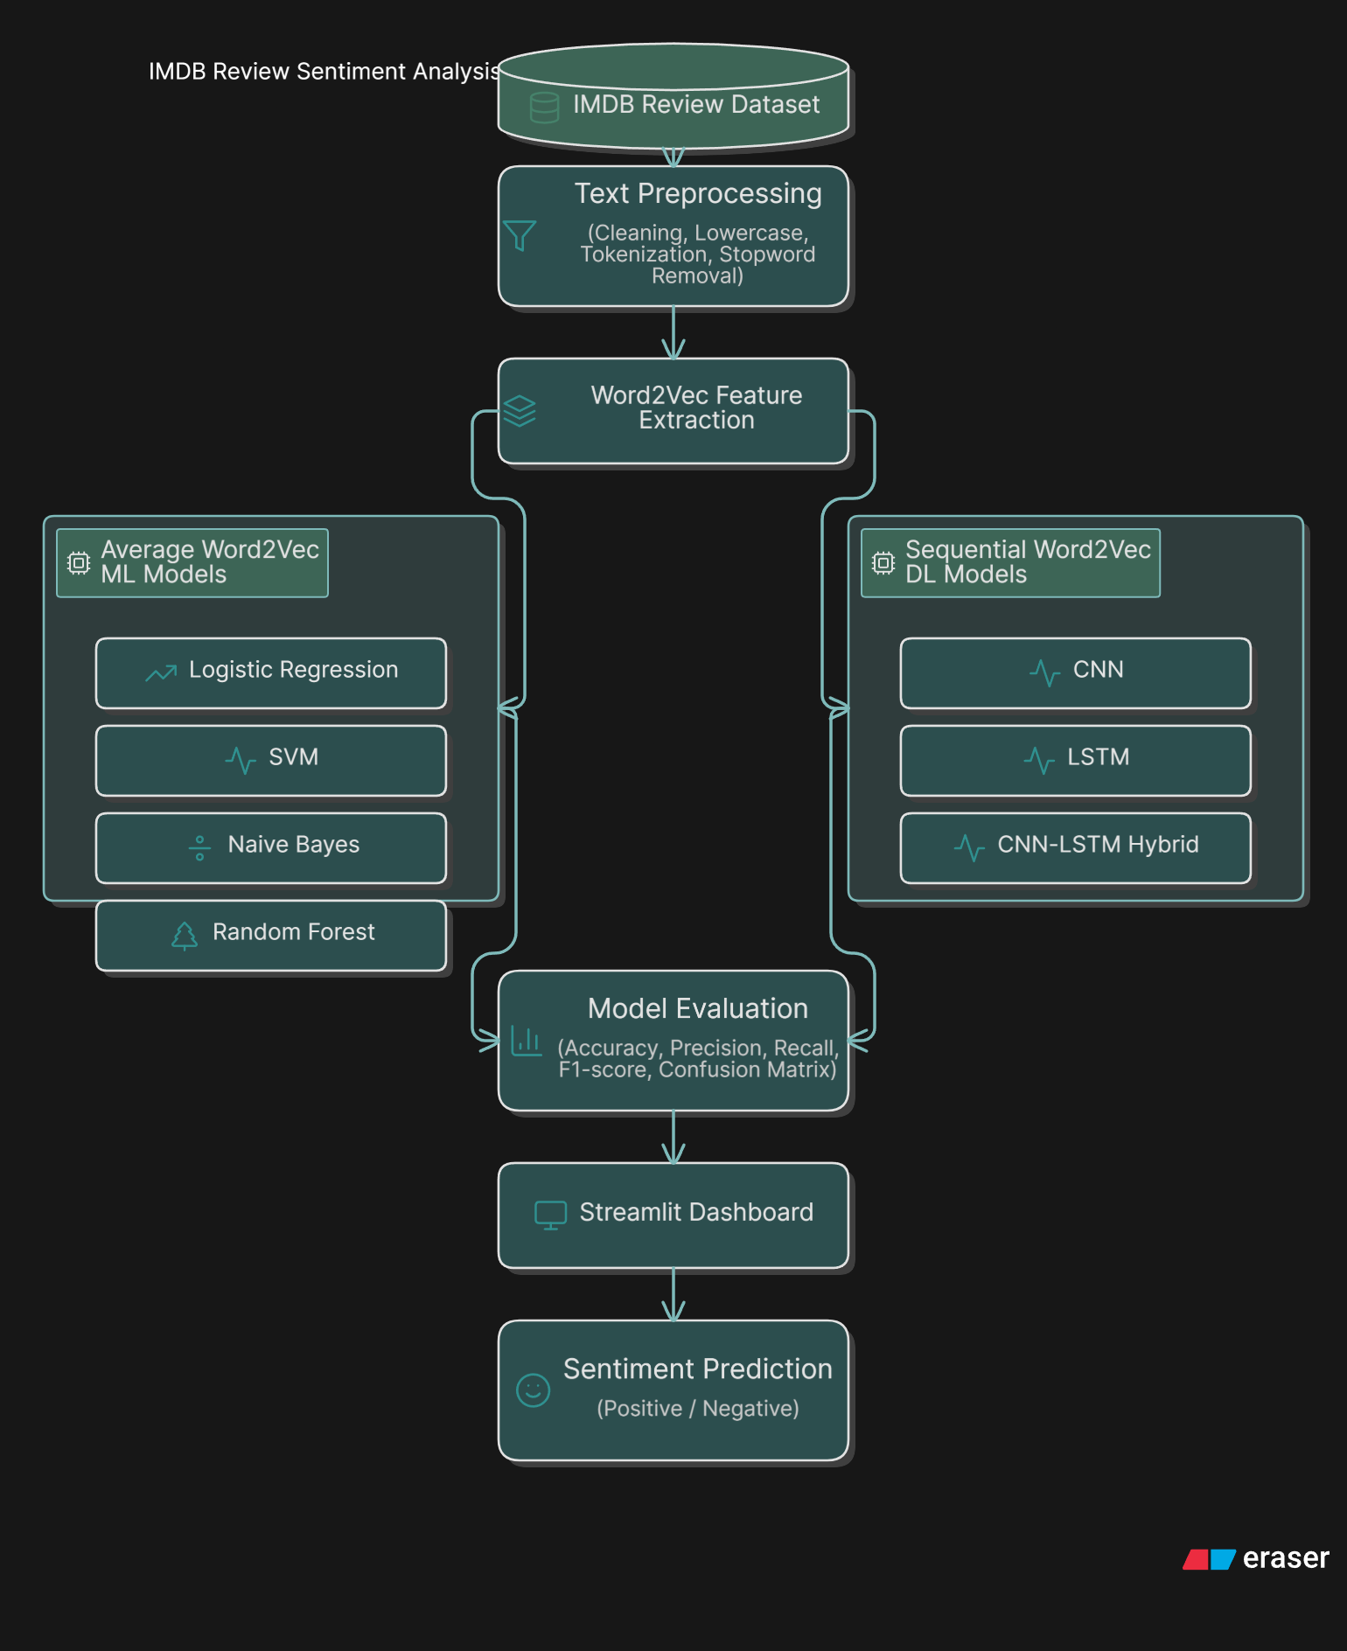:
TOOLS AND PLATFORM
Programming Language
- Python
Development Platforms
- Google Colab
- Visual Studio Code
Libraries Used
- Pandas and NumPy for data handling
- NLTK for text preprocessing
- Gensim for Word2Vec
- Scikit-learn for ML models and evaluation
- TensorFlow / Keras for deep learning models
- Streamlit for dashboard development

DATASET AND PREPROCESSING
The dataset contains text reviews and sentiment labels. The sentiment labels are positive and negative. Positive labels are encoded as 1 and negative labels are encoded as 0.
Preprocessing Steps
- Removing HTML tags and special characters
- Converting text to lowercase
- Tokenizing text into words
- Removing stopwords
- Encoding sentiment labels
- Generating Word2Vec vectors
Dataset Preview
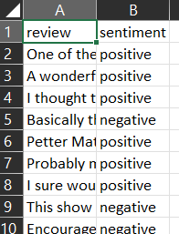

Preprocessing Code
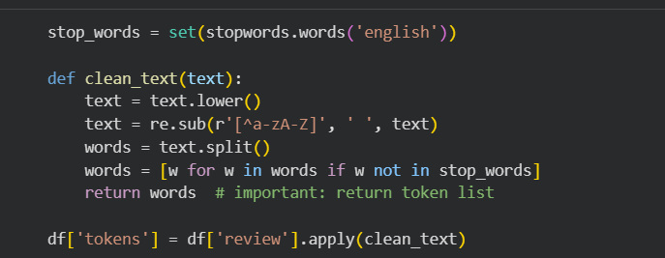

MACHINE LEARNING MODELS
The Machine Learning models use average Word2Vec vectors. In average Word2Vec, all word vectors in a review are averaged to create one fixed-size vector for the complete review.
Models Used
- Logistic Regression: A linear classification model used as a strong baseline.
- Linear SVM: A margin-based classifier that works well for high-dimensional text data.
- Gaussian Naive Bayes: A probability-based classifier used as a simple baseline.
- Random Forest: An ensemble model that combines multiple decision trees.
ML Notebook Training Output
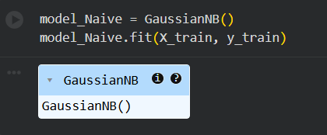
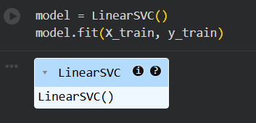
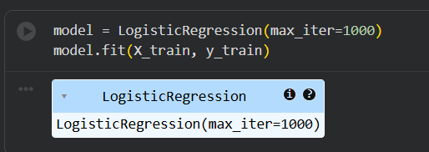
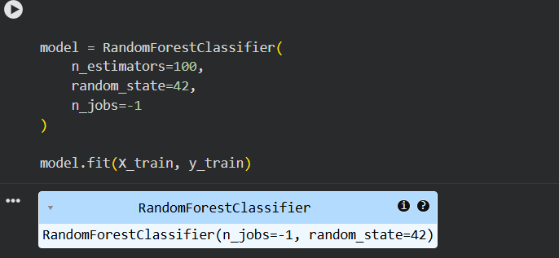

DEEP LEARNING MODELS
The Deep Learning models use sequential Word2Vec vectors. Instead of averaging word vectors, sequential Word2Vec keeps vectors in word order, which helps neural networks understand context.
CNN
CNN extracts local phrase patterns such as 'very good', 'not good', or 'excellent acting'.
LSTM
LSTM is designed for sequence data. It can remember previous words and understand context, which is useful for sentiment analysis.
CNN-LSTM Hybrid
The hybrid model combines CNN and LSTM. CNN extracts local phrase features, and LSTM learns sequence-level context.

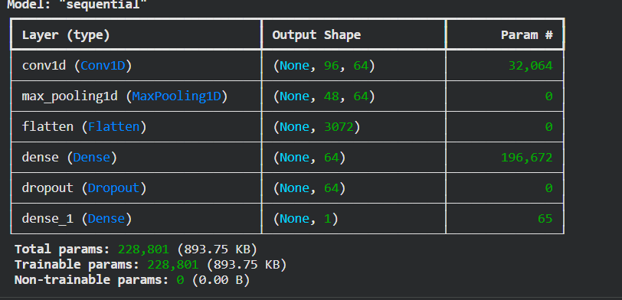
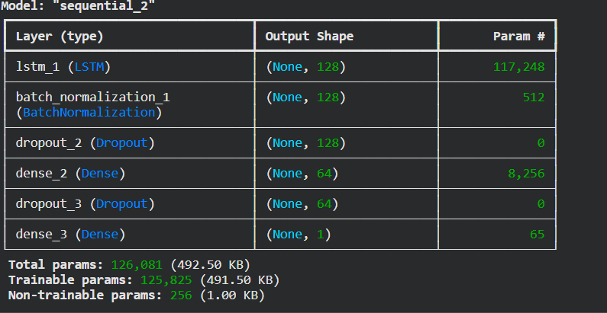

IMPLEMENTATION
The project implementation is divided into two major parts: model training in notebooks and dashboard development using Streamlit.
Model Training
- Text reviews are loaded and cleaned.
- Word2Vec embeddings are created or loaded.
- ML models are trained using average vectors.
- DL models are trained using sequence vectors.
- Models are saved as .pkl or .keras files.
Dashboard Development
The Streamlit dashboard is created in app.py. It displays model comparison, accuracy charts, metric balance, confusion matrices, model artifact status, and sentiment prediction output.
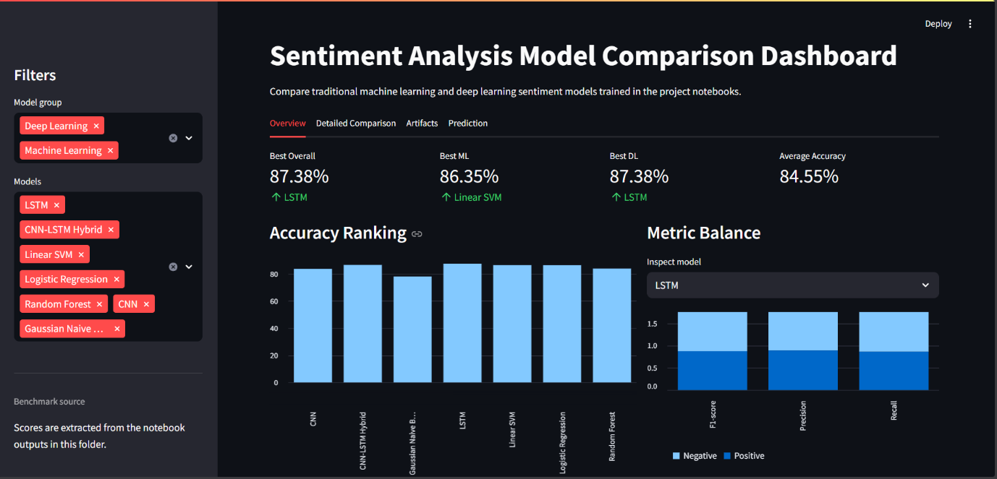

Prediction Positive Output
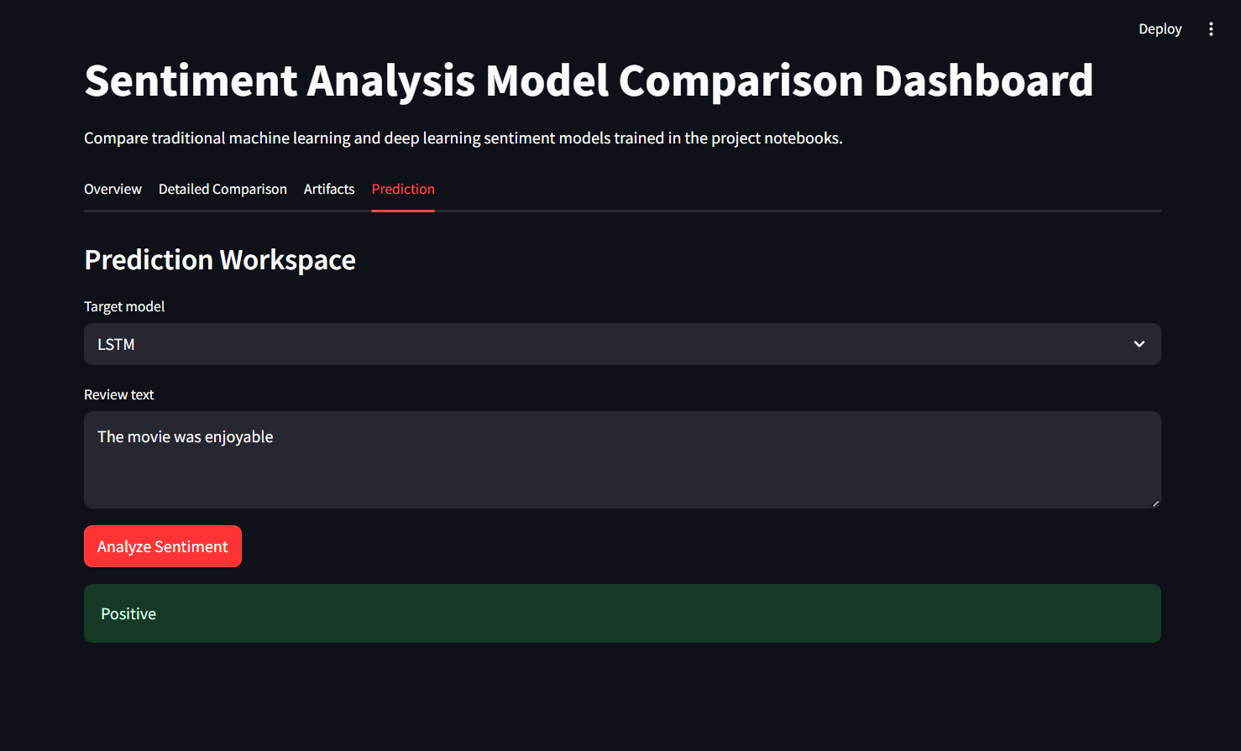

Prediction Negative Output
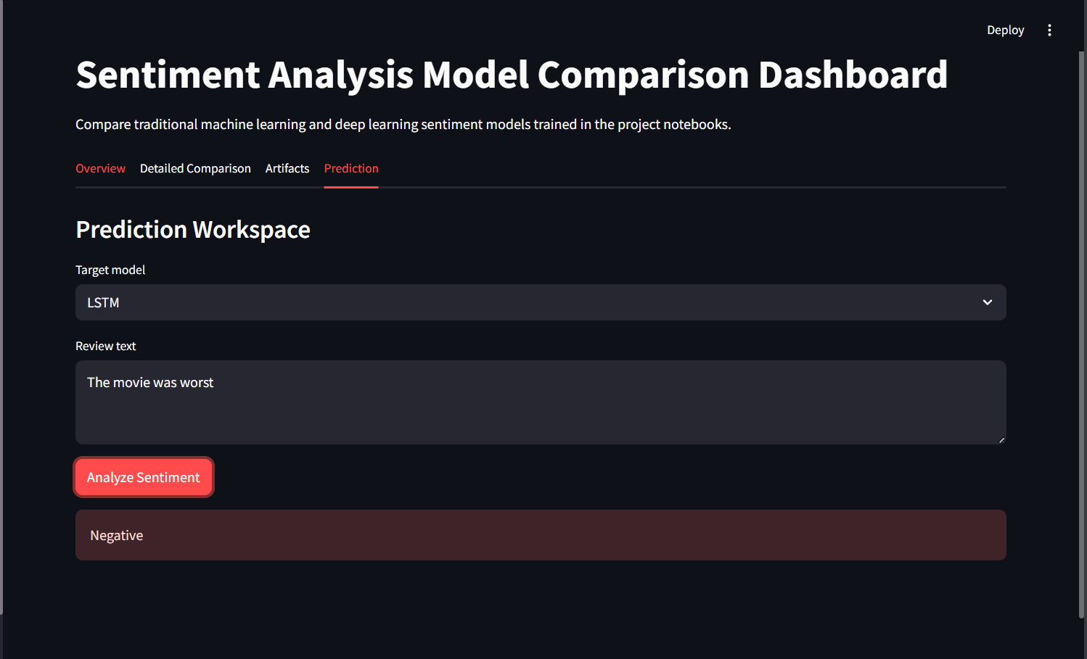

RESULT AND ANALYSIS
The models were evaluated using accuracy, precision, recall, F1-score, and confusion matrix. The table below shows the comparison of all models.
Model | Type | Accuracy | Precision | Recall | F1-score
Logistic Regression | ML | 86.30% | 0.86 | 0.86 | 0.86
Linear SVM | ML | 86.35% | 0.86 | 0.86 | 0.86
Gaussian Naive Bayes | ML | 77.94% | 0.78 | 0.78 | 0.78
Random Forest | ML | 83.82% | 0.84 | 0.84 | 0.84
CNN | DL | 83.56% | 0.84 | 0.84 | 0.84
LSTM | DL | 87.38% | 0.87 | 0.87 | 0.87
CNN-LSTM Hybrid | DL | 86.52% | 0.87 | 0.87 | 0.87
From the results, LSTM achieved the highest accuracy of 87.38%. Linear SVM achieved the best performance among Machine Learning models with 86.35% accuracy. Naive Bayes had the lowest accuracy but is simple and fast.
Accuracy Ranking Chart
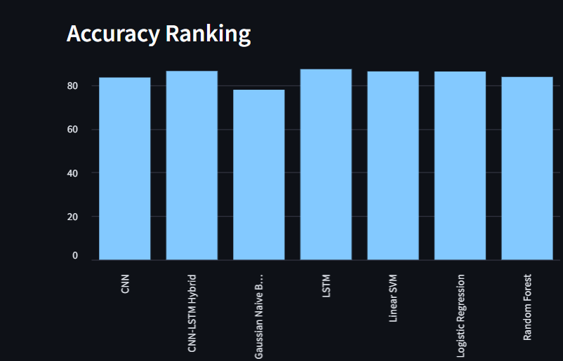

Model Comparison Table
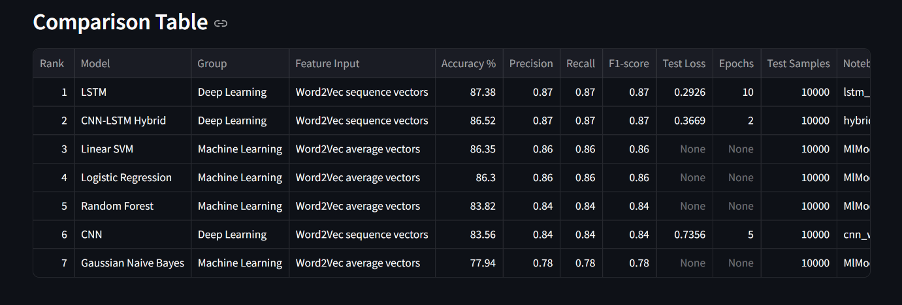

Confusion Matrix Section
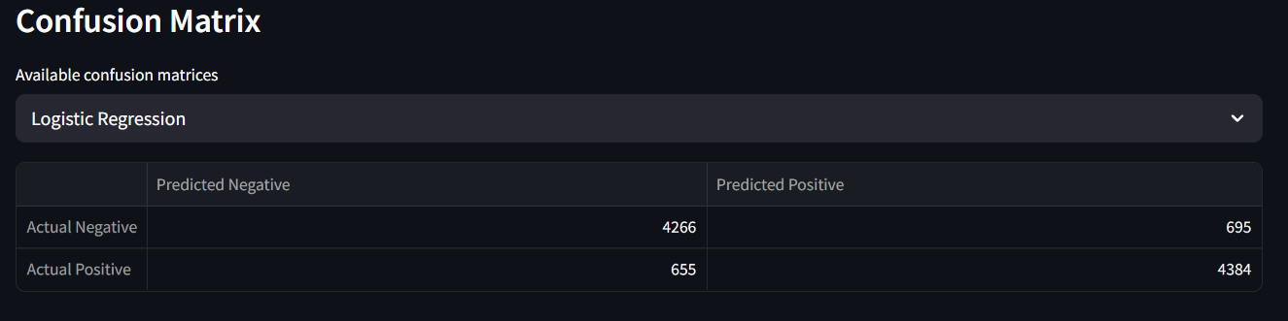

CONCLUSION
This project successfully compares different Machine Learning and Deep Learning algorithms for sentiment analysis. The system classifies reviews into positive and negative sentiment categories using Word2Vec feature extraction and multiple classification models.
The comparison shows that LSTM achieved the best overall performance with 87.38% accuracy because it is able to understand sequence and context in text. Linear SVM and Logistic Regression also performed strongly among traditional ML models. The Streamlit dashboard makes the comparison easier by showing charts, tables, confusion matrices, and prediction output in an interactive interface.
Overall, the project demonstrates the practical use of NLP, Machine Learning, Deep Learning, and dashboard development for sentiment analysis.
FUTURE SCOPE
- Use transformer-based models such as BERT for improved sentiment classification.
- Add a neutral sentiment class along with positive and negative.
- Use larger datasets from Twitter, Amazon reviews, or product feedback.
- Improve hyperparameter tuning for CNN, LSTM, and Hybrid models.
- Deploy the Streamlit dashboard online.
- Add explainability features to show why a review is classified as positive or negative.

REFERENCES
1. Mikolov, T., Chen, K., Corrado, G., and Dean, J., Efficient Estimation of Word Representations in Vector Space, 2013.
2. Scikit-learn Documentation, https://scikit-learn.org/
3. TensorFlow Documentation, https://www.tensorflow.org/
4. Keras Documentation, https://keras.io/
5. Gensim Word2Vec Documentation, https://radimrehurek.com/gensim/
6. Streamlit Documentation, https://docs.streamlit.io/
7. NLTK Documentation, https://www.nltk.org/

