**Introduction:**

The Furniture Management System (FMS) is a new concept designed to cater for furniture inventory for companies. Specifically built for the management of inventory chores, the system provides easy to use functions for improved tasks accomplishment. These are likely to give rise to errors and are also time-consuming, in contrast with FMS that has integrated inventory, sales and reporting.

The main objectives of the FMS are identification of furniture items, easy and efficient sale of furniture and the provision of complete reports to facilitate decision making. From features such as those that oversee the stock, orders and reporting services the operation is improved and made less prone to mistakes. Thus, it will be valuable for furniture retailers, manufacturers, and wholesalers who want to manage their inventory and enhance their firm’s performance. The FMS also guarantees that real time data is available and achievable to enhance the management of resources and surviving the market pressures.

**Task Description:**

The Furniture Management System which is also referred to as the FMS project is aimed at designing a total facility of Web based furniture inventory management system. It is intended to provide easier way to handle things like inventory, sales and reporting among others. It starts from the gathering and analyzing of the requirements to realize the requirement of the users and the functionalities of the system. After this, the system architecture will be endeavored which would include the database schema, user interfaces, and the main functionalities of the system. The database implementation will allow the creation, reading, update, and deletion of furniture items and stock, as well as the creation and update of sale record. The user interface of the application shall be coded in HTML, CSS and Bootstrap to enable the application to work well in different devices. Some of them are to create, modify and delete furniture items, to make sales and issue statements and reports. The system will be tested adequately and wen to remove any possible bugs ready for its organizational deployment. The end products will therefore be functional system, with a well designed database, good interfaces and documented systems. After the phased deployment is complete, there will always be cases where people will need assistance or a particular system updated, and therefore support will be availed continually.

**User Interface Design:**

In the context of the Furniture Management System the provided code has been followed maintaining the look and feel by using Bootstrap and having a responsive user interface design in mind. The top header is positioned at the top and is permanent; there you can find the name of the system, as well as the buttons Home, About Us, Inventory, and Contact, so that the users of the site will be able to get around without much difficulty.

In the Inventory page, there is a clean and neat table that has Disks of furniture such as an item ID, Name of the piece of furniture, Category, Price, and Stock of the piece of furniture. This format is quite effective for the purpose of readouts and, at the same time, for organizing the data regarding product stock. Bootstrap’s table styling brings an additive look and feel to the tables while increasing usability and making it easy to go through and click on the data provided in the tables.

The bottom is a fixed position on the page that offers the possibility of providing basic and constantly visible info that can help users while reminding that the brand is following them through it.

In terms of layout and style, it is maximalists and the entire concept is focused on usability with responsive features to adapt to the device capability. Bootstrap provides integration of a grid system and even contains predesigned components that help to facilitate the work and achieve a rather professional appearance. This approach of design helps to make Furniture Management System functional and also makes it to be attractive to the eye since its organizing brings joy and a good health to its users.

**Home Page:**

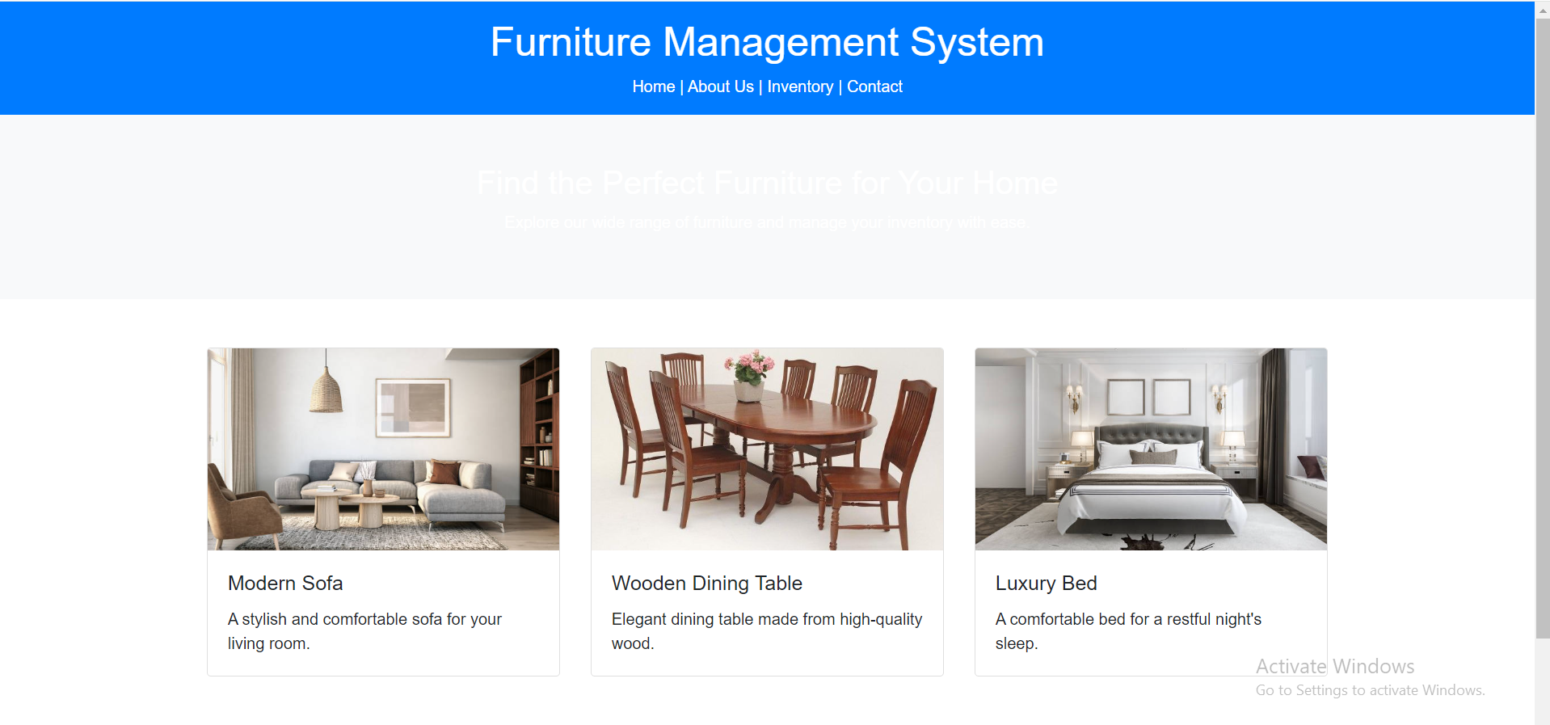



**About Us Page:**

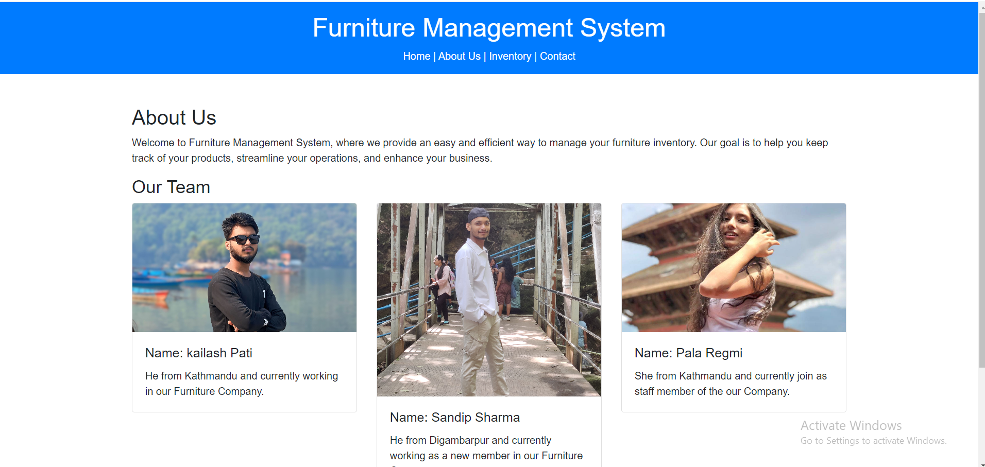

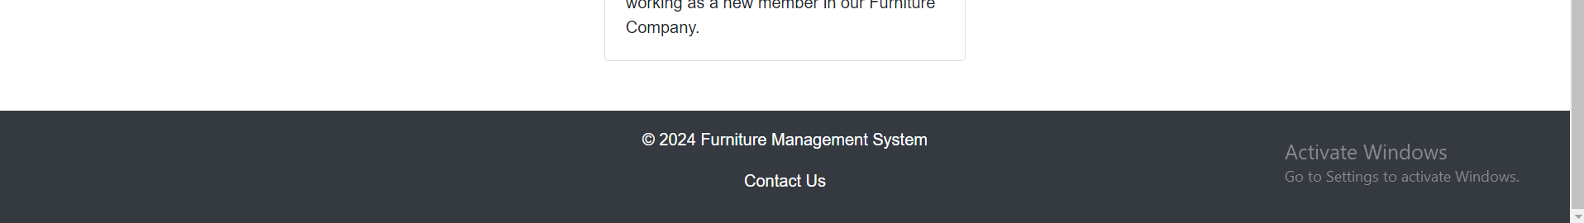

**Inventory page:**

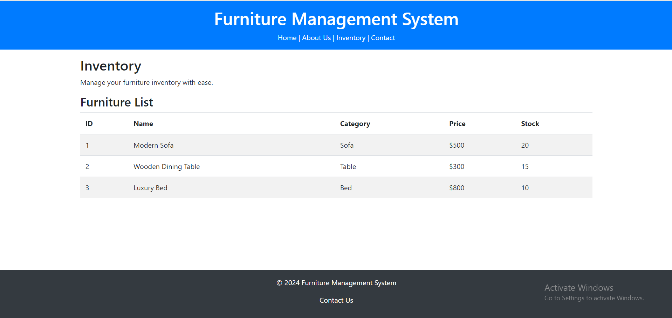

**Contact US Page:**

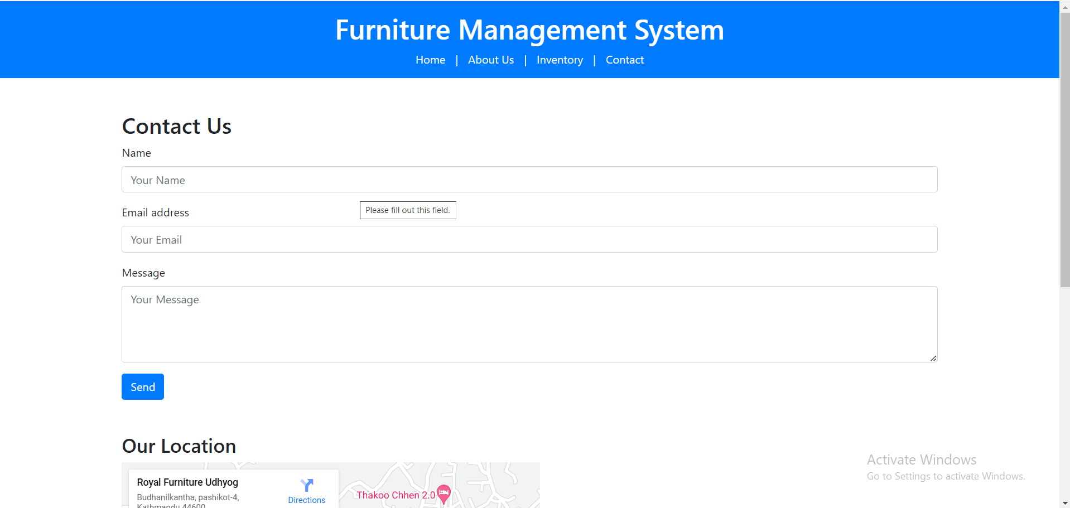

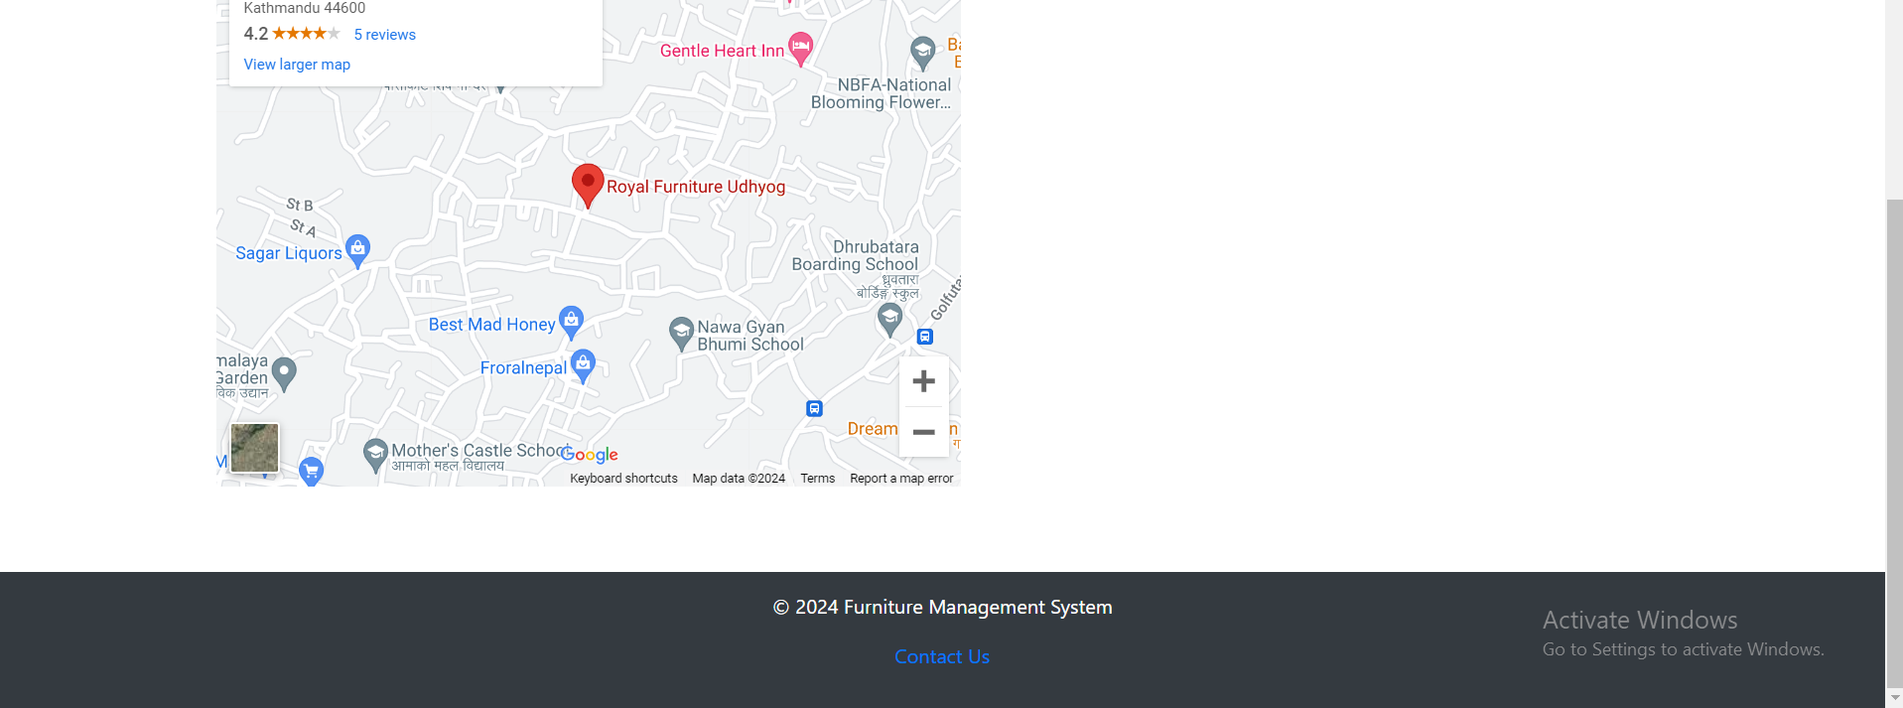

**Testing:**

Here, the Testing of the Furniture Management System is considered to consist in compliance with all the components to work properly and the ergonomics of the User Interface. This involves tests where modules that were developed independently are combined together to ensure that interactions are seamless, UI tests to ensure that everyone sees the similar interface regardless of device. Cross browser checking focuses on making your website or application run well on different browsers while usability checks collects user opinions that would help in enhancing the website or application. Due to the fact that development is completed it is critical to ensure that testing is also done properly as it helps in the achievement of the primary objectives of the applica-tion; namely reliability and user-friendliness.

**Responsive:**

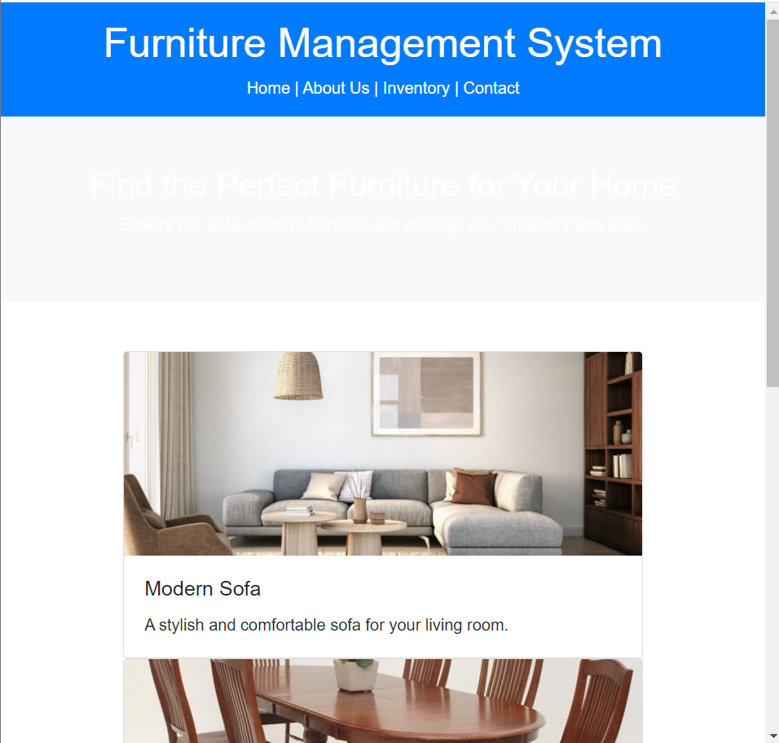

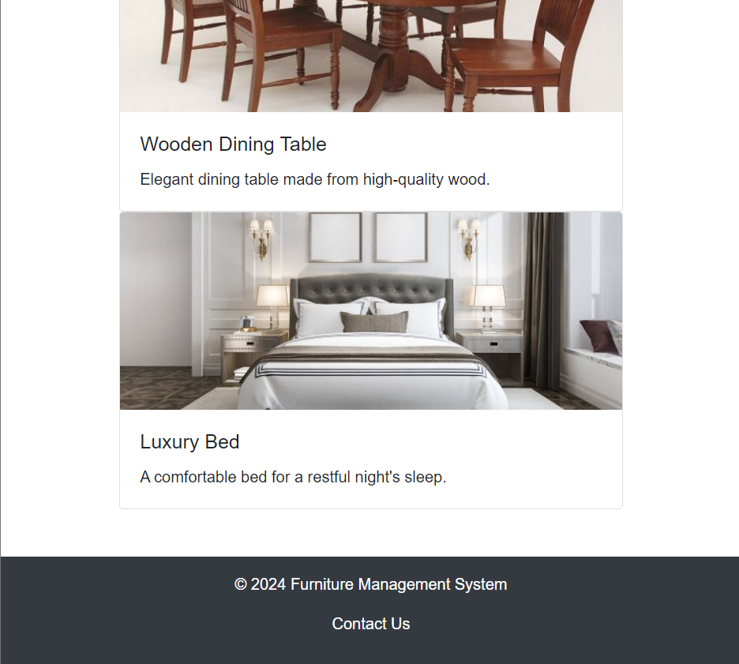

**Input Information:**

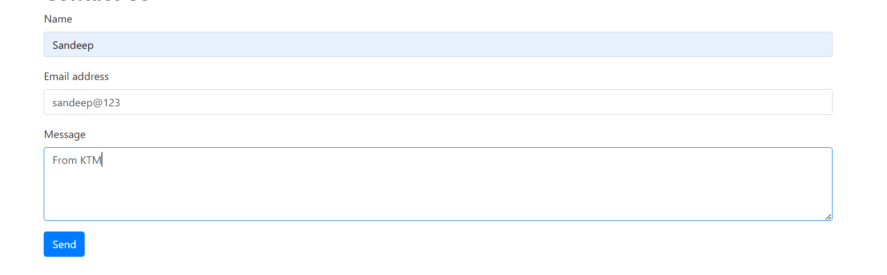

**Conclusion:**

Lastly, to control furniture items, I have developed the Furniture Management System to be rather friendly to the users and process the data effectively. Technologies used The following are modern web technologies used in the development of this system HTML, CSS, and Bootstrap have been integrated in the construction of the user interface to make it more interactive and easy to use. Not only does this system advance the means of managing a store’s inventory, but also provides the basic framework for the system’s future advancements. From this project, I have well illustrated how the various functions should be included within a nice and easy to work with layout, which I am sure the businesses will find of great help to help them manage their business.

**Reference:**

* Bootstrap Documentation. (n.d.). Retrieved from https://getbootstrap.com/docs
* Google Maps Platform Documentation. (n.d.). Retrieved from https://developers.google.com/maps/documentation
* W3Schools. (n.d.). HTML, CSS, and Bootstrap Tutorials. Retrieved from <https://www.w3schools.com/>