AI-Based Predictive Model
Customer Churn Prediction — Academic Mini-Project
Raj Gaurav Singh | B.Tech Computer Science Engineering, Chandigarh University

1. Objective
This project builds a machine learning classification model that predicts whether a telecom customer is likely to churn (cancel their subscription), based on account, billing, and service-usage attributes. The goal is to demonstrate an end-to-end applied-ML workflow: data preparation, model training, evaluation, and persistence of results in a relational database for further analysis.

2. Dataset
The dataset contains 2,000 customer records with 13 features, including tenure, monthly and total charges, contract type, internet service, technical support, online security, payment method, number of support calls, and demographic flags. The target variable, churn, is binary (1 = customer churned, 0 = customer retained).
Overall churn rate in the dataset: 37.1%.

3. Methodology

3.1 Data Structures & Algorithms
Efficient vectorized pandas/NumPy operations were used for feature engineering and data validation instead of manual loops, ensuring the pipeline scales to larger datasets without a change in code.

3.2 Preprocessing
Numeric features (tenure, charges, support calls) were standardized using StandardScaler. Categorical features (contract type, internet service, payment method, etc.) were one-hot encoded. The same fitted transformer is reused at both training and inference time to avoid train/serve skew.

3.3 Object-Oriented Design
The codebase is organized into single-responsibility classes: DataLoader (loading & validation), Preprocessor (feature engineering), PredictiveModel (a swappable wrapper around scikit-learn classifiers, supporting Random Forest and Logistic Regression), Evaluator (metrics & plots), and DatabaseManager (all MySQL access). This modular structure keeps each component independently testable and reusable.

3.4 Model Training
An 80/20 stratified train-test split was used. The primary model reported below is a Random Forest classifier (200 trees, max depth 8, class-balanced weights) chosen for its strong performance on tabular data with mixed feature types.

3.5 Database Design (MySQL)
A relational schema with three tables was designed and queried:
- customers — raw customer records used for training/inference
- model_runs — one row per training run (algorithm, dataset sizes, all metrics, timestamp) for experiment tracking
- predictions — per-customer predicted labels and churn probabilities, linked to customers and model_runs by foreign key
This design allows every experiment to be logged, compared, and queried later — for example, retrieving the highest-risk customers from the most recent run.

3.6 Version Control
The project is tracked with Git, with incremental commits for the pipeline code, tests, and generated evaluation reports.

4. Evaluation Results
The trained Random Forest model was evaluated on a held-out test set of 400 customers (not seen during training):
Metric | Score
Accuracy | 79.5%
Precision | 70.9%
Recall | 75.7%
F1 Score | 73.2%
ROC-AUC | 0.869

An F1 score of 73.2% and ROC-AUC of 0.869 indicate the model distinguishes churners from non-churners considerably better than chance, while remaining balanced between false positives and false negatives — important in a churn-prevention context where both wasted retention offers and missed at-risk customers are costly.

4.1 Confusion Matrix
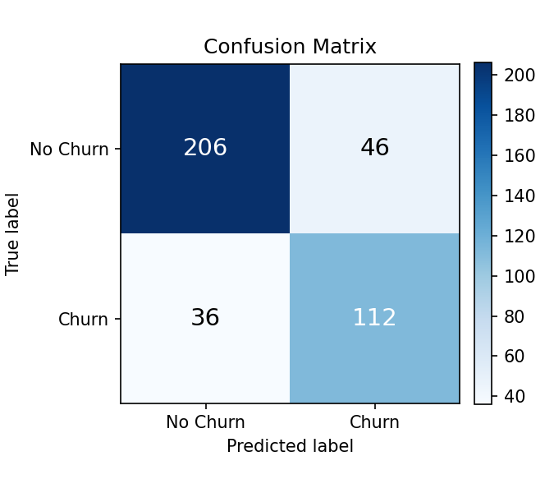

4.2 ROC Curve
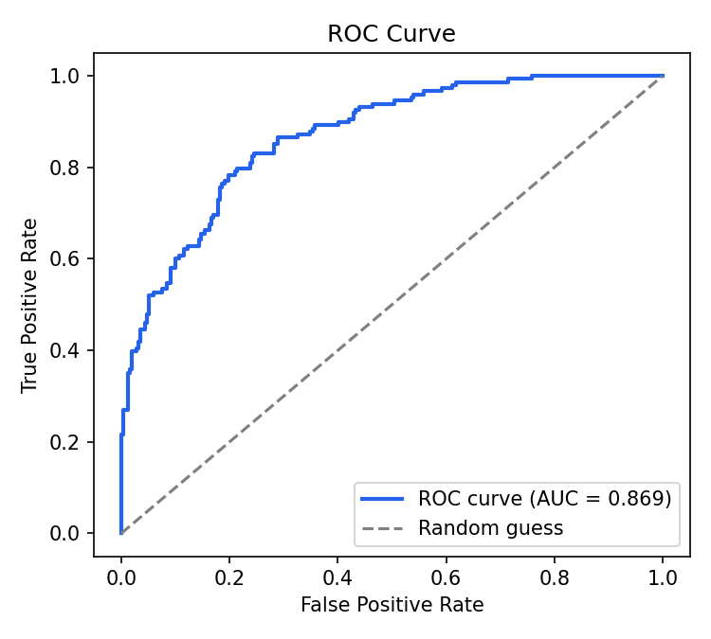

4.3 Top Predictive Features
Feature importances from the Random Forest model show which attributes drive churn risk most strongly:
Feature | Importance
tenure_months | 0.2454
total_charges | 0.1797
monthly_charges | 0.1113
contract_type_Two Year | 0.1102
contract_type_One Year | 0.0718
num_support_calls | 0.0564
internet_service_Fiber Optic | 0.0503
online_security_Yes | 0.0361

Consistent with industry-known churn drivers, tenure and billing amount dominate, followed by contract type — customers on longer (one/two-year) contracts are markedly less likely to churn than month-to-month customers.

5. Conclusion & Future Work
The project demonstrates a complete, reproducible applied-ML workflow: from raw data through a modular, object-oriented Python pipeline, into a relational database for persistent, queryable results. Potential extensions include hyperparameter tuning (grid/random search), testing additional algorithms (gradient boosting, SVM), deploying the model behind a REST API, and building a dashboard on top of the MySQL tables for real-time churn monitoring.

6. Tech Stack
- Languages: Python, SQL
- Libraries: pandas, NumPy, scikit-learn, matplotlib, joblib
- Database: MySQL (mysql-connector-python)
- Testing: pytest
- Version control: Git

