RCB - IPL Strategy - SQL Projects
Objective Questions
Q1. List the different dtypes of columns in table “ball_by_ball” (using information schema).
Ans. Use the below query to get the dtypes of columns in table “ball_by_ball” and there is total 11 columns with int datatype in the table “ball_by_ball”.
Query:-
SELECT
COLUMN_NAME, DATA_TYPE
FROM
INFORMATION_SCHEMA.COLUMNS
WHERE
TABLE_NAME = 'ball_by_ball';
O/P:-
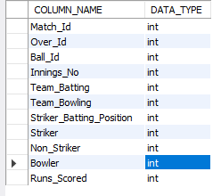
Q2. What is the total number of runs scored in 1st season by RCB (bonus: also include the extra runs using the extra runs table)
Ans. To find the total runs scored by Royal Challengers Bangalore (RCB) in the first IPL season, including extra runs, the following tables are needed:
Required Tables:
- matches: Contains match details, including the teams and season. team: Provides team names and IDs.
- ball_by_ball: Tracks each ball bowled, including the team batting.
- extra_runs: Tracks additional runs like wides and no-balls.
Query Approach:
- Match Selection: Filters matches where RCB played (Team_Id = 2) in the first season.
- Joining Tables: Joins relevant tables to link matches, balls, runs scored, and extra runs.
- Sum Runs: Adds up runs scored by RCB's batsmen and any extra runs.
Query:
SELECT
SUM(b.Runs_Scored + COALESCE(e.Extra_Runs,0))AS Total_Runs_With_Extras
FROM
Ball_by_Ball b
JOIN Matches m ON b.Match_Id = m.Match_Id
LEFT JOIN Extra_Runs e ON b.Match_Id = e.Match_Id AND b.Over_Id = e.Over_Id AND b.Ball_Id = e.Ball_Id AND b.Innings_No = e.Innings_No
WHERE m.Season_Id = 6 AND b.Team_Batting = (SELECT Team_Id FROM Team WHERE Team_Name = 'Royal Challengers Bangalore');
Output:
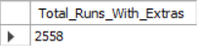
Q3. How many players were more than the age of 25 during season 2014?
Ans. 89
Tables Required:
- player - To get the player's date of birth.
- player_match - To find which players participated in matches during season 2014.
- matches - To find matches in season 2014.
- season - To identify season 2014 and its matches.
Query Approach: This query calculates the number of unique players whose age was above 25 during the 2014 season. To achieve this:
- Join the player, player_match, and matches tables: This allows access to the player's date of birth.
- Filter by season: The matches table is restricted to only those that belong to the 2014 season by matching the season ID for the year 2014 from the season table.
- Age Calculation: The TIMESTAMPDIFF function computes the player's age at the time of each match. Only records where the player's age exceeds 25 on the date ‘2014-01-01’ are considered.
- Count Unique Players: The query counts distinct player IDs who meet the criteria above, giving the total number of players above 25 years of age during the 2014 season.
Query:
SELECT
COUNT(DISTINCT p.player_id) as Total_players_above25
FROM
player p
INNER JOIN player_match pm ON p.player_id = pm.player_id
INNER JOIN matches m ON m.match_id = pm.match_Id
WHERE TIMESTAMPDIFF(YEAR, p.dob, '2014-01-01') > 25 AND m.season_id = (SELECT season_id FROM season WHERE season_year = ‘2014’);
Output:
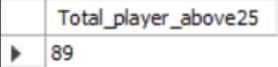

Q4. How many matches did RCB win in 2013?
Ans. To find the matches played by RCB in 2013
Tables Required
- Matches – To get matches with match_winner and season_id
- Team – To get team_id of RCB
- Season – to filter season_year 2013.
Query Approach:
- Join the table matches and season with season_id
- Filter with season_year 2013 and to get the team RCB team id done the filter of match_winner using the subquery from team table to get the RCB id.
- And lastly in the Select clause count the records to get the count of matches RCB won.
Query:
SELECT
COUNT(*) AS Matches_Won_By_RCB
FROM
Matches m
JOIN Season s ON m.season_id = s.season_id
WHERE s.season_year = 2013 and m.Match_Winner =(SELECT Team_id
FROM Team
Where Team_Name=’Royal Challengers Bangalore’);
Output:
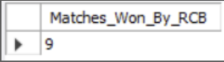
Q5. List the top 10 players according to their strike rate in the last 4 season.
Ans. Top 10 players according to their strike rate in the last 4 seasons are below:
Tables Required:
- Player – To get player name
- Matches – To get the matched of last four season
- Season – To get the last four season
- Ball_by_ball – Contains run_scored and striker(player_id)
Query Approach:
- Identify last 4 seasons
- Filter relevant matches
- Use ball_by_ball table to get collect balls faced and runs scored for each player in the filtered matches.
- Calculate steike rate using the formula
Strike Rate=(Total Balls Faced/Total Runs Scored)×100
- Sort the result by strike rate in decending order and limit the output to top 10 players.
Query:
WITH last4_seasons AS (
SELECT s.Season_Id
FROM season s
ORDER BY s.Season_Id DESC
LIMIT 4
),
recent_matches AS (
SELECT m.Match_Id
FROM matches m
WHERE m.Season_Id IN (SELECT Season_Id FROM last4_seasons)
)
SELECT
p.Player_Name AS player_name,
ROUND(100.0 * SUM(b.Runs_Scored) / COUNT(b.Runs_Scored),2) AS strike_rate
FROM player p
JOIN ball_by_ball b ON b.Striker = p.Player_Id
WHERE b.Match_Id IN (SELECT Match_Id FROM recent_matches)
AND NOT EXISTS (
SELECT 1
FROM extra_runs e
WHERE b.Match_Id = e.Match_Id
AND b.Over_Id = e.Over_Id
AND b.Ball_Id = e.Ball_Id
AND e.Extra_Type_Id NOT IN(1,3)
AND b.Innings_No = e.Innings_No
)
GROUP BY p.Player_Id, p.Player_Name
HAVING COUNT(b.Runs_Scored) >= 500
ORDER BY strike_rate DESC
LIMIT 10;
Output:
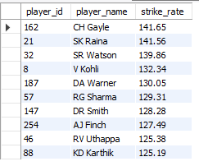
Q6. What are the average runs scored by each batsman considering all the seasons?
Ans. The average runs scored by each batsman in all seasons:

Table Required:
- Ball_by_ball – To calculate total runs scored by each player and to count total innings played.
- Player – To get player details such as player name and id.
Query Approach:
- Group the data in the Ball_by_Ball table by player (Striker) and match-innings to calculate runs scored by each player in each innings.
- Then, group the result again by player to calculate total runs and total innings played.
- Finally, calculate the average runs per innings for each player by dividing total runs by innings played.
- Join with the Player table to display the player names.

Query:
SELECT
p.Player_Name,
ROUND(SUM(sub.Total_Runs) * 1.0 / COUNT(*), 2) AS Avg_Runs
FROM
(
SELECT
Striker,
Match_Id,
Innings_No,
SUM(Runs_Scored) AS Total_Runs
FROM
Ball_by_Ball
GROUP BY
Strike Rate = (Total Runs Scored / Total Balls Faced) × 100
) AS sub
Sort the result by strike rate in descending order and limit the output to the top 10 players.
GROUP BY
p.Player_Name
ORDER BY
Avg_Runs DESC;
Output:
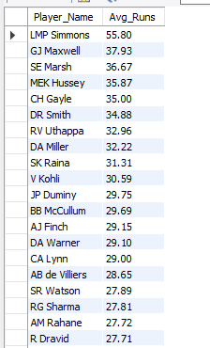

Q7. What are the average wickets taken by each bowler considering all the seasons?
Ans. The average wickets taken by each bowler per season are shown in the output.
Output:
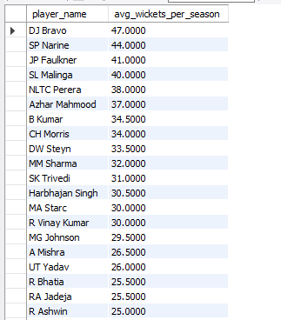
Tables Required:
- player: Provides player names and IDs.
- wicket_taken: Contains information about the wickets taken by each bowler on each ball.
- ball_by_ball: Links each ball to the bowler who delivered it.
- Matches: Link each ball and wicket to a specific season.
Query Approach:
- Join the player table with ball_by_ball on bowler's player_id.
- Join ball_by_ball with wicket_taken on match_id, over_id, and ball_id to identify wickets taken by each bowler.
- Join ball_by_ball (or wicket_taken) with matches on match_id to access season information.
- Group data by player name.
- Calculate total wickets by counting player_out entries.
- Calculate the number of distinct seasons bowled by counting unique season_ids.
- Compute average wickets per season by dividing total wickets by number of seasons.
- Order results by average wickets in descending order.
Query:
SELECT
p.player_name,
COUNT(wt.player_out) / COUNT(DISTINCT m.season_id) AS avg_wickets_per_season
FROM
player p
JOIN
ball_by_ball b ON b.bowler = p.player_id
JOIN
wicket_taken wt ON wt.match_id = b.match_id AND wt.over_id = b.over_id AND wt.ball_id = b.ball_id
JOIN
matches m ON m.match_id = b.match_id
GROUP BY
p.player_name
ORDER BY
avg_wickets_per_season DESC;
Q8. List all the players who have average runs scored greater than the overall average and who have taken wickets greater than the overall average
Ans.
Output:
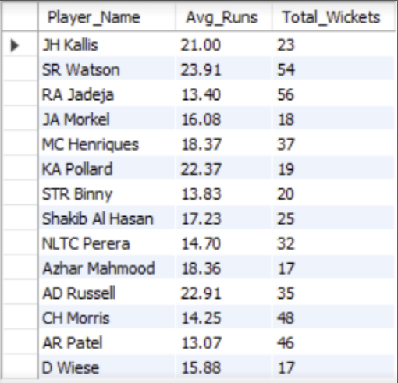
Query Approach:
We’ll solve this in three parts using Common Table Expressions (CTEs):
Part 1: Calculate average runs per batsman From the Ball_by_Ball table.
Part 2: Calculate total wickets per bowler From the Wicket_Taken + Ball_by_Ball tables.
Part 3: Calculate overall averages for both
Query:
WITH player_runs AS (
SELECT
Striker AS Player_Id,
SUM(Runs_Scored) AS Total_Runs,
COUNT(DISTINCT CONCAT(Match_Id, '-', Innings_No)) AS Innings_Played
FROM
Ball_by_Ball
GROUP BY
Striker
),
player_avg_runs AS (
SELECT
Player_Id,
ROUND(Total_Runs * 1.0 / Innings_Played, 2) AS Avg_Runs
FROM
player_runs
WHERE Innings_Played > 0
),
overall_avg_runs AS (
SELECT
ROUND(AVG(Total_Runs * 1.0 / Innings_Played), 2) AS Overall_Avg_Runs
FROM
player_runs
WHERE Innings_Played > 0
),
player_wickets AS (
SELECT
b.Bowler AS Player_Id,
COUNT(w.Player_Out) AS Total_Wickets
FROM
Ball_by_Ball b
JOIN
Wicket_Taken w ON b.Match_Id = w.Match_Id
AND b.Over_Id = w.Over_Id
AND b.Ball_Id = w.Ball_Id
AND b.Innings_No = w.Innings_No
GROUP BY
b.Bowler
),
overall_avg_wickets AS (
SELECT
ROUND(AVG(Total_Wickets), 2) AS Overall_Wickets
FROM
player_wickets
)
SELECT
p.Player_Name,
r.Avg_Runs,
w.Total_Wickets
FROM
player_avg_runs r
JOIN
overall_avg_runs oar ON 1=1
JOIN
player_wickets w ON r.Player_Id = w.Player_Id
JOIN
overall_avg_wickets oaw ON 1=1
JOIN
Player p ON p.Player_Id = r.Player_Id
WHERE
r.Avg_Runs > oar.Overall_Avg_Runs
AND w.Total_Wickets > oaw.Overall_Wickets;
What this query does:
Section | Purpose
player_avg_runs | Calculates average runs per batsman
overall_avg_runs | Gets the overall average run rate
player_wickets | Total wickets per bowler
overall_avg_wickets | Overall average wickets taken
Final SELECT | Combines players who exceed both averages and gets their name

Q9. Create a table rcb_record table that shows the wins and losses of RCB in an individual venue.
Ans. Below is the rcb_record table that shows the win and losses of RCB in an individual venue:
Output:
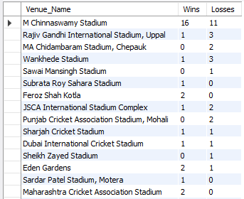
Table Required:
- Matches – To get match outcome and venue
- Team – To get RCB team_id
- Venue – To show venue name
Query:

Step 1: Create the Table:
CREATE TABLE rcb_record (
Venue_Name VARCHAR(100),
Wins INT DEFAULT 0,
Losses INT DEFAULT 0
);

Step 2: Insert the Wins and Losses by Venue:

SELECT
v.Venue_Name,
SUM(CASE WHEN m.Match_Winner = 2 THEN 1 ELSE 0 END) AS Wins,
SUM(CASE
WHEN (m.Match_Winner IS NOT NULL AND m.Match_Winner != 2 AND (m.Team_1 = 2 OR m.Team_2 = 2))
THEN 1
ELSE 0
END) AS Losses
FROM
Matches m
JOIN
Venue v ON m.Venue_Id = v.Venue_Id
WHERE
(m.Team_1 = 2 OR m.Team_2 = 2) -- RCB participated
GROUP BY
v.Venue_Name
order by wins desc, losses asc;

Q10. What is the impact of bowling style on wickets taken?
Ans. To Analyze the impact of bowling style on wickets taken, the following tables are required:
- Player: To get information about the players, including their bowling style.
- bowling_style: To determine the type of bowling style associated with each player.
- wicket_taken: To get the details about the wickets taken by each bowler.
- ball_by_ball: To link the wickets taken with the bowler in each ball.
Query Approach:
- Identify each bowler's style.
- Count the total wickets taken by bowlers of each style.
- Compare the wicket counts to assess the impact of different bowling styles.
Insights:
- Right-arm medium bowlers have taken the highest number of wickets (1173), showing their consistency and effectiveness in matches.
- Right-arm fast-medium bowlers follow with 735 wickets, indicating that pace combined with control is a key wicket-taking skill.
- Right-arm offbreak (586) and Left-arm orthodox (567) spinners also play a major role, proving that spin bowling remains an important factor in taking wickets.
- Right-arm fast (453) and Left-arm fast-medium (349) bowlers show solid performance but are less dominant compared to medium pacers.
- Slow left-arm chinaman (56) and Left-arm medium (81) bowlers have the fewest wickets, suggesting these styles are less common or less effective in this dataset.
Recommendations:
- Based on the analysis, teams should focus on strengthening their right-arm medium and fast-medium bowling units, as these bowlers have proven to be the most effective wicket-takers.
- At the same time, maintaining a balance by including quality spin options like right-arm offbreak and left-arm orthodox bowlers can add variety and effectiveness, especially on spin-friendly pitches.

Query:
SELECT
bs. Bowling_skill, COUNT(wt.player_out) as Wicket_taken
FROM
player p
INNER JOIN bowling_style bs on p.bowling_skill = bs.bowling_id
INNER JOIN ball_by_ball bb on p.player_id = bb.bowler
INNER JOIN wicket_taken wt on bb.match_id = wt.match_id and bb.over_id = wt.over_id and bb.ball_id = wt.ball_id
GROUP BY bs.bowling_skill
ORDER BY Wicket_taken desc;
Output:
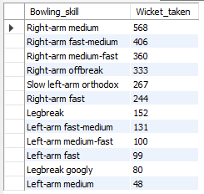

Q11. Write the SQL query to provide a status of whether the performance of the team is better than the previous year's performance on the basis of the number of runs scored by the team in the season and the number of wickets taken.
Ans.
Table Required:
- Ball_by_ball - Contains per-ball data (runs, overs, innings, batting/bowling team)
- Matches - Contains match-level details including season reference
- Wicket_Taken - Contains details of wickets
- Season – Contain season- year mapping
- Team – Contains team details

Query Approach:
- Aggregate total runs per team per season.
- Aggregate total wickets per team per season.
- Combine both to get team performance per season.
- Use LAG() to get the previous year’s performance for the same team.
- Compare current vs. previous to determine if the team improved, declined, or stayed the same.

Query:

WITH team_runs AS (
SELECT
m.Season_Id,
b.Team_Batting AS Team_Id,
SUM(b.Runs_Scored) AS Total_Runs
FROM
Ball_by_Ball b
JOIN
Matches m ON b.Match_Id = m.Match_Id
GROUP BY
m.Season_Id, b.Team_Batting
),
team_wickets AS (
SELECT
m.Season_Id,
b.Team_Bowling AS Team_Id,
COUNT(w.Player_Out) AS Total_Wickets
FROM
Ball_by_Ball b
JOIN
Matches m ON b.Match_Id = m.Match_Id
JOIN
Wicket_Taken w ON b.Match_Id = w.Match_Id
AND b.Over_Id = w.Over_Id
AND b.Ball_Id = w.Ball_Id
AND b.Innings_No = w.Innings_No
GROUP BY
m.Season_Id, b.Team_Bowling
),
combined AS (
SELECT
r.Season_Id,
r.Team_Id,
r.Total_Runs,
w.Total_Wickets
FROM
team_runs r
JOIN
team_wickets w ON r.Season_Id = w.Season_Id AND r.Team_Id = w.Team_Id
),
with_previous AS (
SELECT
c.*,
s.Season_Year,
LAG(c.Total_Runs) OVER (PARTITION BY c.Team_Id ORDER BY s.Season_Year) AS Prev_Total_Runs,
LAG(c.Total_Wickets) OVER (PARTITION BY c.Team_Id ORDER BY s.Season_Year) AS Prev_Total_Wickets
FROM
combined c
JOIN
Season s ON c.Season_Id = s.Season_Id
)
SELECT
t.Team_Name,
wp.Season_Year,
wp.Total_Runs,
wp.Total_Wickets,
wp.Prev_Total_Runs,
wp.Prev_Total_Wickets,
CASE
WHEN wp.Total_Runs > wp.Prev_Total_Runs AND wp.Total_Wickets > wp.Prev_Total_Wickets THEN 'Improved'
WHEN wp.Total_Runs < wp.Prev_Total_Runs AND wp.Total_Wickets < wp.Prev_Total_Wickets THEN 'Declined'
ELSE 'Same'
END AS Performance_Status
FROM
with_previous wp
JOIN
Team t ON wp.Team_Id = t.Team_Id
WHERE
wp.Prev_Total_Runs IS NOT NULL AND wp.Prev_Total_Wickets IS NOT NULL
ORDER BY
t.Team_Name, wp.Season_Year;

Output:

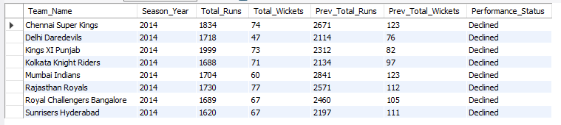

Q12. Can you derive more KPIs for the team strategy?
Ans. Top 5 KPIs for Team Strategy (with Formula):
I derived the following 5 KPIs from the dataset to help analyse team performance and strategy. These KPIs are calculated using the data available:

1. Win Percentage:
Formula:
(Number of Matches Won/Number of Matches Played​) ×100

Tables & Columns Used:
Matches table:
- Match_Winner – to identify which team won
- Team_1, Team_2 – to count total matches a team played

This helps evaluate a team's overall success rate.
Query Approach:
Use the Matches table, filter by team as MatchWinner, and divide the number of wins by matches played.
Query:
SELECT t.team_name, COUNT(CASE WHEN m.match_winner = t.team_id THEN 1 END) * 100.0 / COUNT(*) AS win_percentage FROM matches m JOIN team t ON t.team_id = m.team1 OR t.team_id = m.team2 GROUP BY t.team_name;

Output:
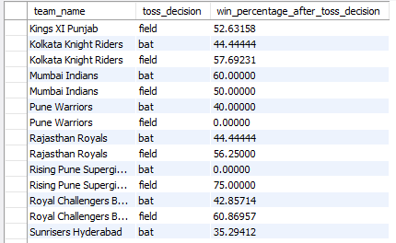

2. Average Runs per Match:
Formula:
(Total Runs Scored​ / Total Matches Played​)

Tables & Columns Used:
Ball_by_Ball table:
- Runs_Scored – the runs scored per ball
- Team_Batting – which team scored the run

Matches table:
- Match_Id – to count unique matches per team
Useful for understanding the team's scoring consistency.
Query Approach:
- Join the ball_by_ball, matches, and team tables to relate runs scored to the team and match context.
- Filter/group by batting team to sum up runs for each team.
- Count unique matches played (using COUNT(DISTINCT m.match_id)) to get matches per team.
- Divide total runs by total matches to calculate the average per team.
Query:
SELECT t.team_name, SUM(b.runs_scored) / COUNT(DISTINCT m.match_id) AS avg_runs_per_match FROM ball_by_ball b JOIN matches m ON b.match_id = m.match_id JOIN team t ON b.team_batting = t.team_id GROUP BY t.team_name ORDER BY avg_runs_per_match DESC;
Output:
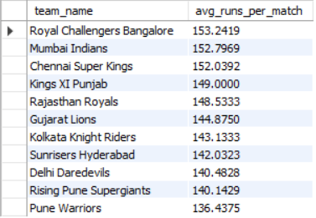
3. Average Wickets per Match:
Formula:
(Total Wickets Taken​​ / Total Matches Played​)

Tables & Columns Used:
Wicket_Taken table:
- Player_Out – identifies a wicket taken

Ball_by_Ball table:
- Team_Bowling – to know which team took the wicket

Matches table:
- Match_Id – to group wickets match-wise

This shows the bowling strength of a team
Query Approach:
- Join wicket_taken with ball_by_ball to relate each wicket to the team bowling that ball.
- Join matches to associate matches context.
- Join team on bowling team for readable output.
- Count total wickets using the player_out column in wicket_taken for each team.
- Count unique matches bowled by each team.
- Divide total wickets by total matches to get average wickets per match.

Query:
SELECT t.team_name, COUNT(w.player_out) / COUNT(DISTINCT m.match_id) AS avg_wickets_per_match FROM wicket_taken w JOIN ball_by_ball b ON w.match_id = b.match_id AND w.over_id = b.over_id AND w.ball_id = b.ball_id JOIN matches m ON w.match_id = m.match_id JOIN team t ON b.team_bowling = t.team_id GROUP BY t.team_name ORDER BY avg_wickets_per_match DESC;
Output:
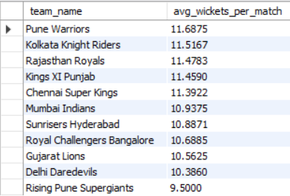
4. Run Rate:
Formula:
(Total Runs Scored​​​ / Total Overs Faced​)

Tables & Columns Used:
Ball_by_Ball table:
- Runs_Scored – for total runs
- Over_Id – to calculate total overs
- Team_Batting – to group by team
Helps understand how quickly a team scores runs.
Query Approach:
- Join ball_by_ball and team to relate runs to teams.
- Sum runs scored for each team.
- Count all balls faced
- Divide runs by overs to get overall run rate for each team.
- Count matches if differentiating between average per match and total run rate.
Query:
SELECT t.team_name, SUM(b.runs_scored) / (COUNT(DISTINCT m.match_id) * 20) AS run_rate FROM ball_by_ball b JOIN matches m ON b.match_id = m.match_id JOIN team t ON b.team_batting = t.team_id GROUP BY t.team_name ORDER BY run_rate DESC;
Note: Assuming each match has 20 overs.

Output:
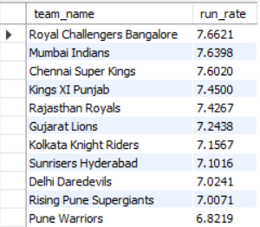

5. Toss Impact KPI:
Formula:
Win % After Toss Decision (Bat/Field):

(Matches Won After Toss Decision / Matches with That Toss Decision) * 100

Understand if choosing to bat or field first affects performance.

Tables & Columns Used:
Matches table:
- Toss_Winner – to identify which team won the toss
- Toss_Decide – to check if the team chose to bat or field
- Match_Winner – to verify if the toss-winning team also won the match
Team table:
- Team_Id, Team_Name – to display readable team names in the output

Helps evaluate whether teams make the right decision after winning the toss and how it affects their chances of winning.
Query Approach:
- Join matches and team on the toss winner to get readable team names.
- Join matches and toss_decision on the toss_decide column to get the toss decision name.
- Group by team and toss decision to separate results for each decision per team.
- Calculate win percentage using a conditional count where toss winner is also match winner, divided by total matches for that toss decision.
- Order by team and toss decision for clear output.
Query:
SELECT t.team_name, td.toss_name AS toss_decision, COUNT(CASE WHEN m.toss_winner = m.match_winner THEN 1 END) * 100.0 / COUNT(*) AS win_percentage_after_toss_decision FROM matches m JOIN team t ON m.toss_winner = t.team_id JOIN toss_decision td ON m.toss_decide = td.toss_id GROUP BY t.team_name, td.toss_name ORDER BY t.team_name, td.toss_name;
Output:
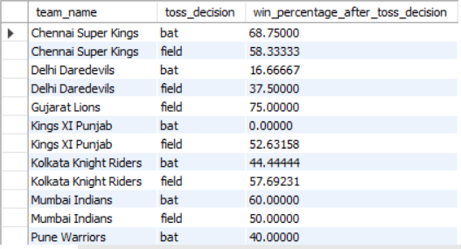

Q13. Using SQL, write a query to find out the average wickets taken by each bowler in each venue. Also, rank the gender according to the average value.
Ans. The intended analysis is to compare wickets by bowler and venue. However, the current query uses AVG(wt.Player_Out), which averages player IDs rather than counting wickets. The output values such as 434.00 for CJ Jordan at M Chinnaswamy are therefore not valid average-wicket values.
Tables Required:
- player: To get the name of the bowler (using Player_Name).
- player_match: To associate each player with the matches they played.
- matches: To get information about the match and to connect with the venue.
- wicket_taken: To count the number of wickets taken by each bowler in each match.
- venue: To get the name of the venue where the matches were played.

Query Approach:
- Identify Bowler and Venue: The player, player_match, matches, and venue tables are used to identify which bowler (player) took wickets at which venue.
- Calculate Wickets: The wicket_taken table is utilized to calculate the number of wickets taken by each bowler at different venues.
- Calculate Average: The AVG () function is used to calculate the average number of wickets taken by each bowler at each venue.
- Ranking: The RANK () function is used to rank the bowlers based on their average wickets taken.
Insights:
- Top Performers: This query helps in identifying the bowlers who have consistently performed well across different venues by taking the highest average number of wickets.
- Venue Impact: By analyzing this data, one can infer which venues Favor certain bowlers, as some bowlers might have higher averages in particular venues due to pitch conditions or other factors.
- Strategic Team Selection: Teams can use this information for strategic decisions, selecting bowlers who have a proven track record at certain venues for upcoming matches.
Query:
SELECT
p.Player_Name,
v.Venue_Name,
AVG(wt.Player_Out) AS Average_Wickets,
RANK() OVER (ORDER BY AVG(wt.Player_Out) DESC) AS Wicket_Rank
FROM
player p
INNER JOIN
player_match pm ON p.Player_Id = pm.Player_Id
INNER JOIN
matches m ON pm.Match_Id = m.Match_Id
INNER JOIN
wicket_taken wt ON m.Match_Id = wt.Match_Id
AND p.Player_Id = wt.Player_Out
INNER JOIN
venue v ON m.Venue_Id = v.Venue_Id
GROUP BY
p.Player_Name, v.Venue_Name
ORDER BY
Wicket_Rank;

Output:

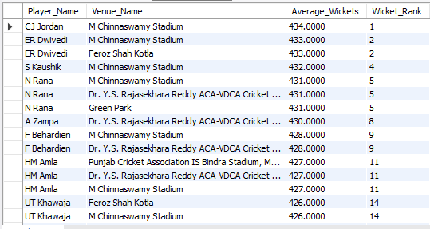

Q14. Which of the given players have consistently performed well in past seasons? (will you use any visualization to solve the problem)
Ans. To find out which players have consistently performed well in past seasons, I looked at two main performance indicators:
- Runs scored by each batsman in every season
- Wickets taken by each bowler in every season

I grouped the data season-wise and player-wise to compare runs and wickets across seasons. The queries provide season-wise totals; consistency should be judged by repeated strong performance across multiple seasons rather than by one season alone.

Step-by-Step Process:

1. For Batsman – Season-wise Runs Scored
The following SQL query to get the total runs scored by each batsman in every season:
Query:
SELECT
p.Player_Name,
s.Season_Year,
SUM(b.Runs_Scored) AS Total_Runs
FROM
Ball_by_Ball b
JOIN Matches m ON b.Match_Id = m.Match_Id
JOIN Season s ON m.Season_Id = s.Season_Id
JOIN Player p ON b.Striker = p.Player_Id
GROUP BY
p.Player_Name, s.Season_Year
ORDER BY
p.Player_Name, s.Season_Year;

Output:
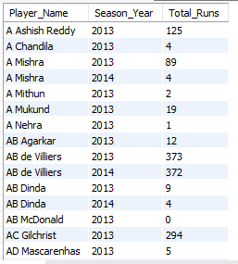

2. For Bowlers – Season-wise Wickets Taken

To find how many wickets each bowler took in every season, I used this query:
Query:

SELECT
p.Player_Name,
s.Season_Year,
COUNT(w.Player_Out) AS Total_Wickets
FROM
Ball_by_Ball b
JOIN Wicket_Taken w ON b.Match_Id = w.Match_Id
AND b.Over_Id = w.Over_Id
AND b.Ball_Id = w.Ball_Id
AND b.Innings_No = w.Innings_No
JOIN Matches m ON b.Match_Id = m.Match_Id
JOIN Season s ON m.Season_Id = s.Season_Id
JOIN Player p ON b.Bowler = p.Player_Id
GROUP BY
p.Player_Name, s.Season_Year
ORDER BY
p.Player_Name, s.Season_Year;

Output:
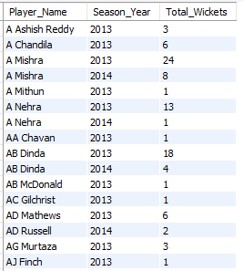

Q15. Are there players whose performance is more suited to specific venues or conditions? (how would you present this using charts?)
Ans. The queries identify players with the highest runs or wickets at particular venues. This can highlight strong venue-specific performers, but the current queries use total runs/wickets and do not divide by matches played, so they do not by themselves prove that a player is more efficient at that venue.
Step 1: Write SQL Queries to Get Player-Venue Performance:
For Batsman (Runs per Venue):
SELECT
p.Player_Name,
v.Venue_Name,
SUM(b.Runs_Scored) AS Total_Runs
FROM
Ball_by_Ball b
JOIN Matches m ON b.Match_Id = m.Match_Id
JOIN Venue v ON m.Venue_Id = v.Venue_Id
JOIN Player p ON b.Striker = p.Player_Id
GROUP BY
p.Player_Name, v.Venue_Name
Order by Total_Runs desc
Limit 10;

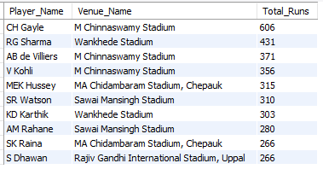

For Bowlers (Wickets per Venue):
SELECT
p.Player_Name,
v.Venue_Name,
COUNT(w.Player_Out) AS Total_Wickets
FROM
Ball_by_Ball b
JOIN Wicket_Taken w ON b.Match_Id = w.Match_Id
AND b.Over_Id = w.Over_Id
AND b.Ball_Id = w.Ball_Id
AND b.Innings_No = w.Innings_No
JOIN Matches m ON b.Match_Id = m.Match_Id
JOIN Venue v ON m.Venue_Id = v.Venue_Id
JOIN Player p ON b.Bowler = p.Player_Id
GROUP BY
p.Player_Name, v.Venue_Name
Order by Total_wickets desc
Limit 10;

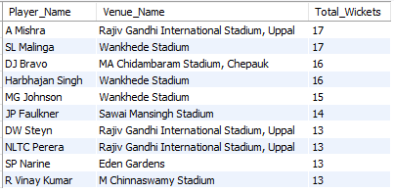

Conclusion: The SQL queries can identify the players with the highest total runs or wickets at each venue. For a stronger “venue suitability” conclusion, compare performance per match or per ball at each venue.
Yes, there are players whose performance is more suited to specific venues.
I used SQL to fetch venue-wise stats and Excel (pivot table, Column charts) to visualize and compare.
This helped me clearly identify which players are most effective at each stadium.

Subjective Questions

Q1. How does the toss decision affect the result of the match? (which visualizations could be used to present your answer better) And is the impact limited to only specific venues?
Ans. To understand how toss decisions have influenced match results, we need to Analyze data from three key tables:
Tables Required
- matches: To identify the toss winner, match winner, and link with venue and toss decisions.
- toss_decision: To determine whether the toss-winning team chose to bat or bowl.
- venue: To identify the venue of the match for venue-specific analysis.
Query Approach
- Filter the data to venues where at least 10 matches were played with the same toss decision.
- Calculate the percentage of matches won by the toss winner for each venue and toss decision.
- Sort and limit the results to highlight the top 10 most relevant venue-toss decision combinations.
Insights
- Venue-Specific Impact: The toss impact varies by venue and by the decision to bat or field.
- Highest result in the output: At MA Chidambaram Stadium, Chepauk, the toss winner won 8 of 11 matches (72.73%) when choosing to bat.
- Other strong combinations include Feroz Shah Kotla with fielding at 66.67% (12 of 18) and Wankhede Stadium with batting at 64.29% (9 of 14).
Recommendations:
- Data-Driven Decisions: Use venue-wise toss history as one input when deciding whether to bat or field.
- Venue Strategy: The output shows that the best toss decision is not the same at every venue; for example, batting performs strongly at Chepauk while fielding performs strongly at Feroz Shah Kotla.
Query:
WITH Toss_Win_Stats AS (
SELECT v.Venue_Name,
td.Toss_Name AS Toss_Decision,
COUNT(*) AS Total_Matches,
SUM(CASE WHEN m.Match_Winner = m.Toss_Winner THEN 1 ELSE 0 END) AS Matches_Won_After_Toss,
(SUM(CASE WHEN m.Match_Winner = m.Toss_Winner THEN 1 ELSE 0 END) / COUNT(*)) * 100 AS Win_Percentage
FROM matches m
INNER JOIN toss_decision td ON m.Toss_Decide = td.Toss_Id
INNER JOIN venue v ON m.Venue_Id = v.Venue_Id
GROUP BY v.Venue_Name, td.Toss_Name
)
SELECT Venue_Name,
Toss_Decision,
Total_Matches,
Matches_Won_After_Toss,
Win_Percentage
FROM Toss_Win_Stats
WHERE Total_Matches >= 10
ORDER BY Win_Percentage DESC, Total_Matches DESC;

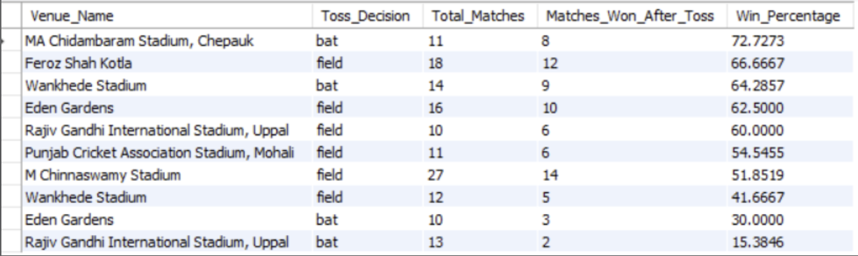

Q2. Suggest some of the players who would be best fit for the team.
Ans. To suggest the best-fit players, I used the metrics produced by the queries: average runs per match for batsmen and total wickets for bowlers. The output highlights players with strong scoring or wicket-taking records.

How I selected the best players:

For Batsman, I checked:
- Total Runs
- Average Runs per Match
- Strike Rate (from the available analysis)
- Performance in different venues
For Bowlers, I checked:
- Total Wickets
- Total Wickets
- Consistency through a minimum match threshold where used by the query
- Consistency over seasons

Query:

Top 10 Batsmen by Average Runs per Match:
SELECT
p.Player_Name,
ROUND(SUM(b.Runs_Scored) * 1.0 / COUNT(DISTINCT m.Match_Id), 2) AS Avg_Runs_Per_Match
FROM
Ball_by_Ball b
JOIN Matches m ON b.Match_Id = m.Match_Id
JOIN Player p ON b.Striker = p.Player_Id
GROUP BY
p.Player_Name
HAVING
COUNT(DISTINCT m.Match_Id) >= 5 -- filters out players who played too few matches
Insights: The current chart/output should not be used to claim that a bowler took 434 average wickets. The values are produced by averaging Player_Out IDs. A corrected query should count wickets and divide by the relevant number of matches or bowling appearances.
Avg_Runs_Per_Match DESC
LIMIT 10;

Query Approach:
- Joins tables:
  - Ball_by_Ball for runs scored
  - Strategic Team Selection: After correcting the calculation, venue-wise wicket averages can help identify bowlers who perform well at specific grounds.
  - Player for player names
- Calculates:
  - Total runs scored by each player → SUM(b.Runs_Scored)
  - Total matches played → COUNT(DISTINCT m.Match_Id)
  - Average runs per match → Total Runs ÷ Distinct Matches
- Filters out players with less than 5 matches using HAVING -- filters out players who played too few matches
- Sorts the players by average runs in descending order.
- Limits the result to the top 10 players.

Output: The chart/output shows LMP Simmons at 55.80 average runs per match, followed by GJ Maxwell at 37.93 and SE Marsh at 36.67.
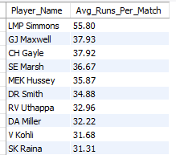

Top 10 Bowlers by Total Wickets:
SELECT
p.Player_Name,
COUNT(w.Player_Out) AS Total_Wickets
FROM
Ball_by_Ball b
JOIN Wicket_Taken w ON b.Match_Id = w.Match_Id
AND b.Over_Id = w.Over_Id
AND b.Ball_Id = w.Ball_Id
AND b.Innings_No = w.Innings_No
JOIN Player p ON b.Bowler = p.Player_Id
GROUP BY
p.Player_Name
ORDER BY
Total_Wickets DESC
LIMIT 10;
Query Approach:
- Joins tables:
  - Ball_by_Ball to get ball-wise details.
  - Wicket_Taken to check if a wicket was taken on that ball.
  - Player to get the bowler's name.
- Matches the exact ball where the wicket was taken using:
  - Match_Id, Over_Id, Ball_Id, and Innings_No
- Counts the total wickets taken by each bowler using COUNT(w.Player_Out).
- Groups by Player_Name to get wicket count per player.
- Sorts the result in descending order of Total_Wickets
- Limits the result to the top 10 bowlers.

Output: The chart lists the leading wicket-takers, including JP Faulkner, SP Narine, MM Sharma, SL Malinga and RR Vinay Kumar.
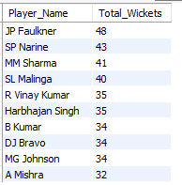

Q3. What are some of the parameters that should be focused on while selecting the players?
Ans. The query focuses on matches played, total runs, average runs per ball, strike rate, and total wickets. These are the main performance measures available in this query for comparing players.
Tables Required:
- player: To get the player's name and unique identifier.
- ball_by_ball: To track each ball's outcome and identify the players involved and runs scored by player.
- wicket_taken: To track the wickets taken by each player.
Approach:
- Player Details: The player table is used to identify the player names.
- Ball-by-Ball Data: Join with the ball_by_ball table to link each ball event with players.
- Wickets: Use the wicket_taken table to count the number of wickets taken by each player (bowler).
- Calculation: Calculate total runs, average runs per ball, strike rate and total wickets for players who have played more than 10 matches.
- Final Output: Return the top 10 players ordered by total runs.
Insights:
- Top Run-Scorers: The output ranks players by total runs, so it is useful for identifying strong batting contributors.
- All-Rounders: Players with meaningful batting and wicket contributions can provide extra team balance, although the query itself is not a dedicated all-rounder ranking.
- Strike Rate Impact: Players with higher strike rates offer greater impact in limited-overs games, particularly in high-pressure overs.
Recommendations:
- Focus on High Performers: Consider total runs, strike rate, matches played and wickets together rather than relying on one metric.
- All-Rounder Strategy: Select all-rounders who contribute significantly with both the bat and ball, providing extra flexibility in team composition.
Query:
WITH Player_Stats AS (
SELECT
p.Player_Name,
COUNT(DISTINCT m.Match_Id) AS Matches_Played,
-- Batting metrics
SUM(bbb.Runs_Scored) AS Total_Runs,
AVG(bbb.Runs_Scored) AS Avg_Runs_Per_Ball,
(SUM(bbb.Runs_Scored) /COUNT(bbb.ball_id ))* 100.0 AS Strike_Rate,
-- Bowling metrics
COUNT(wt.Player_Out) AS Total_Wickets
FROM player p
INNER JOIN ball_by_ball bbb ON p.Player_Id = bbb.Striker OR p.Player_Id = bbb.Bowler
INNER JOIN matches m ON bbb.Match_Id = m.Match_Id
LEFT JOIN wicket_taken wt
ON bbb.Match_Id = wt.Match_Id
AND bbb.Over_Id = wt.Over_Id
AND bbb.Ball_Id = wt.Ball_Id
GROUP BY p.Player_Name
)
SELECT
Player_Name,
Matches_Played,
Total_Runs,
ROUND(Avg_Runs_Per_Ball, 2) AS Avg_Runs_Per_Ball,
ROUND(Strike_Rate, 2) AS Strike_Rate,
Total_Wickets
FROM Player_Stats
WHERE Matches_Played > 10
ORDER BY
Total_Runs DESC
LIMIT 10;

Output:

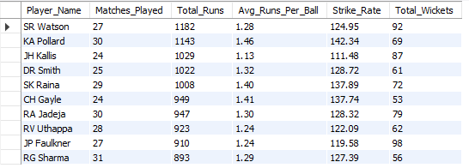

Q4. Which players offer versatility in their skills and can contribute effectively with both bat and ball? (can you visualize the data for the same)
Ans. The query identifies players who have contributed in both batting and bowling. It compares batting strike rate with bowling runs per ball (labelled Economy Rate in the query) after applying minimum balls-faced and balls-bowled filters.
- Required Tables:
- player: Contains player information (Player_Name, Player_Id).
- player_match: Links players to specific matches.
- ball_by_ball: Provides details on balls bowled, batsmen faced, and wickets taken.

Query Approach:

Step |  | Purpose | Key Columns
Step 1 |  | Calculates batting stats (total runs and balls faced) | Total_Runs, Balls_Faced
Step 2 |  | Calculates bowling stats (runs conceded and balls bowled) | Runs_Conceded, Balls_Bowled
Step 3 |  | Combines both, filters for players who have contributed significantly in both departments, and ranks them | Strike_Rate, Economy_Rate
Insights:
- The output highlights players with high batting strike rates and lower bowling runs per ball. For example, GJ Maxwell has a 178.91 strike rate and 1.92 bowling runs per ball, while Shakib Al Hasan has a 151.65 strike rate and 0.98 bowling runs per ball.
- The minimum of more than 50 balls faced and more than 30 balls bowled helps avoid very small samples.
- The result can be visualized with a scatter chart using strike rate on one axis and bowling runs per ball on the other.
Recommendations:
- Use these players as potential all-round options when building a balanced squad, while also checking their total runs, wickets and role fit before auction decisions.
- Use this data to strategically position these players in the lineup for maximum impact, both in middle-order batting and as reliable bowlers.
Query:
-- Step 1: Calculate batting performance
CREATE TEMPORARY TABLE IF NOT EXISTS BattingPerformance AS
SELECT
p.Player_Name,
SUM(bbb.Runs_Scored) AS Total_Runs,
COUNT(bbb.Ball_Id) AS Balls_Faced
FROM player p
INNER JOIN ball_by_ball bbb ON p.Player_Id = bbb.Striker
INNER JOIN matches m ON bbb.Match_Id = m.Match_Id
GROUP BY p.Player_Name;

-- Step 2: Calculate bowling performance
CREATE TEMPORARY TABLE IF NOT EXISTS BowlingPerformance AS
SELECT
p.Player_Name,
COUNT(bbb.Ball_Id) AS Balls_Bowled,
SUM(bbb.Runs_Scored) AS Runs_Conceded
FROM player p
INNER JOIN ball_by_ball bbb ON p.Player_Id = bbb.Bowler
INNER JOIN matches m ON bbb.Match_Id = m.Match_Id
GROUP BY p.Player_Name;
-- Step 3: Combine both performances and calculate metrics
SELECT
bp.Player_Name,
bp.Total_Runs,
(bp.Total_Runs * 100.0 / bp.Balls_Faced) AS Strike_Rate,
wp.Runs_Conceded,
(wp.Runs_Conceded * 1.0 / wp.Balls_Bowled) AS Economy_Rate
FROM BattingPerformance bp
INNER JOIN BowlingPerformance wp ON bp.Player_Name = wp.Player_Name
WHERE bp.Balls_Faced > 50 AND wp.Balls_Bowled > 30
ORDER BY Strike_Rate DESC, Economy_Rate ASC
LIMIT 10;

Output:
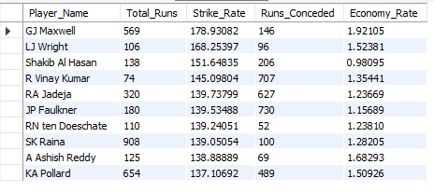

Q5. Are there players whose presence positively influences the morale and performance of the team? (justify your answer using visualization)
Ans. The query identifies players whose team won more often in matches where the player appeared as a striker. This can show match association, but it does not directly measure morale, leadership or motivation.
How I Identified Them:
To analyse this, I checked:
How many matches a player played
- How many of those matches the team won
- The win percentage when the player was in the match

Insights
- Win Percentage Association: The query calculates the team win percentage across matches in which the player appeared, using a minimum of 10 matches.
  - High win percentages show a strong association with winning results, but they should not be interpreted as proof that the player caused the wins.
- Player Roles: Leadership or experience may be considered separately; they are not measured by this SQL query.
- Beyond Individual Stats: The metric adds team-result context, but it is still a match-association measure rather than a direct morale measure.

Recommendations
- Use the result as one input for retention and team selection, together with individual performance metrics.
- Do not use win percentage alone to judge leadership or morale.
- Combine this metric with runs, wickets, strike rate, economy and consistency for a more complete decision.
Query:
SELECT
Player_Name,
COUNT(*) AS Matches_Played,
SUM(CASE WHEN Team_Id = Match_Winner THEN 1 ELSE 0 END) AS Matches_Won,
ROUND(SUM(CASE WHEN Team_Id = Match_Winner THEN 1 ELSE 0 END) * 100.0 / COUNT(*), 2) AS Win_Percentage
FROM (
SELECT DISTINCT
m.Match_Id,
p.Player_Name,
pb.Team_Batting AS Team_Id,
m.Match_Winner
FROM Ball_by_Ball pb
JOIN Matches m ON pb.Match_Id = m.Match_Id
JOIN Player p ON pb.Striker = p.Player_Id
) AS player_matches
GROUP BY Player_Name
HAVING Matches_Played >= 10
ORDER BY Win_Percentage DESC
Limit 10;

Output:
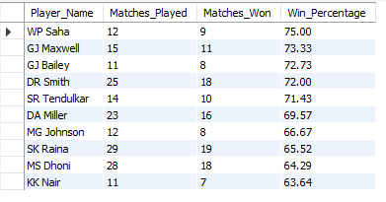

Q6. What would you suggest to RCB before going to the mega auction?
Ans. Before the mega auction, RCB should focus on players who consistently contribute and fit the team balance. The analysis suggests looking at batting, bowling, all-round ability and match-win association rather than selecting players on one statistic alone.

Objective:
- Pick players who contribute in batting and/or bowling. → This gives the team more flexibility.
- Select consistent performers. → Use repeated performance across matches and seasons rather than one strong performance.
- Consider match-winning impact. → Use team win association as one supporting metric.

Retain existing RCB players with strong match association:
We find players who played for RCB and were often part of winning matches.

The query checks RCB batting appearances, counts distinct matches, and calculates a win percentage. However, Matches_Won is summed at ball level, so the same winning match can be counted many times. Therefore, this output should not be treated as an exact player win percentage without first making the player-match records distinct.
- We are checking for players who batted for RCB (Team_Batting = 2)
- We count how many matches they played (DISTINCT Match_Id)
- We check if RCB won those matches
- We calculate Win_Percentage when the player was in the match
- We keep only players with 10 or more matches
- Use this query as an initial directional analysis, not as the final retention ranking.

Query:
SELECT
p.Player_Name,
COUNT(DISTINCT m.Match_Id) AS Matches_Played,
SUM(CASE WHEN m.Match_Winner = b.Team_Batting THEN 1 ELSE 0 END) AS Matches_Won,
ROUND(SUM(CASE WHEN m.Match_Winner = b.Team_Batting THEN 1 ELSE 0 END) * 100.0 / COUNT(DISTINCT m.Match_Id), 2) AS Win_Percentage
FROM
Ball_by_Ball b
JOIN Matches m ON b.Match_Id = m.Match_Id
JOIN Player p ON b.Striker = p.Player_Id
WHERE
b.Team_Batting = 2
GROUP BY
p.Player_Name
HAVING
Matches_Played >= 10
ORDER BY
Win_Percentage DESC
LIMIT 5;

Output:

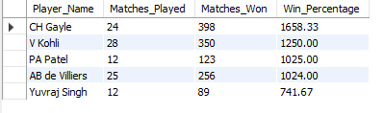

Q7. What do you think could be the factors contributing to the high-scoring matches and the impact on viewership and team strategies
Ans. The query calculates average runs scored per ball at each venue. This helps compare which venues in the dataset have higher scoring rates.
Query Approach:
- This query joins the Ball_by_ball,matches and venue tables.
- Calculate the average number of runs scored per ball at each venue.
- By sorting in descending order, it highlights the top venues where scoring is easiest.
Query:
SELECT v.Venue_Name, ROUND(SUM(b.Runs_Scored) * 1.0 / COUNT(b.Ball_Id), 2) AS Avg_Runs_Per_Ball FROM Ball_by_Ball b JOIN Matches m ON b.Match_Id = m.Match_Id JOIN Venue v ON m.Venue_Id = v.Venue_Id
GROUP BY v.Venue_Name ORDER BY Avg_Runs_Per_Ball DESC;
Output:
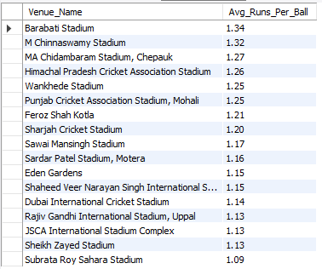

Insights from the Query:
- The output shows higher scoring rates at some venues than others.
  - For example, Barabati Stadium has 1.34 average runs per ball and M Chinnaswamy Stadium has 1.32 in the chart output.
  - This metric indicates scoring level at the venue; it does not by itself prove that pitch type or boundary size caused the difference.
- The query does not calculate the percentage of matches scoring 180+, so that claim should not be treated as a finding from this analysis.
  - The result can be used to compare batting-friendly and lower-scoring venues within the dataset.
Impact on Viewership:
- High-scoring matches can be more engaging, but the SQL query does not contain viewership or engagement data, so this impact cannot be measured from this query alone.
- Viewership conclusions would require separate audience or broadcast data.
- Broadcaster and sponsor impact also requires external business data and is not directly measured here.
Impact on Team Strategies:
- Player Selection: Use venue scoring patterns as one input when choosing batting combinations.
- Bowling Focus: Give greater attention to bowlers who can control runs at high-scoring venues.
- Toss Decisions: Use the separate toss analysis rather than assuming that teams always prefer to chase at high-scoring venues.
Conclusion:
Conclusion: The query shows that scoring rates differ across venues. These venue-level patterns can support squad and match planning, but causes such as pitch conditions, boundaries, dew and viewership need additional data to confirm.
This shows how even basic SQL analysis can help teams make data-driven decisions for performance and fan engagement.
Q8. Analyze the impact of home-ground advantage on team performance and identify strategies to maximize this advantage for RCB.
Ans. For RCB, the query checks performance at M Chinnaswamy Stadium. The output shows 29 home matches, 16 wins and a 55.17% win rate.
Query:
SELECT t.Team_Name AS Team, v.Venue_Name AS Home_Venue, COUNT(DISTINCT m.Match_Id) AS Matches_Played_At_Home, SUM(CASE WHEN m.Match_Winner = t.Team_Id THEN 1 ELSE 0 END) AS Wins_At_Home, ROUND(SUM(CASE WHEN m.Match_Winner = t.Team_Id THEN 1 ELSE 0 END) * 100.0 / COUNT(DISTINCT m.Match_Id), 2) AS Win_Percentage_At_Home FROM Matches m JOIN Venue v ON m.Venue_Id = v.Venue_Id JOIN Team t ON m.Team_1 = t.Team_Id OR m.Team_2 = t.Team_Id WHERE v.Venue_Name LIKE '%Chinnaswamy%' AND t.team_name ='Royal Challengers Bangalore' GROUP BY t.Team_Name, v.Venue_Name ORDER BY Win_Percentage_At_Home DESC;

Query Approach:
The query joins Matches, Venue and Team, filters RCB matches at Chinnaswamy, counts matches and wins, and calculates the home win percentage.
Output: RCB played 29 matches at M Chinnaswamy Stadium, won 16, and recorded a 55.17% win percentage.

Q9. Come up with a visual and analytical analysis of the RCB's past season's performance and potential reasons for them not winning a trophy.
Ans. RCB Past Performance Analysis:
The following analysis examines Royal Challengers Bangalore’s performance across IPL seasons, focusing on their match outcomes, win percentage, and key factors that may have impacted their ability to win a trophy. Below are the tables required for the analysis.
Required Tables
- matches: For match details like winner, season, and teams.
- team: To identify RCB in matches.
- season: For season-wise performance data (year).
Approach
- Filter RCB Matches: Extract all matches involving RCB.
- Calculate Wins and Losses: For each season, count matches played, won, and lost.
- Win Percentage Calculation: Calculate win percentage by season.
- Season Mapping: Join the performance data with the season table to display season-wise results.
Insights
- Season Performance: RCB had a 56.25% win rate in 2013, fell to 35.71% in 2014, improved to 50.00% in 2015, and returned to 56.25% in 2016.
- The query shows clear variation in season performance; it does not separately analyse close matches.
- A higher league-stage win percentage alone does not explain trophy outcomes because the query does not analyse knockout-stage results.
Potential Reasons for Not Winning a Trophy
- Team Imbalance: This is a possible area to investigate, but it is not directly proven by the season win/loss query.
- Bowling Deficiencies: This requires separate bowling or death-over analysis; it is not directly measured by this query.
- Knockout Pressure: Knockout performance would need a separate knockout-match analysis.
- Injuries and Squad Management: These factors are not present in the SQL output and should be treated as possible external factors, not findings from this query.
Recommendations
- Strengthen Bowling Unit: Use the separate wicket and bowling-style analysis to identify areas for improvement.
- Enhance Squad Depth: Use player and all-rounder analysis to build better balance.
- Improve Match Strategy: Use season, venue, toss and player-performance insights together when planning future matches.

Query:
WITH RCB_Performance AS (
SELECT
m.Season_Id,
COUNT(m.Match_Id) AS Matches_Played,
SUM(CASE WHEN m.Match_Winner = t.Team_Id THEN 1 ELSE 0 END) AS Matches_Won,
SUM(CASE WHEN m.Match_Winner != t.Team_Id THEN 1 ELSE 0 END) AS Matches_Lost,
(SUM(CASE WHEN m.Match_Winner = t.Team_Id THEN 1 ELSE 0 END) / COUNT(m.Match_Id)) * 100 AS Win_Percentage
FROM matches m
INNER JOIN team t ON t.Team_Id = m.Team_1 OR t.Team_Id = m.Team_2
WHERE t.Team_Name = 'Royal Challengers Bangalore'
GROUP BY m.Season_Id
)
SELECT
s.Season_Year,
rp.Matches_Played,
rp.Matches_Won,
rp.Matches_Lost,
rp.Win_Percentage
FROM RCB_Performance rp
INNER JOIN season s ON rp.Season_Id = s.Season_Id
ORDER BY s.Season_Year;

Output:
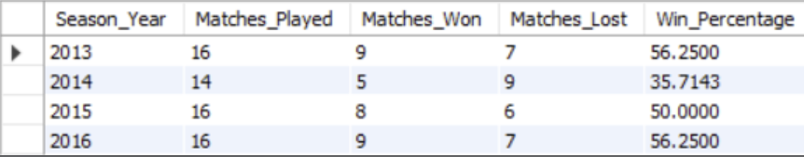

Q10. How would you approach this problem if the objective and subjective questions were not given?
Answer: If the questions were not predefined, I would follow a data-driven exploratory analysis approach. I would first understand the dataset, identify key KPIs, formulate meaningful questions, and then use SQL and visualization to generate insights.

Step-by-step Approach:

Step 1: Understand the Dataset
• Identify available tables such as Matches, Ball_by_Ball, Player, Team, and Venue.
• Understand their structure, relationships, primary/foreign keys, and data granularity.
• Check for missing values, duplicates, and data inconsistencies.
• Identify important fields related to matches, runs, wickets, players, teams, seasons, and venues.

Step 2: Identify Key Areas and KPIs
• Team Performance: Matches, wins, losses, win %, season-wise and home/away performance.
• Batting Performance: Total runs, average, strike rate, top scorers, and consistency.
• Bowling Performance: Wickets, economy rate, runs conceded, and best bowlers.
• Venue & Toss Analysis: Venue-wise performance, scoring patterns, and toss impact on match results.

Step 3: Formulate Questions and Analyze Using SQL
I would convert these areas into questions such as:
• Which team has the highest win percentage?
• Who are the top run-scorers and wicket-takers?
• Which venues have the highest average scores?
• Does winning the toss increase the chances of winning?
I would then use SQL joins, aggregations, CASE statements, and window functions to calculate the required KPIs.

Step 4: Visualize and Interpret
I would present the findings using Excel :
• Bar charts → Top players
• Line charts → Season-wise trends
• Donut charts → Win/loss distribution
• KPI cards → Key performance metrics
• Slicers → Interactive filtering
Finally, I would interpret the results, identify important trends and patterns, and communicate actionable insights.

Conclusion:
My overall approach would be:
Understand Data → Define KPIs → Ask Questions → Analyze with SQL → Visualize → Interpret Insights → Communicate Findings

Q11. In the "Match" table, some entries in the "Opponent_Team" column are incorrectly spelled as "Delhi_Capitals" instead of "Delhi_Daredevils". Write an SQL query to replace all occurrences of "Delhi_Capitals" with "Delhi_Daredevils".
Ans. There is no column named Opponent_Team in the matches table. If such a column were present, the query to replace "Delhi_Capitals" with "Delhi_Daredevils" would look like this:

UPDATE matches
SET Opponent_Team = 'Delhi_Daredevils'
WHERE Opponent_Team = 'Delhi_Capitals';
This query directly updates the Opponent_Team column, replacing all occurrences of "Delhi_Capitals" with "Delhi_Daredevils".

