RAJVEER SINGH
STRATEGY · OPERATIONS · FINANCE
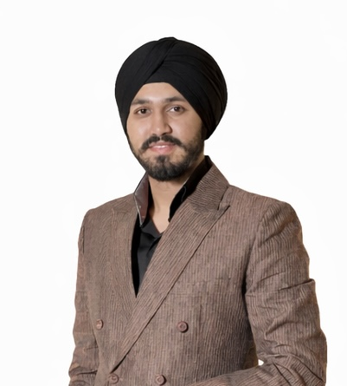  CONTACT  C-3, Sector 44,  Noida, Uttar Pradesh, India  +91 98990 22000  Singhrajveer.1013@gmail.com  linkedin.com/in/rajveer-singh-8b5645268  EDUCATION  Master of Global Business (Finance) | S.P. Jain School of Global Management | Dubai - Singapore - London | Oct 2025 - Oct 2026  BBA in Finance | O.P. Jindal Global University | Sonipat, India | 2022 - 2025  KEY SKILLS  Market Research & Competitive Analysis  Financial Modelling & Valuation  Cost & Pricing Optimization  Go-to-Market & Growth Strategy  Operating Model & Process Improvement  Supply Chain & Procurement Analysis  Data Visualization (Power BI, Advanced Excel)  Stakeholder Management  Business Case Development  Data Analytics | SPSS  CERTIFICATIONS & PROGRAMS  Advanced Excel  BE 10X AI Program  Business Pace Program (Rajiv Talreja)  Business Pitch Competition  Power BI (in progress) | PROFILE  MBA (Global Business) candidate positioning for strategy and operations consulting, translating financial and operational analysis into growth, pricing, and cost-optimization outcomes. Experience spans manufacturing (wire & cable), retail, and D2C ventures — building financial models, pricing frameworks, and dashboards that inform real decisions with founder-level ownership across the GCC and India.  EXPERIENCE  DHN Technologies Pvt Ltd — Finance Intern | Noida, India | Apr 2025 - Oct 2025  Analyzed copper cost structures and price volatility for a wire & cable manufacturer, building a cost-tracking model that flagged ~10% gross-margin exposure to raw-material swings. Supported budgeting and cash-flow forecasting across six cycles (~20% faster reporting) and recommended inventory and procurement adjustments to stabilize gross margin by ~80 bps.  Solemates.in — Founder | Feb 2023 - Oct 2025  Founded and scaled a sneaker resale venture to ~₹70L revenue over two years at ~20% gross margin. Managed sourcing, pricing, and fulfillment across 50+ SKUs and ~500 orders via demand forecasting and inventory-turn optimization, achieving a ~25% repeat-customer rate.  Okami.otw — Co-Founder | Sept 2024 - Oct 2025  Co-founded a streetwear brand, leading design, sourcing, pricing, and brand strategy across limited drops. Negotiated vendor terms cutting unit cost ~12%, achieved ~70% sell-through per drop, and built a ~3,000-follower presence driving direct D2C sales.  Devinder Singh & Associates — Taxation & Compliance Intern | Noida, India | Nov 2024 - Feb 2025  Executed GST returns, reconciliations, and compliance documentation, building working knowledge of India's tax and regulatory processes.  PROJECTS  Global Immersion Project — Grandiose Supermarket Chain (Bakery Division) | 2026  Mapped operational and financial processes across the bakery division to identify margin and efficiency levers. Built pricing and cost-optimization models projecting ~4% margin uplift and ~6% lower category operating costs, and delivered dashboards enabling category-level pricing and inventory decisions. Five-member team, eight-week engagement.  Fintech & Supply Chain Digitalization — Wire & Cable Industry | Oct 2025  Analyzed copper price volatility and credit-cycle challenges facing SME manufacturers, proposing a forecasting model and restructured payment terms to protect gross margins by ~5%. Recommended a supply-chain digitalization roadmap to shorten the working-capital cycle by ~12 days.  LEADERSHIP  Sports Team Manager & Captain — O.P. Jindal Global University | 2022 - 2025  Led and managed university squads across cricket, table tennis, and kabaddi, driving all three to inter-college league titles. Directed selection, training, and match strategy for 30+ athletes — delivering sustained results under competitive pressure.

