[https://health1.aetna.com/app/public/#/one/insurerCode=AETNACVS\_I&brandCode=ALICSI/machine-readable-transparency-in-coverage](https://health1.aetna.com/app/public/" \l "/one/insurerCode=AETNACVS_I&brandCode=ALICSI/machine-readable-transparency-in-coverage)

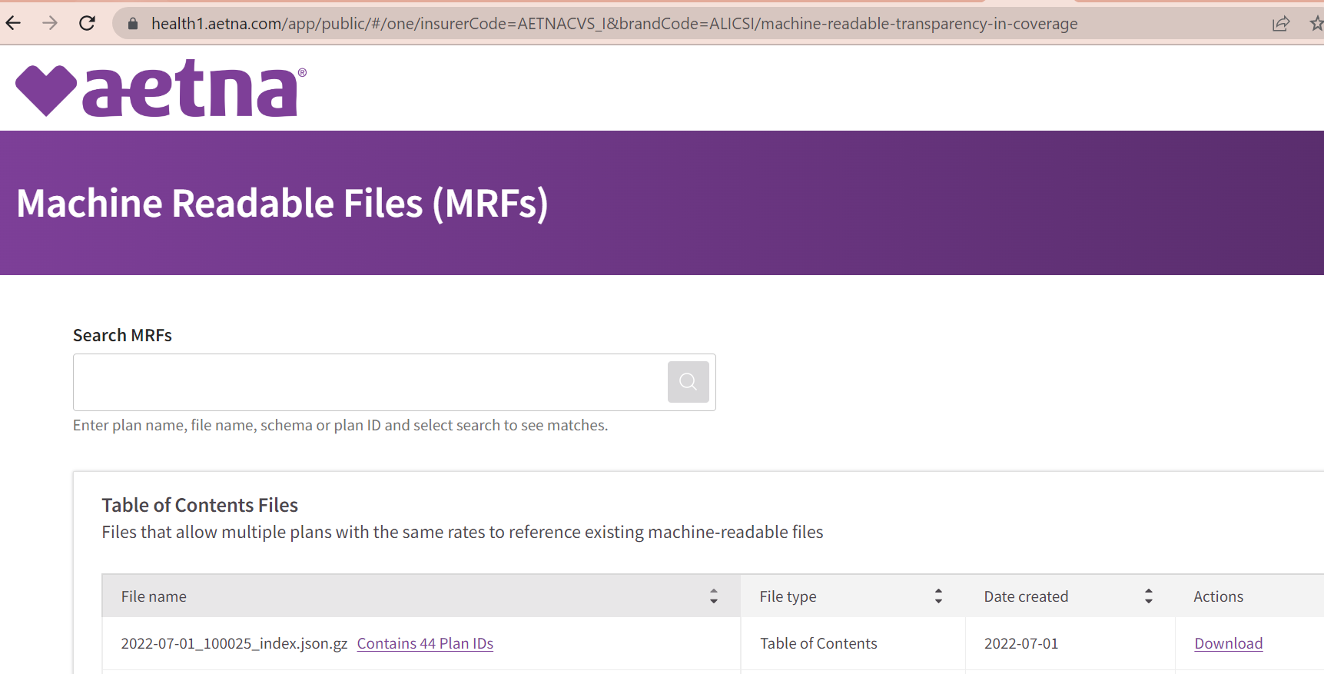

They seem to use TOC in a different format—TOCs are for many plan IDs that use the same rate file eh the first line.

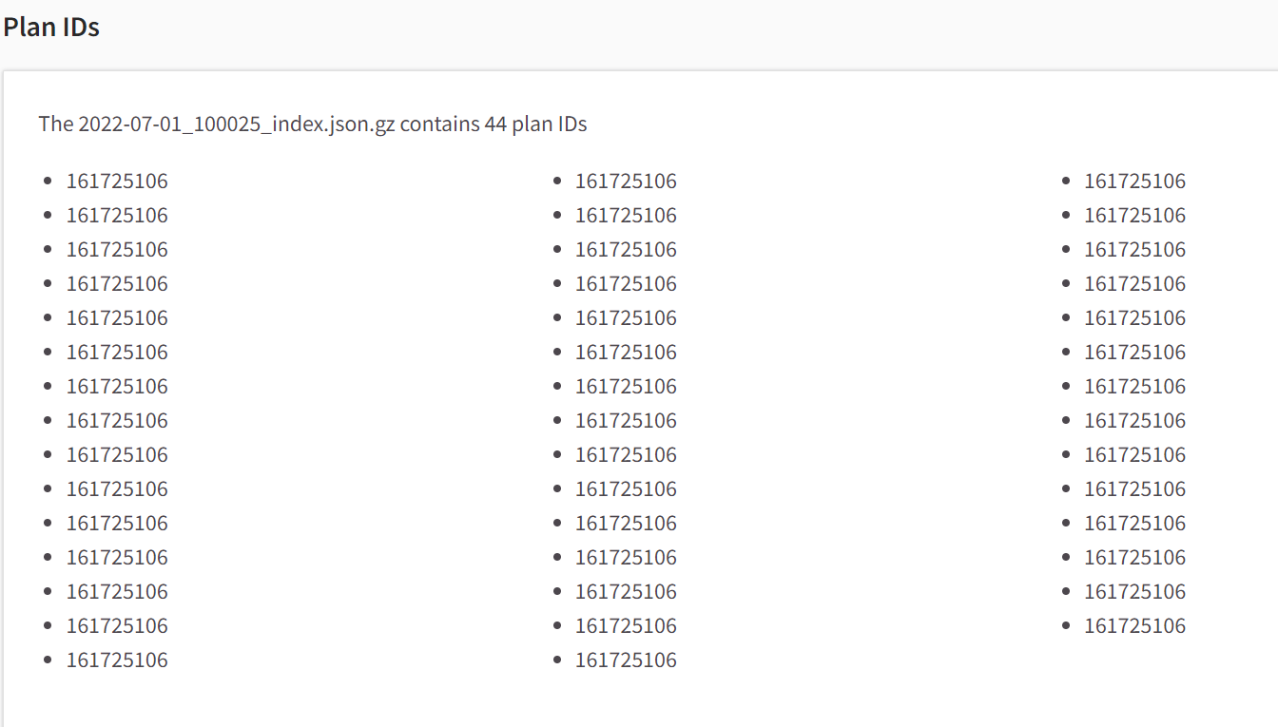

That JSON is zipped , and shows the TOCs are.

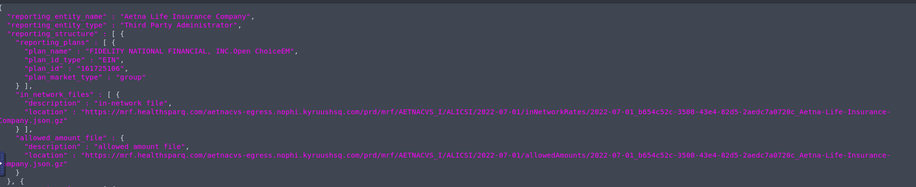

Not sure we can search for an EIN except to look over all these files and find it? It seems by order at least.

They could have made the TOC file one very large one and then could have searched. As is there are 2388sections they have put things into. Maybe we can get all downloaded and added together through a crawler?

Example "161725106"

<https://mrf.healthsparq.com/aetnacvs-egress.nophi.kyruushsq.com/prd/mrf/AETNACVS_I/ALICSI/2022-07-01/inNetworkRates/2022-07-01_b654c52c-3508-43e4-82d5-2aedc7a0720c_Aetna-Life-Insurance-Company.json.gz>

or

“2022-07-01\_b654c52c-3508-43e4-82d5-2aedc7a0720c\_Aetna-Life-Insurance-Company.json.gz”

these open as 2G json files.

Next section has a different way to jump to pricing files.

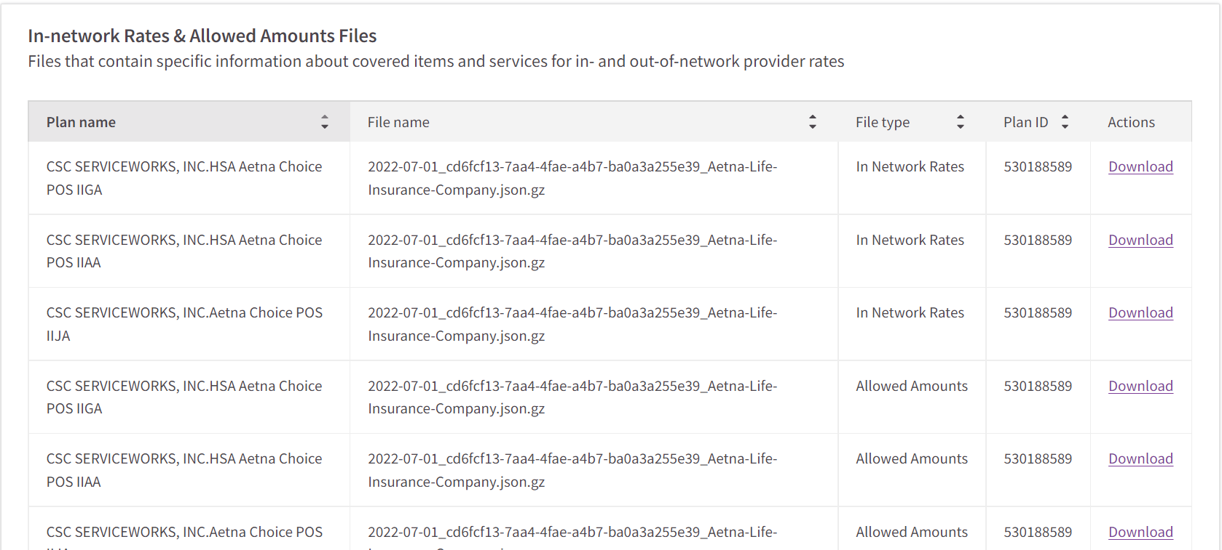

The plan IDs listed there seem to be EINs

Eg 530188589

This turned out to be

|  |  |  |  |
| --- | --- | --- | --- |
| 530188589 | CSC SERVICEWORKS, INC. | NC | 2573 |

With file

2022-07-01\_cd6fcf13-7aa4-4fae-a4b7-ba0a3a255e39\_Aetna-Life-Insurance-Company.json.gz

(so it could also have been known through above perhaps. But are there really 2388 such in network files that are unique?

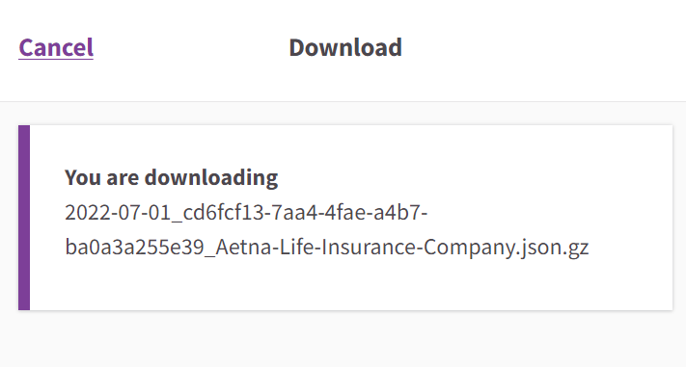

I’ll need to unzip the file on Slate

It doesn’t allow getting the link directly.

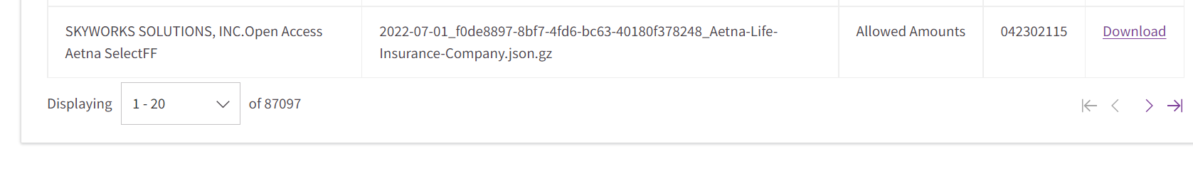

There are 87k different plans that it insures.

But, maybe only 2.3 unique price files?

For example, these are all the same files

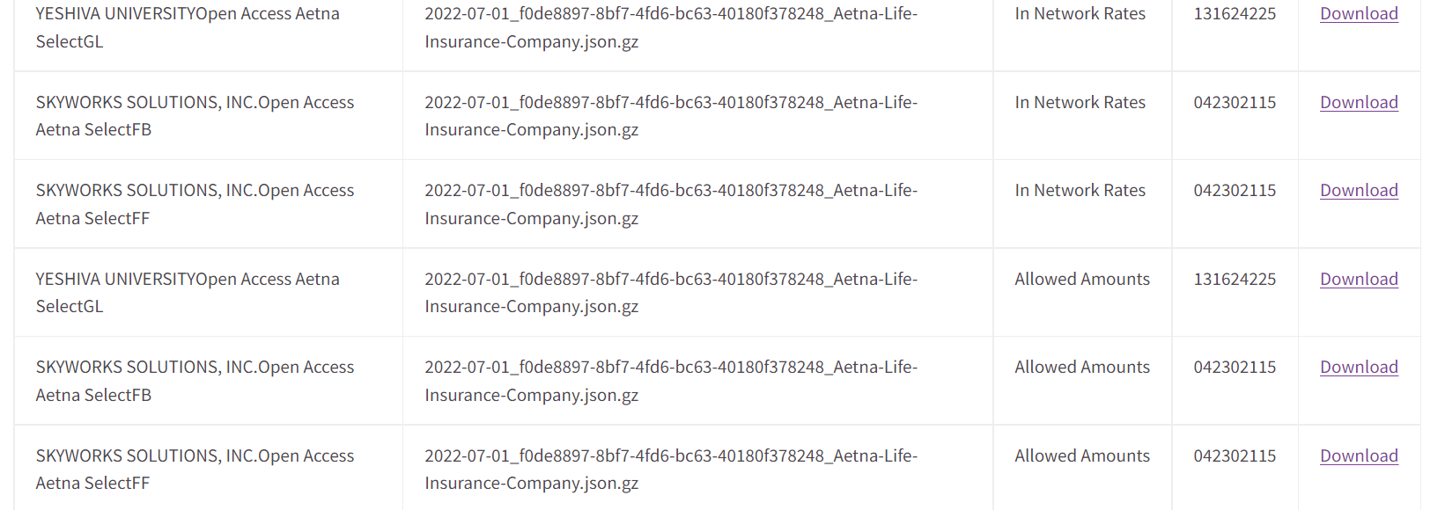

Could be that these are indeed the 44 plans that use this same file.

Not so-

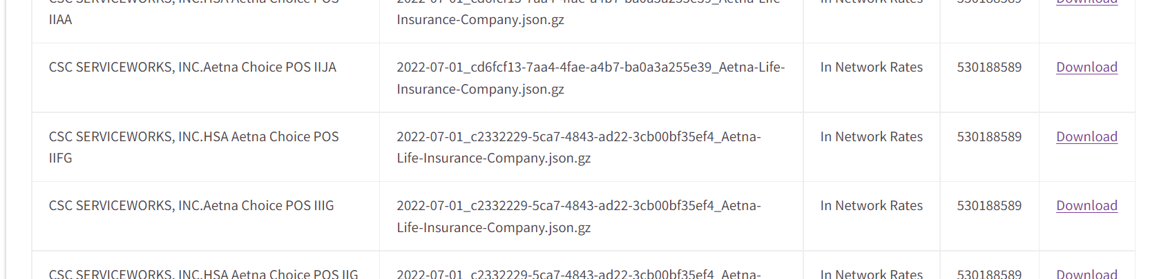

So the file names change

Next: check the downloaded files

Like with Humana, hard to see how these files are split up

But unlike Humana, these are JSON files for the prices. So will need someone to parse them

Price files have the group HIOS or EIN in the plan name and plan id area. The Tax ID refers to the provider.

I searched for an EIN and got 88 pricing files

Could be for 88 different policy types they offer? (in network)

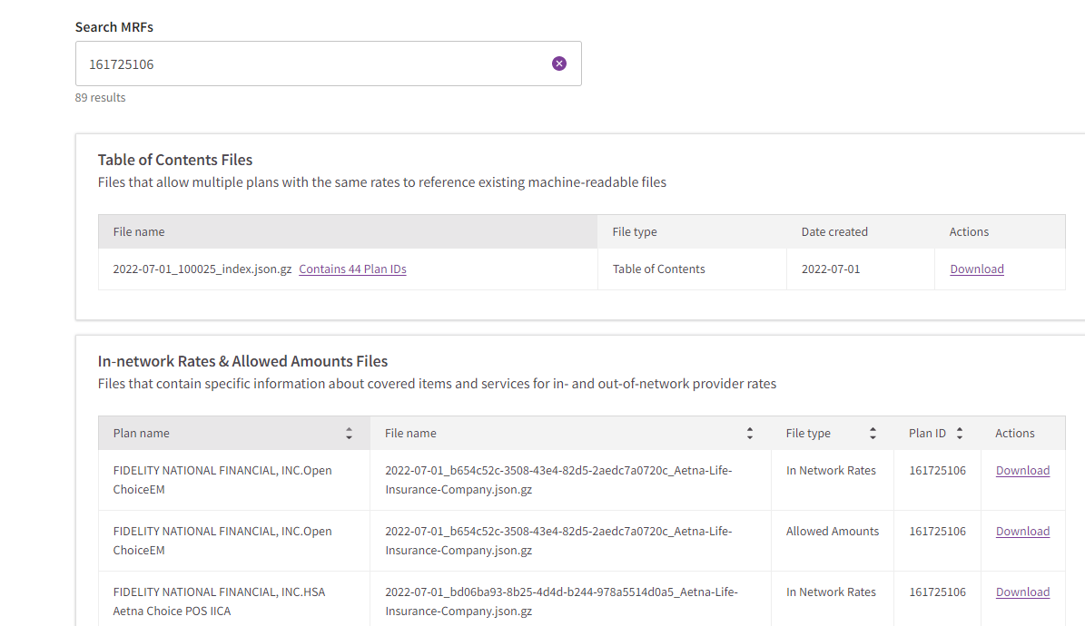

May 44 plans. And many point to same pricing file.

Could come up with some rule. So it is possible to get to an EIN file in Aetna and select one pricing file. Still figuring out how to parse the file.

Opening in stata delimit using colrange as text editor would not open