**OSOC Induction Task**

2. What all permissions are there in Linux? State all permissions and different way of changing permissions with example.

Every file and directory in your UNIX/Linux system has following 3 permissions defined for all three owners.

1. **Read:** This permission give you the authority to open and read a file. Read permission on a directory gives you the ability to lists its content.

**2.** **Write:**The write permission gives you the authority to modify the contents of a file. The write permission on a directory gives you the authority to add, remove and rename files stored in the directory.

3. **Execute:** In Unix/Linux, you cannot run a program unless the execute permission is set. If the execute permission is not set, you might still be able to see/modify the program code(provided read & write permissions are set), but not run it.

**Example:-**

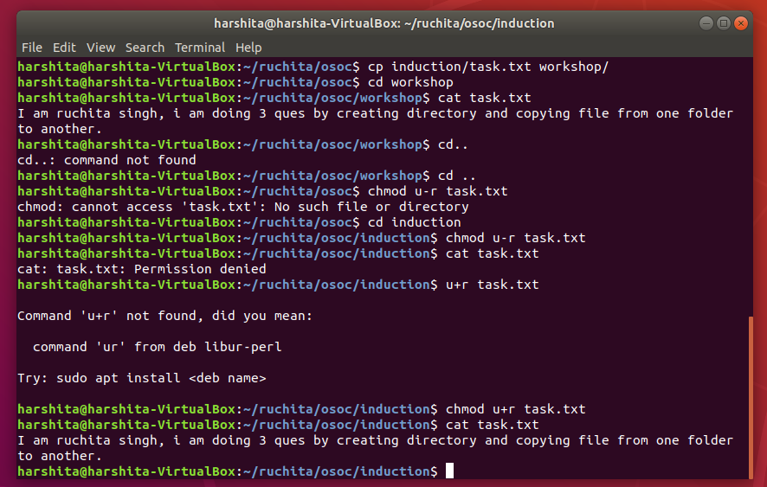

3. Create a folder OSOC and inside that another folder Inductions and now create a file task.txt inside Inductions with some content now copy this file into another folder Workshop in OSOC.

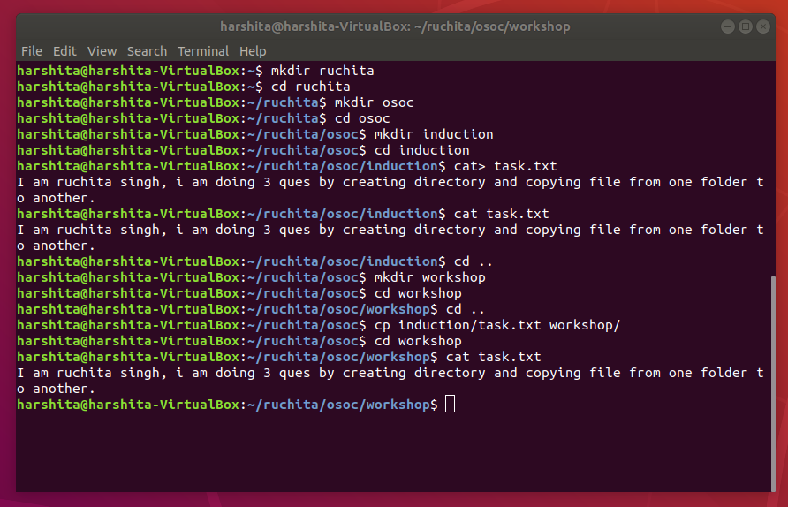

7. Using Shell scripting write a program to reverse a string. Input should be taken from user.

