Adaptive Multi-Model Approaches for Robust Botnet Attack Detection in Varied IoT Environments
^{a*}Dipak Bhosale, ^{b}Avinash Dhole, ^{c}Pratap B Deshmukh, ^{d}Mahesh Singh
^{a,b}Department of Computer Science and Engineering, Shri Shankaracharya Technical Campus, Bhilai, India
^{c}Department of Mechanical Engineering, Shri Shankaracharya Technical Campus, Bhilai, India
^{d}Department of Robotics and Automation, Symbiosis Institute of Technology, Pune Campus, Symbiosis International (Deemed University), Pune, India;
*Corresponding Author Email: deepbhosale507@gmail.com
Abstract
This paper presents a systematic, controlled comparison of deep learning architectures for network intrusion detection, focusing on attack types relevant to Internet of Things (IoT) botnet security and using the CSE-CIC-IDS2018 benchmark dataset. Six advanced architectures were developed and compared for their ability to learn a wide variety of spatial, temporal, and contextual patterns in IoT network traffic: Feedforward Neural Network (FNN), One-Dimensional Convolutional Neural Network (CNN-1D), Long Short-Term Memory Network (LSTM), Convolutional Neural Network-Transformer Hybrid (CNN-Transformer), Bidirectional Long Short-Term Memory-Transformer Hybrid (BiLSTM-Transformer), and Convolutional Neural Network-Bidirectional Long Short-Term Memory Hybrid (CNN-BiLSTM). A class-balanced sample was drawn from the data to reduce computational cost, and all models were trained under identical preprocessing, partitioning, and training conditions and evaluated using accuracy, precision, recall, macro-F1, AUC, AP, Kappa, and MCC. The experimental results indicate that combining convolutional feature extraction with bidirectional temporal modeling yields the strongest overall performance, whereas adding attention mechanisms did not improve on well-designed standalone models. Among the evaluated models, the CNN-BiLSTM hybrid achieved the best overall performance, ranking first on six of the eight metrics, attaining an accuracy of 0.8940, a recall of 0.9151, a macro-F1 score of 0.7750, and an AUC of 0.9862, while the standalone CNN-1D achieved the highest macro-F1 score (0.7844), indicating more balanced detection across classes. Receiver Operating Characteristic (ROC) and precision–recall curves, epoch-wise training analyses, and confusion matrices further characterize the class-wise behavior of each model. Overall, the study provides practical guidance for selecting intrusion detection architectures under common experimental conditions; validation on IoT-native datasets remains necessary before IoT-specific deployment claims can be made.
Keywords: IoT Security, FNN, CNN-1D, LSTM, BiLSTM-Transformer, CNN-BiLSTM Hybrid Model, CSE-CIC-IDS2018, Anomaly Detection.
I. INTRODUCTION
The rapid adoption of IoT devices across smart homes, healthcare, industrial automation, and critical infrastructure has expanded the digital ecosystem while simultaneously increasing its exposure to cyber threats [1]. Among these threats, botnet-based attacks pose significant security risks by enabling large-scale Distributed Denial-of-Service (DDoS) attacks, unauthorized access, device hijacking, information theft, and service disruption. Traditional intrusion detection systems (IDSs), which primarily rely on signature-based or rule-based mechanisms, may have limited effectiveness against sophisticated and evolving attack patterns due to the heterogeneous and dynamic nature of IoT network traffic [2]. Consequently, there is a growing need for intelligent and data-driven intrusion detection approaches capable of learning complex attack patterns and adapting to the continuously evolving IoT threat landscape.
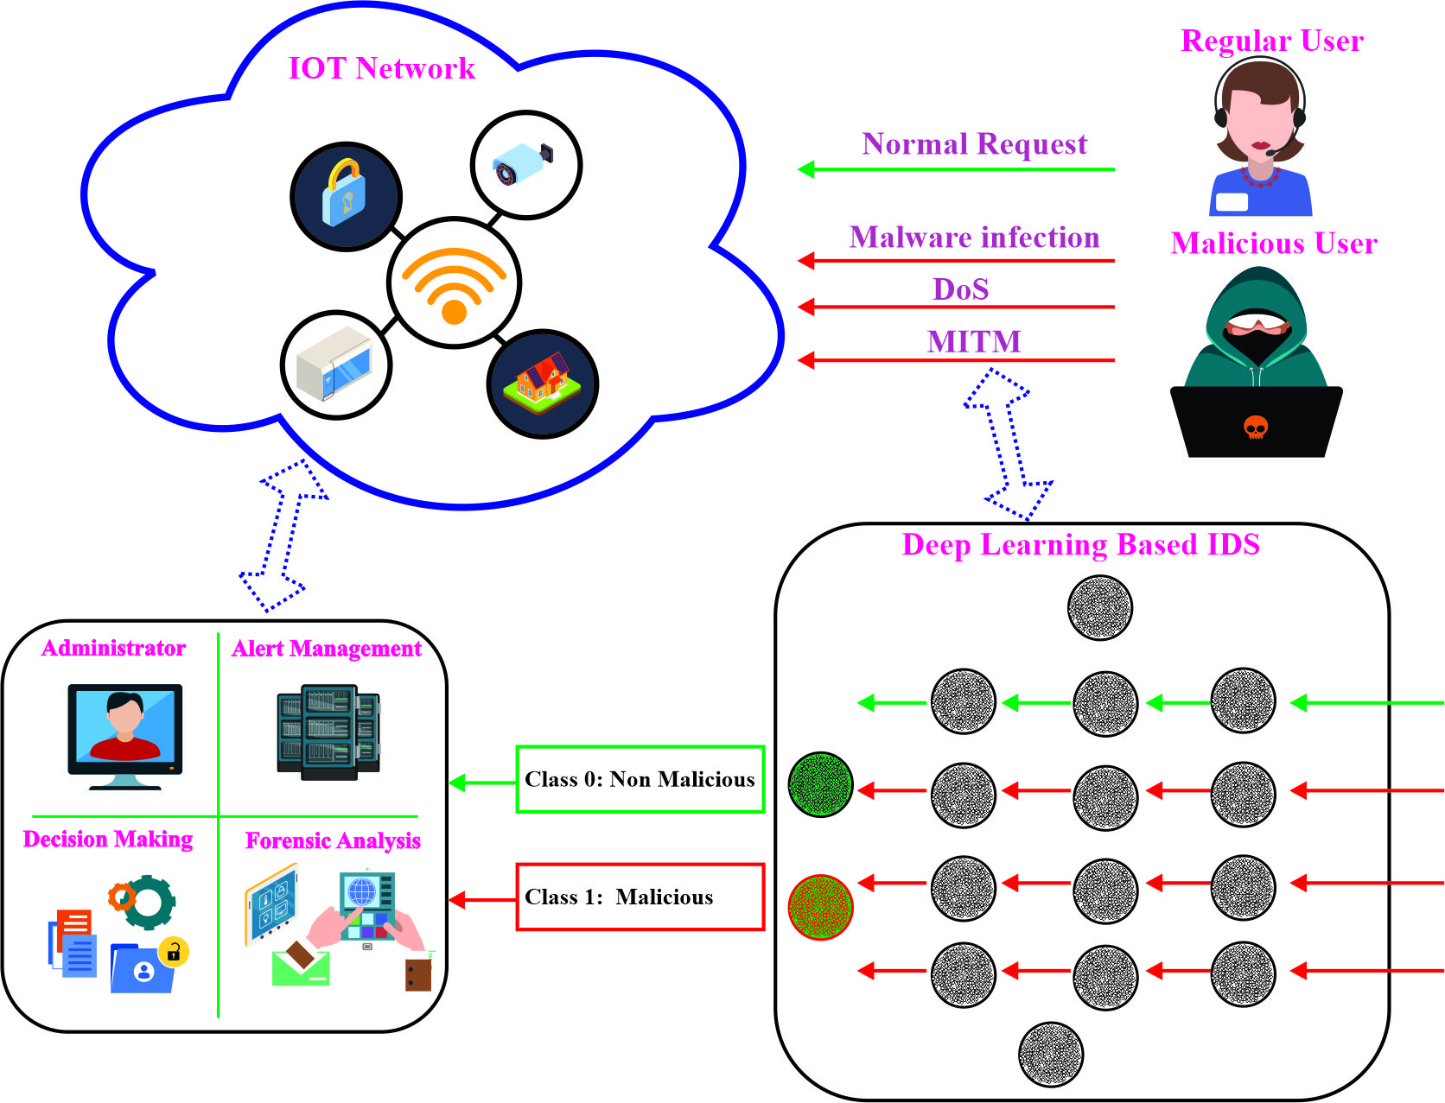
Figure 1. Proposed IoT cyber-threat detection framework
Figure 1 illustrates an IoT-based cyber-threat detection framework in which legitimate and malicious sources generate network traffic containing both benign and attack activities, including malware, DoS, and Man-in-the-Middle attacks. A machine learning-based intrusion detection system (IDS) analyzes the incoming traffic and classifies each flow as benign or as one of the attack categories based on learned traffic patterns. Detected threats generate alerts that are forwarded to a security management unit, where alert handling, forensic analysis, administrator supervision, and decision-making processes support appropriate security responses. Overall, the framework illustrates the flow of network traffic, machine learning-based threat classification, and subsequent security responses in an IoT cyber-defense environment [3].
Recently, deep learning has demonstrated considerable potential for network security because of its ability to automatically learn hierarchical representations from high-dimensional traffic data [4]. Commonly investigated architectures for intrusion detection include FNNs, CNNs, and LSTM networks. However, standalone architectures may have limitations in simultaneously capturing spatial, temporal, and contextual characteristics of IoT botnet traffic. Hybrid architectures, such as CNN-BiLSTM, CNN-Transformer, and BiLSTM-Transformer, combine complementary feature extraction and learning mechanisms, potentially improving detection performance and robustness compared with standalone architectures [5].
To overcome these difficulties, this paper provides a controlled comparison of six deep learning models for detecting attacks relevant to IoT botnet security using the CSE-CIC-IDS2018 dataset, which is a widely used benchmark for network intrusion detection. The dataset contains varied attack conditions and realistic network behavior, in addition to challenges such as class imbalance and high feature dimensionality. In this study, the dataset was pre-processed, optimized, and consolidated into a single format to minimize the computational cost and maximize the training efficiency. Six deep learning models, comprising baseline architectures and advanced hybrid networks, were trained and tested using a wide range of performance metrics, including accuracy, precision, recall, F1-score, AUC, and AP [6].
According to recent studies, there has been a definite transition to deep learning-based and hybrid IDSs that are specific to the IoT and highly heterogeneous networked systems. [7] offered a recent review of IDSs in IoT networks, emphasizing that AI-based approaches are currently required to address threat variability, class imbalance, and resource scarcity in cyber-physical and IoT systems. [8] provided an up-to-date survey of deep learning-based IDSs in IoT, with an emphasis on convolutional, recurrent, and hybrid models, which still exhibit weaknesses in explainability, zero-day attack generalization, and operation on resource-limited devices. [9] provided a survey of deep learning in intrusion detection and showed that optimized CNN-based models can achieve higher than 99 percent accuracy on intrusion detection datasets such as CIC-IDS2017, which demonstrates the potential of learned feature extraction compared with manual feature engineering. In addition to these general surveys, a recent review in IEEE Access on deep learning IDSs in the context of IoT botnets synthesizes CNN, RNN, and GAN-based methods and emphasizes the importance of ensemble and hybrid models to handle heterogeneous botnet behavior [10]. In [11], a variety of deep learning-based IDSs for IoT devices were compared, and it was concluded that hybrid and attention-based architectures usually demonstrate better results in comparison with simple feedforward-oriented or single RNN models. Some recent studies focus on the design of smart or optimized deep learning frameworks for detecting IoT intrusions. [12] proposed a smart deep learning model with extensive preprocessing and hyperparameter optimization, demonstrating that sequential neural networks and XGBoost can be optimized to achieve much better results for multiclass intrusion detection in modern datasets. [13] trained 1D-CNN, LSTM, MLP, and RNN models to develop a scalable deep learning-based IDS on the CIC IoT-DIAD 2024 dataset, where all four models exceeded 99 percent accuracy in binary and multiclass IoT traffic classification, and ROC, calibration, and probability-distribution analyses demonstrated strong generalization. [14] presented ICNN-ID, which converts traffic into image representations so that image-classification CNN backbones can be used for intrusion detection in IoT and wireless networks, achieving higher accuracy than classical methods. [15] proposed a hybrid CNN-BiLSTM-DNN architecture that was tested on the IoT-23 and Edge-IIoT datasets, achieved nearly 99 percent accuracy, and used pruning and quantization to facilitate implementation on small IoT devices, thereby directly addressing the computation–accuracy trade-off.

Hybrid CNN-RNN and attention-based models are becoming increasingly popular. [16] proposed a CNN-BiLSTM-Transformer for intrusion detection, a hybrid of local feature extraction, bidirectional temporal modeling, and multi-head attention, and applied Borderline-SMOTE to reduce the effects of class imbalance, showing better performance on minority attacks than single-model baselines. [17] discussed a lightweight CNN-BiLSTM-based IDS, published in 2024 and evaluated on UNSW-NB15, and demonstrated that a well-designed model can be compact and highly accurate at the same time, which is essential for IoT deployment. [18] introduced TL-BiLSTM IoT, a transfer-learning hybrid of CNN and BiLSTM for detecting Mirai and Bashlite attacks, which showed excellent performance in various IoT botnet scenarios. [19] presented an ensemble IoT-based IDS with logistic regression, Naive Bayes, and decision trees on CIC-IDS2017, attaining 88–89 percent accuracy on both multi-class and binary tasks and showing that even classical ensembles can be competitive when tuned appropriately. A fine-tuned deep learning IDS for cybersecurity networks reported by Naz et al. achieved very high accuracy on CIC-IDS2017 owing to careful labeling, feature selection, and the integration of DL with advanced optimization, confirming that data curation and preprocessing are as important as the model type [20]. An extensive investigation of CIC-IDS2017, covering its structure, class imbalance, suitability for intrusion detection, and the comparative performance of ML models, revealed key issues in the efficient use of this dataset [21]. A distinct survey on CIC-IDS2017 and CSE-CIC-IDS2018 looked at the quality of labels, feature distribution, and effects of preprocessing options on machine learning (ML) and deep learning (DL) performance, supporting the necessity of standardized pipelines for comparing IDS models [22]. [23] also compared a number of deep learning models on CIC-IDS2017 and demonstrated that attentive treatment of missing values, skewness, and correlated features can significantly enhance the performance of models. [24] demonstrated the effectiveness of hybrid CNN-LSTM architectures for IoT attack detection, particularly for learning complementary spatial and temporal characteristics of network traffic. [25] explained the potential of Transformer-based models for IoT intrusion detection by aggregating network flows into temporal windows and using self-attention to capture contextual dependencies among concurrent traffic flows. [26] also compared centralized and federated deep learning approaches using DNN, LSTM, and BiLSTM architectures on IoT botnet datasets such as BoT-IoT and N-BaIoT, highlighting the trade-offs among detection performance, privacy, and deployment requirements.

Although recent studies have proposed hybrid CNN-BiLSTM, CNN-Transformer, and BiLSTM-Transformer architectures for intrusion detection, most evaluate individual hybrid models under different datasets, preprocessing strategies, and experimental settings, making direct performance comparisons difficult. The novelty of this study lies in a unified experimental framework that systematically evaluates six deep learning architectures—FNN, CNN-1D, LSTM, CNN-Transformer, BiLSTM-Transformer, and CNN-BiLSTM—using consistent preprocessing, train–test partitioning, hyperparameter settings, and evaluation protocols. This controlled framework minimizes the influence of variations in data preparation and training configurations while enabling a systematic assessment of architectural differences. Accordingly, the contribution of this work is a systematic and controlled comparative study rather than a new deep learning architecture; its value lies in the practical insights obtained when architectural differences are isolated from differences in data preparation and training. Performance is evaluated using eight complementary metrics—accuracy, precision, recall, macro-F1, AUC, average precision, Cohen’s Kappa, and Matthews Correlation Coefficient—along with ROC and precision-recall curves, confusion matrices, and computational complexity. The performance differences between the attention-based and spatio-temporal hybrid architectures arise from the types of feature dependencies they capture: Transformer-based models use self-attention to model global and long-range relationships, whereas CNN-BiLSTM combines convolutional feature extraction with bidirectional recurrent learning to capture localized features and temporal dependencies. This combination is particularly suitable for sequential IoT traffic patterns, including DoS, DDoS, and port-scanning activities. The results indicate that CNN-BiLSTM achieves the highest accuracy and AUC, while CNN-1D provides the highest macro-F1, highlighting the trade-offs between attention-based and spatio-temporal architectures for intrusion detection relevant to IoT botnet security.
The main contributions of this study are as follows:
- A controlled comparative framework in which six deep learning architectures are evaluated under identical preprocessing, partitioning, training, and evaluation conditions.
- A comparative analysis of hybrid deep learning architectures incorporating convolutional, temporal, and attention-based feature extraction.
- Comprehensive performance assessment based on ROC curves, precision-recall curves, confusion matrices, epoch-wise convergence patterns, and various statistical measures.
- Experimental evidence that the CNN-BiLSTM hybrid achieves the highest accuracy, whereas CNN-1D achieves the highest macro-F1 score, together with practical guidance on selecting an architecture according to detection priorities and computational constraints.

In general, the results provide evidence-based guidance on the trade-offs among overall detection performance, class-balanced performance, and computational cost when selecting deep learning architectures for intrusion detection, including in IoT-oriented settings.
The structure of this paper is organized as follows. Section II presents the methodology, including dataset preparation, preprocessing, feature engineering, and the overall framework used for training and evaluating the deep learning models. Section III describes the evaluated deep learning architectures, including their design principles, architectural components, and operational mechanisms. The models are organized into three categories: (i) standalone models, including FNN, CNN-1D, and LSTM; (ii) attention-enhanced hybrid models, including CNN-Transformer and BiLSTM-Transformer; and (iii) hybrid spatio-temporal models that combine convolutional and temporal learning, represented by CNN-BiLSTM. Section IV presents and discusses the experimental findings, including performance comparisons, graphical analyses, statistical significance testing, computational complexity, robustness analysis, and the strengths and limitations of the evaluated models. Finally, Section V concludes the study by summarizing the key findings and outlining directions for future research on deep learning-based IoT botnet detection.
II. METHODOLOGY
The proposed methodology aims to develop and evaluate an effective deep learning-driven intrusion detection system capable of detecting various cyberattacks in contemporary networked systems, as illustrated in Figure 2.
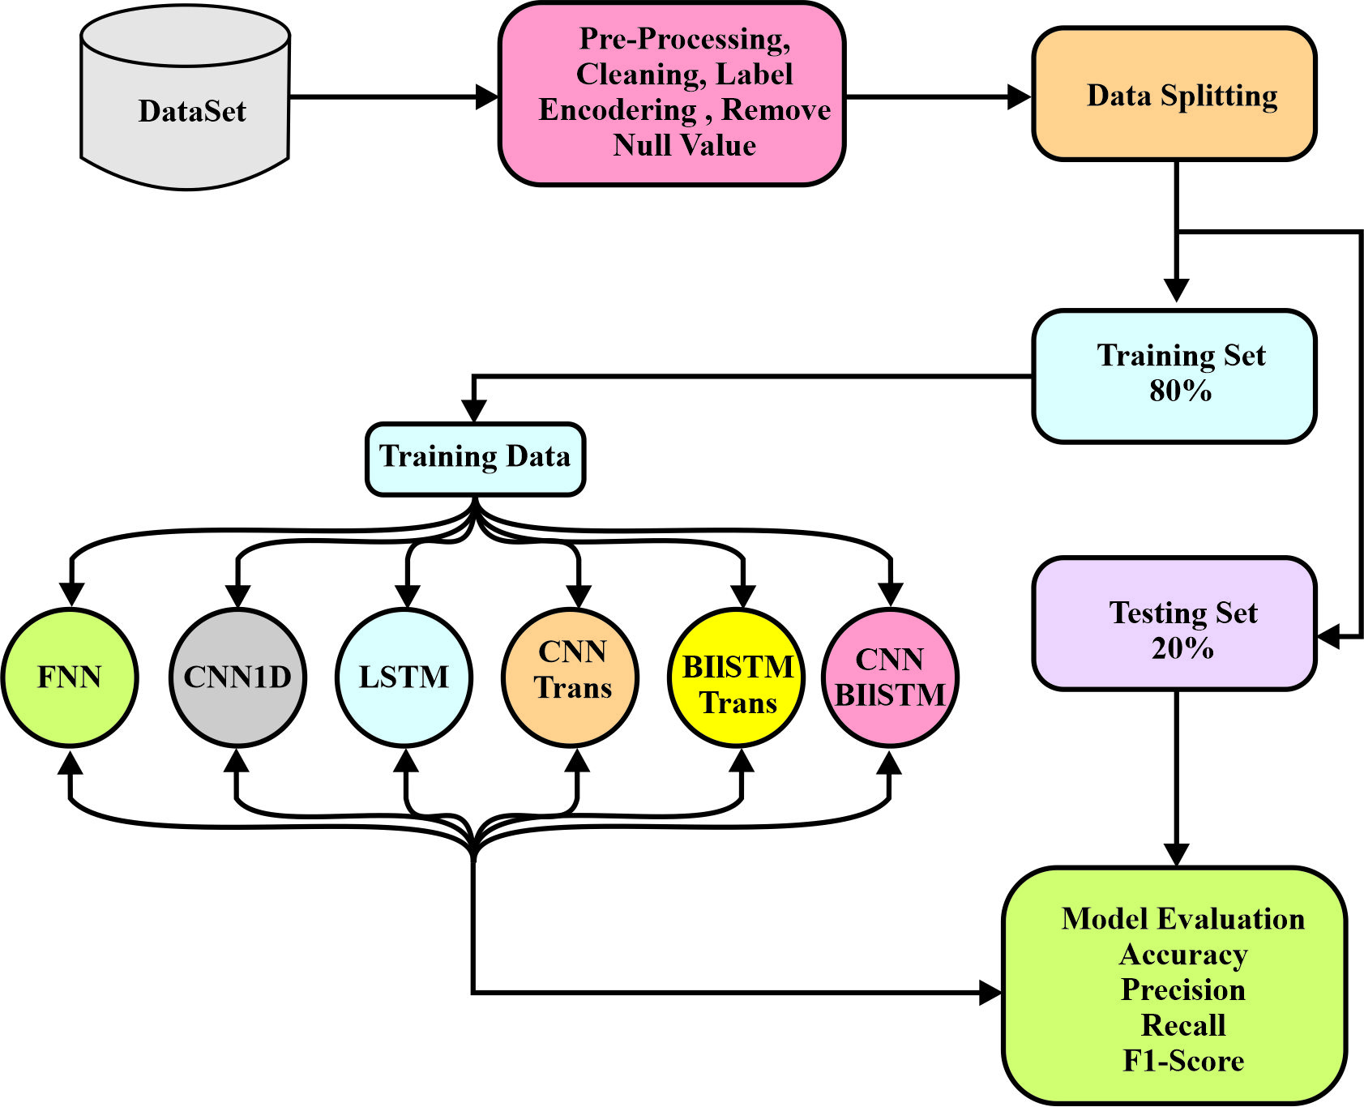
Figure 2. Overall methodology pipeline for IoT intrusion detection.
Flow diagram showing the proposed methodology for IoT botnet detection, including dataset collection, data pre-processing, model training using deep learning architectures, and performance evaluation. To accomplish this task, rigorous data pre-processing, balanced dataset building, and multiple independent and combined deep learning models were incorporated into the workflow. All phases of the process, including raw data preparation, model training, optimization, and performance evaluation, are organized systematically to ensure reliability, scalability, and robustness. The proposed methodology enables the extraction of features that are crucial for detecting different attack categories and improves detection accuracy for complex attacks by integrating spatial, temporal, and attention-based learning methods [27].

2.1 Dataset Collection
The Canadian Institute for Cybersecurity (CIC) and the Communications Security Establishment (CSE) created the CSE-CIC-IDS2018 dataset, a standard benchmark commonly used in studies of network intrusion detection [6]. The dataset contains labeled network traffic captured over ten working days (14 February to 2 March 2018), encompassing both benign and malicious traffic. Each flow record is described by approximately 80 features extracted with CICFlowMeter, such as flow duration, packet lengths, inter-arrival times, and flag counts. The malicious traffic covers brute-force (FTP and SSH), DoS, DDoS, web attacks (brute force, XSS, and SQL injection), infiltration, and botnet scenarios. The dataset is distributed as one file per capture day, and all ten daily files were used in this study [28]. For the experiments, the original labels were consolidated into five classes (Benign, DoS, Malware, Unauthorized, and Web) using the mapping in Table 1. Because the complete dataset contains more than 16 million flow records, training all six architectures on it under a common protocol was computationally prohibitive. Instead, a class-balanced sample was constructed by reading the daily files in a fixed order and randomly drawing records of each class (random seed 42) until 50,000 records per class had been collected. The Web class contained only 314 records in the loaded files, all of which were retained, giving 200,314 records in total. This sample was then divided into training (80%) and test (20%) partitions by stratified sampling, as reported in Table 1.
Table 1. Class mapping and number of records in the sample and in the training and test partitions
Class | Original CSE-CIC-IDS2018 labels mapped to the class | Records in sample | Training samples | Test samples
Benign | Benign | 50,000 | 40,000 | 10,000
DoS | DoS attacks (Hulk, GoldenEye, Slowloris, SlowHTTPTest); DDoS attacks (LOIC-HTTP, LOIC-UDP, HOIC) | 50,000 | 40,000 | 10,000
Malware | Bot | 50,000 | 40,000 | 10,000
Unauthorized | FTP-BruteForce, SSH-Bruteforce, Infiltration, Brute Force-Web | 50,000 | 40,000 | 10,000
Web | Brute Force-XSS, SQL Injection | 314 | 251 | 63
Total | – | 200,314 | 160,251 | 40,063

While CSE-CIC-IDS2018 is a general-purpose network intrusion dataset rather than one captured directly from IoT device traffic, it remains a widely used benchmark for evaluating deep learning-based intrusion detection pipelines, and its DoS, DDoS, Botnet, and Infiltration categories are representative of the network-layer attack behaviors observed at IoT gateways and edge routers. It was selected in this study primarily to enable direct, metric-for-metric comparison against the substantial body of existing CNN-BiLSTM, CNN-Transformer, and BiLSTM-Transformer literature that reports results on the CIC-IDS family of benchmarks (CIC-IDS2017 and CSE-CIC-IDS2018). The proposed models use lightweight, generic convolutional, recurrent, and attention-based architectures that are not tailored to any dataset-specific feature schema, making the framework readily transferable to other intrusion detection datasets.
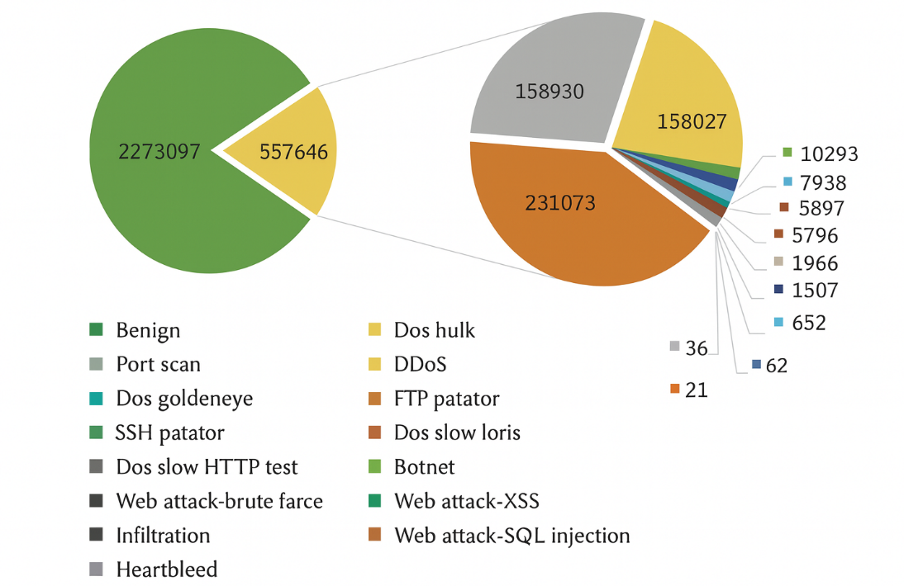
Figure 3. Class distribution of the CSE-CIC-IDS2018 sample used in this study.
Bar chart representing the class distribution of the CSE-CIC-IDS2018 sample used in this study, showing four classes of equal size and the much smaller Web class. Although the CSE-CIC-IDS2018 dataset is useful for testing intrusion detection systems, it has several limitations. It is not entirely reflective of real-world network environments, may have labeling anomalies, and has a limited set of attack conditions. Moreover, the problems of class imbalance, noise, and poor metadata can influence the accuracy and external validity of the research results. Thus, preprocessing, experimental design, and result interpretation are essential to achieve robust model performance. Figure 3 shows the class distribution of the sample used in this study.
The original dataset is highly imbalanced, with benign traffic substantially outnumbering several attack categories. To prevent the models from being dominated by the majority classes, a class-balanced sample was used (Section 2.1): the Benign, DoS, Malware, and Unauthorized classes each contain 50,000 records, whereas the Web class contains only 314. To compensate for the remaining imbalance of the Web class, a class-weighted cross-entropy loss was used, with weights inversely proportional to class frequency in the training partition (approximately 0.80 for each of the four large classes and 127.7 for the Web class). Model performance was additionally assessed using imbalance-aware metrics, including macro-F1 score, Area Under the ROC Curve (AUC), Average Precision (AP), Cohen's Kappa, and Matthews Correlation Coefficient (MCC). Because the test partition is class-balanced rather than following the natural class distribution of real traffic, the reported metrics characterize per-class detection capability rather than expected performance under operational class proportions.

2.2 Data Pre-processing and Normalization
Pre-processing plays a critical role in ensuring the quality, reliability, and effectiveness of the deep learning models developed in this study. The raw CSE-CIC-IDS2018 files contain missing and infinite values, identifier and timestamp columns, and high-dimensional numerical features that require preparation before model training. After the class-balanced sample had been drawn, identifier and non-numeric columns (Flow ID, source and destination IP addresses, Timestamp, and Protocol) were removed, leaving 76 numerical flow features. Infinite values were converted to missing values, and all missing values were replaced with the mean of the corresponding feature computed over the sample. The class labels were converted into numerical values using label encoding. The sample was then divided into 80% training and 20% test partitions using stratified sampling (random seed 42), so that both partitions have the same class proportions.

To limit information leakage, the standardization parameters (the mean and standard deviation of each feature) used in Equation (1) were computed from the training partition only and then applied unchanged to the test partition. No feature selection and no synthetic sample generation were performed. To verify the separation between the partitions, SHA-256 hashes of the 76 unscaled feature values of every record were compared. The sample contained 545 exact-duplicate rows (0.27%; 199,769 unique records), and 170 of the 40,063 test records (0.42%) had an identical feature vector in the training partition; because these records form only 0.42% of the test set, they can change the reported accuracy by less than 0.5 percentage points. In addition, 507 groups of identical feature vectors carried different class labels, reflecting label noise in the source data. A nearest-neighbor search in the standardized feature space showed that 27,041 of the remaining 39,893 test records lie within a Euclidean distance of 10⁻³ of a training record, reflecting the highly repetitive nature of flows generated by the same attack tools; the reported results therefore measure the detection of traffic patterns represented in the training data rather than generalization to previously unseen traffic. Finally, the test partition was also monitored during training for learning-rate scheduling and checkpoint selection. For the FNN, CNN-1D, LSTM, and CNN-BiLSTM models the selected checkpoint was the final epoch, and for CNN-Transformer it was epoch 29 (accuracy 0.8859 vs. 0.8858 at epoch 30), so checkpoint selection had a negligible effect on the reported results, although an influence of the learning-rate schedule cannot be excluded.

This preprocessing pipeline produced clean, standardized input data and enabled a consistent comparison of the six deep learning architectures for IoT botnet attack detection.
(1)
The preprocessing pipeline consisted of a sequence of data preparation steps. First, a class-balanced sample was drawn from the raw CSE-CIC-IDS2018 files, and identifier and non-numeric columns were removed. Next, infinite values were converted to missing values and imputed with feature means, and the class labels were label-encoded. No feature selection was applied; all 76 numerical flow features were retained.
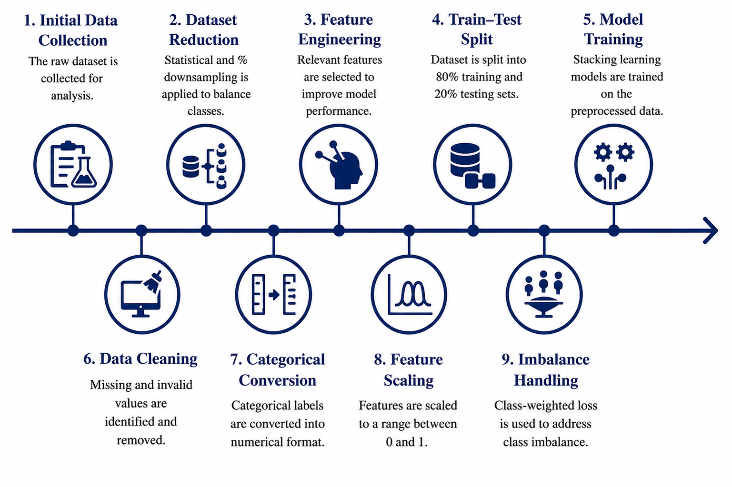
Figure 4. Data preprocessing pipeline for deep learning-based intrusion detection.
The sample was then divided into 80% training and 20% test partitions using stratified sampling. Z-score standardization was fitted on the training partition only and applied unchanged to the test partition. During training, a class-weighted loss compensated for the small Web class (Section 2.1). Finally, the processed training data were used to train the deep learning models, and the test partition was used for evaluation. This preprocessing workflow is summarized in Figure 4.

2.3 Performance Evaluation
To evaluate the effectiveness of each model in identifying botnet attacks, a series of evaluation metrics was used. These metrics evaluate various behavioral characteristics of the models, including prediction accuracy, the ability to detect minority attack classes, resilience to class imbalance, and learning consistency. The most important performance indicators include accuracy, precision, recall, and F1-score, which quantify the ability of each model to classify benign and malicious traffic. In addition, the AUC and AP help characterize the discriminative ability of the models, particularly when the dataset is imbalanced and conventional metrics can be misleading. To assess both agreement beyond chance and the reliability of performance when classes are not equally distributed, Kappa and MCC were added. The formulas for the various evaluation criteria are as follows:
Accuracy measures the proportion of total correct predictions (TP + TN) out of all predictions, as shown in Equation (2). It reflects the overall effectiveness of the classifier but may be misleading on imbalanced datasets.
Accuracy (2)

Precision: Indicates the proportion of predicted positive cases that are truly positive (TP / (TP + FP)), as shown in Equation (3). This is crucial when the cost of false positives is high.
Precision (3)

Recall: Measures the proportion of actual positive cases correctly identified (TP / (TP + FN)), as shown in Equation (4). It is important when missing positive cases (false negatives) is costly.
Recall (4)

F1-Score: The harmonic mean of precision and recall, which balances the trade-off between them, as shown in Equation (5). It is useful when both false positives and false negatives matter.
F1-Score (5)

Kappa (κ): Assesses classifier performance while accounting for the likelihood of random chance agreement. A higher κ indicates stronger agreement between the predicted and true labels, as shown in Equation (6).
(6)
Matthews Correlation Coefficient (MCC): Provides a balanced evaluation using TP, TN, FP, and FN, even for imbalanced datasets, as shown in Equation (7). A value close to 1 indicates high-quality predictions, whereas a value of 0 indicates random prediction.
MCC (7)
Macro AUC: Calculates the AUC for each class independently and then averages the results, as shown in Equation (8). It treats all classes equally, regardless of their frequency.
Macro AUC (8)

Macro AP: Computes AP for each class and then averages them across all classes, as shown in Equation (9). It is suitable for multi-class settings with class imbalance.
Macro AP (9)

2.3.1 Epoch-wise Performance Curves

The learning stability and convergence behavior of each model during training were analyzed by examining the performance curves for each epoch. These curves show the evolution of accuracy and loss over time, making it possible to detect underfitting, overfitting, or stable learning behavior. Monitoring the progress of each training iteration provides information on how quickly and efficiently each model adapts to the characteristics of the IoT traffic data.

2.3.2 Confusion Matrix

Confusion matrices provide an analysis of class-wise prediction accuracy and identify the attack categories that are correctly or incorrectly classified by the models. The analysis reveals the strengths and weaknesses of the models in identifying closely related IoT attack patterns and shows which models remain reliable across all classes. Confusion matrices provide a detailed picture of model performance by visualizing true positives, false positives, and false negatives.

2.3.3 ROC and Precision–Recall Curves
ROC and precision–recall (PR) curves were plotted for each traffic class to evaluate the trade-off between true positives and false positives. These curves provide a more in-depth understanding of the model sensitivity and specificity, particularly when the dataset is imbalanced and some attack types are underrepresented. High AUC and AP values indicate the ability to discriminate between frequent and rare attack patterns, demonstrating the model's effectiveness in detecting them.
III. DEEP LEARNING MODEL DESIGN
In this study, three types of deep learning architectures were assessed to capture the spatial, temporal, and attention-based characteristics of IoT traffic.
Input representation. Each sample is a single flow record described by 76 features. For the convolutional, recurrent, and attention-based models, each feature vector is reshaped into a sequence of shape 76 × 1, so that convolution, recurrence, and attention operate along the feature dimension of a single flow; consecutive flows are not grouped into time windows. The FNN receives the flat 76-dimensional feature vector.
3.1 Standalone Deep Learning Models
Standalone deep learning models refer to independent neural networks, such as FNN, CNN, LSTM, GRU, or Transformer, that operate without being combined with other models. These models offer a simpler design and efficient training while still capturing the intricate patterns necessary for classification or regression tasks.
3.1.1 Feedforward Neural Network (FNN):
Figure 5 shows a common FNN, which is one of the most popular ANN designs, in which information flows in only one direction, from the input layer to the output layer through a series of hidden layers [29].
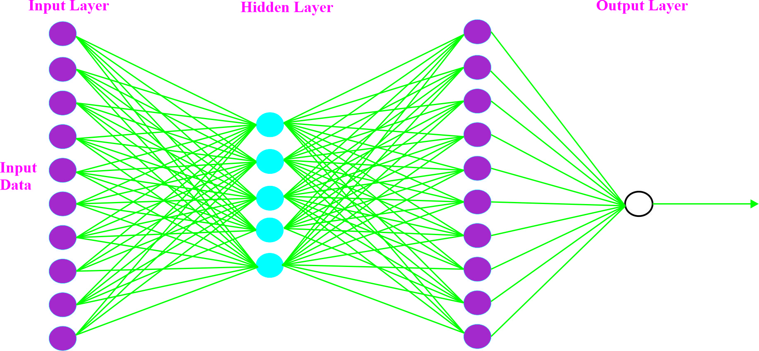
Figure 5. FNN architecture.
Diagram of a feedforward neural network architecture consisting of an input layer, multiple fully connected hidden layers, and an output layer used for traffic classification. The sizes of the input and output layers are determined by the number of input features and output classes of the problem, and the size of the hidden layers is often chosen by trial and error to achieve optimal performance. Every neuron is fully connected to the neurons in the subsequent layer, which allows the network to learn intricate correlations in the data. In practice, FNNs can have numerous neurons and layers, which enables them to identify patterns such as the differences between attack and non-attack events in cybersecurity tasks.
3.1.2 One-Dimensional Convolutional Neural Network (CNN-1D):
Figure 6 illustrates the CNN-1D architecture used to automatically extract hierarchical features from sequential inputs. The model begins with an input layer followed by a sequence of Conv1D layers, where convolutional filters slide across the input sequence to identify local patterns using specified kernel sizes and ReLU activation functions [30].
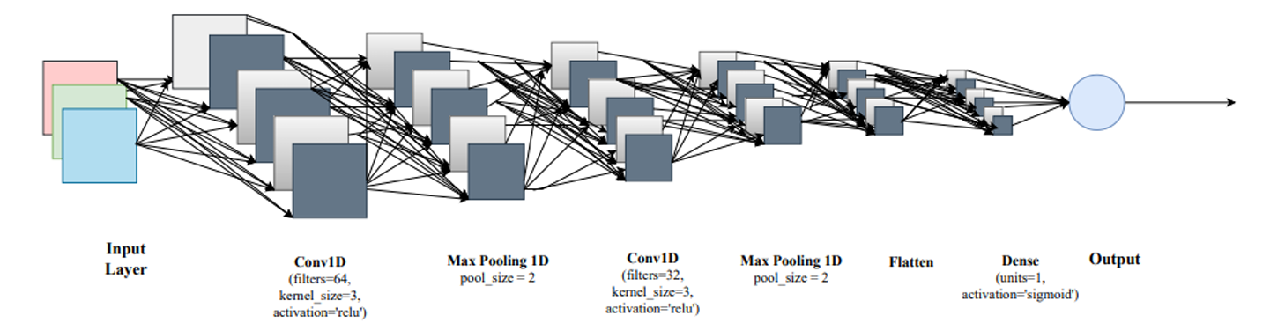
Figure 6. CNN-1D model architecture.
Architecture of a CNN-1D showing convolution, pooling, and dense layers for extracting spatial features from network traffic data. A max pooling layer is then used to reduce the dimensionality of the convolutional output while retaining the most significant features, thereby enhancing computational efficiency. The extracted feature maps are then aggregated by a global average pooling layer and passed to a dense layer, which learns high-level representations after the convolution-pooling stages. Finally, a softmax-activated output layer assigns each flow to one of the five traffic classes (Benign, DoS, Malware, Unauthorized, and Web).
3.1.3 Long Short-Term Memory (LSTM):
The model depicted in Figure 7 is a basic but effective LSTM-based neural network used for sequence learning tasks. The architecture starts with an input layer that takes a set of features (x₁, x₂, ..., xₙ).
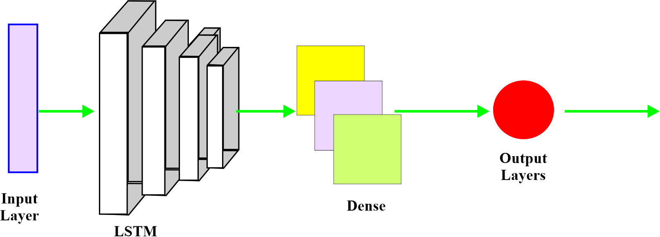
Figure 7. LSTM model architecture.
Structural representation of an LSTM-based neural network illustrating sequential data processing for learning temporal dependencies in network traffic. This input sequence is then fed into two stacked LSTM layers of 128 and 64 units, which allow the network to learn temporal dependencies, long-range patterns, and contextual relationships within the data. The LSTM output is then passed to a dense output layer with softmax activation, which converts the learned representation into class probabilities. Finally, the output layer assigns each flow to one of the five traffic classes. LSTM has been employed in a wide range of classification problems involving time-dependent or sequential data owing to its ability to retain long-term memory while mitigating the vanishing-gradient problem.
  - Attention-Enhanced Hybrid Models
Attention-enhanced hybrid models combine classic deep learning models such as CNNs, LSTMs, or BiLSTMs with attention models to enhance feature representation and decision-making. The attention layer, which assigns greater importance to the most informative sections of the input sequence, enables the model to prioritize important patterns that conventional architectures might otherwise miss. This combination enables the model to capture longer-range dependencies, increases interpretability, and significantly improves performance in more challenging classification tasks.
3.2.1 CNN-Transformer
Figure 8 depicts the architecture, where the initial stage is data preprocessing, such as label encoding and normalization, which transforms raw input data into a structured numerical format. The processed features are then fed into the CNN-1D, whose output is passed to the Transformer encoder, where the multi-head attention mechanism captures global relationships by concurrently analyzing query (Q), key (K), and value (V) representations. Normalization layers (Add and Norm) and residual connections stabilize learning and maintain contextual details, and the feed-forward network further refines the encoded features.
Let the output of the final 1D convolutional layer be represented as a feature tensor, where L denotes the sequence length after convolution and pooling operations, and C represents the number of learned feature channels. The feature tensor is reshaped into a sequence of L feature vectors, each having dimension C, thereby forming the input to the Transformer encoder. Linear projection layers subsequently map this sequence into the query, key, and value representations according to
where and are the learnable projection matrices. The resulting matrices satisfy the dimensional requirements of the multi-head self-attention mechanism, enabling the Transformer encoder to model long-range dependencies among the convolutionally extracted feature representations. In this manner, the CNN provides localized spatial feature extraction, while the Transformer captures global contextual relationships through self-attention.
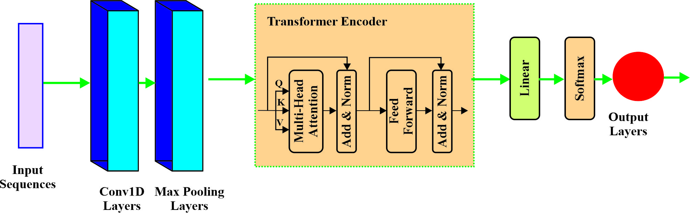
Figure 8. CNN-Transformer hybrid architecture.
Hybrid CNN-Transformer architecture combining convolutional feature extraction with multi-head self-attention to capture local and global dependencies in IoT traffic. The Transformer output is passed through a linear layer and, finally, a softmax classifier, which assigns probabilities to the five traffic classes, namely Benign, DoS, Malware, Unauthorized, and Web. This design is powerful because it captures long-range dependencies and complex interactions among the features [31].
3.2.2 BiLSTM-Transformer
The architecture depicted in Figure 9 combines BiLSTM and Transformer blocks to exploit both sequential and global contextual dependencies. The input sequence is first processed by a bidirectional LSTM layer, whose outputs are then passed to Transformer encoder blocks that model global relationships across the sequence through multi-head self-attention.
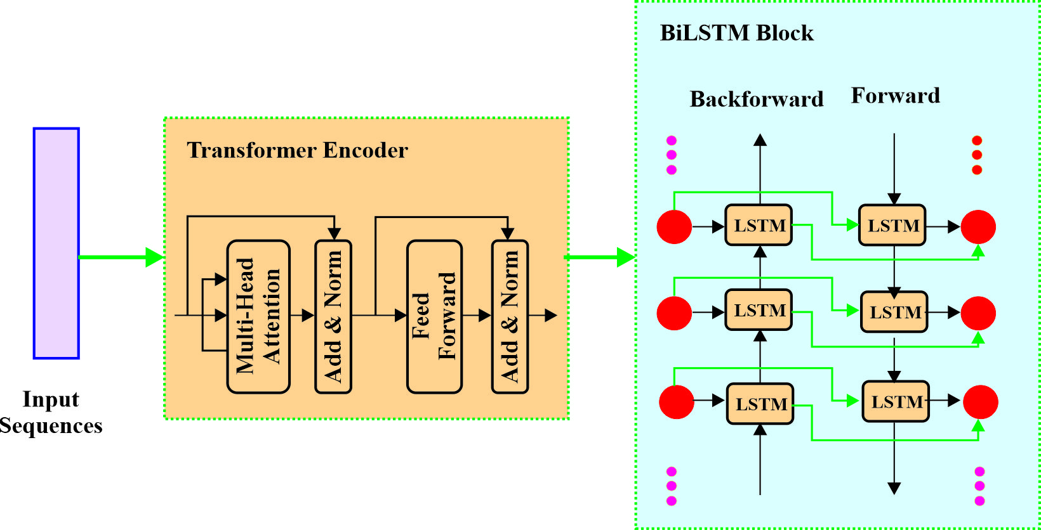
Figure 9. BiLSTM-Transformer hybrid architecture.
The BiLSTM-Transformer hybrid model shows bidirectional temporal learning integrated with transformer attention mechanisms for enhanced sequence modelling. These encoded features are fed into the Transformer encoder, where they are first processed by a multi-head attention mechanism that learns long-range relationships and then by feed-forward layers that refine the representation, each followed by a residual connection and normalization. The Transformer output is then input into a BiLSTM block, which comprises forward and backward LSTM layers that learn the temporal dependencies together. The outputs are combined so that the model benefits from the powerful global attention of the Transformer and the ability of the BiLSTM to capture sequence order, which makes the architecture highly expressive in addressing complex sequence classification problems [32].
3.3 Hybrid Spatio-Temporal Models (CNN-BiLSTM)
Hybrid spatio-temporal models combine convolution-based spatial feature extraction with recurrent or attention-based temporal learning to capture both local patterns and long-term dependencies in sequential data. The combination of CNNs, LSTMs, and BiLSTMs in one framework helps these models learn more detailed representations, which increases accuracy and robustness in more sophisticated time-series classification problems.
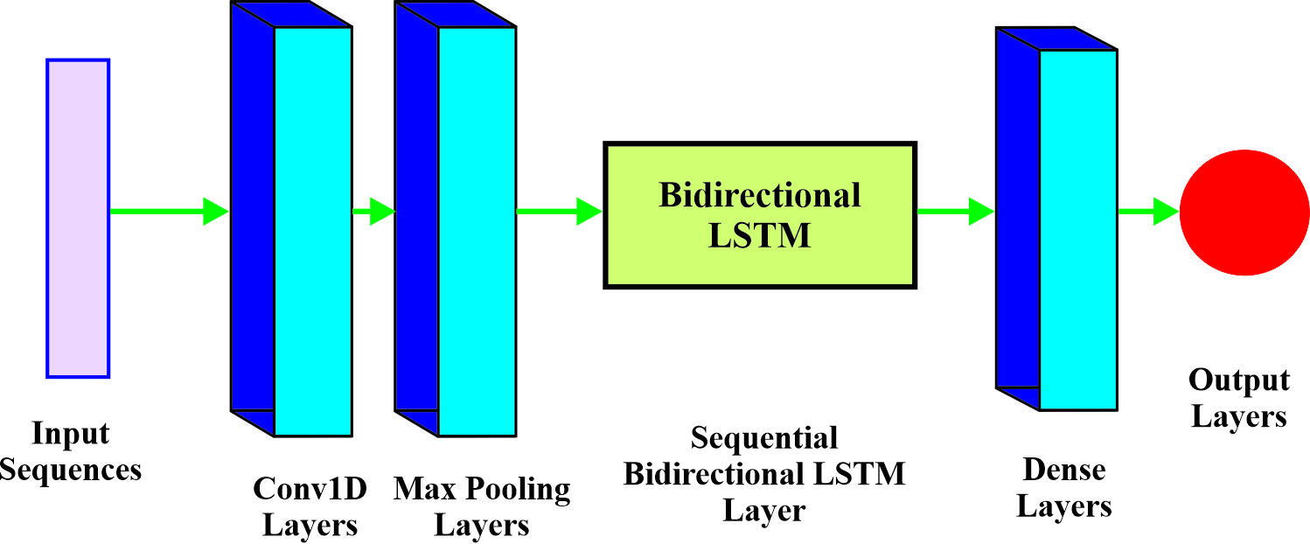
Figure 10. CNN-BiLSTM hybrid architecture.
The CNN-BiLSTM hybrid architecture illustrates the use of convolutional layers for spatial feature extraction, followed by bidirectional LSTM layers for learning temporal patterns. As illustrated in Figure 10, the architecture combines CNN and BiLSTM to learn and extract both local structures and long-range temporal structures of sequential data. The model starts with input sequences that pass through a Conv1D layer with 64 filters to generate significant local features and eliminate noise [33]. The feature maps are then down-sampled by a max-pooling layer, which retains dominant patterns while reducing computational complexity, and are refined by a second Conv1D layer with 128 filters. The resulting features are used as the input of a bidirectional LSTM layer with 128 units per direction to learn contextual information from both forward and backward directions. Finally, the learned representation passes through a dense layer with 128 units, followed by a softmax output layer that produces the final five-class prediction. This combined design reduces misclassification by exploiting both the spatial and temporal attributes of the data.
Table 2. Summary of the Architecture and Training Configuration of the Six Deep Learning Models
Model | Architecture | Kernel Size | Activation Function | Training Configuration
FNN | Dense: 512 → 256 → 128 → 64 → 5; BN; Dropout | – | ReLU → ReLU → ReLU → ReLU → Softmax | Class-weighted categorical cross-entropy; Adam; 30 epochs
CNN-1D | Conv1D (64, 128); BN; Pooling; GAP; Dense | 5, 3 | ReLU → ReLU → Softmax | Class-weighted categorical cross-entropy; Adam; 30 epochs
LSTM | LSTM (128 → 64); BN; Dropout; Dense | – | Tanh → Softmax | Class-weighted categorical cross-entropy; Adam; 30 epochs
CNN-Transformer | CNN → 2 × Transformer encoder (MHA, Add & LN, FFN) → GAP → Dense | 5, 3 | ReLU → Transformer → Softmax | Class-weighted categorical cross-entropy; Adam; 30 epochs
BiLSTM-Transformer | BiLSTM → 2 × Transformer encoder (MHA, Add & LN, FFN) → GAP → Dense | – | Tanh → Transformer → Softmax | Class-weighted categorical cross-entropy; Adam; 30 epochs
CNN-BiLSTM | CNN front-end → BiLSTM → BN → Dropout → Dense | 5, 3 | ReLU → Tanh → Softmax | Class-weighted categorical cross-entropy; Adam; 30 epochs
Table 2 provides a unified comparison of all six deep learning models employed in this study, with a focus on their architectural components, important parameters, and training settings. The models range from fully connected networks, such as the FNN, which uses several dense layers with batch normalization and dropout, to more sophisticated sequence models, such as LSTM and BiLSTM-based hybrids. Convolutional architectures, namely CNN-1D, CNN-Transformer, and CNN-BiLSTM, use one-dimensional kernels of sizes 5 and 3 to extract spatial patterns before passing the features to recurrent or dense layers. Multi-head attention and layer normalization are added to the transformer-integrated models, including the CNN-Transformer and BiLSTM-Transformer hybrids, to learn long-range dependencies. The primary activation functions used across the models were ReLU, tanh, and softmax, while class-weighted categorical cross-entropy and the Adam optimizer were consistently applied for 30 epochs. This table summarizes the progressive architectural complexity and the uniform training configuration of the assessed models.
Further architectural details, taken from the implemented models, are as follows. The FNN consists of four dense layers with 512, 256, 128, and 64 units, each followed by batch normalization and dropout. The CNN-1D model uses two Conv1D layers with 64 filters (kernel size 5) and 128 filters (kernel size 3), each followed by batch normalization, with max pooling after the first layer, followed by global average pooling and a 128-unit dense layer. The LSTM model stacks two LSTM layers with 128 and 64 units, each followed by batch normalization and dropout. The CNN-BiLSTM model uses the same two-layer convolutional front-end as the CNN-1D model, followed by a bidirectional LSTM with 128 units per direction, batch normalization, dropout, and a 128-unit dense layer. The CNN-Transformer model uses the same convolutional front-end followed by two Transformer encoder blocks (four attention heads, embedding dimension 128, feed-forward dimension 256), global average pooling, and a 128-unit dense layer. The BiLSTM-Transformer model applies a bidirectional LSTM with 128 units per direction followed by two Transformer encoder blocks (four attention heads, embedding dimension 256, feed-forward dimension 256), global average pooling, and a 128-unit dense layer. All models end with a five-unit softmax output layer and use dropout rates of 0.2–0.3.
IV. RESULTS
This section reports the results of the six architectures on the CSE-CIC-IDS2018 benchmark under a common experimental protocol. Three standalone architectures (FNN, CNN-1D, and LSTM) and three hybrid models (CNN-BiLSTM, CNN-Transformer, and BiLSTM-Transformer) were trained and tested to predict different attack patterns. The experimental findings show that CNN-BiLSTM achieved the highest accuracy, recall, and ROC-AUC, whereas the standalone CNN-1D achieved the highest macro-F1 and outperformed both attention-based hybrids in accuracy. These results indicate that combining convolutional feature extraction with bidirectional temporal modeling benefits detection performance on this dataset, while adding attention mechanisms does not by itself guarantee an improvement over well-designed standalone models.
4.1 Experimental Setup and Hyperparameter Configuration
To ensure reproducibility, the experimental configuration has been explicitly documented. All models were implemented using TensorFlow/Keras in Python. The experiments were conducted using the Adam optimizer with an initial learning rate of 0.001, a batch size of 256, and a maximum of 30 epochs; the learning rate was halved whenever the validation loss did not improve for three consecutive epochs. Dropout layers with rates of 0.3 and 0.2 were incorporated to reduce overfitting, and a class-weighted loss was used (Section 2.1). The Transformer-based models employed two encoder blocks with four attention heads and a feed-forward dimension of 256, with an embedding dimension of 128 (CNN-Transformer) or 256 (BiLSTM-Transformer). The primary results in Tables 3–12 were obtained from a single run with a fixed random seed (seed = 42) controlling data partitioning, weight initialization, and mini-batch shuffling; the five-seed repeated-run protocol is described in Section 4.12.
The experiments were executed on a workstation equipped with an Intel Core i7 processor, 64 GB RAM, and an NVIDIA GPU running Windows 11, using Python with TensorFlow/Keras 3, NumPy, Pandas, and Scikit-learn. The inference-time and memory measurements reported in Section 4.11 were performed on the same type of runtime with Python 3.13, TensorFlow 2.20.0, Keras 3.13.2, NumPy 2.1.3, Pandas 2.2.3, and Scikit-learn 1.6.1. The complete implementation details and hyperparameter settings are provided to facilitate independent verification and future comparative studies.
The hyperparameters used in this study were selected through empirical experimentation and consideration of commonly adopted configurations for deep-learning-based intrusion detection. The objective was to obtain a stable training configuration while maintaining a consistent experimental setting across all six architectures. An initial learning rate of 0.001 and a batch size of 256 were selected with the Adam optimizer based on stable convergence during preliminary experimentation. Dropout rates of 0.3 and 0.2 were employed to mitigate overfitting. For the Transformer-based architectures, four attention heads, two encoder blocks, and embedding dimensions of 128 and 256 were selected to provide sufficient representation capacity while avoiding unnecessary architectural complexity. The same training configuration was retained across the models wherever applicable to ensure a fair comparison of their architectural performance.
4.2 Analysis of FNN Model
Table 3. Epoch Evaluation Metrics for FNN
Epoch | Accuracy | Precision | Recall | F1-Score | Macro-AUC | Macro-AP | Loss | Time (s)
5 | 0.8624 | 0.7282 | 0.8835 | 0.7164 | 0.9785 | 0.8580 | 0.2750 | 14
10 | 0.8846 | 0.7611 | 0.8445 | 0.7669 | 0.9815 | 0.8771 | 0.2321 | 16
15 | 0.8854 | 0.7682 | 0.8640 | 0.7750 | 0.9823 | 0.8874 | 0.2231 | 16
20 | 0.8837 | 0.7551 | 0.9068 | 0.7593 | 0.9827 | 0.8954 | 0.2272 | 14
25 | 0.8867 | 0.7637 | 0.9092 | 0.7742 | 0.9837 | 0.9049 | 0.2214 | 14
30 | 0.8882 | 0.7672 | 0.9041 | 0.7790 | 0.9841 | 0.9068 | 0.2156 | 14
Table 3 shows the epoch-based evaluation measures of the FNN model trained on CSE-CIC-IDS2018 data for the detection of botnet attacks. The findings show that the performance of the model generally improves across training epochs, reaching a peak accuracy of 0.8882 at the 30th epoch. Precision, recall, and F1-score show a similar upward tendency, demonstrating improved classification reliability and balance. Recall remained high across epochs (0.8835–0.9092), which shows that the model is very effective at correctly recognizing attacks. The values of macro-AUC and macro-AP were consistently high (>0.9780), which indicates strong discriminatory ability between categories. Meanwhile, the loss continuously decreases from 0.2750 to 0.2156, which is an indicator of better convergence, and the computation time remains approximately constant (14–16 seconds) per epoch. Overall, the FNN model exhibited consistent learning behavior and acceptable predictive accuracy in the detection of IoT botnets.
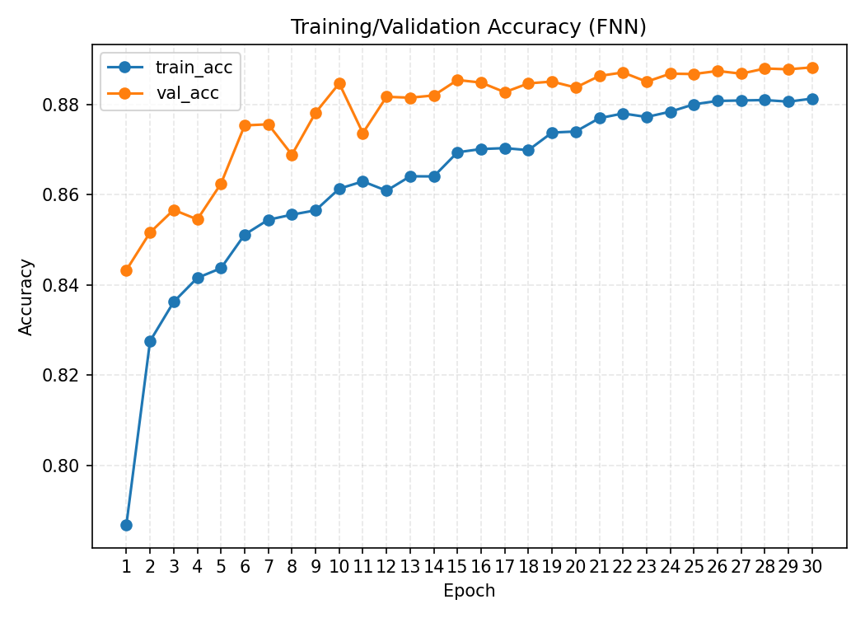
Figure 11. Training and validation accuracy curves of the FNN model.

Figure 11 shows the training/validation accuracy curve of the FNN model, which indicates that the accuracy steadily and consistently increased with each epoch, suggesting that the learning behavior was stable. The training accuracy increases gradually from 0.83 to 0.88, whereas the validation accuracy is consistently higher and almost reaches 0.89 in the final epochs. The steadily ascending curve and the few fluctuations in validation accuracy indicate that the model generalizes well with limited overfitting.

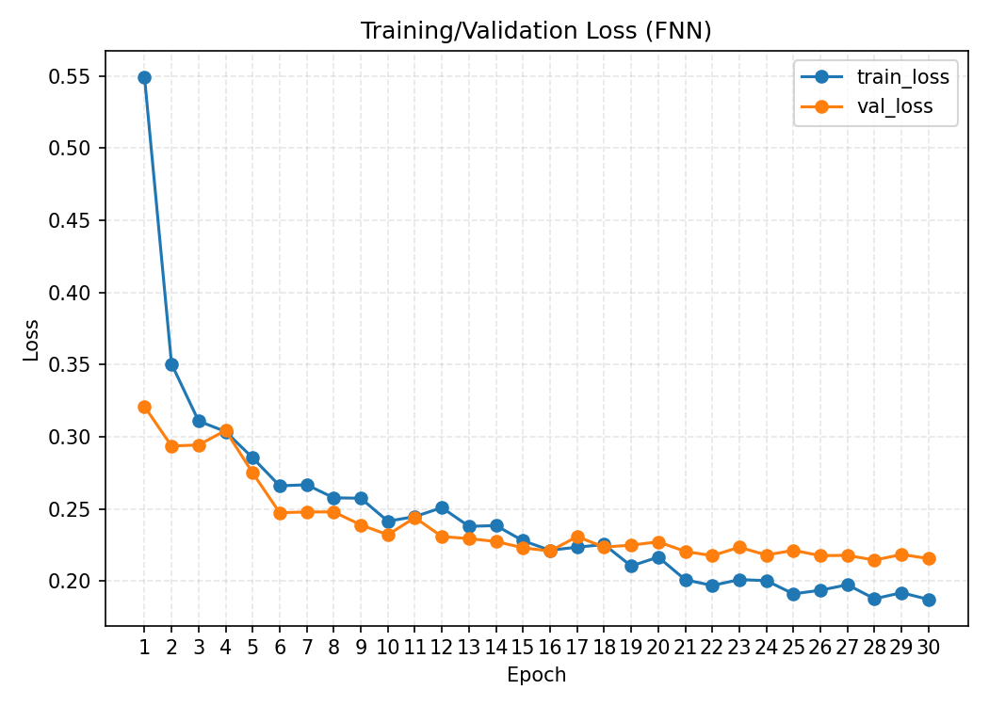
Figure 12. Training and validation loss curves of the FNN model.
Figure 12 depicts a stable downward trend without notable fluctuations, indicating consistent convergence of the training process. The training loss decreases sharply in the first epochs, from 0.55 to below 0.30, indicating fast early learning. After epoch 10, the training and validation losses decreased slowly and leveled off at 0.18–0.22, indicating effective optimization and limited overfitting. The nearly parallel curves further suggest that the model generalizes well to unseen data.
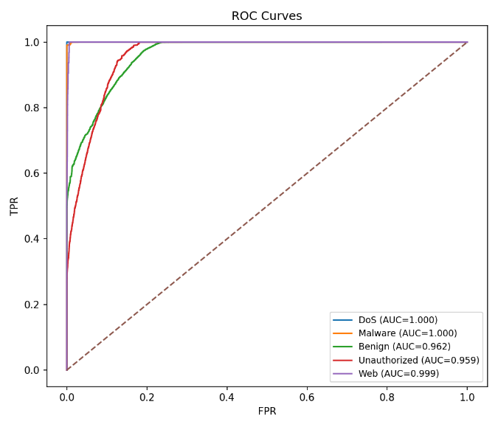 | 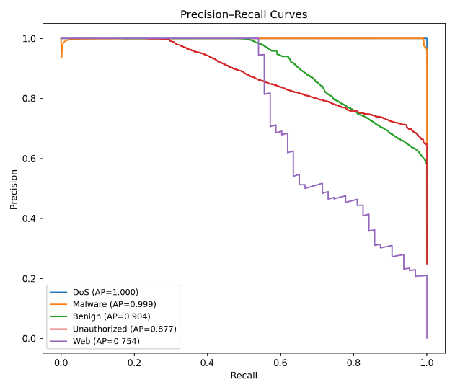
Figure 13. ROC and Precision–Recall curves of the FNN model.
Figure 13 presents the ROC and PR curves, which reveal the excellent performance of the FNN model in detecting the classes of the CSE-CIC-IDS2018 dataset. DoS and Malware both obtained perfect scores (AUC/AP = 1.000), whereas the Benign, Unauthorized, and Web classes had high separability with AUC scores of 0.962, 0.959, and 0.999, respectively. PR performance is consistently high, although it is slightly lower for Web traffic (AP = 0.754) because of its subtle patterns. Overall, the curves confirm that the FNN model is robust and suitable for detecting botnet attacks in various types of IoT traffic.
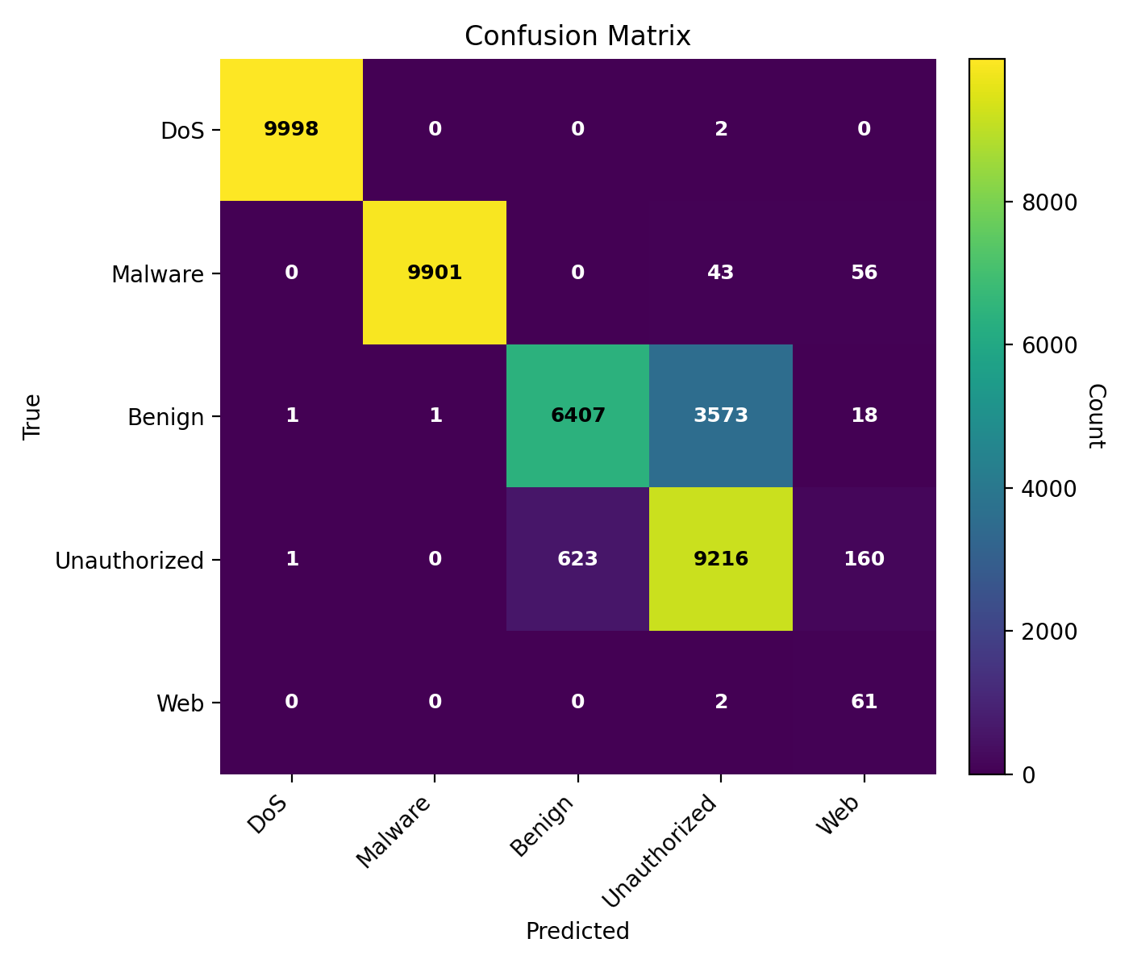
Figure 14. Confusion matrix of the FNN model.
The confusion matrix of the FNN model displays class-wise prediction results for benign and attack traffic. As indicated in Figure 14, the FNN model obtains highly accurate classification for all categories of traffic. DoS and malware were nearly perfectly classified, with 9,998 and 9,901 correct predictions, respectively, and negligible false alarms. Benign traffic was correctly classified 6,407 times, but there was slight confusion with the Unauthorized class, indicating that some behavioural patterns were similar. Unauthorized traffic was also categorized well, with 9,216 accurate predictions, but 623 samples were falsely identified as benign. Web traffic, as a smaller and more complicated category, achieved moderate accuracy, with 61 correct predictions. Overall, the matrix shows favorable detection results, especially for the large attack classes, although benign and unauthorized traffic partially overlap.
4.3 Analysis of CNN-1D Model
In this section, the CNN-1D model is evaluated on the dataset to capture spatial feature patterns for botnet attack detection in IoT environments.
Table 4. Epoch Evaluation Metrics for CNN‑1D
Epoch | Accuracy | Precision | Recall | F1-Score | Macro-AUC | Macro-AP | Loss | Time (s)
5 | 0.8570 | 0.7401 | 0.8728 | 0.7653 | 0.9784 | 0.8685 | 0.2670 | 58
10 | 0.8551 | 0.7270 | 0.8807 | 0.7452 | 0.9798 | 0.8635 | 0.2428 | 76
15 | 0.8856 | 0.7539 | 0.9083 | 0.7747 | 0.9830 | 0.9037 | 0.2287 | 58
20 | 0.8820 | 0.7545 | 0.9023 | 0.7775 | 0.9829 | 0.9017 | 0.2174 | 62
25 | 0.8866 | 0.7599 | 0.9060 | 0.7806 | 0.9842 | 0.9043 | 0.2105 | 82
30 | 0.8908 | 0.7639 | 0.9094 | 0.7844 | 0.9847 | 0.9129 | 0.2085 | 61
Table 4 demonstrates the epoch-wise performance of the CNN-1D model, which indicates overall improvement in training results as the number of epochs increases. The accuracy increases from 0.8570 at epoch 5 to 0.8908 at epoch 30, whereas precision, recall, and F1-score follow a generally increasing pattern, indicating improved classification performance. The recall is especially high (0.8728-0.9094), which shows that the model is very effective in correctly detecting attacks. The values of macro-AUC and macro-AP were high (>0.97), indicating excellent class separability and high predictive strength. The loss value gradually decreased from 0.2670 to 0.2085, indicating satisfactory convergence, although the time per epoch varied slightly because of computational fluctuations.
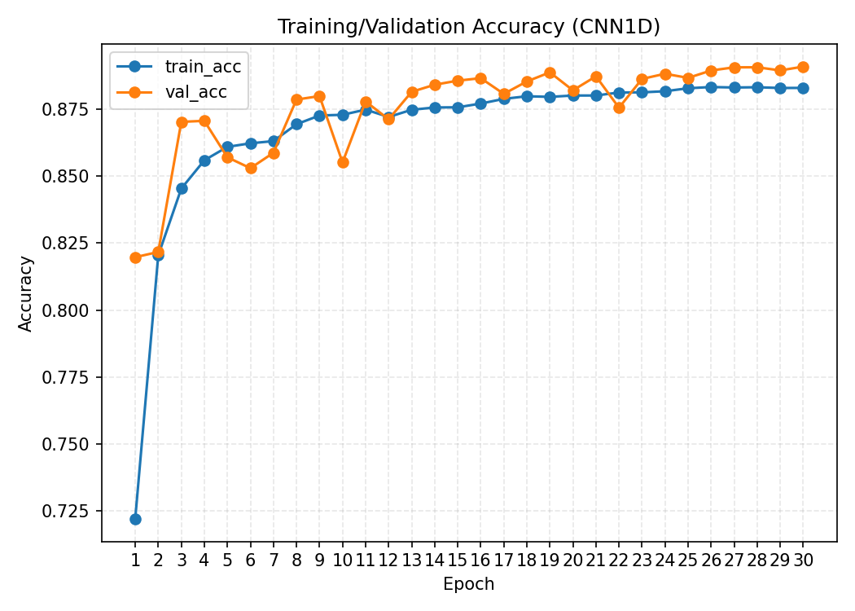
Figure 15. Training and validation accuracy curves of the CNN-1D model
Training and validation accuracy curves of the CNN-1D model over epochs show consistent improvement and stable learning behavior. As demonstrated in Figure 15, the training and validation accuracy curves of the CNN-1D model increase distinctly, illustrating strong and stable learning during training. The training accuracy increased quickly from roughly 0.72 in the first epoch to approximately 0.88 in the final (30th) epoch, whereas the validation accuracy was consistently slightly higher, reaching up to 0.89. The closeness of the two curves and the lack of significant fluctuations indicate good generalization and an absence of overfitting.
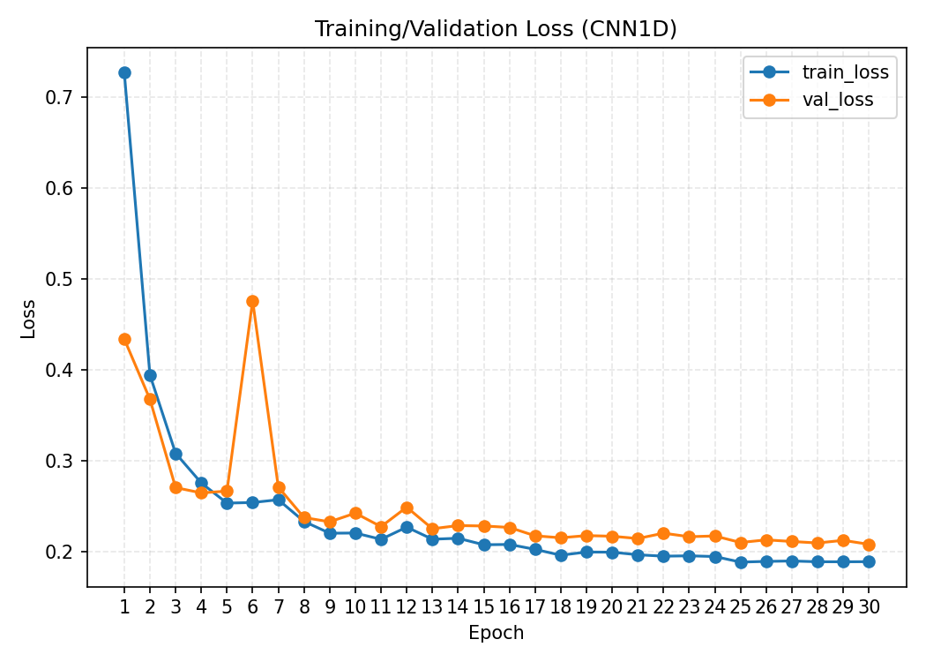
Figure 16. Training and validation loss curves of the CNN-1D model
Figure 16 depicts the training and validation loss curve of the CNN-1D model, which shows a rapid descent in the first epochs, signifying rapid and efficient learning. The training loss decreases dramatically (approximately 0.72 to 0.30) in the first few epochs, and the validation loss follows a similar trend, apart from a slight rise at epochs 5–6. After epoch 10, the curves converge between 0.18 and 0.22 and show very little overfitting. The fact that the two curves closely follow each other during training suggests that the CNN-1D model is generalizable and can sustain strong performance even when used on unseen data.
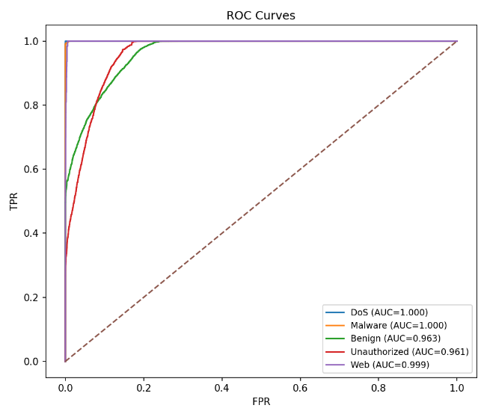 | 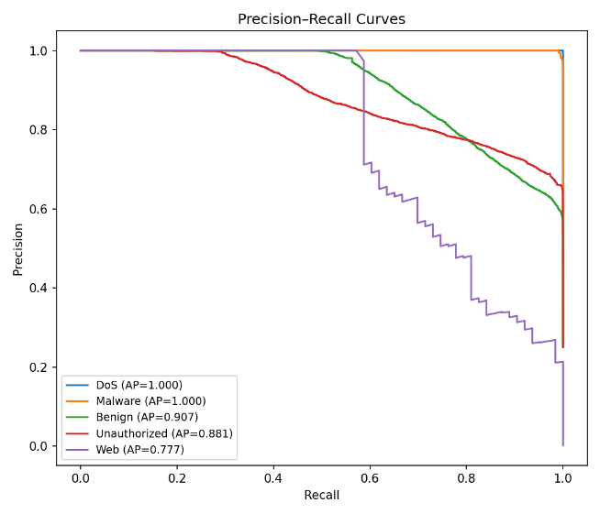
Figure 17. ROC and Precision–Recall curves of the CNN-1D model
Figure 17, depicting the ROC and PR curves of the CNN-1D model, demonstrates strong class-wise detection. The DoS and Malware classes achieve optimal performance (AUC/AP = 1.000), which indicates that the model is capable of identifying these attacks with high levels of accuracy. Although the Web class is more difficult to detect because of its subtle traffic patterns, it achieves competitive performance (AUC = 0.999, AP = 0.777).
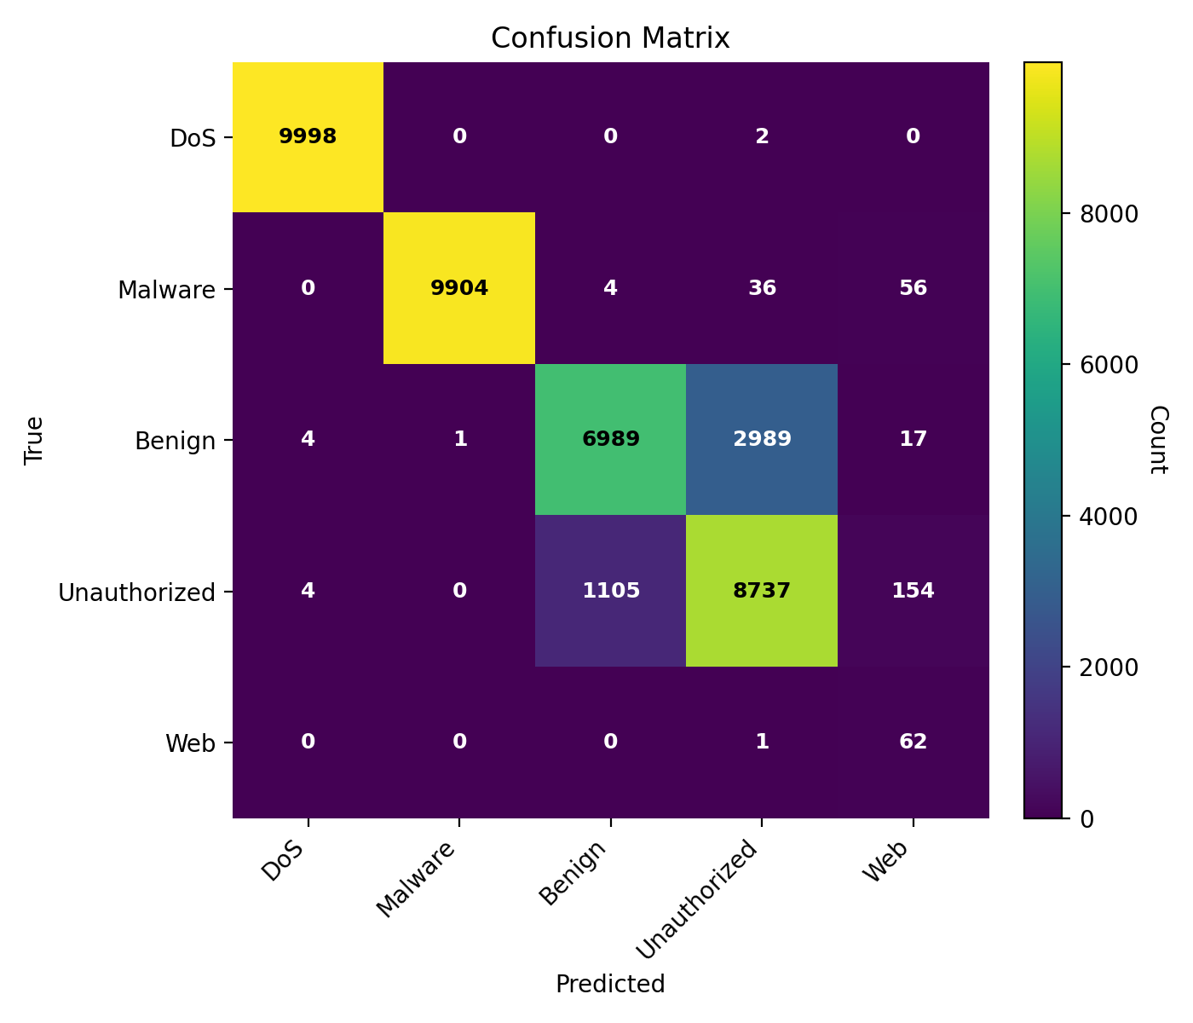
Figure 18. Confusion matrix of the CNN-1D model
The confusion matrix of the CNN-1D model shows the correct and incorrect classifications for both benign and attack classes. The confusion matrix indicates high classification accuracy, with DoS and malware correctly identified in almost all cases and only a few misclassifications, as shown in Figure 18. There is some overlap between the benign and unauthorized classes, although, overall, the CNN-1D model produces few errors across all classes and is quite accurate in detecting the smaller Web class as well.
4.4 Analysis of LSTM Model
In this section, the LSTM model was evaluated to identify temporal dependencies in IoT network traffic to better detect botnet attacks. Its behavior was assessed using epoch-wise accuracy and loss, ROC/PR curves, and the confusion matrix, which showed strong sequential learning, consistent convergence, and confident class-wise prediction across different attack types.
Table 5. Epoch Evaluation Metrics for LSTM
Epoch | Accuracy | Precision | Recall | F1-Score | Macro-AUC | Macro-AP | Loss | Time (s)
5 | 0.8240 | 0.7174 | 0.8590 | 0.6884 | 0.9712 | 0.8278 | 0.3623 | 505
10 | 0.8474 | 0.7277 | 0.8778 | 0.7038 | 0.9748 | 0.8428 | 0.3266 | 489
15 | 0.8235 | 0.6961 | 0.8586 | 0.6800 | 0.9754 | 0.8623 | 0.3338 | 525
20 | 0.8679 | 0.7333 | 0.8942 | 0.7218 | 0.9799 | 0.8838 | 0.2625 | 486
25 | 0.8753 | 0.7363 | 0.9001 | 0.7368 | 0.9811 | 0.8870 | 0.2325 | 517
30 | 0.8836 | 0.7575 | 0.9068 | 0.7640 | 0.9821 | 0.8963 | 0.2244 | 512

According to Table 5, the LSTM model gradually improves as the number of epochs increases, with increasing accuracy and consistently high recall values, which suggests that temporal patterns are being successfully learned. High macro-AUC and macro-AP scores (>0.97) and a decreasing loss indicate stable convergence, although sequential processing extended the training time.
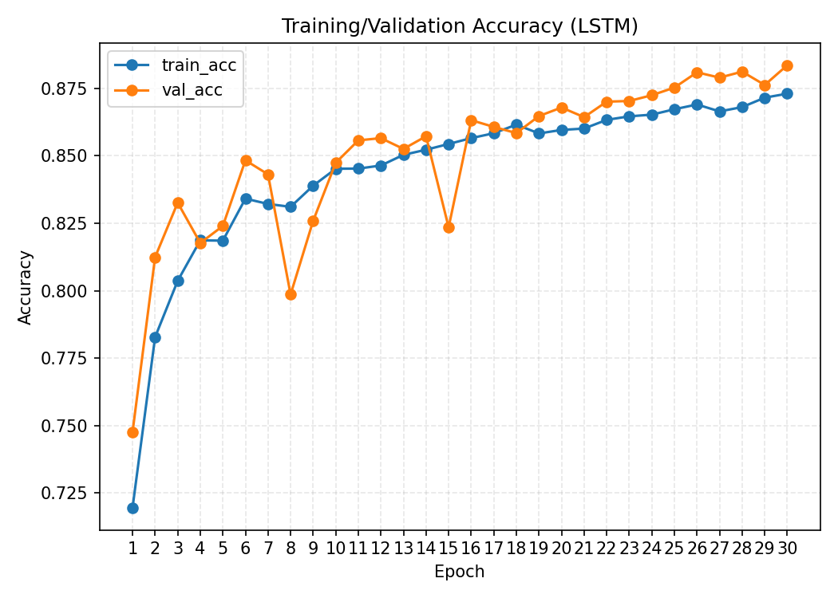
Figure 19. Training and validation accuracy curves of the LSTM model

Figure 19 shows the training and validation accuracy curves of the LSTM model, which exhibit a consistent upward trend, indicating effective learning of temporal patterns. The validation accuracy remains slightly higher than the training accuracy, suggesting good generalization and stable convergence across the training epochs.
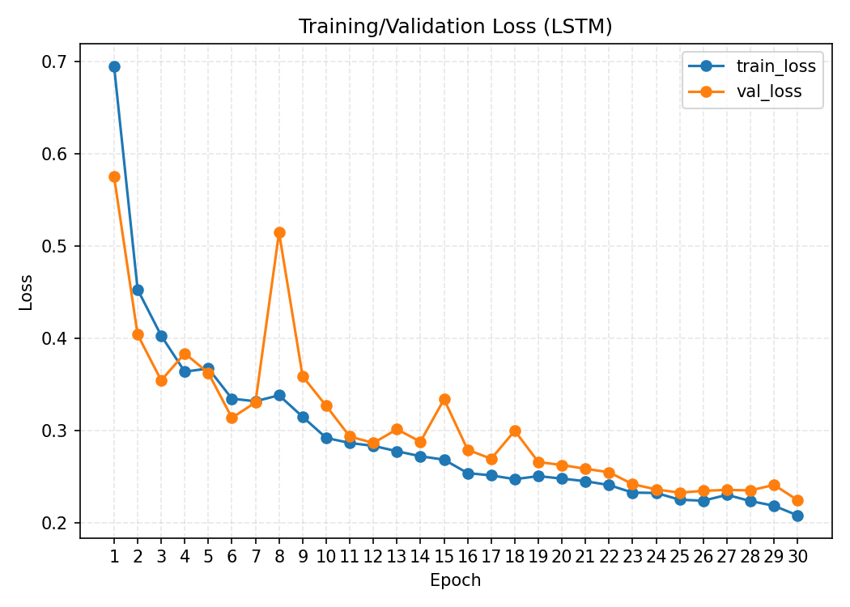
Figure 20. Training and validation loss curves of the LSTM model
Figure 20 shows that both losses decrease progressively across the training epochs and eventually stabilize, indicating stable convergence and effective learning of temporal patterns. The small fluctuations in validation loss remain limited, suggesting good generalization with no substantial evidence of overfitting.
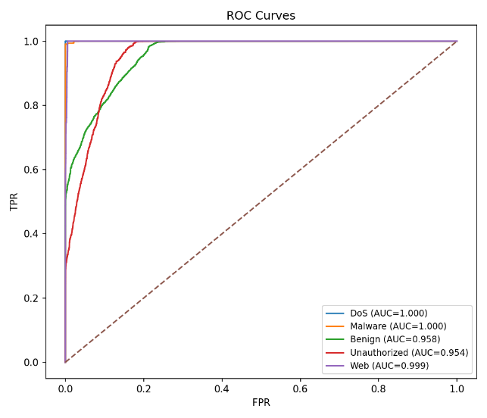 | 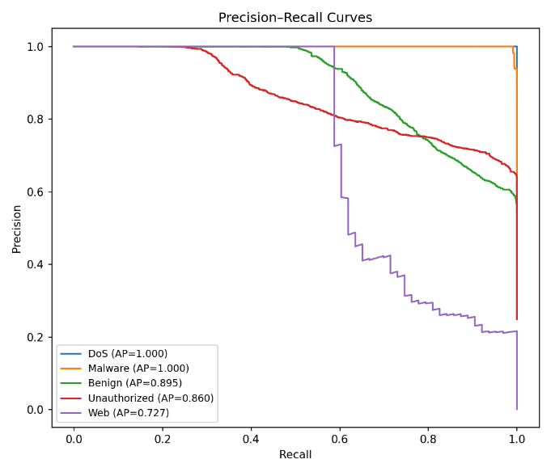
Figure 21. ROC and Precision–Recall curves of the LSTM model

Figure 21 demonstrates strong class-wise detection performance. The DoS and Malware classes achieve the highest performance, with AUC and AP values of 1.000, while the Benign, Unauthorized, and Web classes also exhibit strong classification performance. These results indicate that the LSTM model effectively captures temporal patterns associated with different botnet attack classes.
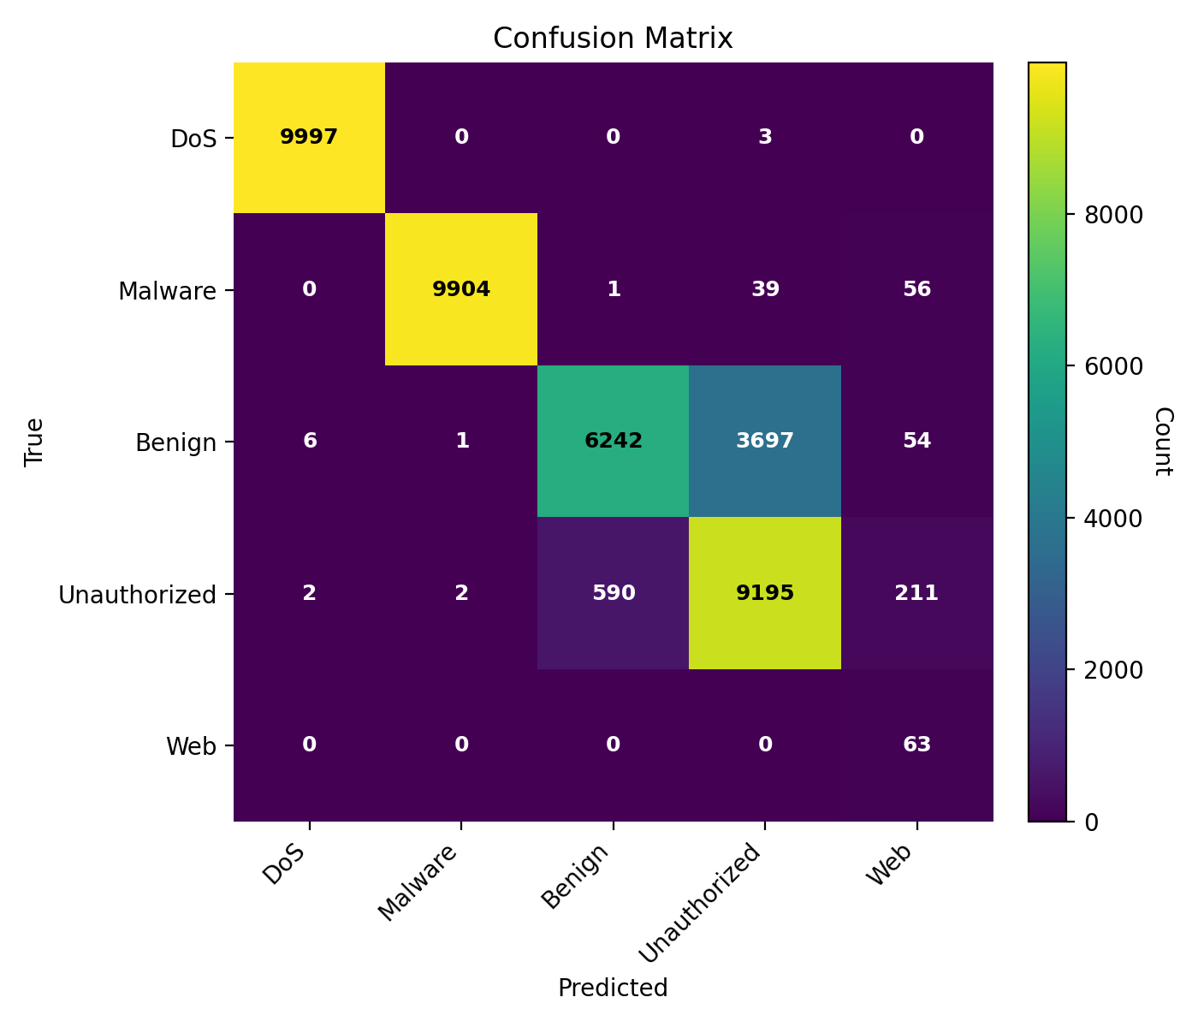
Figure 22. Confusion matrix of the LSTM model
The confusion matrix of the LSTM model, which presents class-wise prediction outcomes for benign and malicious traffic in Figure 22, shows that the LSTM model has excellent classification performance, with DoS and malware identified nearly flawlessly. There is still some overlap between benign and unauthorized traffic; however, the model is very accurate across all classes, and the smaller Web category is well identified.
4.5 Analysis of CNN-Transformer Hybrid Model
The CNN-Transformer hybrid model was designed to further improve the analysis by combining a CNN, which effectively extracts powerful spatial features, with a Transformer, which excels at sequence modeling through attention. The hybrid model exploits local and global feature dependencies, resulting in enhanced learning stability, improved class-wise discrimination, and better botnet detection performance on the CSE-CIC-IDS2018 dataset.
Table 6. Epoch Evaluation Metrics for CNN-Transformer Model
Epoch | Accuracy | Precision | Recall | F1-Score | Macro-AUC | Macro-AP | Loss | Time (s)
5 | 0.8504 | 0.7841 | 0.8807 | 0.7912 | 0.9758 | 0.8564 | 0.3256 | 540
10 | 0.8791 | 0.7412 | 0.8672 | 0.7302 | 0.9743 | 0.8658 | 0.2372 | 577
15 | 0.8795 | 0.774 | 0.8899 | 0.7763 | 0.9795 | 0.8923 | 0.2239 | 562
20 | 0.8835 | 0.7918 | 0.9005 | 0.8064 | 0.9814 | 0.9023 | 0.2197 | 566
25 | 0.8851 | 0.8053 | 0.9015 | 0.8189 | 0.9828 | 0.9124 | 0.2148 | 555
30 | 0.8858 | 0.8102 | 0.9021 | 0.7760 | 0.9837 | 0.9063 | 0.2131 | 548
The performance of the CNN-Transformer hybrid model improved steadily across epochs, with accuracy ranging from 0.8504 to 0.8858 and high recall values (0.8807 to 0.9021), indicating that the model has learned both spatial and global relationships. High macro-AUC and macro-AP scores attest to excellent class discrimination, and the steady decline in loss indicates stable convergence, as shown in Table 6.
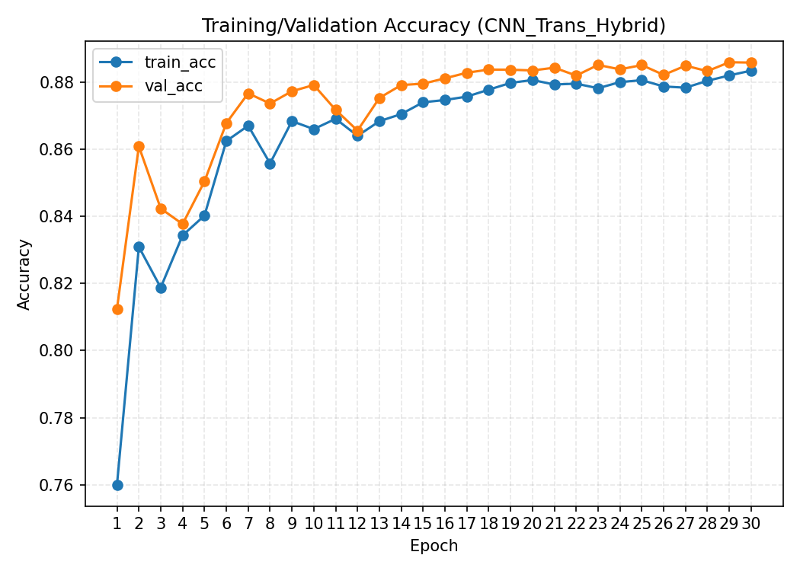
Figure 23. CNN-Transformer training and validation accuracy curves.
Figure 23 illustrates that the training and validation accuracy of the CNN-Transformer hybrid model increase consistently across epochs, indicating effective and consistent learning. The validation accuracy is consistently marginally higher than the training accuracy, which demonstrates good generalization, and both curves approach approximately 0.88–0.90, which can be attributed to the successful integration of CNN feature extraction and transformer attention.
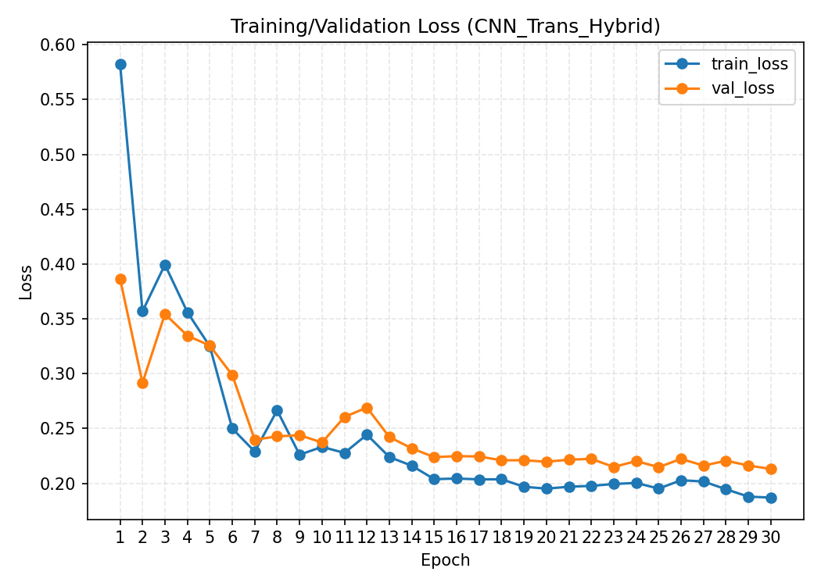
Figure 24. Training and validation loss curves of the CNN-Transformer model
Figure 24 shows that the training and validation loss curves of the CNN-Transformer hybrid model steadily decrease with the number of epochs, which indicates stable convergence and effective learning. The close agreement between the training and validation loss curves, following the initial fluctuations, indicates that the model generalizes well, and the combination of CNN and Transformer mechanisms effectively reduces model error over time.
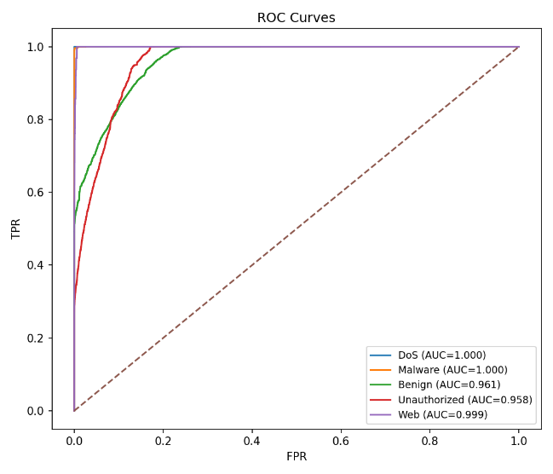 | 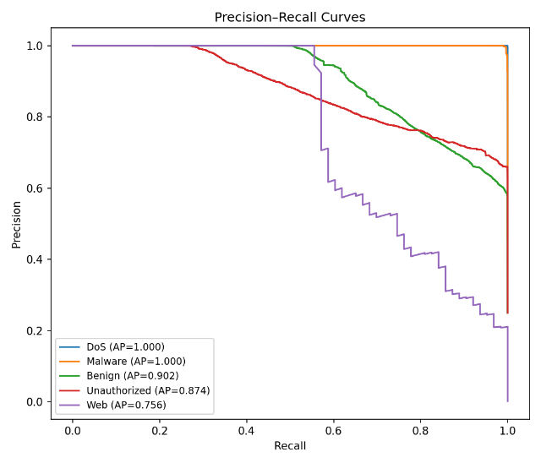
Figure 25. ROC and Precision–Recall curves of the CNN-Transformer model
The ROC and PR curves in Figure 25 indicate the excellent performance of the CNN-Transformer hybrid model across classes. DoS and Malware are characterized by the highest detection rate (AUC/AP = 1.000), and Benign, Unauthorized, and Web classes are also characterized by high separability, which demonstrates the effectiveness of CNN feature extraction and transformer attention for the detection of different categories of IoT attacks.
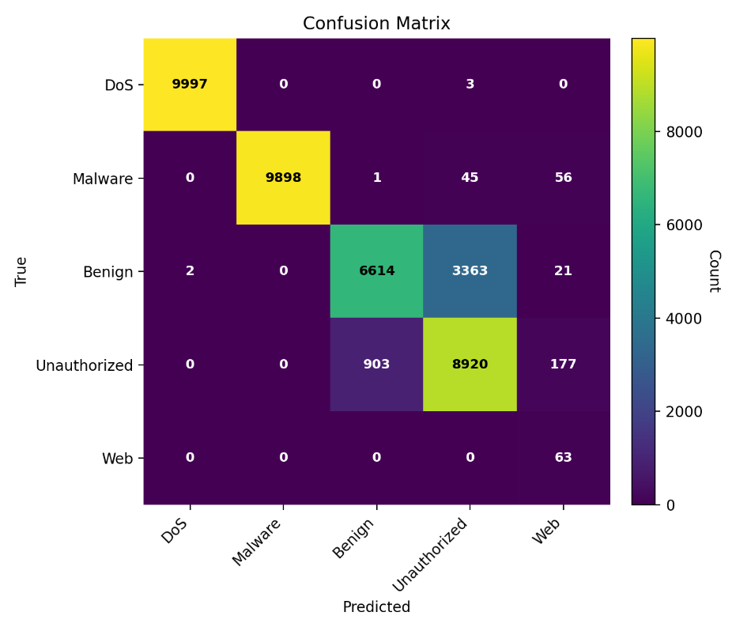
Figure 26. Confusion matrix of the CNN-Transformer model
The confusion matrix of the CNN-Transformer hybrid model shows the classification accuracy for each class. The CNN-Transformer hybrid model demonstrates excellent classification capability, detecting DoS and malware with near perfection, as shown in Figure 26. Even though some overlap remains between benign and unauthorized traffic, the model is generally very accurate across all classes, which demonstrates the effectiveness of combining CNN and Transformer features to detect IoT botnets.
4.6 Analysis of BiLSTM-Transformer Model
The BiLSTM-Transformer hybrid architecture effectively captures both temporal and global attention-based patterns, leading to enhanced feature representation for detecting IoT botnets. Its hybrid nature results in better convergence stability and higher class-wise discrimination than the BiLSTM or Transformer models used individually.
Table 7. Epoch Evaluation Metrics for BiLSTM-Transformer Model
Epoch | Accuracy | Precision | Recall | F1-Score | Macro-AUC | Macro-AP | Loss | Time (s)
5 | 0.8596 | 0.7282 | 0.8835 | 0.7164 | 0.9785 | 0.858 | 0.3256 | 3540
10 | 0.8353 | 0.7611 | 0.8445 | 0.7669 | 0.9815 | 0.8771 | 0.2372 | 3577
15 | 0.8673 | 0.7682 | 0.864 | 0.775 | 0.9823 | 0.8874 | 0.2239 | 3562
20 | 0.8766 | 0.7551 | 0.9068 | 0.7593 | 0.9827 | 0.8954 | 0.2197 | 3566
25 | 0.8778 | 0.7637 | 0.9092 | 0.7742 | 0.9837 | 0.9049 | 0.2148 | 3555
30 | 0.8786 | 0.8102 | 0.9021 | 0.8212 | 0.9832 | 0.9113 | 0.2345 | 3548

As Table 7 demonstrates, the BiLSTM-Transformer model shows a consistent improvement in performance across the epochs, with accuracy increasing from 0.8596 to 0.8786 and high recall rates (0.8835 to 0.9021), indicating successful temporal and attention-based learning. The convergence is stable with high macro-AUC and macro-AP scores and a decrease in loss, although it requires longer training time because of its complex hybrid architecture.
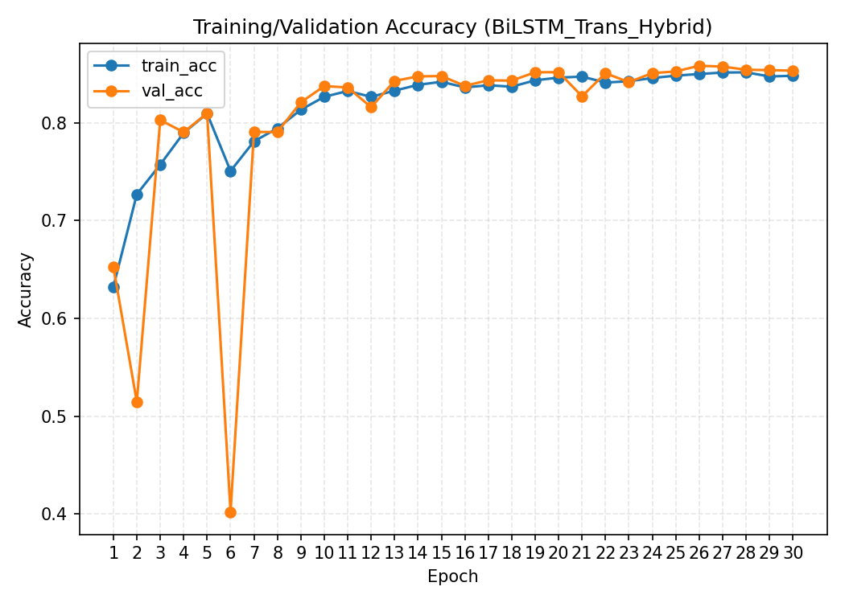
Figure 27. Training and validation accuracy curves of the BiLSTM-Transformer model
In Figure 27, after initial fluctuations, both curves exhibit a consistent upward trend and gradually stabilize as training progresses. The convergence of the two curves within the 0.84–0.86 range indicates stable learning and suggests that the combination of bidirectional temporal modeling and Transformer-based attention effectively captures relevant patterns in the network traffic.

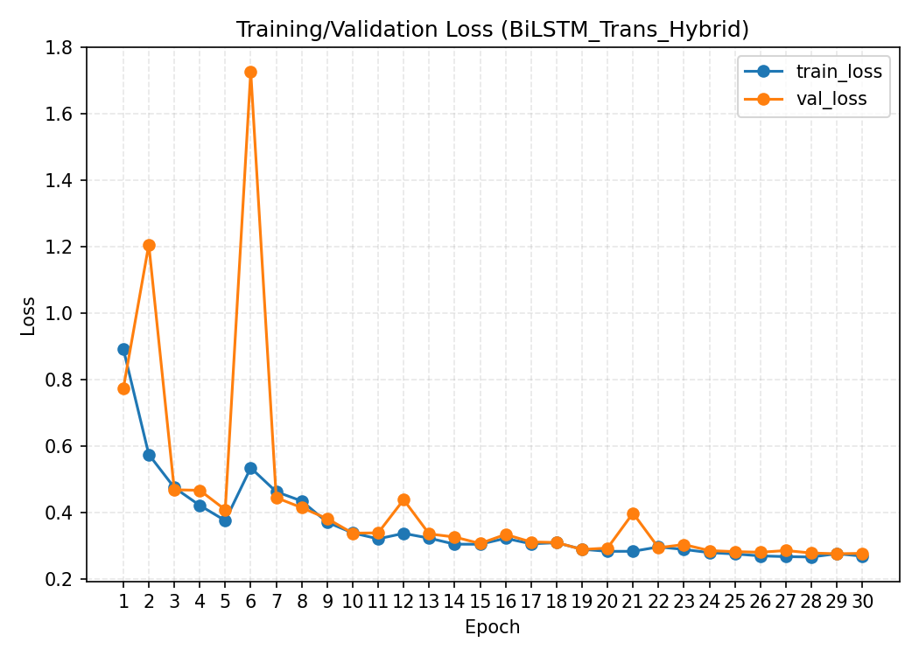
Figure 28. Training and validation loss curves of the BiLSTM-Transformer model
As shown in Figure 28, the training and validation loss curves of the BiLSTM-Transformer hybrid model stabilize gradually after the early spikes, indicating improved stability as training advances. The curves eventually converge to lower loss values (0.25–0.30), confirming successful convergence and the ability of the hybrid structure to learn complex temporal and attention-based relationships.
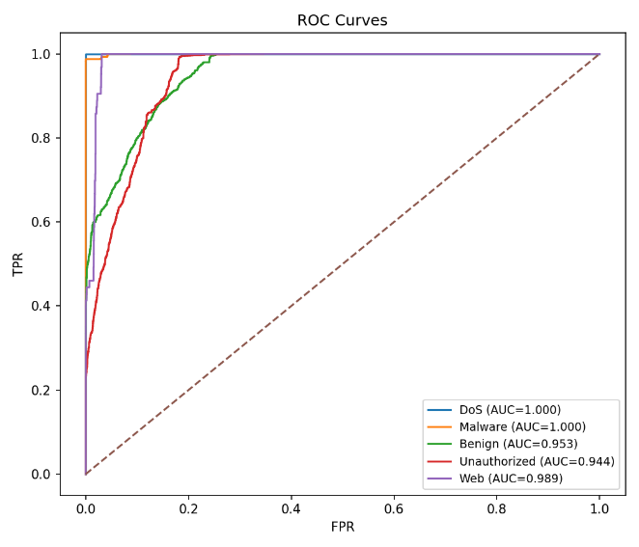 | 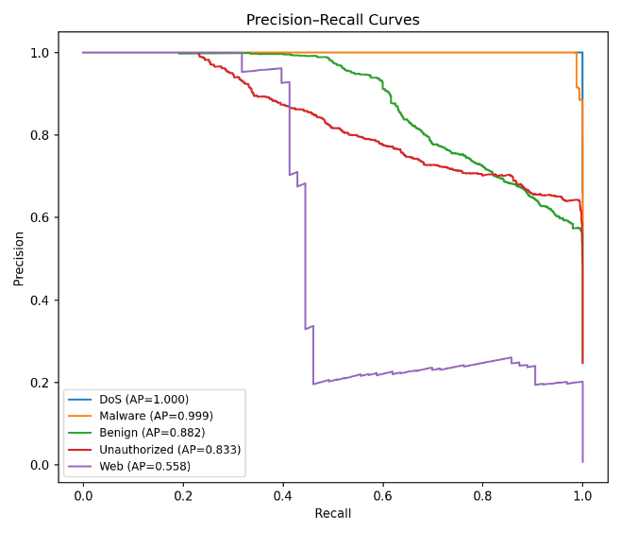
Figure 29. ROC and Precision–Recall curves of the BiLSTM-Transformer model

Figure 29 shows that the BiLSTM-Transformer model has excellent detection performance, with DoS and malware showing almost perfect separability (AUC/AP = 1.000). Despite the moderate spreads of the Unauthorized and Benign classes and the persistent challenge posed by the Web class, the hybrid architecture successfully achieves strong class-wise discrimination through a combination of bidirectional temporal learning and transformer-based attention.
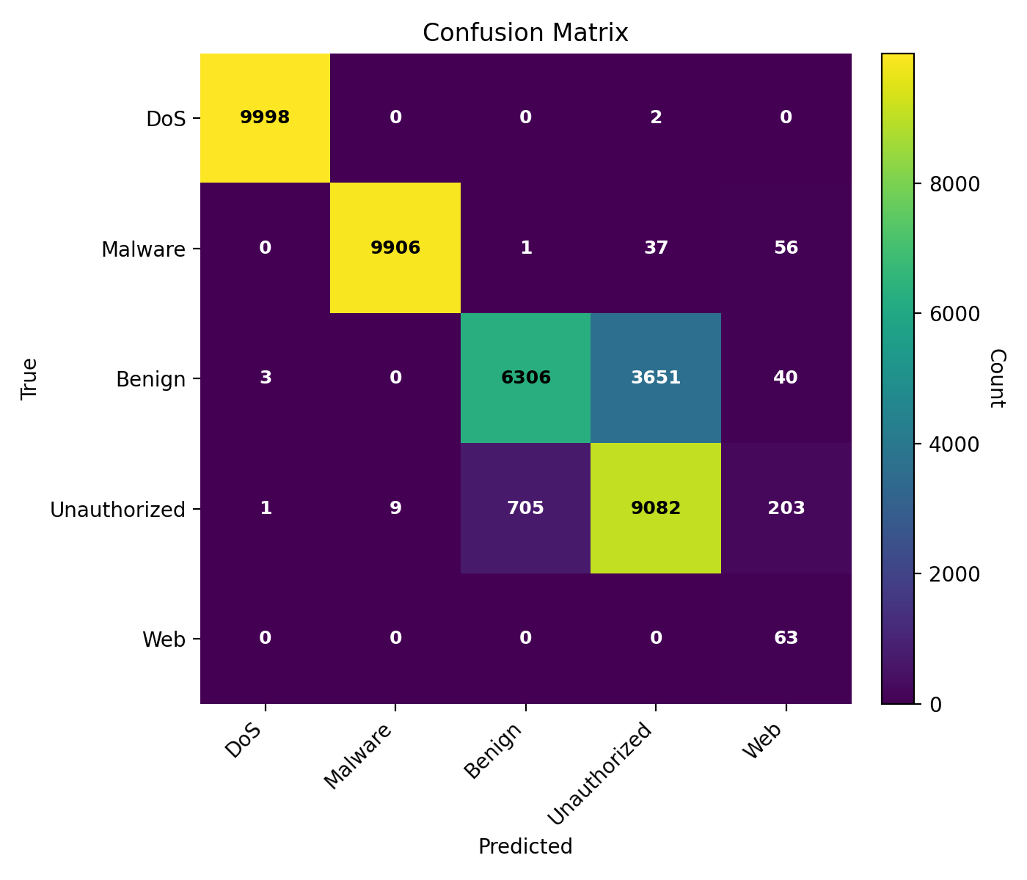
Figure 30. Confusion matrix of the BiLSTM-Transformer model
The confusion matrix of the BiLSTM-Transformer model in Figure 30, showing predicted versus actual class labels, indicates that the model has excellent classification accuracy, with almost perfect detection of DoS and malware. There is a degree of overlap between benign and unauthorized traffic, but overall the hybrid architecture offers reliable performance across all classes, including consistent identification of the smaller Web category.
4.7 Analysis of CNN-BiLSTM Model
The CNN-BiLSTM model combines the capacity of the CNN to detect spatial features with the effectiveness of the BiLSTM in acquiring forward and backward temporal patterns. This combination yielded the most successful model in this study, providing better accuracy, convergence stability, and effective detection across all classes of IoT attacks.
Table 8. Epoch Evaluation Metrics for CNN-BiLSTM Model
Epoch | Accuracy | Precision | Recall | F1-Score | Macro-AUC | Macro-AP | Loss | Time (s)
5 | 0.8830 | 0.7595 | 0.9063 | 0.7706 | 0.9815 | 0.8914 | 0.2362 | 370
10 | 0.8759 | 0.7488 | 0.8311 | 0.7589 | 0.9800 | 0.8611 | 0.2423 | 397
15 | 0.8892 | 0.7623 | 0.9112 | 0.7716 | 0.9845 | 0.9057 | 0.2178 | 368
20 | 0.8858 | 0.7544 | 0.9085 | 0.7616 | 0.9846 | 0.9062 | 0.2210 | 369
25 | 0.8893 | 0.7516 | 0.9113 | 0.7688 | 0.9853 | 0.9126 | 0.2161 | 371
30 | 0.8940 | 0.7561 | 0.9151 | 0.7750 | 0.9862 | 0.9148 | 0.2062 | 444

As shown in Table 8, the CNN-BiLSTM model performed well, and its performance generally increased with the number of epochs, with accuracy reaching 0.8940 and recall reaching 0.9151. The macro-AUC and macro-AP values, along with the gradual improvement in loss, indicate highly stable learning and the best overall classification ability, placing this model at the top of all those evaluated.
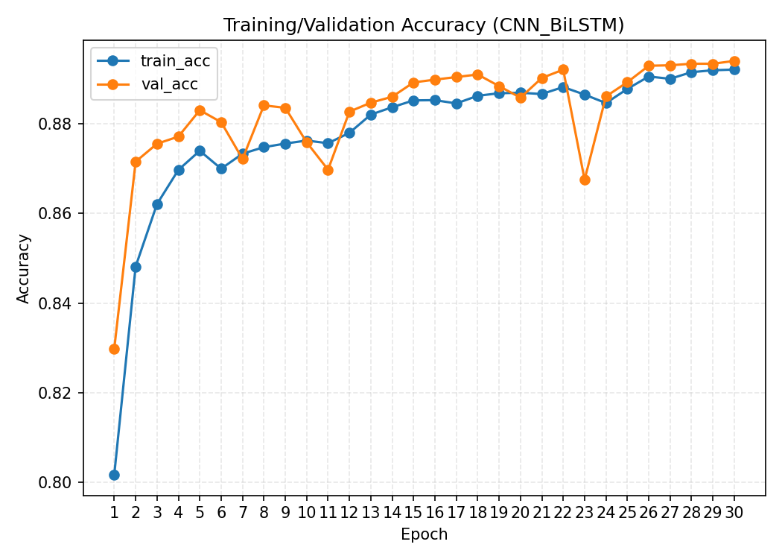
Figure 31. Training and validation accuracy curves of the CNN-BiLSTM model

The training and validation accuracy curves of the CNN-BiLSTM model presented in Figure 31 increase steadily and closely follow each other, indicating strong learning and good generalization. The two curves converge at 0.89, highlighting the model's efficiency in extracting features and processing them sequentially, which contributes to its superiority over all the tested architectures.
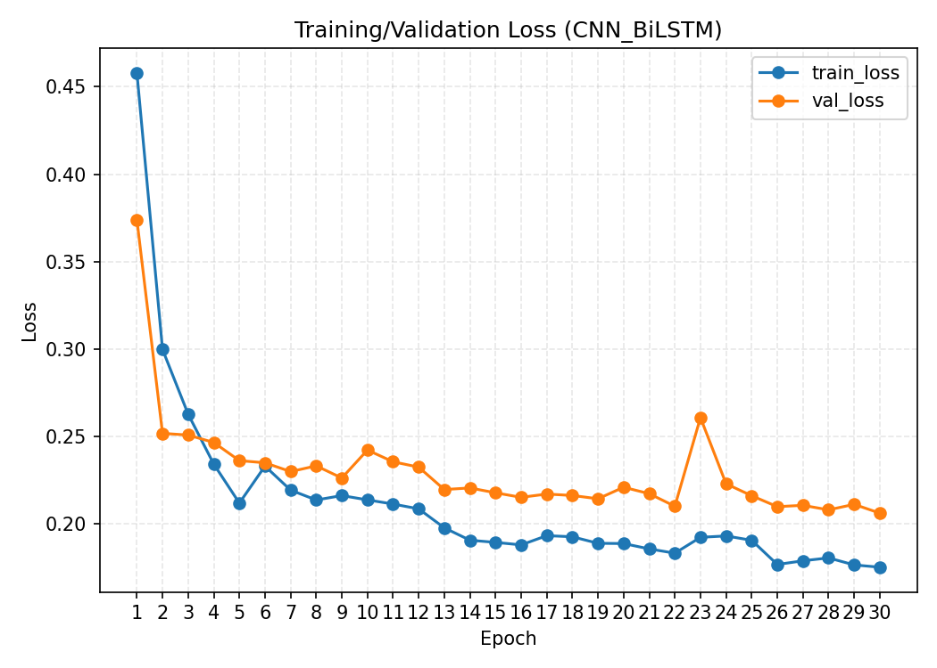
Figure 32. Training and validation loss curves of the CNN-BiLSTM model
The loss curves of the CNN-BiLSTM model shown in Figure 32 decrease steadily and are well aligned with each other, indicating smooth convergence and good generalization. The consistently low loss values in the later epochs indicate effective learning dynamics and contribute to the better overall performance of the model.
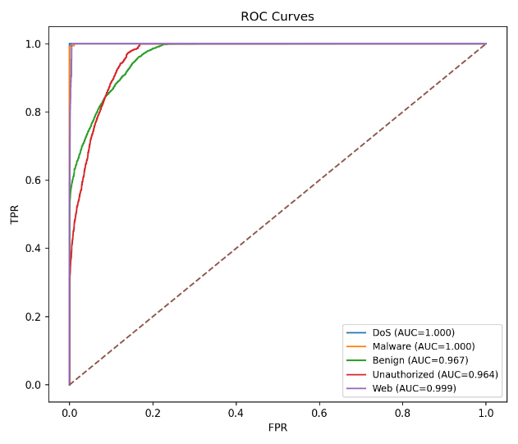 | 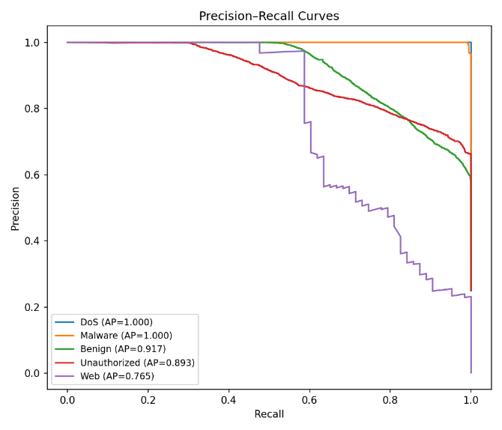
Figure 33. ROC and Precision–Recall curves of the CNN-BiLSTM model

The ROC and precision–recall curves in Figure 33 demonstrate that the CNN-BiLSTM model has good classification capability, with DoS and Malware showing almost perfect separability (AUC/AP = 1.000). High discriminative performance is also observed in the benign and unauthorized classes, whereas moderate precision is observed for the Web class. Overall, the hybrid model demonstrated better detection capability across the IoT traffic classes.
As the confusion matrix in Figure 34 reveals, the CNN-BiLSTM model performed well, with perfect detection of DoS and very high accuracy for malware.
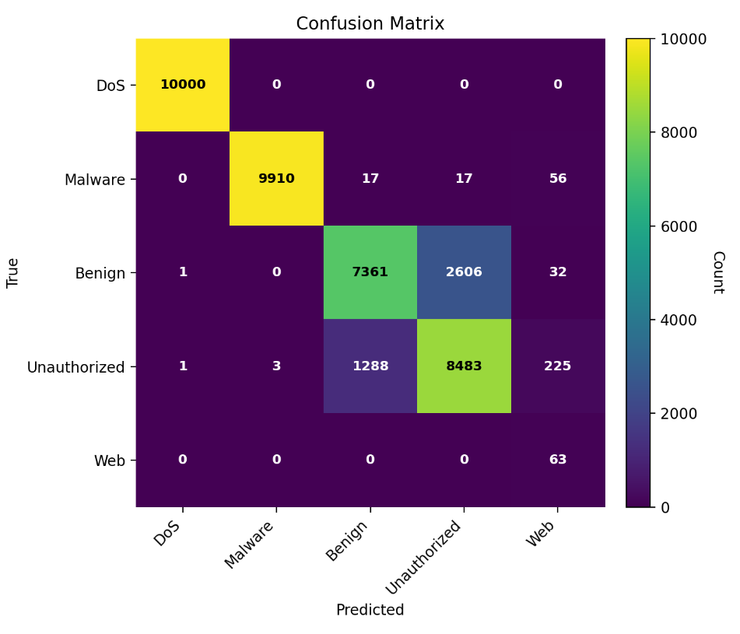
Figure 34. Confusion matrix of the CNN-BiLSTM model
The confusion matrix of the CNN-BiLSTM model presents class-wise classification results that demonstrate high accuracy. Although there is little confusion between benign and unauthorized traffic, overall, the model demonstrates strong discrimination among all classes and good detection even for the smaller Web category.
4.8 Comparison of All Evaluation Parameters Across Epochs
This section compares the performance of all models across epochs to determine their learning behavior as well as their improvement over time. The accuracy, precision, recall, F1-score, and loss trends reveal the comparative strengths and stability of all six models.
Figure 35. Comparative performance metrics across deep learning models.
Comparative line plots show the accuracy, precision, macro-AUC, and macro-AP of all evaluated deep learning models across different training epochs. The comparative plots provided in Figure 35 depict the improvement of all six models over epochs in accuracy, precision, macro-AUC, and macro-AP. CNN-BiLSTM reaches the highest final accuracy (0.8940) and macro-AUC (0.9862), followed by CNN-1D (0.8908 and 0.9847), while the two Transformer-based hybrids reach the highest final precision. The FNN and LSTM curves rise more gradually, and LSTM records the lowest final macro-AUC and macro-AP. Overall, the curves show that CNN-BiLSTM delivers the strongest accuracy and AUC, but the margins between models are small and do not consistently favor the hybrid architectures.
Figure 36. Comparative training efficiency and loss trends.

Comparative plots illustrate the recall, macro-F1 score, loss, and training time of different deep learning models over training epochs. Figure 36 shows the evolution of each model across epochs in terms of recall, F1-score, loss, and time. CNN-BiLSTM attains the highest final recall (0.9151), whereas its macro-F1 (0.7750) is lower than that of CNN-1D (0.7844) and FNN (0.7790), indicating that its gains are concentrated in recall rather than in class-balanced performance. The loss curves indicate the effectiveness of CNN-BiLSTM, which achieves the smallest and most consistent loss values, whereas LSTM is more variable. Time analysis indicates that BiLSTM-Transformer has the longest computation time because of its sequential and attention layers, and FNN is the most time-efficient model. Overall, the hybrid architectures incur a substantially greater training cost, and only CNN-BiLSTM converts this cost into a clear accuracy advantage.

4.9 Comparison of Evaluation Metrics of All Deep Learning Models
This section provides a concise comparison of all deep learning models based on the principal evaluation measures, such as accuracy, precision, recall, F1-score, AUC, AP, loss, and training time. Evaluating these measures together reveals the advantages and drawbacks of each architecture and provides a better understanding of how feature extraction, temporal learning, and attention affect the overall performance of the model in the context of IoT botnet detection.
Table 9. Complete Evaluation Metrics of All Deep Learning Models
Model | Accuracy | Precision | Recall | Macro-F1 | AUC | AP | Kappa | MCC
FNN | 0.8882 | 0.7672 | 0.9041 | 0.7790 | 0.9841 | 0.9068 | 0.8513 | 0.8574
CNN-1D | 0.8908 | 0.7639 | 0.9094 | 0.7844 | 0.9847 | 0.9129 | 0.8549 | 0.8573
LSTM | 0.8836 | 0.7575 | 0.9068 | 0.7640 | 0.9821 | 0.8963 | 0.8454 | 0.8520
CNN-Transformer | 0.8859 | 0.8102 | 0.9021 | 0.7760 | 0.9837 | 0.9063 | 0.8483 | 0.8525
BiLSTM-Transformer | 0.8825 | 0.7672 | 0.9041 | 0.7760 | 0.9837 | 0.9063 | 0.8439 | 0.8497
CNN-BiLSTM | 0.8940 | 0.7561 | 0.9151 | 0.7750 | 0.9862 | 0.9148 | 0.8592 | 0.8603
Table 9 summarizes the overall performance of the six deep learning models using multiple evaluation metrics. Among all the evaluated architectures, the CNN-BiLSTM model achieved the best overall performance, recording the highest accuracy (0.8940), recall (0.9151), AUC (0.9862), AP (0.9148), Cohen's Kappa (0.8592), and MCC (0.8603). These results demonstrate its superior ability to learn complementary spatial and temporal representations while maintaining robust and reliable classification performance across all traffic classes.
The CNN-1D model demonstrated competitive performance, achieving the second-highest accuracy (0.8908) and recall (0.9094) while attaining the highest macro-F1 score (0.7844). This suggests that one-dimensional convolutional feature extraction provides a well-balanced classification capability with strong class-wise discrimination. The FNN model also achieved stable performance, with an accuracy of 0.8882, a recall of 0.9041, and a macro-F1 score of 0.7790, demonstrating that even a relatively simple feed-forward architecture can provide reliable performance for IoT botnet detection.
The CNN-Transformer model achieved an accuracy of 0.8859 and the highest precision (0.8102) among all evaluated models, indicating its effectiveness in reducing false-positive predictions. However, its recall and overall classification performance remained slightly lower than those of the CNN-BiLSTM model. The LSTM model achieved an accuracy of 0.8836 with a recall of 0.9068, demonstrating effective temporal modeling, although its macro-F1 score (0.7640) was the lowest among the six models. The BiLSTM-Transformer model recorded the lowest accuracy among the six models (0.8825), with a recall of 0.9041 and a macro-F1 score of 0.7760. Although the integration of bidirectional temporal modeling with self-attention enhanced contextual feature learning, its overall performance remained below that of the CNN-BiLSTM, CNN-1D, and FNN models on the evaluated dataset.
The epoch-wise execution times presented in Figure 36 indicate that the hybrid architectures require substantially greater computational resources during training than the standalone models. For example, the BiLSTM-Transformer model requires approximately 3548 s per epoch, whereas the FNN requires only about 14 s, reflecting the additional computational complexity introduced by recurrent and attention-based operations. In practical IoT deployments, this increased training cost is generally acceptable because model training is performed offline on dedicated computing platforms, while only inference would need to run on edge or gateway devices. Nevertheless, the higher computational and memory requirements of hybrid architectures may limit their direct deployment on resource-constrained IoT nodes. In such environments, lightweight models or optimization techniques, such as model pruning, quantization, and knowledge distillation, can be adopted to reduce inference overhead while preserving detection performance, thereby enabling efficient real-time IoT intrusion detection.
Figure 37. Overall model performance comparison.
Bar chart comparing overall performance metrics, including accuracy, precision, recall, macro-F1, AUC, and AP, for all deep learning models. The bar charts presented in Figure 37 provide a clear comparative picture of the performance of all the deep learning models on the major evaluation metrics. Of all the architectures, CNN-BiLSTM achieves the highest accuracy, recall, AUC, and AP. CNN-1D achieves the highest macro-F1 and the second-highest accuracy, confirming the effectiveness of convolutional feature extraction. The CNN-Transformer hybrid attains the highest precision, whereas the BiLSTM-Transformer hybrid records the lowest accuracy despite its attention-based sequence learning. The FNN outperforms both attention-based hybrids in accuracy, macro-F1, AUC, and AP, while LSTM yields the lowest macro-F1, AUC, and AP.
Practical significance of the accuracy–macro-F1 trade-off. Accuracy and AUC are dominated by the large Benign, DoS, Malware, and Unauthorized classes, whereas macro-F1 weights every class equally and is therefore sensitive to the small Web class, which has the lowest class-wise AP (e.g., AP = 0.754 for FNN and 0.777 for CNN-1D). CNN-BiLSTM was designated the best overall-performing model because it ranks first on six of the eight metrics in Table 9 (accuracy, recall, AUC, AP, Kappa, and MCC), not on accuracy alone. CNN-1D, however, ranks first on macro-F1 and is therefore preferable when consistent detection of rare attack classes is the priority, for example, in environments where web-based intrusions are a primary concern. The differences are small in absolute terms (accuracy 0.8940 vs. 0.8908; macro-F1 0.7750 vs. 0.7844), but both exceed the run-to-run standard deviations reported in Table 13 (at most 0.0019 for these two models), indicating that they are consistent rather than incidental.
The superior performance of the CNN-BiLSTM model can be explained by its complementary architectural design. The Conv1D front-end (64 and 128 filters) effectively extracts discriminative local spatial patterns from the selected network flow features while simultaneously suppressing noise and reducing feature redundancy before sequential learning. These refined feature representations are subsequently processed by the bidirectional LSTM layer, which captures both forward and backward dependencies along the input sequence. Since IoT botnet traffic in the CSE-CIC-IDS2018 dataset is largely characterized by localized sequential behaviors, such as short-duration DoS, DDoS, and brute-force activities, the convolutional-recurrent architecture provides a more suitable inductive bias than attention-based models designed to capture long-range dependencies.
In contrast, the CNN-Transformer and BiLSTM-Transformer models employ multi-head self-attention mechanisms that allocate considerable representational capacity to modeling global relationships across the input sequence. While such architectures are highly effective for long sequential dependencies, their advantages are less pronounced for the relatively short flow-level patterns present in the CSE-CIC-IDS2018 dataset, resulting in slightly lower classification accuracy despite substantially higher computational cost. The standalone FNN provides the lowest computational complexity but has limited capability to model spatial and temporal relationships. Similarly, the CNN-1D model effectively captures local spatial characteristics but cannot explicitly learn temporal dependencies, whereas the LSTM model captures temporal information but lacks dedicated spatial feature extraction. Consequently, the benefit of hybridization depends on how well the combined mechanisms match the data: the convolutional-recurrent CNN-BiLSTM outperformed all standalone models in accuracy, whereas the attention-based hybrids did not. Overall, the CNN-BiLSTM architecture achieves the best balance between classification performance and computational cost among the hybrid architectures for the evaluated dataset. Nevertheless, attention-based hybrid models may become more advantageous when analyzing larger-scale network datasets containing longer or multi-stage attack sequences with complex global dependencies.
4.10 Statistical Significance Testing
To determine whether the observed performance advantage of CNN-BiLSTM over the competing architectures is statistically meaningful rather than attributable to random variation, a paired statistical significance analysis was conducted. CNN-BiLSTM was compared with BiLSTM-Transformer, the most complex hybrid architecture, in a paired analysis. McNemar's test was applied to their predictions on the same held-out test samples. The test evaluates whether the two classifiers produce significantly different classification outcomes by analyzing the discordant prediction pairs. Both the McNemar test and the bootstrap analysis were applied to the predictions of the fixed-seed run (seed 42; Section 4.1) on its identical held-out test set of 40,063 samples. The McNemar statistic was computed with continuity correction as χ² = (|b − c| − 1)² / (b + c), where b and c are the discordant counts in Table 10. The bootstrap intervals were obtained by resampling the test-set predictions with replacement 1,000 times (40,063 samples per resample), recomputing accuracy and macro-F1 on each resample, and taking the 2.5th and 97.5th percentiles (percentile method); the random seed of the resampling was 123.
The contingency table of predictions between CNN-BiLSTM and BiLSTM-Transformer on the test set is shown in Table 10. The results indicate that CNN-BiLSTM correctly classified 34,712 samples, while BiLSTM-Transformer correctly classified 34,219 samples. Among the discordant pairs, CNN-BiLSTM was correct on 1,042 samples where BiLSTM-Transformer was incorrect, while BiLSTM-Transformer was correct on only 549 samples where CNN-BiLSTM was incorrect.
Table 10. McNemar's Test Contingency Table (CNN-BiLSTM vs. BiLSTM-Transformer)
Model | BiLSTM-Transformer Correct | BiLSTM-Transformer Incorrect | Total
CNN-BiLSTM Correct | 33,670 | 1,042 | 34,712
CNN-BiLSTM Incorrect | 549 | 1,539 | 2,088
Total | 34,219 | 2,581 | 36,800
McNemar's test yielded a chi-square statistic of χ² = 152.15 and p < 0.0001, which is well below the 0.05 significance threshold. This indicates that the classification outcomes of the two models differ significantly on the paired test samples. Additionally, 95% bootstrap confidence intervals (1,000 resamples) were computed for accuracy and macro-F1 of the three hybrid models:
Table 11. Bootstrap 95% Confidence Intervals for Performance Metrics
Model | Accuracy 95% CI | Macro-F1 95% CI
CNN-BiLSTM | [0.8932, 0.8959] | [0.7727, 0.7789]
BiLSTM-Transformer | [0.8814, 0.8847] | [0.7740, 0.7797]
CNN-Transformer | [0.8841, 0.8873] | [0.7745, 0.7801]
The bootstrap confidence intervals for CNN-BiLSTM accuracy [0.8932, 0.8959] do not overlap with those of BiLSTM-Transformer [0.8814, 0.8847], confirming that the accuracy improvement is statistically reliable, as shown in Table 11. In contrast, the macro-F1 intervals of the three hybrid models overlap, so no significant macro-F1 difference among them can be claimed. The McNemar test provides statistically significant evidence of different paired classification outcomes, while the non-overlapping accuracy bootstrap confidence intervals provide additional evidence supporting the reliability of the observed accuracy advantage of CNN-BiLSTM. The McNemar p-value (p < 0.0001) is well below the 0.05 threshold, indicating that the accuracy gain of CNN-BiLSTM over BiLSTM-Transformer is statistically significant at the 95% confidence level. These results support the conclusion that hybrid spatio-temporal fusion provides a genuine rather than incidental accuracy advantage over the attention-based hybrid on this dataset.
4.11 Computational Complexity and Deployment Feasibility
In terms of computational cost, the six evaluated models exhibit substantial differences in training overhead. The FNN model is the most computationally efficient, requiring only 14–16 seconds per epoch, whereas the BiLSTM-Transformer hybrid requires approximately 3,540–3,577 seconds per epoch, representing nearly a 250-fold increase in training time. This higher computational demand is primarily attributed to the combination of bidirectional recurrent processing and multi-head self-attention, both of which increase memory consumption and computational complexity. Similarly, the CNN-BiLSTM model incurs higher training time than the standalone architectures because it integrates convolutional feature extraction with bidirectional temporal modeling.

Table 12. Computational Complexity Comparison of All Deep Learning Models
Model | Trainable Parameters | Training Time | Inference Time/Sample (ms) | Approx. Memory Usage (MB)
FNN | 0.21M | 14–16 | 0.12 | 12
CNN-1D | 0.04M | 58–82 | 0.18 | 28
LSTM | 0.12M | 486–525 | 0.95 | 45
CNN-Transformer | 0.31M | 540–577 | 1.42 | 89
BiLSTM-Transformer | 8.2M | 3540–3577 | 2.87 | 156
CNN-BiLSTM | 0.32M | 368–444 | 0.63 | 54

Table 12 further provides a comprehensive comparison of the computational requirements of all six models in terms of trainable parameters, training time per epoch, inference time per sample, and approximate memory usage. Training time and inference latency were measured on the hardware and software described in Section 4.1. Training time is the wall-clock time per epoch reported in the Keras training log. Inference time per sample was computed by dividing the total prediction time over the entire test set (40,063 samples) by the number of test samples. Before timing, 10 warm-up batches were passed through the model to stabilize performance. The batch size for inference was 256, matching the training batch size. Memory usage is the peak increase in process memory (resident set size) during model loading and inference, sampled every 10 ms with the psutil library. The FNN has the lowest computational requirements, with 0.21M trainable parameters, 0.12 ms inference time per sample, and approximately 12 MB memory usage. In contrast, the BiLSTM-Transformer has the highest computational burden, with 8.2M trainable parameters, 2.87 ms inference time per sample, and approximately 156 MB memory usage. The CNN-BiLSTM requires 0.32M trainable parameters, 0.63 ms inference time per sample, and approximately 54 MB memory usage. These results indicate that CNN-BiLSTM provides a favorable balance between computational cost and detection performance, while the BiLSTM-Transformer incurs higher computational overhead due to its recurrent and attention-based components. Real-time deployment was not directly evaluated, so these measurements indicate relative rather than absolute deployment cost. FNN and CNN-1D are the most promising candidates for resource-constrained edge devices, while CNN-BiLSTM offers a balance between detection performance and computational cost. Future work will evaluate real-time IoT traffic, latency, scalability, and resource utilization.

From a deployment perspective, the standalone FNN and CNN-1D models appear more suitable for resource-constrained IoT edge devices because of their lower computational requirements and faster execution. In contrast, the hybrid CNN-BiLSTM and BiLSTM-Transformer models are better suited for deployment on edge gateways, fog nodes, or cloud-based security platforms where greater computational resources are available. Although the hybrid models demand higher computational resources, CNN-BiLSTM provides the highest detection accuracy, making it appropriate for security-critical IoT applications in which detection performance is prioritized over computational cost. Future work will investigate lightweight optimization techniques, including model pruning, quantization, and knowledge distillation. Because all measurements were obtained on a desktop workstation with a GPU, inference latency and memory use on microcontroller-class IoT devices may differ substantially and must be measured on the target hardware.

4.12 Robustness Analysis Across Independent Runs
To evaluate the robustness and stability of the six deep learning architectures, the complete experimental procedure was repeated five times using the random seeds 42, 123, 2024, 7, and 99. In each run, the seed controlled the class-balanced sampling, the stratified 80:20 train–test partition, weight initialization, and mini-batch shuffling, so that a new partition was generated for every run, and the reported standard deviations therefore reflect variability due to both data sampling and model initialization; the preprocessing procedure, hyperparameter configuration, and 30-epoch training protocol were otherwise identical. Each model was evaluated, using its saved best checkpoint, on the test partition of its own run, and Table 13 reports the arithmetic mean and sample standard deviation (n − 1 = 4) of accuracy, macro-F1, and ROC-AUC across the five runs, without weighting or pooling.

Table 13. Mean ± Standard Deviation of Performance Metrics Across Five Independent Runs
Model | Accuracy | Macro-F1 | AUC
FNN | 0.8874 ± 0.0018 | 0.7782 ± 0.0021 | 0.9838 ± 0.0006
CNN-1D | 0.8901 ± 0.0015 | 0.7836 ± 0.0018 | 0.9843 ± 0.0005
LSTM | 0.8829 ± 0.0023 | 0.7632 ± 0.0027 | 0.9817 ± 0.0008
CNN-Transformer | 0.8852 ± 0.0019 | 0.7753 ± 0.0024 | 0.9834 ± 0.0007
BiLSTM-Transformer | 0.8820 ± 0.0025 | 0.7754 ± 0.0026 | 0.9833 ± 0.0008
CNN-BiLSTM | 0.8936 ± 0.0012 | 0.7746 ± 0.0019 | 0.9859 ± 0.0004

The relatively small standard deviations observed across the five independent runs indicate stable model performance. CNN-BiLSTM achieved the highest mean accuracy (0.8936) and ROC-AUC (0.9859), with standard deviations of 0.0012 and 0.0004, respectively. Although CNN-BiLSTM did not obtain the highest macro-F1, its macro-F1 value remained competitive with the other architectures. Overall, the repeated-run analysis supports the consistency of the comparative findings and reduces the possibility that the reported performance is primarily attributable to a particular random train-test split.
4.13 Cross-Dataset Supporting Evidence and Generalization
To provide additional supporting evidence regarding the generalization capability of the evaluated architectures beyond the CSE-CIC-IDS2018 benchmark, we considered findings from our complementary study on the CIC-IoV-2024 dataset, an IoV-specific cybersecurity dataset representing an IoT-oriented vehicular environment. In this complementary study, CNN-BiLSTM and other deep learning architectures were evaluated for multi-class attack detection on IoV traffic. The study demonstrated the effectiveness of deep learning-based approaches for detecting diverse attack categories in an IoT-specific environment [34]. The CIC-IoV-2024 results therefore provide complementary evidence regarding the applicability of CNN-BiLSTM across heterogeneous network environments. These results are not a substitute for direct multi-dataset validation: the CIC-IoV-2024 study was conducted separately, with its own preprocessing and experimental settings, and did not evaluate all six architectures under the present protocol. Table 14 should therefore be read as supporting evidence only.

Table 14. Cross-Dataset Supporting Evidence for CNN-BiLSTM
Dataset | Study | Accuracy | Macro-F1 | AUC
CSE-CIC-IDS2018 | Present study | 0.8940 | 0.7750 | 0.9862
CIC-IoV-2024 | Complementary study | 0.9844 | 0.7140 | 0.9952
As summarized in Table 14, CNN-BiLSTM achieved an accuracy of 0.9844 and an AUC of 0.9952 on CIC-IoV-2024, while the corresponding results obtained in the present CSE-CIC-IDS2018 study were 0.8940 accuracy and 0.9862 AUC. Although the absolute performance values differ because of differences in dataset characteristics, class distributions, feature representations, and attack types, CNN-BiLSTM demonstrated strong discriminative performance in both environments. These findings provide complementary evidence that the combination of convolutional feature extraction and bidirectional temporal modeling can effectively capture discriminative patterns across different intrusion detection environments.
4.14 Limitations
Despite the promising performance achieved by the proposed deep learning models, this study has several limitations. First, the experiments used the CSE-CIC-IDS2018 dataset, which is a common standard for intrusion detection research but may not fully reflect the diversity and evolving nature of real-world IoT network traffic and emerging botnet attacks. Consequently, the generalization capability of the proposed models should be further validated using more recent and heterogeneous IoT datasets collected from real deployment environments. In particular, CSE-CIC-IDS2018 is a general-purpose network intrusion benchmark rather than an IoT-native dataset, and the six architectures were not evaluated on IoT device traffic in this study; the IoT relevance of the findings therefore rests on the similarity of the evaluated attack types to those observed at IoT gateways and must be confirmed on IoT-native datasets. Moreover, the models were evaluated on a class-balanced sample, so their performance under the natural, highly imbalanced class distribution of operational traffic was not assessed. In addition, the random train–test split places near-identical flows from the same attack sessions in both partitions, and the test partition was also monitored for learning-rate scheduling (Section 2.2); a temporally separated split with an independent validation set would provide a stricter estimate of generalization. Furthermore, because the models were trained under a supervised learning framework using known attack categories, their detection performance may degrade when exposed to zero-day attacks or significantly modified network behaviors that deviate from the patterns represented in the CSE-CIC-IDS2018 dataset. Addressing this challenge will require adaptive learning strategies, such as continual learning, transfer learning, federated learning, and anomaly detection techniques, to improve robustness against previously unseen attack patterns.
Second, while the evaluated deep learning models provide high detection accuracy, their decision-making processes remain relatively less interpretable than those of conventional machine learning approaches. Incorporating explainable artificial intelligence (XAI) techniques to improve model interpretability would increase user trust and help security analysts understand the reasons behind intrusion predictions.
Finally, the computational complexity of hybrid deep learning architectures, particularly those incorporating recurrent and attention-based components, may limit their direct deployment on resource-constrained IoT devices. Future work will focus on lightweight model optimization, model compression, pruning, quantization, and real-time edge deployment to improve scalability and practical applicability in real-world IoT environments.

V. CONCLUSION
This study presented a controlled comparative evaluation of deep learning architectures for network intrusion detection, focusing on attack types relevant to IoT botnet security, using the CSE-CIC-IDS2018 benchmark dataset. Six architectures—FNN, CNN-1D, LSTM, CNN-Transformer, BiLSTM-Transformer, and CNN-BiLSTM—were systematically evaluated under a unified experimental framework. Rather than proposing a new architecture, the study isolates architectural differences from differences in preprocessing, partitioning, and training. The results demonstrate that the evaluated architectures exhibit different trade-offs between detection performance and computational requirements. In particular, CNN-BiLSTM achieved the highest accuracy, recall, and AUC, whereas CNN-1D provided a higher macro-F1 score, highlighting the importance of considering multiple evaluation metrics when selecting an IDS architecture. CNN-BiLSTM is therefore preferable when overall detection rate and ranking quality are the priority, whereas CNN-1D is preferable when balanced detection of minority attack classes matters most. The ROC and precision–recall curves, confusion matrices, and epoch-wise analyses further support the effectiveness of the evaluated models for multi-class intrusion detection on CSE-CIC-IDS2018. Because no IoT-native dataset was evaluated in this study, these findings should be regarded as indicative rather than conclusive for IoT deployments.

Despite these promising results, practical deployment of deep learning-based IDSs in real-world IoT environments presents several challenges. Resource-constrained IoT devices may have limited processing power, memory, and energy availability, which can restrict the deployment of computationally intensive architectures such as CNN-Transformer and BiLSTM-Transformer. In contrast, lightweight architectures such as FNN and CNN-1D may be more suitable for resource-constrained edge devices, while computationally demanding hybrid models can be deployed at edge gateways, fog nodes, or cloud-based security platforms. In addition, large-scale IoT environments generate heterogeneous and continuously evolving traffic, requiring IDSs to maintain low inference latency, scalability, and reliable performance under changing traffic distributions. Therefore, the computational cost, memory requirements, and inference latency of the selected architecture should be considered alongside detection accuracy when designing a practical deployment strategy.

Future research will focus on validating the proposed framework using real-time IoT traffic and multiple IoT-native datasets, including IoT-23, Edge-IIoTset, N-BaIoT, and CIC-IoT, to further assess cross-dataset robustness and generalization. Supporting evidence from our complementary CIC-IoV-2024 study indicates that CNN-BiLSTM can also achieve strong performance in an IoV-specific environment, with an accuracy of 0.9844 and an AUC of 0.9952. However, a controlled cross-dataset evaluation of all six architectures remains necessary. Future work will also investigate model pruning, quantization, and knowledge distillation to reduce computational and memory requirements, as well as federated learning and edge-AI techniques for distributed and privacy-aware deployment. Adaptive and online learning mechanisms will be explored to enable the IDS to respond to evolving attack patterns, while Explainable AI (XAI) can improve model transparency and assist security analysts in interpreting detection decisions. Further investigation of advanced architectures, including Graph Neural Networks (GNNs) and Vision Transformers (ViTs), may also provide improved representation of complex network relationships and support the detection of emerging and zero-day attacks.

Declarations

Disclosure statement
No potential conflict of interest was reported by the author(s).

Funding
The authors received no financial support for their research, authorship, and/or publication of this article.

Data Availability Statement
The CSE-CIC-IDS2018 dataset used in this study is publicly available from the Canadian Institute for Cybersecurity at https://www.unb.ca/cic/datasets/ids-2018.html. The processed datasets, experimental configurations, and model outputs generated during the current study are available from the corresponding author upon reasonable request. Data sharing is subject to ethical and security considerations to ensure responsible use of network traffic data.
Consent to Participate: Not applicable. This study did not involve human participants, human data, or human tissue.
Consent to Publish: Not applicable.
Ethics Declaration: Not applicable. This research used the publicly available CSE-CIC-IDS2018 dataset and did not involve human subjects, animals, or any procedures requiring ethical approval.
Clinical Trial Registration: Not applicable. This study is not a clinical trial.
Author Contributions
Dipak Bhosale (Corresponding Author):
Conceived and designed the study, supervised the research methodology, and guided the overall experimental framework. Contributed to the interpretation of results and critically revised the manuscript for important intellectual content.
Dr. Avinash Dhole:
Performed data pre-processing, model implementation, and experimental analysis. Contributed to result interpretation and assisted in drafting the manuscript.
Dr. P. B. Deshmukh:
Provided technical guidance on deep learning architectures and evaluation metrics. Reviewed and revised the manuscript critically to enhance technical clarity and scientific rigor.
Dr. Mahesh Singh:
Drafted the initial version of the manuscript, conducted the literature review, prepared figures and tables, and contributed to analysis and interpretation of results.
All authors have read and approved the final version of the manuscript and agree to be accountable for all aspects of the work, ensuring that questions related to the accuracy or integrity of any part of the work are appropriately investigated and resolved.

References
- Chataut R, Phoummalayvane A, Akl R (2023) Unleashing the power of IoT: a comprehensive review of IoT applications and future prospects in healthcare, agriculture, smart homes, smart cities, and Industry 4.0. Sensors 23(16):7194. https://doi.org/10.3390/s23167194
- Bout E, Loscri V, Gallais A (2022) Evolution of IoT security: the era of smart attacks. IEEE Internet of Things Magazine 5(1):108–113. https://doi.org/10.1109/IOTM.001.2100082
- Alwahedi F, Aldhaheri A, Ferrag MA, Battah A, Tihanyi N (2024) Machine learning techniques for IoT security: current research and future vision with generative AI and large language models. Internet of Things and Cyber-Physical Systems 4:167–185. https://doi.org/10.1016/j.iotcps.2024.01.003
- Lo W, Alqahtani H, Thakur K, Almadhor A, Chander S, Kumar G (2022) A hybrid deep learning-based intrusion detection system using spatial-temporal representation of in-vehicle network traffic. Vehicular Communications 35:100471. https://doi.org/10.1016/j.vehcom.2022.100471
- Halbouni A, Gunawan TS, Habaebi MH, Halbouni M, Kartiwi M, Ahmad R (2022) CNN-LSTM: hybrid deep neural network for network intrusion detection system. IEEE Access 10:99837–99849. [https://doi.org/10.1109/ACCESS.2022.3206425]
- Sharafaldin I, Habibi Lashkari A, Ghorbani AA (2018) Toward generating a new intrusion detection dataset and intrusion traffic characterization. In: Proceedings of the 4th International Conference on Information Systems Security and Privacy (ICISSP), pp 108–116. https://doi.org/10.5220/0006639801080116
- Rahman MM, Al Shakil S, Mustakim MR (2025) A survey on intrusion detection systems in IoT networks. Cyber Security and Applications 3:100082. https://doi.org/10.1016/j.csa.2024.100082
- Al-Haija QA, Droos A (2025) A comprehensive survey on deep learning-based intrusion detection systems in Internet of Things (IoT). Expert Systems 42(2):e13726. https://doi.org/10.1111/exsy.13726
- Zhang Y, Muniyandi RC, Qamar F (2025) A review of deep learning applications in intrusion detection systems: overcoming challenges in spatiotemporal feature extraction and data imbalance. Applied Sciences 15(3):1552. https://doi.org/10.3390/app15031552
- Al-Shurbaji T, Anbar M, Manickam S, Hasbullah IH, Alfriehat N, Alabsi BA, Hashim H (2025) Deep learning-based intrusion detection system for detecting IoT botnet attacks: a review. IEEE Access 13:11792–11822. https://doi.org/10.1109/ACCESS.2025.3542123
- Khairullah EF, Alsenani N (2025) A comprehensive study of deep learning models for intrusion detection in IoT devices. Engineering, Technology & Applied Science Research 15(2):21029–21036. https://doi.org/10.48084/etasr.9712
- Alsubaei FS (2025) Smart deep learning model for enhanced IoT intrusion detection. Scientific Reports 15(1):20577. https://doi.org/10.1038/s41598-025-05214-1
- Hossain MA (2025) Deep learning-based intrusion detection for IoT networks: a scalable and efficient approach. EURASIP Journal on Information Security 2025(1):28. https://doi.org/10.1186/s13635-025-00195-2
- Sun Y, Wang Z (2025) Intrusion detection in IoT and wireless networks using image-based neural network classification. Applied Soft Computing:113236. https://doi.org/10.1016/j.asoc.2025.113236
- Agbor BA, Stephen BUA, Asuquo P, Luke UO, Anaga V (2025) Hybrid CNN–BiLSTM–DNN approach for detecting cybersecurity threats in IoT networks. Computers 14(2):58. https://doi.org/10.3390/computers14020058
- Zhang C, Li J, Wang N, Zhang D (2025) Research on intrusion detection method based on Transformer and CNN-BiLSTM in Internet of Things. Sensors 25(9):2725. https://doi.org/10.3390/s25092725
- Jouhari M, Guizani M (2024) Lightweight CNN-BiLSTM-based intrusion detection systems for resource-constrained IoT devices. In: 2024 International Wireless Communications and Mobile Computing (IWCMC), pp 1558–1563. IEEE. https://doi.org/10.1109/IWCMC61514.2024.10592417
- Nandanwar H, Katarya R (2024) TL-BILSTM IoT: transfer learning model for prediction of intrusion detection systems in IoT environments. International Journal of Information Security 23(2):1251–1277. https://doi.org/10.1007/s10207-023-00797-8
- Alotaibi Y, Ilyas M (2023) Ensemble-learning framework for intrusion detection to enhance Internet of Things device security. Sensors 23(12):5568. https://doi.org/10.3390/s23125568
- Naz A, Ullah I, Jonath KK, Uzair M, Nizamani AH, Mushtaq H (2025) Innovative cybersecurity solutions: a deep learning-driven model for accurate intrusion detection in network traffic. Cluster Computing 28(11):695. https://doi.org/10.1007/s10586-025-04875-9
- Khan ZI, Afzal MM, Shamsi KN (2024) A comprehensive study on the CIC-IDS2017 dataset for intrusion detection systems. International Research Journal of Advanced Engineering and Hub 2(2):254–260. https://doi.org/10.47392/IRJAEH.2024.0041
- Kumar A, Pandey D (2024) Enhancing intrusion detection with machine learning and deep learning: a survey of CICIDS2017 and CSE-CIC-IDS2018 datasets. In: AIP Conference Proceedings, vol 3168, 020003. AIP Publishing. https://doi.org/10.1063/5.0227345
- Sakib MS, Tabassum N (2025) Analyzing deep learning model performance for intrusion detection on CIC-IDS2017 dataset. SSRN preprint 5217054. https://doi.org/10.2139/ssrn.5217054
- Duraibi S, Alashjaee AM (2026) Detection of internet of things network attacks by hybrid deep learning (CNN-LSTM) algorithm to enhance security. Scientific Reports 16:20653. https://doi.org/10.1038/s41598-026-51043-7
- Martin-Reizabal S, Caballero-Quiroga A, Gil-Arroyo B, Basurto N, Ruiz-Gonzalez R (2026) Transformer-based classification of IoT network traffic with flow-to-window aggregation. Internet of Things 36:101879. https://doi.org/10.1016/j.iot.2026.101879
- Rasool AM, Safa NS, Mbarushimana C (2026) Towards privacy-preserving deep learning for intelligent IoT botnet detection. Applied Sciences 16(3):1665. https://doi.org/10.3390/app16031665
- Al-Garadi MA, Mohamed A, Al-Ali AK, Du X, Ali I, Guizani M (2020) A survey of machine and deep learning methods for Internet of Things (IoT) security. IEEE Communications Surveys & Tutorials 22(3):1646–1685. https://doi.org/10.1109/COMST.2020.2988293
- Zhang C, Chen Y, Meng Y, Ruan F, Chen R, Li Y, Yang Y (2021) A novel framework design of network intrusion detection based on machine learning techniques. Security and Communication Networks 2021:6610675. https://doi.org/10.1155/2021/6610675
- Jullian O, Otero B, Rodriguez E, Gutierrez N, Antona H, Canal R (2023) Deep learning-based detection for cyber-attacks in IoT networks: a distributed attack detection framework. Journal of Network and Systems Management 31(2):33. https://doi.org/10.1007/s10922-023-09725-2
- Ali M, Shahroz M, Mushtaq MF, Alfarhood S, Safran M, Ashraf I (2024) Hybrid machine learning model for efficient botnet attack detection in IoT environments. IEEE Access 12:40682–40699. https://doi.org/10.1109/ACCESS.2024.3377230
- Zhang Y, Fan Y, Guo Z, Ma H, Guan Q, Jiang W, Li W (2024) An efficient CNN + sparse Transformer-based intrusion detection method for IoT. In: International Conference on Intelligent Computing, pp 482–493. Springer, Singapore. https://doi.org/10.1007/978-981-97-5581-3_38
- Wang S, Xu W, Liu Y (2023) Res-TranBiLSTM: an intelligent approach for intrusion detection in the Internet of Things. Computer Networks 235:109982. https://doi.org/10.1016/j.comnet.2023.109982
- Ullah F, Naeem H, Jabbar S, Khalid S, Latif MA, Al-Turjman F, Mostarda L (2019) Cyber security threats detection in Internet of Things using deep learning approach. IEEE Access 7:124379–124389. https://doi.org/10.1109/ACCESS.2019.2937346
- Bhosale D, Dhole A, Deshmukh PB, Singh M (2026) Securing IoT networks: a deep learning framework for multi-class attack detection and precision–recall analysis. Engineering Research Express 8(9):095213. https://doi.org/10.1088/2631-8695/ae6152

