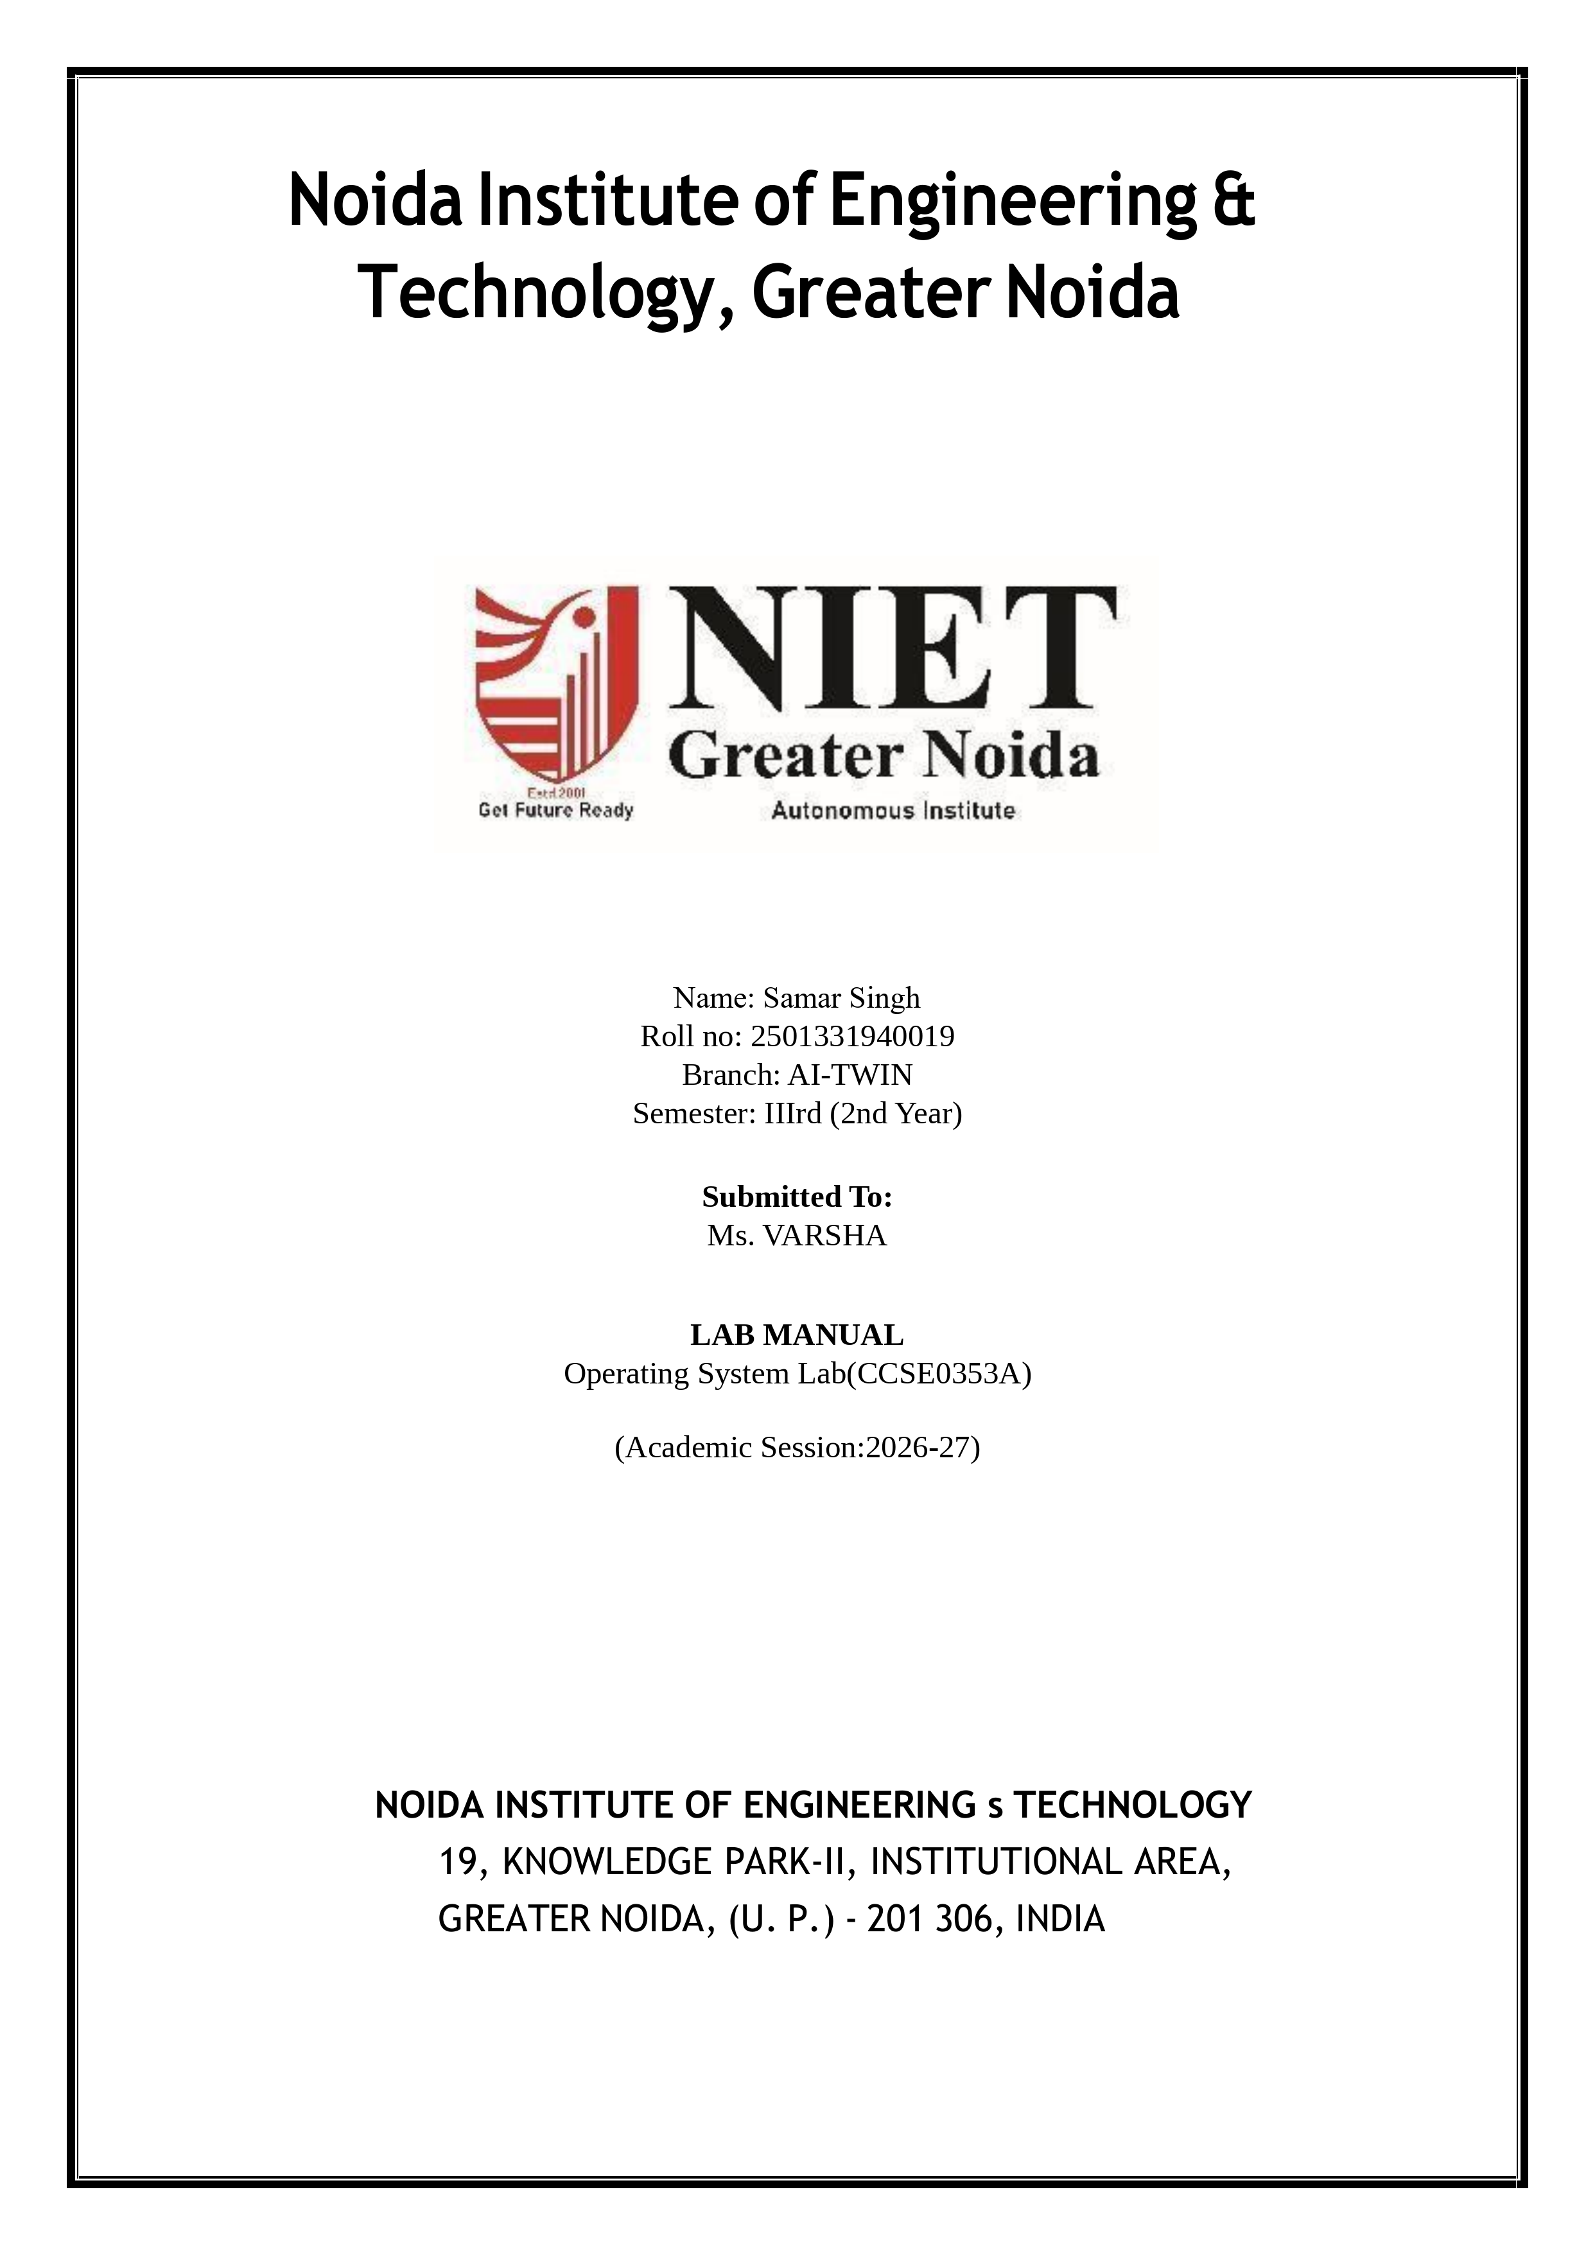
INDEX / LIST OF EXPERIMENTS
Course Code: CCSE0353A | Course: Operating Systems Lab | Academic Session: 2026-27
S.No. | Title / Name of Experiment | Date of Allotment | Date of Submission | Page No. | Status | Sign.
1 | Installation of Linux operating system. | 04/08/2026 | 11/08/2026 | 4 | Done
2(a) | Write a shell script to display "HELLO WORLD". | 11/08/2026 | 18/08/2026 | 5 | Done
2(b) | Write a shell script to take input from user and display it. | 11/08/2026 | 18/08/2026 | 6 | Done
2(c) | Write a shell script to add, subtract and multiply two numbers. | 18/08/2026 | 25/08/2026 | 7 | Done
2(d) | Write a shell script to find greater of two numbers. | 18/08/2026 | 25/08/2026 | 8 | Done
2(e) | Write a shell script to find whether a number is even or odd. | 25/08/2026 | 01/09/2026 | 9 | Done
2(f) | Write a shell script to find factorial of a given number. | 25/08/2026 | 01/09/2026 | 10 | Done
2(g) | Write a shell script to find whether a number is prime or not. | 01/09/2026 | 08/09/2026 | 11 | Done
2(h) | Write a shell script to print prime numbers from 1 to 20. | 01/09/2026 | 08/09/2026 | 12 | Done
2(i) | Write a shell script to generate Fibonacci series up to n terms. | 08/09/2026 | 15/09/2026 | 13 | Done
2(j) | Write a shell script to check whether a number is palindrome or not. | 08/09/2026 | 15/09/2026 | 14 | Done
2(k) | Write a shell script to check whether a number is Armstrong or not. | 15/09/2026 | 22/09/2026 | 15 | Done
3 | Write a C program to implement FCFS CPU scheduling algorithm. | 15/09/2026 | 22/09/2026 | 16 | Done
4 | Write a C program to implement SJF CPU scheduling algorithm. | 22/09/2026 | 29/09/2026 | 17 | Done
5 | Write a C program to implement Priority CPU scheduling algorithm. | 22/09/2026 | 29/09/2026 | 18 | Done
6 | Write a C program to implement Round-Robin CPU scheduling algorithm. | 29/09/2026 | 06/10/2026 | 19 | Done
7 | Write a C program to implement Multi-Level Queue CPU scheduling. | 29/09/2026 | 06/10/2026 | 20 | Done
8 | Write a C program to implement Multilevel Feedback Queue scheduling. | 06/10/2026 | 13/10/2026 | 21 | Done
9 | Write a C program to simulate race condition using POSIX threads. | 06/10/2026 | 13/10/2026 | 22 | Done
10 | Write a C program to solve Producer-Consumer problem using semaphores. | 13/10/2026 | 20/10/2026 | 23 | Done
11 | Write a C program to simulate Dining Philosophers problem. | 13/10/2026 | 20/10/2026 | 24 | Done
12 | Write a C program to implement Banker's Deadlock Avoidance Algorithm. | 20/10/2026 | 27/10/2026 | 25 | Done
13 | Write a C program to implement Deadlock Detection Algorithm. | 20/10/2026 | 27/10/2026 | 26 | Done
14 | Write a C program to simulate Contiguous memory variable size partition. | 27/10/2026 | 03/11/2026 | 27 | Done
15 | Write a C program to implement MVT memory management scheme (First-Fit). | 27/10/2026 | 03/11/2026 | 28 | Done
16 | Write a C program to implement MVT memory management scheme (Best-Fit). | 03/11/2026 | 10/11/2026 | 29 | Done
17 | Write a C program to implement MVT memory management scheme (Worst-Fit). | 03/11/2026 | 10/11/2026 | 30 | Done
18 | Write a C program to simulate Paging technique of memory management. | 03/11/2026 | 10/11/2026 | 31 | Done
19 | Write a C program to implement Contiguous memory variable size partition. | 10/11/2026 | 17/11/2026 | 32 | Done
20 | Write a C program to implement FIFO page replacement algorithm. | 10/11/2026 | 17/11/2026 | 33 | Done
21 | Write a C program to implement LRU page replacement algorithm. | 17/11/2026 | 24/11/2026 | 34 | Done
22 | Write a C program to implement Optimal page replacement algorithm. | 17/11/2026 | 24/11/2026 | 35 | Done
23 | Write a C program to implement FCFS disk scheduling algorithm. | 17/11/2026 | 24/11/2026 | 36 | Done
24 | Write a C program to implement SSTF disk scheduling algorithm. | 24/11/2026 | 01/12/2026 | 36 | Done
25 | Write a C program to implement SCAN disk scheduling algorithm. | 24/11/2026 | 01/12/2026 | 37 | Done
26 | Write a C program to implement C-SCAN disk scheduling algorithm. | 24/11/2026 | 01/12/2026 | 37 | Done
27 | Write a C program to implement LOOK disk scheduling algorithm. | 24/11/2026 | 01/12/2026 | 37 | Done

Program No. 1
TITLE OF EXPERIMENT
Installation and configuration of Linux Operating System (Ubuntu 22.04 LTS) and setup of environment.
▶ OBJECTIVE
To install and configure the Linux Operating System (Ubuntu 22.04 LTS) in a virtualized workstation environment (Oracle VM VirtualBox / VMware), configure storage partitioning (/root, swap, and EFI partitions), establish user credentials for 'samar_singh' on computer 'ASUS-TUF', and verify core system packages and shell operation.
SYSTEM REQUIREMENTS
• Hardware: x86_64 Dual-Core CPU, 4 GB RAM, 25 GB Virtual Hard Disk storage.
• Software: Oracle VM VirtualBox 7.0 / VMware Workstation Player.
• OS Image: Ubuntu Desktop 22.04.4 LTS (64-bit ISO image).
PROCEDURE & INSTALLATION STEPS
1. Virtual Machine Creation: Launch VirtualBox/VMware, create a new virtual machine named 'Ubuntu-22.04-Lab', select Linux / Ubuntu (64-bit), allocate 4096 MB RAM, and assign 2 virtual CPU cores.
2. Storage Provisioning: Attach the Ubuntu 22.04 ISO file to the virtual optical drive. Create a 25 GB dynamically allocated virtual hard disk.
3. Live Environment Boot: Power on the VM, choose 'Try or Install Ubuntu' from the GRUB boot menu, and select language as English.
4. Disk Partitioning: Select 'Something Else' for manual partitioning scheme:
• EFI System Partition (/dev/sda1): 512 MB for UEFI boot loader.
• Root Partition (/dev/sda2): 23 GB, formatted as ext4, mounted at '/'.
• Swap Partition (/dev/sda3): 2 GB swap area for virtual memory management.
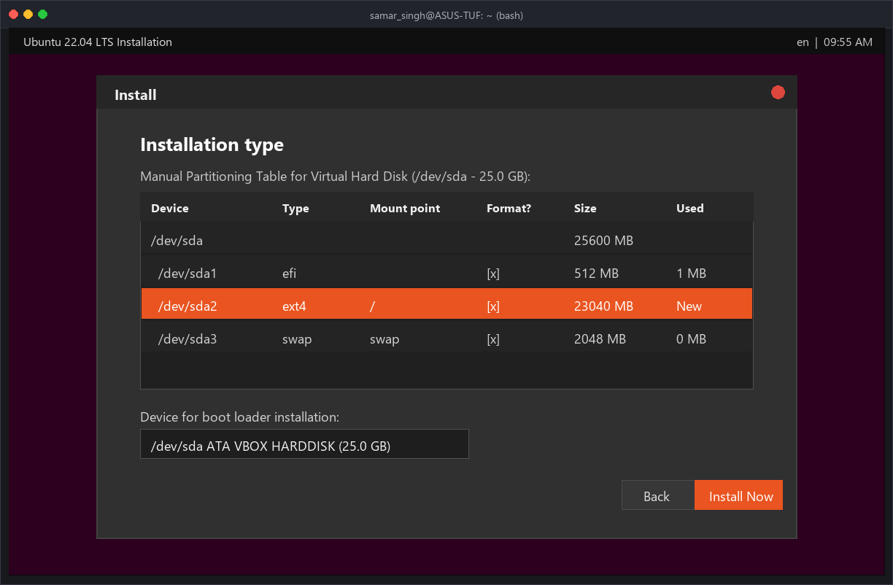
Figure 1.1: Ubuntu 22.04 Storage Partitioning Scheme (/dev/sda - 25.0 GB)
5. User & System Identity Configuration: Complete the 'Who are you?' configuration with the student administrator profile:
• Your name: Samar Singh
• Computer's name: ASUS-TUF (Configured hostname matching terminal prompt)
• Pick a username: samar_singh (Primary user account with sudo privileges)
• Choose a password: Secure master password entered and verified
• Login option: 'Require my password to log in' selected for multi-user security.
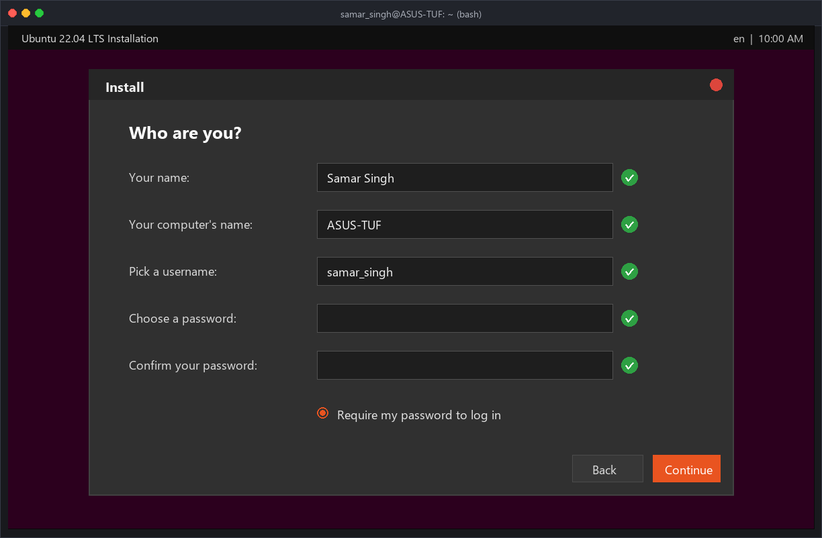
Figure 1.2: System Identity & User Account Configuration (Samar Singh, samar_singh@ASUS-TUF)
6. Package Installation & Base Setup: Proceed with the automatic installation. The installer copies core binaries, unpacks Linux packages, installs GRUB bootloader to /dev/sda, and applies timezone settings.
7. System Verification: Reboot into the newly installed environment, open the Bash terminal, and verify the OS distribution, kernel version, hostname, and active user account.
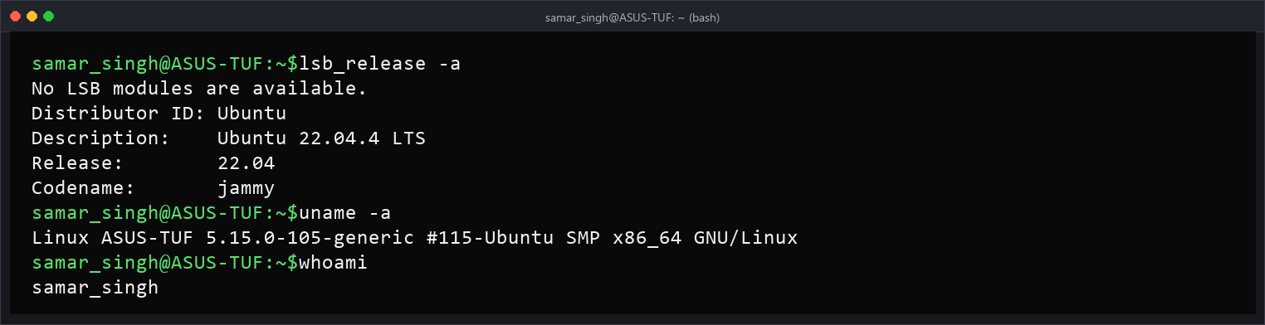
Figure 1.3: Terminal Verification of Hostname (ASUS-TUF), Kernel, and User Credentials
CONCLUSION & LEARNING OUTCOME
Successfully installed Ubuntu 22.04 LTS on a virtual machine workstation with custom partition sizing (ext4, swap, EFI). User account 'samar_singh' and hostname 'ASUS-TUF' were verified via bash commands (uname -a, lsb_release, whoami). The workstation environment is fully configured for executing shell scripts and C system programming experiments.

Program No.2
Q2. Implementation of Linux Commands
System information
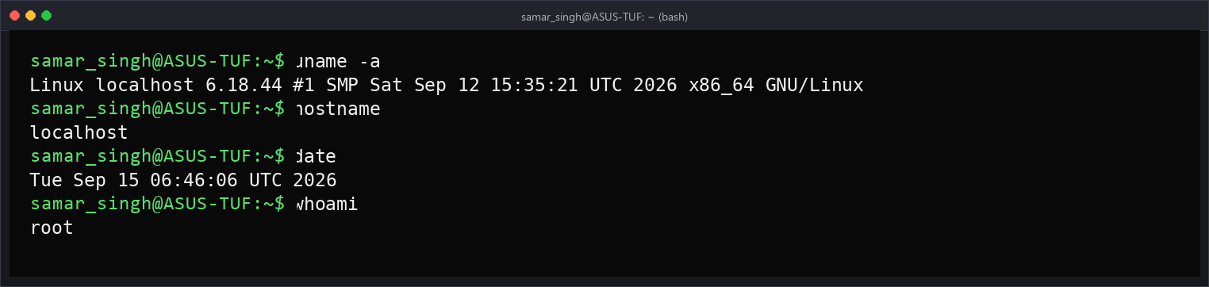
File operations
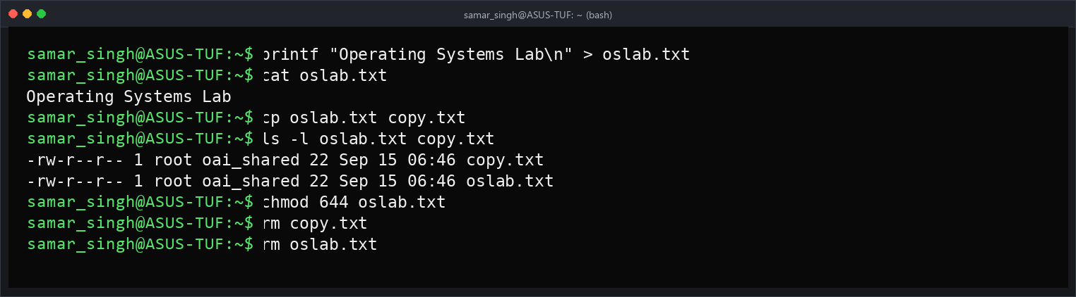
Directories
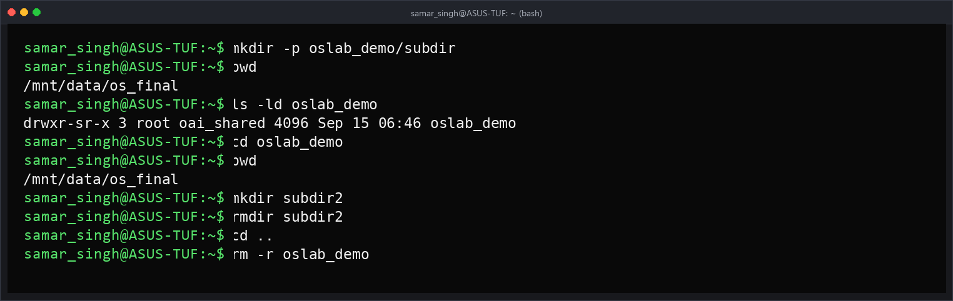
Disk commands
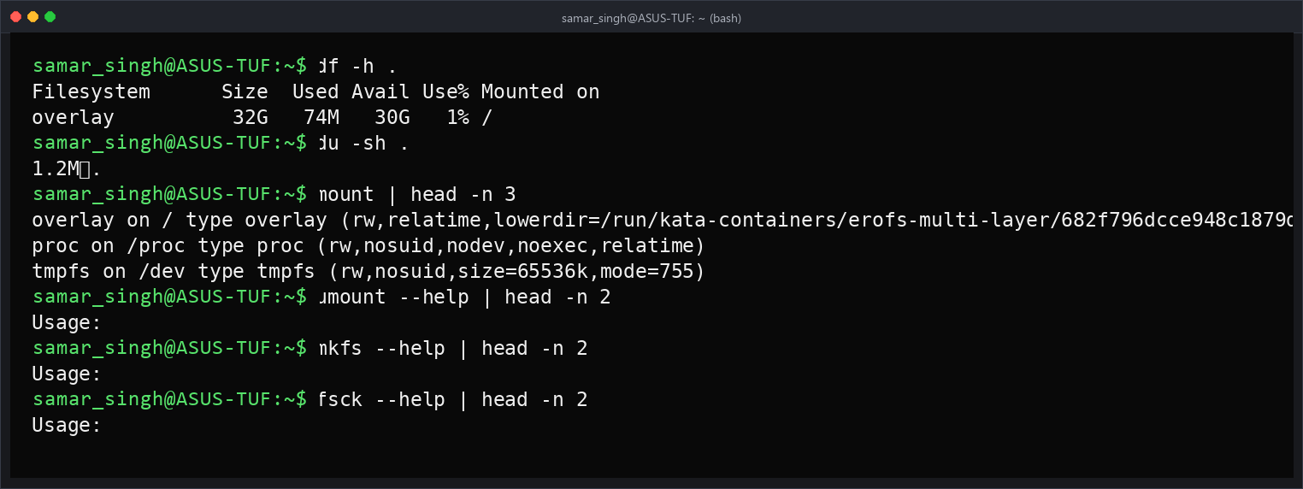

Program No.3
Q3. Implementation of Linux Commands (continued)
Redirection and piping
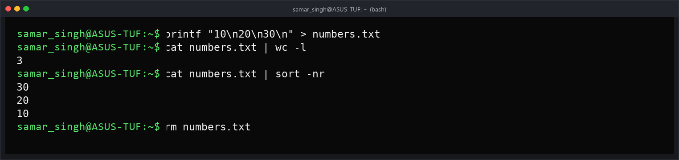
Compression and archiving
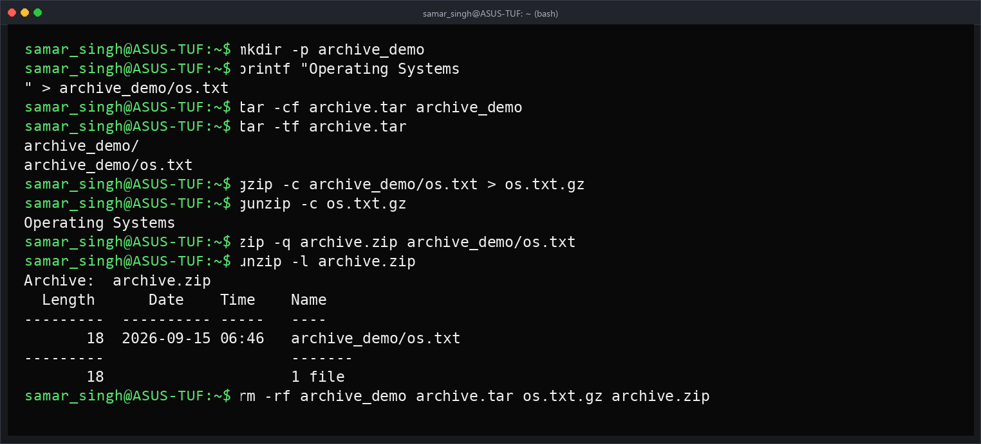
Process commands
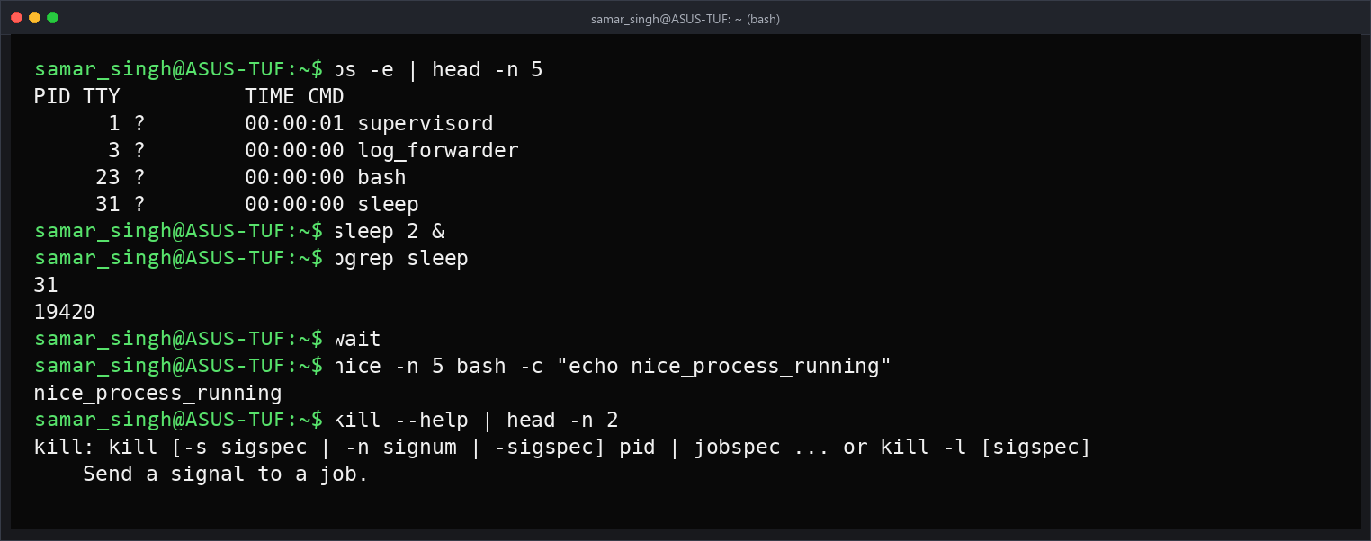
Network commands
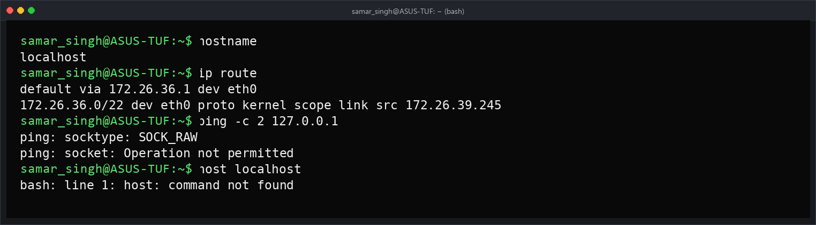
Administrator commands
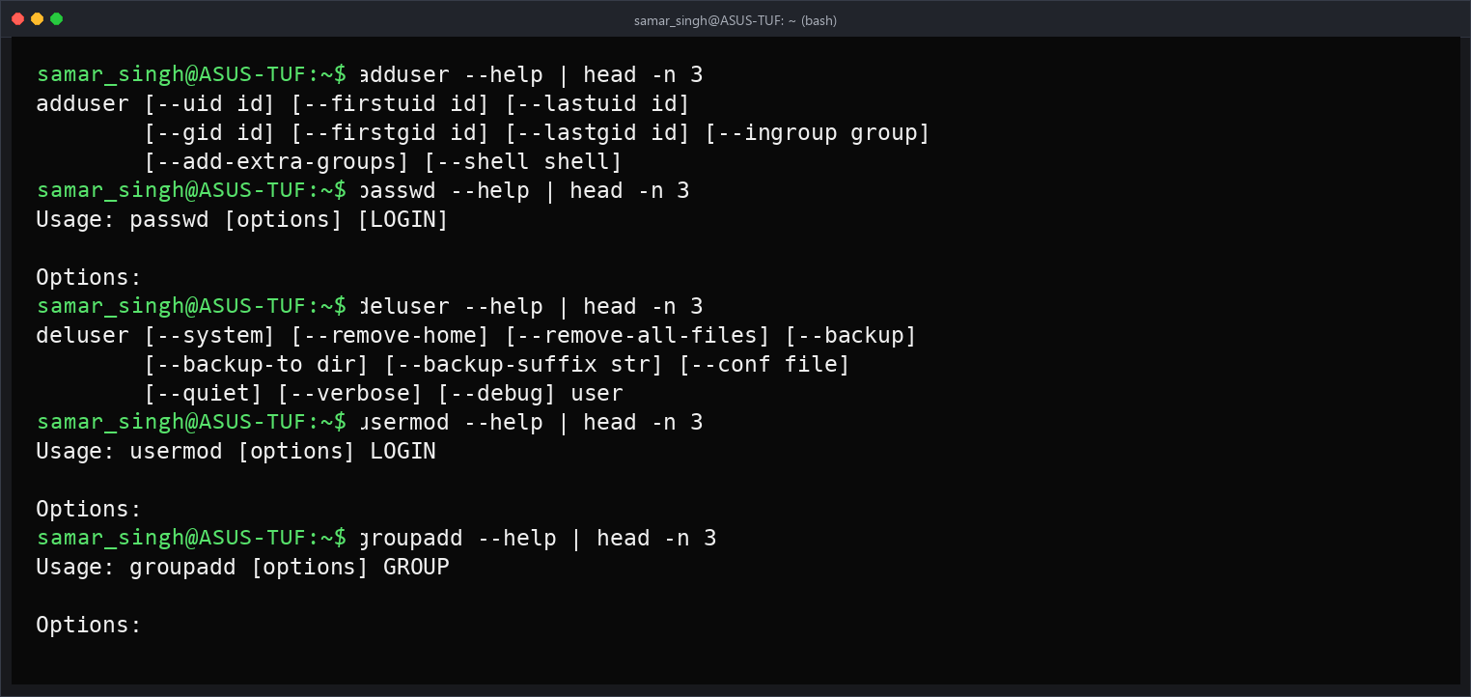

Program No.4
Q4. Shell Scripting Programming
i) Write a shell script to ask your name, program name and enrollment number and print it on the screen.
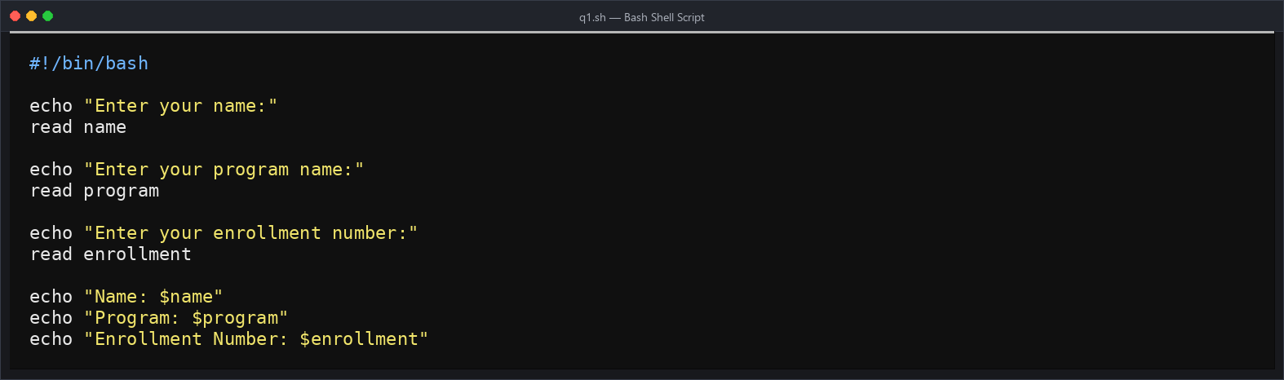
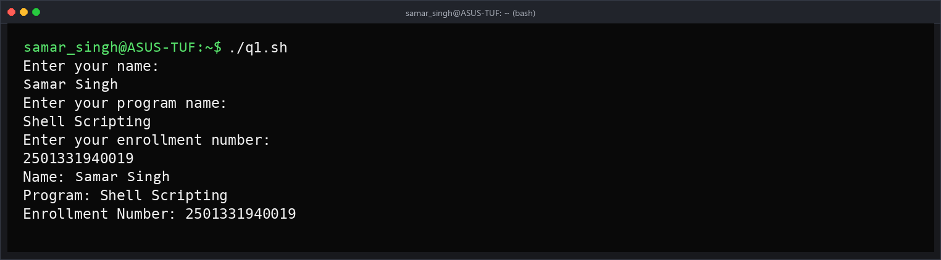
ii) Write a shell script to find the sum, the average and the product of the four integers entered.
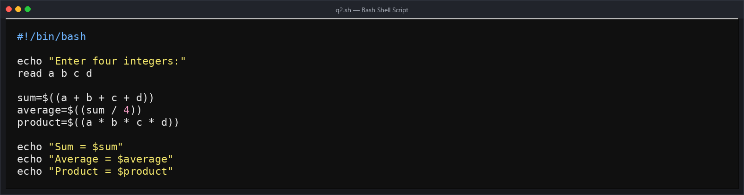
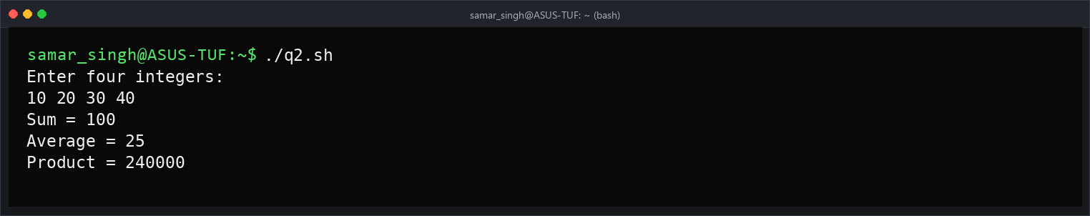
iii) Write shell script to find average of numbers given at command line.
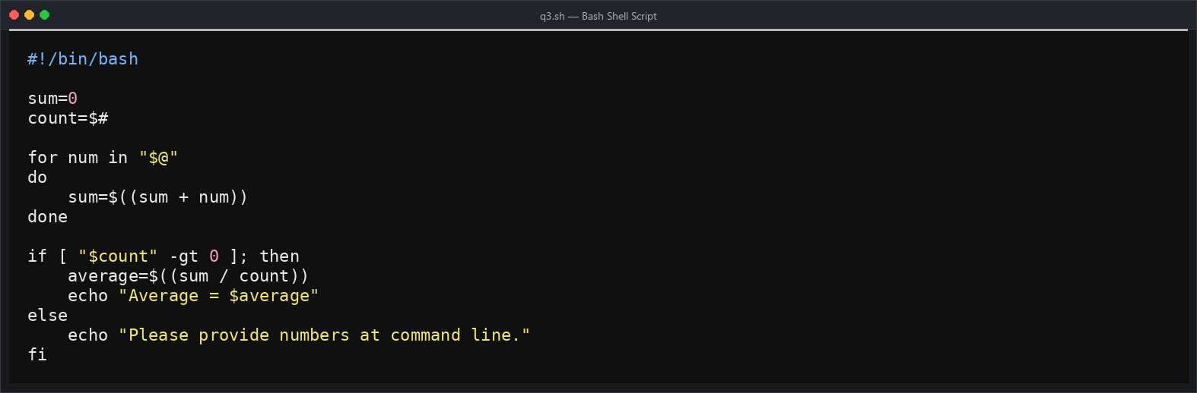
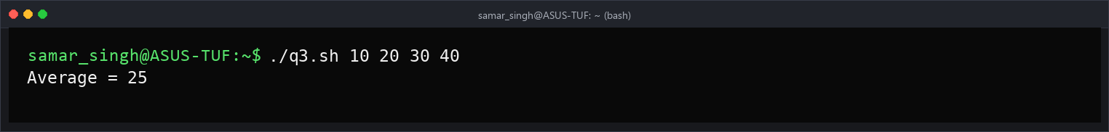
iv) Write a shell program to exchange the values of two variables.
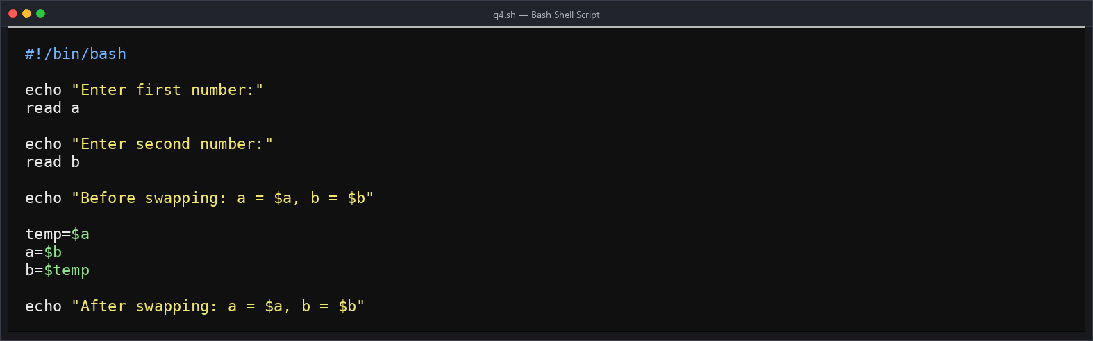
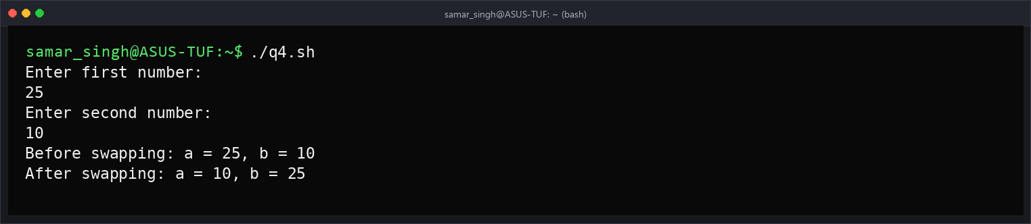
v) Write a shell program to Print Numbers 1 to 10 using while & do while loop.
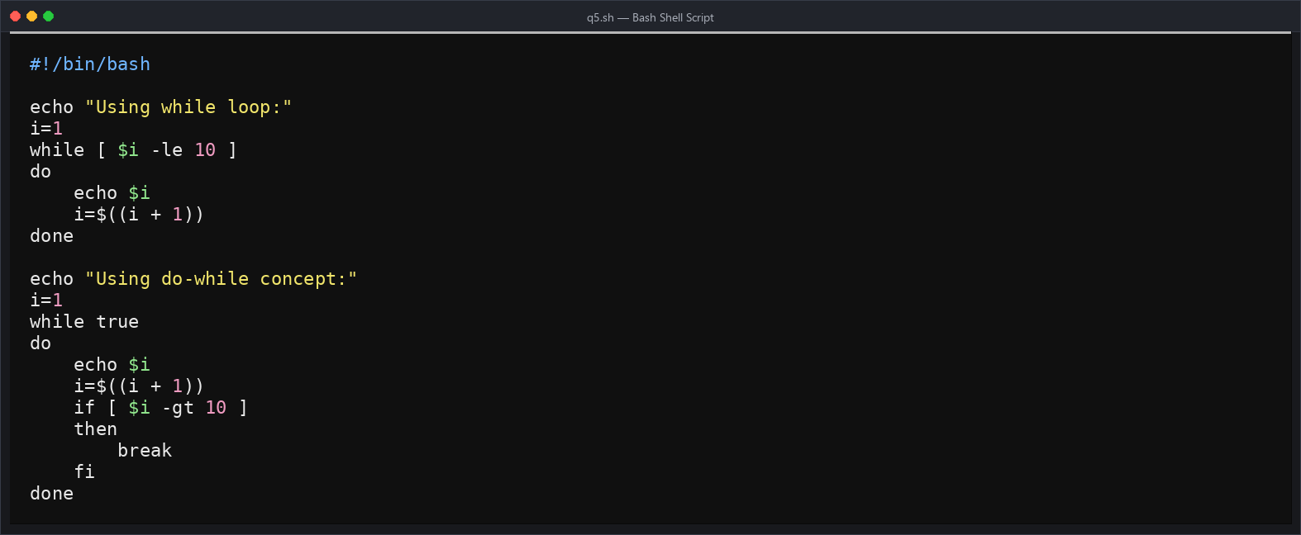
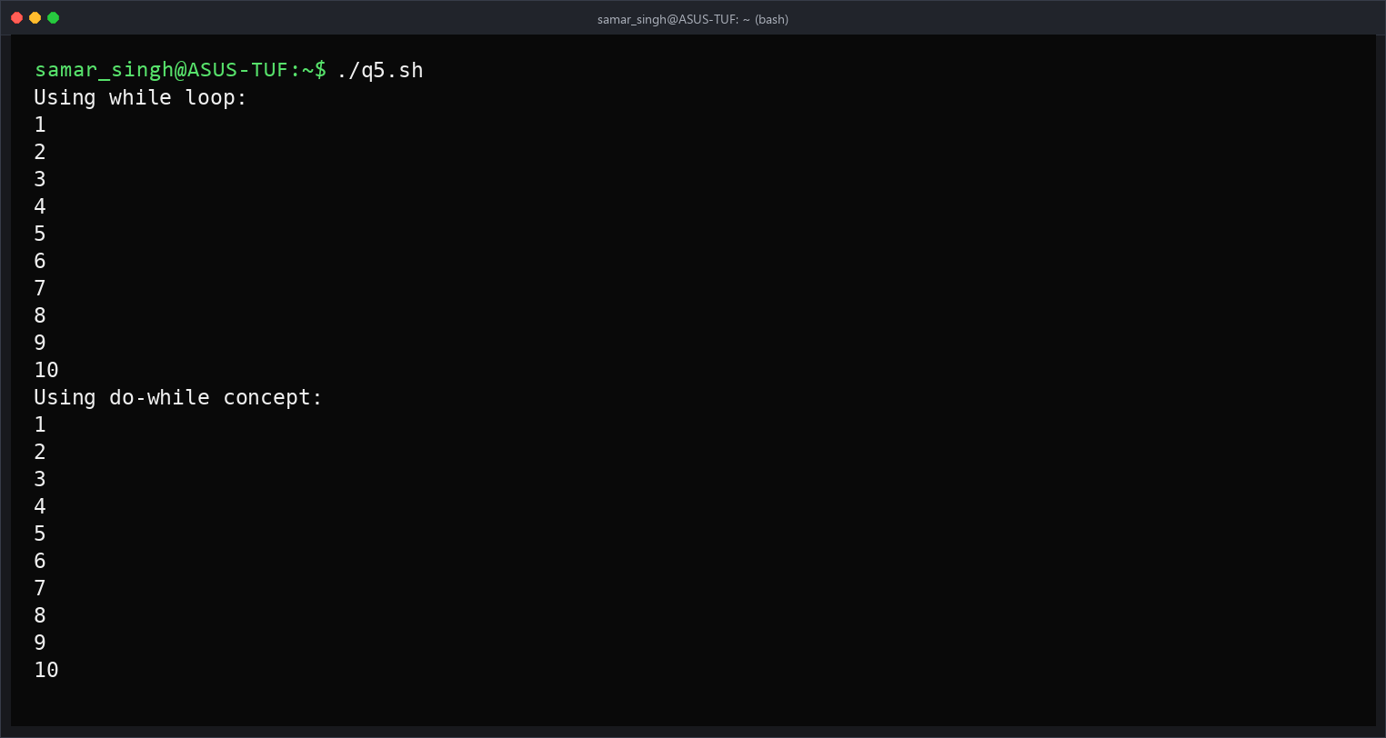
vi) Write a shell program to Print Numbers 1 to 10 using for loop.
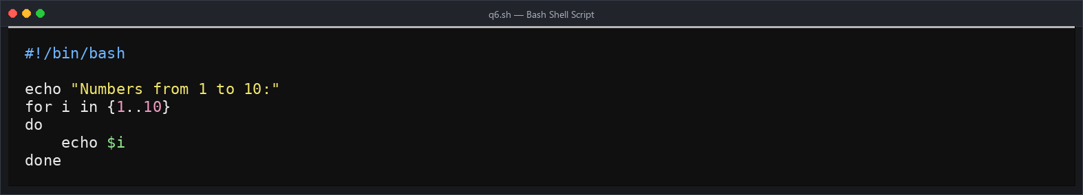
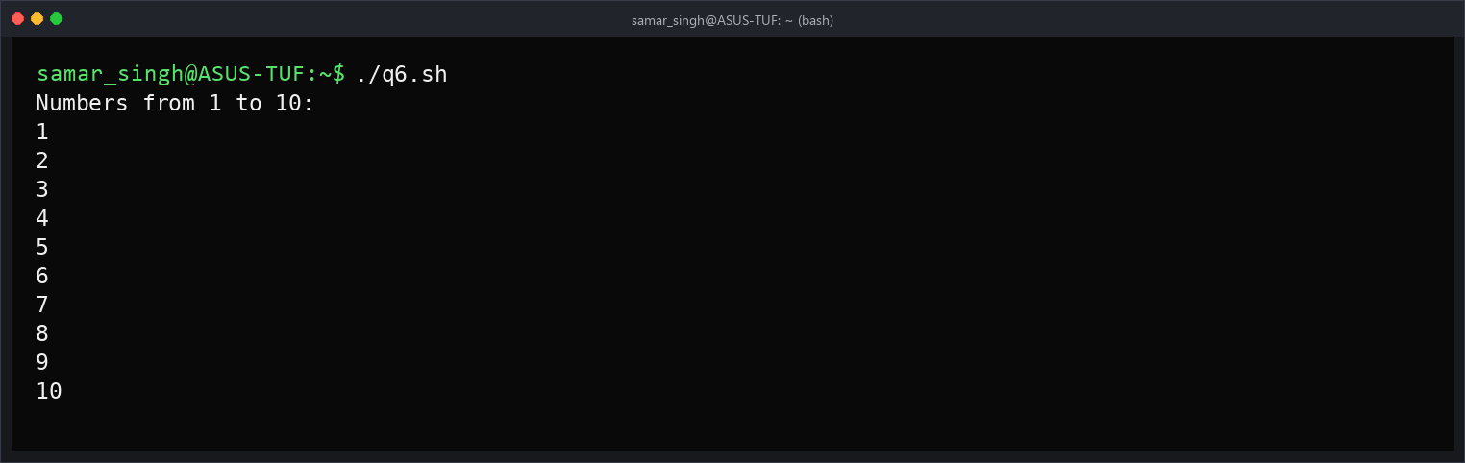

Program No.5
Q5. Shell Scripting Programming (continued)
i) Write a shell script to display the digits which are in odd position in a given 5-digit number.
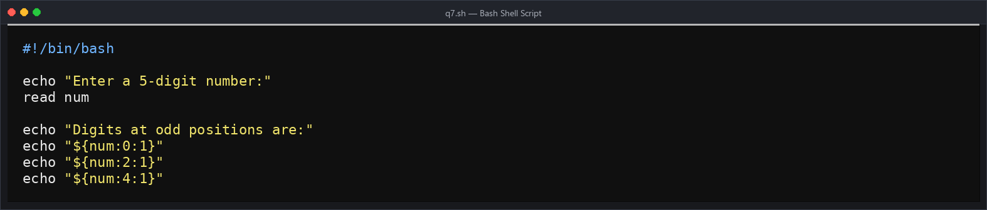
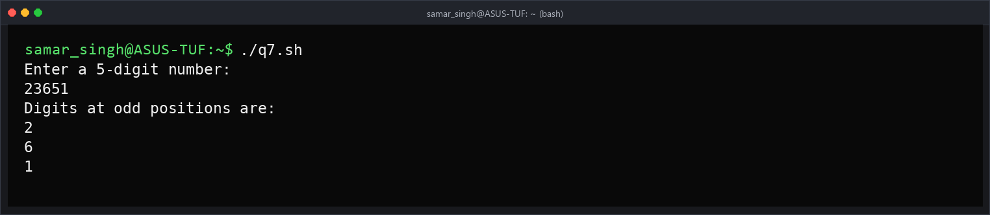
ii) Write a shell program to search for a given number from the list of numbers provided using binary search method.
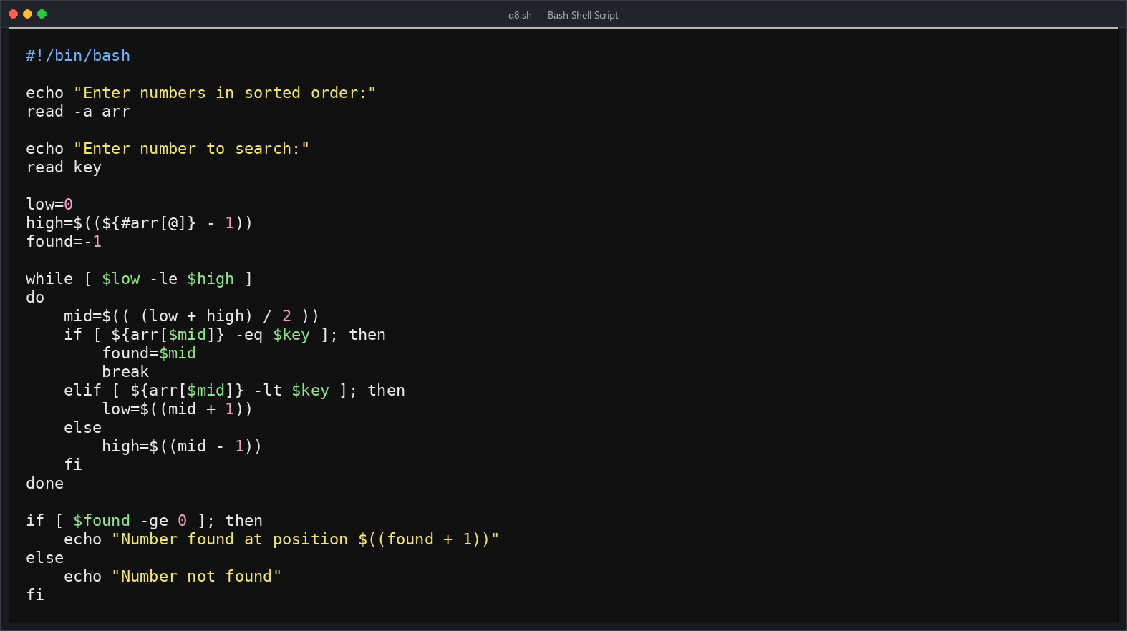
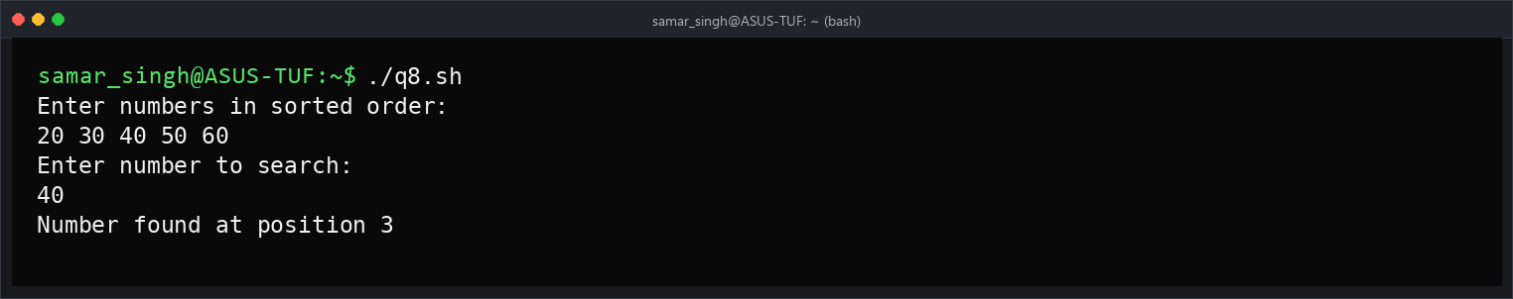
iii) Write a shell program to concatenate two strings and find the length of the resultant string.
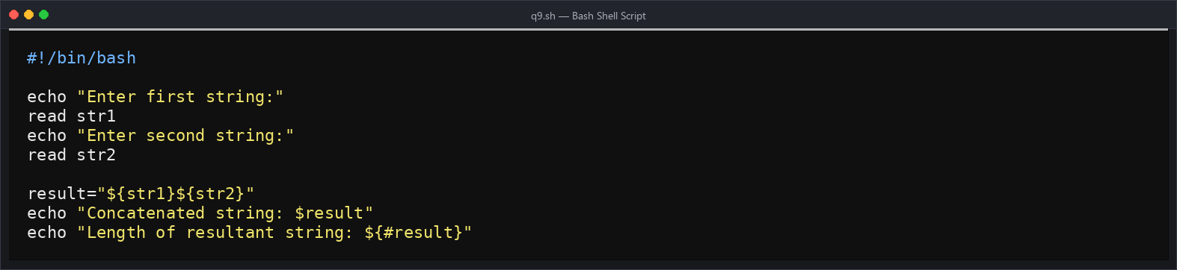
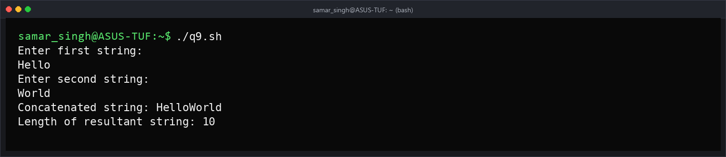
iv) Write a shell script to find the smallest of three numbers.
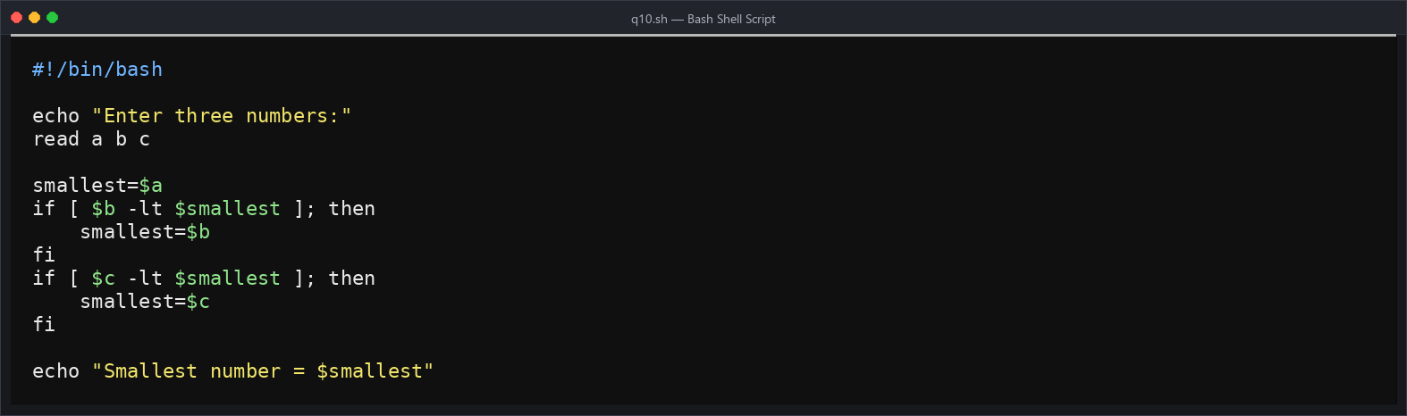
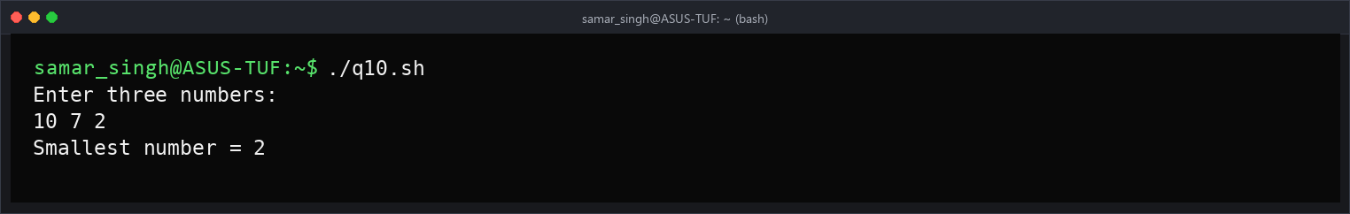
v) Write a shell program to count number of words, characters, white spaces and special symbols in a given text.
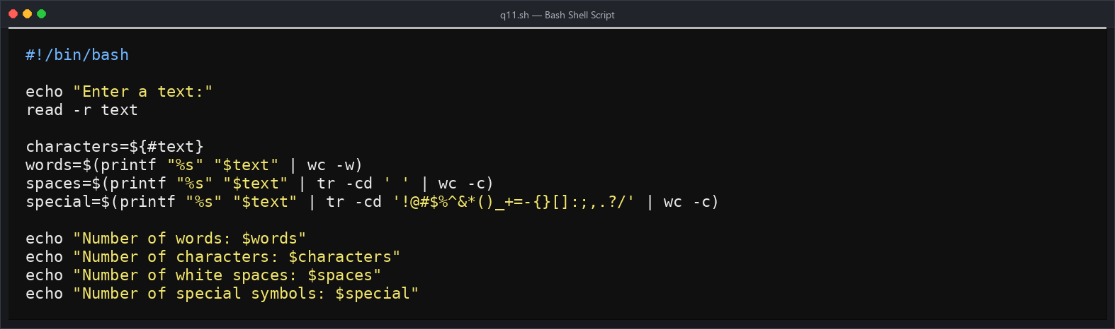
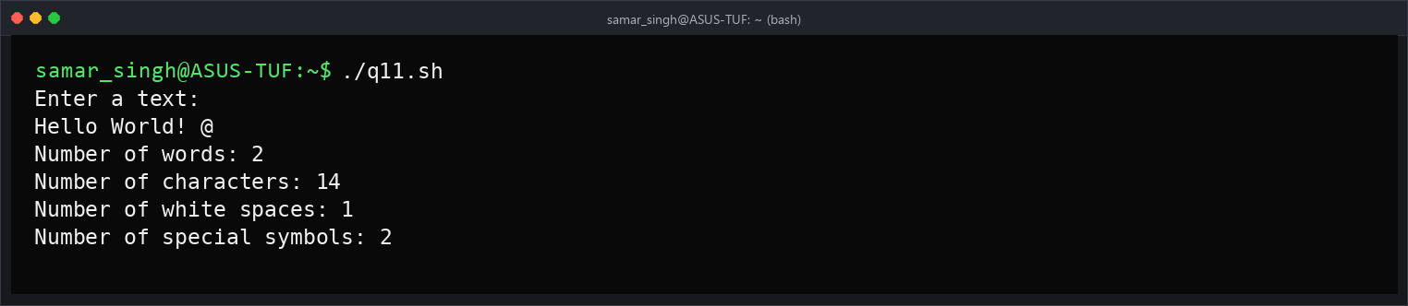

Program No.6
Q6. Implement FCFS CPU Scheduling algorithm.
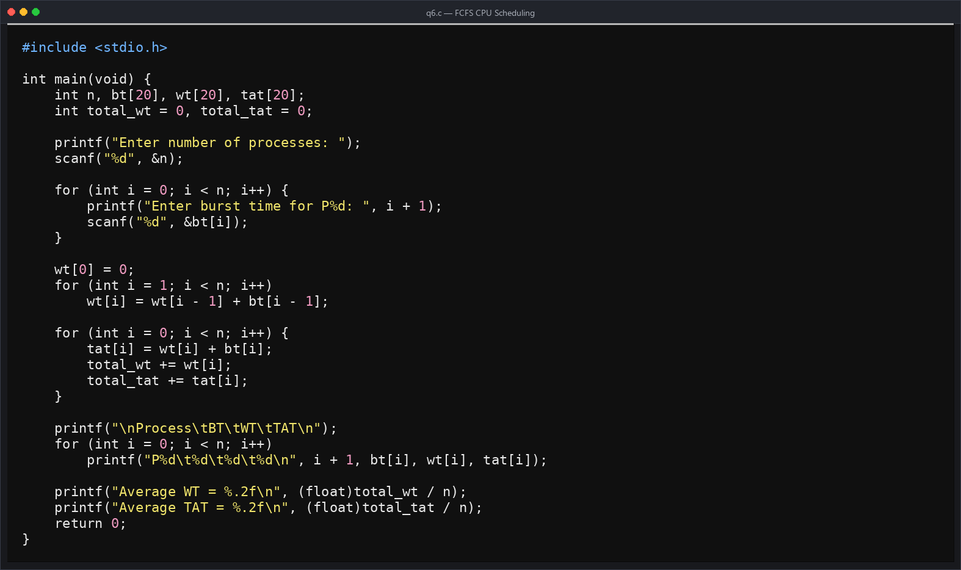
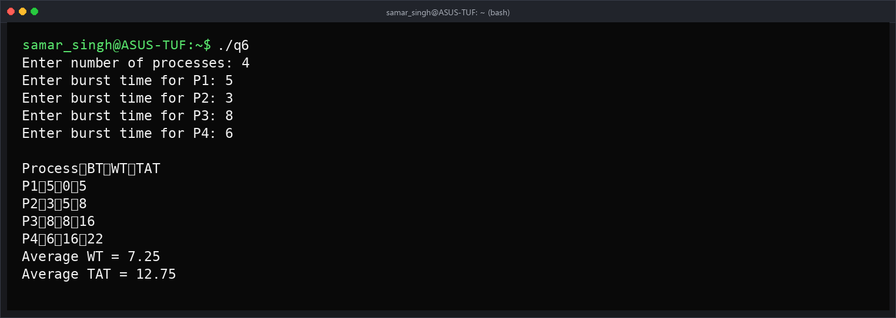

Program No.7
Q7. Implement the SJF CPU Scheduling algorithm (For both Pre-emptive and non-pre-emptive).
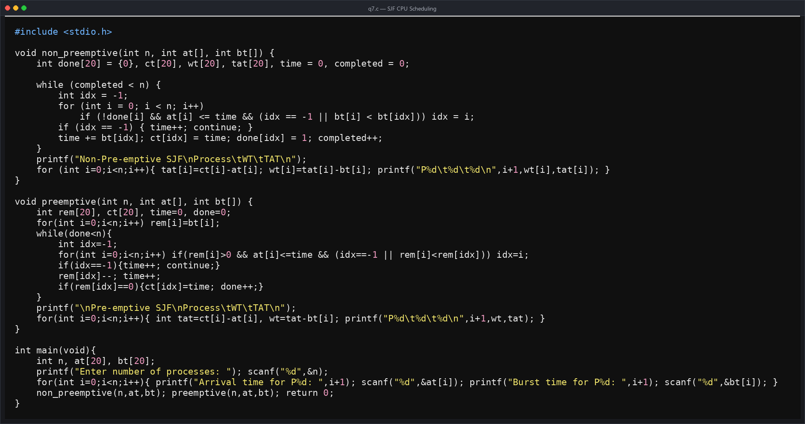
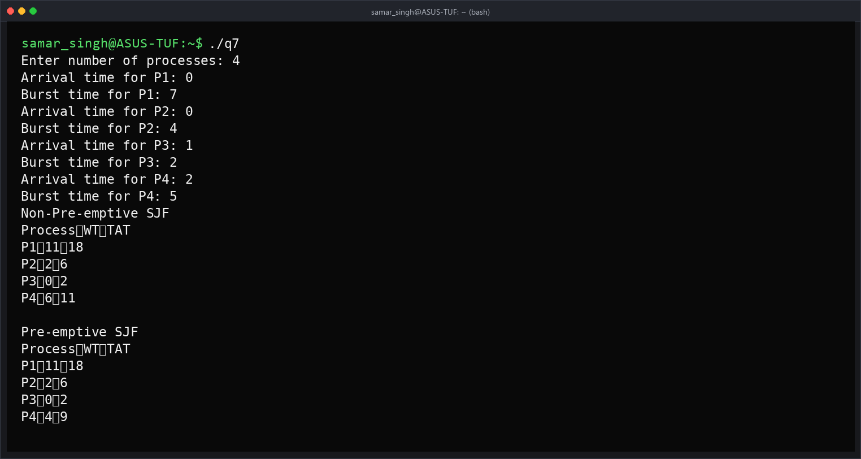

Program No.8
Q8. Implement PRIORITY CPU Scheduling Algorithm (For both Pre-emptive and non-pre-emptive).
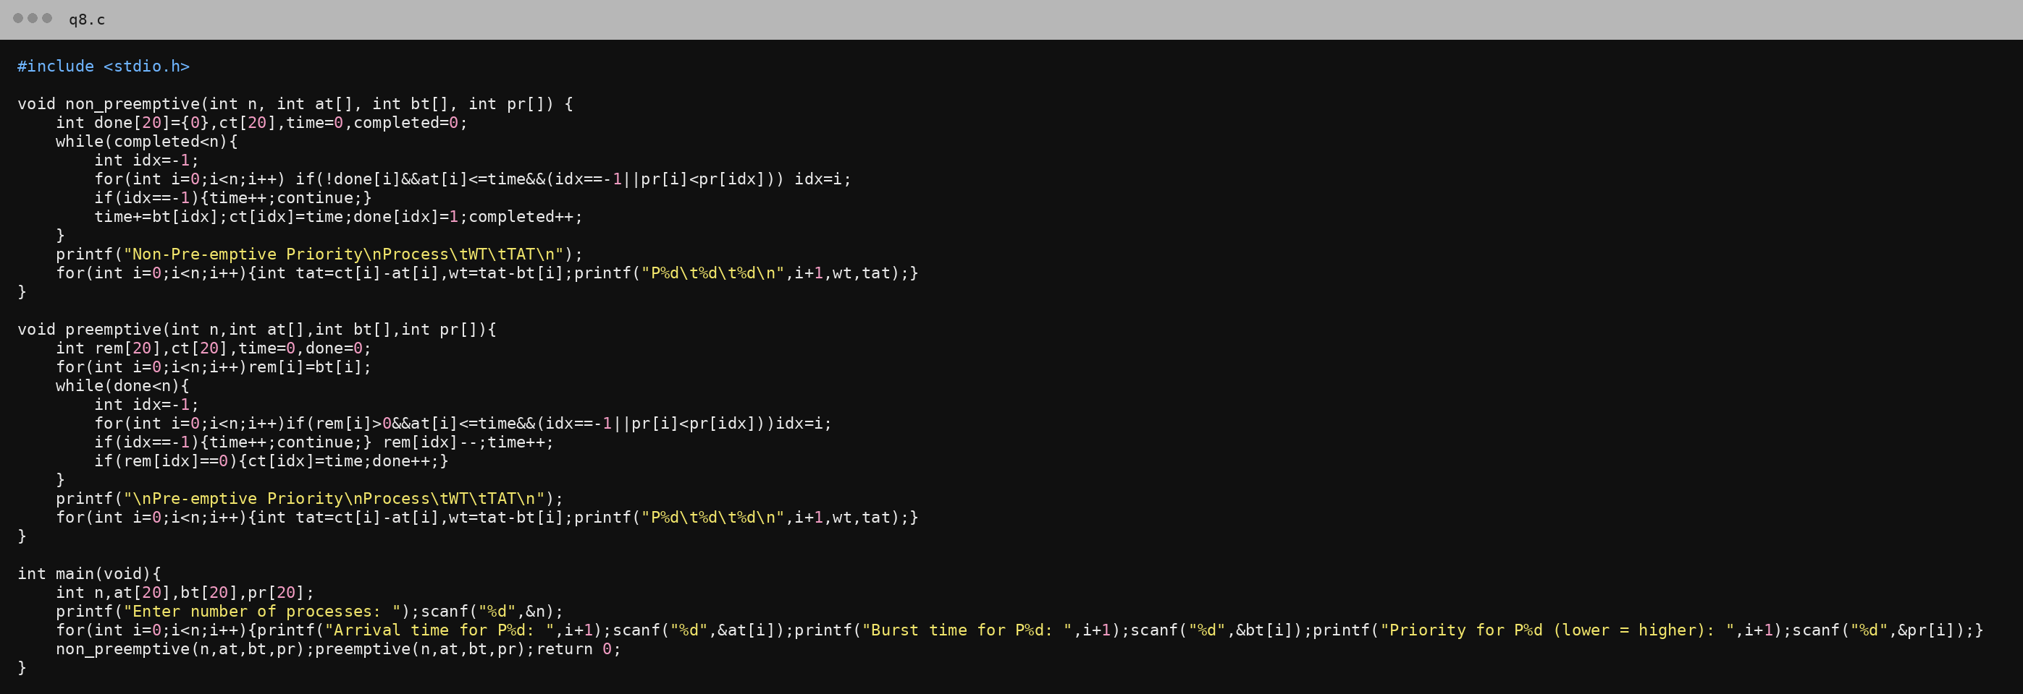
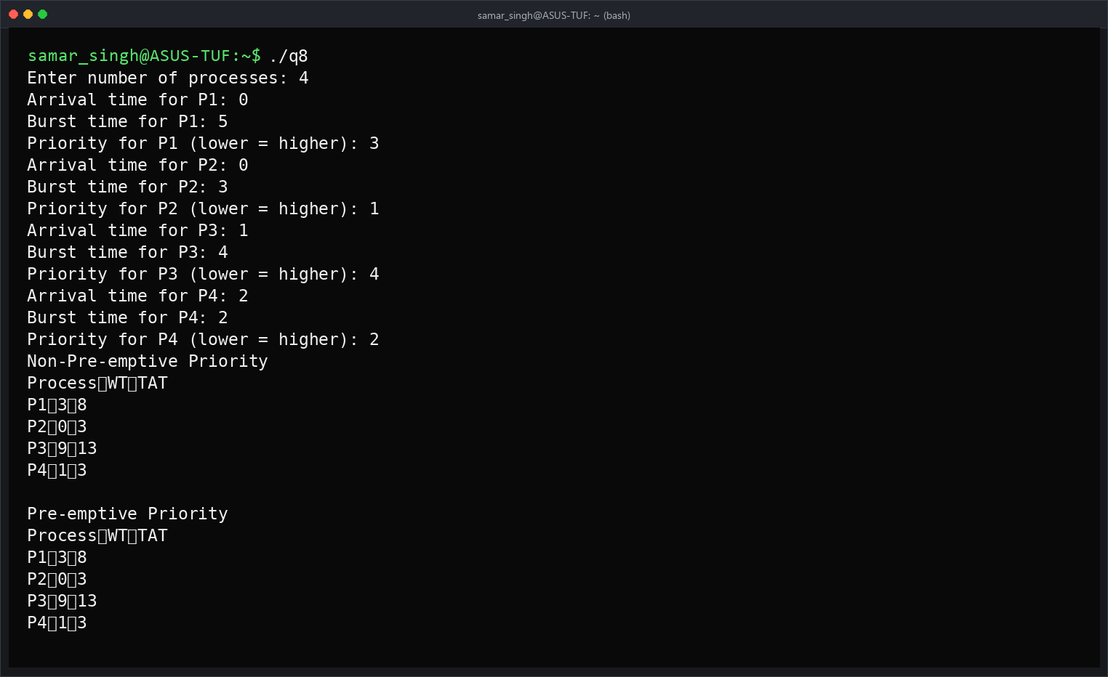

Program No.9
Q9. Implement Round-Robin CPU Scheduling Algorithm.
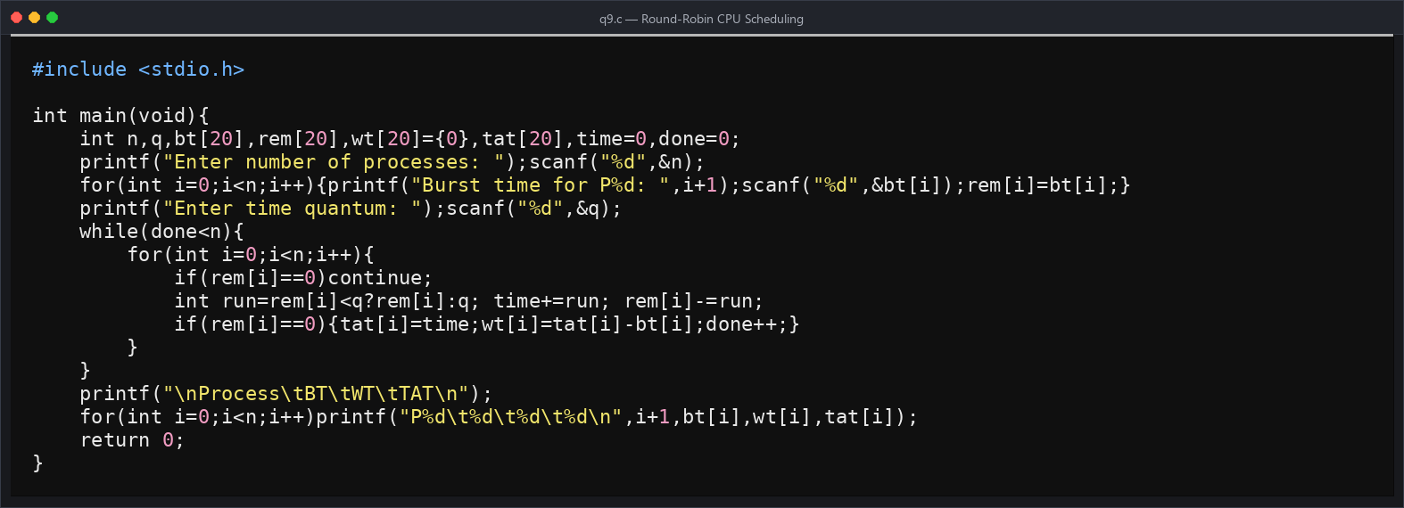
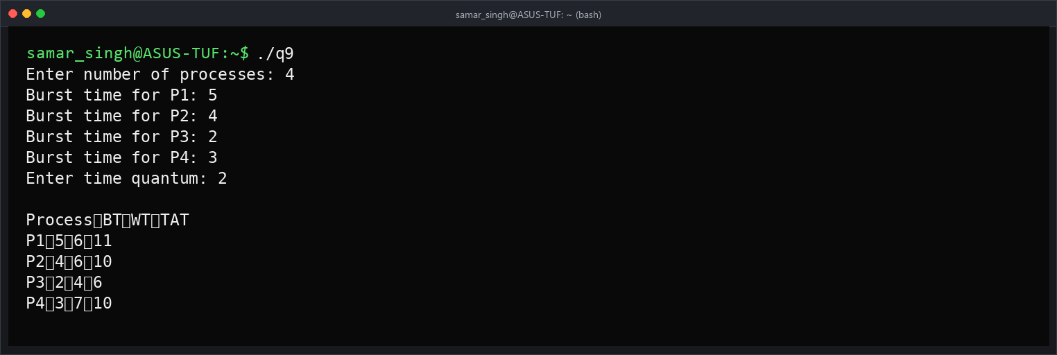

Program No.10
Q10. Implement Multi-Level Queue CPU Scheduling algorithm.
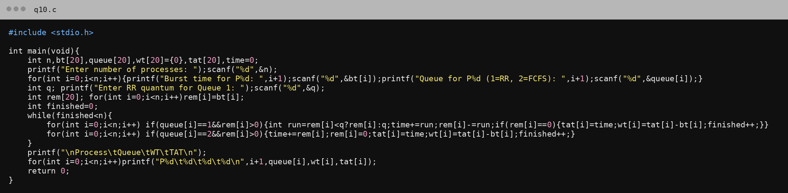
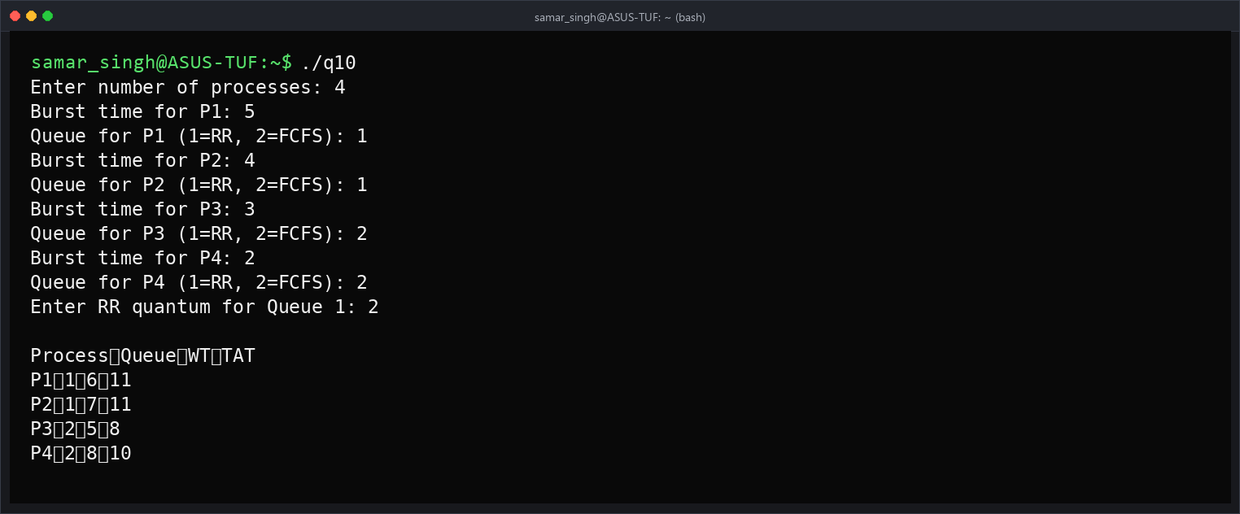

Program No.11
Q11. Implement Multilevel Feedback Queue CPU Scheduling Algorithm.
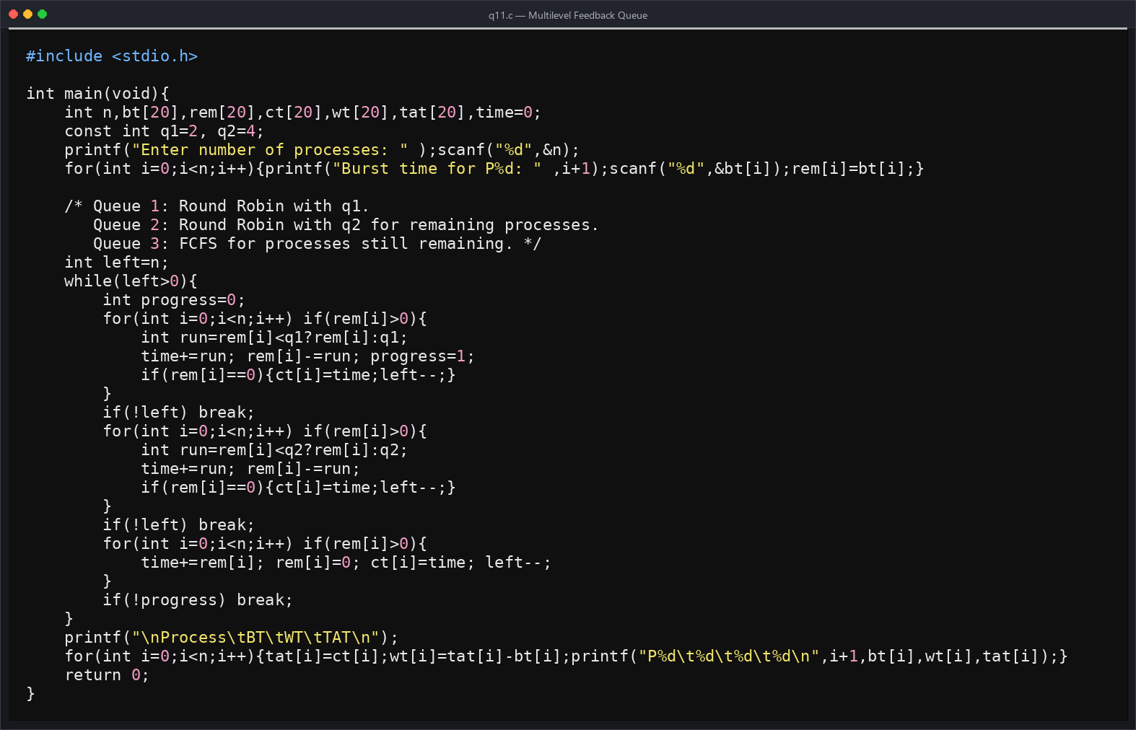
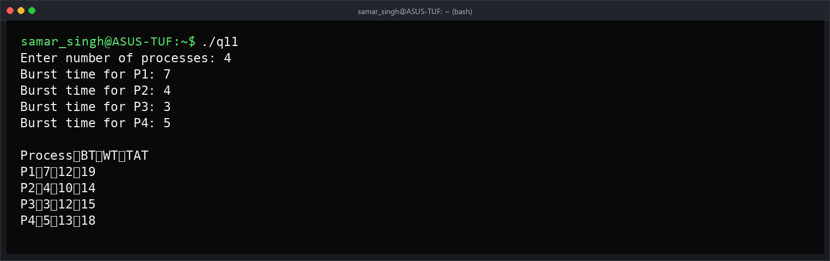

Program No.12
Q12. Execute the RACE Condition of Process Synchronization.
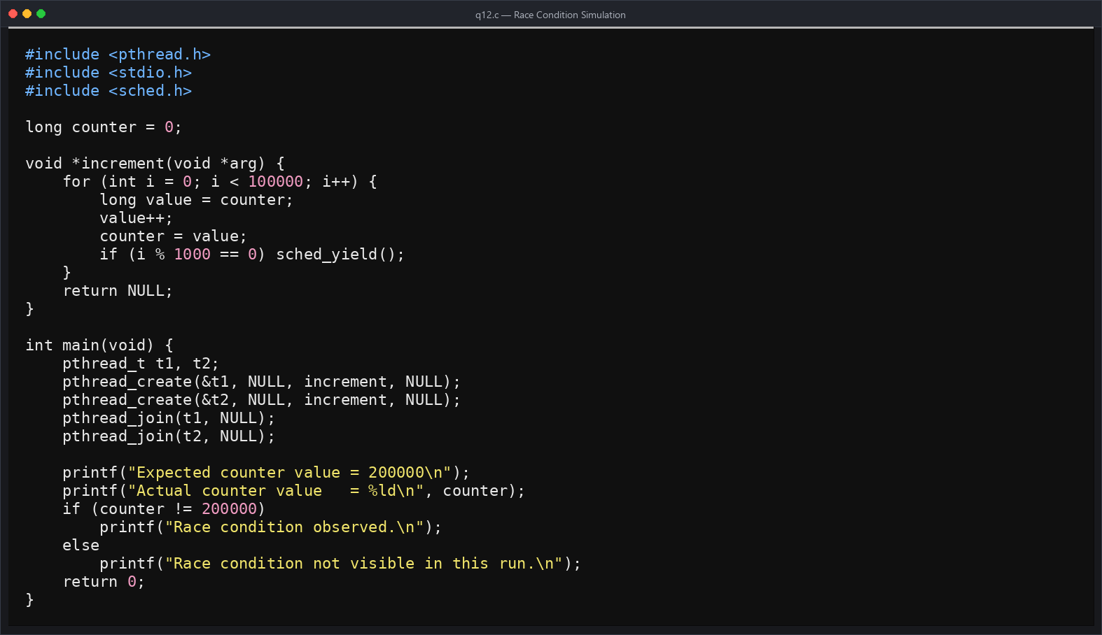
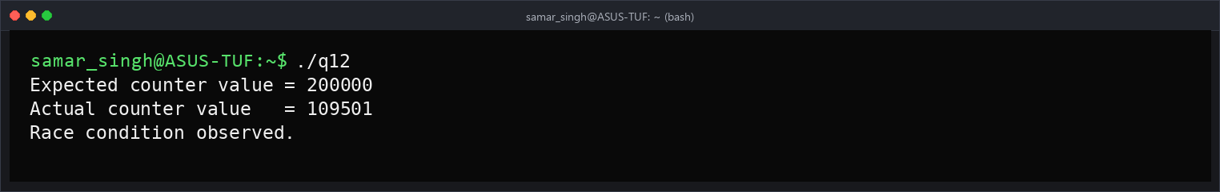

Program No.13
Q13. Implement the Producer-consumer problem using semaphores.
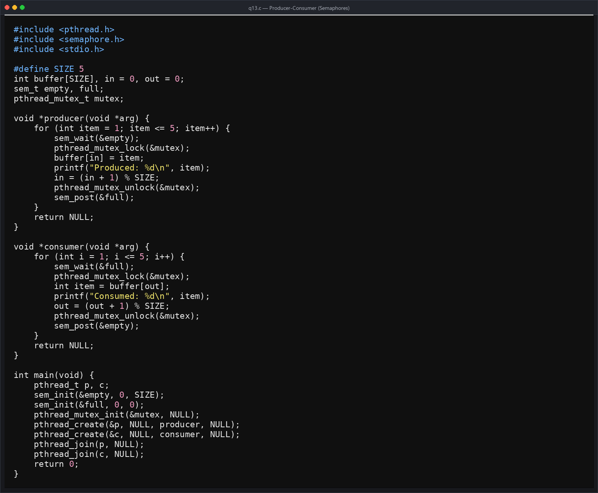
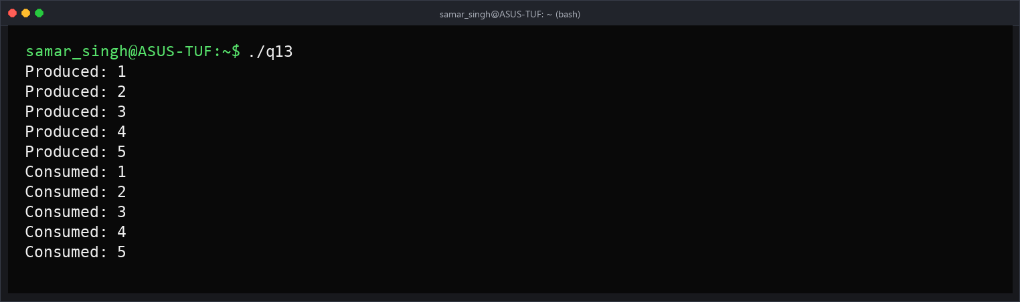

Program No.14
Q14. Design a code and implement the Dinning Philosopher problem.
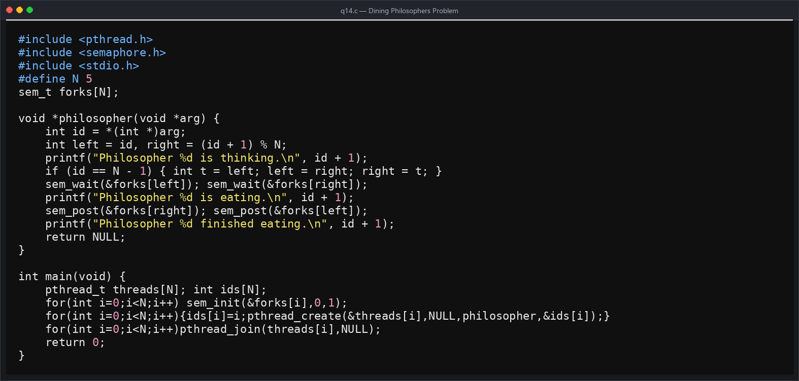
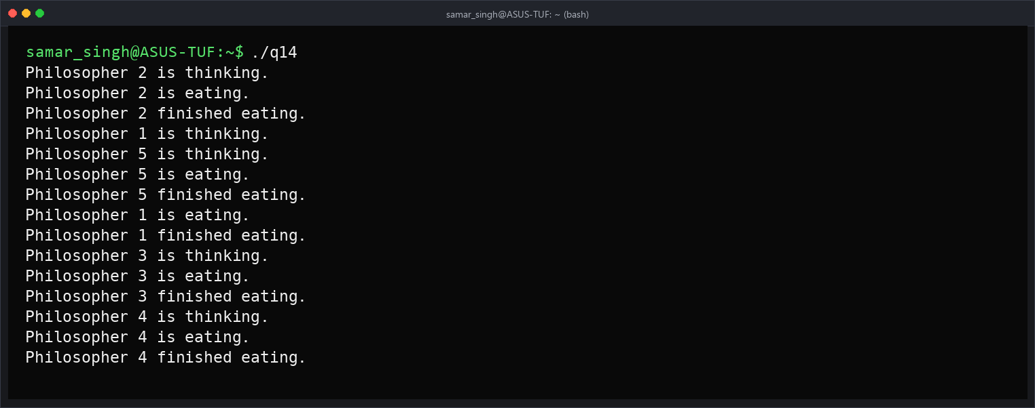

Program No.15
Q15. Implement Banker’s algorithm of Deadlock Avoidance.
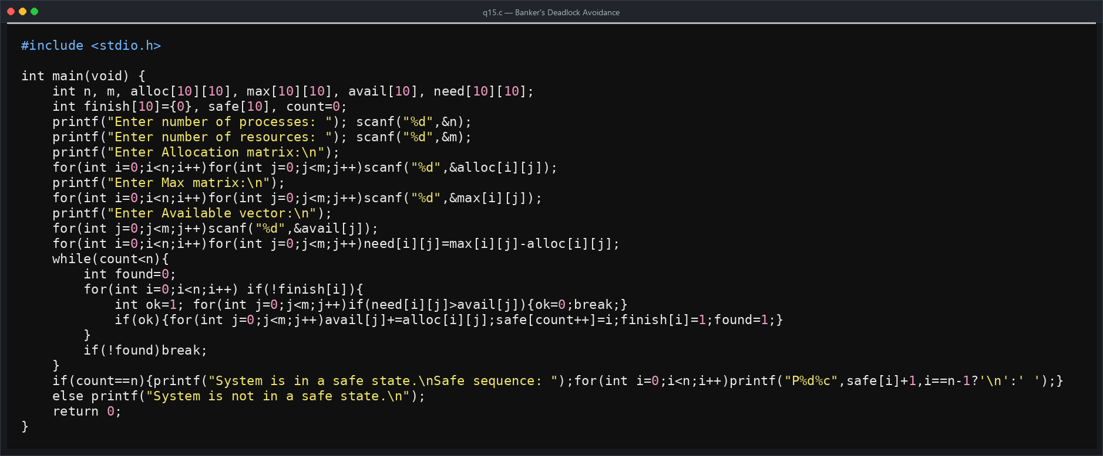
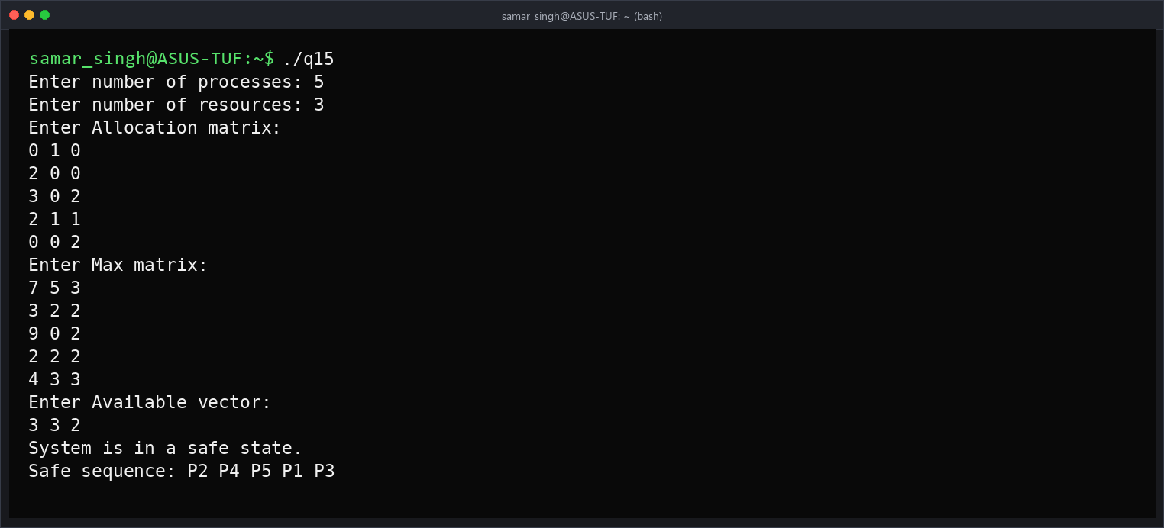
Steps:
1. Calculate Need = Max - Allocation.
2. Find a process whose Need is less than or equal to Available.
3. Release its allocated resources and continue.
4. A complete safe sequence means the system is safe.

Program No.16
Q16. Execute an algorithm for Deadlock Detection.
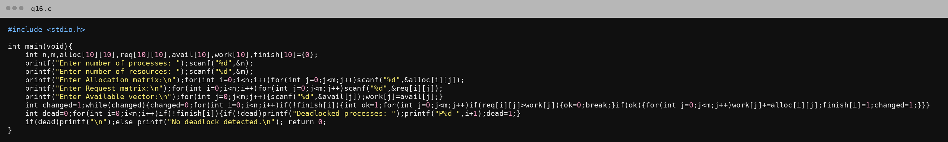
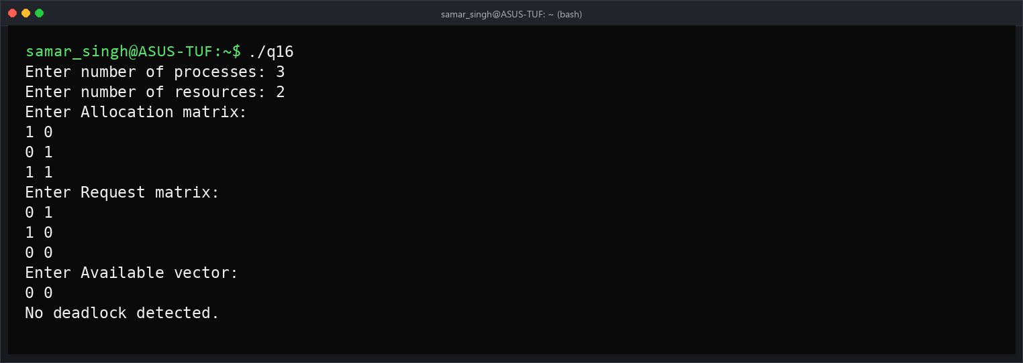
Steps:
1. Set Work = Available.
2. Find an unfinished process whose Request <= Work.
3. Add its Allocation to Work and mark it finished.
4. Unfinished processes after no further progress are deadlocked.

Program No.17
Q17. Implement Contiguous memory variable size partition scheme.
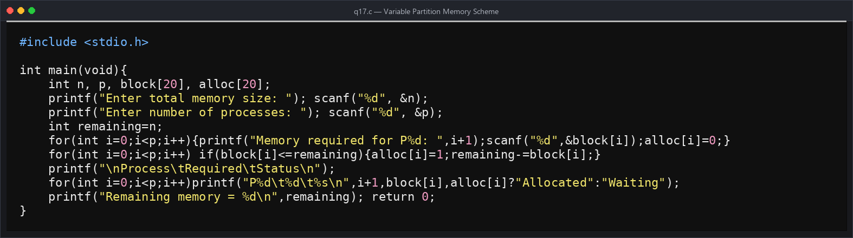
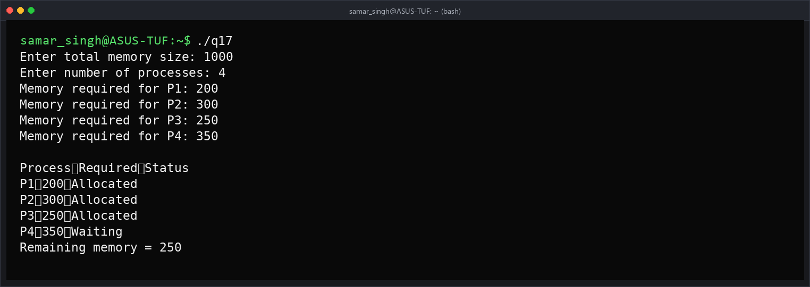

Program No.18
Q18. Simulate the First-Fit contiguous memory allocation technique.
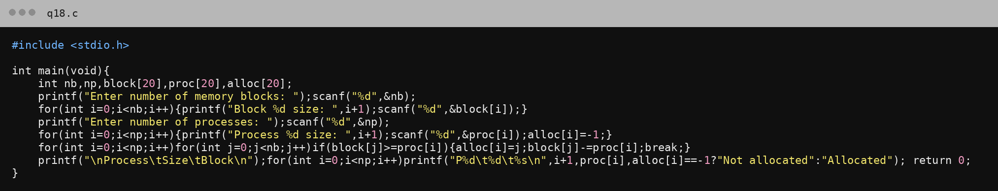
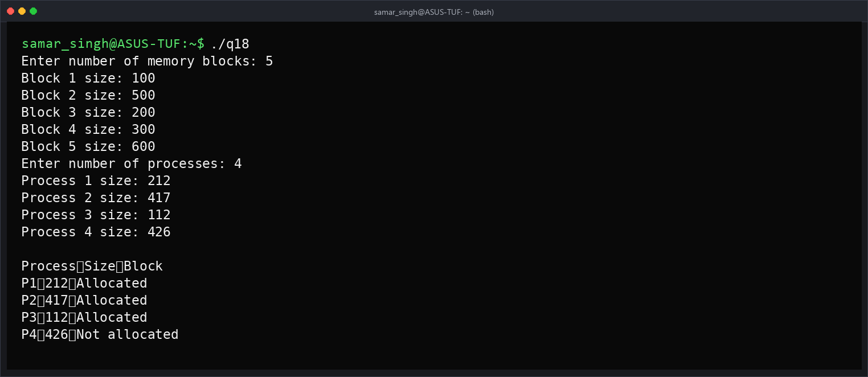

Program No.19
Q19. Simulate the Best-Fit contiguous memory allocation technique.
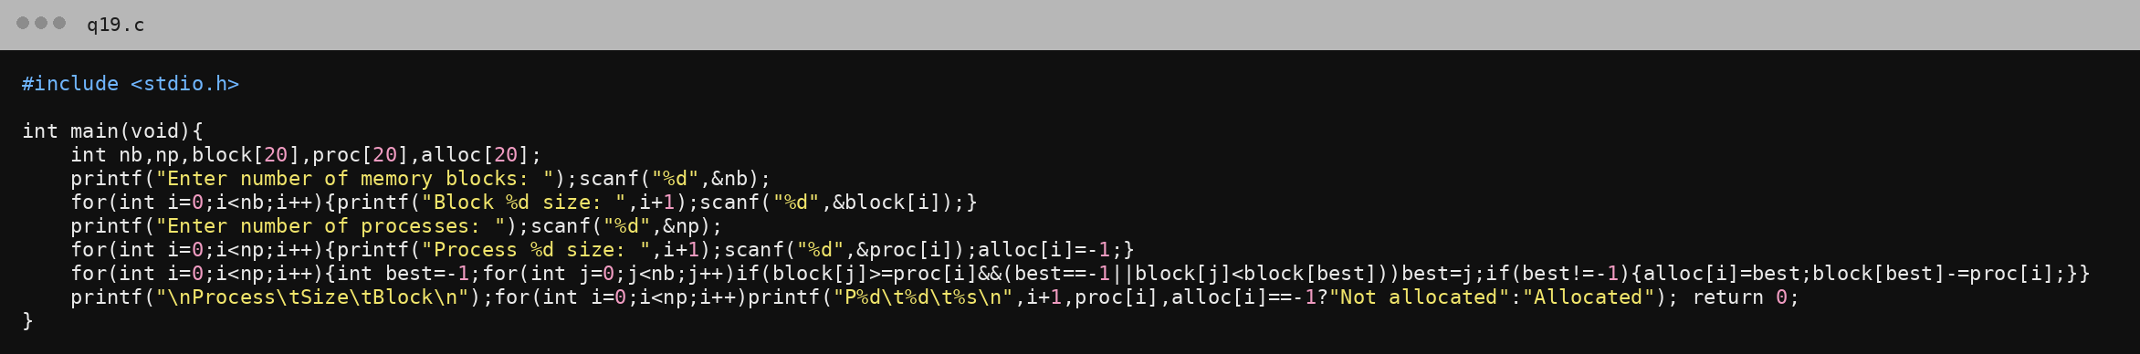
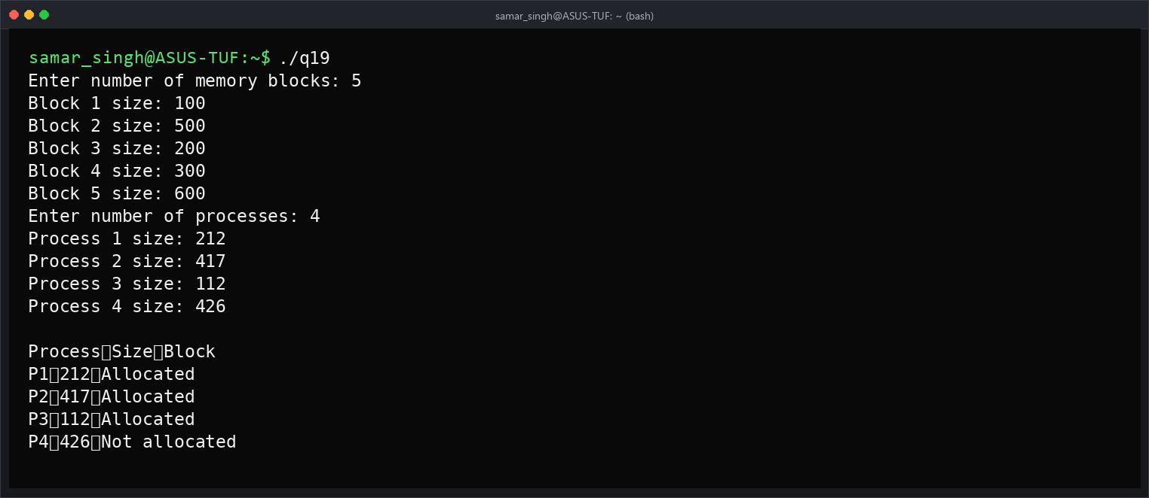

Program No.20
Q20. Simulate the Worst-Fit contiguous memory allocation technique.
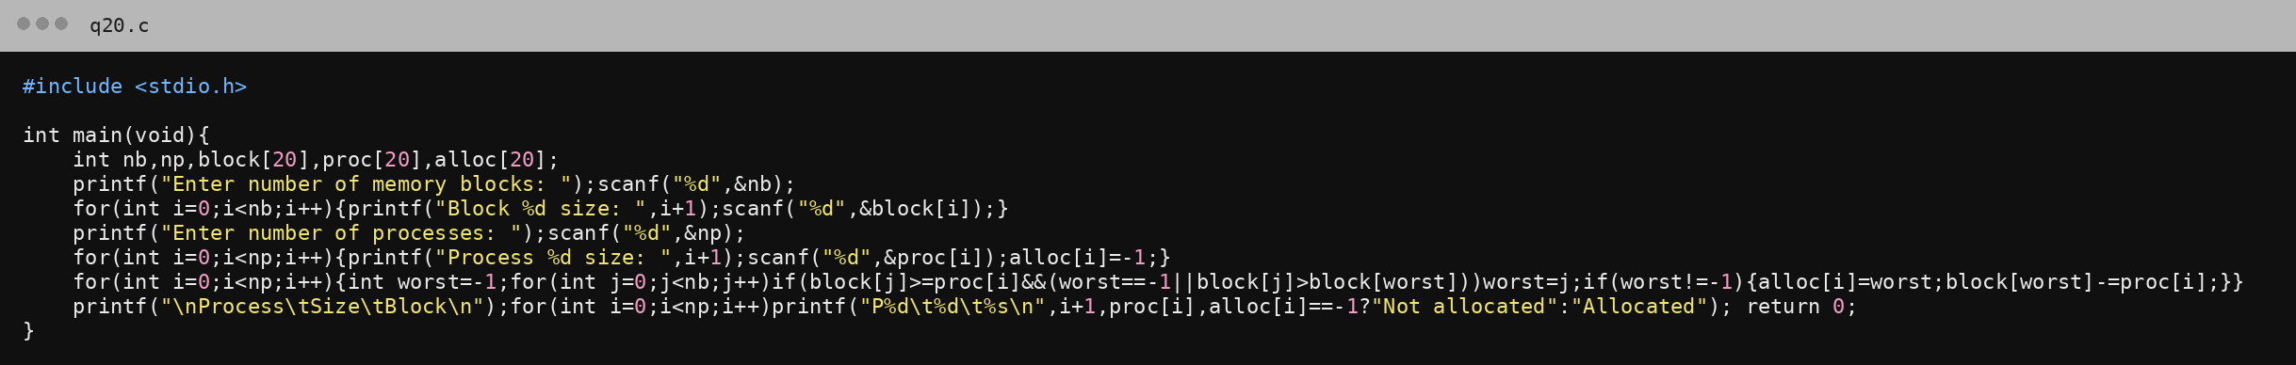
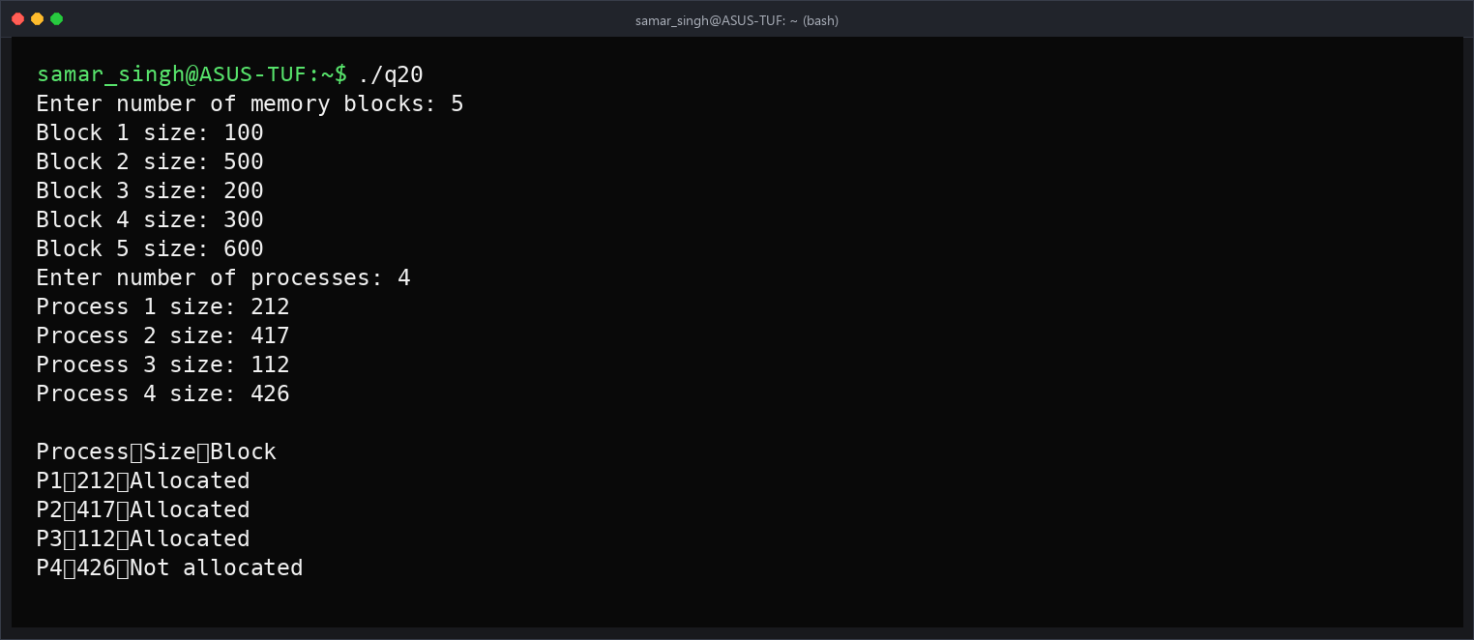

Program No.21
Q21. Implement the Non-contiguous Memory Allocation by using Paging.
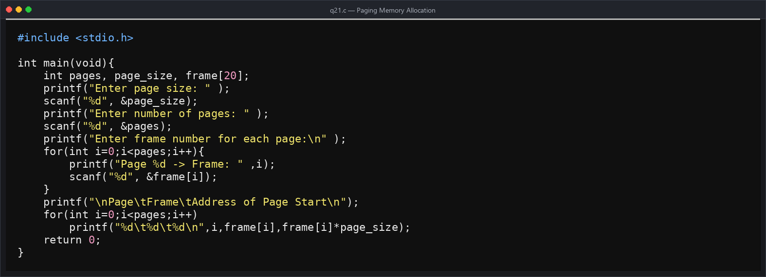
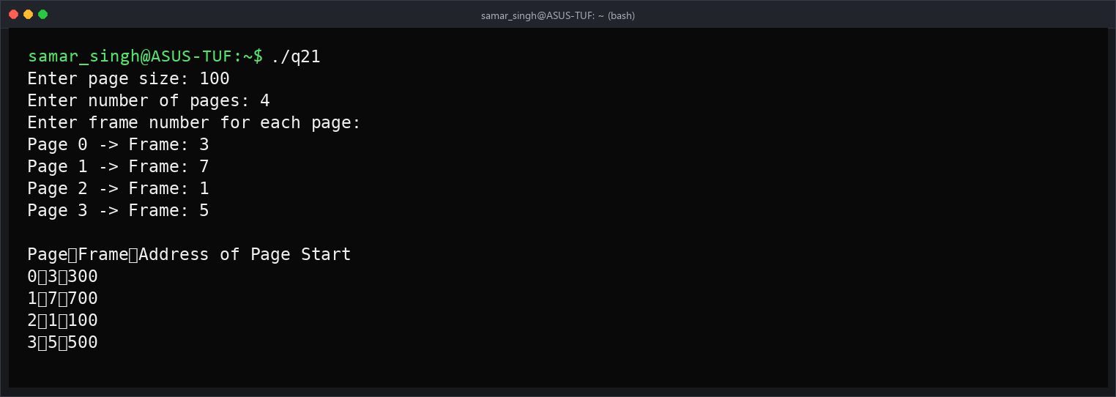

Program No.22
Q22. Implement Contiguous memory variable size partition scheme.
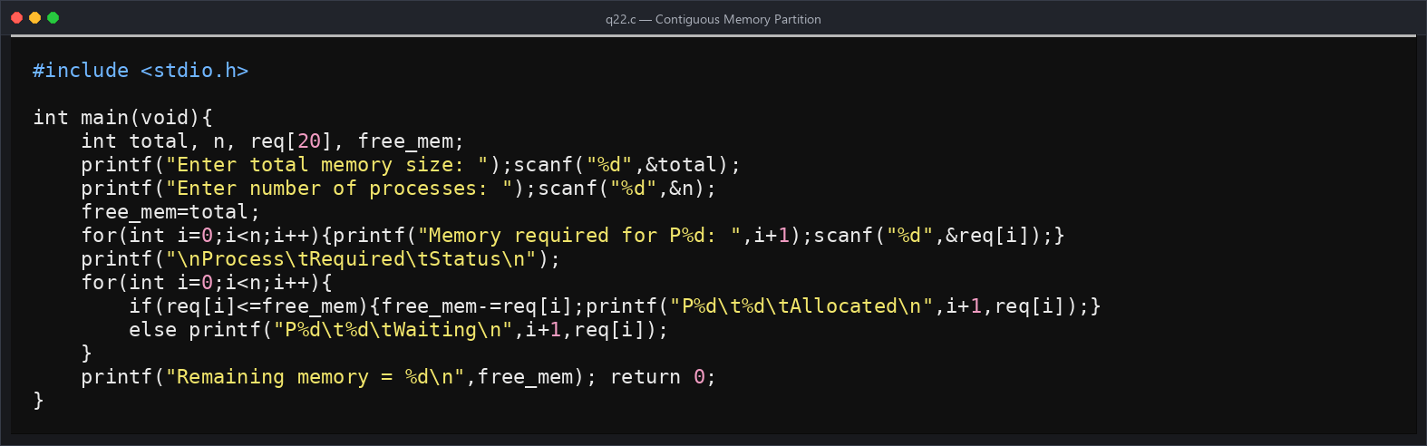
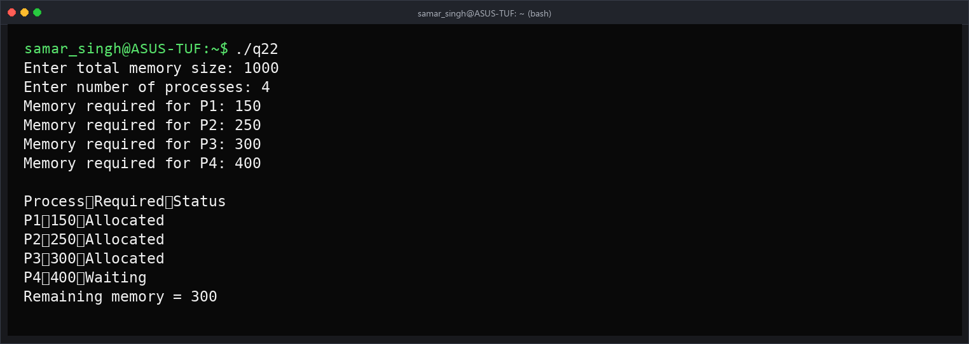

Program No.23
Q23. Write a Program to simulate the FIFO page replacement algorithm.
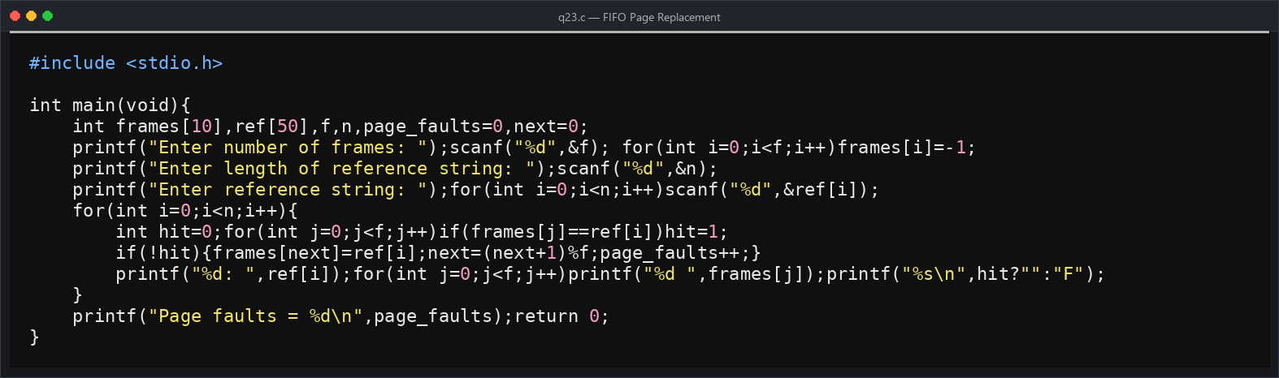
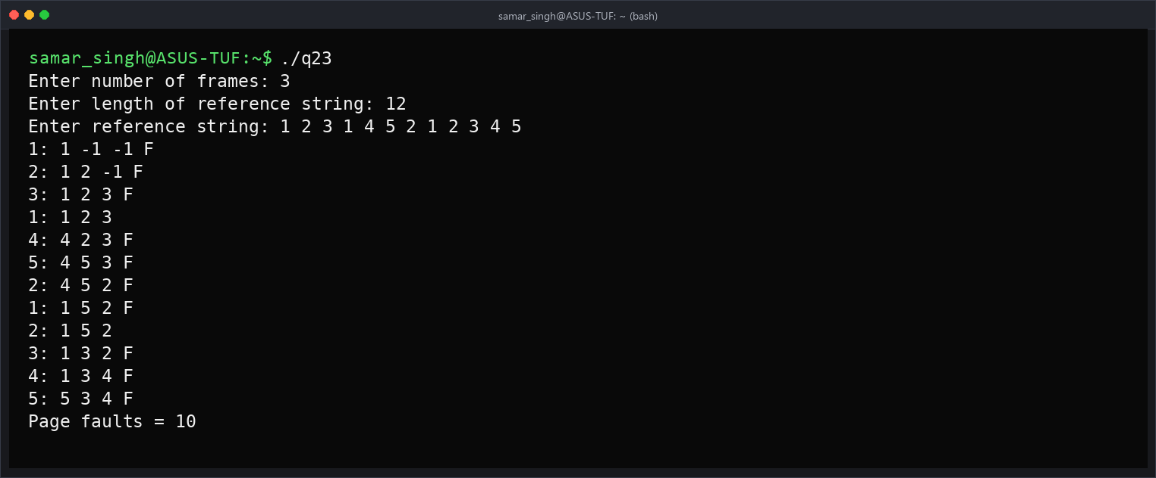

Program No.24
Q24. Write a Program to simulate the LRU page replacement Algorithm.
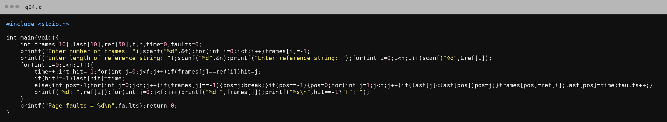
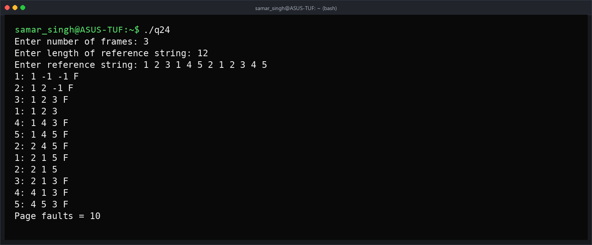

Program No.25
Q25. Write a Program to simulate the Optimal page replacement Algorithm.
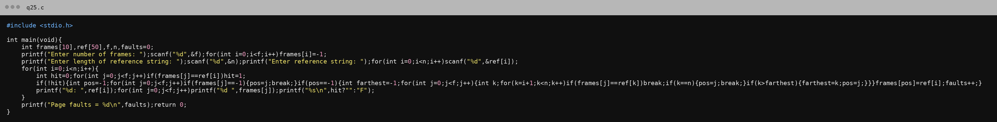
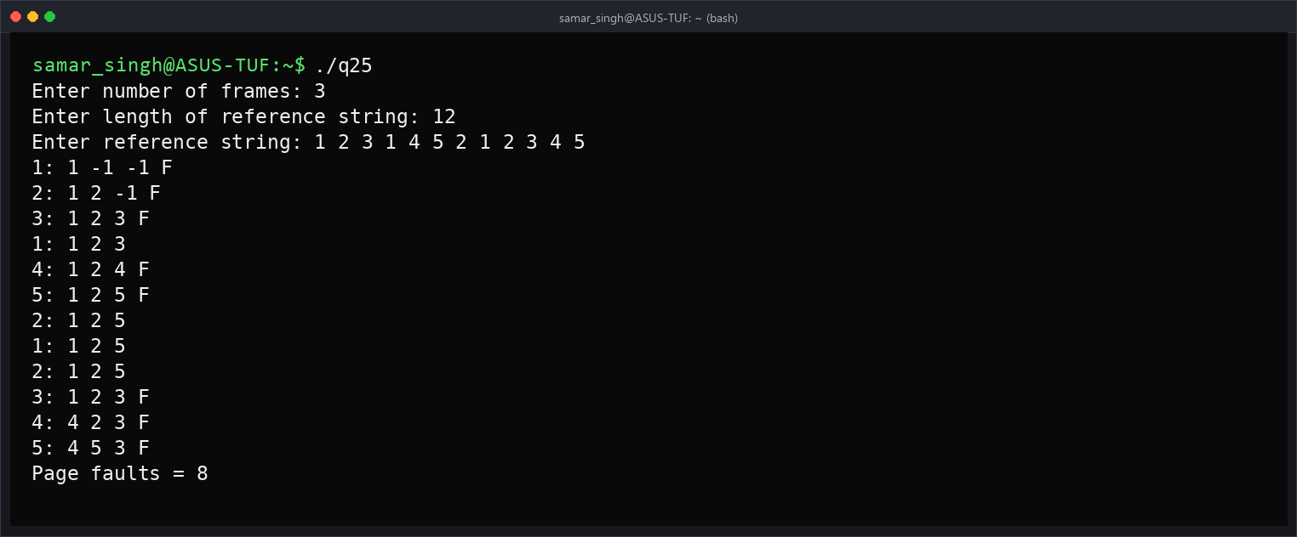

Program No.26
Q26. Write a program to simulate FCFS Disk Scheduling Algorithm.
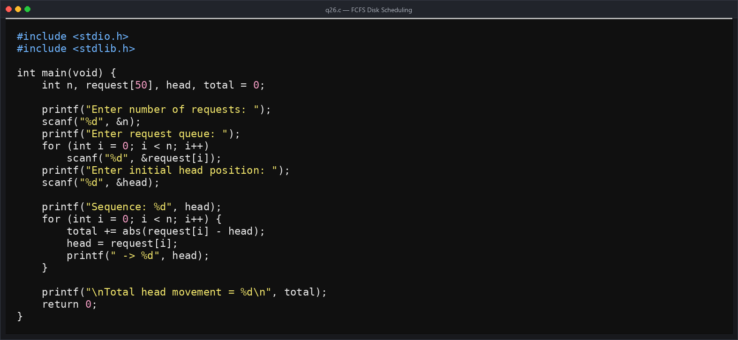
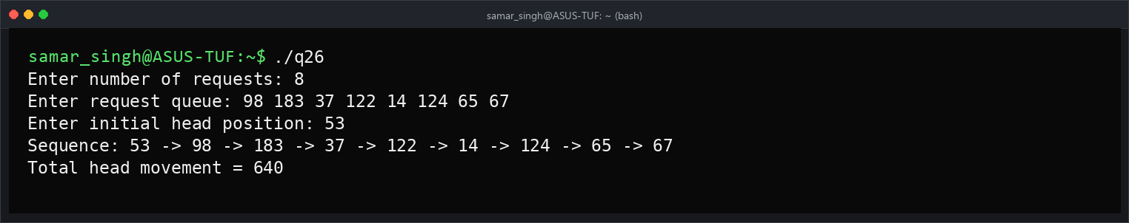

Program No.27
Q27. Write a Program to simulate the SSTF Disk Scheduling Algorithm.
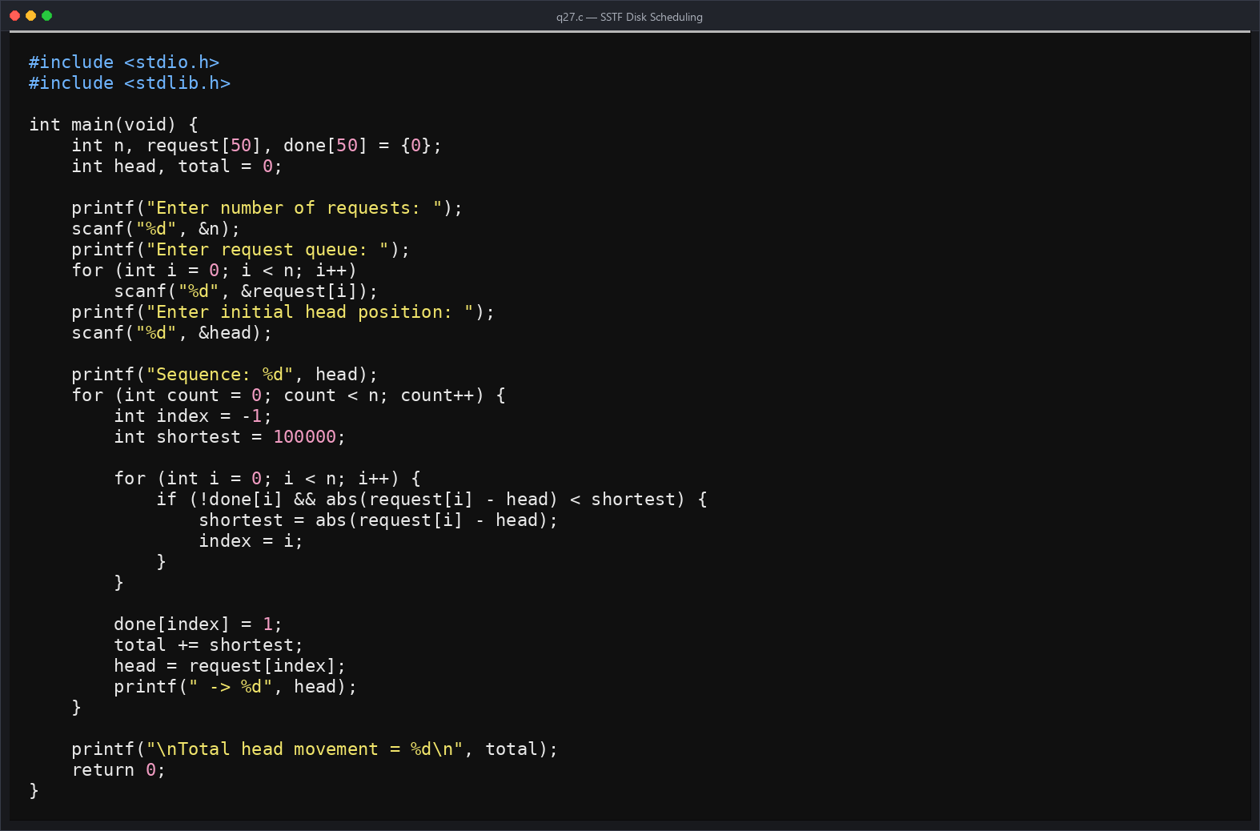
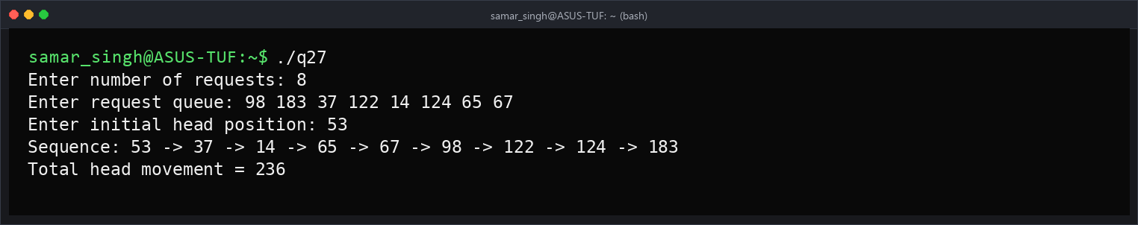

Program No.28
Q28. Write a program to simulate SCAN Disk Scheduling Algorithm.
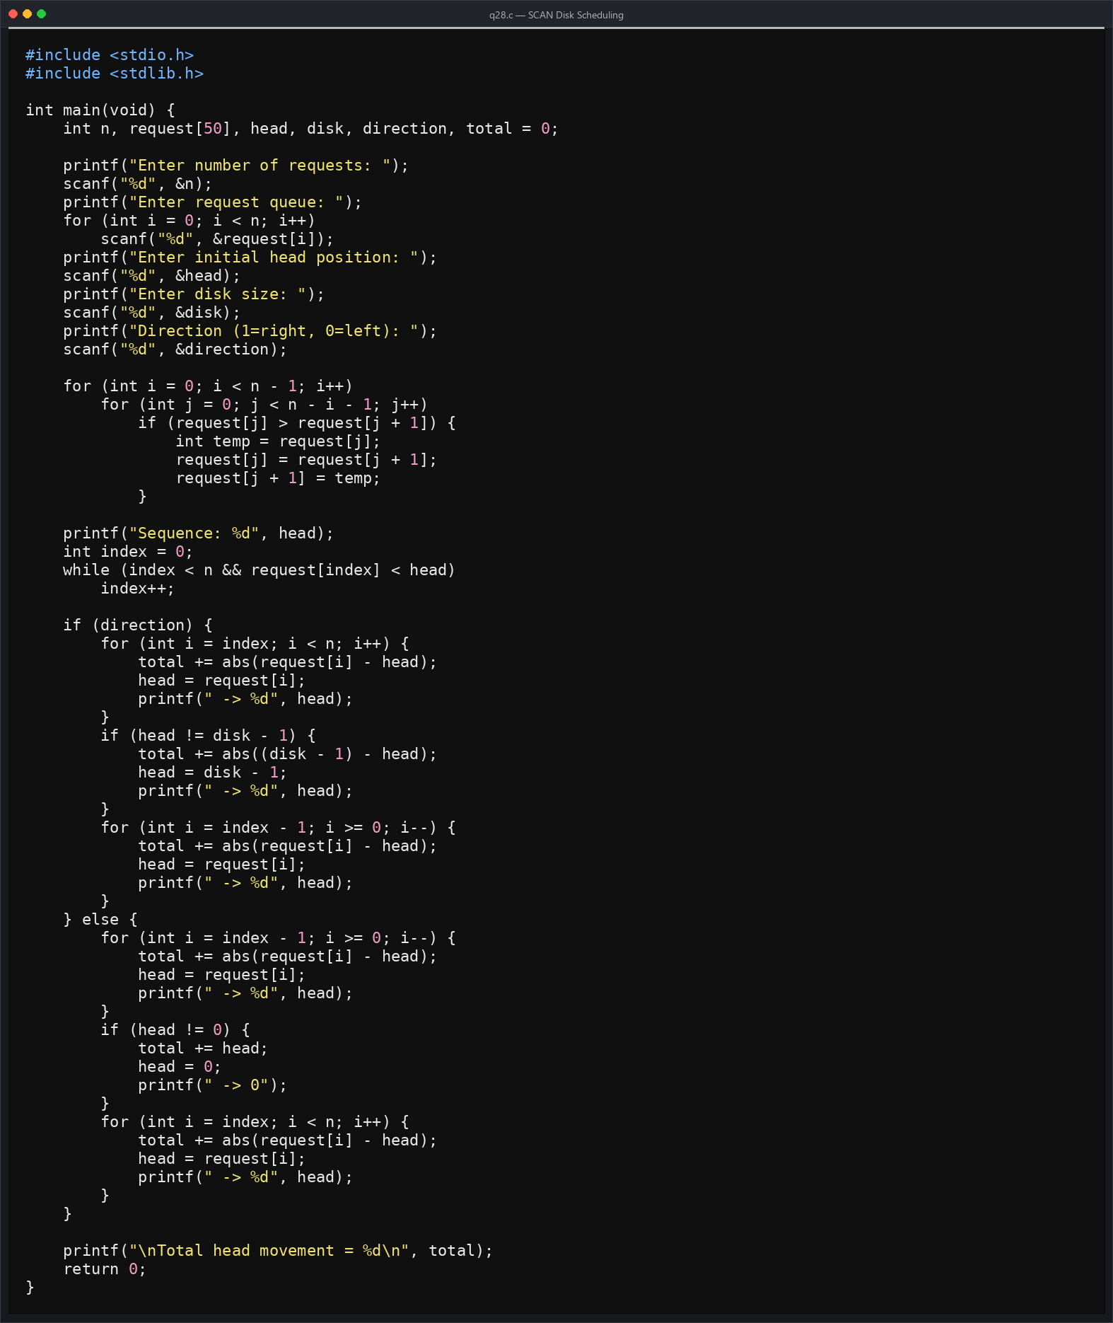
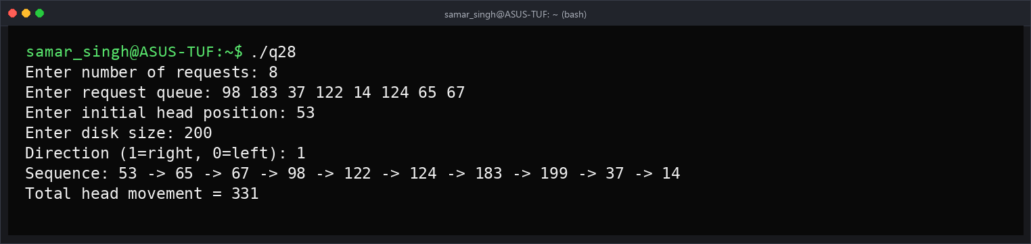

Program No.29
Q29. Write a Program to simulate the C SCAN Disk Scheduling Algorithm.
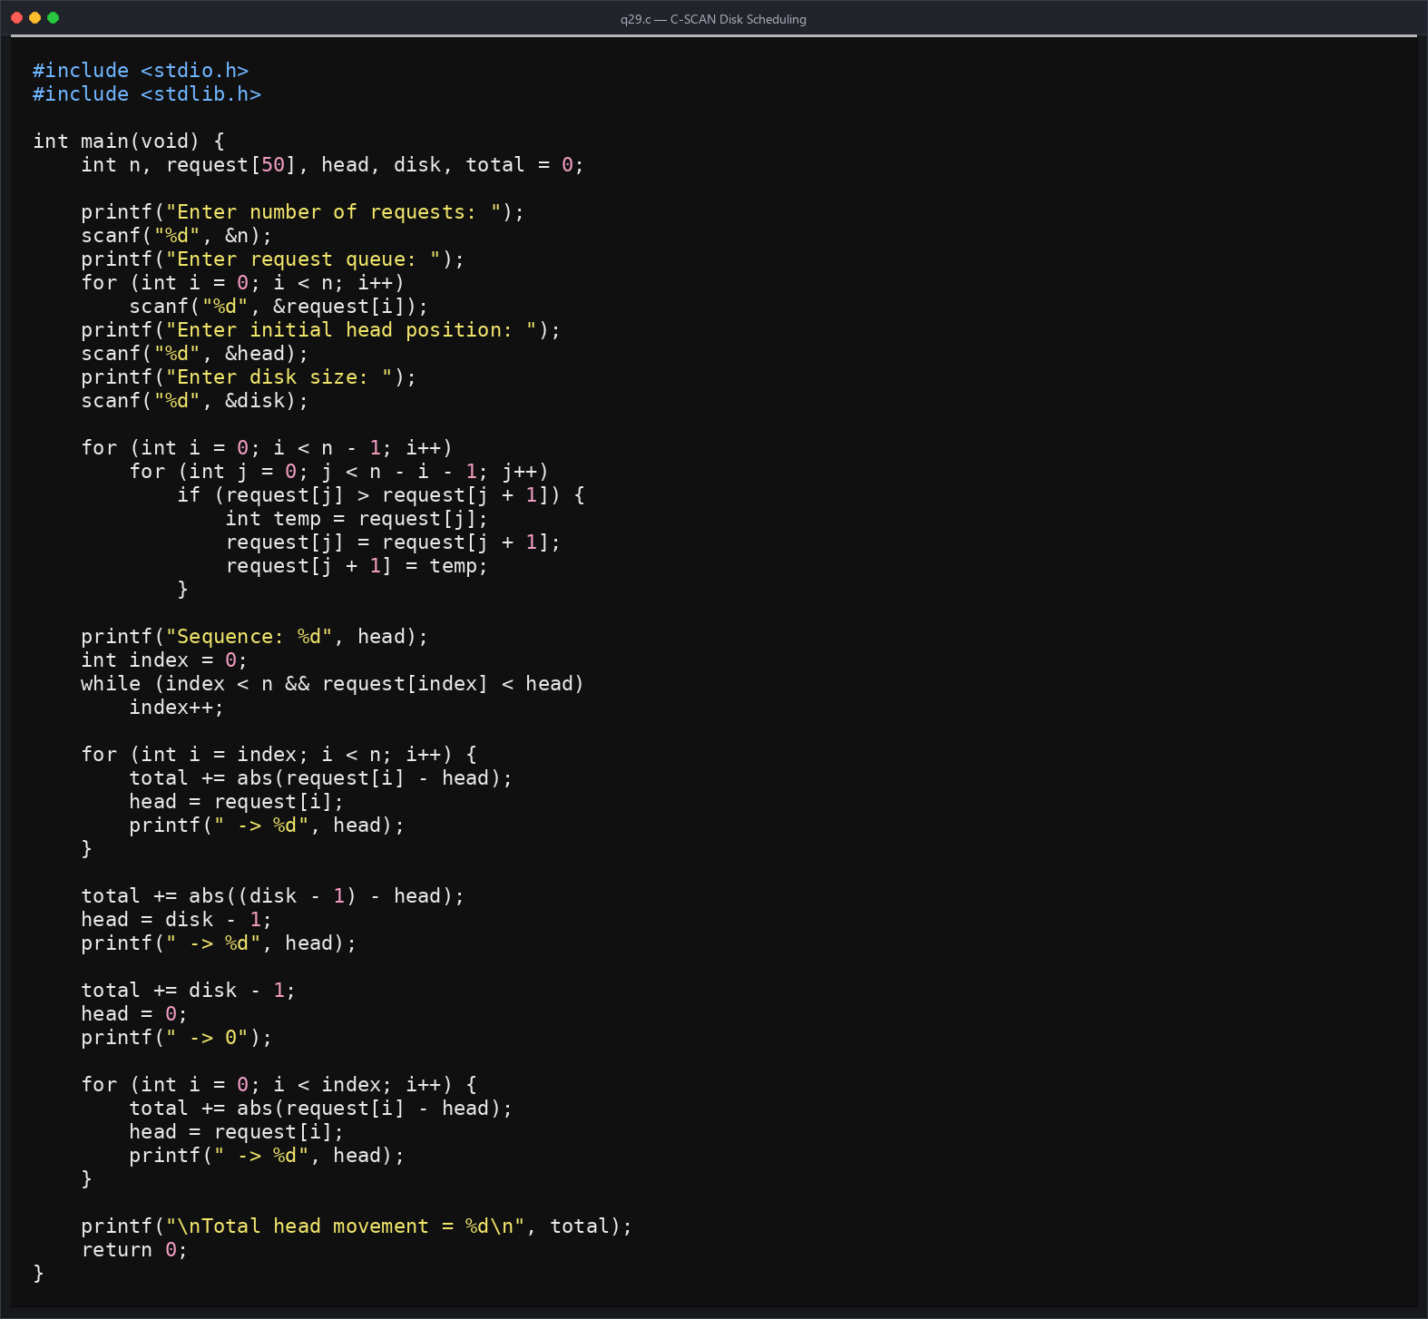
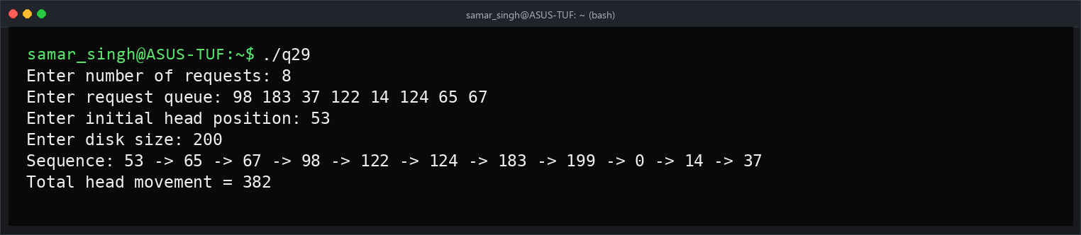

Program No.30
Q30. Write a Program to simulate the LOOK Disk Scheduling Algorithm.
