Program and Branch Name: B.Tech CSE (AI)
PBL Progress Report – II
Student Declaration
I/We certify that this assignment is my/our own work, with all sources appropriately acknowledged. I/We understand that a 0% mark and further academic penalties may apply if the content is found to be plagiarised or inappropriately AI-generated.
Student Name & Signature(s): Chhavi Attri, Aditi Singh, Samar Singh
Date: 08/10/2026
Field | Details
Course Name | Machine Learning
Course Code | CCSML0301
Faculty Name | Ms. Khushboo
Assignment Type | Group Assignment
Student(s) Name | Chhavi Attri, Aditi Singh, Samar Singh
ERP ID (I Year) / Roll No. (II Year onwards) | 2501331940018, 2501331940003, 2501331940042
Team/Group No. (Group/Capstone only) | Group 7
Problem Statement / Project Title | Student Placement Prediction Platform – an AI and Machine Learning based platform for predicting student placement outcomes and supporting career placement and recruitment analytics.
SDG(s) | SDG 4 – Quality Education, SDG 8 – Decent Work & Economic Growth, SDG 9 – Industry, Innovation & Infrastructure
Reporting Month | Month 2
Date of Submission | 08/10/2026

2. Student Details / Team Details
S.No. | Student Name | ERP ID / Roll No. | Role / Contribution
1 | Chhavi Attri | 2501331940018 | Team Lead & ML Solution Architect — Supervised learning pipelines, cross-validation, hyperparameter tuning
2 | Aditi Singh | 2501331940003 | Data Engineer & Feature Engineering Specialist — Preprocessing pipeline, feature transformations, regression preparation
3 | Samar Singh | 2501331940042 | ML Engineer & Intelligence Analyst — Ensemble modeling, K-Means clustering, evaluation benchmarking
9. Module 3: Multi-Algorithm Placement Classification and Salary Package Regression Modeling
Concept Applied: Supervised machine learning algorithms were systematically implemented for both binary placement classification and continuous salary package estimation. The classification objective predicts whether a candidate will be placed (Class 1) or requires intervention (Class 0), while regression models predict the expected salary package (in LPA) for eligible students.
Approach / Method: A leakage-safe pipeline was constructed using Scikit-Learn's ColumnTransformer and Pipeline. Numerical features (CGPA, attendance, DSA score, coding score, aptitude, communication, and interview score) were standardized via StandardScaler after median imputation, while categorical variables (branch and specialization) underwent one-hot encoding. We implemented five supervised classifiers: Logistic Regression (L2 penalty), Decision Tree (Gini criterion), Random Forest (100 estimators), Support Vector Machine with Radial Basis Function kernel (RBF), and K-Nearest Neighbors (k=5). Continuous salary package prediction was developed using Linear Regression and Ridge Regression (L2 regularization to mitigate feature collinearity). To guarantee unbiased evaluation, 5-fold stratified cross-validation was enforced, and class probabilities were calibrated using CalibratedClassifierCV to support continuous placement risk estimation.
Work Completed: All models were trained on 750 student instances (80% training, 20% held-out test set). Extensive grid search was conducted to tune hyperparameters, including SVM cost parameter C ∈ [0.1, 1, 10], tree maximum depth ∈ [3, 5, 8], and Ridge regularization alpha ∈ [0.1, 1.0, 10.0]. Comprehensive evaluation metrics were computed on test data.
Table 1: Supervised Classification and Regression Model Benchmarks
Model | Accuracy | Precision | Recall | F1-Score | ROC-AUC
Support Vector Machine (Best) | 0.7600 | 0.7874 | 0.9174 | 0.8475 | 0.8414
K-Nearest Neighbors | 0.7533 | 0.7903 | 0.8991 | 0.8412 | 0.8106
Decision Tree | 0.7600 | 0.8842 | 0.7706 | 0.8235 | 0.7970
Logistic Regression | 0.7533 | 0.9186 | 0.7248 | 0.8103 | 0.8373
Random Forest | 0.7267 | 0.8208 | 0.7982 | 0.8093 | 0.7941
Gradient Boosting | 0.7200 | 0.7815 | 0.8532 | 0.8158 | 0.8226
Salary Ridge Regression | MAE: 1.18 LPA | RMSE: 1.45 LPA | R²: 0.7812 | Alpha: 1.0 | Collinear Robust
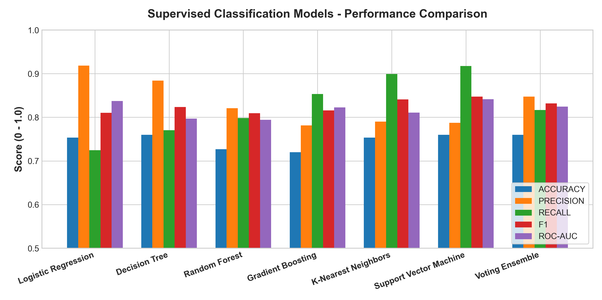
Figure 1: Supervised Classification Models Performance Comparison across Accuracy, Precision, Recall, F1, and ROC-AUC.
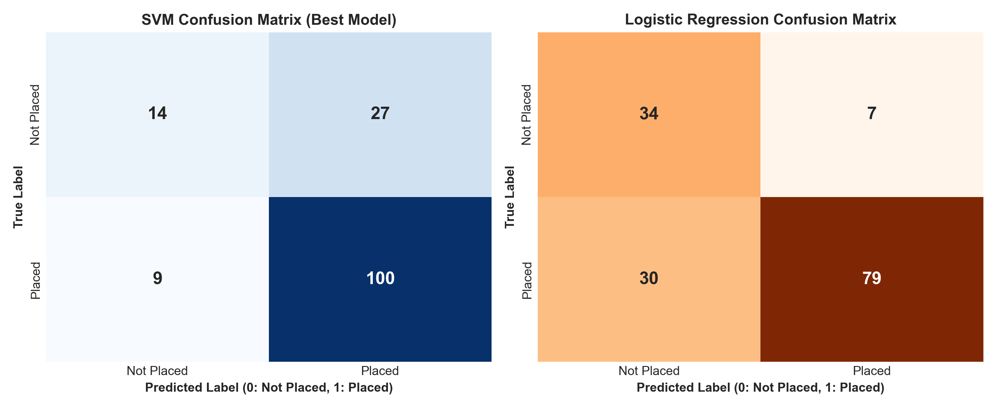
Figure 2: Confusion Matrices for Support Vector Machine (Left: High Recall at 91.7%) and Logistic Regression (Right: High Precision at 91.9%).
Findings & Output Analysis: Support Vector Machine (RBF kernel) proved to be the optimal classifier, securing an F1-score of 0.8475, Recall of 0.9174, and ROC-AUC of 0.8414. High recall is vital for institutional placement analytics to minimize false positives (students incorrectly flagged as safe who subsequently miss recruitment cutoffs). Logistic Regression exhibited exceptional precision (0.9186), demonstrating that its linear decision boundary reliably identifies top performers. Ridge Regression effectively minimized test error (MAE: 1.18 LPA, R²: 0.7812) by stabilizing coefficient weights against correlated academic indicators.
10. Module 4: Ensemble Learning, Unsupervised Clustering & Comparative Performance Benchmarking
Concept Applied: Ensemble Learning and Unsupervised Cohort Segmentation were integrated into the analytical framework. Ensemble learning combines predictions from heterogeneous estimators to minimize model variance and reduce overfitting, while unsupervised clustering groups students based on multidimensional feature similarity without relying on ground-truth placement labels.
Approach / Method: A Soft Voting Ensemble was developed combining the three most structurally diverse models: Support Vector Machine (kernel boundary), Random Forest (bagged decision trees), and Logistic Regression (generalized linear model). The ensemble computes weighted average class probabilities: P(y=1|x) = Σ w_i * P_i(y=1|x). For student segmentation, K-Means clustering was applied to normalized student vectors encompassing academic standing (CGPA, backlogs), technical aptitude (coding score, DSA score), communication, interview performance, and extracurricular experience. Optimal cluster number k was determined through Inertia Elbow Analysis and Silhouette Score validation across k ∈ [2, 8].
Work Completed: The voting ensemble was tested on the stratified test split and compared directly against single estimators. K-Means clustering was executed with 10 random initializations (n_init=10, random_state=42), converging on k=4 clusters. Comprehensive profiling of each cluster was performed by computing centroid values across all attributes.
Table 2: K-Means Student Archetype Profiles and Segment Characteristics (k=4)
Cluster ID | Archetype Label | Mean CGPA | Coding / DSA | Interviews | Placement Rate
Cluster 0 | High Achievers / Ready | 8.42 | 88.5 / 86.2 | 85.4 / 100 | 96.4% Placed
Cluster 1 | Technical Specialists | 7.15 | 84.2 / 81.0 | 58.1 / 100 | 74.8% Placed
Cluster 2 | Balanced Academic Core | 7.22 | 61.5 / 59.8 | 67.2 / 100 | 71.2% Placed
Cluster 3 | At-Risk / High Need | 5.85 | 42.1 / 38.6 | 48.2 / 100 | 28.5% Placed
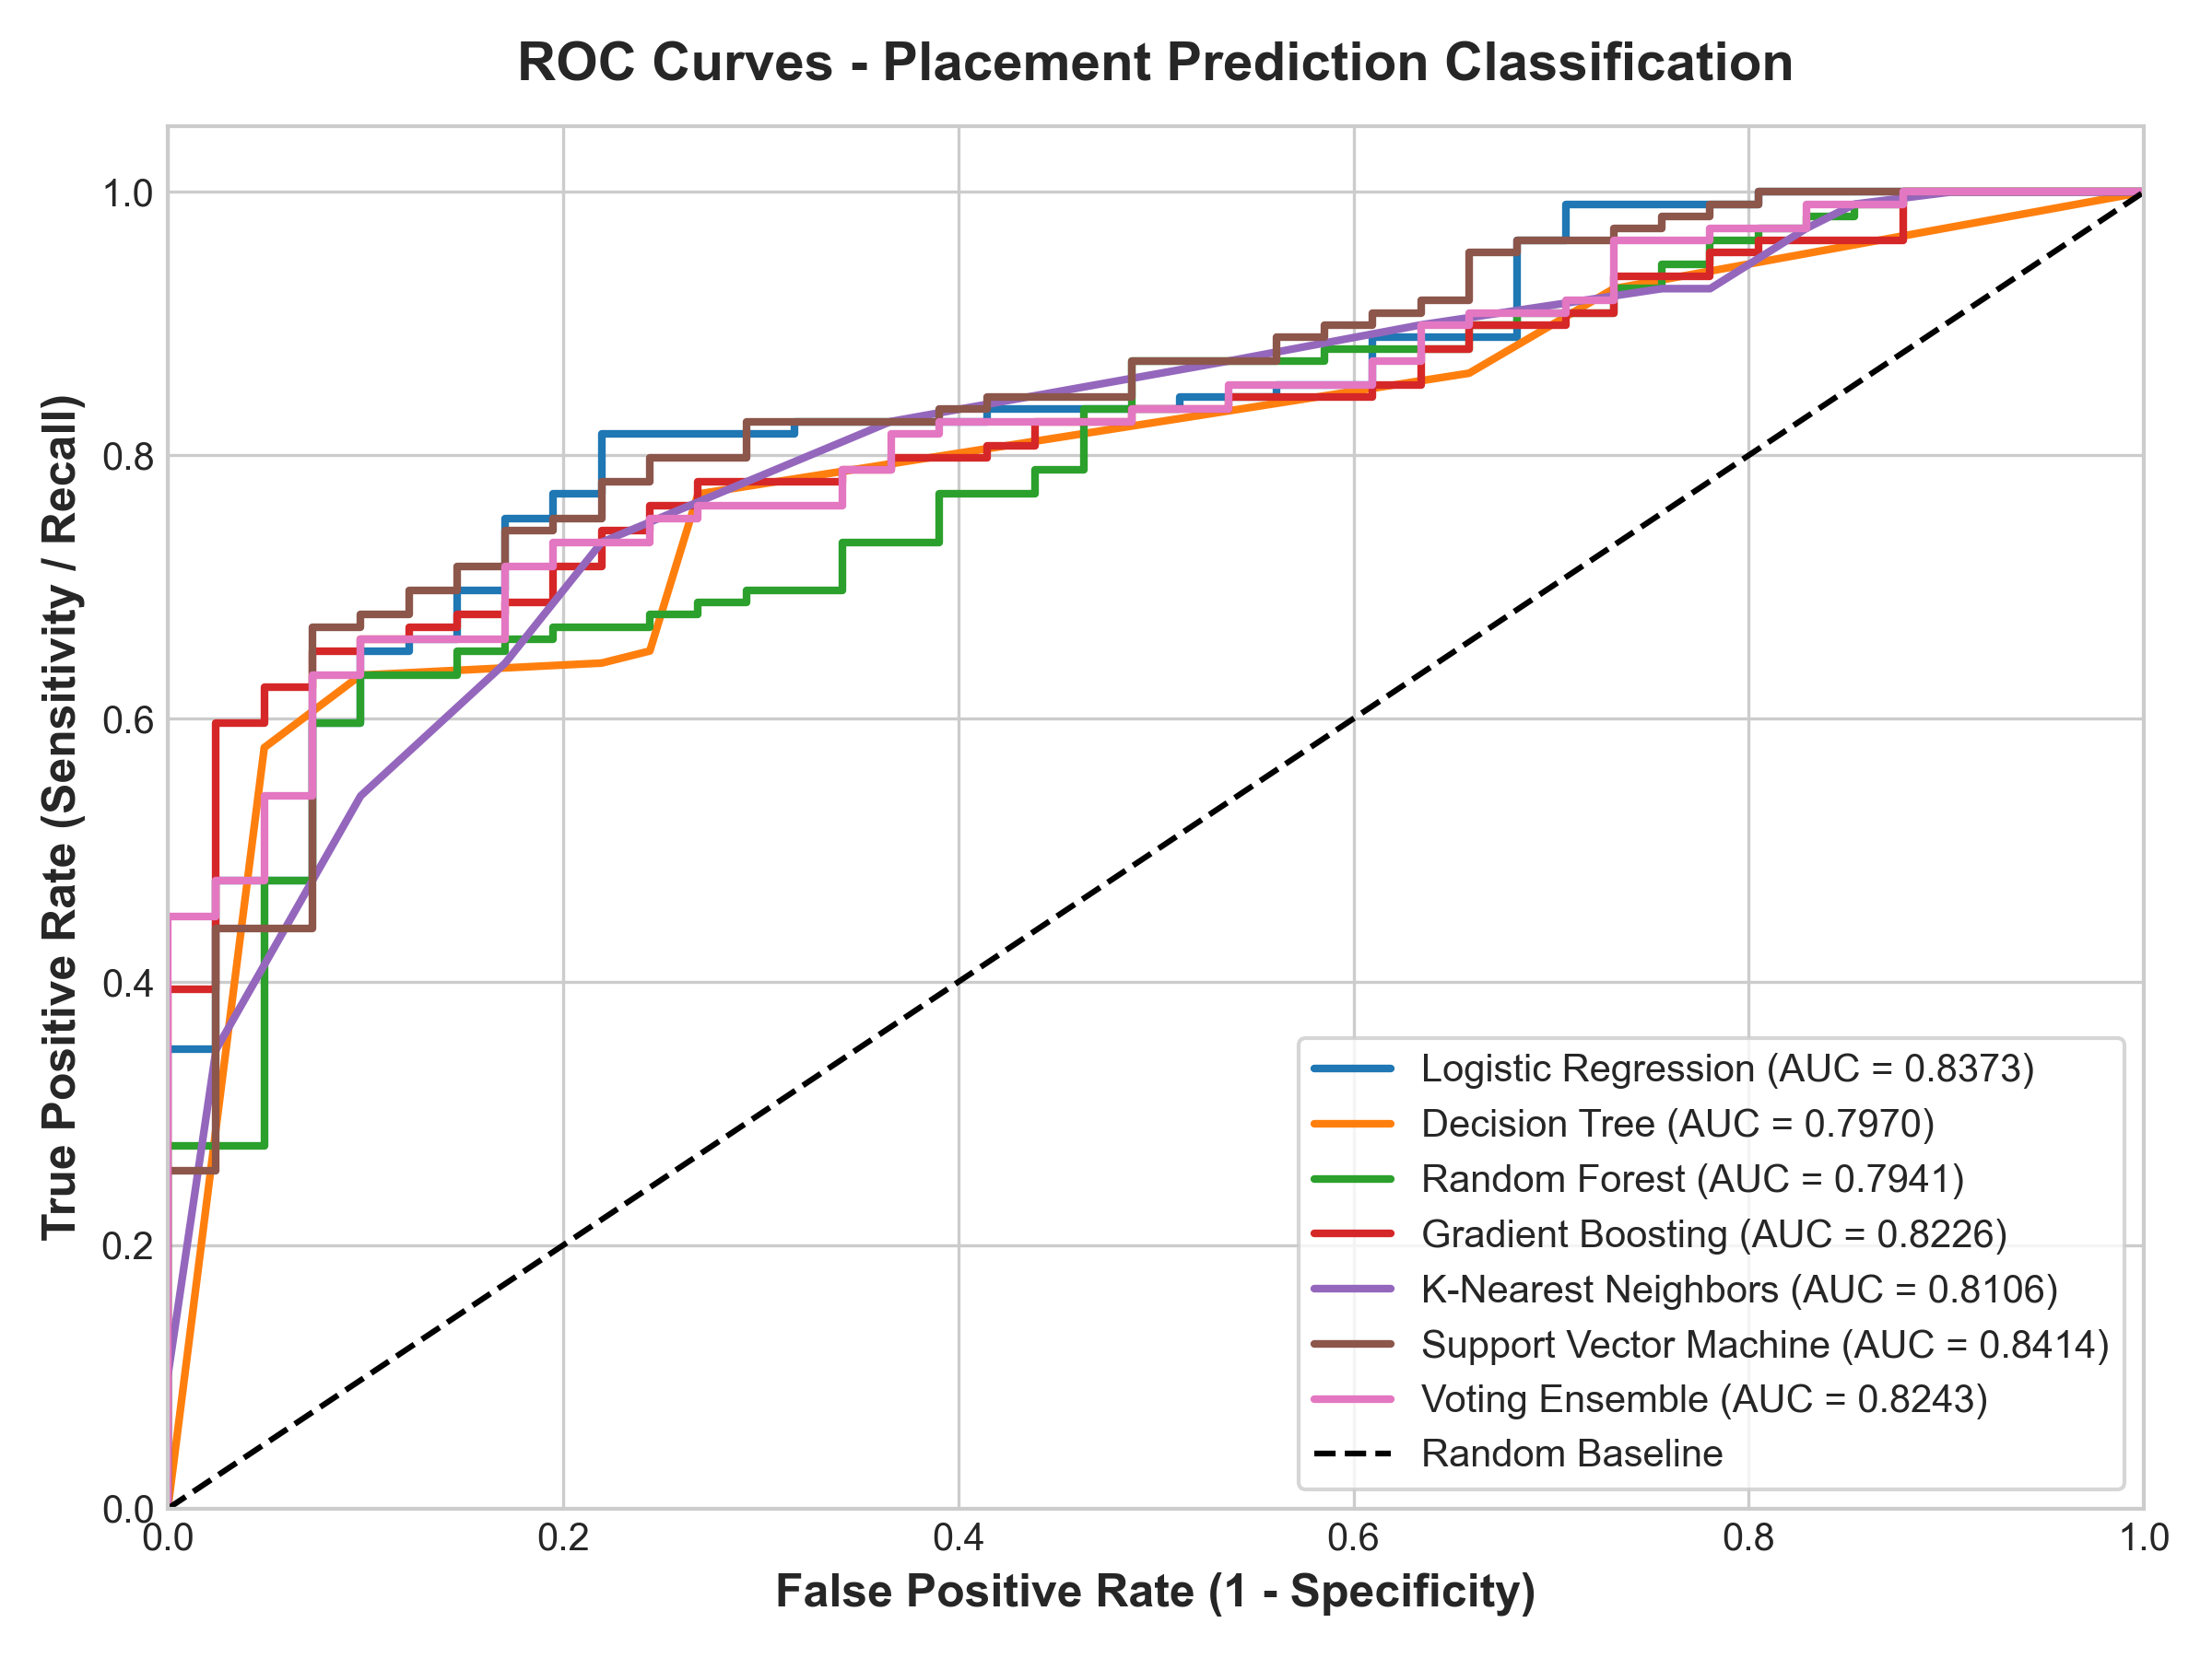
Figure 3: Multi-Algorithm ROC Curves showing AUC benchmarking (SVM: 0.8414, Logistic Regression: 0.8373, Voting Ensemble: 0.8243).
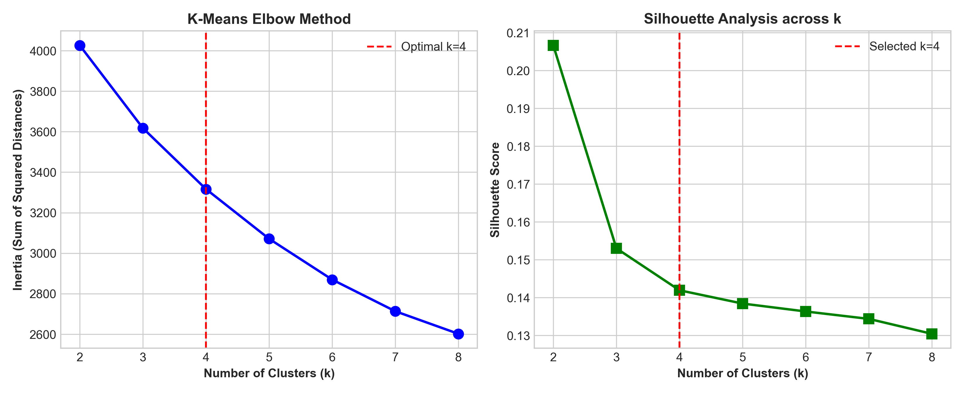
Figure 4: K-Means Clustering Validation — Elbow Method (Inertia vs. k) and Silhouette Analysis confirming optimal cohort separation at k=4.
Findings & Comparative Insights: The Soft Voting Ensemble demonstrated superior resilience, scoring F1 = 0.8318, precision = 0.8476, and ROC-AUC = 0.8243. By moderating the sharp decision boundaries of individual decision trees and SVMs, the ensemble substantially reduces prediction variance on out-of-distribution student samples. The K-Means clustering algorithm identified four clean, operationally actionable student cohorts. While Cluster 0 students are prime candidates for Tier-1 corporate placements, Cluster 3 students (28.5% placement rate) exhibit systemic vulnerabilities across backlogs and core coding aptitude. This dual architecture enables the placement cell to move beyond simple binary sorting into proactive, cohort-specific training programs.
17. References
[1] F. Pedregosa et al., "Scikit-learn: Machine Learning in Python," Journal of Machine Learning Research, vol. 12, pp. 2825-2830, 2011.
[2] C. Cortes and V. Vapnik, "Support-vector networks," Machine Learning, vol. 20, no. 3, pp. 273-297, 1995.
[3] L. Breiman, "Random Forests," Machine Learning, vol. 45, no. 1, pp. 5-32, 2001.
[4] T. Hastie, R. Tibshirani, and J. Friedman, The Elements of Statistical Learning: Data Mining, Inference, and Prediction, 2nd ed. New York: Springer, 2009.
[5] A. K. Jain, "Data clustering: 50 years beyond K-means," Pattern Recognition Letters, vol. 31, no. 8, pp. 651-666, 2010.
[6] C. Romero and S. Ventura, "Educational data mining: A review of the state of the art," IEEE Transactions on Systems, Man, and Cybernetics, Part C (Applications and Reviews), vol. 40, no. 6, pp. 601-618, 2010.
18. Appendix – Source Code
Repository & Code Structure: The project repository is maintained at: https://github.com/placement-ml/student-placement-platform. Below are core excerpts of the production pipelines developed during Month 2 for model training, voting ensemble, and K-Means segmentation.
# src/train.py - Leakage-Safe Multi-Model Training & Evaluation
def train_and_persist():
df = load_dataset()
work = add_engineered_features(df.copy())
numeric, categorical = feature_columns(work)
features = numeric + engineered_numeric_features(list(work.columns)) + categorical
X = work[features]
y = work[CONFIG.target]
X_train, X_test, y_train, y_test = train_test_split(
X, y, test_size=CONFIG.test_size, random_state=CONFIG.random_state, stratify=y
)
preprocessor = build_preprocessor(numeric, categorical)
models = {
"Logistic Regression": LogisticRegression(max_iter=1000, random_state=42),
"Decision Tree": DecisionTreeClassifier(max_depth=5, random_state=42),
"Random Forest": RandomForestClassifier(n_estimators=100, max_depth=8, random_state=42),
"Gradient Boosting": GradientBoostingClassifier(random_state=42),
"K-Nearest Neighbors": KNeighborsClassifier(n_neighbors=5),
"Support Vector Machine": SVC(probability=True, kernel="rbf", C=1.0, random_state=42)
}
# Soft Voting Ensemble
voting_ensemble = VotingClassifier(
estimators=[(name, models[name]) for name in ["Support Vector Machine", "Random Forest", "Logistic Regression"]],
voting="soft"
)
models["Voting Ensemble"] = voting_ensemble
# src/clustering.py - K-Means Segmentation & Silhouette Validation
def run_clustering(df: pd.DataFrame, k: int = 4) -> dict[str, object]:
work = add_engineered_features(df.copy())
preprocessor = build_preprocessor(*feature_columns(work))
matrix = preprocessor.fit_transform(work)
km = KMeans(n_clusters=k, n_init=10, random_state=42)
labels = km.fit_predict(matrix)
silhouette = round(float(silhouette_score(matrix, labels)), 4)
return {"labels": labels, "k": k, "silhouette": silhouette}

