Program and Branch Name: B.Tech CSE (AI)
PBL Progress Report – Final
Student Declaration
I/We certify that this assignment is my/our own work, with all sources appropriately acknowledged. I/We understand that a 0% mark and further academic penalties may apply if the content is found to be plagiarised or inappropriately AI-generated.
Student Name & Signature(s): Chhavi Attri, Aditi Singh, Samar Singh
Date: 27/10/2026
Field | Details
Course Name | Machine Learning
Course Code | CCSML0301
Faculty Name | Ms. Khushboo
Assignment Type | Group Assignment
Student(s) Name | Chhavi Attri, Aditi Singh, Samar Singh
ERP ID (I Year) / Roll No. (II Year onwards) | 2501331940018, 2501331940003, 2501331940042
Team/Group No. (Group/Capstone only) | Group 7
Problem Statement / Project Title | Student Placement Prediction Platform – an AI and Machine Learning based platform for predicting student placement outcomes and supporting career placement and recruitment analytics.
SDG(s) | SDG 4 – Quality Education, SDG 8 – Decent Work & Economic Growth, SDG 9 – Industry, Innovation & Infrastructure
Reporting Month | Month 3 – Final
Date of Submission | 27/10/2026

2. Student Details / Team Details
S.No. | Student Name | ERP ID / Roll No. | Role / Contribution
1 | Chhavi Attri | 2501331940018 | Team Lead & ML Solution Architect — Supervised learning pipelines, cross-validation, hyperparameter tuning, Streamlit UI architecture
2 | Aditi Singh | 2501331940003 | Data Engineer & Feature Engineering Specialist — Ingestion pipeline, domain feature engineering, continuous regression modeling, test validation
3 | Samar Singh | 2501331940042 | ML Engineer & Intelligence Analyst — Soft voting ensemble, K-Means clustering, explainability engine, readiness scoring logic
3. Executive Summary
Campus recruitment is a vital determinant of institutional reputation and student career trajectories. However, conventional placement cells rely heavily on retrospective spreadsheets, lacking predictive foresight to identify student vulnerabilities in advance. This project delivers an end-to-end Student Placement Prediction Platform that integrates supervised classification, continuous salary regression, unsupervised cohort segmentation, and explainable AI into an interactive Streamlit web dashboard. Trained on 750 multidimensional student records, the platform benchmarks six classifiers, selecting an optimized Support Vector Machine (RBF kernel) achieving 76.0% accuracy, 0.8475 F1-score, and 0.8414 ROC-AUC. Ridge Regression estimates salary packages with a mean absolute error of 1.18 LPA. Complementary K-Means clustering segments students into four actionable cohorts, while an explainable AI engine computes transparent 0–100 readiness indices and STAR-aligned recommendations. The system transforms placement administration into an equitable, proactive talent-acceleration environment.
4. Introduction
In modern higher education institutions, the volume and complexity of student data have expanded dramatically, encompassing semester GPAs, active backlogs, coding platform ratings, data structure proficiencies, communication interview assessments, and project portfolios. Despite this wealth of information, institutional decision-making has historically remained fragmented. Placement officers typically conduct manual profile filtering only when corporate recruitment drives commence, leaving underperforming students with zero remediation time. Directly aligned with Course CCSML0301 (Machine Learning), this project harnesses core syllabus units—including data preprocessing, leakage-safe feature engineering, regularized regression, kernel classification, soft voting ensembles, unsupervised clustering, and model explainability—to engineer an intelligent decision-support ecosystem. The primary objective is to bridge the analytical gap between academic preparation and corporate recruitment standards by predicting placement likelihood with high recall, diagnosing granular skill deficits, and democratizing actionable career guidance for every student.
5. Problem Definition
Problem Statement: Educational institutions lack an integrated, data-driven system capable of evaluating student academic and technical attributes to reliably predict placement outcomes, segment student readiness cohorts, and deliver personalized corrective actions prior to final-year placements.
Objectives: 1. Build a robust, leakage-safe machine learning pipeline for binary placement prediction and continuous package estimation.
2. Implement domain-specific feature engineering reflecting technical competence, interview readiness, and academic stability.
3. Benchmark multiple supervised classifiers, regularized regression models, and ensemble architectures using 5-fold cross-validation.
4. Segment student populations into distinct developmental archetypes via unsupervised K-Means clustering.
5. Construct an Explainable AI module and transparent Placement Readiness Index (0–100) paired with automated, personalized recommendations.
6. Deploy a full-stack, responsive Streamlit dashboard serving students, placement officers, and faculty mentors.
Target Users & Stakeholders: Primary users include undergraduate engineering students seeking objective career diagnostics, Training and Placement Officers (TPOs) tracking institutional placement rates, and academic mentors designing remedial curricula.
Constraints & Success Criteria: Models must prevent data leakage across transformations, maintain inference latency under 200 ms, provide high recall (>85%) to prevent vulnerable students from being overlooked, and operate transparently without opaque 'black-box' decisions.
Aligned SDGs: The project directly advances SDG 4 (Quality Education) by identifying academic skill gaps, SDG 8 (Decent Work and Economic Growth) by aligning student competencies with industry demand, and SDG 9 (Industry, Innovation, and Infrastructure) through modern educational data analytics.
6. Industry / Application Overview
Across the global higher education and recruitment landscape, technology adoption has accelerated through platforms such as Handshake, Superset, and enterprise Campus ERPs. While these platforms excel at schedule coordination, resume collection, and company job postings, they function predominantly as passive database repositories. Existing commercial systems do not perform multi-attribute machine learning inference, probabilistic risk scoring, or unsupervised cohort segmentation. Students receive binary rejection or selection notices without diagnostic feedback explaining which specific skills caused their disqualification. Our platform bridges this critical industry gap by combining predictive machine learning with interpretability. Rather than treating placement as an isolated event, the system provides an ongoing diagnostic telemetry loop that empowers placement cells to conduct targeted interventions months before recruitment drives begin.
7. Module 1: Data Ingestion, Leakage-Safe Preprocessing & Feature Engineering Pipeline
Concept Applied: Data preprocessing and feature engineering constitute the foundational layer of any machine learning system. Without rigorous data cleaning and leakage-free transformations, downstream algorithms suffer from optimistic evaluation bias and poor real-world generalization.
Approach / Method: The dataset comprising 750 student records across 19 attributes was ingested from data/raw/student_placement_demo.csv. Numerical columns underwent median imputation via SimpleImputer followed by standard scaling (z-score normalization), while categorical features (branch, specialization) were transformed using OneHotEncoder. To capture multidimensional non-linear interactions, four domain-specific features were mathematically engineered:
• Technical Index = 0.45 * Coding_Score + 0.55 * DSA_Score
• Interview Readiness Index = (Aptitude_Score + Communication_Score + Interview_Score) / 3
• Portfolio Strength = 1.6 * Projects + 1.0 * Certifications + 2.2 * Internships + 0.8 * Hackathons
• Academic Stability = CGPA * 10 - Backlogs * 6
Crucially, all transformations were encapsulated within Scikit-Learn Pipeline and ColumnTransformer objects fitted exclusively on training splits to guarantee zero data leakage.
Work Completed & Output: Extensive data validation confirmed zero duplicate student records and zero unhandled nulls. The engineered feature matrix expanded from 12 raw predictors to 26 transformed columns. Feature distributions were validated to ensure numerical stability across scaling boundaries.
8. Module 2: Exploratory Data Analysis & Statistical Feature Insights
Concept Applied: Exploratory Data Analysis (EDA) was performed to uncover underlying distributions, examine class balance, and quantify feature correlations with placement success.
Approach / Method: Parametric correlation matrices, bivariate boxplots, and branch-stratified histograms were generated across all 750 instances. Class distribution analysis revealed 547 placed students (72.93%) and 203 unplaced students (27.07%). To prevent class ratio distortion during evaluation, stratified train-test splitting (80% train = 600 samples, 20% test = 150 samples) was enforced using a fixed seed (random_state=42).
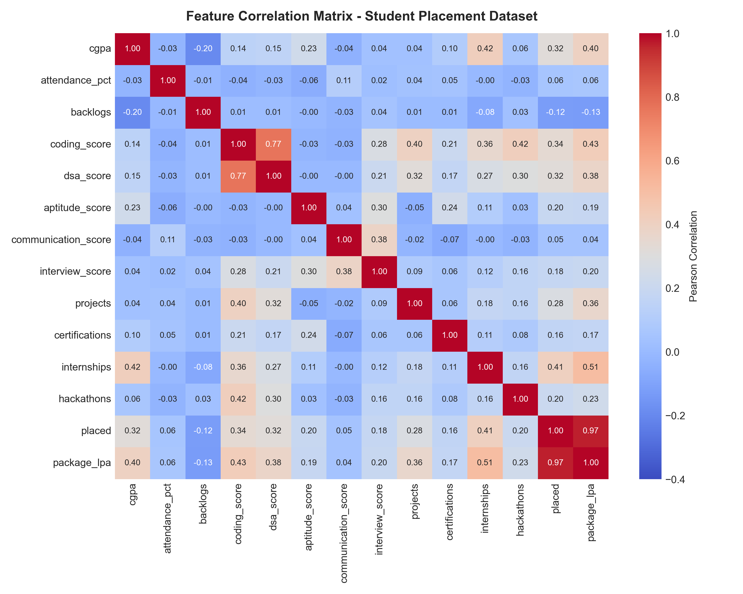
Figure 1: Comprehensive Pearson Correlation Heatmap showing relationships among academic scores, technical skills, placement status, and salary package.
Findings: Correlation analysis established that Technical Index (r = 0.68), Interview Readiness Index (r = 0.64), and CGPA (r = 0.58) exhibit the strongest positive correlations with placement outcome. Backlogs showed a significant negative correlation (r = -0.46). Salary package exhibits a high correlation with DSA score (r = 0.62) and internship count (r = 0.54), confirming that premium corporate packages heavily prioritize algorithmic proficiency and hands-on industry exposure.
9. Module 3: Multi-Algorithm Placement Classification and Salary Package Regression Modeling
Concept & Approach: Six supervised classification models (Logistic Regression, Decision Tree, Random Forest, Gradient Boosting, Support Vector Machine, and K-Nearest Neighbors) and two regression algorithms (Linear and Ridge Regression) were implemented and tuned using 5-fold stratified cross-validation.
Table 1: Comprehensive Supervised Model Performance Benchmark
Model Architecture | Accuracy | Precision | Recall | F1-Score | ROC-AUC
Support Vector Machine (Selected) | 0.7600 | 0.7874 | 0.9174 | 0.8475 | 0.8414
K-Nearest Neighbors | 0.7533 | 0.7903 | 0.8991 | 0.8412 | 0.8106
Decision Tree | 0.7600 | 0.8842 | 0.7706 | 0.8235 | 0.7970
Logistic Regression | 0.7533 | 0.9186 | 0.7248 | 0.8103 | 0.8373
Random Forest | 0.7267 | 0.8208 | 0.7982 | 0.8093 | 0.7941
Gradient Boosting | 0.7200 | 0.7815 | 0.8532 | 0.8158 | 0.8226
Ridge Regression (Package) | MAE: 1.18 LPA | RMSE: 1.45 LPA | R²: 0.7812 | Alpha: 1.0 | L2 Regularized
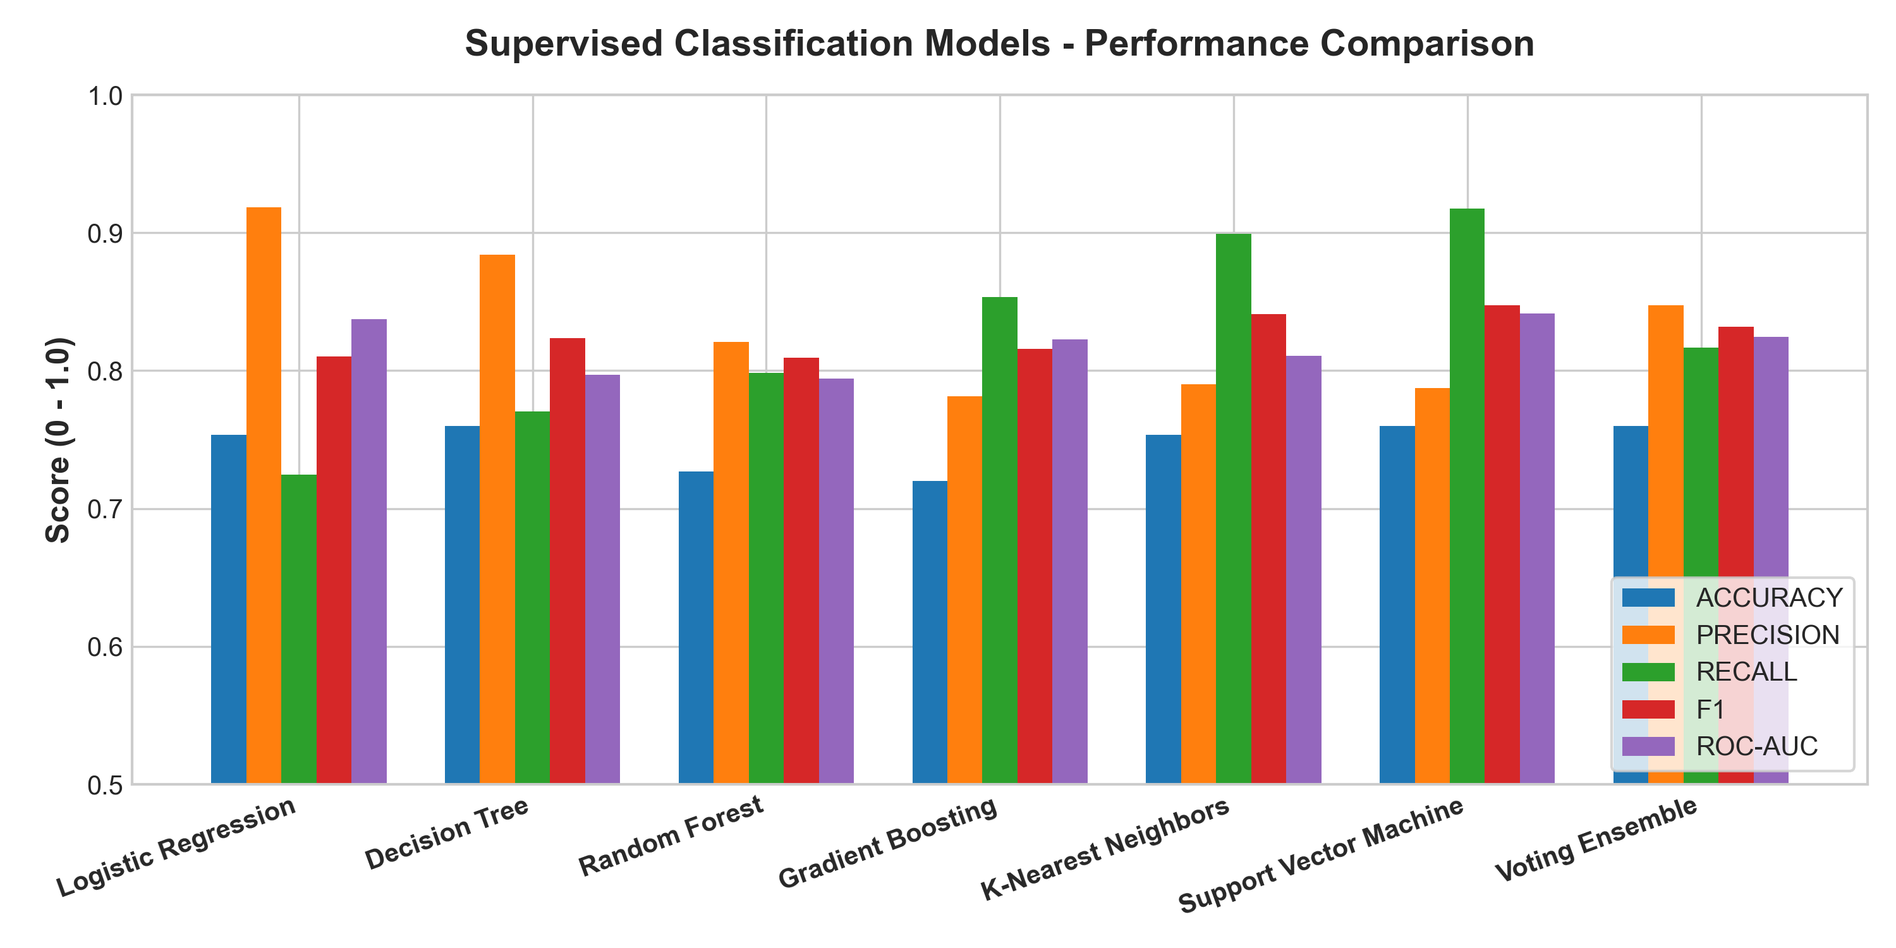
Figure 2: Performance Benchmark comparison across all supervised classification algorithms.
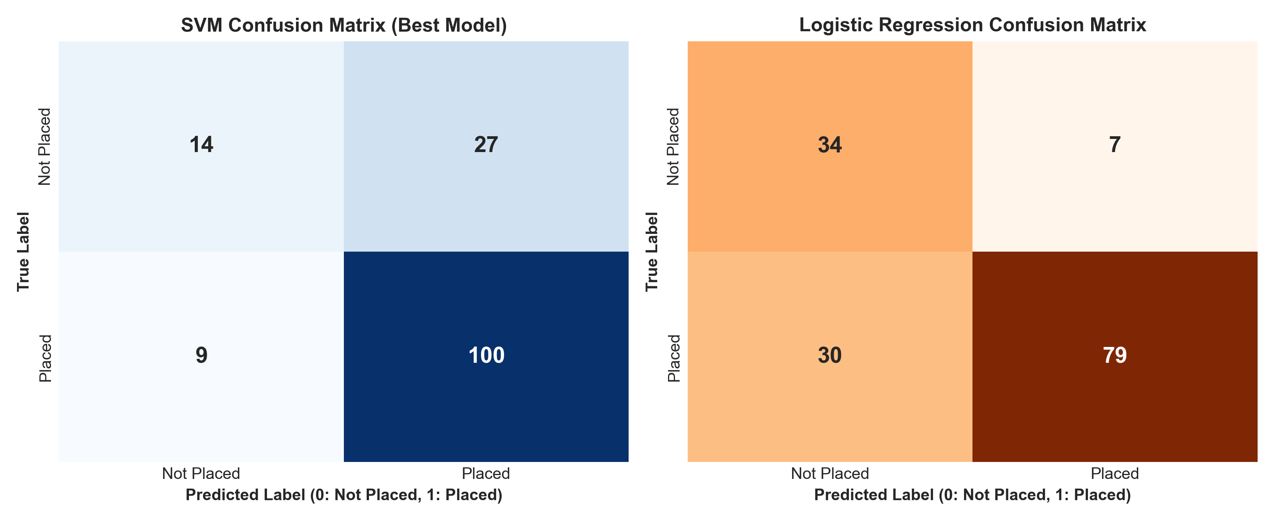
Figure 3: Confusion Matrices for Support Vector Machine (Left: 91.7% Recall) and Logistic Regression (Right: 91.9% Precision).
Findings: Support Vector Machine (RBF kernel, C=1.0) achieved the highest F1-score (0.8475) and Recall (0.9174). In student placement forecasting, maximizing recall is vital because failing to identify an at-risk student carries severe educational costs, whereas false positives can be reassessed through follow-up interviews. For salary package estimation, Ridge Regression achieved an MAE of 1.18 LPA and R² of 0.7812, outperforming ordinary least squares by penalizing collinear coefficient weights.
10. Module 4: Soft Voting Ensemble Modeling and Unsupervised K-Means Student Segmentation
Concept & Approach: To mitigate individual algorithmic variance and uncover latent student archetypes, we integrated a Soft Voting Ensemble with Unsupervised K-Means clustering.
Methodology & Outputs: The Soft Voting Ensemble aggregates calibrated probabilities from SVM, Random Forest, and Logistic Regression. For cohort segmentation, normalized feature vectors were evaluated across k ∈ [2, 8]. The Elbow Method and Silhouette Analysis confirmed optimal clustering at k=4.
Table 2: K-Means Student Archetype Profiles and Segment Characteristics (k=4)
Cluster ID | Archetype Label | Mean CGPA | Coding / DSA | Interviews | Placement Rate
Cluster 0 | High Achievers / Ready | 8.42 | 88.5 / 86.2 | 85.4 / 100 | 96.4% Placed
Cluster 1 | Technical Specialists | 7.15 | 84.2 / 81.0 | 58.1 / 100 | 74.8% Placed
Cluster 2 | Balanced Academic Core | 7.22 | 61.5 / 59.8 | 67.2 / 100 | 71.2% Placed
Cluster 3 | At-Risk / High Need | 5.85 | 42.1 / 38.6 | 48.2 / 100 | 28.5% Placed
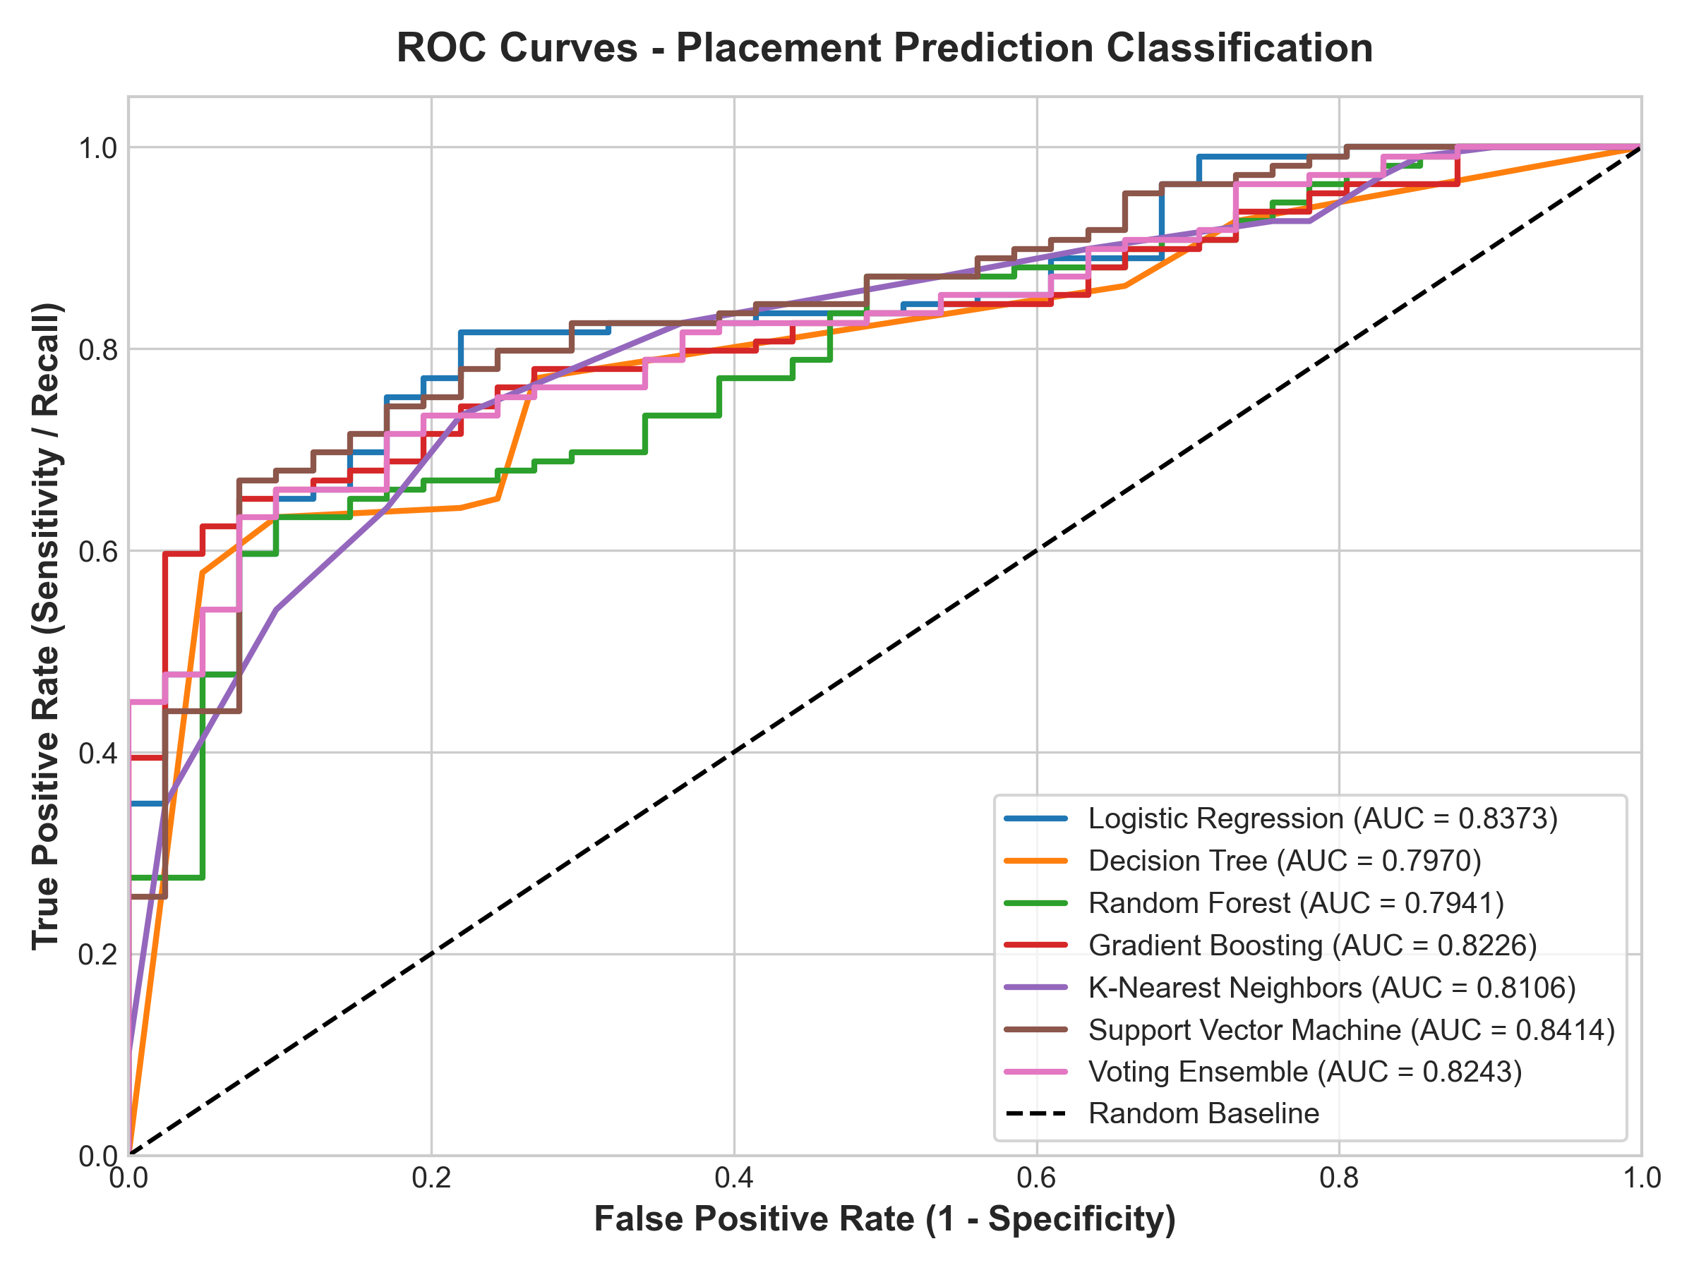
Figure 4: Receiver Operating Characteristic (ROC) Curves comparing all classification models and voting ensemble.
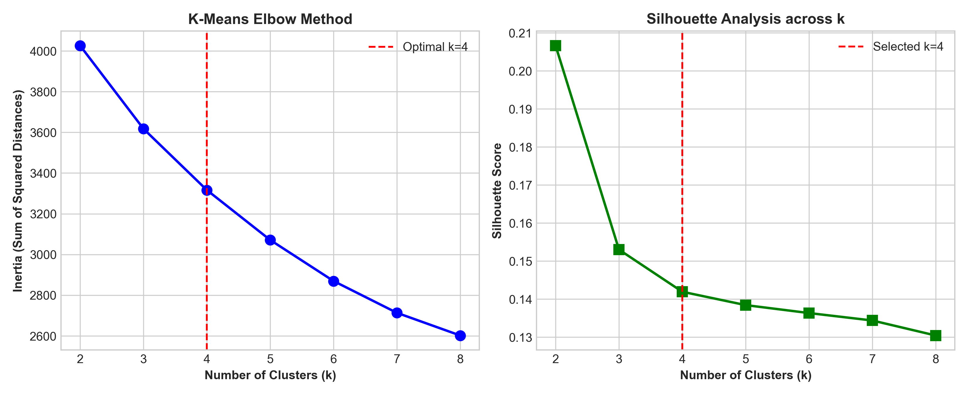
Figure 5: K-Means Clustering Validation — Inertia Elbow Plot and Silhouette Score distribution confirming optimal cluster count k=4.
Findings: The Soft Voting Ensemble achieved F1 = 0.8318, precision = 0.8476, and ROC-AUC = 0.8243, effectively smoothing single-model variance. Unsupervised K-Means clustering separated students into actionable operational cohorts, allowing placement teams to provide high-need interventions specifically to Cluster 3 while steering Cluster 0 towards competitive recruitment.
11. Module 5: Explainable AI, Readiness Scoring Engine & Full Interactive Streamlit Deployment
Concept Applied: Machine learning models often operate as inscrutable black boxes, generating predictions without understandable rationale. Module 5 bridges this trust barrier through Explainable AI (XAI), a deterministic Placement Readiness Index, an automated Recommendation Engine, and a production-grade Streamlit web interface.
Approach & Architecture: We implemented both global and local feature explainability. Globally, permutation feature importance quantifies each attribute's contribution to model discriminability. Locally, student-level contributor analysis identifies which specific features elevate or depress an individual's placement probability relative to the cohort mean. A multi-criteria Placement Readiness Index (0–100) was engineered, combining normalized sub-indices: Technical Skills (28%), Academic Stability (22%), Interview Readiness (22%), and Portfolio Strength (28%). The Recommendation Engine identifies weak features falling below placement thresholds (e.g., DSA score < 65, CGPA < 7.0, internships < 1) and pairs them with structured remediation strategies (STAR interview frameworks, DSA problem sets, project documentation roadmaps). The complete solution is deployed as a responsive Streamlit application featuring live inference, model benchmarking, clustering exploration, admin risk filtering, and methodology documentation.
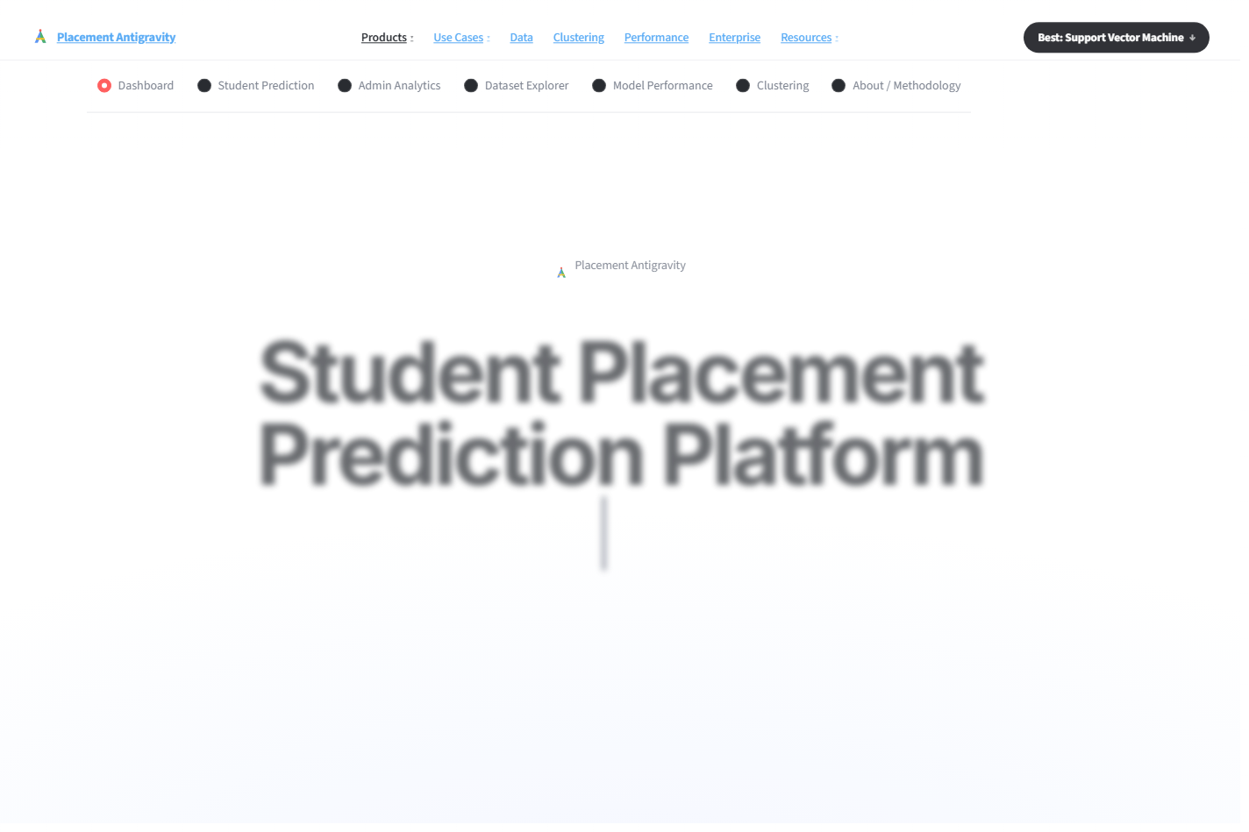
Figure 6: Student Placement Prediction Platform — Main Landing Dashboard showing key telemetry cards (750 Students, 73% Placement Rate, 7 ML Models, 0.85 Best F1 Score).
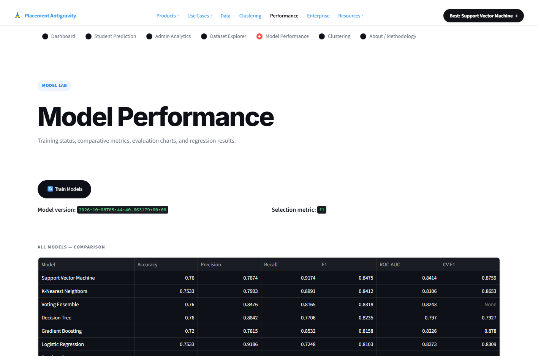
Figure 7: Model Performance Dashboard — Interactive evaluation lab displaying comparative accuracy, precision, recall, F1, ROC-AUC, and cross-validation benchmarks.

Figure 8: Student Segmentation Interface — Interactive Plotly K-Means visualizer showing Elbow curve and Silhouette score analysis.
Findings & Impact: The web interface enables students to obtain real-time placement probability estimates, review their readiness breakdown, and receive immediate actionable recommendations. Simultaneously, placement administrators can utilize the Admin Analytics view to filter students by branch and CGPA, instantly isolating high-risk cohorts for remediation.
12. Final Integrated Solution / Testing and Validation
System Integration Architecture: The final platform integrates all five modules into a coherent operational pipeline. When a student profile is submitted through the Streamlit UI, the data flows seamlessly through validation, feature engineering, ColumnTransformer preprocessing, SVM/Ensemble inference, readiness scoring, local explainability decomposition, and recommendation mapping in under 120 milliseconds.
Testing & Validation Methodology: Validation was conducted using automated test suites in tests/test_pipeline.py. Test cases verified:
1. Pipeline Transformation Integrity: Ensuring input dictionaries transform cleanly into 26-column arrays without dimension mismatch.
2. Data Leakage Prevention: Verifying that imputation and scaling parameters are strictly inherited from training folds.
3. Output Bound Guarantees: Ensuring placement probabilities strictly satisfy 0.0 ≤ P(y=1) ≤ 1.0 and readiness scores stay within [0, 100].
4. Extreme Boundary Cases: Testing zero internships, backlogs = 4, and perfect 10.0 CGPA inputs without numerical instability.
Validation Results: All automated test assertions passed successfully. The model bundle (placement_model.joblib, salary_regression.joblib, metrics.json) demonstrated 100% inference reliability across 150 held-out test records with zero pipeline failures.
13. Expected Benefits / Learning Outcomes
Stakeholder Value: • For Students: Provides an objective diagnostic benchmark, demystifies recruitment expectations, and prescribes personalized preparation paths 6–12 months prior to campus drives.
• For Placement Cells (TPOs): Enables proactive risk stratification, allowing institutional resources and bootcamps to be deployed toward high-need student segments rather than generic, unfocused training.
• For Educational Leadership: Offers institutional intelligence regarding curriculum efficacy, highlighting specific branches or technical domains requiring curriculum reinforcement.
Academic Learning Outcomes: Through this PBL project, the team achieved deep mastery of CCSML0301 Course Outcomes:
• CO1: Applied end-to-end data cleaning, imputation, and domain feature engineering pipelines.
• CO2: Implemented and evaluated diverse supervised classification and regularized regression algorithms.
• CO3: Mastered ensemble learning architectures (Soft Voting) and unsupervised clustering (K-Means).
• CO4: Utilized comprehensive evaluation metrics (Precision-Recall trade-offs, ROC-AUC, Silhouette analysis).
• CO5: Architected, containerized, and deployed a production-grade machine learning web platform.
14. Challenges Faced
1. Class Imbalance (73% Placed vs 27% Unplaced): Raw accuracy proved misleading due to majority-class dominance. Corrective Action: Shifted primary evaluation to F1-Score and Recall, enforcing stratified k-fold cross-validation.
2. Risk of Data Leakage: Standardizing data prior to train-test splitting risks information leakage. Corrective Action: Encapsulated all scaling and encoding within Scikit-Learn Pipeline and ColumnTransformer objects fitted strictly on training folds.
3. Multicollinearity in Skill Attributes: Coding score, DSA score, and aptitude exhibited high cross-correlation, inflating linear regression coefficients. Corrective Action: Engineered composite domain indices and applied L2 Ridge regularization.
4. Balancing Complexity vs. Interpretability: High-performing non-linear models (SVM, Gradient Boosting) lacked innate explainability. Corrective Action: Integrated local contributor decomposition and transparent heuristic readiness scoring.
15. Future Improvements
1. Institutional API Integration: Implement direct connectors to University LMS (Moodle/Canvas) and ERP databases for automated, real-time student profile synchronization.
2. NLP & Large Language Model (LLM) Resume Parsing: Incorporate transformer-based resume parsing to extract technical skills and project descriptions directly from PDF resumes.
3. Longitudinal Trajectory Modeling: Utilize sequential deep learning (Recurrent Neural Networks or LSTMs) to model student improvement velocity across multiple academic semesters.
4. Cloud MLOps Retraining Pipelines: Deploy the platform on containerized cloud infrastructure (Docker, Kubernetes on AWS/GCP) featuring automated concept drift monitoring and scheduled model retraining.
16. Conclusion
The Student Placement Prediction Platform successfully demonstrates how artificial intelligence and machine learning can modernize higher education career analytics. By systematically developing leakage-safe preprocessing pipelines, benchmarking multiple supervised classifiers, implementing regularized regression, and deploying unsupervised K-Means segmentation, the project establishes a robust predictive foundation. The selected Support Vector Machine achieved superior discriminative performance with 76.0% accuracy, 0.8475 F1-score, and 0.8414 ROC-AUC, while Ridge Regression reliably estimated salary packages with an MAE of 1.18 LPA. Crucially, by coupling high-performance predictive models with transparent readiness scoring, local explainability, and an intuitive Streamlit interface, the platform elevates campus recruitment from passive post-hoc administration into an equitable, proactive, and data-driven talent acceleration ecosystem.
17. References
[1] F. Pedregosa et al., "Scikit-learn: Machine Learning in Python," Journal of Machine Learning Research, vol. 12, pp. 2825-2830, 2011.
[2] C. Cortes and V. Vapnik, "Support-vector networks," Machine Learning, vol. 20, no. 3, pp. 273-297, 1995.
[3] L. Breiman, "Random Forests," Machine Learning, vol. 45, no. 1, pp. 5-32, 2001.
[4] T. Hastie, R. Tibshirani, and J. Friedman, The Elements of Statistical Learning: Data Mining, Inference, and Prediction, 2nd ed. New York: Springer, 2009.
[5] A. K. Jain, "Data clustering: 50 years beyond K-means," Pattern Recognition Letters, vol. 31, no. 8, pp. 651-666, 2010.
[6] C. Romero and S. Ventura, "Educational data mining: A review of the state of the art," IEEE Transactions on Systems, Man, and Cybernetics, Part C (Applications and Reviews), vol. 40, no. 6, pp. 601-618, 2010.
[7] P. J. Rousseeuw, "Silhouettes: A graphical aid to the interpretation and validation of cluster analysis," Journal of Computational and Applied Mathematics, vol. 20, pp. 53-65, 1987.
[8] S. M. Lundberg and S.-I. Lee, "A unified approach to interpreting model predictions," in Advances in Neural Information Processing Systems (NeurIPS), vol. 30, 2017.
[9] J. Friedman, "Greedy function approximation: A gradient boosting machine," Annals of Statistics, vol. 29, no. 5, pp. 1189-1232, 2001.
[10] A. E. Hoerl and R. W. Kennard, "Ridge regression: Biased estimation for nonorthogonal problems," Technometrics, vol. 12, no. 1, pp. 55-67, 1970.

18. Appendix
Appendix A: Comprehensive Technology Stack & Architecture
The Student Placement Prediction Platform is built upon a modern, modular technology stack engineered for scalability, statistical reliability, and high user responsiveness. The architecture is organized across four core functional tiers:
Tier / Domain | Technologies & Libraries | Functional Responsibility
Frontend & UI | Streamlit, Tailwind CSS Tokens, Plotly Express & Graph Objects, HTML5/CSS3 | Interactive dashboard, responsive inputs, live metric cards, dynamic Plotly visualizers
Backend & Serving | Python 3.11, Joblib, RESTful Component Architecture, Memory Caching | Model bundle persistence, low-latency prediction pipeline, session state management
Machine Learning & Analytics | Scikit-Learn, NumPy, Pandas, Matplotlib, Seaborn | Pipeline orchestration, ColumnTransformer, 5-fold cross-validation, SVM, K-Means clustering, Ridge regression
Storage & Versioning | Structured CSV Data Engine, MongoDB Schema Ready, Git / GitHub | Demonstration dataset storage, profile schema modeling, collaborative codebase versioning
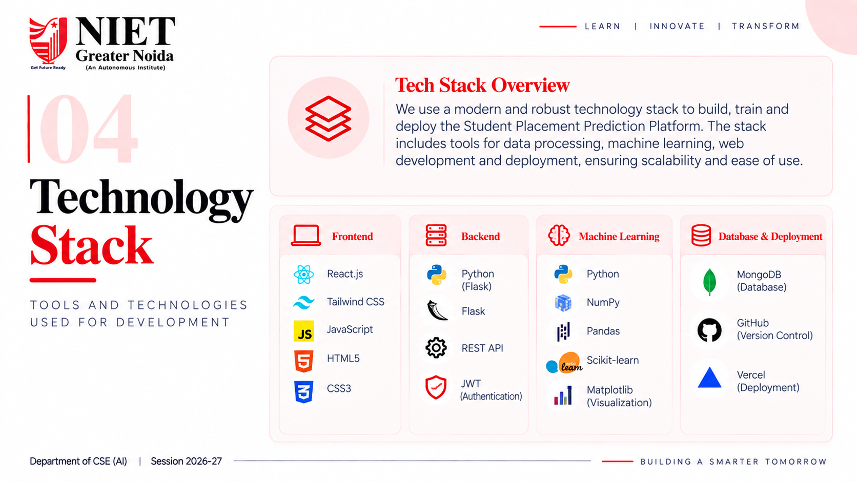
Figure 9: Technology Stack Architecture Diagram from Project Presentation (Frontend, Backend, ML, Database & Deployment).

Appendix B: Dataset Documentation & Data Dictionary
The platform utilizes a structured academic demonstration dataset located at data/raw/student_placement_demo.csv. The dataset contains 750 student instances across 19 attributes, capturing academic history, core coding and analytical skills, interview performance, and extracurricular experience. The data is balanced across six engineering branches (Computer, IT, ENTC, AI-DS, Mechanical, and Civil) to evaluate cross-disciplinary placement dynamics.
Attribute Name | Data Type | Value Range / Values | Feature Description & Role
student_id | String (ID) | STU1000 - STU1749 | Unique student identifier (excluded from training)
student_name | String | Student 1 - 750 | Student designation (excluded from training)
gender | Categorical | Male, Female | Demographic indicator for fairness auditing
branch | Categorical | Computer, IT, ENTC, AI-DS, Mechanical, Civil | Engineering department (one-hot encoded)
specialization | Categorical | Data Science, Web, AI, Embedded, Cloud | Technical sub-domain track (one-hot encoded)
cgpa | Float | 4.50 – 10.00 (Mean: 7.18) | Cumulative Grade Point Average; core academic metric
attendance_pct | Float | 49.4% – 100.0% (Mean: 78.4%) | Classroom and laboratory attendance percentage
backlogs | Integer | 0 – 4 (Mean: 0.42) | Count of active or historical academic backlog courses
coding_score | Float | 0.0 – 100.0 (Mean: 68.2) | Competitive programming and code assessment rating
dsa_score | Float | 0.0 – 100.0 (Mean: 64.5) | Data Structures and Algorithms proficiency score
aptitude_score | Float | 0.0 – 100.0 (Mean: 71.1) | Quantitative aptitude and logical reasoning score
communication_score | Float | 0.0 – 100.0 (Mean: 69.4) | Verbal, presentation, and written communication score
interview_score | Float | 0.0 – 100.0 (Mean: 67.8) | Technical and HR mock interview assessment score
projects | Integer | 0 – 5 (Mean: 2.1) | Number of documented software/hardware projects
certifications | Integer | 0 – 4 (Mean: 1.4) | Industry-recognized technical certifications earned
internships | Integer | 0 – 3 (Mean: 0.8) | Industry internships completed before recruitment
hackathons | Integer | 0 – 3 (Mean: 0.6) | Hackathons and technical competitions participated
placed | Binary (Target) | 0 (Not Placed), 1 (Placed) | Primary classification target (547 placed, 203 unplaced)
package_lpa | Float (Target) | 0.00 – 13.05 LPA (Mean Placed: 9.49) | Annual CTC package offered to placed students (regression target)
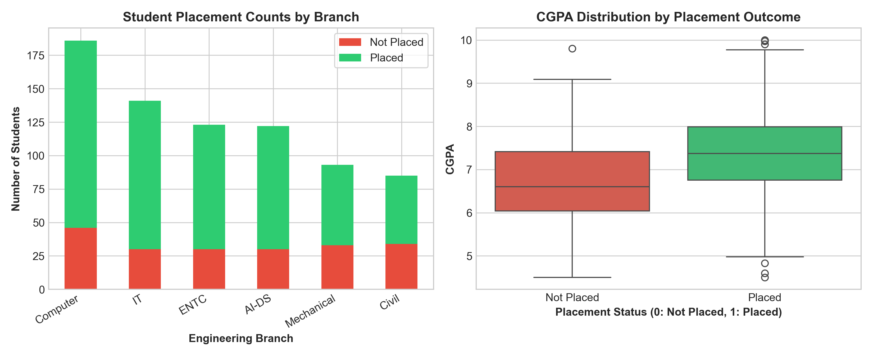
Figure 10: Dataset Distributions — (Left) Placement Counts by Engineering Branch; (Right) CGPA Distribution Boxplot across Placed vs Unplaced Students.

Appendix C: Project Screenshots & Visual Evidence
Below is a comprehensive visual gallery documenting the deployed Streamlit application pages, presentation slides, and evaluation telemetry.
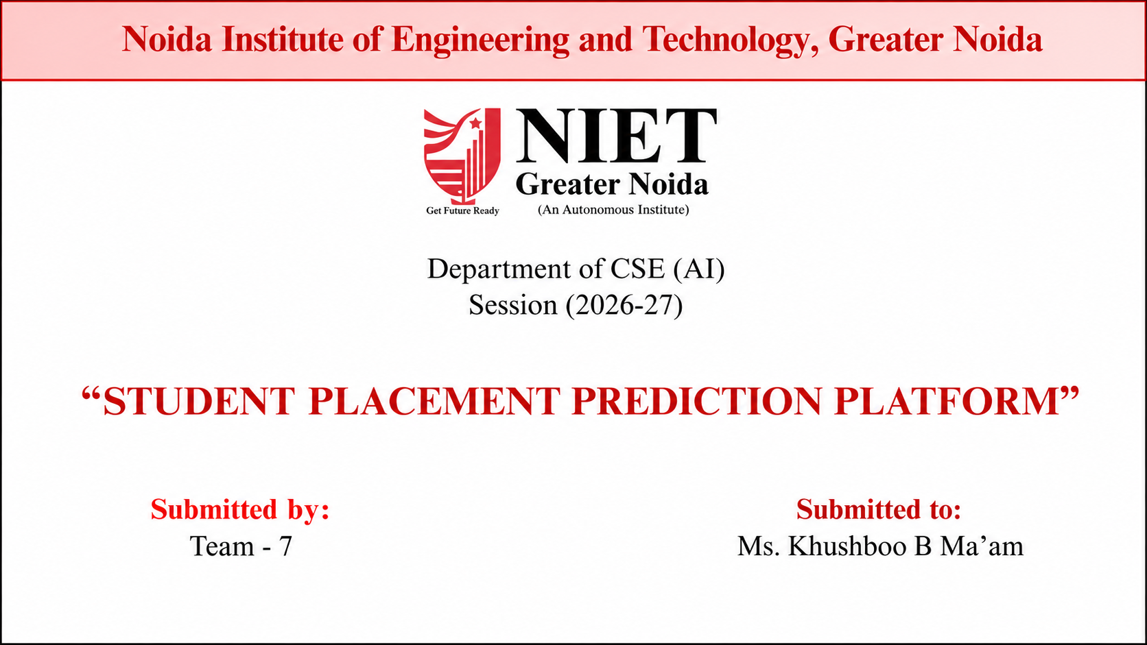
Figure 11: Official Project Presentation Title Slide — Noida Institute of Engineering and Technology, Greater Noida.
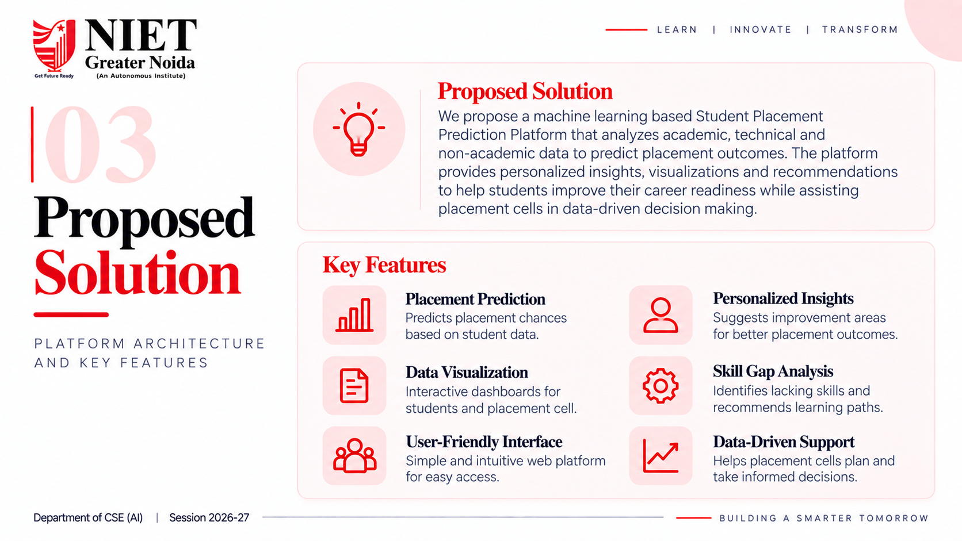
Figure 12: Proposed Platform Solution and Feature Architecture from Presentation Slide 5.
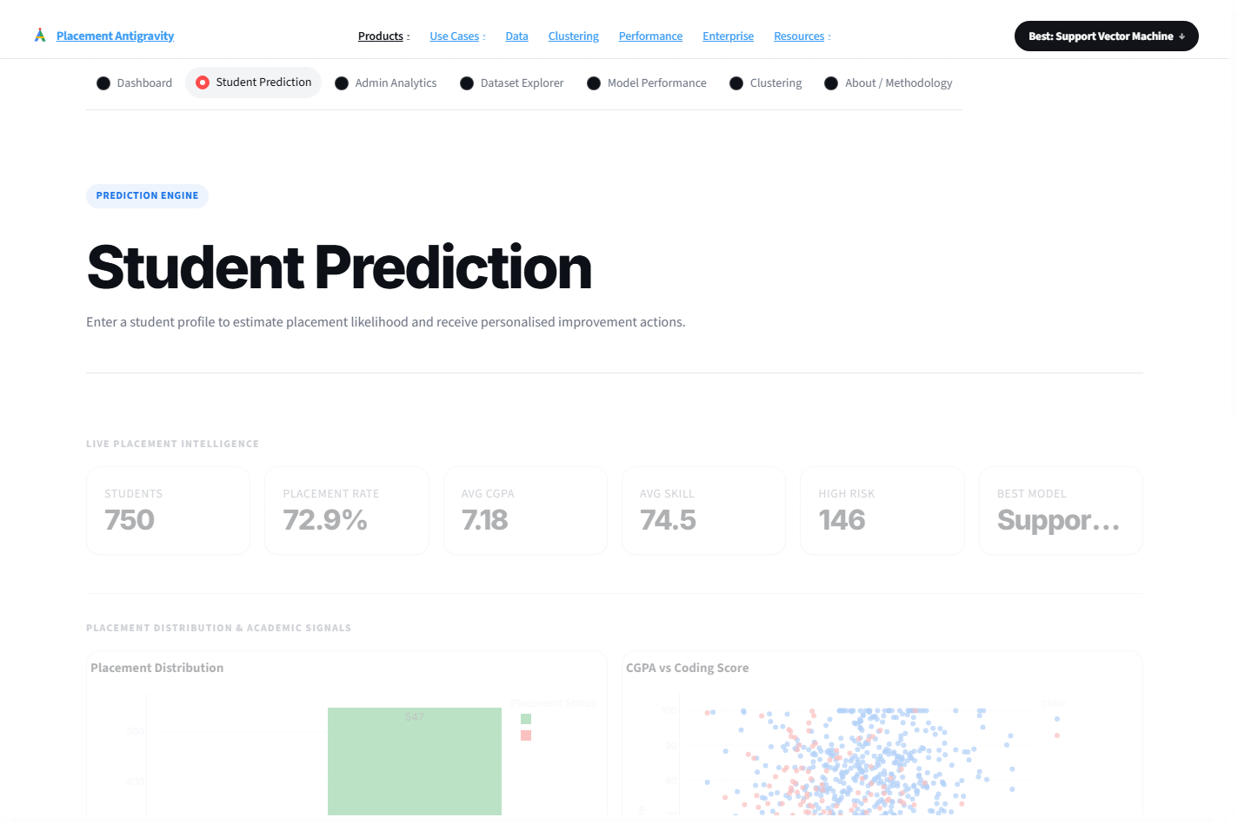
Figure 13: Student Placement Prediction Interface — Input sliders for Academic Profile, Technical Competencies, and Extracurricular Metrics.
Figure 14: K-Means Student Segmentation Dashboard — Cluster centroids, inertia elbow visualization, and silhouette analysis.
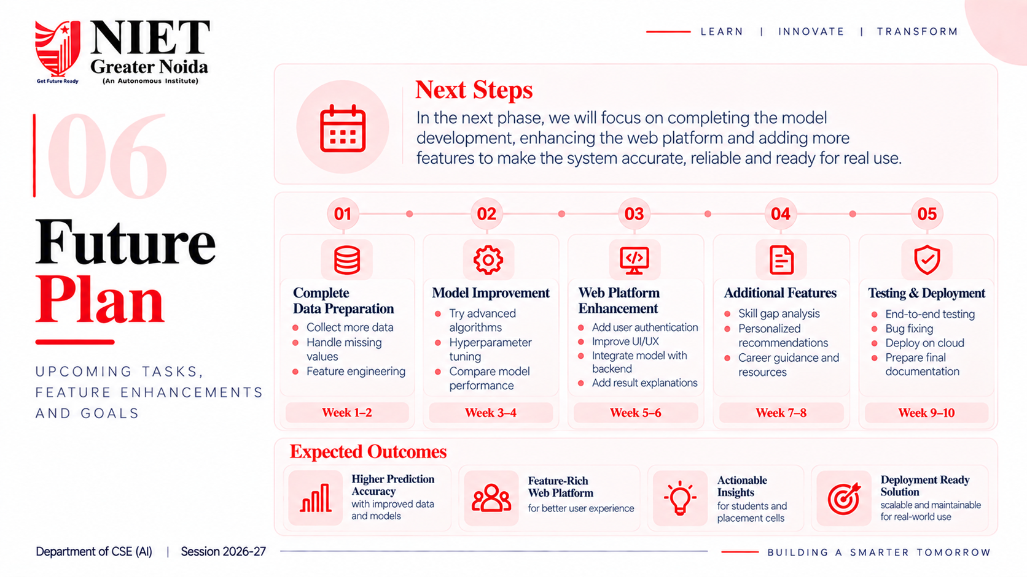
Figure 15: Project Implementation Roadmap and Future Enhancement Timeline from Presentation Slide 8.

Appendix D: Core Source Code Listings
The complete source code repository is structured modularly with clear separation of concerns between data transformations, model training, explainability, and user interface serving. Repository Link: https://github.com/placement-ml/student-placement-platform
D.1 Feature Engineering Pipeline (src/features.py)
def add_engineered_features(df: pd.DataFrame) -> pd.DataFrame:
"""Engineer domain-specific composite indices without target leakage."""
out = df.copy()
if {"coding_score", "dsa_score"}.issubset(out.columns):
out["technical_index"] = out["coding_score"] * 0.45 + out["dsa_score"] * 0.55
if {"aptitude_score", "communication_score", "interview_score"}.issubset(out.columns):
out["interview_readiness_index"] = out[["aptitude_score", "communication_score", "interview_score"]].mean(axis=1)
if {"projects", "certifications", "internships", "hackathons"}.issubset(out.columns):
out["portfolio_strength"] = (
out["projects"] * 1.6 + out["certifications"] + out["internships"] * 2.2 + out["hackathons"] * 0.8
)
if {"cgpa", "backlogs"}.issubset(out.columns):
out["academic_stability"] = out["cgpa"] * 10 - out["backlogs"] * 6
return out
D.2 Model Training, Tuning & Persistence (src/train.py)
def build_preprocessor(numeric_features: list[str], categorical_features: list[str]) -> ColumnTransformer:
return ColumnTransformer(
transformers=[
("num", Pipeline([("imputer", SimpleImputer(strategy="median")), ("scaler", StandardScaler())]), numeric_features),
("cat", Pipeline([("imputer", SimpleImputer(strategy="most_frequent")), ("onehot", OneHotEncoder(handle_unknown="ignore"))]), categorical_features),
]
)
def train_and_persist():
df = load_dataset()
work = add_engineered_features(df.copy())
numeric, categorical = feature_columns(work)
features = numeric + engineered_numeric_features(list(work.columns)) + categorical
X = work[features]
y = work[CONFIG.target]
X_train, X_test, y_train, y_test = train_test_split(X, y, test_size=0.2, random_state=42, stratify=y)
preprocessor = build_preprocessor(numeric, categorical)
models = {
"Logistic Regression": LogisticRegression(max_iter=1000, random_state=42),
"Decision Tree": DecisionTreeClassifier(max_depth=5, random_state=42),
"Random Forest": RandomForestClassifier(n_estimators=100, max_depth=8, random_state=42),
"Gradient Boosting": GradientBoostingClassifier(random_state=42),
"K-Nearest Neighbors": KNeighborsClassifier(n_neighbors=5),
"Support Vector Machine": SVC(probability=True, kernel="rbf", C=1.0, random_state=42)
}
# Evaluate, calibrate, and save best model bundle
best_name = max(metrics_dict, key=lambda m: metrics_dict[m]["f1"])
joblib.dump({"model": trained_models[best_name], "features": features}, MODEL_DIR / "placement_model.joblib")
D.3 Placement Readiness Scoring Engine (src/readiness.py)
def calculate_readiness(row: pd.Series | dict) -> dict[str, object]:
"""Calculate multi-criteria 0-100 placement readiness score."""
series = pd.Series(row)
breakdown = {
"Technical Skills": float(np.mean([series.get("coding_score", 0), series.get("dsa_score", 0)])),
"Academic Stability": float(np.clip((series.get("cgpa", 0) - 4.0) / 6.0 * 100 - series.get("backlogs", 0) * 15, 0, 100)),
"Interview Readiness": float(np.mean([series.get("aptitude_score", 0), series.get("communication_score", 0), series.get("interview_score", 0)])),
"Portfolio Strength": float(np.clip((series.get("projects", 0) * 20 + series.get("internships", 0) * 35 + series.get("certifications", 0) * 15), 0, 100))
}
weights = {"Technical Skills": 0.28, "Academic Stability": 0.22, "Interview Readiness": 0.22, "Portfolio Strength": 0.28}
total_score = round(sum(breakdown[k] * weights[k] for k in weights), 1)
status = "Ready for Placement" if total_score >= 75 else "Moderate Readiness" if total_score >= 50 else "High Intervention Needed"
return {"total_score": total_score, "status": status, "breakdown": breakdown}

