Phase 2 Logical Data Relationship Diagram
Official Website and Customer Enquiry Management System for a UK Auto Parts SME
Field | Details
Client Name Used | Auto Parts SME
Project Phase | Phase 2 Future Enhancement
Working Date | 29 May 2026
Prepared By | Business Analyst
Purpose | Define a logical data relationship view for enquiry and sales lead tracking before SQL and Power BI design.
Note: This is a logical BA-level diagram. It is not a final physical database design. Final table structure, indexes, keys, data types, security rules, and retention rules should be confirmed by the technical team and relevant business/compliance owner.

1. Diagram
The diagram below shows the proposed logical relationship between customer enquiry data, quote requests, product categories, lead status, follow-up notes, enquiry source, and newsletter subscription data.
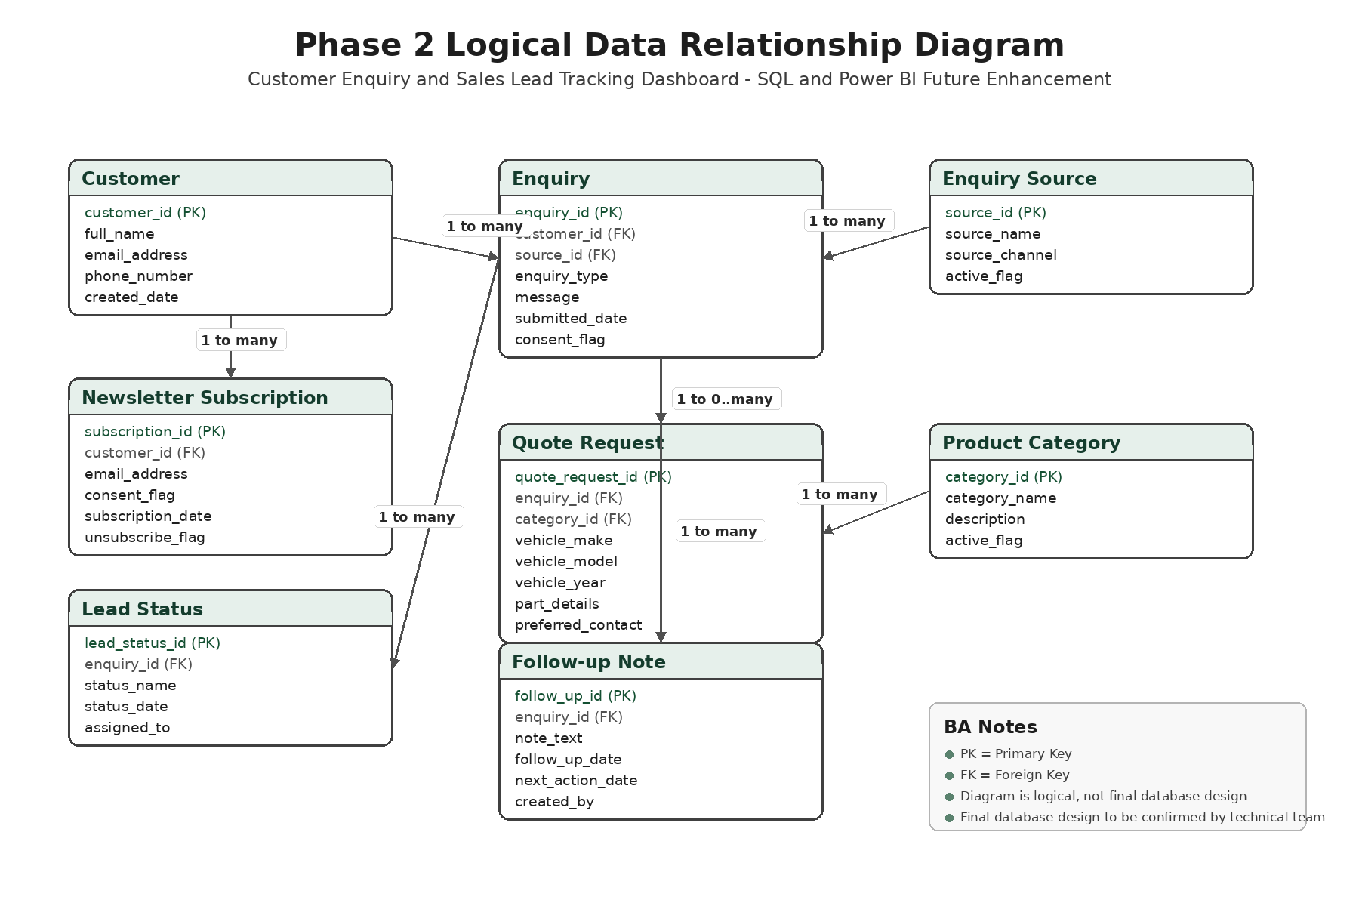

2. Logical Entities
Entity | Business Purpose
Customer | Stores basic customer contact details captured through enquiry, quote, feedback, or newsletter forms.
Enquiry | Stores the main customer enquiry record submitted through the website.
Quote Request | Stores additional quote-specific details such as product category and vehicle details.
Product Category | Stores the agreed auto parts categories used in enquiry and reporting.
Lead Status | Stores lead progress such as New, Contacted, Quoted, Won, Lost, or Closed.
Follow-up Note | Stores business follow-up notes and next action dates for each enquiry.
Enquiry Source | Stores where the enquiry came from, such as website quote form, contact form, feedback form, or newsletter.
Newsletter Subscription | Stores newsletter consent and unsubscribe status.

3. Relationship Summary
Relationship | Meaning
Customer to Enquiry | One customer can submit many enquiries. Each enquiry should belong to one customer record where contact details are available.
Customer to Newsletter Subscription | One customer may have one or more newsletter subscription records depending on consent and unsubscribe history.
Enquiry Source to Enquiry | One enquiry source can be linked to many enquiries for reporting by source.
Enquiry to Quote Request | One enquiry may become one or more quote requests where the customer asks for parts pricing or availability response.
Product Category to Quote Request | One product category can be selected in many quote requests.
Enquiry to Lead Status | One enquiry can have multiple status updates during follow-up.
Enquiry to Follow-up Note | One enquiry can have many follow-up notes.

4. BA Validation Notes
Validation Area | BA Note
Data completeness | Customer name and email should be captured for quote and contact enquiries where required by the form.
Consent | Consent flag should be captured for forms where personal data is used to respond.
Lead status | Lead status values should be standardised to avoid reporting mismatch in Power BI.
Product category | Product category values should match the approved website categories.
Follow-up tracking | Follow-up notes should include follow-up date, next action date, and owner where required.
Reporting readiness | Fields should support Power BI metrics such as total enquiries, quote requests, top categories, pending follow-ups, conversion rate, and monthly trend.

5. Portfolio and Interview Note
Portfolio use: Upload the PNG diagram, editable Draw.io file, Word document, and PDF under the Phase 2 SQL and Power BI Reporting Enhancement section.
Interview explanation: For Phase 2, I prepared a logical data relationship diagram to show how customer, enquiry, quote request, product category, lead status, follow-up, source, and newsletter data would connect for future SQL and Power BI reporting. This helped translate business reporting needs into a structured data requirement view before technical database design.

