Power BI Dashboard Wireframe
Official Website and Customer Enquiry Management System for a UK Auto Parts SME
Client: Auto Parts SME | Phase 2 Future Enhancement | Date: 29 May 2026
Field | Details
Document Owner | Business Analyst
Sprint | Sprint 4 Future SQL and Power BI Enhancement
Stage | Stage 48
Status | Draft for stakeholder review
Confidentiality note | Anonymised portfolio version. No real client details used.

1. Purpose
This wireframe shows the proposed layout for the future Power BI, meaning Business Intelligence, dashboard. The dashboard will help the business track website enquiries, quote requests, lead status, follow-ups, enquiry source, and product category performance.

2. Scope
This is a Phase 2 future enhancement wireframe. It does not confirm that the dashboard has been technically built. It confirms the proposed reporting layout and business view required before dashboard development.

3. Users
Primary users are the Business Owner, Sales User, and Product Owner. The Business Analyst supports requirement validation and acceptance criteria review.
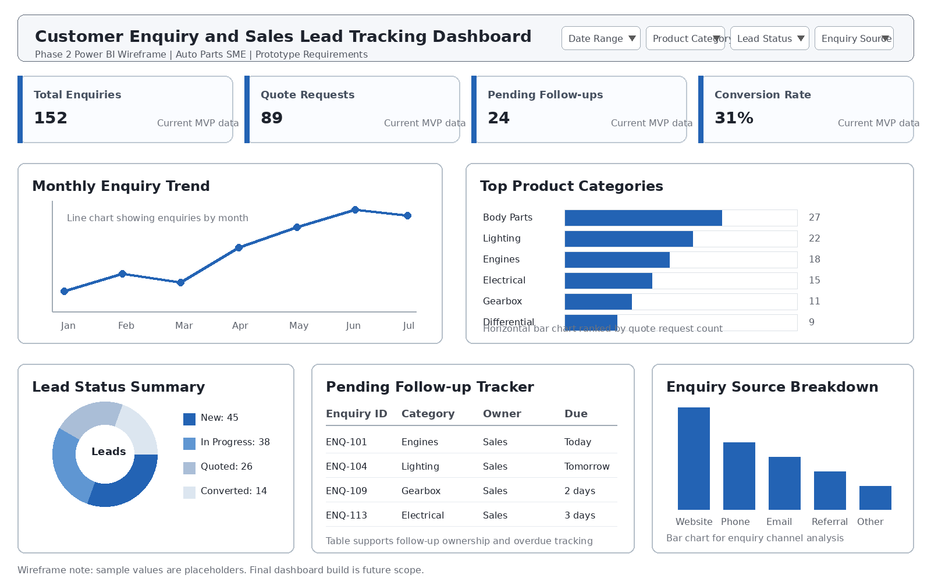
Figure 1: Proposed Power BI dashboard wireframe for customer enquiry and sales lead tracking.

4. Dashboard Wireframe Components
Component | Requirement
Header and Filters | Dashboard title, date range, product category, lead status, and enquiry source filters.
KPI Cards | Total enquiries, quote requests, pending follow-ups, and conversion rate.
Monthly Enquiry Trend | Line chart to show enquiry trend by month.
Top Product Categories | Bar chart to show the most requested auto parts categories.
Lead Status Summary | Donut or stacked visual showing New, In Progress, Quoted, Converted, and Closed leads.
Pending Follow-up Tracker | Table showing enquiries requiring follow-up, owner, due date, and status.
Enquiry Source Breakdown | Bar chart showing website, phone, email, referral, and other enquiry sources.

5. Key Performance Indicators
KPI | Business meaning
Total Enquiries | Count of all submitted enquiries in selected period
Quote Requests | Count of enquiries submitted through the Request a Quote form
Pending Follow-ups | Count of enquiries not yet closed and needing action
Conversion Rate | Converted leads divided by total quote requests
Top Categories | Most requested product categories by enquiry/quote count
Monthly Trend | Number of enquiries by month

6. Data and Compliance Notes
Area | Note
Data source | Expected source is future SQL data for customers, enquiries, quote requests, product categories, lead status, follow-up notes, enquiry source, and newsletter subscription.
Refresh expectation | Daily refresh is enough for a small business. Real-time refresh is not required for Phase 2 requirements.
Access consideration | Dashboard access should be limited to authorised business users. Customer contact details may need masking depending on agreed policy.
Data quality | Missing contact details, duplicate leads, invalid status values, and missing follow-up dates should be highlighted before dashboard use.
Compliance note | Personal data use, retention, export, and newsletter consent reporting should be confirmed by the Business Owner or relevant advisor.

7. Acceptance Criteria
• Dashboard wireframe includes required KPIs and filters.
• Wireframe supports enquiry, quote request, category, lead status, follow-up, and source reporting.
• Wireframe avoids personal data exposure unless access control and masking are confirmed.
• Wireframe is linked to SQL data requirements and logical data relationship diagram.
• Business users can understand what the future Power BI dashboard will show.

8. Portfolio Note
This wireframe can be shown under Phase 2: SQL and Power BI Reporting Enhancement. Clearly mention that it is a future enhancement requirement artefact, not a fully delivered production dashboard.

9. BA Interview Explanation
I prepared a Power BI dashboard wireframe to translate reporting requirements into a simple visual layout. It showed KPIs, filters, trend chart, category analysis, lead status summary, pending follow-up tracker, and enquiry source breakdown. This helped business users validate what they expected from the future dashboard before technical build.

