**Website on college**

A Report for the Evaluation of MTE PBL Web Tech

**NEELESH SINGH**

Admission No.: 17SCSE105077

Under the Supervision of

**V. Arul**



**School of Computing Science and Engineering**

**Greater Noida, Uttar Pradesh**

**Winter 2019-2020**

TABLE OF CONTENTS

1. Abstract

2. Introduction (i) Overall description (ii) Purpose (iii) Motivations and scope

3. Use Case Diagram

4. Flow Chart

5. References

1. ABSTRACT

Software Requirement Specification (SRS) on Internet provide detail view of University which help student to know about the university and it help us to advertise our college through website and solve student queries through website and by the website which provide true detail of us increase the chance of number of admission. Which help in growth of college.

Name of Project: College Website

SRS Prepared by: NEELESH SINGH

Date of SRS Prepared:27/04/20

1. INTRODUCTION:

Software Requirement Specification SRS is designed document and describe the agreement between the customer and the developer regarding the specification of college website.

***2.1 Purpose:***

College website help students and university staff. To give overview of us to student and also help in to give information to students through website so that each and every student an aware of that information.

***2.2 Scope:***

It is interface between students and college which can be used to provide any kind of information and resolving the problem of students.

***2.3 References:***

Websites like promote self business(example: Amazon, Tour website,etc)

1. **OVERALL DESCRIPTION:**

***3.1 User Classes and Characteristics***

The system provides different types of services based on the type of users. Here users are accessing the website after create his/her own account. When a user open his/her account then shows his/herposts and also show the all members. Users can also edit their profile along with all the details and his/her profile photo.

The features that are available to the Users are:

>Create his/her own profile along with all the details and his/her profile photo.

>Every users have individual & unique log in credential to go through the portal.

>There will be group facility which can be created by user.

>Each user can see his/her own group’s post as well as other groups’ post if permission is given. >User can send message to another specific user.

>User can also report spam to the portal for any unwanted post.

>This website provides separate access for different sections of college (viz. Academic, Administration, Training & Placement, Library, Finance, Examination sections).

***3.2 Operating Environment***

This application will be operating in webpages through browser. The College Communication System is a web application and can be operated through browser in web pages. The only requirement to use this website would be the internet connection and a device which can access high speed internet.

***3.3 Requirement Software Configuration:***

This software package is developed using HTML, CSS as front end, MySQL as to store the database and Apache as web server.

**Operating System:**

Windows XP, Windows 7, Windows 8, Windows 10 Front end: HTML, CSS, MySQL Web Server: Apache

**Hardware Configuration:**

Processor: Core i3, 1.5MHz

Hard Disk: 1 TB

RAM: 4GB

***3.4 Data Requirement***

The inputs consist of the query to the database and the output consists of the solutions for the query. The output also includes the user receiving the details of their accounts. In this project the inputs will be queries as fired by the users like create an account. Now the output will be visible when the user requests the server to get details of their own account and also accounts of the other members in the form of time, date.

***3.5 System Features***

This is possible by providing:-

>User accessibility available if he/she is a part of a particular college campus.

>Every users have individual & unique log in credential to go through the portal.   
>User can register his/her profile along with all the details and his/her profile photo.

>This website provides separate access for different sections of college (viz. Academic, Administration, Training & Placement, Library, Finance, Examination sections)

>User can post including photo, audio documents, video documents & any other kind of file. >User can also comments with respect to the post.

> Each user can see his/her own group’s post as well as other groups’ post if permission is given. >User can also report spam to the portal for any unwanted post.

>Admin functionality will be added(admin can modify and delete unwanted post and even can block users).

***3.6 User Requirement***

The users of the system are members of the “College Communication System”. The users are assumed to have basic knowledge of the computers and internet browsing. The administrators of the system should have more knowledge of the internals of the system and is able to rectify the small problems that may arise due to disk crashes, power failures and other catastrophes to maintain the system. The proper user interface, user manual, online help and the guide to install and maintain the system must be sufficient to educate the users on how to use the system without any problems.

1. **ENTITY RELATIONSHIP DIAGRAM(ERD)**

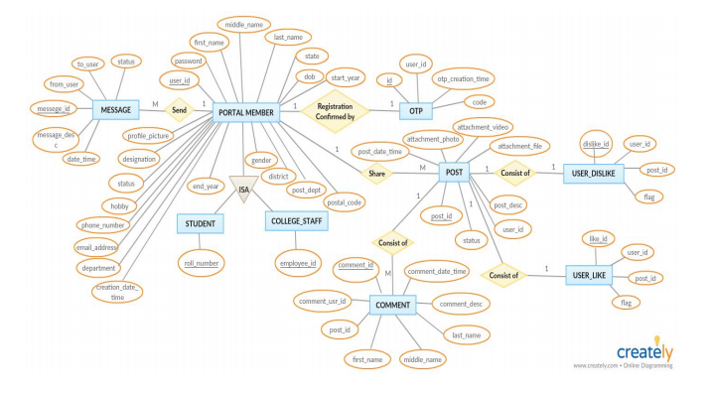

***DATA FLOW DIAGRAM(DFD)***

