KEEPER-APP

**Introduction:-**

This is a note making app used as a reminder tool for reminding important events as well as necessary items.

User can easily add or delete a note.

**Technology used:-**

* *React.js*
* *HTML*
* *CSS*

**Features:-**

➢ It’s an app for making short notes (like a small reminder list) which helps a user to look, what all tasks he has to perform.

➢ In this app, user can add as many notes as he wishes.

➢ After the completion of the task, the user can delete the notes which he/she might had finished.

**Group members –**

**Mentor’s name: -** 1) Vivek Kumar.

2) Vivek Kashyap.

**Group leader-** Ashish Kumar (C.S.E)

**Other members-**

|  |  |  |
| --- | --- | --- |
| Name | Branch | Year |
| Ashish kumar | Computer Science and Engineering | 2nd year |
| Abhishek Gupta | Computer Science and Engineering | 2nd year |
| Divyanshi Mishra | Computer Science and Engineering | 2nd year |
| Aman Srivastava | Computer Science and Engineering | 2nd year |
| Shraddha Gupta | Computer Science and Engineering | 2nd year |

**Screenshots:-**

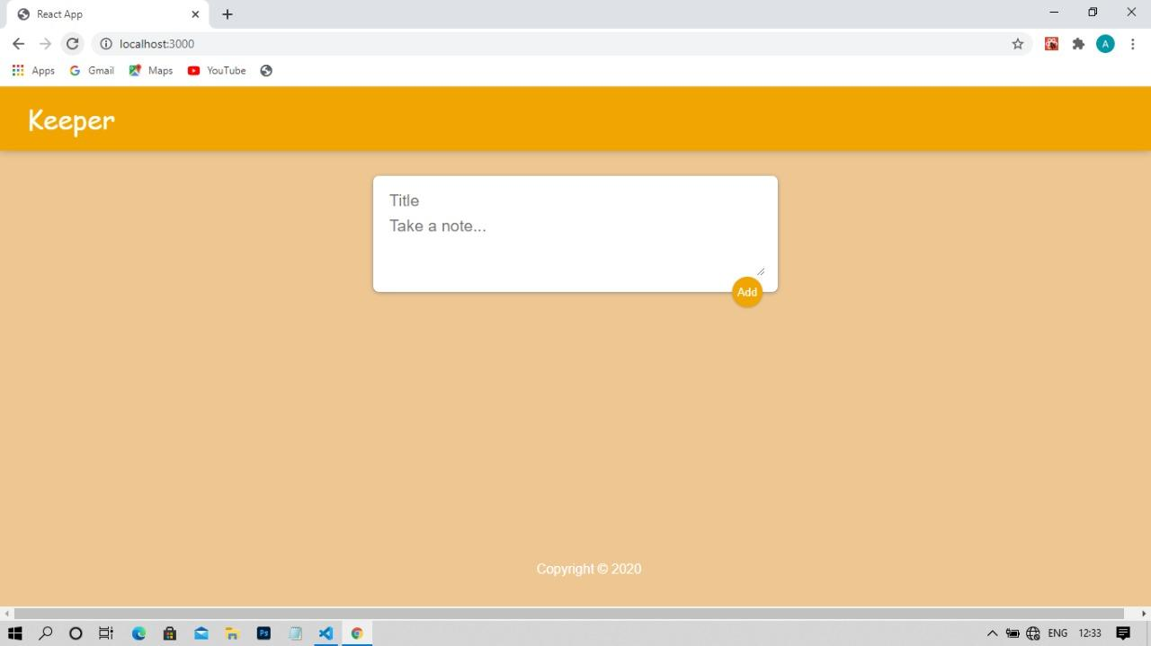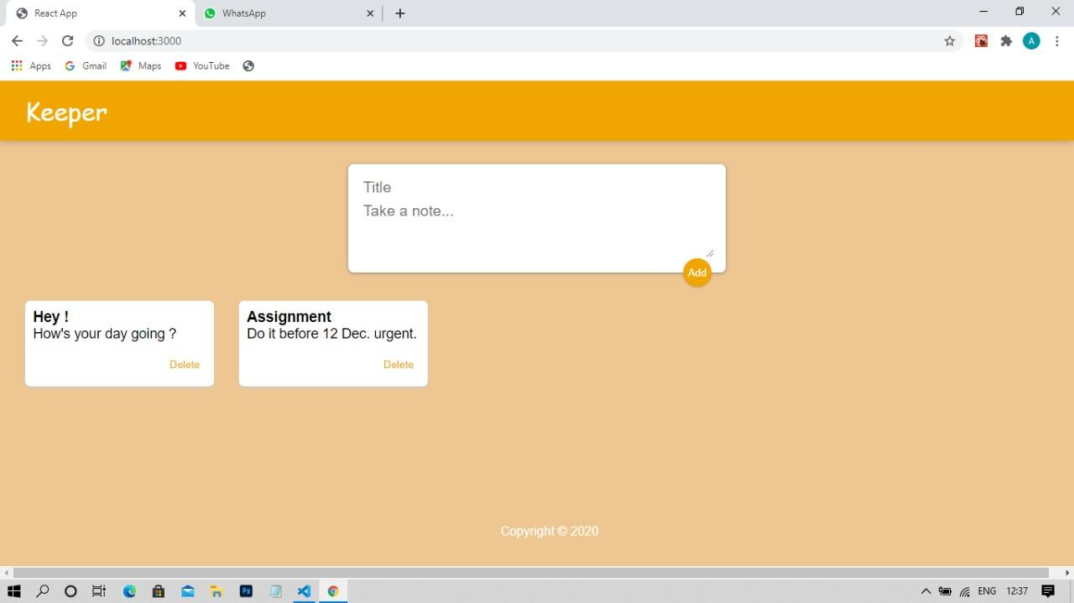

**Link of Github Repository:-**

<https://github.com/codebiet/Keeper-App.git>

**Presentation video:**

<https://drive.google.com/folderview?id=1MfwLVH3nJevW5jvW8cWyLLWHWcl9jW-d>

**References-**

* <https://www.w3schools.com/>
* https://www.tutorialspoint.com/nodejs/index.htm