Apache Tomcat setup steps

- Download and install Java JDK - amazon-corretto-11.0.15.9.1-windows-x64
Installed Java into directory: C:\Program Files\Amazon Corretto\jdk11.0.15_9
  - URL: https://aws.amazon.com/corretto/?filtered-posts.sort-by=item.additionalFields.createdDate&filtered-posts.sort-order=desc
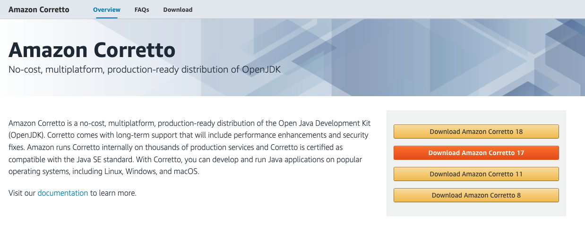
  - Click on Download Amazon Corretto 11. And download Windows x64 msi installer.
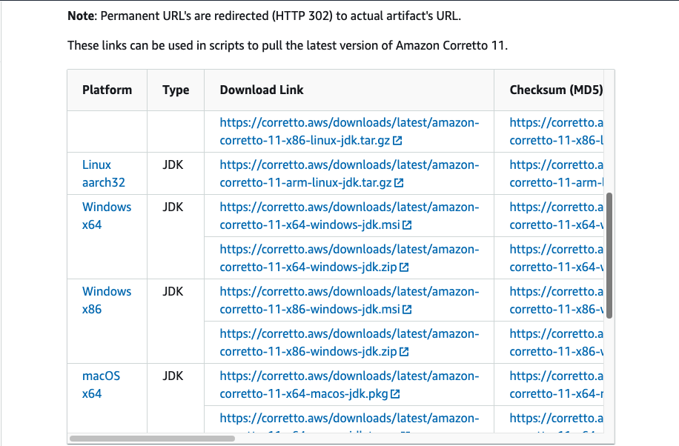

  - Amazon Corretto installation
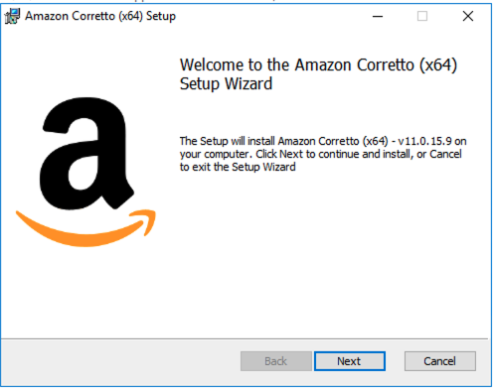
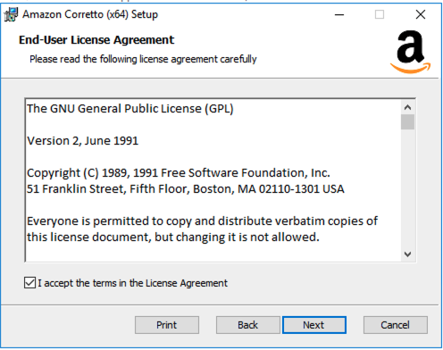
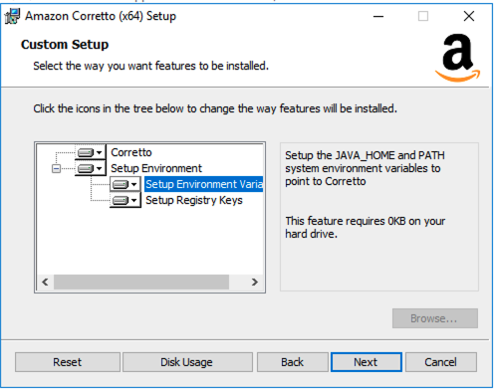
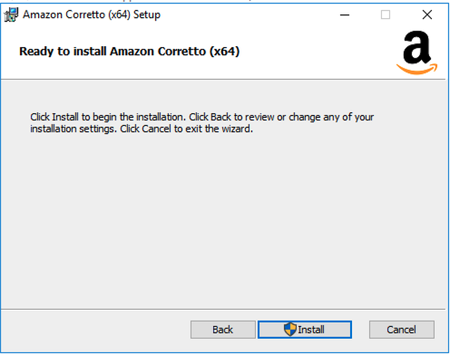
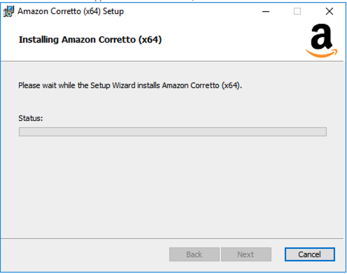
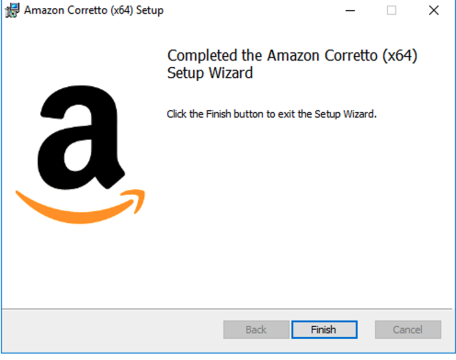
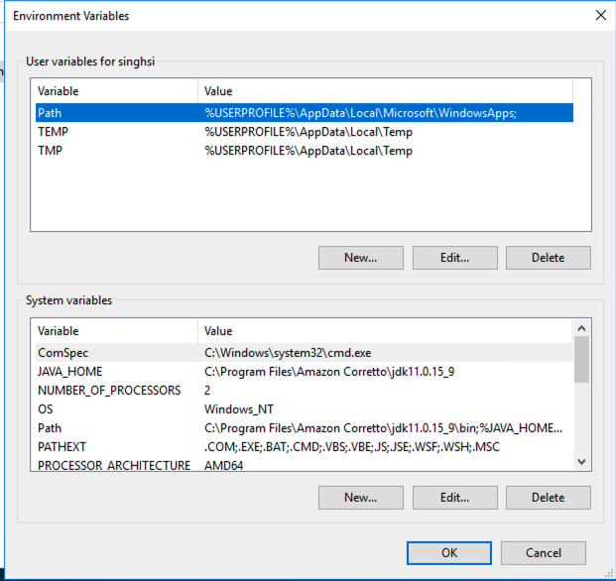
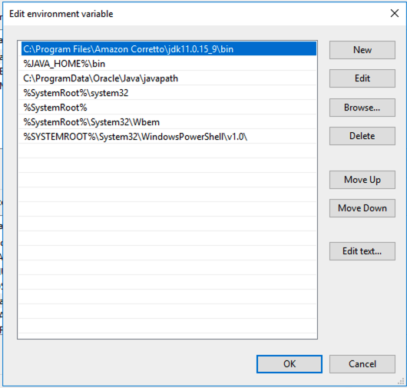
- Amazon Corretto MSI installer will set the required system environment variables.
If not, set system environment variables manually.
JAVA_HOME=C:\Program Files\Amazon Corretto\jdk11.0.15_9
PATH=%JAVA_HOME%\bin

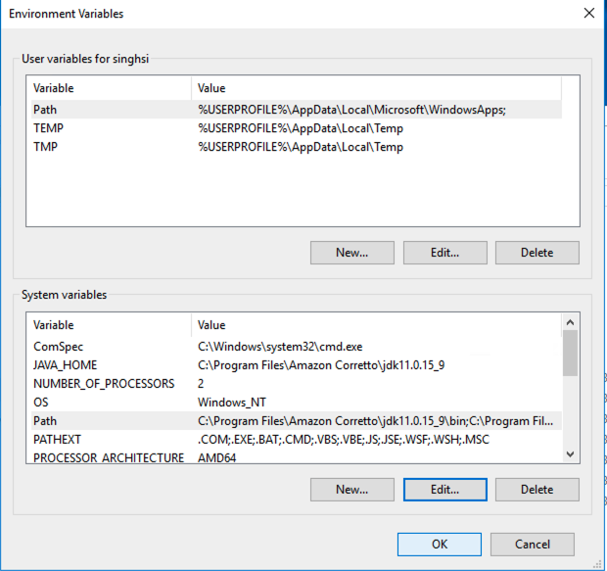

- Install Apache Tomcat - apache-tomcat-9.0.63
  - Welcome: Select “Next” button
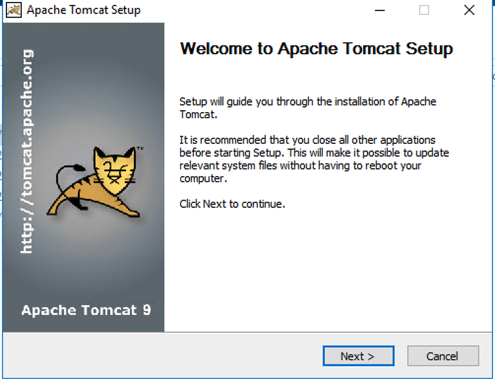
  - Accept license Agreement
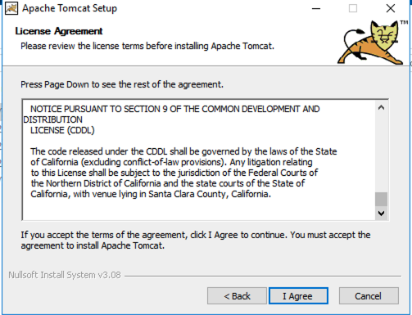
  - Select the type of install: Normal
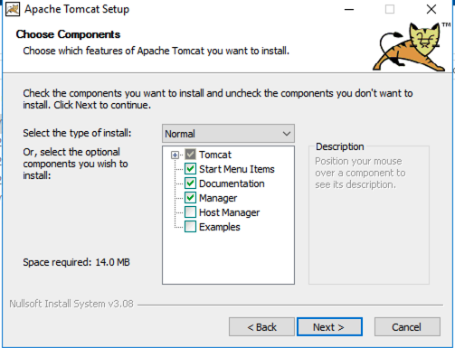
  - Add tomcat configuration and create admin username and password (admin/M!ch!g@n)
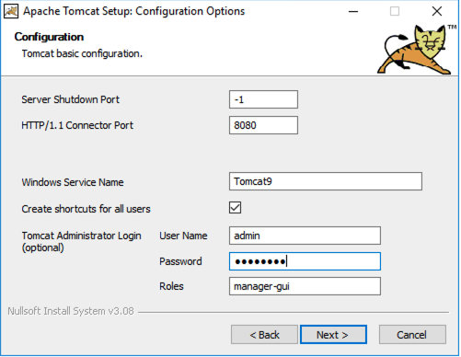
  - Select the Amazon Corrotto JRE path
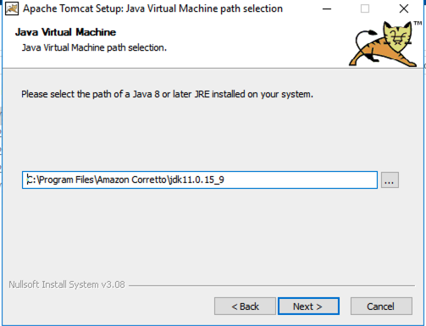
  - Choose Installation directory for Apache Tomcat and click install
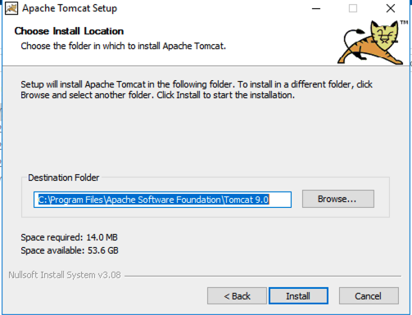
  - Uncheck both checkboxes and click on finish (Note the below screenshot has one of the boxes checked).
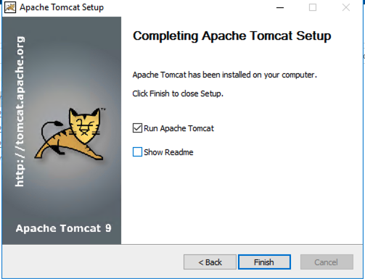
- Run Apache Tomcat
  - Open Command Prompt in Administrator mode and change directory to Tomcat “bin” directory
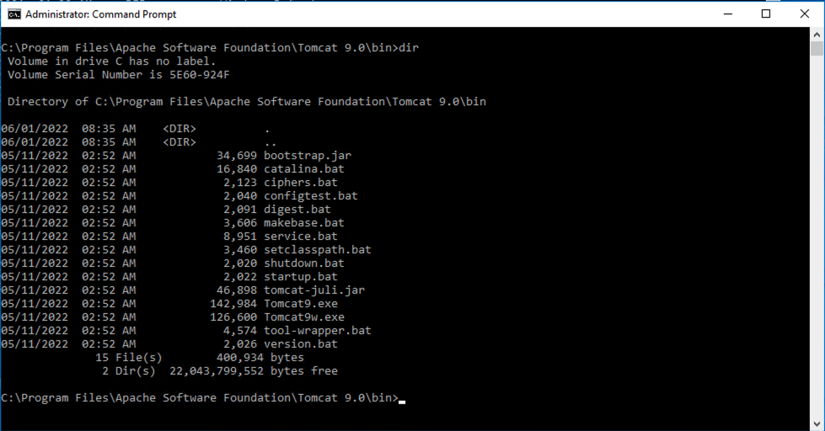
  - Run Tomcat using the Catalina.bat script and passing “start” as parameter
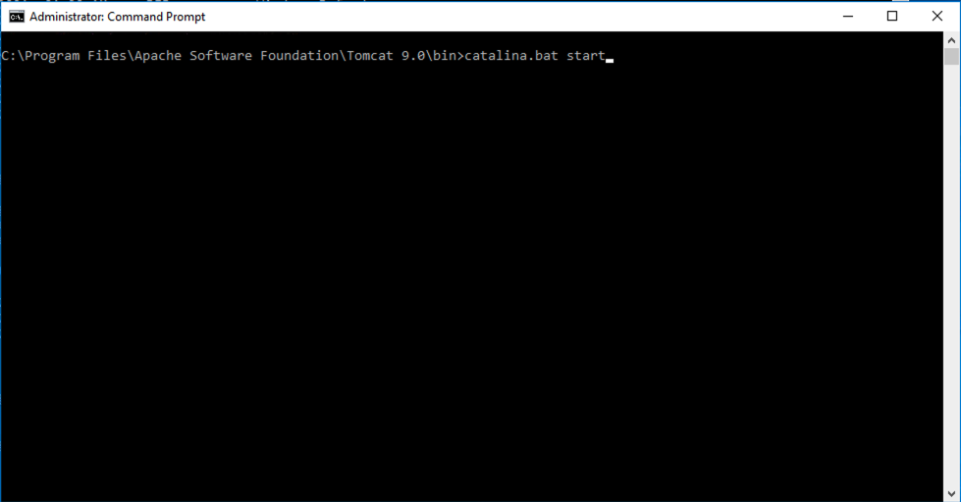
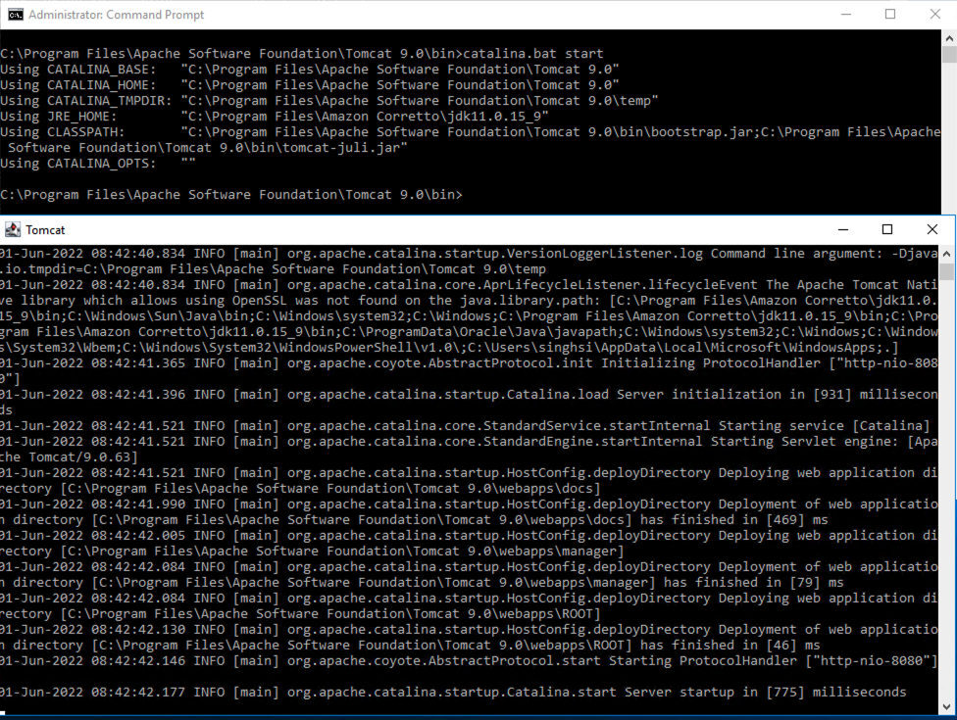
  - As an alternative, you can install tomcat by using service.bat in C:\Program Files\Apache Software Foundation\Tomcat 9.0\bin
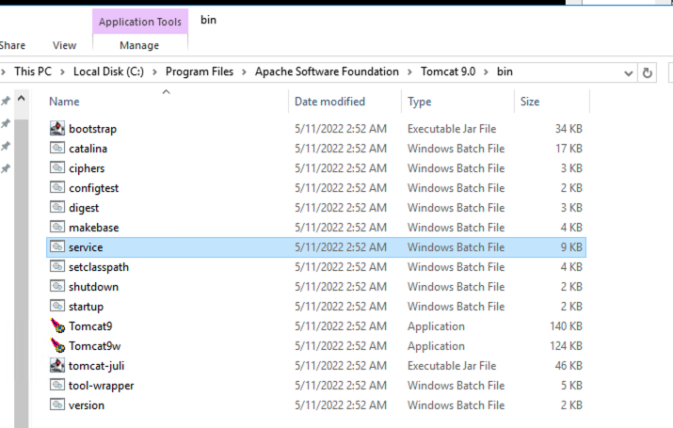

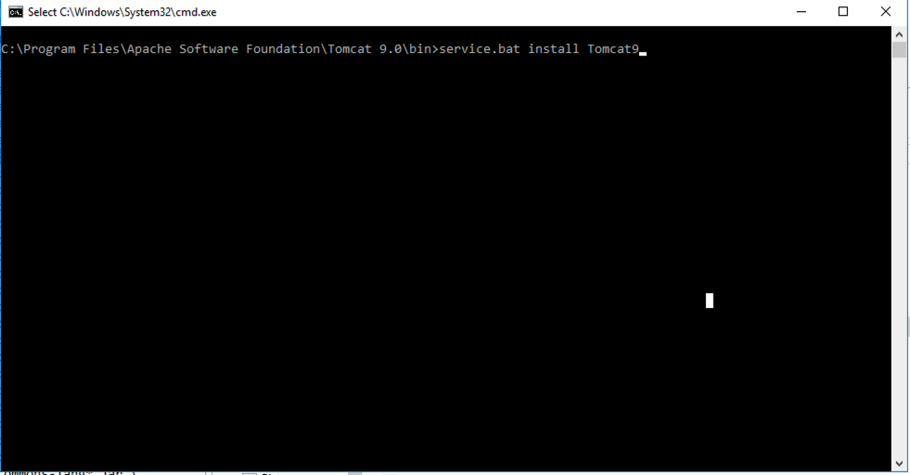

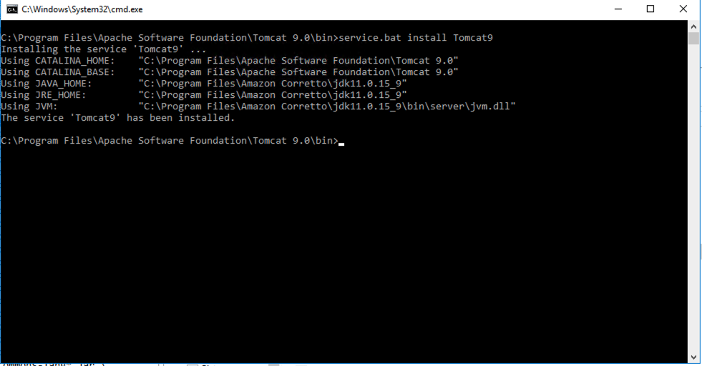

  - Verify in task manager, under services tab that Tomcat 9 service is installed
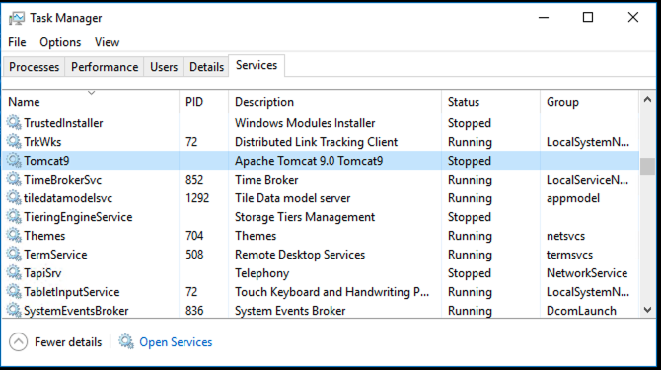

  - Right click of the service and start the service.
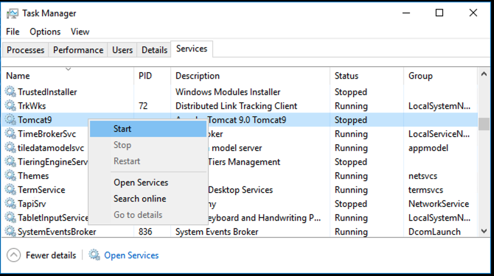
  - Open http://localhost:8080/ and verify tomcat is running
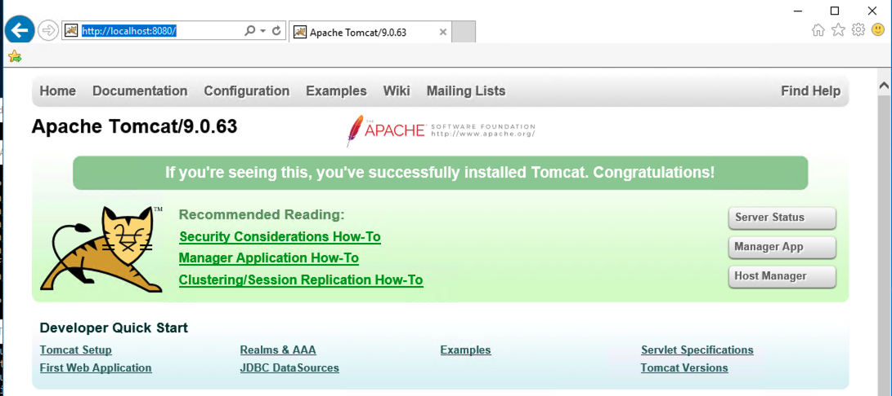
  - To install a web application click on “Manager App” and provide admin credentials
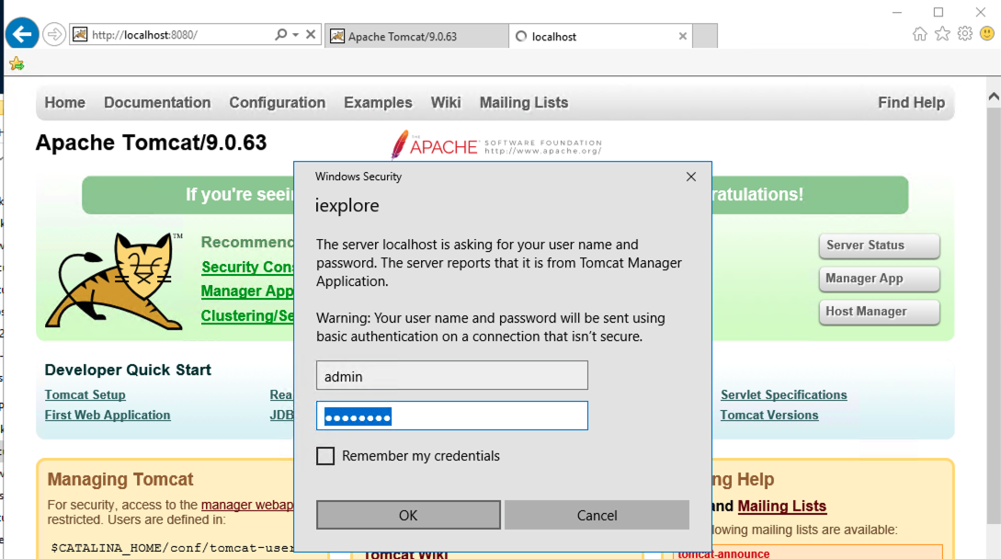
  - Copy the war file of the application to C:\Program Files\Apache Software Foundation\Tomcat 9.0\webapps. Tomcat will automatically detect the war and deploy the application.
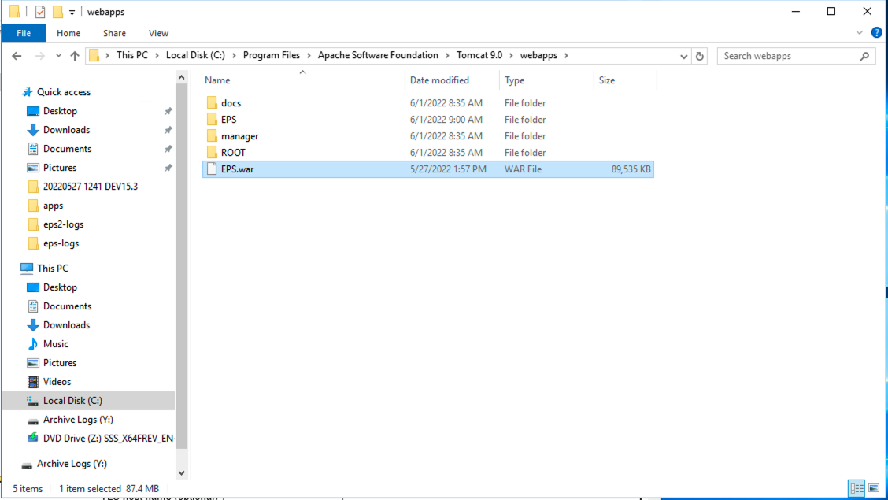
  - Go to the “Manager App” dashboard to view the deployed application status.
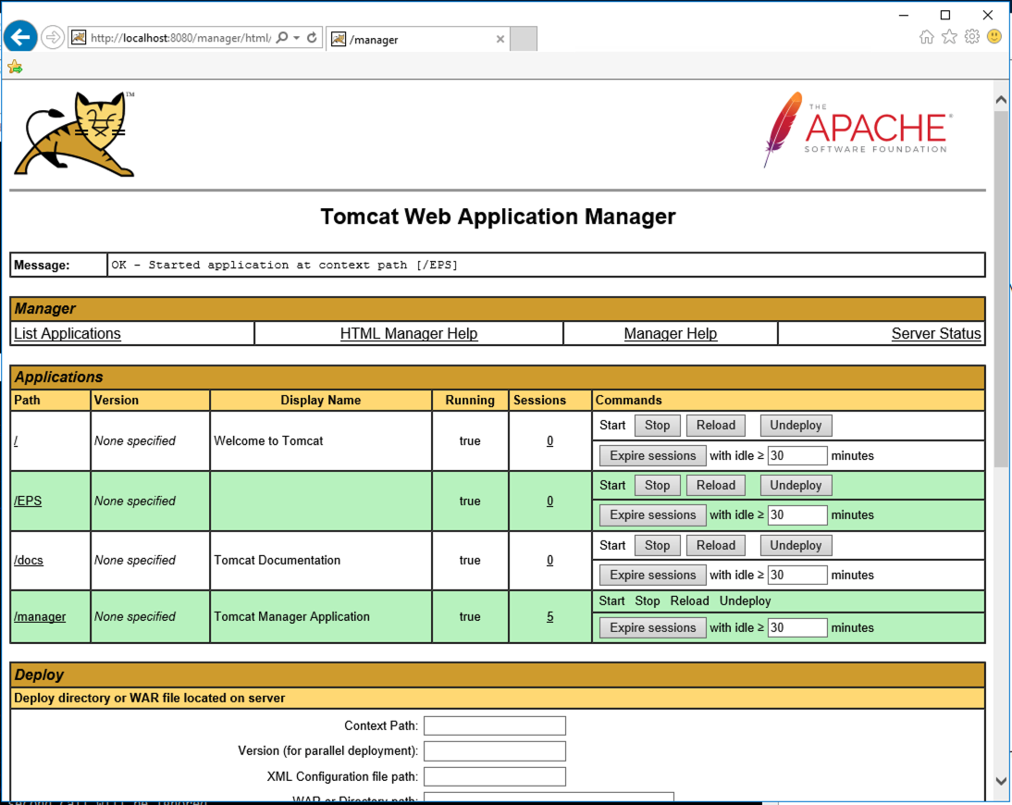

Tomcat Configuration

- In C:\Program Files\Apache Software Foundation\Tomcat 9.0\conf\catalina.properties, add bcprov*.jar to tomcat.util.scan.StandardJarScanFilter.jarsToSkip=.
  - This jar was added to JarsToSkip to resolve the EPS war deployment issue. When we tried to deploy the application the following error was thrown.
    - Unable to complete the scan for annotations for web application [/EPS] due to a StackOverflowError. Possible root causes include a too low setting for -Xss and illegal cyclic inheritance dependencies. The class hierarchy being processed was [org.bouncycastle.asn1.ASN1EncodableVector->org.bouncycastle.asn1.DEREncodableVector->org.bouncycastle.asn1.ASN1EncodableVector]

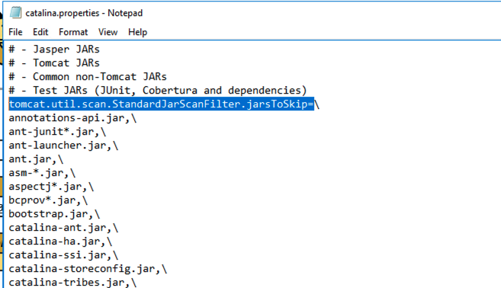
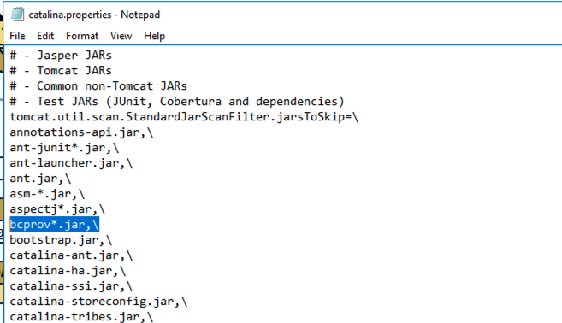

- The Deploy and war file to deploy results in war file not found issue. So, we are deploying webapp by deleting and adding new war into webapps folder.

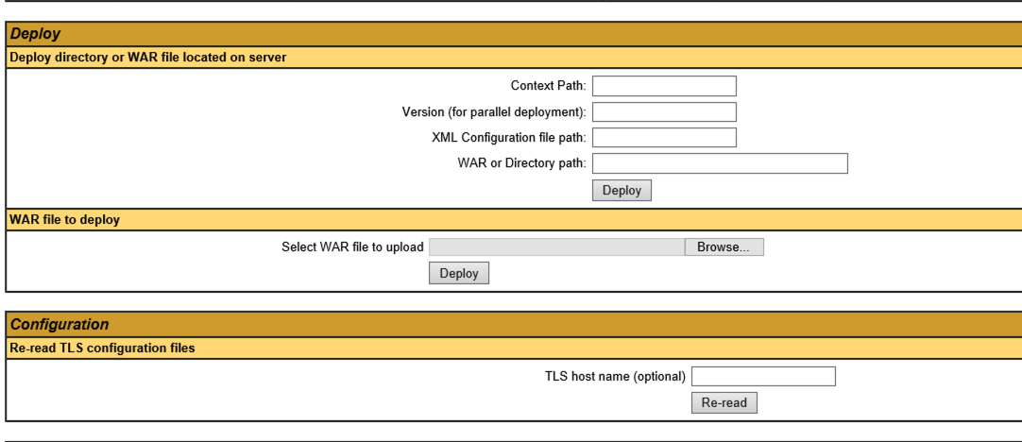

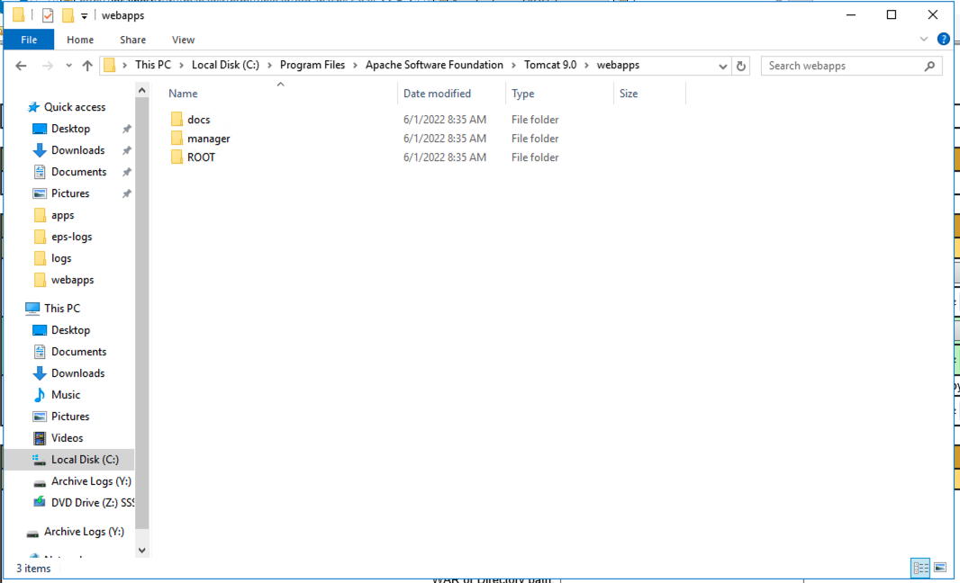

- After the paste the war file, EPS folder will be generated by Tomcat.

