* **Add Instance of DB Node-3 (secondary – 100.65.132.230)**

**On** [**DB Server :- 100.65.132.254**](mailto:dbadmin@100.65.132.254)

DB Node-1 (Primary – 100.65.132.254): -

#mysqlsh –uri [root@127.0.0.1:3306](mailto:root@127.0.0.1:3306)

Js> var cluster = dba.getCluster();

Js> cluster.status();

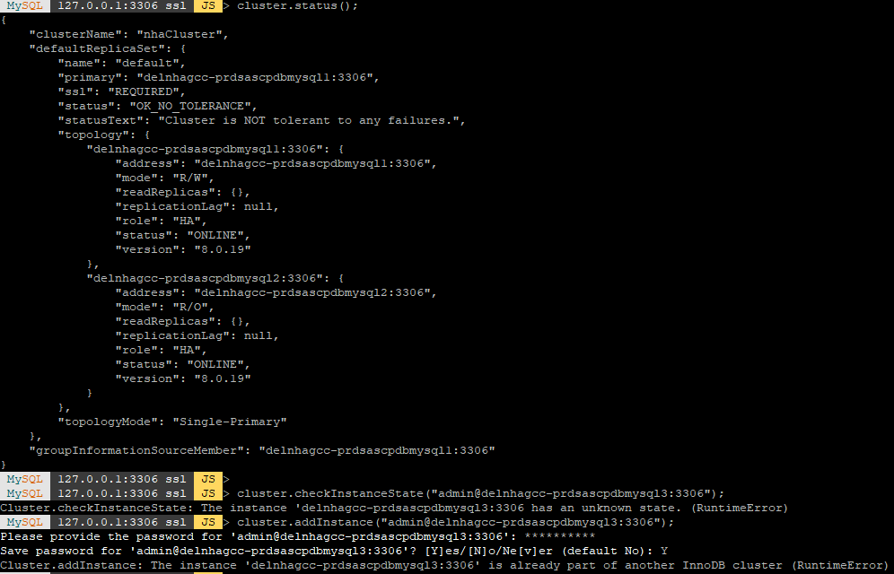

After google search, I found some solutions of above error in oracle support portal. I had try the steps of below this screen shot(according to the oracle support web portal).

Sql> stop group_replication;

Js> dba.dropMetadataSchema();

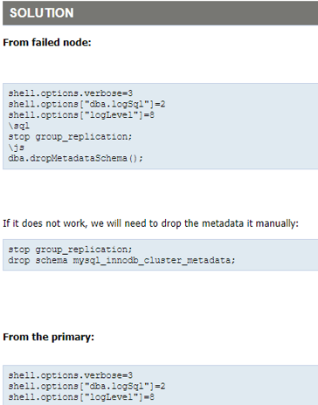

And then I fallow these steps.

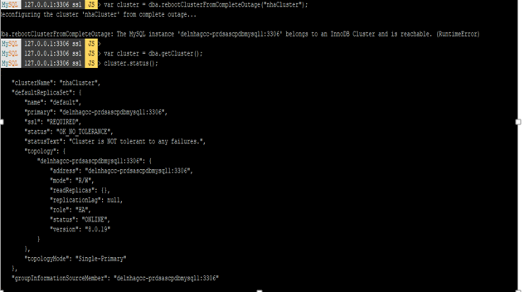

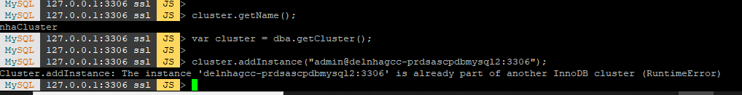

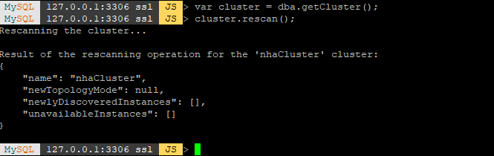

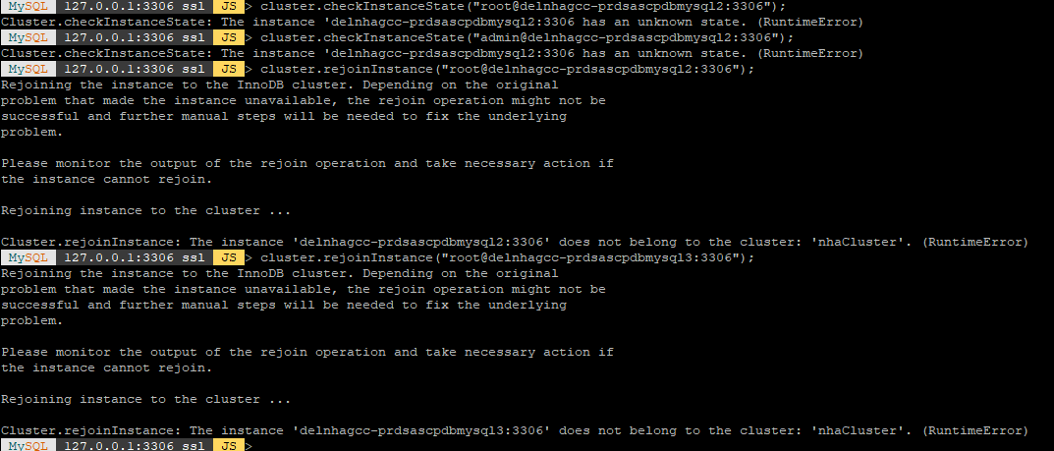

At last, I tries add and rejoin the instance in cluster. But I couldn’t add the instances in InnoDB Cluster.

* **Cause of Destroying InnoDB Cluster:** I was executed the command js> dba.dropMetadataSchema() and check global variable super_read_only=OFF on Pramary Server only.
* **After DB Node1 (Primary – 100.65.132.254) patching,**

At **DB Node1 (Primary – 100.65.132.254):** Again I am trying to add the Instance into innoDB Cluster after dba.rebootClusterFromCompleteOutage (); But I couldn’t add the instances in cluster.

At **DB Node2 (Secondary – 100.65.132.229):** - we are setting the global variable from super_read_only=ON to super_read_only=OFF.

Again we are trying to add instance into cluster with admin user (not root user).

Js> cluster.addInstance (“admin@delnhagcc-prdsascpdbmysql2:3306”);

And adding successfully this instance into InnoDB Cluster.

Same process follows these steps at DB Node-3 (Secondary - 100.65.132.230).

And finally, we are getting to recovery the InnoDB Cluster status.

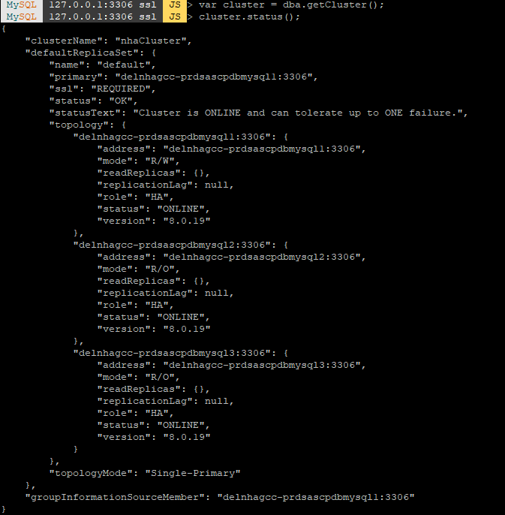

* **Sql> stop group_replication;**

[STOP GROUP_REPLICATION](https://dev.mysql.com/doc/refman/8.0/en/stop-group-replication.html) the member is set to [super_read_only=ON](https://dev.mysql.com/doc/refman/8.0/en/server-system-variables.html#sysvar_super_read_only), which ensures that no writes can be made to the member while Group Replication stops. Any other asynchronous replication channels running on the members are also stopped. Any user credentials that I specified in the [START GROUP_REPLICATION](https://dev.mysql.com/doc/refman/8.0/en/start-group-replication.html) statement when starting Group Replication on this member is removed from memory, and must be supplied when I start Group Replication again.

* **Js> dba.dropMetadataSchema();**

Dropping cluster metadata using MySQL Shell causes Router to drop all current connections and forbid new connections.