CHANDIGARH UNIVERSITY
PYTHON PROGRAMMING
M I N I P R O J E C T R E P O R T
LAST MINUTE
STUDY PLANNER

A smart Python-based exam preparation scheduler
Submitted by | Sukhbeer Singh
UID | 25bcd10043
Section | 25bcd1
Group | B
Submitted to | Mr. Ishant Bharol
Designation | Professor
Course | Python Programming

Plan smart • Study smarter • Ace the exam

About this report
Acknowledgement  I would like to express my sincere gratitude to my faculty, Mr. Ishant Bharol (Professor), for his guidance, encouragement and valuable feedback throughout the Python Programming course. His teaching helped me understand the core concepts of Python, which I applied while building this mini project.  I also thank Chandigarh University for the learning environment and resources, and my friends and family for their constant support. |  | Declaration  I, Sukhbeer Singh (UID: 25bcd10043), hereby declare that the mini project titled “Last Minute Study Planner” is my own work, carried out as part of the Python Programming course.  The sources and references that I used while preparing this project have been listed at the end of this report.
Table of Contents
01 Introduction 2
02 Problem Statement 3
03 Objectives of the Project 3
04 Scope and Limitations 3
05 Tools and Technologies Used 3
06 System Design 4
07 Priority Scoring Algorithm 5
08 Complete Source Code 6
09 Code Explanation 8
10 Sample Output 10
11 Testing and Results 11
12 Advantages of the Project 11
13 Future Scope 11
14 Conclusion 11
15 GitHub Repository 12
16 References 13

01 Introduction
Every student has faced this situation: the exam is only a few days away, the syllabus is large, and there is no clear idea of where to start. Most of the precious time is wasted on deciding what to study first instead of actually studying. Students often spend hours on the subjects they already like and ignore the difficult ones until it is too late.
The Last Minute Study Planner is a Python mini project designed to solve exactly this problem. The user enters the subjects, exam dates, difficulty level and their own confidence in each subject. The program then calculates a priority score for every subject and distributes the available daily study hours across the remaining days, giving more time to subjects that are difficult, urgent and weak.
The project is built entirely with core Python and its standard library (datetime, json and os). It needs no external package, so it is lightweight and runs on any system. It also demonstrates fundamental programming concepts such as functions, loops, conditionals, dictionaries, lists, file handling and exception handling.

12  Functions | 3  Standard modules | 0  External libraries | 195  Lines of code

02 Problem Statement
Students who begin preparing close to their exams face the following problems:
- No clear plan: they do not know how to divide limited time between several subjects.
- Poor prioritisation: easy or favourite subjects get more time than difficult or weak ones.
- Ignoring deadlines: subjects with nearer exam dates are not given enough urgency.
- Manual planning is slow: a hand-made timetable takes time and must be redone whenever something changes.
- No record: plans made on paper are easily lost and difficult to update.

The need
A simple tool that takes a few basic inputs from the student and produces a logical, realistic study schedule within seconds.

03 Objectives of the Project
- To design a Python program that generates a personalised last-minute study schedule.
- To calculate a priority score for each subject using difficulty, confidence, exam urgency and pending topics.
- To divide the daily available study hours among all active subjects in proportion to priority.
- To store subject data permanently in a JSON file so that it is not lost when the program closes.
- To validate every user input and prevent the program from crashing on wrong entries.
- To let the user track progress by updating the number of topics completed.
- To apply the core concepts of the Python Programming course in a practical, real-life project.

04 Scope and Limitations
Scope  - Suitable for school and college students preparing for several exams at once.  - Works fully offline on any computer with Python 3.  - Handles any number of subjects and any daily study time.  - Easy to extend into a GUI, web or mobile app. | Limitations  - Console based: there is no graphical interface yet.  - Priority depends on the honesty of the ratings entered.  - Time is divided in half-hour blocks and does not include breaks.  - No reminders or notifications.

05 Tools and Technologies Used
Component | Details
Programming language | Python 3.x
Standard modules | datetime, json, os
Editor / IDE | VS Code / IDLE / PyCharm
Data storage | JSON file (planner_data.json)
Version control | Git and GitHub
Operating system | Windows / Linux / macOS

Python was chosen for its simple, readable syntax, its powerful built-in lists and dictionaries, and its strong standard library. The three modules used are: datetime (exam dates, today’s date and days left), json (saving and loading the subject list in a readable file) and os (checking whether the data file already exists).
How to run the project
1. Install Python 3 from python.org and save the code as planner.py.
2. Open a terminal in that folder and type python planner.py.
3. Follow the on-screen menu: add subjects, then choose “Generate study plan”.

06 System Design

6.1 Working of the system
The program is menu driven. It loads the saved subjects, shows the main menu and calls the function for the chosen option. After every change the data is written to the JSON file, and the loop continues until the user selects Exit.
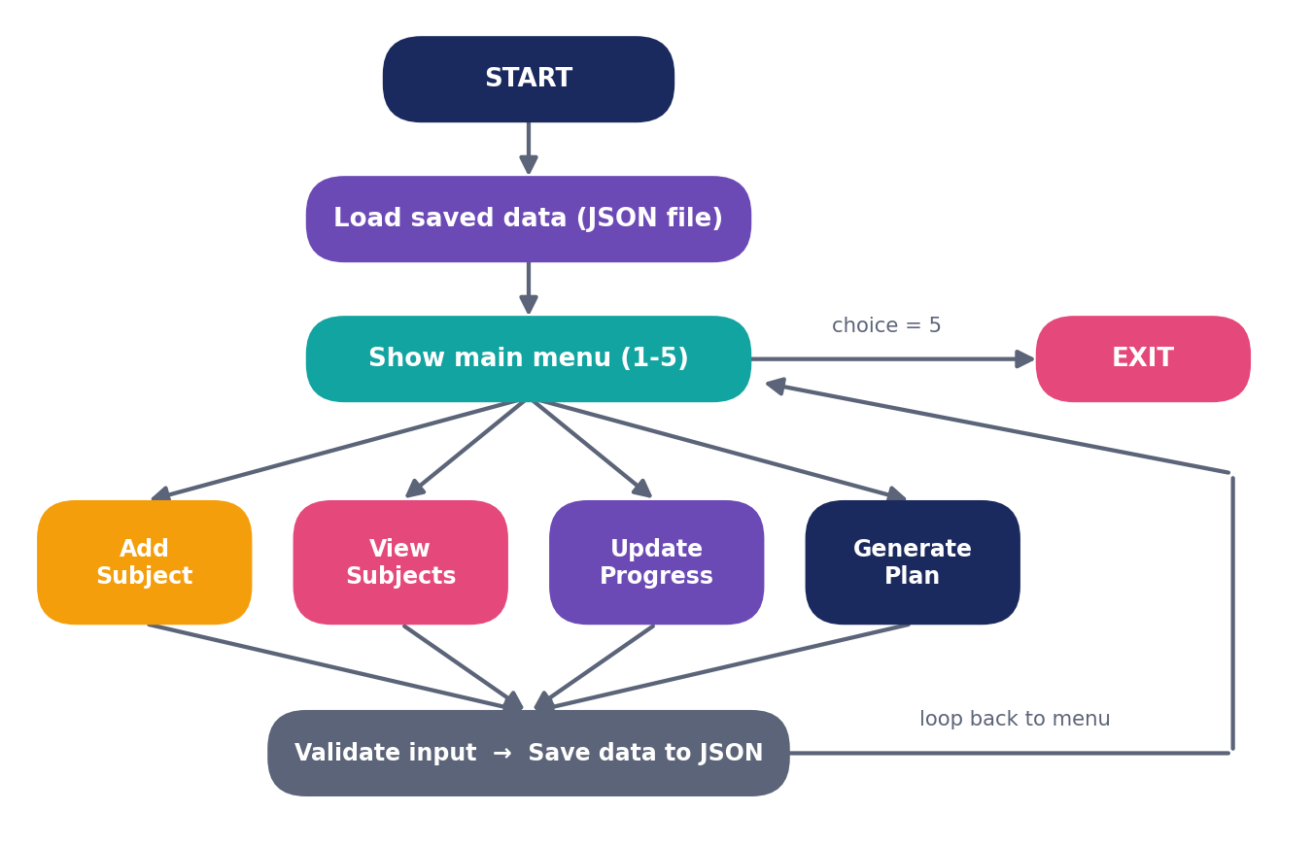
Figure 1: Flow of the Last Minute Study Planner

6.2 Data structure
Each subject is a Python dictionary and all subjects are stored together in a list, which is saved as JSON.
Key | Type | Meaning
name | string | Name of the subject
exam_date | string | Exam date in DD-MM-YYYY format
difficulty | integer (1-5) | How difficult the subject is
confidence | integer (1-5) | How well-prepared the student feels
total_topics | integer | Total number of topics in the syllabus
done_topics | integer | Topics completed so far

6.3 Functions of the program
Function | Purpose
load_data() / save_data() | Read and write the subject list in the JSON file
read_int() / read_date() | Take validated numbers and future dates from the user
add_subject() | Add a new subject to the list
days_left() | Return the number of days left for an exam
view_subjects() | Display all subjects with their progress
update_progress() | Update the completed topics of a subject
priority_score() | Calculate the priority of a subject
generate_plan() / show_plan() | Create and print the day-wise study schedule
main() | Run the menu loop

07 Priority Scoring Algorithm
The heart of the project is the priority score. A subject should get more time if it is difficult, if the student is not confident about it, if the exam is near, and if many topics are still pending.
Priority Score
Score = 0.30 × Difficulty + 0.25 × Weakness + 0.30 × Urgency + 0.15 × Pending

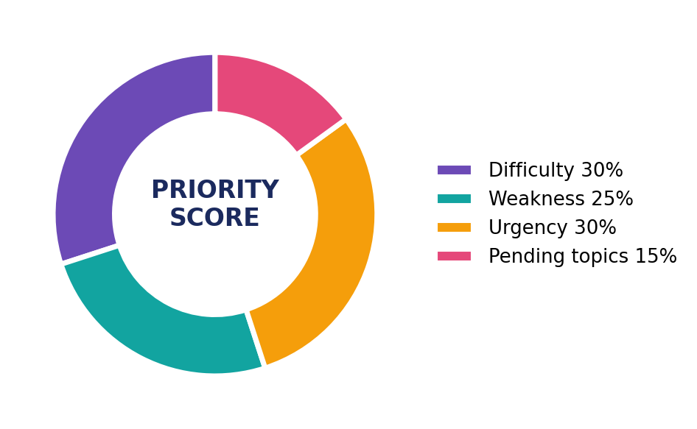  Figure 2: Weight of each factor | Weakness = 6 − Confidence  Urgency = 5 if the exam is within 3 days, 4 within 7 days, 3 within 14 days, 2 within 30 days, otherwise 1  Pending = (remaining topics ÷ total topics) × 5  Every subject keeps a minimum score of 0.1, so no subject ever gets zero time.

7.1 Time allocation
For every day of the plan, the daily study hours are divided among all subjects whose exams are not over yet:
Hours for a subject = Daily hours × (Subject score ÷ Sum of all active scores)
The result is rounded to the nearest half hour so that the schedule stays practical.

7.2 Algorithm (step by step)
- Start and load the saved data from the file.
- Ask the user for the number of study hours available per day.
- Calculate the priority score of every subject.
- For each day from today, select the subjects whose exam is not yet over.
- Add up the scores of the selected subjects.
- Allocate hours to each subject in proportion to its score.
- Print the schedule as a table and stop.

08 Complete Source Code
The complete program is a single file, planner.py. The code below is shown with syntax colouring.
● ● ● planner.py
"""
Last Minute Study Planner
Python Programming Mini Project - Chandigarh University
Author: Sukhbeer Singh (UID: 25bcd10043)
"""

import json
import os
from datetime import date, datetime, timedelta

DATA_FILE = "planner_data.json"
DATE_FORMAT = "%d-%m-%Y"

def load_data():
"""Load subjects from the JSON file (empty list if no file)."""
if os.path.exists(DATA_FILE):
with open(DATA_FILE, "r") as file:
return json.load(file)
return []

def save_data(subjects):
"""Save subjects to the JSON file."""
with open(DATA_FILE, "w") as file:
json.dump(subjects, file, indent=4)

def read_int(prompt, low, high):
"""Keep asking until the user enters an integer in [low, high]."""
while True:
try:
value = int(input(prompt))
if low <= value <= high:
return value
print(f" Please enter a number between {low} and {high}.")
except ValueError:
print(" Invalid input. Please enter a number.")

def read_date(prompt):
"""Keep asking until the user enters a valid future date."""
while True:
text = input(prompt)
try:
exam = datetime.strptime(text, DATE_FORMAT).date()
if exam >= date.today():
return text
print(" Exam date cannot be in the past.")
except ValueError:
print(" Wrong format. Use DD-MM-YYYY.")

def add_subject(subjects):
"""Take subject details from the user and add them to the list."""
name = input("Subject name: ").strip().title()
if not name:
print(" Subject name cannot be empty.")
return
subject = {
"name": name,
"exam_date": read_date("Exam date (DD-MM-YYYY): "),
"difficulty": read_int("Difficulty (1-5): ", 1, 5),
"confidence": read_int("Your confidence (1-5): ", 1, 5),
"total_topics": read_int("Total topics in syllabus: ", 1, 100),
"done_topics": 0,
}
subjects.append(subject)
save_data(subjects)
print(f" '{name}' added successfully!")

def days_left(subject):
"""Return the number of days left for the exam."""
exam = datetime.strptime(subject["exam_date"], DATE_FORMAT).date()
return (exam - date.today()).days

def view_subjects(subjects):
"""Display all subjects with progress."""
if not subjects:
print(" No subjects added yet.")
return
print(f"\n{'No':<4}{'Subject':<20}{'Exam Date':<13}{'Days':<6}{'Progress'}")
print("-" * 55)
for i, s in enumerate(subjects, 1):
progress = f"{s['done_topics']}/{s['total_topics']}"
print(f"{i:<4}{s['name']:<20}{s['exam_date']:<13}{days_left(s):<6}{progress}")

def update_progress(subjects):
"""Update the number of topics completed for a subject."""
view_subjects(subjects)
if not subjects:
return
index = read_int("Select subject number: ", 1, len(subjects)) - 1
subject = subjects[index]
subject["done_topics"] = read_int(
"Topics completed so far: ", 0, subject["total_topics"]
)
save_data(subjects)
print(" Progress updated!")

def priority_score(subject):
"""Calculate the priority score of a subject."""
left = days_left(subject)
if left <= 3:
urgency = 5
elif left <= 7:
urgency = 4
elif left <= 14:
urgency = 3
elif left <= 30:
urgency = 2
else:
urgency = 1

weakness = 6 - subject["confidence"]
pending = (1 - subject["done_topics"] / subject["total_topics"]) * 5

score = (0.30 * subject["difficulty"] + 0.25 * weakness
+ 0.30 * urgency + 0.15 * pending)
return round(max(score, 0.1), 2)

def generate_plan(subjects, hours_per_day, max_days=7):
"""Create a day-wise plan as a list of (date, subject, hours)."""
plan = []
today = date.today()
for i in range(max_days):
day = today + timedelta(days=i)
active = [s for s in subjects
if datetime.strptime(s["exam_date"], DATE_FORMAT).date() >= day]
if not active:
break
total = sum(priority_score(s) for s in active)
for s in active:
hours = round(hours_per_day * priority_score(s) / total * 2) / 2
if hours > 0:
plan.append((day, s["name"], hours))
return plan

def show_plan(subjects):
"""Ask for daily hours and print the study plan."""
if not subjects:
print(" Add at least one subject first.")
return
hours = read_int("Study hours available per day (1-16): ", 1, 16)
plan = generate_plan(subjects, hours)

print("\nPRIORITY RANKING")
print("-" * 35)
ranked = sorted(subjects, key=priority_score, reverse=True)
for rank, s in enumerate(ranked, 1):
print(f"{rank}. {s['name']:<20} score = {priority_score(s)}")

print(f"\n{'DATE':<14}{'SUBJECT':<22}{'HOURS'}")
print("-" * 45)
last_day = None
for day, name, hrs in plan:
label = day.strftime("%d-%m-%Y") if day != last_day else ""
print(f"{label:<14}{name:<22}{hrs}")
last_day = day

def main():
subjects = load_data()
while True:
print("\n===== LAST MINUTE STUDY PLANNER =====")
print("1. Add subject")
print("2. View subjects")
print("3. Update progress")
print("4. Generate study plan")
print("5. Exit")
choice = input("Enter your choice: ").strip()

if choice == "1":
add_subject(subjects)
elif choice == "2":
view_subjects(subjects)
elif choice == "3":
update_progress(subjects)
elif choice == "4":
show_plan(subjects)
elif choice == "5":
print("All the best for your exams!")
break
else:
print(" Invalid choice. Please select 1-5.")

if __name__ == "__main__":
main()

09 Code Explanation
Part of the code | What it does
Imports and constants | Imports json, os and datetime. DATA_FILE and DATE_FORMAT are defined once at the top so they are easy to change.
File handling | load_data() checks the file with os.path.exists() and reads it with json.load(). save_data() writes with json.dump() and indent=4, giving permanent storage without a database.
Input validation | read_int() and read_date() use a while True loop with try-except. A ValueError is caught and the question is asked again; past dates are rejected.
Adding and viewing | add_subject() builds a dictionary and appends it to the list. view_subjects() uses enumerate() and f-string alignment such as {s['name']:<20} for a neat table.
Updating progress | update_progress() lets the user enter completed topics. As progress grows, the pending part of the score falls and attention moves to other subjects.
Priority calculation | priority_score() turns days left into urgency with an if-elif-else ladder, then combines the four factors with the weighted formula.
Plan generation | generate_plan() loops through the next 7 days, picks active subjects with a list comprehension and shares the hours using round(x * 2) / 2.
Main menu | main() runs an infinite loop and calls the right function. if __name__ == "__main__" makes the program run only when executed directly.

Python concepts demonstrated
Variables and data types • Lists and dictionaries • Functions • for and while loops • Conditionals • Exception handling • File handling • List comprehension • f-string formatting • Date and time handling

10 Sample Output
The program was run with three subjects: Mathematics (exam in 3 days, difficulty 4, confidence 2), DBMS (5 days, difficulty 3, confidence 3) and Python (9 days, difficulty 2, confidence 4), with 8 study hours per day. The output below is the real output of that run (22-10-2026).
● ● ● Terminal — python planner.py
No Subject Exam Date Days Progress
-------------------------------------------------------
1 Mathematics 25-10-2026 3 0/20
2 Dbms 27-10-2026 5 0/15
3 Python 31-10-2026 9 0/10

PRIORITY RANKING
-----------------------------------
1. Mathematics score = 4.15
2. Dbms score = 3.6
3. Python score = 2.75

DATE SUBJECT HOURS
---------------------------------------------
22-10-2026 Mathematics 3.0
Dbms 2.5
Python 2.0
23-10-2026 Mathematics 3.0
Dbms 2.5
Python 2.0
24-10-2026 Mathematics 3.0
Dbms 2.5
Python 2.0
25-10-2026 Mathematics 3.0
Dbms 2.5
Python 2.0
26-10-2026 Dbms 4.5
Python 3.5
27-10-2026 Dbms 4.5
Python 3.5
28-10-2026 Python 8.0

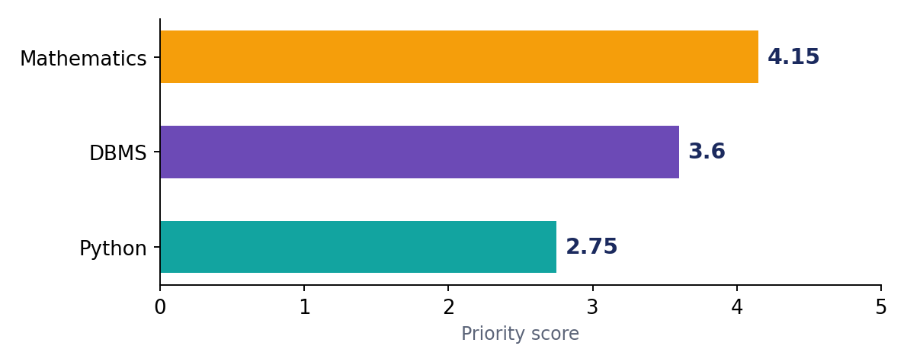  Figure 3: Priority scores | 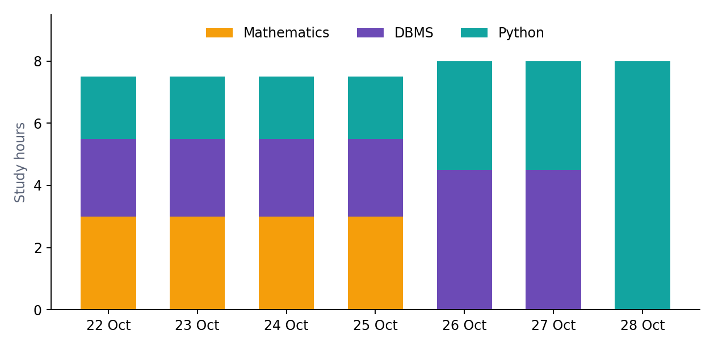  Figure 4: Study hours per day
Mathematics has the nearest exam and the lowest confidence, so it gets the highest score and the most hours. Once its exam is over, its hours automatically move to the remaining subjects; on the last day Python gets all 8 hours.

11 Testing and Results
Every module was tested with valid and invalid inputs. All ten test cases below were run on the final program.
No. | Test case | Input | Result observed | Status
1 | Add valid subject | Maths, valid date, 4, 2, 20 | Subject saved successfully | ✔ Pass
2 | Wrong date format | 2026/11/05 | Error message, asks again | ✔ Pass
3 | Past exam date | 01-01-2020 | Rejected with message | ✔ Pass
4 | Text instead of number | "abc" for difficulty | Error message, no crash | ✔ Pass
5 | Out-of-range rating | Difficulty = 9 | Asks for 1-5 again | ✔ Pass
6 | Empty subject name | Enter pressed | Subject not added | ✔ Pass
7 | Plan with no data | Option 4 on empty list | Asks to add a subject first | ✔ Pass
8 | Update progress | 10 of 20 topics | Progress saved (10/20) | ✔ Pass
9 | Restart the program | Close and reopen | Old subjects reloaded from file | ✔ Pass
10 | Invalid menu choice | 9 | Invalid choice message | ✔ Pass

Result
The project fulfilled all its objectives. The planner produced a logical schedule in every test, handled wrong inputs without crashing, and preserved data between sessions.

12 Advantages of the Project
- Saves time: a complete plan in seconds.  - Smart prioritisation: weak, difficult and urgent subjects get more time.  - No installation problems: only core Python is needed.  - Data is saved: subjects remain available next time. | - Beginner friendly: simple, modular, well-commented code.  - Flexible: the weights of the formula can be changed.  - Reduces stress: the student knows what to study each day.

13 Future Scope
- Graphical interface using Tkinter or PyQt.  - Web or mobile version using Flask, Django or Kivy.  - Reminders by email or desktop notifications.  - Pomodoro timer with short breaks between sessions. | - Charts of progress using Matplotlib.  - Export the timetable to PDF or Excel.  - AI suggestions that learn from past performance.  - Cloud sync so the plan is available on every device.

14 Conclusion
The Last Minute Study Planner shows how Python can solve a real problem faced by students. By combining simple inputs such as difficulty, confidence and exam date, the program calculates a fair priority for every subject and prepares a clear day-wise schedule. The use of functions, dictionaries, loops, exception handling and file handling made the project a valuable exercise in the concepts covered in the Python Programming course.
Through this mini project I learned how to break a problem into smaller modules, validate user input, store data permanently and present output in a clean format. Although the current version is console based, it is a strong foundation that can be extended into a full application. Overall, the project meets its objectives and shows that even a small Python program can make a real difference to a student’s exam preparation.

15 GitHub Repository
The complete source code of this project is uploaded on GitHub:
GitHub Link
https://github.com/YOUR-USERNAME/last-minute-study-planner

Screenshot of the GitHub repository
(paste your repository screenshot here)

16 References
- Python Software Foundation. Python 3 Documentation. https://docs.python.org/3/
- Python Software Foundation. datetime – Basic date and time types. https://docs.python.org/3/library/datetime.html
- Python Software Foundation. json – JSON encoder and decoder. https://docs.python.org/3/library/json.html
- Python Software Foundation. os – Miscellaneous operating system interfaces. https://docs.python.org/3/library/os.html
- Matthes, E. Python Crash Course. No Starch Press.
- Downey, A. Think Python: How to Think Like a Computer Scientist. O’Reilly Media.
- Sweigart, A. Automate the Boring Stuff with Python. No Starch Press.
- GitHub Docs. Hello World – GitHub Guides. https://docs.github.com/en/get-started/start-your-journey/hello-world
- Chandigarh University. Python Programming Course Material.

