PROGRESS REPORT
Plaksha Streams Multi-Pipeline Kafka Video Analytics System
Phase 2 Stabilisation & Daily CSV Handoff Architecture

Report Date | May 21, 2026
Author | Tejpreet Singh
Role | Research Intern
Organisation | Plaksha University — Dixon IoT Lab
Project | End-to-End Real-Time Multi-Pipeline Kafka Video Analytics(PALL)
Coverage Period | May 8 – May 20, 2026
Commits Covered | f8342bc → ddb199e (branch: main) GITEA
Production Server | NVIDIA L40S — 10.1.41.46
Data Science Server | HPC-1 — 10.1.40.43

INTERNAL — RESTRICTED | Plaksha University Dixon IoT Lab. Do not distribute externally.

1. Executive Summary
This report documents engineering work completed between May 8 and May 20, 2026 on the Plaksha Streams multi-pipeline Kafka video analytics system. Work spanned two parallel tracks:
Track | Scope | Outcome
Phase 2 Consumer Stabilisation | Three targeted bug fixes to the Kafka consumer addressing partition selection logic, unsupported config parameters, and batch-timing measurement windows. | All 6 previously-dead cameras restored to live inference.
Daily CSV Rotation & Data Handoff | Architectural upgrade to output strategy: day-wise CSV files, automated secure rsync to Data Science HPC-1, and supporting maintenance tooling. | Data Science team has automated daily access to structured analytics. Video feeds remain isolated on the production server.
The pipeline processes three concurrent AI inference workloads — Animal Detection (AN), Head Count (HC), and Entry/Exit (EE) — across multiple live RTSP camera feeds, running 24/7 on an NVIDIA L40S GPU server.
2. System Architecture Overview
The system is a multi-stage real-time data pipeline that ingests RTSP video streams, publishes encoded frames to Kafka topics, performs GPU-accelerated inference on a consumer service, writes analytics to structured CSVs, and streams live results to a web dashboard.
2.1 System Components
Component | Technology | Host | Role
RTSP Producers (×10) | Python / OpenCV / confluent-kafka | 10.1.41.56 (L40S) | Capture and publish encoded frames to Kafka topics
Kafka Broker | Apache Kafka | 10.1.41.56 | Topic-based message bus; one topic per camera
Multi-Pipeline Consumer | Python / kafka-python / PyTorch / TF | 10.1.41.56 (L40S) | Run AN/HC/EE inference, write CSVs, serve dashboard
Live Dashboard | Flask-SocketIO / WebSocket | 10.1.41.56 — port 8675 | Real-time per-camera feed and analytics overlay
CSV Output Store | /data/multi_pipeline_consumer/output/ | 10.1.41.56 | Day-wise dated CSV files per camera per pipeline
Backup Store | /data/Plaksha_streams_backup/ | 10.1.41.56 | Timestamped snapshots of output/ and logs/
HPC-1 Data Science Server | rsync over SSH (Ed25519) | 10.1.40.43 (HPC-1) | Receives CSV-only sync every 60 seconds via cron
2.2 Active Inference Pipelines
Pipeline | Model | Output Metrics | CSV Rotation Pattern
Animal Detection (AN) | YOLOv8m — custom weights | Detection count, confidence, bounding box stats | YYYY-MM-DD_{cam}_AN.csv
Head Count (HC) | YOLOv8 — person detection | Per-frame count, rolling stats (mean, peak) | YYYY-MM-DD_{cam}_HC.csv
Head Count Buckets (HC) | YOLOv8 — aggregation | Time-windowed occupancy buckets for trend analysis | YYYY-MM-DD_{cam}_HC_bucket.csv
Entry / Exit (EE) | YOLOv9 + ByteTrack | Entry count, exit count, net delta per 5-min interval | YYYY-MM-DD_{cam}_EE.csv

3. Phase 2 Consumer Stabilisation — Bug Fixes (May 8–13)
Phase 2 built on Phase 1 stability work which resolved exit-139 segfaults caused by eventlet.monkey_patch() conflicting with CUDA/TensorFlow C-level threads. Three targeted bugs were identified and resolved on May 8, followed by a consolidated final build on May 13.
3.1 Fix Summary
Fix ID | Commit | Date | Description | Impact
FIX-P2-A | f8342bc | May 8 | Removed unsupported group_instance_id parameter from KafkaConsumer config. This is a broker-side static membership feature not exposed in kafka-python. | Silent TypeError on startup; consumer failed to initialise cleanly.
FIX-P2-B | 84a54bd | May 8 | Refactored dominant partition selection from absolute-offset-based to delta-based: snapshot offsets twice, choose partition with greatest growth. | 6 of 10 cameras showed frozen/dead feeds — historical partitions selected over live ones.
FIX-P2-C | 3ea0c04 | May 8 | Increased partition offset sample window to 3.5 seconds to exceed the 2.7-second Kafka producer batching window. | Delta measurement undersampled batches, causing incorrect partition selection even after FIX-P2-B.
FIX-P2-FINAL | 01d6a26 | May 13 | Consolidated final Phase 2 build: all fixes integrated, per-camera consumer group isolation confirmed, shutdown paths hardened. 359 additions / 354 deletions. | Production-ready build — deployed to L40S.
3.2 Root Cause: Partition Selection Logic
The original consumer selected the Kafka partition to consume from by querying committed offsets and picking the partition with the highest absolute value. On cameras with historical backlogs, older inactive partitions had accumulated large offsets from past sessions, ranking above the live partition and causing 6 cameras to appear frozen.
The replacement approach samples the rate of change in partition offsets over a 3.5-second window. Only partitions actively receiving new frames show offset growth. The 3.5-second window is specifically sized to exceed the producer's 2.7-second message batching interval, ensuring at least one complete batch cycle is captured.
3.3 Phase 1 Stability Foundation (Carried Forward)
Fix ID | Description
FIX-T1 | Removed eventlet + monkey_patch() — eliminated exit-139 segfaults under CUDA
FIX-T2 | Set SocketIO async_mode='threading' — CUDA-safe WebSocket server
FIX-T3 | Split GPU semaphores: _pytorch_sem=Semaphore(3), _tf_sem=Semaphore(2)
FIX-T4 | Added torch.cuda.synchronize() in AN pipeline after model.track()
FIX-E1 | Delta-based partition detection (developed in Phase 1 as emergency fix)
FIX-E2 | Video rotation every 18,000 frames (~16 min) to prevent AVI corruption (8.5 GB frozen video bug)
FIX-E3 | Dynamic lag-based frame skipping: if Kafka lag > 3s, skip GPU inference to catch up to real-time

4. Daily CSV Rotation & Secure Data Handoff Architecture (May 20)
This section documents the primary architectural upgrade delivered on May 20, 2026. It consisted of four coordinated deliverables: a new consumer build with midnight CSV rotation, a maintenance and backup script for safe deployment transitions, an automated rsync-over-SSH transfer to the Data Science server, and a post-deployment cleanup utility.
4.0 Deliverable Overview
Deliverable | File | Lines | Purpose
New Consumer Build | consumers/test_consumer_phase02.py | 1,812 | Full Phase 2 production consumer with midnight CSV rotation logic
Rotation Test Suite | consumers/test_daily_csv_rotation.py | 166 | 22-case isolated test for rotation logic (no GPU/Kafka/TF deps)
Maintenance Backup Script | maintenance_backup.sh | 283 | Safe stop → backup → verify script for deployment transitions
rsync + Cron Setup | setup_rsync_cron.sh | 148 | One-shot setup for passwordless SSH + 1-minute CSV sync to HPC-1
Cleanup Script | cleanup_old_output.sh | 131 | Safe deletion of pre-backup output files from L40S after deployment
Launcher Update | run_consumer.sh | 1 change | CONSUMER_SCRIPT updated to point to test_consumer_phase02.py
4.1 New Consumer Build — test_consumer_phase02.py
A new top-level consumer file was introduced as the production build, carrying forward all Phase 1 and Phase 2 fixes while introducing automatic midnight CSV rotation. The file is 1,812 lines and is now the active script pointed to by run_consumer.sh.
CSV Rotation Design
All four CSV output types are written through a single helper function _get_daily_csv_path(base_path, headers). This function recomputes the target filename on every write call by calling datetime.now().strftime('%Y-%m-%d') at the time of write. At midnight the date string changes, a new file is created automatically with the correct column headers, and the previous day's file is closed and preserved intact. There is no scheduler, no background thread, and no explicit midnight trigger — rotation is a natural consequence of including the date in the filename.
CSV Type | Filename Pattern | Write Trigger | Key Columns
Animal Detection Stats | YYYY-MM-DD_{cam}_AN.csv | Per inference frame | timestamp, camera_id, detection_count, avg_confidence
Head Count Stats | YYYY-MM-DD_{cam}_HC.csv | Per inference frame | timestamp, camera_id, person_count, peak_count
Head Count Buckets | YYYY-MM-DD_{cam}_HC_bucket.csv | Per inference frame | timestamp, camera_id, bucket_id, occupancy
Entry / Exit Counts | YYYY-MM-DD_{cam}_EE.csv | Every 300 s (configurable) | timestamp, camera_id, entries, exits, net_delta
Rotation Test Suite
An isolated test module of 166 lines validates 22 scenarios including: new-day file creation, header writing, cross-midnight rotation continuity, concurrent writer safety, and append behaviour within a single day. Zero dependencies on GPU, Kafka, TensorFlow, or OpenCV.
python3 consumers/test_daily_csv_rotation.py # 22/22 pass
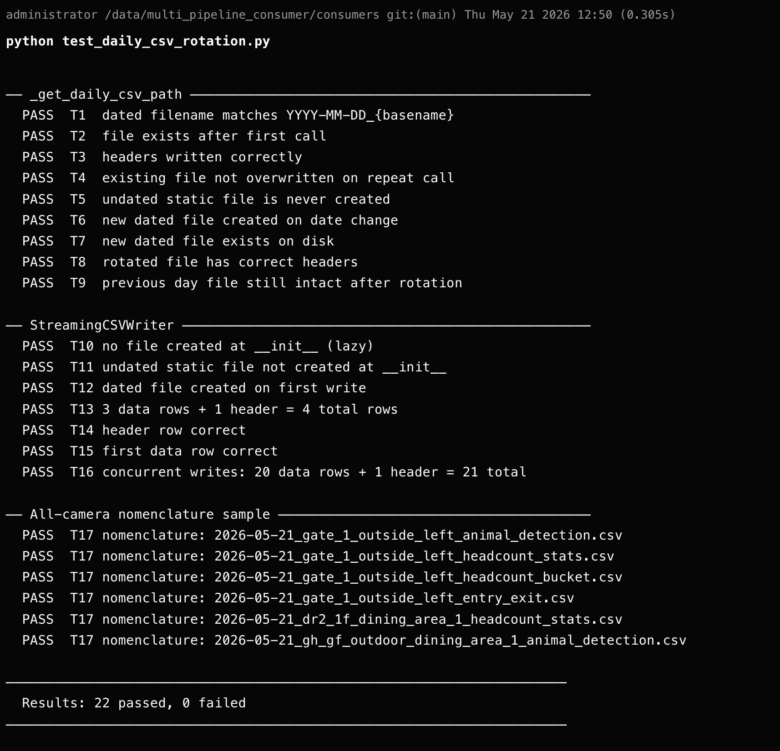
[ Screenshot: test_daily_csv_rotation.py — terminal showing 22/22 tests passing ]
4.2 Maintenance & Backup Script — maintenance_backup.sh
A 283-line bash script provides a safe, repeatable deployment procedure to be run on the L40S server before switching the active consumer to a new build. No files are deleted anywhere in this script.
Step | Action | Detail | Safety Guarantee
1 | User confirmation | Operator must type YES to proceed | No services stopped without explicit consent
2 | Stop all 10 producers | SIGTERM via PID files; pkill fallback after 15s; polls until all PIDs dead | SIGKILL only used as last resort after graceful wait
3 | Stop consumer | Kills run_consumer.sh shell loop + Python process; confirms dead via PID polling | Waits for clean shutdown before proceeding
4 | Create backup | rsync -av copies output/ and logs/ to /data/Plaksha_streams_backup/<YYYY-MM-DD_HHMMSS>/ | rsync is additive — source is never modified
5 | Verify backup | Compares source vs. destination file counts and disk sizes; exits non-zero on mismatch | Deployment cannot proceed if verification fails
6 | Report | Colour-coded output with per-step timestamps | Full audit trail before touching the new consumer
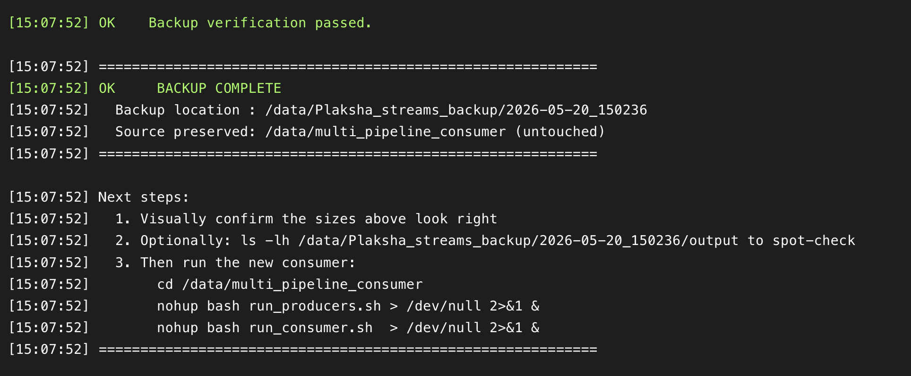
[ Screenshot: maintenance_backup.sh — stop sequence + rsync + verification PASS output ]
4.3 Automated rsync Transfer to HPC-1 — setup_rsync_cron.sh
A 148-line one-shot setup script establishes a fully automated, secure CSV transfer from the L40S production server (10.1.41.56) to the Data Science HPC-1 server (10.1.40.43). Once run it requires no further maintenance.
Step | Action | Detail
1 | SSH key generation | Generates Ed25519 key at ~/.ssh/id_ed25519 if none exists. No passphrase — required for cron.
2 | Key distribution to HPC-1 | ssh-copy-id copies public key to 10.1.40.43. Operator enters HPC-1 password exactly once.
3 | Connectivity test | Runs ssh -o BatchMode=yes 10.1.40.43 echo OK to confirm passwordless auth.
4 | Destination directory creation | Creates /home/administrator/plaksha_streams_hpc1/plaksha_day_wise_csv/ on HPC-1.
5 | Dry-run rsync | Executes rsync --dry-run so the operator can verify what files would transfer before committing.
6 | Cron job installation | Appends cron entry to run sync every 1 minute. Log written to /data/multi_pipeline_consumer/logs/rsync_backup.log.
Privacy Enforcement — rsync Filter
The rsync command uses an explicit include/exclude filter to enforce the privacy boundary between the production server and the Data Science environment:
rsync -avz --update --itemize-changes --include="*/" --include="*.csv" --exclude="*" /data/multi_pipeline_consumer/output/ administrator@10.1.40.43:/home/administrator/plaksha_streams_hpc1/plaksha_day_wise_csv/
File Type | Action | Reason
*.csv (day-wise analytics) | INCLUDED — transferred every 60s | Structured tabular output — the intended data product for the Data Science team
*.avi / *.mp4 (video files) | EXCLUDED — never transferred | Raw footage from lab cameras; privacy constraint — must remain on production server only
*.log (log files) | EXCLUDED — never transferred | Operational logs contain infrastructure details not relevant to Data Science workflows
Any other file type | EXCLUDED — never transferred | Explicit allowlist: unknown file types blocked by default
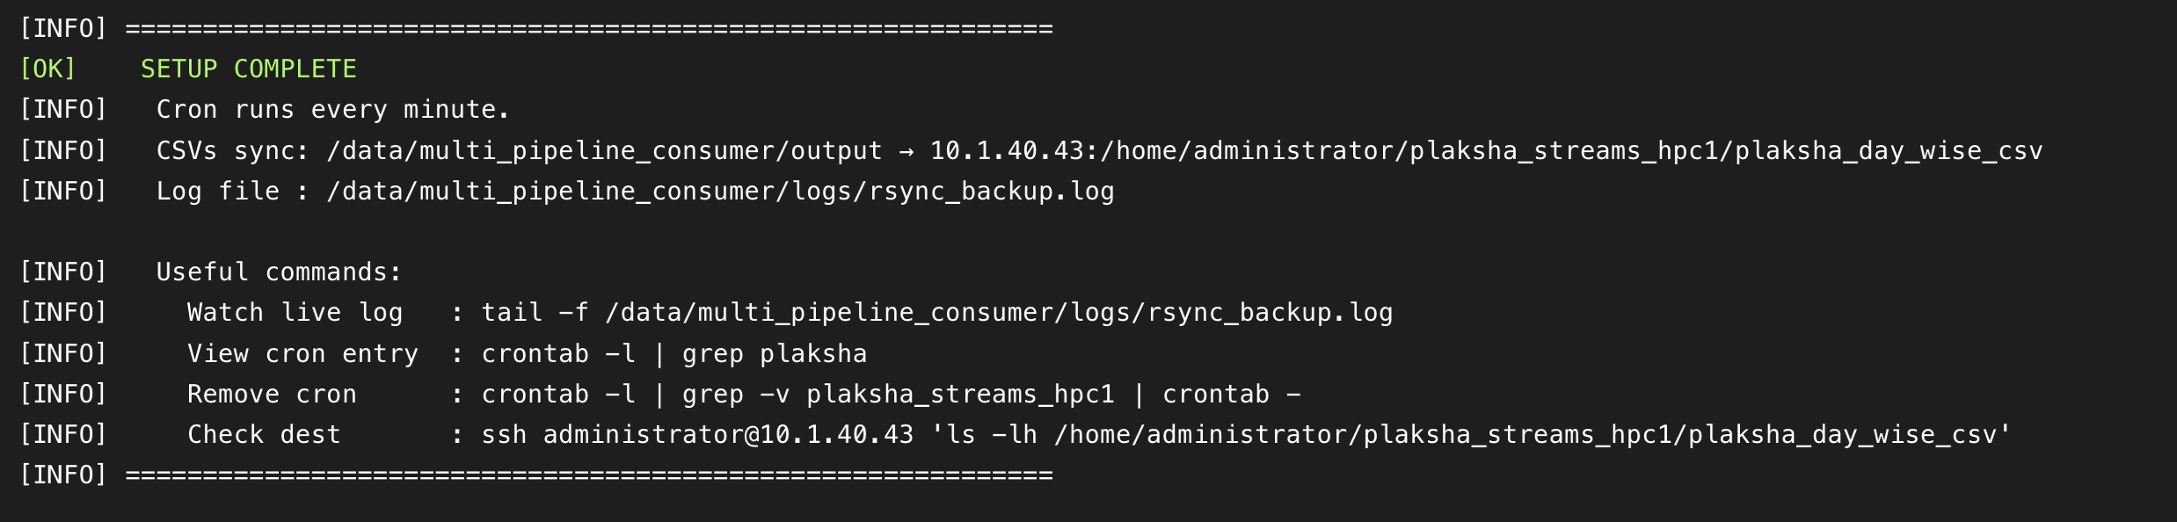
[ Screenshot: setup_rsync_cron.sh — SSH key setup, dry-run rsync output, cron installation ]
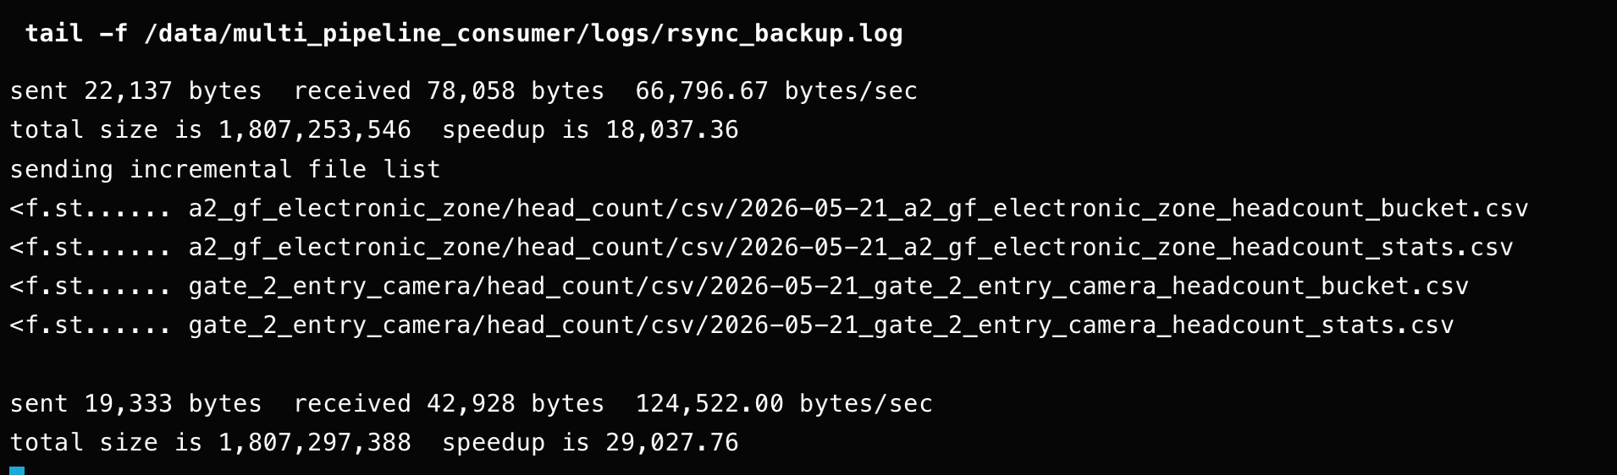
[ Screenshot: rsync_backup.log — cron job log showing periodic CSV-only sync runs ]

4.4 Post-Deployment Cleanup — cleanup_old_output.sh
After the new consumer is confirmed running, the cleanup script provides a safe auditable mechanism to delete pre-migration output files from the L40S. The deletion boundary is determined by the mtime of the most recent backup directory — files written by the running consumer (newer than the backup) are never included in the deletion set.
Safety Control | Mechanism
Mandatory dry-run | Script always lists every file + total size before any deletion. Operator must review first.
Explicit DELETE confirmation | Operator must type DELETE (uppercase). Any other input aborts.
mtime-based boundary | Uses backup directory mtime as cutoff — no filename parsing, immune to filename format changes.
Running consumer protected | Files newer than the backup cutoff excluded by find -not -newer. Active output never at risk.
Backup directory untouched | /data/Plaksha_streams_backup/ is read-only in this script — find operates only on output/.
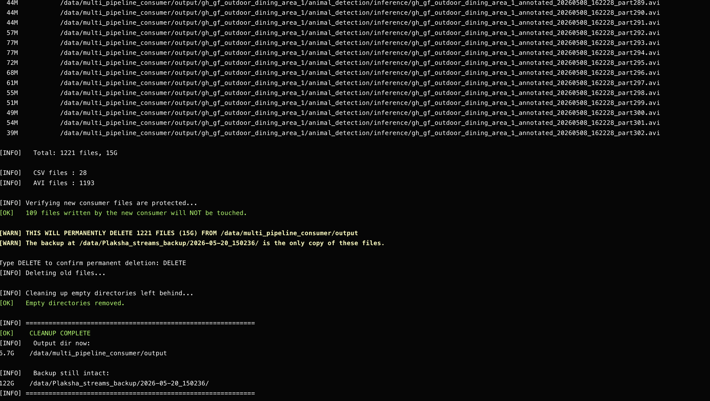
[ Screenshot: cleanup_old_output.sh — dry-run listing + DELETE confirmation prompt ]
5. Implementation Timeline
Date | Commit | Type | Change | Files Affected
May 8 | f8342bc | Fix | Remove unsupported group_instance_id from KafkaConsumer config | test_consumer_phase2.py
May 8 | 84a54bd | Fix | Refactor partition selection to delta-based offset growth detection | test_consumer_phase2.py (+40 / −94)
May 8 | 3ea0c04 | Fix | Increase partition sampling window to 3.5s to cover producer batch timing | test_consumer_phase2.py
May 13 | 01d6a26 | Build | Final Phase 2 consolidated build — all fixes integrated | test_consumer_phase2.py (+359 / −354)
May 20 | 762f249 | Feature | New consumer with midnight CSV rotation + maintenance backup + launcher update | test_consumer_phase02.py (1812L), test_daily_csv_rotation.py (166L), maintenance_backup.sh (283L), run_consumer.sh
May 20 | 06fd1c3 | Feature | rsync + cron setup for CSV transfer to HPC-1 (CSV-only filter) | setup_rsync_cron.sh (148L)
May 20 | ddb199e | Ops | Cleanup script to safely remove pre-backup output files from L40S | cleanup_old_output.sh (131L)
6. Current System State
Component | Status | Detail
RTSP Producers | RUNNING | 10 active producers capturing live camera feeds
Kafka Consumer | RUNNING | test_consumer_phase02.py — 24/7 on L40S (10.1.41.56)
AN Pipeline | ACTIVE | YOLOv8m tracking animals across enabled cameras
HC Pipeline | ACTIVE | YOLOv8 person detection with bucket aggregation
EE Pipeline | ACTIVE | YOLOv9 + ByteTrack entry/exit counting, 5-min intervals
CSV Output | ROTATING | Day-wise files rotating automatically at midnight
rsync to HPC-1 | AUTOMATED | Every 60 seconds via cron, CSV-only filter active
Live Dashboard | SERVING | WebSocket feed at http://0.0.0.0:8675
Backup Procedure | AVAILABLE | maintenance_backup.sh ready for next deployment

7. Known Issues & Active Resolution

ID | COMPONENT | DESCRIPTION | SEVERITY | MITIGATION | RESOLUTION STATUS
ISS-01 | GPU / Consumer Pipelines | Frame skipping at high volume due to GPU limits and OOM errors. | Medium | Lag-based skipping active; stream is real-time but data has gaps. | Evaluating GPU optimization and batching with Gurpreet Sir.
ISS-02 | Animal Detection (AN) Pipeline | Sub-second spurious detections are polluting AN CSV output. | Medium | Running with post-hoc filtering for confidence and track duration. | Evaluating threshold tuning and model fine-tuning with Pulkit Sir.
ISS-03 | 3 of 10 Camera Streams | Three streams lack valid output, suspected due to 3-model inference overload. | High | Excluded from reporting; remaining 7 streams operate normally. | Investigation ongoing but deprioritized behind ISS-01 and ISS-02.

