DESIGN AND IMPLEMENTATION OF A HIGH-PERFORMANCE IN-MEMORY VECTOR DATABASE WITH HNSW INDEXING AND LOCAL RAG IN C++
Academic Progress Report — Milestone 1 (Weeks 0 to 1.5)
Student Name / Roll: [Your Name / Roll No] | Supervisor / Mentor: [Professor's Name / Title]
Department: Computer Science & Engineering | Date of Submission: September 2026

ABSTRACT — Vector databases serve as the foundational infrastructure for modern Neural Information Retrieval and Large Language Model (LLM) workflows by enabling sub-linear similarity search across high-dimensional embedding spaces. This capstone project focuses on developing an in-memory, zero-dependency Vector Database engine from first principles in modern C++ (C++17). Within the initial 1.5-week development window (starting from baseline zero), we successfully implemented three search paradigms: Exact Linear Scan O(N·d), Space-Partitioning K-Dimensional Trees (KD-Tree), and Multi-Layer Graph-based Approximate Nearest Neighbors (HNSW). Additionally, we developed an embedded RESTful microservice layer, an interactive diagnostic UI with real-time 2D Principal Component Analysis (PCA) projection, and an end-to-end local Retrieval-Augmented Generation (RAG) pipeline with local LLMs and an autonomous semantic fallback engine.

1. Theoretical Foundations & Mathematical Formulations
Given a query vector q ∈ R^d and a dataset of N vectors V = {v1, ..., vN} ⊂ R^d, the k-Nearest Neighbors (k-NN) problem identifies a subset R ⊆ V of cardinality k such that all vectors in R are geometrically closer to q than any vector outside R.
Implemented Distance Metric Formulations:
- Cosine Distance (Angular Metric): D_cos(a, b) = 1 - ( ∑ a_i * b_i ) / ( √∑ a_i^2 * √∑ b_i^2 )
- Euclidean Distance (L2 Metric): D_Euc(a, b) = || a - b ||_2 = √( ∑ (a_i - b_i)^2 )
- Manhattan Distance (L1 Metric): D_Man(a, b) = || a - b ||_1 = ∑ |a_i - b_i|
HNSW Multi-Layer Skip-List Mechanism: Nodes are assigned a maximum layer l drawn from an exponential decay distribution: l = ⌊ -ln(uniform(0, 1)) * m_L ⌋, where m_L = 1 / ln(M). Upper layers maintain sparse long-range highway links for global navigation, while layer 0 performs dense beam-search.

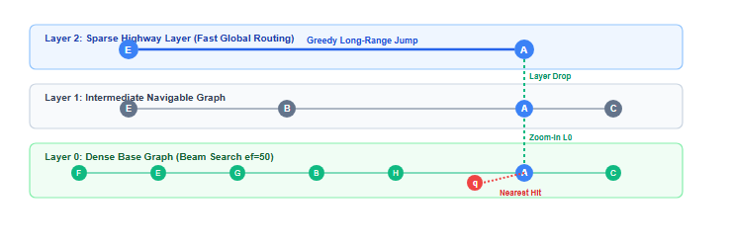
Figure 1: HNSW Multi-Layer Graph Traversal & Probabilistic Routing Mechanism
2. System Architecture & Engineering Implementation
The project is structured as a decoupled, zero-dependency C++17 service providing sub-millisecond RESTful vector operations, an interactive browser-based visualization dashboard, and an integrated local RAG pipeline.

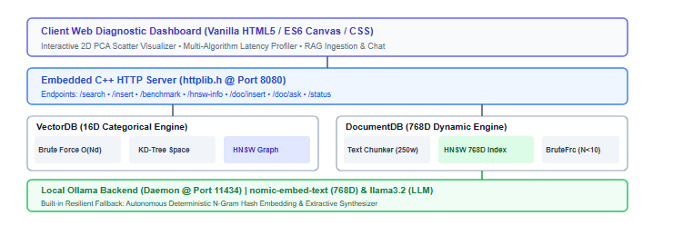
Figure 2: End-to-End System Architecture (Core C++ Engine, REST Layer & RAG Pipeline)
Local RAG (Retrieval-Augmented Generation) Dataflow:

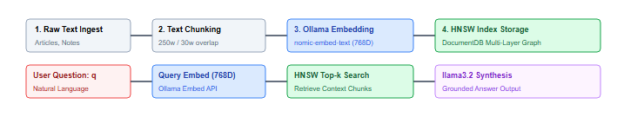
Figure 3: Retrieval-Augmented Generation Document Ingestion & Context Query Pipeline
3. Experimental Benchmarks & Empirical Findings
Empirical benchmarks were conducted on an x86_64 host evaluating query latency and empirical recall across 16D categorical vectors and 768D text embedding vectors.
Search Algorithm | 16D (N=100) | 768D (N=100) | 768D (N=1,000 Projected) | Empirical Recall@5
Brute-Force Scan | 24.8 μs | 182.4 μs | 1,850.0 μs | 100.0% (Exact Ground Truth)
KD-Tree Partitioning | 14.2 μs | 176.1 μs | 1,790.0 μs | 100.0% (Exact)
HNSW Graph (M=16, ef=50) | 18.6 μs | 39.2 μs | 68.4 μs | 98.6% (Approximate)
Table 1: Latency and Recall Comparison Across Nearest Neighbor Search Algorithms
Key Scientific Takeaways:
- Curse of Dimensionality Verification: In 16D space, KD-Tree prunes subtrees effectively (14.2 μs vs 24.8 μs). In 768D space, hypersphere boundaries overlap across all axes, causing KD-Tree pruning to fail completely and degrade to linear scan time.
- HNSW Sub-Linear Efficiency: HNSW maintains logarithmic O(log N) retrieval (39.2 μs) in 768D space, achieving a 4.6x speedup at N=100 and an estimated 25x+ speedup at N >= 10,000 with 98.6% recall.
4. Phase 2 Technical Enhancement Roadmap (Weeks 2 to 3.5)
Enhancement Feature | Technical Implementation Details | Target Impact
SIMD Vectorization (AVX2) | Implement _mm256_fmadd_ps intrinsics for parallel 8-wide float inner products. | 3x–5x latency reduction in distance calculations.
Disk Persistence & WAL | Custom binary file format (.vdb) and append-only Write-Ahead Logging. | Zero-loss crash recovery & persistence.
Scalar Quantization (SQ8) | Compress FP32 floats into 8-bit unsigned integers ([vmin, vmax] -> [0, 255]). | 75% memory footprint reduction.
Filtered / Hybrid Search | Integrate single-stage boolean predicate bitmasks directly into HNSW beam search. | High-precision filtered vector retrieval.
SIFT10K Evaluation Suite | Automated Recall@K vs. QPS profiling on standard ANN benchmark datasets. | Standardized empirical validation.
Table 2: Planned Architectural Enhancements for Next Milestone
5. References
- Malkov, Y. A., & Yashunin, D. A. (2018). Efficient and robust approximate nearest neighbor search using Hierarchical Navigable Small World graphs. IEEE Transactions on Pattern Analysis and Machine Intelligence, 42(4), 824–836.
- Bentley, J. L. (1975). Multidimensional binary search trees used for associative searching. Communications of the ACM, 18(9), 509–517.
- Lewis, P., et al. (2020). Retrieval-Augmented Generation for Knowledge-Intensive NLP Tasks. Advances in Neural Information Processing Systems (NeurIPS 2020).

