$$LAB 6$$

$$Part I$$

$$2. Is resetn synchronous or asynchronous?$$

$$Ans- The resetn signal is a synchronous reset. It has an active low. To reset the FSM to the$$

$$starting state,the clock has to be set to high whenever we want to reset it.$$

$$3. Complete the State Table and Show the Code$$

$$Ans-For the completed code, please refer to sequence_detector.v$$

|  |  |  |
| --- | --- | --- |
| **Current State** | **Switch Input** | **Output State** |
| 000 | 0 | 000 |
| 000 | 1 | 001 |
| 001 | 0 | 000 |
| 001 | 1 | 010 |
| 010 | 0 | 100 |
| 010 | 1 | 011 |
| 011 | 0 | 110 |
| 011 | 1 | 101 |
| 100 | 0 | 000 |
| 100 | 1 | 110 |
| 101 | 0 | 100 |
| 101 | 1 | 101 |
| 110 | 0 | 000 |
| 110 | 1 | 010 |

$$Note:One^{'}s marked in yellow output the result (ie. 1)$$

$$4. Simulate the circuit and post screenshots-$$

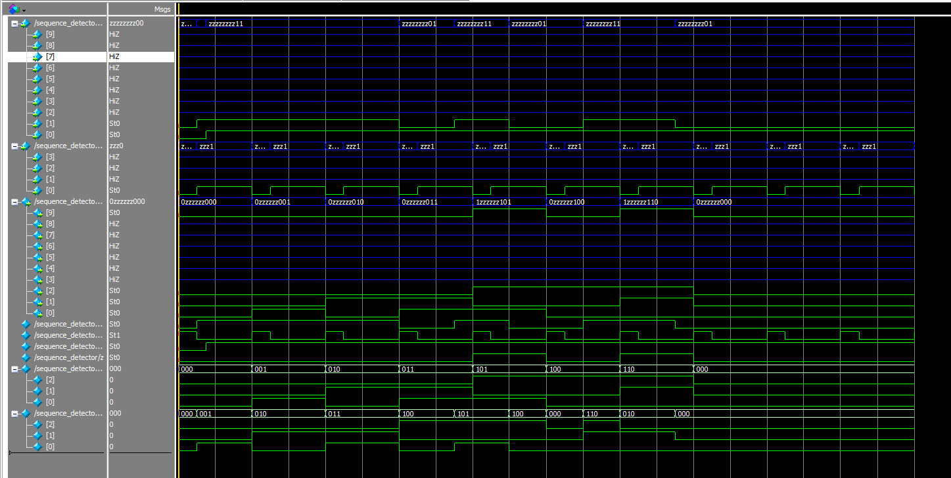

$$Part II$$

$$2. Draw a table that shows the state of the Registers and control signals for each cycle of your computation$$

|  |  |  |  |  |  |
| --- | --- | --- | --- | --- | --- |
| **Cycle** | **Value** | **Alu_select_a** | **Alu_select_b** | **B** | **R** |
| 0 | A*X | 00 | 11 | B | - |
| 1 | A*X+B | 00 | 01 | A*X+B | - |
| 2 | X*(A*X+B) | 11 | 01 | X*(A*X+B) | - |
| 3 | X*(A*X+B)+C | 01 | 10 | X*(A*X+B) | X*(A*X+B) + C |



