Executive Summary - (comes at first and written at last)
- Problem statement -
Users often struggle to find the right bus because their travel preferences—such as budget, timing, comfort, seat type, boarding point, and operator—are difficult to express and evaluate using traditional search filters. As a result, users may spend significant time searching and comparing multiple options before finding a bus that fits their needs.
- Goals and What are my non-goals -
Goals
    - The AI agent will complement the existing search and booking flow rather than replace the entire product experience.
    - Help users find relevant bus options with fewer interactions and less time spent searching.
Non-goals
I do not want to introduct another application
The MVP will focus only on bus travel and will not cover flights, trains, cabs, or hotels.
Cancellations, refunds, rescheduling, complaints, and other customer-support workflows are outside the initial scope.
Success metric
North Star Metric-Successful Bus Discovery Rate-% of AI-agent sessions where a user finds and selects a bus option that matches their stated travel requirements.
L1 — User Value
- Successful Bus Discovery Rate
- Time to Relevant Bus
- Search Interaction Rate
Counter- Task drop rate, D30 inactivation rate
User Empathy:
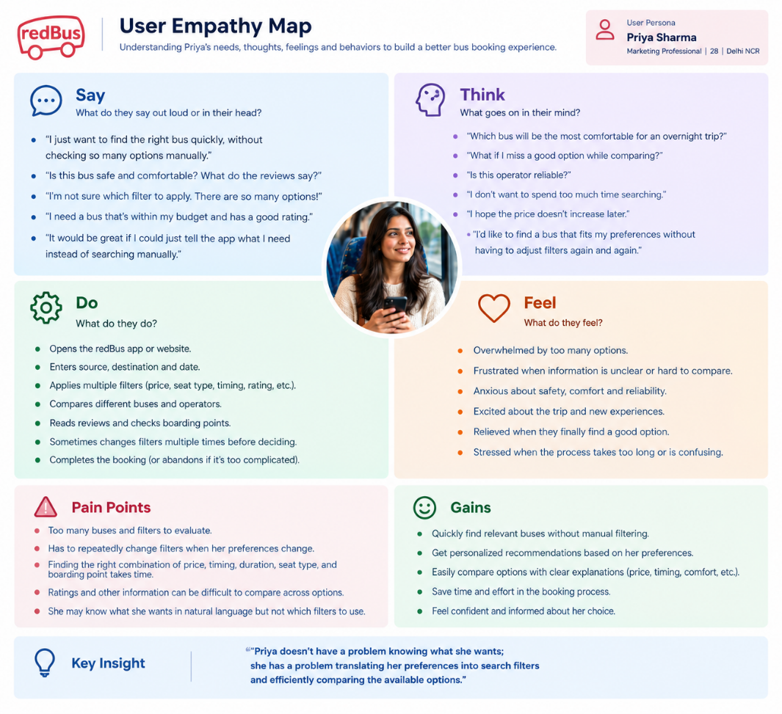
USER JOURNEY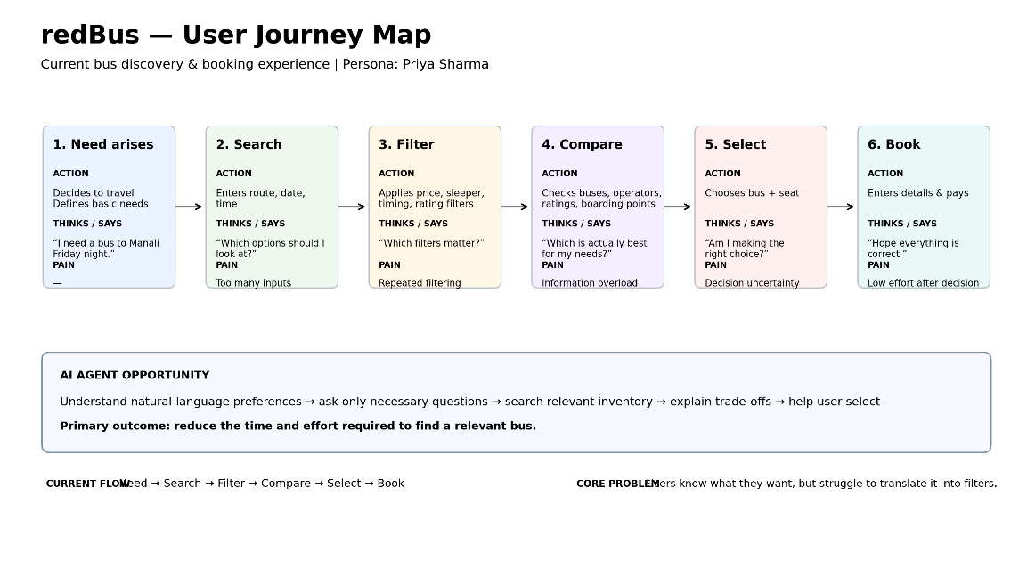
What is Competitor Offering:
# | Opportunity | User problem
1 | Natural-language discovery | “I know what I want, but I don't know which filters to use.”
2 | AI-assisted comparison & recommendation | “There are too many options; help me understand the trade-offs.”
3 | Conversational booking assistance | “Once I've decided, help me complete the booking without navigating multiple steps.”

RICE-inspired prioritization

Opportunity | Reach | Impact | Confidence | Effort | Priority
Natural-language discovery | High | HIGH | High | low | P0
AI-assisted comparison & recommendation | HIGH | HIGH | MED | MED | P0
Conversational booking assistance | MED | HIGH | MED | HIGH | P1

- FUNCTIONAL AND ACCEPTANCE CRITERIA / NON-FUCTIONAL REQUIREMENTS
  - Functionals - Users struggle to translate their preferences into filters and compare multiple options.
  - Non-functional requirement -
P - performance - Agent should respond quickly enough to maintain a conversational experience..
Q - Quality - Responses and recommendations should accurately reflect user preferences and available inventory.
R - Reliability - Agent should remain functional during normal and peak booking periods.
S - ˘Secure - User and transaction data must be protected throughout the interaction.
T - Transparency - All executions should have a clear recoverable log and chain of thought for the user
U - Useability - System should support increasing conversation and search volumes without significant degradation..
- MOCK-UP: https://stitch.withgoogle.com/projects/909021886048338116
- PROTOTYPES (TENTATIVE)
- GITHUB PUSH AS A PORTOLIO

