> use nyse2

> db.stocks.createIndex({stock_symbol:1});

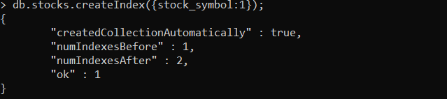

Then run the bat file