>copyFromLocal
./hadoop fs -copyFromLocal /home/vrs1211/Downloads/NYSE/* /user/vrs1211/a2/nyse/

> cat
> checksum
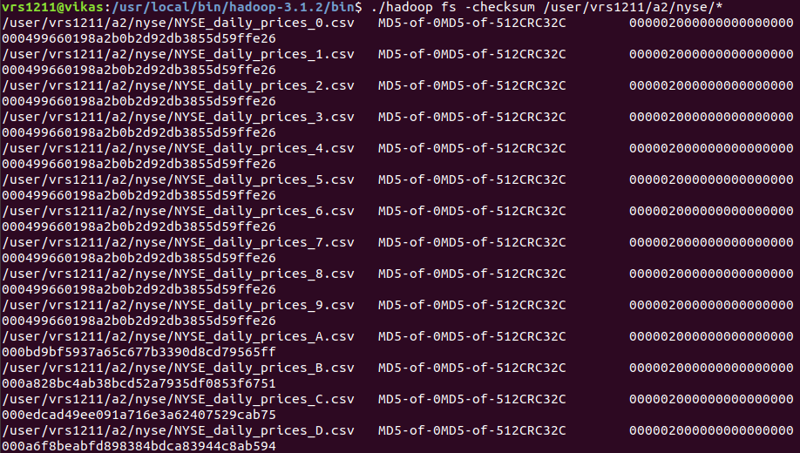
> chmod
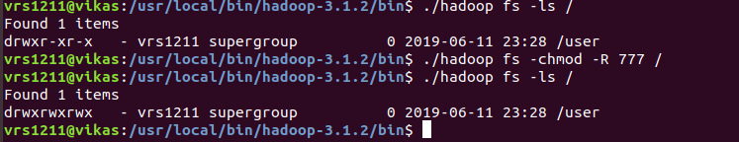

>copyToLocal

> touchz
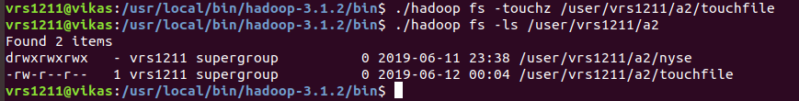
> test

> tail head
