1. bubble sort : compare the elements with adjacent element, if greater then swap the elements.

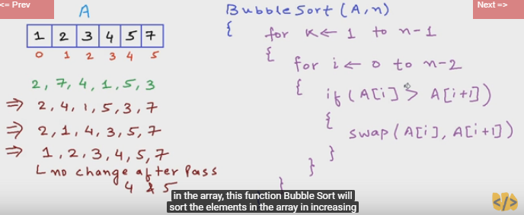

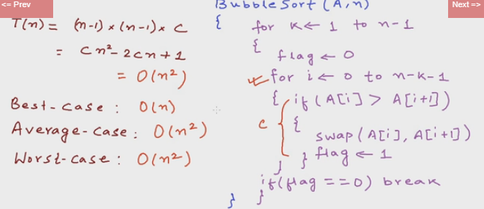

1. selection sort : select the smallest element from unsorted array and swap with 0th element 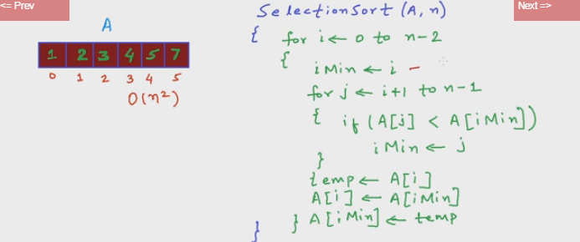

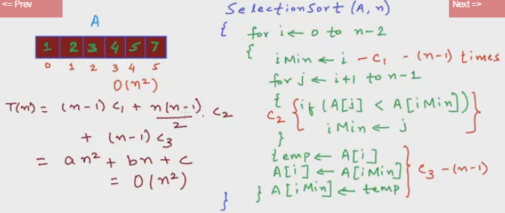.

1. Insertion sort : Shifting and inserting the element.

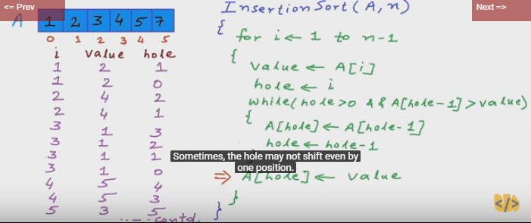

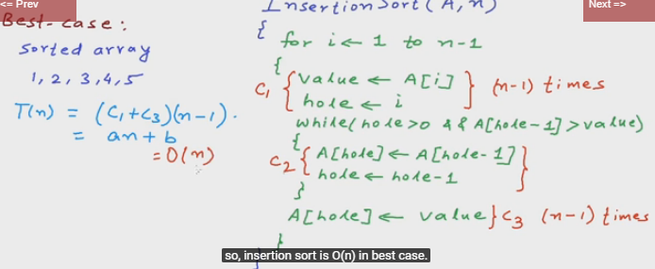

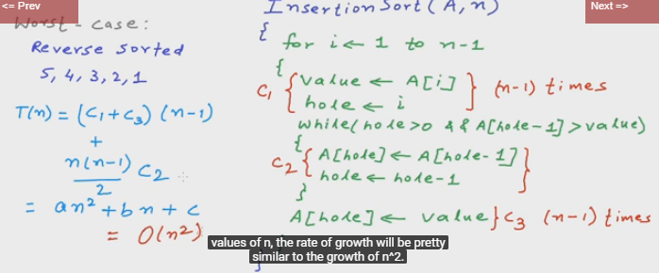

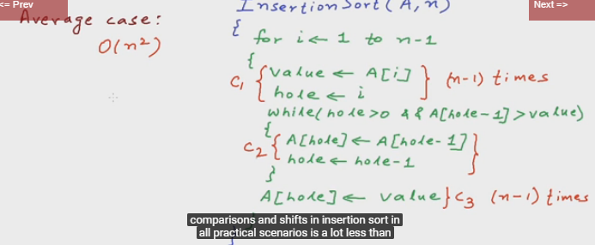

1. Merge sort : Divide into to two parts until we got only one element then sorting and merging back.

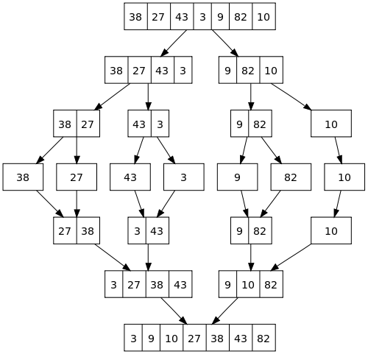



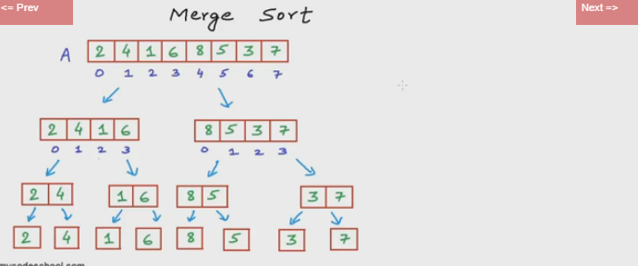

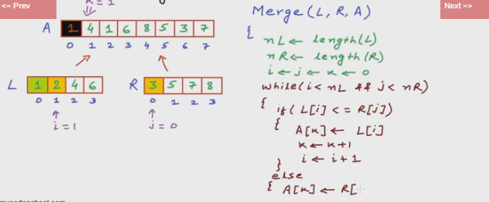

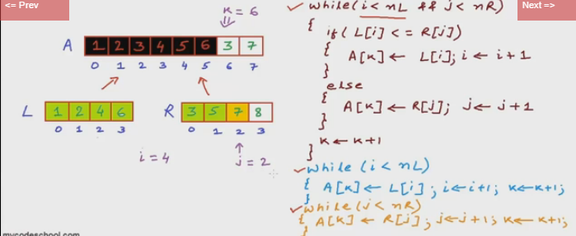

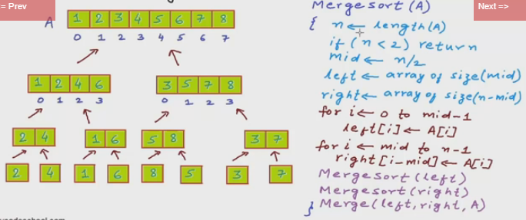

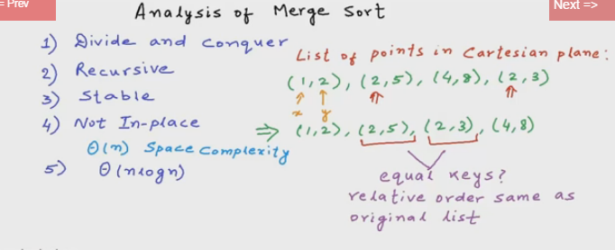

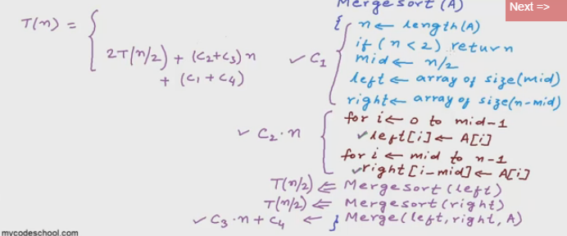

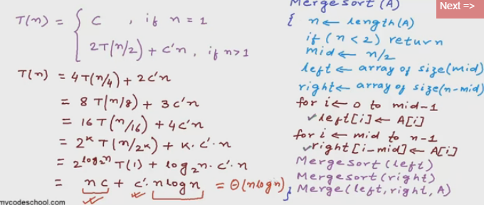

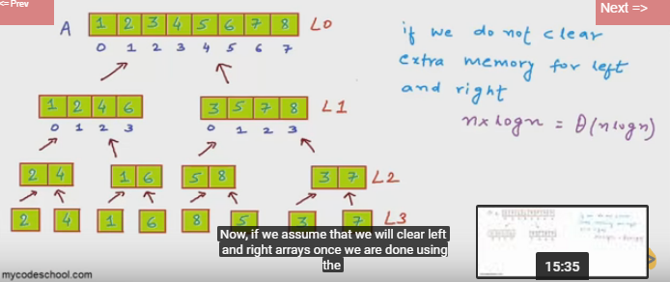

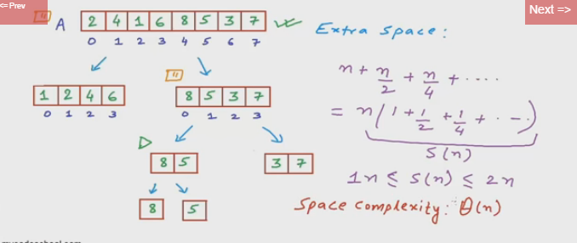

1. Quick sort : Getting the pivot element and will arrange small element to left of the pivot and bigger element in right of the pivot.

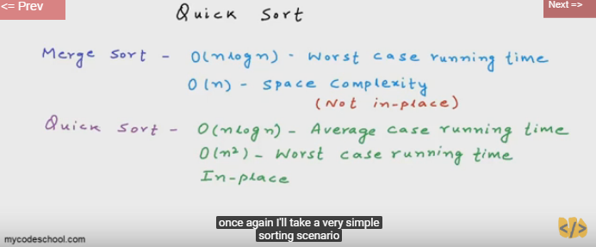

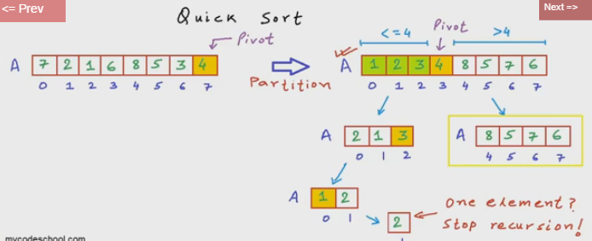

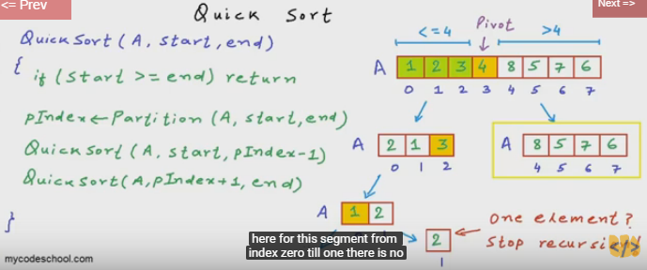

Efficiency

|  |  |  |  |  |
| --- | --- | --- | --- | --- |
| [Quicksort](http://en.wikipedia.org/wiki/Quicksort) | O(n log(n)) | O(n log(n)) | O(n^2) | O(log(n)) |
| [Mergesort](http://en.wikipedia.org/wiki/Merge_sort) | O(n log(n)) | O(n log(n)) | O(n log(n)) | O(n) |
| [Bubble Sort](http://en.wikipedia.org/wiki/Bubble_sort) | O(n) | O(n^2) | O(n^2) | O(1) |
| [Insertion Sort](http://en.wikipedia.org/wiki/Insertion_sort) | O(n) | O(n^2) | O(n^2) | O(1) |
| [Selection Sort](http://en.wikipedia.org/wiki/Selection_sort) | O(n^2) | O(n^2) | O(n^2) | O(1) |