Rugby Event Detection Using Deep Learning

CSIR DSIDE Project Report

Phase 2: Develop a Deep Learning Engine to Automatically Classify Events

29-01-2019

Version 2.0

Table of Contents

1. Executive Summary 1
2. The DSIDE Data Analytics process 1
2.1 Project Question(s)/Problem Statement/Research Question/ Project Objectives 1
2.2 Gather and Prepare 2
2.3 Explore and Assert 2
2.4 Validate 2
2.5 Communicate 3
3. Final Project Outcome 3
4. DSIDE Programme feedback 3
5. Project Team 3
6. Appendix 3
6.1 Detailed description of the dataset(s) provided 4
6.2 Detailed description of your development environment 4

Executive Summary

- The data we acquired was in the form of a spreadsheet containing time stamps and event occurrences as well as video footage from a number of matches..
- These records contained information about the player and team events during a specific time period as well as the number of instances a player has been involved in events.
- The datasets contained both teams playing against each other and event information
- The problem description supplied by the owner of the data included the identification and classification of events in player and team using video streaming, this process is done manually in many sports.
- Using machine learning this process can be optimized automatically so as to ensure the information observed during many of these events can assist for quick coaching and critical decision making related to deployment of resources and implementation of different strategies giving an added advantage for victory in a competitive match.
- The problem also included doing analysis of each event and identifying a strategy to explore based on statistics of player or team performance which was complete during Phase 1 of the DSIDE project during July 2018
- The task at hand in Phase 2 was to develop a deep learning engine to classify the events from a video stream. This required extensive research on computer vision and convolutional neural networks (CNN) and the development on automatic classification engine using machine learning methods

The DSIDE Data Analytic process

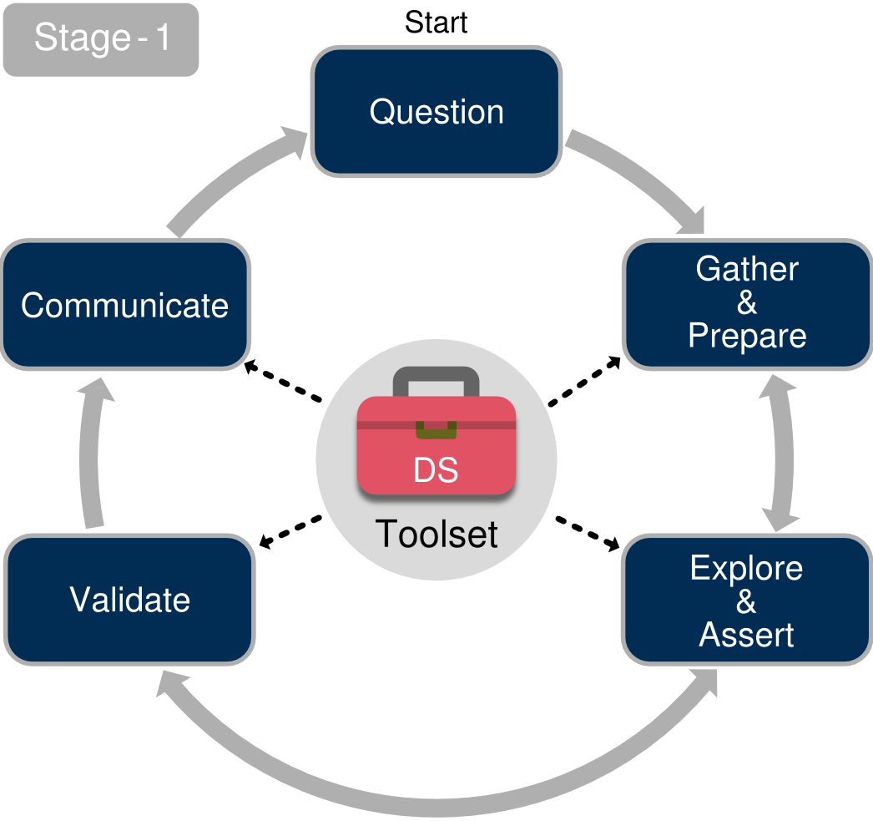

- In the gather and prepare stage of the DSIDE Data Analytics Process, a number of events were identified using the spread sheet with time stamps and the occurrences of events in that period. These were used to create clips of events that happened during the match (passes, scrums, line out). Given the nature of the time stamps and event windows, this had to be done multiple times. Thus we created a dataset that consisted of only video clips.
- In the explore and assert stage, we first did research on different methods used in the field of computer vision, an interdisciplinary scientific field that deals with how computers can be made to gain high-level understanding from digital images or videos and seeks to automate tasks in the same way a human visual system can.
- Research was also done on deep learning models (3D CNN, C3D, CNN+RNN) that use action detection as well as pre-trained datasets that were similar in structure to ours and consisted in only videos.
- From having a working model of based on different human activity datasets (UCF101, Sports 1M and UCF Sports Datasets), a shift was taken to use our own dataset based on rugby clips only.
- This allowed a perfect visualization at which accuracy we should be working at in the detecting events within the scope of rugby.

Problem Statements
- Since the identification and classification of events process is currently done manually and analyzed in video streams at a later stage, the problem explored by our model is finding tools available that can enable us to interpret a series of event types and predict the likelihood of such events turning into a winning strategy.
- The problem is creating an analysis of each event and identify a strategy to explore based on statistics of player or team performance.
- Based on the datasets we were given we had to decide what conclusions can be drawn
without any biasness toward the game of rugby, in other words what are the numbers telling
us?

Gather and Prepare

TASK | TASK DESCRIPTION | TOOLS USED AND DESCRIPTION | CHALLENGES | HOW CHALLENGES WERE OVERCOME
Data Preprocessing & Handling | Using the given data-set consisting of timestamps of different events occurring.  The collection of clips were split by their action class and collected for the entire match | Moviepy was used to to extract the clips from the video stream | Given the nature of the timestamps, a single event could not be in one clip but a series of events were identified within that time stamp | We had to clip the event window video multiple times in order to have a clips consisting of the event of interest.  These clips were separated by their action classes

Explore and Assert

TASK | TASK DESCRIPTION | TOOLS USED AND DESCRIPTION | CHALLENGES | HOW CHALLENGES WERE OVERCOME
Convolutional Neural Network model  Action Classification  Data visualisation | The model type that was chosen was the Sequential. Sequential is the easiest way to build a model in Keras. It allows you to build a model layer by layer.  For further testing, a video was loaded and made to pass through the model. Thereafter the probability of each action class being classified was plotted where the class with the highest probability was used to identify the object as being correct.  We have a model that ran labeled video clips. we checked for the accuracy, test score and validation loss based on the ability of the model, we represented the data in graphical format. We used a plot to visualize. | Keras: The core data structure of Keras is a model, a way to organize layers.  OpenCV: Used to load the video to be passed through the model  Matplotlib: This is a data analysis tool used for data preparation, for the Python programming language. | Identifying which CNN model combinations to use for action detection  None  None | Extensive research from published papers, GitHub, Kaggle challenges and using other datasets of the same structure as our dataset  None  None

Validate

TASK | TASK DESCRIPTION | TOOLS USED AND DESCRIPTION | CHALLENGES | HOW CHALLENGES WERE OVERCOME
Mentor discussions  Mentor suggestion points | This task involved confirming with the mentor which events to focus on to give maximum test scores.  Implementing more data points from the clips that are not classified as scrums, or line-outs and label them non-scrums and non-lineouts. | Jupyter notebook: This is an open-source software for interactively developing and presenting data science projects.  Communication. | Using Python programming language as well as the packages associated with it.  None | On-line sources such as text-based and video tutorials.  None

Communicate

TASK | TASK DESCRIPTION | TOOLS USED AND DESCRIPTION | CHALLENGES | HOW CHALLENGES WERE OVERCOME
Data visualisation | We represented the data in graphical format, to identify the probability of the event to be identified as the action class | Keras:  Matplotlib: | Using Python programming language as well as the packages associated with it. | On-line sources such as text-based and video tutorials.

Final Project Outcome

- We have completed the following tasks for the 2nd phase of the project:

- Develop a deep learning engine to automatically classify events
- Use the current dataset as a training set
- Utilise deep learning (eg. CNN) to develop an automatic classification engineering
- Test accuracy of classification

DSIDE Program feedback

- Recommendations on DSIDE program improvements:

Travel | Excellent
Accommodation | Good
Equipment | Excellent
Mentors | Excellent
Program execution | Excellent
General feedback:
An excellent program to be part of.
Hope this will be an ongoing project with previous DSIDE participants assisting new participants.

Project Team

NAME | CONTACT DETAILS | UNIVERSITY and current degree | STATUS OF STUDY | CONTRIBUTION TO PROJECT
Bongani Nondyiwane | 0734456789 | University of Fort Hare  Bsc (Hons) Computer Science | Complete | Model Development, Video clips collection
Kelebogile Letshwene | 0847730347 | University of South Africa,Bsc Physics(Hons) | In Progress | Model Development, Video clips collection
Singita Ngobeni | 0733450919 | Umuzi Academy, Data Science (Neural Networks) | In Progress | Model Development, Video clips collection

Appendix

Detailed description of the data-set(s) provided

- The data we acquired was in the form of a spreadsheet containing time stamps and event occurrences as well as video footage from a number of matches..
- These records contained information about the player and team events during a specific time period as well as the number of instances a player has been involved in events.
- The datasets contained both teams playing against each other and event information

Detailed description of your development environment

Software components utilized for the project:

Source | Nature of open-source license | Version information
- Anaconda  - Python  https://www.anaconda.com/download/ | New BSD license  PSF | Version 5.2.0  Version 3.6
- Jupyter notebook  https://www.anaconda.com/download/ | Modified BSD license | Python 3.3 or greater
- Gitlab  https://gitlab.com/downloads | Open-source license | Gitlab 11.0
- Slack  https://slack.com/ | Non-exclusive license | Slack 3.2.1
- Plotly  https://plot.ly/#/ | MIT license | Version 2.7.0

Software links to Analytics Process:

Software | Analytics Process-Steps | Function
Jupyter notebook | Gather & Prepare | This software collects and pre-processes the data into a usable format applying built-in libraries.
Python | Explore & Assert | This software is extensively used for data munging and preparatio
Python libraries  (Keras, OpenCV) | Communicate | The software was used in implementing the CNN model with Keras
Slack | Validate | This software is used to push- pull reports, launch surveys and discuss trends and analysis. We also used this platform to interact with the DSIDE team.

- The project is found on the following git-path:
https://gitlab.com/GaryB/rugby_analytics/blob/master/Phase_2_final/3D%20CNN%20in%20Keras%20-%20Action%20Recognition.ipynb

