Group Members

##### Ritika Jha

Registration No.:68703938

##### Aditya singla

Registration No.:14008549

##### Aayush Neelkanth

Registration No.:21703772

##### Kanala Venkatesh

Registration No.:31200854

How To Run Code

Running code 1 (Scraping) will give us all the scrapped data from NDTV Profit website in json format woth fiels of url,title,content,links,image urls with date and an article id.

Running code2 (Twitter Sentiment Analysis) will make stream last 3000 tweets by NDTV Profit and present it in a csv file with the headings tweets,Twitter id,URLs,hashtags,date,source,likes,retweets,Location and give sentiment analysis of each tweet as output.

Details of how we can interpret your data

The data scraped from newspaper gives us all the information regarding a particular article. We can use the json file to get title of all the articles of our interest.

The twitter sentiment analysis code analyses a particualar text and analysis on the basis of words used in it as positive (+1) , neutral(0) or negative (-1) sentiment.

If we want to analyse the functioning of a particular bank the we can get titles of all the relevant articles from the json file .

For every title we look up for the particular tweet and the number of likes ,retweets and categorise the tweets as postive, negative or neutral.

We can understand the importance of a particular event using the retweets ,likes etc. and create a timeline using the date of each tweet and understand whether it is positive,negative or neutral.

Results

0 NTPC Snubs Emissions Tech, Shuts Out GE, Other... 1207639729266577408

1 Sensex, Nifty Close At Records Highs For Third... 1207604324202774528

2 India Ratings Downgrades Yes Bank To A, Places... 1207569314309533697

3 Room For Strong Growth For Microfinance In Ind... 1207569287105265664

4 GST Council Fixes 28% Tax Rate On Lottery, Say... 1207320489237991424

5 Tribunal's Orders Goes Beyond Relief Sought By... 1207298084880830464

6 Cyrus Mistry Restored As Tata Chairman 3 Years... 1207263554191032320

7 Budget Likely To Cut Tax Rates For Individual ... 1207186507871637505

8 What Is Propelling Indian Shares To All-Time P... 1207186452963946497

9 Sensex, Nifty Clock Fresh All-Time Highs\nhttp... 1207155803855048705

URLs hashtags \

0 [{'url': 'https://t.co/bX0M9FU1SO', 'expanded_... []

1 [{'url': 'https://t.co/a5vIHyCWJG', 'expanded_... []

2 [{'url': 'https://t.co/BcjfWtiBaZ', 'expanded_... []

3 [{'url': 'https://t.co/OQBko05wgI', 'expanded_... []

4 [{'url': 'https://t.co/2kFqYCoKGx', 'expanded_... []

5 [{'url': 'https://t.co/J2MyIQcxzg', 'expanded_... []

6 [{'url': 'https://t.co/Ju6Il27uVb', 'expanded_... []

7 [{'url': 'https://t.co/t1AOxuKZ7j', 'expanded_... []

8 [{'url': 'https://t.co/iqgojqHJmK', 'expanded_... []

9 [{'url': 'https://t.co/tjegzMzpEU', 'expanded_... []

date source likes retweets Location sentiment

0 2019-12-19 12:32:02 Twitter Web App 3 1 None 0

1 2019-12-19 10:11:21 Twitter Web App 4 1 None 0

2 2019-12-19 07:52:14 Twitter Web App 2 4 None -1

3 2019-12-19 07:52:08 Twitter Web App 2 3 None 1

4 2019-12-18 15:23:30 Twitter Web App 75 9 None 0

5 2019-12-18 13:54:28 Twitter Web App 12 2 None 0

6 2019-12-18 11:37:15 Twitter Web App 27 11 None 0

7 2019-12-18 06:31:06 Twitter Web App 66 15 None 0

8 2019-12-18 06:30:53 Twitter Web App 4 2 None 0

9 2019-12-18 04:29:06 Twitter Web App 20 4 None 1

We can plot this data using matplotlib to understand how people are reacting to different articles.

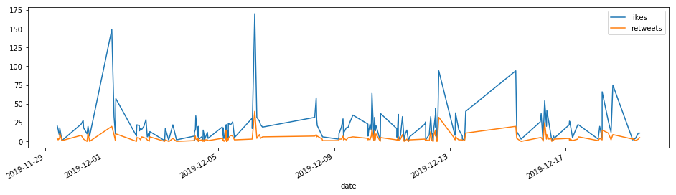

Member wise contribution