Features:
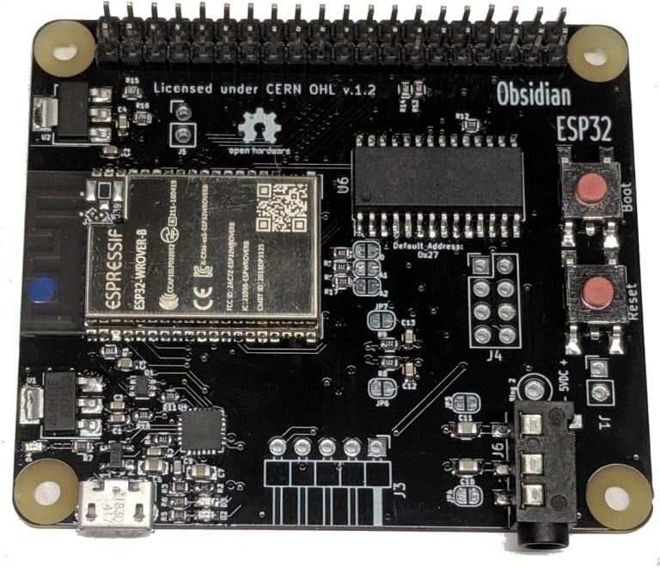Figure 1: Obsidian ESP32
- Espressif Systems ESP32-WROVER-B
  - 16 MiB Flash
  - 8 MiB PSRAM
  - 802.11 b/g/n
  - Bluetooth 4.2/BLE
- Raspberry Pi A+ Form Factor
  - GPIO support with MCP23017
  - 2 High-speed SPI
  - 2 I2C
  - I2S
  - DAC output to Stereo TRS with LPF and DC blocking capacitors
- USB/UART for programming
  - Through Micro-USB power port
  - Silicon Labs CP2102N
  - Automatic boot/reset for simple Flashing
- Separate 3.3V LDO’s for the main board and expansion header.

Applications:
- Education
  - Learn hardware programming
    - Arduino-compatible
    - MicroPython
  - compatible with Raspberry Pi add-on boards
- Raspberry Pi substitute where low power or real-time is needed
- Networked audio player

General Descirption:

The Obsidian ESP32 is a general-purpose development board for the Espressif Systems ESP32-WROVER-B. As an alternative to other similar ESP32 development boards, the Obsidian ESP32 is designed with ease of prototyping in mind, and is compatible with a wide range of existing expansion boards for the Raspberry Pi, including SPI LCD’s and I2S DACs.

This form factor gives the user access to a wide range of ready-designed expansion boards that can easily be swapped in and out of the hardware configuration, and the ability to move to or from single board computers as power requirements or processing needs demand.

Pinouts

The Obsidian ESP32 is designed to be a Raspberry Pi form factor compatible microcontroller development board. As such it has the expected I/O: a 40-pin header, micro-USB connector, and TRRS jack. Missing are USB and HDMI, as those are not supported by the ESP32.

Additional I/O are available, documented below

Figure 2 shows the standard 40-pin header found on many single board computers

Figure 3 shows the additional 8-pin header breaking out the remainder of the GPIO expander’s outputs

Figure 4 shows the 5-pin header located where the HDMI connector would be on a single board computer.

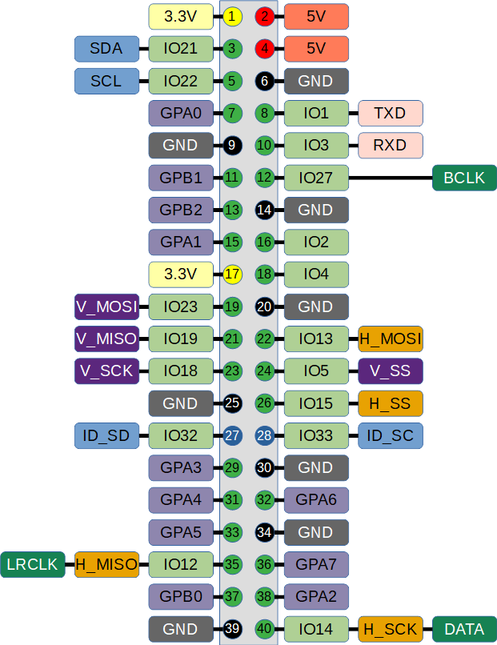Figure 2: 40-pin header
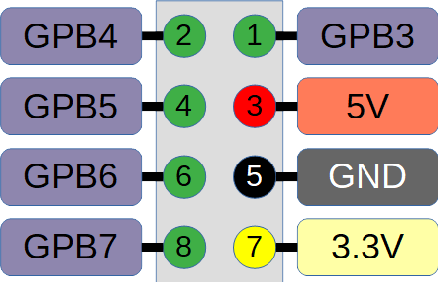Figure 3

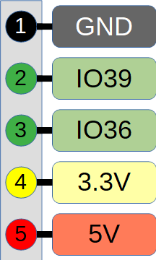Figure 4

The Obsidian ESP32 is an open-source hardware project, see

https://github.com/singleboardsolutions/Obsidian-ESP32

Obsidian ESP32 is powered by the Espressif Systems ESP32-WROVER-B or ESP-32-WROOM-32:

https://www.espressif.com/sites/default/files/documentation/esp32-wrover_datasheet_en.pdf

https://www.espressif.com/sites/default/files/documentation/esp32-wroom-32_datasheet_en.pdf

These modules contain the ESP32-D0WD:

https://www.espressif.com/sites/default/files/documentation/esp32_datasheet_en.pdf

Obsidian ESP32 ships with MicroPython pre-installed. MicroPython is an open-source Python implementation for microcontrollers, and can be found at its home page and github:

http://micropython.org/

https://github.com/micropython/micropython

