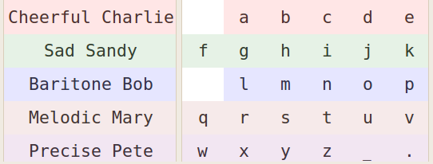llustration 1: Each voice pronounces a different part of the alphabet at a different stereo location. For example, Cheerful Charlie will read "a-e" in your left ear, whereas "Precise Pete" reads "w-." in your right ear. It is important to know which voice is associated with which letters before testing starts. This layout can be looked at on a piece of paper in the first and second session to remind you which voice is saying which letter. During the third and fourth sessions it is expected that you would have memorised it.
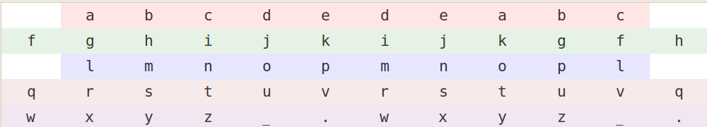Illustration 2: The alphabet configuration has to be memorized during the tutorial session. The colours in each audio channel correspond to those in llustration 1. For example, the alphabet sequence read by Cheerful Charlie is “abcdedeabc”. To select “a” you have to click twice - each time Charlie says the letter “a”. The alphabet is read in rapid succession (“fqwaglrxbhmsy....”), so that it sounds as if many people are talking at the same time. It is therefore important to direct your attention to the voice that reads the letter you want to select. Your brain will quickly learn to filter the other voices out, so that it will sound as if each voice says his/her part of the alphabet slowly. This layout can be looked at on a piece of paper in the first session to remind you of the alphabet sequence withing each channel. During the second, third and fourth sessions it is expected that you would have memorised it.
- Click to start program. The phrase you have to write will be read to you.
- Always try to click twice for each letter selection.
- If a word was selected successfully it will say “you have written...”.
- Repeat your word if you've selected all its letters, but no word was selected.
- Click 4 or more times to undo last letter (you can't undo more than that).
- Wait for 2 alphabet-sequence repetitions to hear the current letter number. For example, it will say “second” if you're busy with the second letter of any word.
- Wait for 6 alphabet repetitions to restart new word. It will say “new word ...”
Phrases:

the_quick_brown_fox_jumps_over_the_lazy_dog_.
it_hurts_a_bit_on_my_right_side_.
i_would_like_a_cake_for_my_birthday_.
i_prefer_the_other_one_.
i_like_to_go_places_.
do_you_think_mom_will_come_.
bath_time_.
why_.
for_you_that_is_great_.
i_bought_the_groceries_yesterday_.
are_we_going_out_today_.
which_day_.
shall_i_take_you_out_for_a_walk_.
can_i_borrow_some_money_.
what_is_on_tv_.
i_need_to_refresh_.
i_wish_i_could_join_you_.
take_care_.
somebody_answer_the_door_.
wish_you_all_the_best_.
why_.
pee_.
did_you_enjoy_your_meal_.
thanks_for_the_burger_.
thank_you_.
who_should_i_write_this_check_to_.
there_is_a_store_over_there_.

