Student Evaluation Summary
FEP appendix · Michelle Blomberg · Spring 2026
This summary focuses on the teaching items, instructor clarity, feedback, communication, care, and the work students produced, and on what students wrote. Logistics and institutional questions (advisor awareness, loaner laptops, and similar) are not measures of teaching and are set aside. Four evaluations are documented: two official department reports and two of my own in-course surveys.

A student who nearly withdrew
“I have never had a 4.0 GPA until I started this degree and I have worked so hard to keep it... I spent two weeks out at sea... When I got back I [was] behind on 70 assignments and the idea of still having my 4.0 was history. I got so discouraged that I reached out to every teacher asking if it was possible to even pass. One teacher was kind of rude, but you and [a colleague] both hyped me up and told me what to focus on, and you two are the reasons I did not drop all my classes. I may not get the perfect grade I was hoping for, but I will finish, and I got to be there for my parents on their bucket-list trip.”
A Digital Media Arts student, April 2026. This is what student support and human connection look like in practice, and why the AVC 100 redesign is built around them.

The numbers at a glance
AVC 297AC official: a perfect 5.00 on every item (3 responses). AVC 182 my survey: 98 percent positive on the teaching items (13 responses). AVC 181 my survey: 99 percent positive on the teaching items (12 responses).

AVC 182, Graphic Design II — my in-course survey (13 responses)
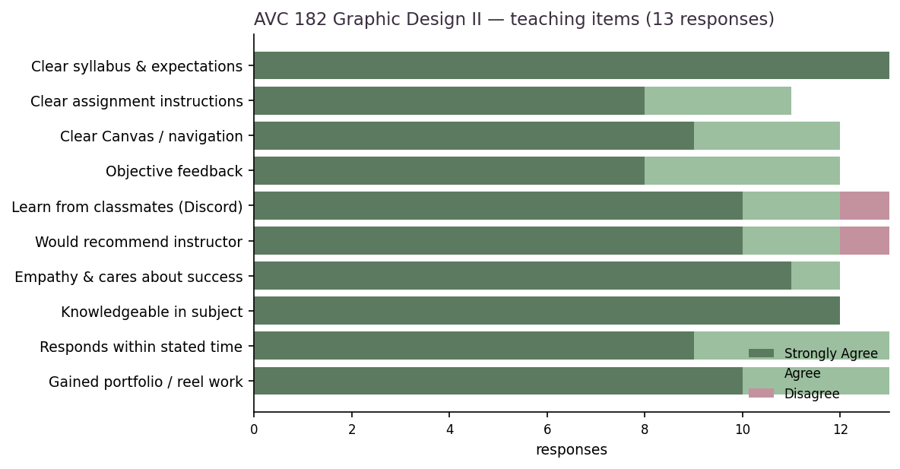

In their words
“Super thoughtful and understanding of students.”
“She has been greatly communicative on the class’s social forum.”
“The instructor provided a variety of resources that are easy to understand, and provided honest feedback on projects that encouraged me to keep going and improve more.”
“She provided helpful critiques along the way that have helped shape my work into the best work.”
“Organized the class in manageable sections, especially for full-time students.”
“Innovation. She is on the cutting edge of AI use in MCCCD.”
“My instructor had everything prepared and ready for us to do.”
“She has helped clarify and explain instructions that were otherwise challenging, in a timely manner, and helped ensure I got a good opportunity to succeed.”
“She has done amazing in providing feedback to our work, in a way that feels both supportive and provides growth in our skills.”
“I have enjoyed being in your class this semester.”
“Michelle Blomberg is awesome. I’ve taken classes from her before and plan to again.”
“Thank you for helping me succeed in this class. I would not have been able to do as much without your help, and thank you for responding to all my messages in a timely manner.”
“This has been an overall amazing course; the way it’s structured is perfect for a student like me. Amazing!”

AVC 181, Graphic Design I — my in-course survey (12 responses)
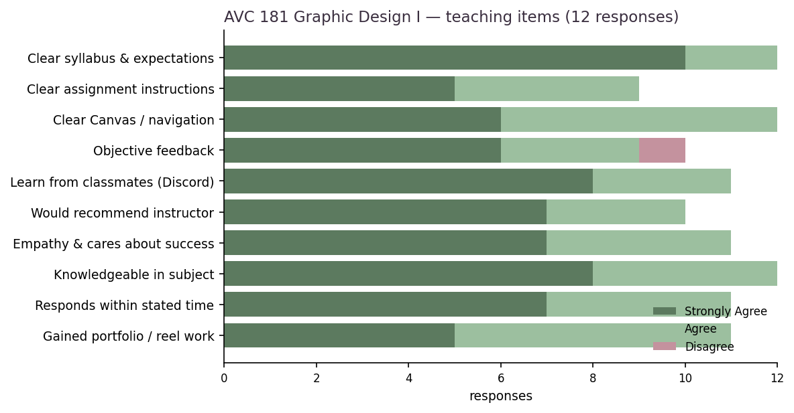

In their words
“She has great empathy. Feeling cared for, and told that I can take care of myself without being penalized heavily, does wonders for my success.”
“My instructor built a good community for us students to share our work and constructive criticism.”
“Her communication was amazing. If I had any questions, she would always respond to my emails or Discord chats. It was so helpful.”
“Breaking a project into Steps and Parts makes it much easier to manage my time and workload, and the learning process feels more streamlined, while granting the opportunity to receive feedback for each part.”
“I feel that my instructor is good at grading our assignments in a timely manner.”
“She always responds quickly to students’ questions. Her lectures are well organized.”
“All the assignments were very helpful and helped me learn new skills I can carry onto my next classes.”
“The book and coursework were great; I enjoyed learning this history and terms for graphic design.”
“She has given us a good variety of projects to complete.”
“Thank you for being patient with me. :)”
“I really enjoy this class.”
“Loved this class! It was my favorite one this semester.”

Official department reports
AVC 297AC, Commercial Art Internship: every rated item scored a perfect 5.00 (minimum 5.00, maximum 5.00), 3 responses. This report also serves as my interns’ reflection on the experience. (Verbatim source attached: Blomberg_27190.pdf)
AVC 181, Graphic Design I (1 response): near-perfect, with 5.00s across content relevance, organization, supportiveness, assignments, collaboration, feedback, and grading, and 4.00s on objectives clarity and instructor expertise. (Verbatim source attached: Blomberg_27186.pdf)

Strengths and growth

What students named
Care and support; communication and responsiveness on email and in Discord; the step-based project structure that made the workload manageable; constructive, growth-oriented feedback; real, portfolio-ready work; and innovation, including AI use.

Where students wanted more
Grading and feedback turnaround on every step of a large class; slightly clearer assignment instructions in a few places; and more even peer critique on Discord.

Reflection
The relational and structural parts of my teaching are clearly working: students feel supported, know I will respond, value the step-based structure, and notice the AI innovation. The student who nearly withdrew says it most directly, and it is exactly the outcome the AVC 100 redesign is built to produce, connection and support that keep students enrolled.
The one fair, recurring growth area is grading and feedback turnaround in 24-student online courses. I am acting on it: for the formative steps of a scaffolded project I am moving to a whole-class video critique in Discord, the online version of a studio critique wall, with checkmark complete-or-incomplete grading, and reserving full individual written feedback for the summative final work where it matters most. That keeps the interaction frequent and substantive while making turnaround sustainable, and it is grounded in regular and substantive interaction, which I keep refining and love comparing notes on with other faculty.

