A brief guide for analytical epidemiology | Prof Jake Bueno de Mesquita, PhD

Plots

Histograms
- plot of 1 variable (must be a numeric/continuous variable) on the x-axis.
- Y-axis is always frequency or count (could also be a density).
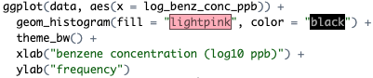
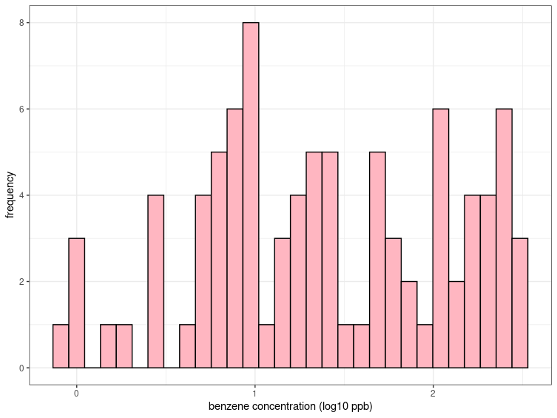

This histogram shows a mode around 1 log10 ppb benzene concentration. This means that most workers had exposure to about 1 log10 ppb of benzene concentration.

Boxplots
- Plots 2 variables:
  - X-axis variable is always categorical
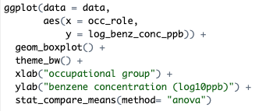
  - Y-axis is always continuous
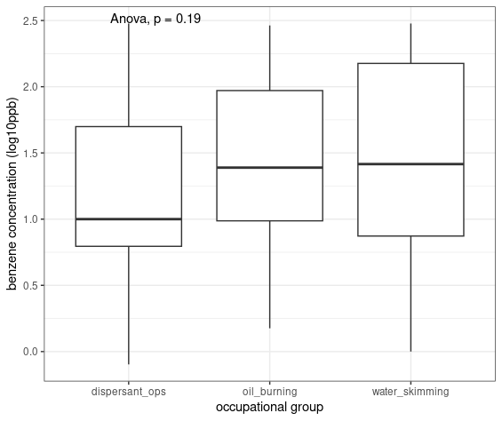
This boxplot shows lots of overlap in the distribution of the benzene concentration across the three occupational groups. Note that the median (middle bar in the box) for dispersant ops is about at the 25th percentile for oil burning and skimming groups meaning more of the dispersant ops workers have lower exposure compared with the other groups. But these differences are also not statistically significant according to the anova test (if we consider an alpha of 0.05) and visually you can see that there is LOTS of overlap between the boxes in all three groups.

Scatter plot
(not a very relevant plot type in the occupational health deepwater horizon oil spill cleanup dataset)
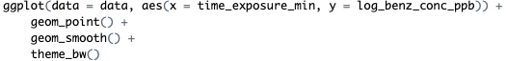
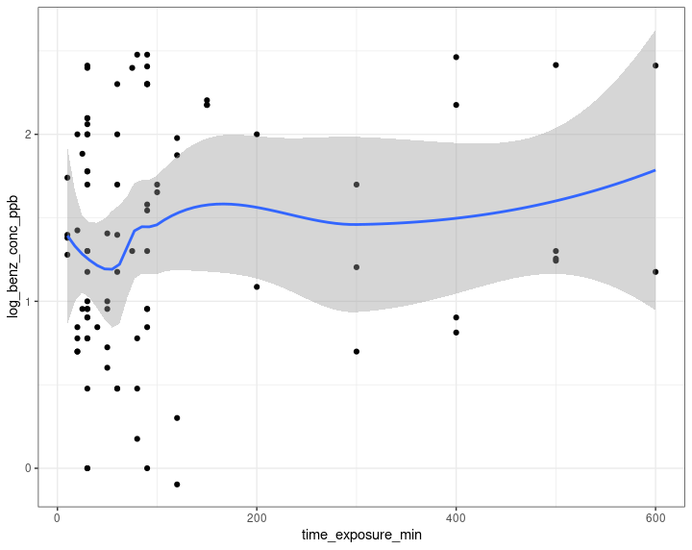
- Plots 2 numeric/continuous variables

This flat line shows that there isn’t much change in benzene concentration as a function of exposure time. Benzene concentrations were taken at various points in time at the working sites of the workers and do not represent cumulative exposure over time.

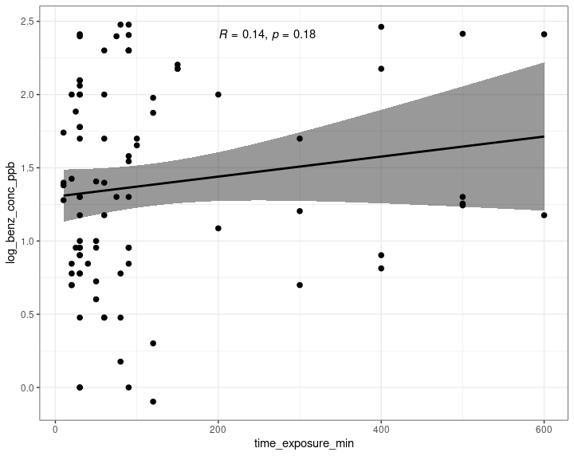
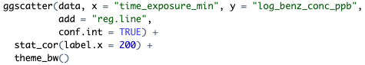
If you want to see how correlated the x and y variables are you can run a pearson correlation coefficient.

An R close to R indicates a strong (1:1 rise/run) linear relationship, while closer to 0 indicates that over the span of x-variable, the y-variable doesn’t change much.

What if I have 2 categorical variables?
You can use the stat.table function to run a frequency table.
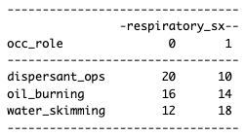
There are statistical tests (like chi-squared tests) that we could explore to show whether the distribution of respiratory symptoms is different across different working groups, but for now, just a visual assessment is fine!

Regression

First consider which variable as the outcome variable.
- If this variable is continuous (e.g., log_benz_conc_ppb) we need linear regression
- If this variable is categorical (e.g., respiratory_sx) we need logistic regression

Linear regression
Note that in this model, log_benz_conc_ppb is the outcome variables (continuous) and occ_role is the exposure variable.

This regression can get at the question: are there important differences in log_benz_conc_ppb exposure between occupational groups?

Let’s look at the model output for effect estimates:
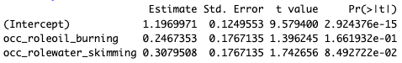
Notice that of the three occupational groups (oil burners, skimmers, and dispersant ops), we only see output for oil burning and skimming. This is because dispersant ops is the REFERENCE GROUP.

We must have a reference group to compare the occupational role groups against.
Ignore the intercept line.

occ_roleoil_burning Estimate is 0.2467353 this means that compared with dispersant ops, oil burners had 0.25 log10 benzene ppm exposure

Let’s look at the model output for confidence intervals:
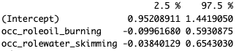
This means that the 95% CI for oil burners compared with dispersant ops is (-0.10-0.59).

Final interpretation: Compared with dispersant ops, oil burners had 0.25 (95% CI -0.10-0.59) log10 ppb benzene exposure. The story for skimmers is similar. Because this value is close to 0 and the confidence interval spans broadly across 0, we can say that in these data, there is little evidence of a difference in benzene exposure between the various occupational groups.

However, it may still be important to investigate any potential differences in risk of the health outcomes by occupational group. Since the health outcome variables (respiratory_sx and systemic_sx) are categorical variables, we could examine them using logistic regression.

Logistic regression
This regression can get at the question: are there important differences in odds of respiratory_sx between occupational groups?

Let’s look at the model output for effect estimates:
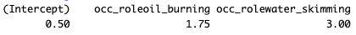
Remember the REFERENCE group is the occupational group that is missing in the output (just like in the linear regression above, the reference group is the dispersant ops).

We could say that compared with dispersant operations, oil burners had 1.75 times the odds of respiratory symptoms. But what about the confidence interval?

Let’s look at the model output for confidence intervals:
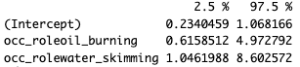

Final interpretation: Compared with dispersant ops, oil burners had 1.75 (95% CI 0.62-4.97) times the odds of having respiratory symptoms during the study period. The effect for skimmers was even higher with 3 times the odds of dispersant ops (95% CI 1.25-8.6). This points to elevated risk of respiratory symptoms potentially associated with workplace exposures.

But, does this relationship still hold after adjusting for potential confounder of smoking?

