**The Beauty of The Artificial Brain**

***Resource from Microsoft Copilot***

Artificial Intelligence is one of the most influence area nowadays.

**What actually AI is?**

Artificial intelligence (AI) is a branch of computer science focused on creating systems that can perform tasks that typically require human intelligence. These tasks include problem-solving, learning, understanding natural language, recognizing patterns, and making decisions. AI is just an overall area, but it divides into 2 areas, one is **machine learning** and the other is **deep learning**. Machine learning (ML) is a subset of artificial intelligence (AI) that focuses on developing algorithms and statistical models that enable computers to learn and make decisions from data. Deep learning is a subset of machine learning that uses neural networks with many layers (hence "deep") to model complex patterns in large amounts of data. Now we know the 2 subset of artificial intelligence, why deep learning so special? The answer is: it reassembles our **human brain**. Our human brain is built upon billions and billions of neurons each connected together to form a network. Neurons communicate at synapses, where neurotransmitters are released to pass signals to other neurons. Synapses has specific roles in mood regulation, learning, memory...etc. Artificial Intelligence clone the process of how the human brain works, it also has a term “**Neural Network**”. We will not be going to talk about machine learning, but will focus the area of deep learning “Neural Network”. In order to allow AI to intimidate the process of human brain, it must have common similarities. The human brain consists of billions and billions of neurons each connected to each other to form a brain network, so as AI, which consists of hundreds or thousands of what we call “**Node**” each connect each other as layers to form a network. Synapses, the chemical substances that regulate learning, memory...etc. AI has a term “**Weight**” like synapses is represent as a numeric digit, which represent the relevance of a matter (matter can be though as a task, problem, knowledge...etc.), the higher the digit “weight” number, the more it is relevant to the matter. Below illustrate how it works:

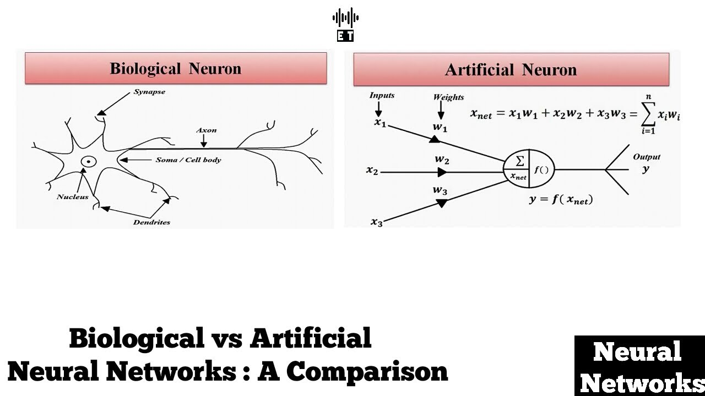

As a human being not like AI, how we deal or solve a matter is by experience and the knowledge we received through different channels, such as going to school, learn by reading text books and learn by doing a job...etc. How AI learns is by what we call “**Training**”. There are 3 types of “Training” methods, “**Supervise Training**”, “**Unsupervised Training**” and “**Reinforce Training**”.

**Supervise Training**

The supervise training paradigm is equivalent to “programming by example”. The neural network is given a problem or case; by training it makes a prediction or classification. Like as a student which is taught by a teacher in class.

**Unsupervised Training**

Unsupervised training is used in cases where we have the problem but don’t know the answer, but we know the question. Such as human we know what happen but don’t know the answer how to deal it. How to deal is base on knowledge and concept we have.

**Reinforce Training**

In reinforce learning, similar to unsupervised training, we have the example of the problem or case, but we do not have the exact answer or at least not immediately. Such as a human, who has knows the answer to some problem or case **but not all**, based on previous examples to solve problems of current tasks. After a brief overall view of what actually an AI is. It is time to discuss why it is so difficult to train and make an AI to learn, and we will provide some ways to remedy this issue.

In order to delve into details of AI, we need to first talk about human, as said before; AI neural network cloned the process of how human brain works. We need to know the problems of what human facing, in order to find a way to solve the most of the problems of AI.

For human, when we are sick, we need to see a doctor. If we have a cold or flu we need to eat medicine. If our brain or thoughts has problem, we need to see a “**Psychiatrist**” doctor. Most human needs to see a “**Psychiatrist”** for several reasons, depression, Manic depression...etc., but the one I want to point out is “**Psychosis**”. Why psychosis? Because if affects the way how we think or learn new things. Below lists out the symptoms of Psychosis:

**Psychosis** is a condition where a person experiences a disconnection from reality. This can manifest in various ways, including:

### Key Symptoms

* **Delusions**: Strongly held false beliefs that are not based in reality. For example, believing that one has superpowers or that they are being persecuted by unseen forces.
* **Hallucinations**: Sensing things that aren't there, such as hearing voices or seeing things that others do not.
* **Disorganized Thinking**: Difficulty organizing thoughts, leading to incoherent speech and behavior.
* **Behavioral Changes**: Social withdrawal, lack of motivation, and inappropriate behavior for the situation.

This kind of mental disorder of how human facing also applies to AI, especially when providing predictions and offer solutions or comments to problems. Products such as **copilot**, **ChatGPT** provide solutions, comments or even ideas to users when provide searching. Theses AI needs to be trained or learn from a given set of examples, if the things (**examples**) they learn from has problem, then it possible that it cannot provide a solution accurately. Just like human, if they learn something including knowledge, concept not properly or inaccurately then it is supposed it will affect their predictions or even how to solve problems**, also if people suffering from Psychosis, they will even have weird in terms of thinking which causes delusions. Some of the AI searching platform also has some symptoms of delusions, that is providing answers or solutions which doesn’t make sense. How to treat this kind of people, usually is by taking medicine subscribed by the doctor, within weeks or months’ time these kinds of symptoms will gradually reduce.**

**Medicine is made from large medicine factory or firms and being test by volunteers’ “patients” for several years in order to allow to use in the hospital. For AI, how do we imitate this process? The answer is by learning the accurate knowledge “Making the Medicine”. The medicine supposed to be correct and effective in order to be allow to use on patients. So as AI. Neural Network is being trained by the accurate knowledge or information. As being trained, the neural network will have some basic understating or concept to the problem. Knowledge or information doesn’t need to be a lot but needs to be accurate. When we have some basic understanding to the matter, we have some knowledge that is what we call “weights (Medicine)”. How doctors decided a person is suffering from Psychosis, is by checking if the person have common sense or by asking reality questions. if the person provides nonsense answers, then it is assumed it has Psychosis and the doctor will subscribe medicine treatment for the person. AI also, we have weights, if the weights generate by the platform “copilot for example” differs (usually 5% ~ 10% tolerance) from the common ones trained. It is assuming the “copilot” has some psychosis “delusion” symptoms. Then we need to manually adjust (“take the medicine”) the weights. Adjusting the weight is by copying those affected nodes (node we store “weights”) from the common trained ones, exactly, for instance if we trained the AI, one of the node stored the weight of “30”, compared to the node of the common ones which is “5”, there will be “83.33%” error, then we have to copy the common ones which is “5” and replace it with “30”, this approach is like a person have some delusion symptoms and needs to take the medicine. After several weeks of adjustment, the delusion symptom will be gradually reduced.**