X-ray And It’s Diagnosis
Resource From Microsoft Copilot

X-rays were discovered by Wilhelm Conrad Röntgen, a German physicist, in 1895. While experimenting with cathode rays, he noticed a new type of radiation that could pass through solid objects and create images of bones and other internal structures. This discovery earned him the first Nobel Prize in Physics in 1901. X-rays are a form of electromagnetic radiation with wavelengths shorter than visible light. They have the ability to pass through many materials, including the human body, which makes them incredibly useful for medical and industrial applications. Here’s a brief overview:
What Are X-Rays?
- Nature: They are a type of electromagnetic wave, like visible light, but with much higher energy.
- Discovery: Discovered by Wilhelm Conrad Röntgen in 1895.
- Production: Generated by X-ray machines that accelerate electrons to high speeds and then collide them with a metal target.
Uses of X-Rays
- Medical Imaging:
  - Diagnostic Radiography: Commonly used to view bones and detect fractures.
  - Computed Tomography (CT): Provides detailed images of the body’s internal structures.
  - Fluoroscopy: Used in real-time imaging to guide procedures.
- Security:
  - Airport Scanners: Check baggage and passengers for prohibited items.
  - Industrial Inspection: Examine the integrity of structures and materials, such as pipelines and airplane components.
- Scientific Research:
  - Astronomy: X-ray telescopes observe astronomical objects.
  - Material Science: Study the atomic structure of materials.

Diagram of X-ray tube
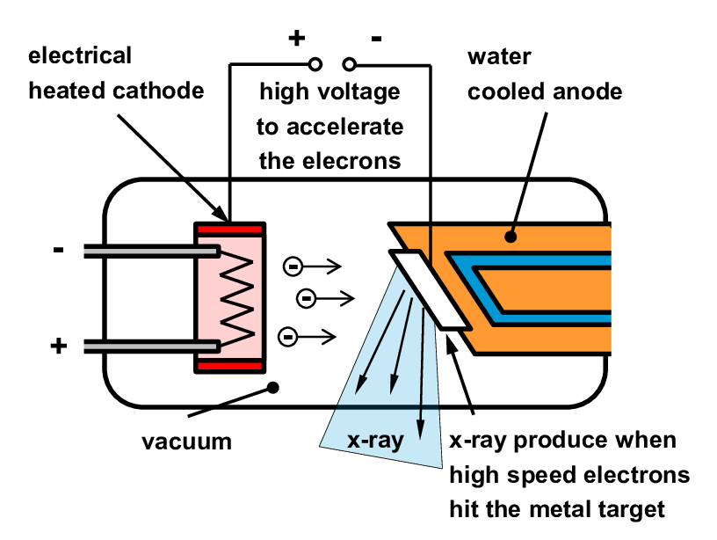
What is anode and cathode and how it is use in X-ray?
Anode and cathode are terms used to describe the electrodes in various types of electrical devices, such as batteries, electrochemical cells, and X-ray tubes. Here's a detailed explanation:
Anode
- Definition: The anode is the electrode where oxidation (loss of electrons) occurs. In general, it is the positive terminal in a device consuming power (like a battery when it's being discharged).
- Role in X-Ray Tubes: In an X-ray tube, the anode is the target where electrons collide to produce X-rays. It is typically made of a high atomic number material (like tungsten) to efficiently generate X-rays.
- Electrochemical Cells: In galvanic cells, the anode is the negative terminal where oxidation happens. In electrolytic cells, the anode is the positive terminal where the electrical current enters the cell.

Cathode
- Definition: The cathode is the electrode where reduction (gain of electrons) occurs. It is typically the negative terminal in a device consuming power.
- Role in X-Ray Tubes: In an X-ray tube, the cathode is the source of electrons. It is usually a heated filament that emits electrons through thermionic emission.
- Electrochemical Cells: In galvanic cells, the cathode is the positive terminal where reduction happens. In electrolytic cells, the cathode is the negative terminal where the current exits the cell.
Summary
- Anode: Electrode where oxidation occurs; positive in devices using power, negative in galvanic cells.
- Cathode: Electrode where reduction occurs; negative in devices using power, positive in galvanic cells.

The wavelength (and thus the energy) of X-rays can be controlled to suit different applications, including diagnostic radiography and computed tomography (CT).

Controlling X-Ray Wavelength
The wavelength of X-rays is primarily determined by the voltage applied across the X-ray tube. Here’s how it works:
- Higher Voltage: Produces X-rays with shorter wavelengths and higher energy. These are more penetrating and suitable for imaging denser tissues.
- Lower Voltage: Produces X-rays with longer wavelengths and lower energy. These are less penetrating and better for imaging softer tissues.
Applications
- Diagnostic Radiography:
  - Purpose: Used to view bones and detect fractures.
  - Wavelength/Energy: Typically uses X-rays with higher energy to penetrate dense bone structures. The contrast between bone and soft tissues is more pronounced, making it easier to see fractures and bone details.

- Computed Tomography (CT):
  - Purpose: Provides detailed cross-sectional images of the body’s internal structures.
  - Wavelength/Energy: Uses a range of X-ray energies. The CT scanner rotates around the body, taking multiple images at different angles. The data is then processed to create detailed 3D images of organs, tissues, and bones. The ability to adjust the X-ray energy is crucial for optimizing image quality and reducing radiation exposure.
Key Points
- Voltage Control: Adjusting the voltage across the X-ray tube controls the energy and wavelength of the X-rays.
- Image Quality: Different applications require different X-ray energies to produce optimal images.
- Safety: Properly controlling X-ray energy helps minimize radiation exposure while providing the necessary diagnostic information.
These adjustments allow X-ray technology to be versatile and effective for a wide range of medical and industrial purposes.

Can you use diagnostic radiography to detect lung cancer? How can the doctor distinguish if the patient is suffering lung cancer or breast cancer?

Yes, diagnostic radiography, such as chest X-rays and CT scans, can be used to detect lung cancer. These imaging techniques help identify abnormal areas in the lungs that might be cancerous1.
Detecting Lung Cancer
- Chest X-ray: Often the first test done to look for any abnormal areas in the lungs. If something suspicious is seen, further tests are usually ordered.
- CT scan: Provides detailed cross-sectional images of the lungs and is more effective at detecting lung tumours than a regular X-ray.

Distinguishing Lung Cancer from Breast Cancer
Distinguishing between lung cancer and breast cancer that has metastasized to the lungs can be challenging, but there are several methods used:
- Imaging Tests: Both chest X-rays and CT scans can show the presence of tumours in the lungs. However, additional imaging tests like MRI or PET scans might be used to get a clearer picture.
- Biopsy: A sample of the lung tissue or the suspicious area is taken and examined under a microscope to determine the type of cancer cells present.
- Immunohistochemical Stains: These stains help identify specific markers on the cancer cells that can indicate whether the cancer originated in the lung or another part of the body, such as the breast.
- Patient History: The patient's medical history, including any previous cancer diagnoses, can provide important clues.
Key Differences
- Primary Lung Cancer: Originates in the lung tissue itself.
- Metastatic Breast Cancer: Originates in the breast but has spread to the lungs.
By combining these diagnostic tools and methods, doctors can accurately determine whether a lung tumour is a primary lung cancer or a metastasis from another cancer, such as breast cancer

