What is the Earth Going On?

Continuous and stable supply of electricity is a must of nowadays electricity company. Although during these decades we seldom hear there is electricity outage, but still in some developing countries still face this issue. Why? The reason is there is no alternative path for the circuit when one path of the circuit is cut off. I don’t and have never work for electric companies before, how they design the electricity circuit plan for the area we are living will be an important issue. There are always a backup plan, in IT industry also, such as data centers, if one place of the data centers have problem, another place of data center picks up the job, we will never face an issue of no data. In electricity world also, if one part of the circuit has problem, another part of the circuit will picks up the job, so the chance of electricity outage will be greatly reduce. How to achieve? Is how you design the circuit plan and by using a special component call “Fuse”. Let’s discuss what is a fuse:

What is a Fuse?
- Definition: A fuse is an electrical component that contains a thin wire or metal strip that melts when too much current flows through it, thereby interrupting the circuit.
- Purpose: To prevent damage to electrical appliances and wiring caused by over current conditions, such as short circuits or overloads.

How It Works
- Normal Operation: Under normal conditions, the fuse allows current to pass through without interruption.
- Over current Situation: If the current exceeds the fuse's rated capacity, the wire or metal strip inside the fuse heats up and melts.
- Circuit Interruption: When the fuse melts, it breaks the circuit, stopping the flow of electricity and protecting the electrical system from damage.

As you see, fuse seems a kind of way of controlling the flow of current to one part of the circuit to another part. I am not going to discuss the circuit design plan here. But will like to take an example to explain how important to this issue, we will take an “electricity plug” as an example.
Before talking what is inside an “electricity plug”, we start talking about a wire. Below show the diagram of a typical wire for an electricity plug:
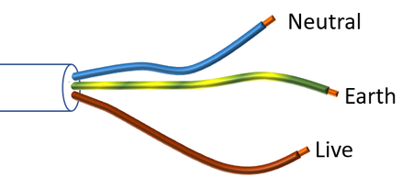

Forget about the naming and usage, Why are there 3 separate cables? As I said alternative path, if one part of the cable has issue, another part of the cable will pick up it’s job. Such as the image shown above, if “Neutral” has problem, “Earth” and “Live” will pick up it’s job equally. If “Live” has problem, “Earth” and “Neutral” will pick up it’s job equally. How to direct the flow of the current to these alternative path? Answer by “Fuse”. Now let’s jump into the design of an “electricity plug”.

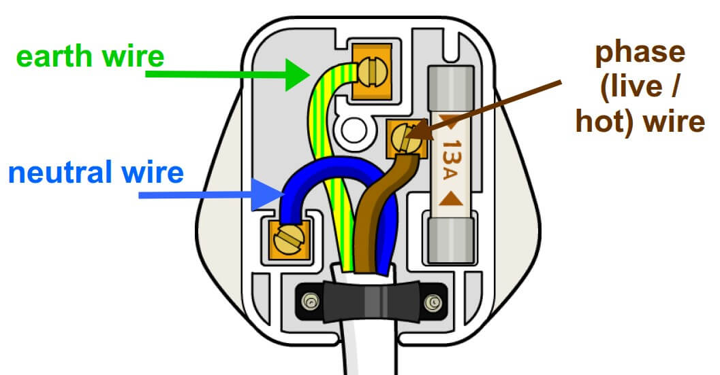

Forget about the design of the plug. What we need to focus is the “Fuse”. As shown above there is a “Fuse” and is printed “13A”, what is “13A”? 13A is the maximum current flow that the fuse can withhold to keep this plug functioning. If the current flow is over 13A, to avoid over heated, the “fuse” will be cut off and the plug will stop functioning and the “fuse” needs to be changed. As we just discuss above the important of “alternative path”. The above design cannot achieve it, we need a little bit of adjustment, how? By changing the fuse position, changing the fuse position connecting to one of the 3 separate cables. For example: If the “fuse” is place under and connected to the “Neutral wire”, what happens is if the fuse of the neural wire is cutoff, the plug will still be functioning, electrical current will be equally directed to the “Earth” and “Live” wires. If, “Live” wire is cutoff, then “Neutral” (with the fuse) and the “Earth” will pick up the job and so on...
You see, how you design the circuit plan greatly affects the stability of the contentious supply of electricity.

