UNIVERSITY OF MAKATI

**ITHINK: IMPLEMENTATION OF PATTERN MATCHING ALGORITHM**

**IN THE DEVELOPMENT OF GAME BASED LEARNING PYTHON TUTORIAL FOR BEGINNERS**

A THESIS SUBMITTED TO THE FACULTY OF COLLEGE OF COMPUTING

AND INFORMATION SCIENCES IN CANDIDACY FOR THE DEGREE OF

BACHELOR OF SCIENCE IN COMPUTER SCIENCE

(APPLICATION DEVELOPMENT TRACK)

DEPARTMENT OF COMPUTER SCIENCE

BY

**ED DOMINIC T. BARISO**

**CARLO RHEGS F. CAMBEL**

**MANUEL G. KOSCA JR.**

**JAYSON B. NARCE**

MAKATI CITY, PHILIPPINES

# April 2024

The THESIS entitled:

**ITHINK: IMPLEMENTATION OF PATTERN MATCHING ALGORITHM**

**IN THE DEVELOPMENT OF GAME BASED LEARNING PYTHON TUTORIAL FOR BEGINNERS**

submitted by Ed Dominic T. Bariso, Carlo Rhegs F. Cambel, Manuel Jr. Kosca and Jayson B. Narce have been examined and are recommended for Oral Defense.

_____________________________ _______________________________

JENNIFER T. CARPIO, DIT ERA MARIE F. GANNABAN

Department Chair Adviser

__________________________________

JOEL B. MANGABA, DT.

Dean

College of Computing and Information Sciences

The Faculty of the Department of Computer Science, College of Computing and Information Sciences, University of Makati, ACCEPTS THE THESIS entitled:

**ITHINK: IMPLEMENTATION OF PATTERN MATCHING ALGORITHM**

**IN THE DEVELOPMENT OF GAME BASED LEARNING PYTHON TUTORIAL FOR BEGINNERS**

submitted by Ed Dominic T. Bariso, Carlo Rhegs F. Cambel, Manuel Jr. Kosca and Jayson B. Narce in partial fulfillment of the requirements for the degree of Bachelor of Science in Computer Science (Application Development Track).

_____________________________ _______________________________

JOMARISS B. PLAN DANIEL P. DELLOSA

Panel Member Panel Member

________________________________

ROMMEL L. DORIN

Panel Chair

__________________________________

CHRISTIAN MICHAEL MANSUETO

Technical Adviser

__________________________________

ERA MARIE F. GANNABAN

Course Adviser

__________________________________

JOEL B. MANGABA, DT.

Dean

College of Computing and Information Sciences

**ABSTRACT**

Drafting an effective abstract is vital for encapsulating the essence of your research paper concisely and informatively. With a length typically limited to 150-250 words, it should provide a structured overview of your study, including the background, objective, methods, results, and conclusions. Use clear, specific language devoid of jargon to ensure comprehensibility. Emphasize key findings and contributions while incorporating relevant keywords for discoverability. Avoid repetition with the main paper, proofread meticulously, and tailor your abstract to the intended audience. Seek feedback, follow any specific guidelines, and remember that your abstract is often one of the last sections to be written, refined to reflect the final results and conclusions accurately.

**ACKNOWLEDGEMENTS**

# When drafting the acknowledgments for your work, begin by expressing your gratitude towards individuals and institutions who contributed directly or indirectly to your research or project. Start with formal acknowledgments, such as funding agencies, institutions, mentors, and advisors, followed by specific mentions of colleagues, collaborators, or friends who provided support, feedback, or resources. Keep the tone sincere and concise, and be sure to acknowledge anyone who had a meaningful impact on your work while respecting their privacy and preferences.

# **TABLE OF CONTENTS**

TITLE PAGE

ABSTRACT

ACKNOWLEDGEMENTS

TABLE OF CONTENTS

LIST OF FIGURES

LIST OF TABLES

LIST OF ABBREVIATIONS

# **CHAPTER I – INTRODUCTION**

Operational Definition of Terms

Project Context

Purpose and Description

Objectives

Specific Objectives

Scope and Limitations

# **CHAPTER 2 - RELATED LITERATURE**

Python for Beginners

Game Based

Game Based Learning

Benefits

Significance

KMP Algorithm

Pattern Matching

Evaluation Metrics for Algorithm

Agile Development

Software Evaluation Criteria

Synthesis

Conceptual Model of the Study

# **CHAPTER 3 – DESIGN AND METHODOLOGY**

# **CHAPTER 4 – RESULTS AND DISCUSSION**

# **CHAPTER 5 – CONCLUSIONS AND RECOMMENDATIONS**

# APPENDICES

Appendix A

Appendix B

Appendix C

Appendix D

Appendix E

References

**LIST OF FIGURES**

**LIST OF TABLES**

**LIST OF APPENDICES**

**CHAPTER I**

**INTRODUCTION**

In the digital age, students must acquire programming skills, as they are essential. Understanding the principles of programming allows individuals to effectively communicate and interact with technical teams in today's fast changing digital landscape. Professionals acquire insights into how software and technology function by learning basic programming ideas, allowing them to participate more effectively in debates, problem-solving, and decision-making processes inside their organizations.

In the context of higher education, programming education teaches students how to break down complex problems into smaller components and create systematic, step-by-step procedures for developing functional programs using computer-friendly languages. Learning should not be perceived as dull and repetitive, where students simply memorize concepts without understanding them. Some educators have turned to online platforms to enhance learning experiences. Games offer a playful way for students to acquire these skills, fostering critical thinking and problem-solving abilities by introducing rules and conditions within the game. Moreover, utilizing games is especially beneficial for students with attention disabilities, as it provides an enjoyable learning method that captures their attention.

.

**Definition of Terms**

*Game Based Learning* is a learning approach that incorporates elements of gaming into educational activities. Instead of traditional methods like lectures or textbooks, game based tutorials use interactive games and simulations to teach specific concepts, skills, or subjects. These tutorials leverage the engaging and motivating aspects of games to enhance the learning experience and make it more enjoyable for the participants.

*Drag and Drop* is a user interface interaction technique that allows users to click on a virtual object, drag it across the screen, and drop it onto another location or object. This interaction method is commonly used in computer applications, websites, and mobile devices to enable users to easily move, copy, or organize items without the need for complex commands or keyboard shortcuts.

*Leaderboard* a collection of high scores achieved in a game session during a specific time segment in a specific portion of a game for a specific set of users. It is used to increase the level of competition amongst players by ranking them in a variety of ways to generate more gameplay.

*Progress Report* is a report in which you are updating information about a project. Progress reports make it possible for management and clients to stay informed about a project and to change or adjust assignments, schedules, and budgets. These types of reports are used for projects that have many steps from onset to completion and are issued at regular intervals.

*Puzzle* is a game, toy, or problem that requires creative thinking, logic, and sometimes patience to solve. Puzzles come in various forms, such as jigsaw puzzles, crossword puzzles, Sudoku, brain teasers, and riddles. The goal of a puzzle is to challenge the solver's mind and provide a sense of accomplishment upon reaching a solution.

*Pattern Matching Algorithms* are used to identify patterns in larger text or data sets. In order to determine whether or not a pattern exists, these algorithms compare it to a bigger data collection or text. The ability to swiftly find patterns in massive data sets makes pattern matching algorithms crucial. Pattern matching is the process of checking a perceived sequence of string for the presence of the constituents of some pattern. In contrast to pattern recognition, the match usually has to be exact. The patterns generally have the form sequences of pattern matching include outputting the locations of a pattern within a string sequence, to output some component of the matched pattern, and to substitute the matching pattern with some other string sequence.

*Knuth Morris Pratt* an even more sophisticated Pattern Matching method is the Knuth-Morris-Pratt (KMP) algorithm. It is predicated on the finding that, in cases where a mismatch arises, certain details about the text and the pattern can be utilized to prevent pointless comparisons. A table with details about the pattern is precomputed by the algorithm. The number of characters in the pattern that can be skipped in the event of a mismatch is determined by the table. The KMP algorithm has an O(M+N) time complexity. The KMP algorithm works by preprocessing the pattern string to generate a partial match table (also called the failure function or the next array). This table contains information about the pattern string that allows the algorithm to skip over unnecessary comparisons during the search. During the search, the KMP algorithm compares each character in the text string with the corresponding character in the pattern string. If a mismatch is found, the algorithm uses the information from the partial match table to determine where to start the next comparison. The KMP algorithm has many practical applications, such as in text editors, search engines, and DNA sequencing. It is also used in other algorithms, such as the Boyer-Moore algorithm, which is a faster string-matching algorithm that is based on the KMP algorithm.

*Evaluation Metrics* are quantitative measures used to assess the performance and effectiveness of a statistical or machine learning model. These metrics provide insights into how well the model is performing and help in comparing different models or algorithms.

*Functional Requirement* These are the requirements that the end user specifically demands as basic facilities that the system should offer. All these functionalities need to be necessarily incorporated into the system as a part of the contract. These are represented or stated in the form of input to be given to the system, the operation performed and the output expected. They are basically the requirements stated by the user which one can see directly in the final product, unlike the non-functional requirements.

*Non Functional Requirements* These are basically the quality constraints that the system must satisfy according to the project contract. The priority or extent to which these factors are implemented varies from one project to another. They are also called non-behavioral requirements.

## **Project Context**

Python Programming has a relatively easy learning curve, it is used for a wide range of applications, such as web development, data analysis, scientific computing, machine learning, artificial intelligence, and automation. It has a large and active community, which contributes to a vast ecosystem of libraries and frameworks that make development faster and more efficient. This ensures that the language stays relevant and up-to-date with the latest technologies and trends.

Erovoutika is a distributor and supplier of electronics goods such as robots, modules, sensors, motors, and other training kits. They offer training programs for automation, Internet of Things, Image Processing, and network architecture, software development, web development, cybersecurity, and other IT related areas. Its objective is intended to improve and increase the technical skills of engineers, teachers, and students, as well as industry practitioners. One of the training programs offered by Erovoutika is Python Programming for beginners up to advanced level.

According to Erovoutika, most of the trainees enrolled for beginner modules trainees ages 9 above learn faster if gamified. According to (Priyaadharshini et al, 2020), one of the most cutting-edge learning strategies is game based learning, which encourages students to play games while studying. It refers to utilizing games as a method or tool in education to encourage engagement and learning (Li et al., 2021).

Designing and implementing instructional material into a game format in which players actively participate and interact with the game mechanics in order to gain knowledge or improve skills is known as game based learning. Numerous strategies address the broad topic of game based learning's use in various academic disciplines. Different recreational activities can help kids build knowledge by letting them explore and investigate a real-world issue that is frequently motivated by their curiosity (Hirsh-Pasek, 2020).

The problem that the study addresses is the difficulty of beginners when learning programming concepts such as Python Programming, and the complex traditional programming that lacks interactivity with the use of game based learning methods utilizing the pattern matching algorithms. Traditional programming education methods like Classroom Lectures, Textbooks and Hands-on Coding tend to be complex, text-based, and lack interactivity, making them challenging for young learners.

**Purpose and Description of the Study**

In response to the difficulty beginners often face when learning programming concepts, this research proposes the development of iThink: Python Tutorial for Beginners Utilizing Pattern Matching Algorithm in Game Based Learning. This Game Based learning will create a one-of-a-kind environment in which learners can engage in interactive and problem-solving activities. Learners can acquire programming skills in a motivating and engaging manner by including programming principles and challenges within games.

The proposed study is a game based learning platform for beginners that uses pattern matching algorithms and teaches Python programming concepts such as loops, variables, conditionals and functions. Pattern matching is the process of finding a pattern in a sequence of data. The number of learning modules from Erovoutika is insufficient and traditional programming education tends to be complex and lack interactivity. By integrating pattern matching, which involves recognizing patterns within data sequences, this platform can offer a more engaging and interactive educational approach. This addresses the current deficit in learning modules from Erovoutika and mitigates the complexity often associated with conventional programming education. The goal is to provide beginners with a comprehensive and user-friendly environment that fosters a deeper understanding of programming fundamentals through an interactive, pattern-oriented learning process. Thus, the study provides these features like User Management, a feature that allows to create, update, modify accounts, Module Manager, a feature that will show the learning materials, iThink Projects, a feature that will show the available projects to develop, Practice Game Based Learning, the main feature that will help familiarize the concepts of python by the use of the drag and drop, Progress Report, a feature that will show the progress and provide the required learning module, Leaderboards, a feature that will show the points and ranks and Tutorials, a feature that will also help for the familiarization of the concepts of python by the use of a video. These are the few perceived solutions that have surfaced to make programming education more approachable and interesting for beginners. Using visual programming languages, which enable students to construct code by dragging and dropping blocks of code or by using visual patterns of code, is one of the suggested approaches for teaching beginners to code. This method can make programming principles easier for students to understand and less daunting for newcomers.

The development of a web based application consists of the following features of User Management, a feature that allows to create, update, modify accounts, Module Manager, a feature that will show the learning materials, iThink Projects, a feature that will show the available projects to develop, Practice Game Based Learning, the main feature that will help familiarize the concepts of python by the use of the drag and drop, Progress Report, a feature that will show the progress and provide the required learning module, Leaderboards, a feature that will show the points and ranks and Tutorials, a feature that will also help for the familiarization of the concepts of python by the use of a video, with a strong focus on optimizing the user interface, interaction design, and overall user experience. This purpose directly addresses the problem of introducing programming concepts to beginners. Game based learning has the potential to improve access to computer science education, promote cognitive development and problem-solving skills, and enhance students' readiness for success. It can shed light on the impact of coding education on beginners' long-term academic and career outcomes. The research will contribute significantly to addressing the challenge of teaching programming to young learners and filling the knowledge gap in designing educational software tailored to their needs.

**Objectives**

The general objective of the study is to design and develop an Ithink web application, a python tutorial for beginners utilizing Knuth Morris Pratt Algorithm that will help learning gamified and interactive for the learners to engage.

# **Specific Objectives**

In order to fulfill the main objective of this project, the authors constructed the following specific objectives:

1. Examine and understand the basic programming concepts of Python for beginners through the game.
2. Explore existing systems or applications relevant to the proposed project
3. Analyze, understand, and perform activities on the data gathered towards Knuth Morris Pratt algorithm in the game based learning.
4. Train and evaluate the data in knuth morris pratt algorithm with the following evaluation metrics:
   1. Accuracy F1 Score
   2. Precision & Recall
5. Design and develop a web-based application with the following features:
   1. User Management - This feature allows the user of creating, updating, modifying and removing learners and admin accounts.

i. Learners Account: This feature allows the learner to login and save the progress of the game. They are also able to access the module, projects and leaderboards.

ii. Admin Account: This feature allows the user administrator to modify the modules, projects and progress reports of the learners.

* 1. Module Manager: This feature shows the available learning materials for the user.
  2. Practice Game Based Learning: This feature is the drag and drop that allows the user to familiarize the different concepts of python.
  3. iThink Projects: This feature shows the different projects available to develop by the user.
  4. Progress Report: This feature shows the progress and provides the required module for improvements.

i. Topics in progress: The user can continue the topics that are not completed.

ii. Topics Completed: The user can view the completed topics. They can also add an image of their status for educational purposes.

iii. Topics Suggested: The system will suggest a topic based on the learner’s score.

* 1. Leaderboard: This shows the overall points and ranks of the user from the game.
  2. How to (Tutorial): This shows the familiarization of the game by the use of a video on how the drag and drop works.

1. Test the functionality and non functionality performance efficiency of the prototype.
2. Evaluate the acceptability of the prototype using the ISO 25010 software quality model in terms of:
   1. Functional Suitability
   2. Usability
   3. Performance Efficiency
   4. Compatibility
3. Implement and deploy the system.

## 

## **Scope and Limitations**

**Scope**

The core focus of the research is the design and development of the application utilizing the pattern matching algorithm.

The study primarily focuses on beginners within a specific age range, 9+ years old, as the primary target audience. These formative years are crucial for cognitive development, and introducing programming concepts at this stage can be beneficial for fostering logical thinking and problem-solving skills. By tailoring the "iThink" system to this specific age group, we can ensure that the content and gameplay are appropriate and engaging for the target audience. Furthermore, the study aims to introduce and teach basic Python programming, with a particular emphasis on game based learning. Pattern matching is a fundamental concept in computer science, and by incorporating it into the game mechanics, beginners can learn to identify and manipulate patterns, which are essential skills for coding and problem-solving. The study will provide a structured curriculum that gradually introduces and reinforces these concepts, enabling beginners to develop their programming abilities in an enjoyable and interactive manner (K. Zhang & D. Shasha, 1997). To enhance the learning experience, the "iThink" system adopts a game based learning approach. By integrating elements of gaming into the programming lessons, the study seeks to engage beginners through interactive challenges, rewards, and a visually appealing user interface. The gamification aspect motivates beginners to actively participate, boosts their enthusiasm for learning, and provides a sense of achievement as they progress through the game levels.

The study is based on developing and evaluating the "iThink" system on the OnlineGDB and Codechum platforms. This platform is a web-based application that can deliver an immersive and accessible experience to the target audience. By choosing a specific platform, the study can concentrate on optimizing the user interface, interaction design, and overall user experience tailored to the capabilities and preferences of the chosen platform.

The study covers the design and development of the application that will outline the functional framework of the application. These features include game based learning, which allows the user to familiarize the different concepts of python from the module by the use of drag and drop. Topic Module, which shows the different learning modules or topics available for the user. iThink Projects, shows the different projects to develop by the user. Progress Report, shows the progress and provides the required module for improvements. Leaderboards, shows the overall points of the user from the game. Tutorial, shows the familiarization of the game on how the drag and drop works. Learners Accounts, a feature that grants the user to login and save the progress of the game. Lastly, Admin Account, a feature that grants the administrator to modify and update the system.

The geographical scope of this research extends to the Erovoutika and for beginners who will be interested in playing this game ages 9 above. Data collection, testing, and user interaction are expected to occur within this defined geographical region.

The study encompasses data collected and system development activities conducted during the period from November 2023 to April 2024. It acknowledges that technological advancements beyond this temporal scope may not be considered in the study.

The study employs a range of tools and technologies for the design and development of iThink Game Based Learning. These tools include

1. *Figma* is a collaborative web application for interface design, with additional offline features enabled by desktop applications for macOS and Windows. The feature set of Figma focuses on user interface and user experience design, with an emphasis on real-time collaboration, utilizing a variety of vector graphics editors and prototyping tools.
2. *C#* is an object-oriented programming language created by Microsoft that runs on the.NET Framework. C# has roots in the C family, and the language is close to other popular languages like C++ and Java.
3. *Visual Studio Code, also* commonly referred to as VS Code, is a source-code editor made by Microsoft with the Electron Framework for Windows, Linux, and macOS. Features include support for debugging, syntax highlighting, intelligent code completion, snippets, code refactoring, and embedded Git. Users can change the theme, keyboard shortcuts, preferences, and install extensions that add functionality.
4. *PHP* is a general-purpose scripting language geared towards web development. It was originally created by Danish-Canadian programmer Rasmus Lerdorf in 1993 and released in 1995. code is usually processed on a web server by a PHP interpreter implemented as a module, a daemon or a Common Gateway Interface (CGI) executable. On a web server, the result of the interpreted and executed PHP code which may be any type of data, such as generated HTML or binary image data would form the whole or part of an HTTP response. Various web template systems, web content management systems, and web frameworks exist that can be employed to orchestrate or facilitate the generation of that response.

**Limitations**

Despite the study's objectives, there are certain limitations that should be acknowledged:

The algorithm used for pattern matching is crucial to the study. The efficiency of these algorithms directly affects the application's accuracy and performance. Any restrictions or errors in these methods may have an effect on the application's overall performance.

The findings and outcomes of this research are particular to the geographical area, time frame and context specified in the study's scope. Without additional evaluation, the application performance might not be readily transferable to different areas or eras.

The study cannot control external elements that can affect the application's real-world performance, such as hardware restrictions, network connectivity, and differences in user behavior.

**CHAPTER II**

**REVIEW OF RELATED LITERATURE**

**Python for Beginners**

Python is a multi-paradigm programming language that serves a variety of purposes. a high-level programming language that uses a comparatively small number of lines of code as compared to other programming languages to complete a task. Because of its extremely user-friendly coding style, Python is now regarded as one of the simplest programming languages to learn. The language's standard library includes a sizable number of built-in methods. Python's key characteristics include being straightforward and simple to learn, free to use and open source, a high-level programming language, platform-independent, portable, dynamically typed, both procedure- and object-oriented, interpreted, extendable, embedded, and having a sizable library.

Python was created by Guido van Rossum in the late 1980s, and it was originally made available in 1991 as Python 0.9.0. Because it is a dynamically typed programming language, the user need not define the data type before storing values in the program. Python 2.0 was introduced in 2000, and Python 3.0, which is not entirely backward-compatible with prior versions, was released in 2008. Python is rated as the top programming language by PYPI: Popularity of Programming Language, 2022. Python is the most widely used language globally. Python saw the biggest growth in the last five years (12.1%), whereas Java experienced the biggest decline (-4.5%).

**Applications of Python**

According to Vineesh Cutting and Nehemiah Stephen (2021) web applications can be created in Python using a wide variety of frameworks. Flask or Bottle can be used for medium applications, whereas Pyramid or Django can be used for big projects. The Python libraries are capable of handling a number of internet technologies, including HTML, JSON, and others. The implementation of cryptographic operations is another option for creating safe apps. Python can be used to construct connections and connectionless protocols. Scientific and numerical artificial intelligence and machine learning are becoming more and more commonplace. To do the necessary work, more and more apps are being developed with intricate structures and algorithms. Because of its high-level data abstraction, packages like Numpy, Pandas, Scipy, and Scikit-learn are readily available in Python and can be used to complete tasks quickly. SCons is used to create control and management software utilizing Python software development. Buildbot and Apache Gumpr can be used for automated continuous compilation and testing. Roundup or Trac can be used for bug tracking and project management. Processing images, audio, and video is one of the areas in which Python is developing. To process and alter photos, some libraries include OpenCV, SimpleITK, and Pillow. Python may also use Pyglet, QT Phonon, and other tools to manipulate audio and video data. Education Python's great readability and simple syntax make it the perfect choice for any beginner. Python is a terrific language for people who may or may not have a strong background in coding, from beginners to experts. A person can quickly learn Python and begin exploring the domain-specific libraries with the help of a strong community and instructional materials.

**Game Based Learning**

Modern education is grappling with a range of intricate challenges linked to society's technological progress and social restructuring. Presently, the second generation of individuals known as digital natives is emerging. These individuals have been immersed in a digital environment since birth and perceive it as their natural habitat. The level of a civilization's technology leads to shifts in knowledge acquisition, job requirements, and training guidelines. The idea of lifelong learning is gaining prominence, where the process of gaining knowledge never ceases, making continuous self-education and self-improvement essential professional demands. Consequently, the expectations for school education are evolving. It is no longer limited to basic skills like reading, writing, and basic math; instead, it encompasses specific fundamental abilities collectively referred to as "21st century skills." Although there is no universally accepted definition of this term, according to numerous studies, these skills comprise creativity, problem-solving abilities, collaborative and cooperative interaction skills, and communication proficiency. Game-based learning stands out as an appealing approach for developing such skills. One of the most valuable and ancient pedagogical concepts has been learning through games. The use of video games and components associated with game reality, content, subject, and imagery in the educational process is currently referred to as "game-based learning." The majority of studies carefully distinguish between gamification and game-based learning. Gamification, then, is the application of aesthetics, game mechanics, and critical thinking to draw in and inspire pupils to work through particular difficulties. Gamification is the presentation of any training or working process as a game, without necessarily implying electronics or video games.

Game-Based Learning has become a prominent educational strategy, particularly in complex courses, as observed in studies like Blanié, Amorim, & Benhamou (2020). This approach utilizes educational stimuli to enhance learning outcomes, as demonstrated in research by ALFarsi, Jasiya, Ragad, Sohail, Abir, Maryam, and Hidayah (2020). The primary goal of game-based learning is to foster enthusiastic learners, increase student motivation and engagement, eliminate dull learning methods, and enhance students' focus, self-esteem, and memory. Various educational games are employed in educational institutions, schools, and homes, as noted by ALFARSI, M, & ALSINANI (2017). The integration of games in education primarily focuses on enhancing critical thinking skills. It allows students to explore innovative perspectives within the boundaries of rules. Some games are designed to deepen knowledge on specific topics, with math games being among the most popular options, as indicated by Frey, Fisher, & Smith (2019) and Tawafak & Romli, Ruzaini, and Sohail (2019).

**Game Based Learning Advantages**

Utilizing games in educational settings serves the purpose of engaging students actively and aiding them in retaining the knowledge they acquire. The objective is to encourage students to participate actively and remember what they have learned. Learning extends beyond mere memorization; games provide a platform for students to memorize crucial points that can be applied in practical situations, especially during exams (Tawafak & Romli, Ruzaini, Sohail, 2019; Mathew, Malik, & Tawafak, 2019; Alfarsi, Jasiya, Ragad, Abir, Maryam, 2019; Tawafak, 2019). In today's innovation-driven world, proficiency in optics and computers is highly valuable. By incorporating games, students can acquire visual and computer skills, preparing them for the demands of the professional realm (Pea, 1992). Games also play a role in enhancing critical thinking and problem-solving abilities. They achieve this by establishing a structured set of rules and conditions within the game environment (Mathew, Malik, & Tawafak, 2019; Pea, 1992). Moreover, utilizing games tailored for students with attention disabilities offers a fun and engaging method of learning, capturing the students' focus effectively. Research indicates that web-based games can be particularly beneficial in addressing attention issues among children (Clustering, 2019; Tatnall, 2020).

**Agile Development**

Agile is a type of software development methodology that anticipates the need for flexibility and applies a level of pragmatism to the delivery of the finished product. Agile software development requires a cultural shift in many companies because it focuses on the clean delivery of individual pieces or parts of the software and not on the entire application.

Benefits of Agile include its ability to help teams in an evolving landscape while maintaining a focus on the efficient delivery of business value. The collaborative culture facilitated by Agile also improves efficiency throughout the organization as teams work together and understand their specific roles in the process. Finally, companies using Agile software development can feel confident that they are releasing a high-quality product because testing is performed throughout development. This provides the opportunity to make changes as needed and alert teams to any potential issues. Agile has largely replaced waterfall as the most popular development methodology in most companies, but is itself at risk of being eclipsed or consumed by the growing popularity of DevOps.

**Pattern Matching Algorithm**

Pattern-matching algorithms are used to find patterns within a larger set of data or text. These algorithms work by comparing a pattern with a larger data set or text and determining whether or not the pattern is present. Pattern matching algorithms are important because they allow us to search for patterns in large data sets quickly. Pattern matching is widely used in computer science and many other fields. Pattern Matching algorithms are used to search for patterns within a larger text or data set. One of the most popular algorithms for pattern matching is the Boyer-Moore algorithm, which was first published in 1977.

According to Rahul B. Diwate (2013) Pattern matching is the process of checking a perceived sequence of string for the presence of the constituents of some pattern. In contrast to pattern recognition, the match usually has to be exact. The patterns generally have the form sequences of pattern matching include outputting the locations of a pattern within a string sequence, to output some component of the matched pattern, and to substitute the matching pattern with some other string sequence (i.e., search and replace). Pattern matching concept is used in many applications Following figure shows the different applications.

The use of web applications is increasing day by day. The new web applications are in use for searching data on the internet. String algorithms play an important role for this. Different people are working on software and hardware levels to make pattern searching faster. By applying various algorithms in various applications, the approximate best algorithm for different applications is determined. The recommended algorithms give the reduced complexity and also reduced computation time. The algorithms assigned to various applications may not be the best optimal algorithm but better than the general algorithms. Rather than applying each algorithm to every application one application is explained with a particular optimal algorithm. To support a different type of data, different algorithms are used. Each algorithm plays a different role to searching for data. Pattern matching is used in different applications. Web search engines are one of them. In search engines it deals with different formats of data like Text, Image, Audio, Video files. They used many algorithms.

**Knuth Morris Pratt (KMP) Algorithm**

According to Xiangyu Lu (2019) Knuth-Morris-Pratt (KMP) algorithm is one of the most efficient string matching algorithms in theory. Along with the alarming rise of information quantity and complexity, human beings need to cope with a more considerable amount of data in the fields of information retrieval, DNA data matching, virus feature matching, data compression, etc. Within this context, string pattern matching has attracted much attention for a long time. Pattern matching is one of the basic operations of strings. To illustrate, assuming that P is a given substring and T is a much longer string to be looked up, it is required to find all substrings that are the same as P in string T. In this case, string P is called pattern and T is called the target. Under normal circumstances, when talking about pattern matching, the first attempt is to match the substring P with string T starting from every single element in T, which uses the brute force method. Although this algorithm conforms to the principle, its workload is enormous and cannot be efficient. By way of illustration, if we use f (T) for the length of T, supposing f (T) =n and f (P) =m, “length” means the number of all the letters in a string, when searching P from T, the number of letter matching operations it will take is to be m*(n-m+1). Then the KMP algorithm, an improved string matching algorithm was discovered by Knuth, Morris, and Pratt at the same time, and by avoiding superfluous comparisons of letters, it became relatively fast and popular today.

According to Alzoabi et al. (2013) illustrated in their article, the KMP algorithm has been “considered as the first linear time string-matching algorithm with a serial cost of O(m+n)”. The KMP algorithm traverses the given pattern string from head to tail, trying to find the longest common elements between the prefix and the suffix of each substring of the pattern, and take down the length of the common part in a “Failure Table”, and the table should be of the same length to the pattern. Each letter of the pattern in the Failure Table has a corresponding number to be calculated. Then comparison starts from the first letter of P and T, let N1 denote the number of matched characters and updates with the comparison process, and represents “the corresponding number in the Failure Table of the last matched character” as N2. If the not-match situation starts from one letter of P, then the digits that P needs to move towards the right are: (N1-N2). The array “next” can be used to fulfill the identical functionality.

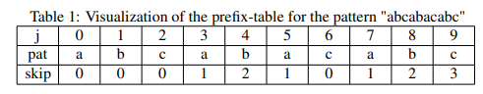

*Table 1: KMP Algorithm*

In this example the longest prefix which is also a suffix is ’abc’, and the bottom row in the table shows how many characters in the patterns can be skipped when trying to match a new pattern. In the Naive version of the pattern matching algorithm the pattern is matched from the start at every character in the text but by using a prefix-table some characters can be skipped since it is known what they contribute to the pattern. The longest prefix which is also a suffix is "abc '' here so if the whole pattern has been matched, then ’abc’ has been read as the last characters in the pattern, now when trying to find a new pattern it will start matching a pattern index 3. Whenever a sub-string of the prefix is encountered in the text it will not need to reread it due to this table, this can save a lot of operations when comparing to the naive pattern-matching solution, especially when the prefix and pattern is long and many skips can be done. To create the prefix-table two numbers are used, one for indexing the pattern and the other for keeping track of the longest prefix suffix value. A check is done to see if the pattern indexed by both of them match, if they do then both are incremented and the prefix suffix value is added to the table. If they do not match and the value is higher than 0 another check is done with the previous value, if the value is 0 then 0 is entered into the table and only the pattern index is incremented.

**Evaluation Metrics**

Precision measures the number of correct instances retrieved divided by all retrieved instances. Recall measures the number of correct instances retrieved divided by all correct instances

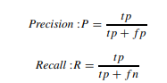

The F-score is defined as the weighted average of both precision and recall depending on the weight function β. The F1-score means the harmonic mean between precision and recall, when it is written F-score it usually means F1-score. The F-score is also called the F-measure. The F1-score can have different indices giving different weights to precision and recall.



With β = 1 the standard F-score is obtained



Precision uses all retrieved documents for the calculation. If there are a large number of documents, there is a possibility to make the calculation simpler by using precision at a cut-off value, for example precision at top 5 or precision at top 10 written as P@5 or P@10 respectively. This measure is called precision at n, or with a general term precision at P@n.

Accuracy is another measurement defined as the proportion of true instances retrieved, both positive and negative, among all instances retrieved. Accuracy is a weighted arithmetic mean of precision and inverse precision. Accuracy can also be high but precision low, meaning the system performs well but the results produced are slightly spread, compare this with hitting the bulls eye meaning both high accuracy and high precision



*Figure 1: Evaluation Metrics*

**ISO 25010**

The quality model is the cornerstone of a product quality evaluation system. The quality model determines which quality characteristics will be taken into account when evaluating the properties of a software product.

The quality of a system is the degree to which the system satisfies the stated and implied needs of its various stakeholders, and thus provides value. Those stakeholders' needs (functionality, performance, security, maintainability, etc.) are precisely what is represented in the quality model, which categorizes the product quality into characteristics and sub-characteristics. The product quality models that will be used are Functional Suitability, Usability, Performance Efficiency and Compatibility.

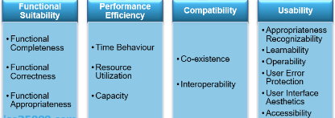

*Figure 2: ISO 25010*

## **Synthesis**

The synthesis of the literature is creating a dynamic, immersive learning environment. The game based learning serves as a pivotal force for altering the traditional educational paradigm. As society recovers from the pandemic, there is a rare opportunity to transform education and give students access and flexibility never before possible. The ideal way to gamify learning and growth is up for debate.

The gap identified where involvement of game based learning is a substantial gap in the literature that has been reviewed. There is a notable lack of research pertaining to the educational setting, but game based learning can only be successful if the player/learner is willing to engage with the game and to be persistent. As a result of these factors, game based learning has become more and more popular in recent years. The medium not only engages people in quality learning experiences but also has the ability to consume player's attention.

## **Conceptual Model of the Study**

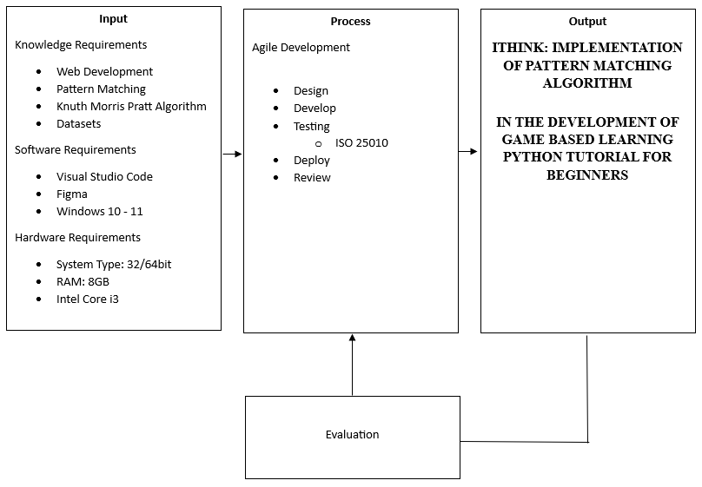

*Figure 3: Conceptual Model*

The conceptual model showcases how the input, process, and output of the research paradigm are interconnected. The input refers to the knowledge requirements, including web development, game designing, modeling, and the datasets. The Software Requirements specify the use of Visual Studio Code, Figma, and the app must run on Windows 10 to 11 Computers. The hardware requirements include 32 and 64-bit quad core processor and have at least 8GB RAM.

In the process, we use an agile approach that includes planning, designing, developing, testing, deploying, and reviewing the application. These steps enable us to continuously improve the web app, ultimately enhancing the learning experience for Python Beginners.

The final output of the research is the study results that will determine the KMP Pattern Matching Algorithm Game Based Learning. These results will be based on the testing and evaluation.

# 

# **CHAPTER III**

# **DESIGN AND METHODOLOGY**

This chapter of the paper presents an overview of the proposed study's fundamental theoretical foundations. The research framework is guided by these foundations in order to give substantial results to the research questions at the conclusion of the study. It was also utilized to monitor the progression of the system's workflow.

**Research Design**

In this research, we employ developmental research to track the progression of application development over time, aligning with the research objective of understanding the pattern matching game processes. It starts with a tutorial review to understand the game. A prototype is then developed and refined through several iterations based on testing feedback. User interaction data is collected and analyzed to gain insights into the user engagement. These insights are used to further refine the application. The developmental research framework allows for systematic tracking and documentation of each development stage.

**Research Methodology**

In this research, Agile is a project management approach that involves breaking the project into phases and emphasizes continuous collaboration and improvement. Teams follow a cycle of planning, executing, and evaluating. In developing the project, the researchers underwent different activities shown below. which identifies the analysis, resources, and procedures in designing, developing and testing the project. The Agile methodology encompasses distinct phases, each contributing to the research process in a unique manner. These activities are illustrated below:

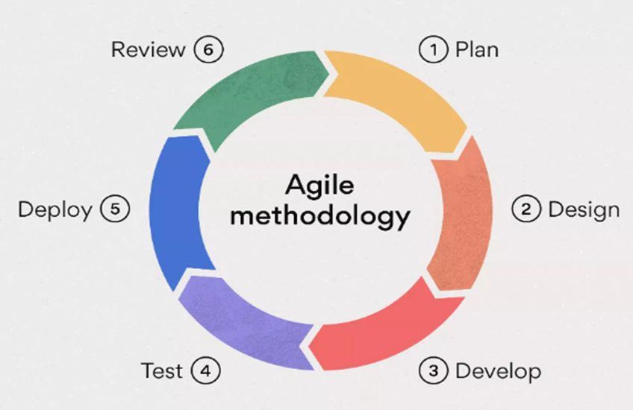

*Figure 4: Research Methodology*

**Plan**

Researchers carried out a number of tasks during the project's initial planning stage to collect crucial information for the creation of a iThink Python tutorial with game based learning. In-depth interviews with the organization were conducted at the beginning of the process in order to acquire a thorough understanding of their unique needs and goals. A pre-survey was conducted to identify the pain points and difficulties experienced by users. With these insights in hand, a thorough list of user requirements was created, addressing the particular problems and difficulties that plague the current apps. The planning step created a solid foundation for the subsequent stages of development, ensuring that the solutions to be implemented were precisely customized to address the identified issues and improve the users' overall learning experience.

**Design**

The research team will develop a detailed design for the iThink Python Tutorial with game based learning from the user needs acquired during the planning phase. To make sure that all user needs and system requirements are properly satisfied, this phase develops an architecture for the system's design and functionality. After user stories are created, they should specify how users will interact with the system and what their expectations are. Designers may create and work together on a variety of design projects with the help of Figma, a cloud-based design and prototyping tool. For websites, mobile apps, and other digital goods, it enables users to design visuals, create interactive prototypes, and create user interfaces. The user stories act as a basis for designing a user interface and user experience (UI/UX) that places a high priority on simplifying user interactions with the system so that users can easily navigate the platform without running into complications and make sure that all features function properly.

**Software Architecture**

Using a pattern matching method, the iThink Python Tutorial is being developed. There will be diagrams and pseudocode to show the reasoning and phases involved in the algorithms. The system is created to provide a dynamic and personalized game based learning environment, strengthening its function as an engaging and interactive platform for learners by matching these algorithms with the primary goal of increasing user engagement.

**Use Case Diagram**

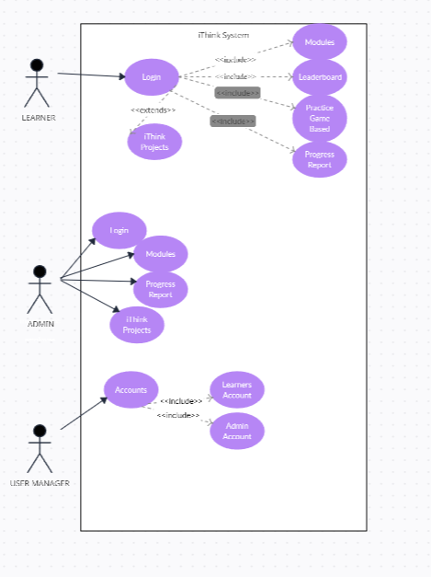

*Figure 5: Use Case*

The use case diagram shows the interaction between the learner, user manager, and administrator. For learners, the journey encompasses accessing login, homepage, module, projects and leaderboard features. The login includes the module and leaderboard. The module extends to the projects. Administrators engage with Login, Module, Progress Report, Projects and Updates the system. The user manager holds the creation, update and modifying the learner and admin accounts.

**Entity Relationship Diagram**

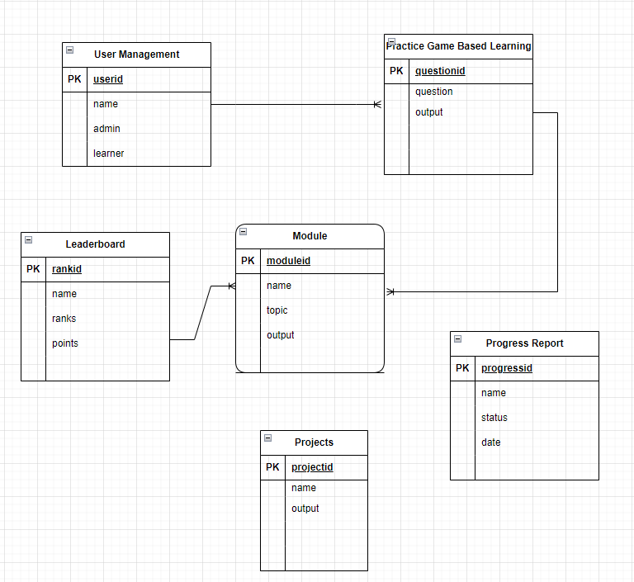

*Figure 6: Entity Relationship Diagram*

The relationships between the User Management, Practice Game Based Learning, Module, Leaderboard, iThink Projects, and Progress Report entities are depicted in the Entity-Relationship Diagram. These entities, which show the connections between user management, practice game-based learning, modules, leaderboards, iThink projects, and progress reports inside the system, reflect the many components of the iThink system. The relationship between the user management, practice game based learning, module and leaderboard entities has a one-to-many relationship. The ERD offers the visual organization framework for user data and instructional content.

**Algorithm Flowchart**

Knuth Morris Pratt Algorithm (KMP)

The Knuth-Morris-Pratt Algorithm, one of the applications of is to create a program that can help to gamify the Ithink. This Web application is to help students learn python programming in the easiest way by dragging and dropping the code blocks in the code area. The Flowchart for the implementation of KMP algorithm in the drag and drop if the code block matches on the pattern is as follows.

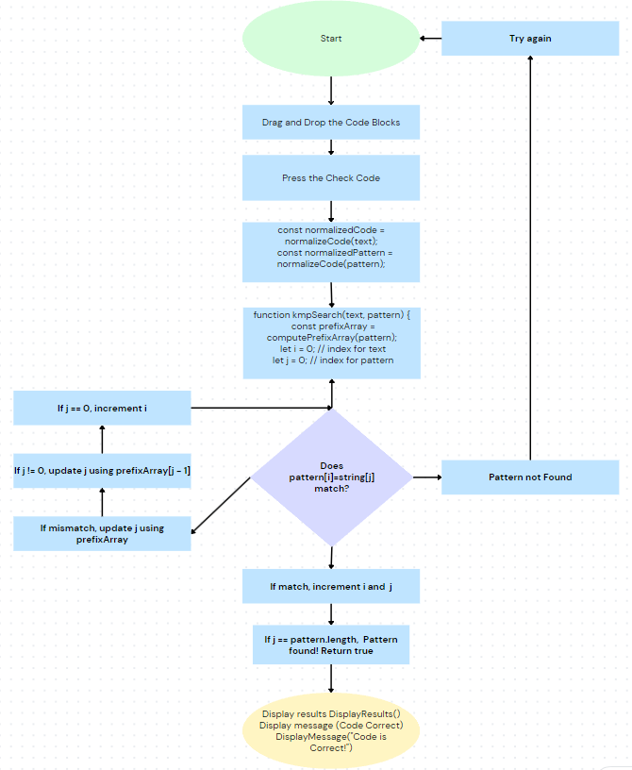

*Figure 7: KMP Algorithm Flowchart*

**Develop**

The project proceeds to the development stage of the Agile Software Development Life Cycle following the design phase. Using the design concept and user stories, the development team now begins coding the proposed iThink Python Tutorial System. The purpose is to provide a useful system that supports the project's goals. Developer cooperation ensures effective and best practice coding. This stage prepares the ground for deployment and testing.

**Algorithm Pseudocode**

Start

Drag and Drop the Code Blocks

While user is interacting:

If CodeBlockIsDropped():

Press the Check Code button

CheckCode()

Check Code Function

CheckCode():

Normalize the code

normalizedCode = normalizeCode(text)

normalizedPattern = normalizeCode(pattern)

Apply KMP Search algorithm

If kmpSearch(normalizedCode, normalizedPattern):

DisplayResults("Correct")

DisplayMessage("Code is Correct!")

Else:

DisplayResults("Incorrect")

DisplayMessage("Try Again")

End

**Test**

**Testing Procedure for Functionality**

|  |  |  |  |
| --- | --- | --- | --- |
| NO. | COMPONENTS | EXPECTED OUTCOME | ACTUAL OUTCOME |
|  |  |  |  |
| 1 | User Management | This feature allows the user to create, update, modify and remove learners and admin accounts. |  |
| 2 | Practice Learning | This feature is the drag and drop that allows the user to familiarize the different concepts of python. |  |
| 3 | Module Manager | This feature shows the available learning materials for the user. |  |
| 4 | iThink Projects | This feature shows the different projects available to develop by the user. |  |
| 5 | Progress Report | This feature shows the progress and provides the required module for improvements. |  |
| 6 | Leaderboard | This shows the overall points and ranks of the user from the game. |  |
| 7 | Tutorial | This shows the familiarization of the game by the use of a video on how the drag and drop works. |  |

*Table 2: Functional*

The table outlined appears to be a comprehensive and versatile learning management system, designed to cater to both learners and administrators. The user management functionality facilitates the seamless creation, modification, and removal of learner and admin accounts, ensuring a smooth administrative process. The 'Practice Learning' feature employing drag-and-drop functionality seems particularly engaging and effective for familiarizing users with Python concepts in an interactive manner. The 'Module Manager' offers a centralized hub for accessing various learning materials, providing a structured learning path. The iThink Projects section presents users with diverse projects, fostering practical application and skill development. The 'Progress Report' feature is crucial, offering insights into user advancement and suggesting modules for improvement, enabling personalized learning. The 'Leaderboard' adds a competitive element, motivating users through points and ranks, while the 'Tutorial' video serves as an instructional guide, enhancing user understanding of the platform's functionalities.

**Testing Procedure for Non-Functional**

|  |  |  |
| --- | --- | --- |
| **NO.** | **CRITERIA** | **DESCRIPTION** |
| **1.** | Functional Suitability | ● The system meets all the defined goals and user objectives.  ● The system delivers the required level of accuracy and the right results.  ● The system functions and accomplishes specified tasks and objectives. |
| **2.** | Usability | ● The system can be used by specified users to achieve specific goals.  ● The system has attributes that make it easy to operate and control.  ● The system's interface is pleasing and has satisfying interaction for the user |
| **3.** | Performance Efficiency | ● The system responds and processes events faster  ● The system utilizes information resources efficiently  ● The system parameters meet their system requirements |
| **4.** | Compatibility | ● The system can be utilized on a variety of devices.  ● The system is compatible with a wide range of browsers. |

*Figure 8: Non Functional*

|  |  |  |  |  |  |  |  |
| --- | --- | --- | --- | --- | --- | --- | --- |
| **No.** | **CRITERIA** | **RESEARCH QUESTIONS** | **5**  **Strongly Agree** | **4**  **Agree** | **3**  **Neutral** | **2**  **Disagree** | **1**  **Strongly Disagree** |
| A. | **FUNCTIONAL SUITABILITY** | 1. Does the iThink Python Tutorial provide all the functions that are needed? |  |  |  |  |  |
|  |  | 2. Does the iThink cover all the required learning materials for beginners? |  |  |  |  |  |
|  |  | 1. Does iThink provide effective learning materials with the use of game based learning? |  |  |  |  |  |
| B. | **PERFORMANCE EFFICIENCY** | 1. Does the iThink system have fast response time and action? |  |  |  |  |  |
| 1. Does iThink utilize its information resources and learning experiences? |  |  |  |  |  |
|  |  | 1. Does iThink meet its functions in learning? |  |  |  |  |  |
| C. | **COMPATIBILITY** | 1. Is it compatible with different devices and browsers? |  |  |  |  |  |
| C. | **USABILITY** | 1. Does iThink provide a pleasing interface for learning? |  |  |  |  |  |
| 1. Is it easy to use? |  |  |  |  |  |
| 1. Does iThink provide a quality learning experience? |  |  |  |  |  |

*Table 3: ISO 25010*

During the testing phase, testers and developers collaborate closely during the testing process to regularly assess the system and make sure it satisfies both functional and non-functional requirements. This continuing evaluation takes into account both functional and non-functional performance, reliability, security, and usability factors. measures are used by testers to evaluate the effectiveness of the pattern matching algorithm, such as the F1 Score, Confusion Matrix, Accuracy, Precision and Recall measures. Each user narrative must go through testing to find possible problems and fix them as they appear, guaranteeing that the system is ready for deployment.

**Deploy**

Following the testing phase, the development denotes when the iThink system is prepared for actual usage, representing a substantial transition. The system's internet accessibility, user convenience, and quick feedback are all priorities during this phase. It marks a crucial turning point in the application's growth from a development project to a useful, real-world tool with the potential to dramatically enhance the educational experience. The capability of the program to actively engage users, improve the learning process, and successfully satisfy the indicated needs.

**Review**

The review phase, the last step in the research technique, is when the performance of the system is examined using the ISO 25010 software evaluation standards. Surveys are carried out by researchers to evaluate the functional suitability, usability, performance efficiency, and compatibility of a system. In order to get input and improve the system's alignment with user needs, the researchers also show the system to stakeholders. This allows them to make changes right away. In order to improve and improve the system, this phase collects crucial information and embodies the principles of continuous improvement.

**References**

**Chapter 1**

**Introduction**

A Study of First-Year Students’ Attitudes toward Programming in the Innovation in Educational Technology Course

<https://www.hindawi.com/journals/edri/2021/9105342/>

A Study of Difficulties in Teaching and Learning Programming: A Systematic Literature Review

Rozita Kadar, Naemah Abdul Wahab, Jamal Othman, Maisurah

Shamsuddin & Siti Balqis Mahlan

<https://hrmars.com/papers_submitted/11100/a-study-of-difficulties-in-teaching-and-learning-programming-a-systematic-literature-review.pdf>

How to Implement Game Based Learning in a Smart Classroom?

A Model Based on a Systematic Literature Review and Delphi Method

Liuxia Pan1 Ahmed Tlili2 Jiaping Li1 Feng Jiang1 Gaojun Shi1 Huiju Yu3* Junfeng Yang1*

<https://www.frontiersin.org/articles/10.3389/fpsyg.2021.749837/full>

C#

<https://en.wikipedia.org/wiki/C_Sharp_(programming_language)>

Figma

<https://en.wikipedia.org/wiki/Figma>

Visual Studio Code

<https://en.wikipedia.org/wiki/Visual_Studio_Code>

PHP

<https://en.wikipedia.org/wiki/PHP>

**Definition of Terms**

Leaderboard

<https://www.linkedin.com/pulse/climbing-ranks-guide-leaderboards-mobile-gaming-ratic/>

Pattern Matching (Definition of Terms)

<https://www.javatpoint.com/pattern-matching-algorithm-in-c#:~:text=What%20is%20a%20Pattern%20Matching%20Algorithm%3F&text=Pattern%20Matching%20algorithms%20are%20used,not%20the%20pattern%20is%20present>.

<https://www.researchgate.net/publication/282652139_Study_of_Different_Algorithms_for_Pattern_Matching>

Game Based Learning

https://elearningindustry.com/why-is-game-based-learning-important

Puzzle

<https://en.wikipedia.org/wiki/Puzzle>

KMP algo

<https://www.geeksforgeeks.org/kmp-algorithm-for-pattern-searching>

<https://medium.com/@vad.pinchuk/understanding-and-applying-the-knuth-morris-pratt-algorithm-from-string-matching-to-stream-search-70ed63115c91>

Evaluation Metris

<https://www.analyticsvidhya.com/blog/2019/08/11-important-model-evaluation-error-metrics/#:~:text=Evaluation%20metrics%20are%20quantitative%20measures,comparing%20different%20models%20or%20algorithms>.

Progress report

<https://walton.uark.edu/business-communication-lab/Resources/downloads/business-forms/Progress_Report.pdf>

Functional & Non Functional Requirements

<https://www.geeksforgeeks.org/functional-vs-non-functional-requirements/>

Pattern Matching

<https://www.researchgate.net/publication/46433896_Pattern_Matching>

Can Students’ Computer Programming Learning Motivation and Effectiveness Be Enhanced by Learning Python Language? A Multi-Group Analysis. (2021).

https://www.frontiersin.org/articles/10.3389/fpsyg.2020.600814/full

Students' Performances in Computer Programming of Higher Education for Sustainable Development: The Effects of a Peer-Evaluation System. (2022). <https://www.frontiersin.org/articles/10.3389/fpsyg.2022.911417/full>

What is Programming? Codecademy Team

<https://www.codecademy.com/article/what-is-programming>

<https://www.academia.edu/34673459/REVIEW_OF_RELATED_LITERATURE>

Factors Contributing to the Difficulties in Teaching and Learning of Computer Programming: A Literature Review. (2020). <https://www.cedtech.net/download/factors-contributing-to-the-difficulties-in-teaching-and-learning-ofcomputer-programming-a-8247.pdf>

Make 21st Century Education: The Importance of Teaching Programming in Schools. (2020). <http://www.ijlt.org/uploadfile/2020/0903/20200903031346728.pdf>

**Chapter 2**

A Review on using Python as a Preferred Programming Language for Beginners

Vineesh Cutting 1, Nehemiah Stephen2

<https://www.researchgate.net/publication/359379004_A_Review_on_using_Python_as_a_Preferred_Programming_Language_for_Beginners>

Retracted Article: Using the Concept of Game-Based Learning in Education

<https://www.learntechlib.org/p/217589/>

General View about Games based Learning: Literature Review

<https://www.scitepress.org/Papers/2020/103048/103048.pdf>

Evaluation Metrics

<https://link.springer.com/content/pdf/10.1007/978-3-319-78503-5_6.pdf>

**Agile Development**

[**https://www.techtarget.com/searchsoftwarequality/definition/agile-software-development**](https://www.techtarget.com/searchsoftwarequality/definition/agile-software-development)

Pattern Matching Algorithm (KMP)

<https://www.researchgate.net/profile/Rahul-Diwate/publication/282652139_Study_of_Different_Algorithms_for_Pattern_Matching/links/56160e4408aed47facf01383/Study-of-Different-Algorithms-for-Pattern-Matching.pdf>

<http://www.diva-portal.org/smash/get/diva2:1740594/FULLTEXT01.pdf>

ISO 25010

<https://iso25000.com/index.php/en/iso-25000-standards/iso-25010>

**Synthesis**

Systematic Review of Enjoyment Element in HealthRelated Game Based Learning

Habibah Ab Jalil () , Nurul Amelina Nasharuddin, Erzam Marlisah

<https://www.learntechlib.org/p/218356/article_218356.pdf>

**Metrics**

Understanding Confusion Matrix. (2018).<https://towardsdatascience.com/understanding-confusion-matrix-a9ad42dcfd62>

The Effect of Coding Education on 5th, 6th and 7th Grade Students' Programming Self-Efficacy and Attitudes About Technology. (2020).<https://files.eric.ed.gov/fulltext/EJ1263433.pdf>

The Impact of Coding Apps to Support Young Children in Computational Thinking and Computational Fluency. A Literature Review. (2021). <https://www.researchgate.net/publication/352285341_The_Impact_of_Coding_Apps_to_Support_Young_Children_in_Computational_Thinking_and_Computational_Fluency_A_Literature_Review>

Teaching Python to Children: A Review of the Literature by F. García-Sánchez, P. Conde-González, and J. Rodríguez-Fórmaz (2015). <https://www.tandfonline.com/doi/full/10.11120/ital.2011.10010086>

The Effectiveness of a Game Based Approach for Teaching Python Programming to Children by S. Al-Shammari, A. Mohamed, and M. Shehab (2017). <https://ieeexplore.ieee.org/document/8030767>

A Study on the Effectiveness of Using Python Programming Language to Enhance Children's Computational Thinking Skills" by H. Al-Badi, S. Al-Shammari, and M. Shehab. (2020). <https://ieeexplore.ieee.org/document/9039452>

Game based learning in computer science education: a scoping literature review. (2023)

https://stemeducationjournal.springeropen.com/articles/10.1186/s40594-023-00447-2

Erovoutika: Robotics & Automation Solutions. (2017).

<https://ph.linkedin.com/company/erovoutika>

Codechum: A programming teacher’s tool to simplify grading and assess students effortlessly. (2018). <https://help.codechum.com/students>

Software Development Life Cycle

<https://www.synopsys.com/glossary/what-is-sdlc.html#:~:text=Definition,all%20customer%20expectations%20and%20demands>.

Pattern Matching Algorithm

https://www.javatpoint.com/pattern-matching-algorithm-in-c#:~:text=What%20is%20a%20Pattern%20Matching%20Algorithm%3F&text=Pattern%20Matching%20algorithms%20are%20used,not%20the%20pattern%20is%20present.

**Chapter 3**

<https://asana.com/resources/agile-methodology>

<https://www.visual-paradigm.com/guide/data-modeling/what-is-entity-relationship-diagram/>