**OUTPUT from similarity.py:**

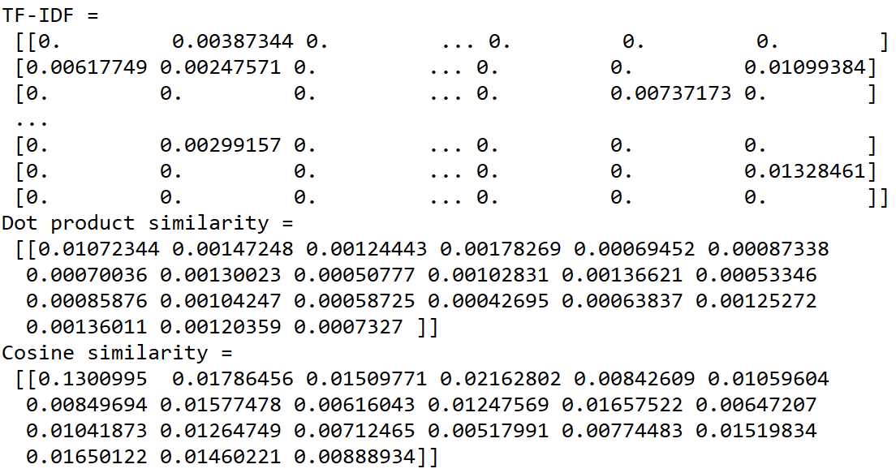

**From the table tfidf_result.xlsx, the row head is:**

**[doc_0, doc_1, doc_10, doc_11, doc_12, doc_13, doc_14, doc_15, doc_16, doc_17, doc_18, doc_19, doc_2, doc_20, doc_3, doc_4, doc_5, doc_6, doc_7, doc_8, doc_9]**

**Apart from doc_0, the 5 most similar documents to doc_0.txt in Dot product similarity is:**

**[ 0.00147248 0.00178269 0.00130023 0.00136621 0.00136011 ]**

**Which representing doc_1, doc_11, doc_15, doc_18, doc_7.**

**Thus, the 5 most similar documents to doc_0 in Dot product similarity are doc_1, doc_11, doc_15, doc_18, doc_7.**

**Apart from doc_0, the 5 most similar documents to doc_0.txt** **in Cosine similarity is:**

**[ 0.01786456 0.02162802 0.01577478 0.01657522 0.01650122]**

**Which representing doc_1, doc_11, doc_15, doc_18, doc_7.**

**Thus, the 5 most similar documents to doc_0 in Cosine similarity are doc_1, doc_11, doc_15, doc_18, doc_7.**