Radial Particle Accelerator

By Nathan Ross

August 29, 2012

Radial Particle Accelerator

A radial accelerator is a new type of particle accelerator. It consists of radial spiral or loop modules interconnected to form a linear accelerator or ring accelerator. The radial modules
are similar to a disc and spiral in a loop of a n dimensional width. The track size can be
anywhere from a micron or several centimenters. Each module can be several milimeters in circumference to several meters in circumference and form a disc. It provides for a particle accelerator thousands of times larger than a simple ring or linear accelerator. Each module can be interconnected to the next in series in a linnear accelerator or a circular accelerator.

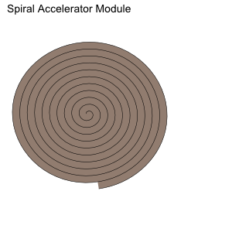

This is a diagram of a radial Accelerator. It conists of a interconnected group of modules where a particle is looped through each spiral and sent to the next loop. In this manner a conventional accelerator can contain a track a thousand kilometers or more in length. There are three main parts the track and the radial modules and the modular interconnects. The spiralling modules have a diameter and a track size from several microns to several centermeters and interconnects to connect to the next spiral accelerator module. The modules can consist of radial accelerator pipes with the accelerator machinery or be a simple interconnected radial module.

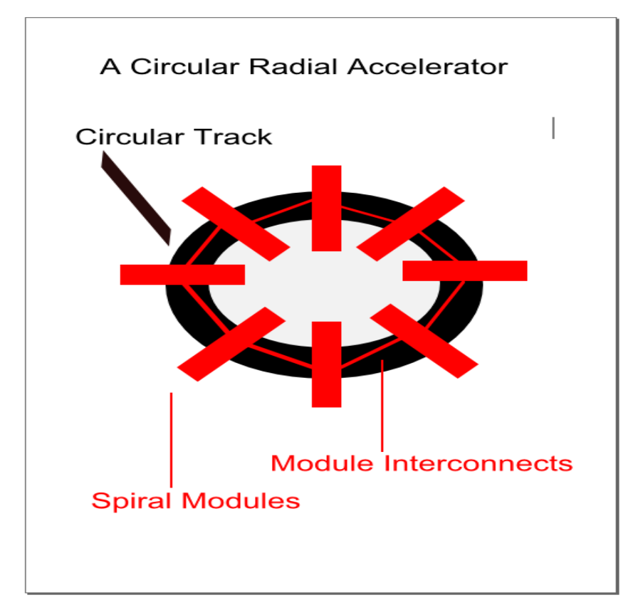

To calculate the length of the spiral

N = Number of turns
P = Distance between turns
Length = sqrt( ( (π * Diameter * N)^2 + (P * N)^2) ) )

Another type of radial accelerator is a designed like a coiled loop. It is a series of interconnected channels with connecting linear loops with an input and an output to the next connected module. A module can contain several kilometers or more of accelerator track depending on track size and module area.

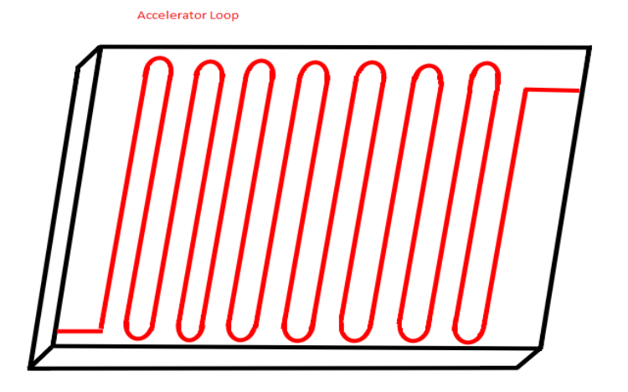
As an example a accelerator module is created 1 centimeter square. The track size of 1 micron 0.001 mm with a space of 1 micron between each loop. Each linear loop is .9 centimers long this will result in 5000 linear loops. The semicircular interconnect is (2*π*r)/2 with a given radius of
.001 mm or 1 micron which equals .00314 mm (.000628 cm). 5000 loops multiplied times .9 centimeters equals 4500 centimeters or 45 meters.

10 mm / .002 mm per track = 5000 linear loops
.9 cm x 5000 = 4500 cm or 45 meters per centimeter + the radial interconnect + the input and output connection

.000314 * 5000 = 1.57 cm for the semicircle interconnect.
4501.57 cm total length estimated

If you connect one hundred 1-centimeter modules together into a 1 meter accelerator it will have a track length of (4500) 4.5 kilometers per meter.

The modules can be stacked into a 3-d block with 3-dimensional interconnects between the layers. Submicron lithography can also be used to define the tracks.

